【習題2.3.1】
考慮圖2.3.1所示有障礙物及陷阱的迷宮。在此，S是起始狀態，G是代表目標狀態(即終止狀態)，O是代表障礙物，而T是陷阱
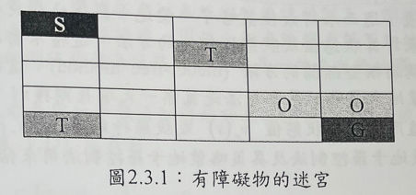
除了目標狀態、障礙物及陷阱之外，代理者在每一個狀態都有4個行動可選擇，分別是左上右下 4個方向，各移動一個單位。若到達目標狀態，則遊戲結束且獲得獎勵為0。若代理者落入陷阱，則在下一個時刻會直接送回起始狀態並得到獎勵為 -50。其他情況之獎勵為-1。若是碰到障礙物或牆壁會返回原狀態。設折扣因子為 Y=0.95。假設策略 是選擇4 個方向行動的機率都一樣。試以動態規劃的方法來計算狀態值 Vπ(s)、狀態行動值 qπ(s,a)及貪婪策略。
(1)應用(2.1.1)
答:
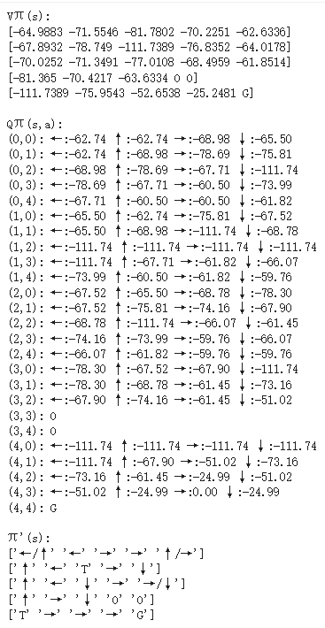
(2)應用(2.1.2)
答:
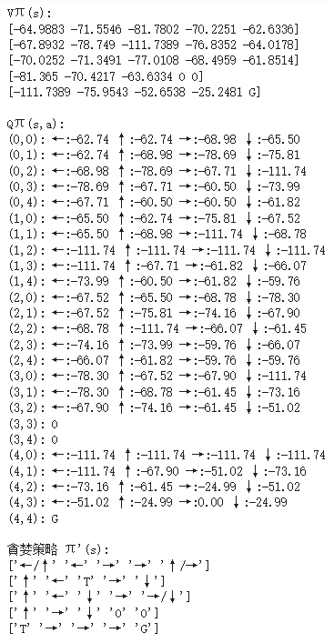

【習題2.3.2】
考慮[習題2.3.1]。試以動態規劃的方法來計算最佳狀態值 Vπ(s)、最佳狀態行動值 qπ(s,a)及最佳策略。
(1)應用(2.1.3)
答:
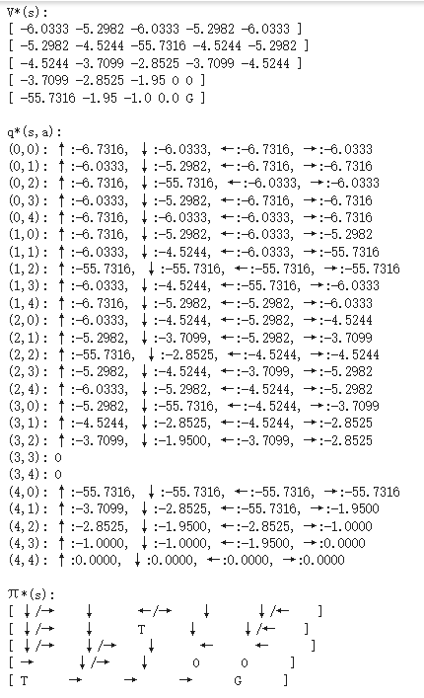

(2)應用(2.1.4)
答:
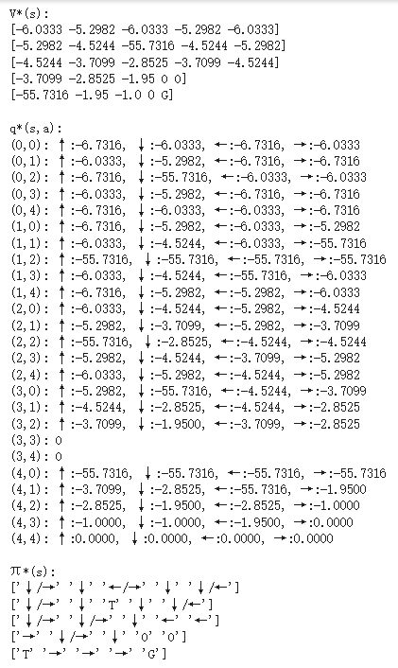

【習題2.3.1】
應用(2.1.1)程式碼如下:
import numpy as np

nrow, ncol = 5, 5 # 迷宮大小 5x5
gamma = 0.95 # 折扣因子γ
eps = 1e-5 # 收斂閾值
actions = ["←", "↑", "→", "↓"] # 四個方向

start = (0, 0) # 起點
goal = (4, 4) # 目標
traps = [(1, 2), (4, 0)] # 陷阱
obstacles = [(3, 3), (3, 4)] # 障礙物

# 獎勵設定
reward_step = -1 # 一般步驟懲罰
reward_trap = -50 # 掉入陷阱懲罰

# 初始化狀態值 V(s) 與狀態-行動值 Q(s,a)
V = np.zeros((nrow, ncol), dtype=float) # Vπ(s)
Q = np.zeros((nrow, ncol, 4), dtype=float) # Qπ(s,a)
policy_prob = np.ones(4) / 4 # 均勻隨機策略 π(a|s)

# 環境轉移函數
def step(state, action):
"""
根據當前狀態與行動，計算下一狀態和獎勵。
特殊情況：
- 掉入陷阱 -> 回到起點，獎勵 reward_trap
- 遇到障礙物或目標 -> 留在原地
邊界處理：
- 超出迷宮邊界 -> 留在原地
"""
if state in traps:
return start, reward_trap
if state == goal or state in obstacles:
return state, 0

x, y = state
if action == 0: # ←
y -= 1
elif action == 1: # ↑
x -= 1
elif action == 2: # →
y += 1
elif action == 3: # ↓
x += 1

# 邊界處理
if x < 0 or x >= nrow or y < 0 or y >= ncol:
next_state = state
else:
next_state = (x, y)

# 碰到障礙物 -> 留在原地
if next_state in obstacles:
next_state = state

# 獎勵規則
if next_state == goal:
reward = 0
elif next_state in traps:
reward = reward_trap
next_state = start
else:
reward = reward_step

return next_state, reward

# 策略評估
iteration = 0
while True:
delta = 0.0
V_old = V.copy()
for i in range(nrow):
for j in range(ncol):
s = (i, j)
if s in obstacles or s == goal: # 障礙物或目標不更新
continue
v_new = 0.0
# 計算期望值：對每個動作，依照策略的概率加權
for a in range(4):
s_next, r = step(s, a)
v_new += policy_prob[a] * (r + gamma * V_old[s_next])
delta = max(delta, abs(v_new - V[i, j])) # 記錄最大更新差值
V[i, j] = v_new
iteration += 1
if delta < eps: # 收斂判斷
break

# 計算狀態-行動值Qπ(s,a)
for i in range(nrow):
for j in range(ncol):
s = (i, j)
if s in obstacles or s == goal: # 障礙物與目標 Q(s,a)=0
Q[i, j, :] = 0.0
continue
for a in range(4):
s_next, r = step(s, a)
Q[i, j, a] = r + gamma * V[s_next] # Q(s,a) = r + γ * V(s')

# 生成貪婪策略 π'(s)（允許多個最佳動作）
greedy_policy = np.full((nrow, ncol), " ", dtype=object)
for i in range(nrow):
for j in range(ncol):
s = (i, j)
if s in obstacles:
greedy_policy[i, j] = "O" # 障礙物
elif s in traps:
greedy_policy[i, j] = "T" # 陷阱
elif s == goal:
greedy_policy[i, j] = "G" # 目標
else:
best_q = np.max(Q[i, j, :]) # 找出最大 Q 值
optimal_actions = [actions[a] for a in range(4) if np.isclose(Q[i, j, a], best_q)]
greedy_policy[i, j] = "/".join(optimal_actions) # 多個最優動作用 '/' 分隔

# 輸出結果
print("Vπ(s):")
V_display = np.round(V, 4).astype(object) # 四捨五入到4位小數
V_display[goal] = 'G' # 將目標位置替換成"G"
# 將障礙物位置替換成"O"
for obs in obstacles:
V_display[obs] = 'O'
# 將 0.0 替換成整數 0
V_display[V_display == 0.0] = 0
for row in V_display:
print("[", end="")
print(" ".join(str(x) for x in row), end="")
print("]")

print("\nQπ(s,a):")
for i in range(nrow):
for j in range(ncol):
s = (i, j)
if s in obstacles:
print(f"({i},{j}): O")
elif s == goal:
print(f"({i},{j}): G")
else:
q_values = [f"{actions[a]}:{Q[i,j,a]:.2f}" for a in range(4)]
print(f"({i},{j}): " + " ".join(q_values))

print("\nπ'(s):")
for row in greedy_policy:
print(row)
應用(2.1.2)程式碼如下:
import numpy as np

nrow, ncol = 5, 5 # 迷宮大小 5x5
gamma = 0.95 # 折扣因子 γ
eps = 1e-5 # 收斂閾值
actions = ["←", "↑", "→", "↓"] # 四個方向

start = (0, 0) # 起點
goal = (4, 4) # 目標
traps = [(1, 2), (4, 0)] # 陷阱
obstacles = [(3, 3), (3, 4)] # 障礙物

# 獎勵設定
reward_step = -1 # 每一步懲罰
reward_trap = -50 # 掉入陷阱懲罰

# 初始化 Q(s,a)
Q = np.zeros((nrow, ncol, 4), dtype=float) # 狀態-行動值
policy_prob = np.ones(4) / 4 # 均勻策略 π(a|s)

# 環境轉移函數
def step(state, action):
"""
根據當前狀態與動作，計算下一狀態與獎勵
特殊處理：
- 陷阱 -> 回到起點，獎勵 reward_trap
- 障礙物或目標 -> 留在原地
- 邊界 -> 留在原地
一般步驟 -> 獎勵 reward_step
"""
if state in traps:
return start, reward_trap
if state == goal or state in obstacles:
return state, 0

x, y = state
if action == 0: # ←
y -= 1
elif action == 1: # ↑
x -= 1
elif action == 2: # →
y += 1
elif action == 3: # ↓
x += 1

# 邊界處理
if x < 0 or x >= nrow or y < 0 or y >= ncol:
next_state = state
else:
next_state = (x, y)

# 碰到障礙物 -> 留在原地
if next_state in obstacles:
next_state = state

# 計算獎勵
if next_state == goal:
reward = 0
elif next_state in traps:
reward = reward_trap
next_state = start
else:
reward = reward_step

return next_state, reward

# Q-policy evaluation
iteration = 0
while True:
delta = 0.0
Q_old = Q.copy()
for i in range(nrow):
for j in range(ncol):
s = (i, j)
if s in obstacles or s == goal: # 障礙物或目標不更新
continue
for a in range(4):
s_next, r = step(s, a)
# 計算下一狀態的期望 Q 值（均勻策略）
expected_Q_next = np.sum(policy_prob * Q_old[s_next])
q_new = r + gamma * expected_Q_next
delta = max(delta, abs(q_new - Q[i, j, a])) # 記錄最大更新差距
Q[i, j, a] = q_new
iteration += 1
if delta < eps: # 收斂條件
break

# 計算狀態值 V(s)
V = np.zeros((nrow, ncol))
for i in range(nrow):
for j in range(ncol):
# V(s) = 對所有動作的期望 Q(s,a)
V[i, j] = np.sum(policy_prob * Q[i, j, :])

# 生成貪婪策略 π'(s)（允許多個最佳動作）
greedy_policy = np.full((nrow, ncol), " ", dtype=object)
for i in range(nrow):
for j in range(ncol):
s = (i, j)
if s in obstacles:
greedy_policy[i, j] = "O" # 障礙物
elif s in traps:
greedy_policy[i, j] = "T" # 陷阱
elif s == goal:
greedy_policy[i, j] = "G" # 目標
else:
# 找出最大 Q 值對應的動作
best_q = np.max(Q[i, j, :])
best_actions = [actions[a] for a in range(4) if np.isclose(Q[i, j, a], best_q)]
greedy_policy[i, j] = "/".join(best_actions) # 多個最優動作用 '/' 分隔

# 輸出結果
print("Vπ(s):")
V_display = np.round(V, 4).astype(object) # 四捨五入到4位小數
V_display[goal] = 'G' # 將目標位置替換成"G"
# 將障礙物位置替換成"O"
for obs in obstacles:
V_display[obs] = 'O'
# 將 0.0 替換成整數 0
V_display[V_display == 0.0] = 0
for row in V_display:
print("[", end="")
print(" ".join(str(x) for x in row), end="")
print("]")

print("\nQπ(s,a):")
for i in range(nrow):
for j in range(ncol):
s = (i, j)
if s in obstacles:
print(f"({i},{j}): O")
elif s == goal:
print(f"({i},{j}): G")
else:
q_values = [f"{actions[a]}:{Q[i,j,a]:.2f}" for a in range(4)]

print(f"({i},{j}): " + " ".join(q_values))
print("\n貪婪策略 π'(s):")
for row in greedy_policy:
print(row)
【習題2.3.2】
應用(2.1.3)程式碼如下:
import numpy as np

rows, cols = 5, 5 ## 迷宮大小 5x5
gamma = 0.95 # 折扣因子γ
reward_step = -1 # 一般步行的懲罰
reward_trap = -50 # 掉入陷阱懲罰

goal = (4, 4) # 目標格子
obstacles = {(3, 3), (3, 4)} # 障礙物
traps = {(1, 2), (4, 0)} # 陷阱
start = (0, 0) # 起點

actions = ['↑', '↓', '←', '→'] # 可用動作
action_delta = {'↑': (-1, 0), '↓': (1, 0), '←': (0, -1), '→': (0, 1)}

# 判斷位置是否合法
def is_valid(pos):
r, c = pos
if r < 0 or r >= rows or c < 0 or c >= cols: # 邊界檢查
return False
if pos in obstacles: # 障礙物檢查
return False
return True

# 計算V(s)
V = np.zeros((rows, cols)) # 初始化所有格子的價值為0

for iteration in range(500):
delta = 0
new_V = np.copy(V)

for r in range(rows):
for c in range(cols):
s = (r, c)
if s in obstacles or s == goal or s in traps:
continue # 障礙、目標、陷阱不用更新

v_list = []
for a in actions:
dr, dc = action_delta[a]
ns = (r + dr, c + dc) # 計算下一格座標

if not is_valid(ns):
ns = s # 遇到邊界或障礙 -> 留在原地

# 根據不同情況計算價值
if ns in traps:
v = reward_trap + gamma * V[start] # 陷阱價值固定
elif ns == goal:
v = 0 # 到達目標，價值為0
else:
v = reward_step + gamma * V[ns] # 一般步行價值

v_list.append(v)

# 取最大值作為該格子的最優價值
new_V[r, c] = max(v_list)
delta = max(delta, abs(new_V[r, c] - V[r, c])) # 收斂檢查

V = new_V
if delta < 1e-4:
break # 收斂後停止迭代

# 固定陷阱價值（避免陷阱被迭代覆蓋）
for (r, c) in traps:
V[r, c] = reward_trap + gamma * V[start]

# 計算 Q*(s,a)
Q = {}
for r in range(rows):
for c in range(cols):
s = (r, c)
if s in obstacles or s == goal or s in traps:
continue # 這些格子不計算Q值

Q[s] = {}
for a in actions:
dr, dc = action_delta[a]
ns = (r + dr, c + dc)

if not is_valid(ns):
ns = s # 邊界或障礙 -> 留在原地

# Q值計算
if ns in traps:
v = reward_trap + gamma * V[start]
elif ns == goal:
v = 0
else:
v = reward_step + gamma * V[ns]

Q[s][a] = float(v) # 儲存每個動作的Q值

# 計算最優策略 π*(s)
policy = np.full((rows, cols), ' ', dtype=object)

for r in range(rows):
for c in range(cols):
s = (r, c)
if s == goal:
policy[r, c] = 'G' # 目標
continue
if s in obstacles:
policy[r, c] = 'O' # 障礙
continue
if s in traps:
policy[r, c] = 'T' # 陷阱
continue

max_q = max(Q[s].values())
best_actions = [a for a in actions if Q[s][a] == max_q] # 取所有最優動作
policy[r, c] = '/'.join(best_actions)

# 輸出結果
print("V*(s):")
V_display = np.round(V, 4).astype(object)
V_display[goal] = 'G'
for obs in obstacles:
V_display[obs] = 'O'
for row in V_display:
print("[", " ".join(str(x) for x in row), "]")

print("\nq*(s,a):")
for r in range(rows):
for c in range(cols):
s = (r, c)
if s in obstacles:
print(f"({r},{c}): O")
else:
q_values = {}
if s in traps:
# 陷阱，每個方向都固定為 reward_trap + gamma*V[start]
fixed_val = reward_trap + gamma * V[start]
for a in actions:
q_values[a] = fixed_val
elif s == goal:
# 目標，每個方向都是0
for a in actions:
q_values[a] = 0.0
else:
# 一般格子
q_values = Q[s]

q_str = ", ".join([f"{a}:{q_values[a]:6.4f}" for a in actions])
print(f"({r},{c}): {q_str}")
print("\nπ*(s):")
for row in policy:
print("[", " ".join(f"{x:6}" for x in row), "]")

應用(2.1.4)程式碼如下:
import numpy as np

rows, cols = 5, 5
gamma = 0.95 # 折扣因子 γ
reward_step = -1 # 每走一步的獎勵（成本）
reward_trap = -50 # 掉入陷阱的懲罰

goal = (4, 4) # 目標格子
obstacles = {(3, 3), (3, 4)} # 障礙物
traps = {(1, 2), (4, 0)} # 陷阱格子
start = (0, 0) # 起點

actions = ['↑', '↓', '←', '→'] # 可用行動
action_delta = {'↑': (-1, 0), '↓': (1, 0), '←': (0, -1), '→': (0, 1)} # 行動對應的行列變化

# 檢查位置是否合法
def is_valid(pos):
r, c = pos
if r < 0 or r >= rows or c < 0 or c >= cols: # 超出地圖範圍
return False
if pos in obstacles: # 遇到障礙物
return False
return True

# 初始化 Q(s,a)
Q = {}
for r in range(rows):
for c in range(cols):
s = (r, c)
if s in obstacles or s in traps or s == goal: # 障礙物、陷阱、目標不更新 Q
continue
Q[s] = {a: 0.0 for a in actions} # 初始化每個動作價值為 0

# Q-Learning / Value Iteration 更新 Q(s,a)
for iteration in range(500):
delta = 0
new_Q = {}
for s in Q:
r, c = s
new_Q[s] = {}
for a in actions:
dr, dc = action_delta[a]
ns = (r + dr, c + dc) # 計算下一狀態
if not is_valid(ns):
ns = s # 邊界或障礙 -> 留在原地

# 計算獎勵與下一狀態價值
if ns in traps:
v = reward_trap + gamma * max(Q[start].values()) # 掉入陷阱 -> 懲罰 + 回到起點最大 Q
elif ns == goal:
v = 0 # 到達目標 -> 價值 0
else:
# 一般步驟 -> 獎勵 + 折扣後續最大 Q
v = reward_step + gamma * max(Q.get(ns, {a:0 for a in actions}).values())

new_Q[s][a] = v
delta = max(delta, abs(v - Q[s][a])) # 記錄最大變化

Q = new_Q
if delta < 1e-4: # 收斂判斷
break

# 計算每個格子的 V(s)
V = np.zeros((rows, cols))
for r in range(rows):
for c in range(cols):
s = (r, c)
if s in obstacles:
V[r, c] = 0
elif s in traps:
V[r, c] = reward_trap + gamma * max(Q[start].values())
elif s == goal:
V[r, c] = 0
elif s in Q:
V[r, c] = max(Q[s].values()) # 每個格子的最大 Q 值就是 V(s)

# 計算最優策略 π*(s)
policy = np.full((rows, cols), ' ', dtype=object)
for r in range(rows):
for c in range(cols):
s = (r, c)
if s == goal:
policy[r, c] = 'G' # 目標格子
elif s in obstacles:
policy[r, c] = 'O' # 障礙物
elif s in traps:
policy[r, c] = 'T' # 陷阱
elif s in Q:
max_value = max(Q[s].values()) # 找出最優動作的 Q 值
best_actions = [a for a in actions if Q[s][a] == max_value] # 所有最優動作
policy[r, c] = '/'.join(best_actions) # 多個最優動作用 '/' 分隔

# 輸出結果
print("V*(s):")
V_display = np.round(V, 4).astype(object) # 四捨五入到4位小數
V_display[goal] = 'G' # 將目標位置替換成"G"
# 將障礙物位置替換成"O"
for obs in obstacles:
V_display[obs] = 'O'
# 將 0.0 替換成整數 0
V_display[V_display == 0.0] = 0
for row in V_display:
print("[", end="")
print(" ".join(str(x) for x in row), end="")
print("]")

print("\nq*(s,a):")
for r in range(rows):
for c in range(cols):
s = (r, c)
if s in obstacles:
print(f"({r},{c}): O")
else:
q_values = {}
if s in traps:
# 陷阱，每個方向都固定為 reward_trap + gamma*V[start]
fixed_val = reward_trap + gamma * V[start]
for a in actions:
q_values[a] = fixed_val
elif s == goal:
# 目標，每個方向都是0
for a in actions:
q_values[a] = 0.0
else:
# 一般格子
q_values = Q[s]

q_str = ", ".join([f"{a}:{q_values[a]:6.4f}" for a in actions])
print(f"({r},{c}): {q_str}")
print("\nπ*(s):")
for row in policy:
print(row)

