【習題3.3.3】

考慮[習題2.3.1]有障礙物及陷阱的迷宮。試以同策略蒙地卡羅法來計算狀態值Vπ(s)、狀態行動值 qπ(s,a)及貪婪策略π`

答:

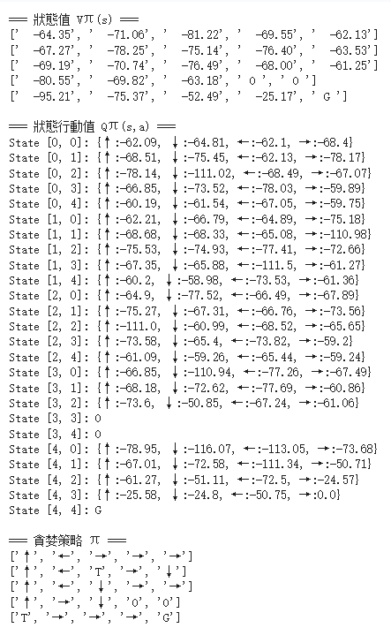

【習題3.3.4】

考慮[習題2.3.1]有障礙物及陷阱的迷宮。試以同策略 ε-貪婪蒙地卡羅法來計算最佳狀態值V*(s)、最佳狀態行動值q*(s,a)及最佳策略π*，其中ε=0.1

答:

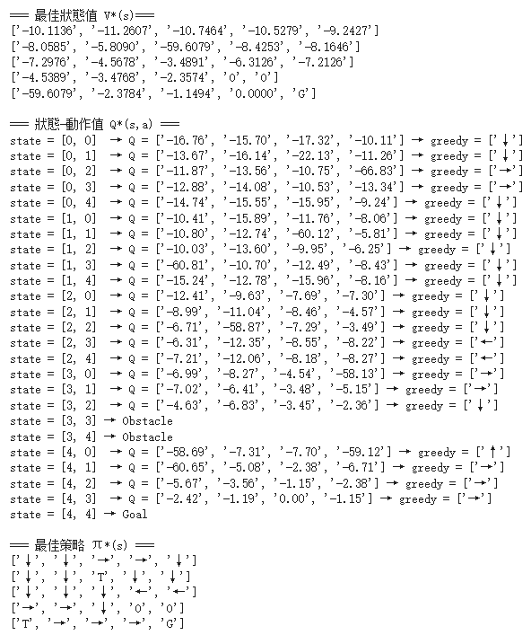

【習題3.3.5】

考慮[習題2.3.1]有障礙物及陷阱的迷宮。試以異策略 ε-貪婪蒙地卡羅法來計算最佳狀態值V*(s)、最佳狀態行動值q*(s,a)及最佳策略π*，其中ε=0.1。假設行為策略b是選擇4個方向行動的機率都一樣。

答:

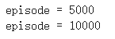
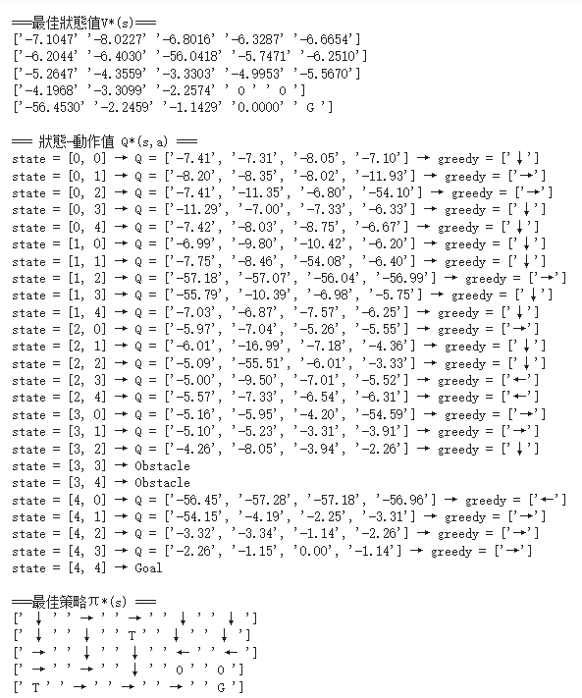

【習題3.3.3】

試以同策略蒙地卡羅法來計算狀態值Vπ(s)、狀態行動值 qπ(s,a)及貪婪策略π`，程式碼如下:

import numpy as np

nrow, ncol = 5, 5
discount = 0.95
eps = 1.0e-5
action_word = np.array(["↑", "↓", "←", "→"])
action_num = 4
action_prob = np.ones(action_num) / action_num # 初始為均勻隨機策略

obstacle = [[3, 3], [3, 4]]
trap = [[1, 2], [4, 0]]
terminal = [4, 4]

state_value = np.zeros((nrow, ncol)) # V(s)
state_action_value = np.zeros((nrow, ncol, action_num)) # Q(s,a)
state_visit_num = np.zeros((nrow, ncol), dtype=int) # V(s) 訪問次數
state_return_accum = np.zeros((nrow, ncol)) # V(s) 回報累積
state_action_visit_num = np.zeros((nrow, ncol, action_num), dtype=int) # Q(s,a) 訪問次數
state_action_return_accum = np.zeros((nrow, ncol, action_num)) # Q(s,a) 回報累積
greedy_action = np.zeros((nrow, ncol, action_num)) # 最終貪婪策略

# 判斷是否到達終點
def is_terminal(state):
return state == terminal
# 判斷是否為障礙格子
def is_obstacle(state):
return state in obstacle
# 判斷是否為陷阱格子
def is_trap(state):
return state in trap

# 隨機選取初始狀態，避開終點、障礙與陷阱
def get_initial():
while True:
r = np.random.randint(0, nrow)
c = np.random.randint(0, ncol)
if not is_terminal([r, c]) and not is_obstacle([r, c]):
return [r, c]

# 根據動作計算下一狀態與獎勵
def step(state, action):

r, c = state
next_r, next_c = r, c

if is_terminal([r, c]): # 終點不動
return {"next_state": [r, c], "reward": 0.0, "trap": False}

# 根據動作更新位置
if action == 0: # ↑
next_r = max(r - 1, 0)
elif action == 1: # ↓
next_r = min(r + 1, nrow - 1)
elif action == 2: # ←
next_c = max(c - 1, 0)
elif action == 3: # →
next_c = min(c + 1, ncol - 1)

next_state = [next_r, next_c]

# 特殊狀態判斷
if is_obstacle(next_state):
return {"next_state": [r, c], "reward": -1.0, "trap": False} # 撞到障礙物停下
elif is_trap(next_state):
return {"next_state": [0, 0], "reward": -50.0, "trap": True} # 掉入陷阱回到起點
elif is_terminal(next_state):
return {"next_state": next_state, "reward": 0.0, "trap": False} # 終點
else:
return {"next_state": next_state, "reward": -1.0, "trap": False} # 一般移動

# 蒙地卡羅隨機策略更新
episode_num = 10000
np.random.seed(42)
max_steps_per_episode = 1000

for episode in range(episode_num):
state = get_initial()
trajectory = [] # 用於存儲 (state, action, reward)
steps = 0

while not is_terminal(state) and steps < max_steps_per_episode:
steps += 1
action = np.random.choice(action_num, p=action_prob) # 根據隨機策略選動作
step_info = step(state, action)
next_state = step_info["next_state"]
reward = step_info["reward"]
trap_flag = step_info["trap"]

trajectory.append((state[0], state[1], action, reward))

if trap_flag:
state = [0, 0] # 掉陷阱回起點
else:
state = next_state

# 計算回報 Gt (從最後一步往回折扣累計)
Gt = 0.0
for s_r, s_c, a, r in reversed(trajectory):
Gt = discount * Gt + r

# 更新狀態值 V(s)
state_visit_num[s_r, s_c] += 1
state_return_accum[s_r, s_c] += Gt
state_value[s_r, s_c] = state_return_accum[s_r, s_c] / state_visit_num[s_r, s_c]

# 更新狀態-行動值 Q(s,a)
state_action_visit_num[s_r, s_c, a] += 1
state_action_return_accum[s_r, s_c, a] += Gt
state_action_value[s_r, s_c, a] = state_action_return_accum[s_r, s_c, a] / state_action_visit_num[s_r, s_c, a]

#處理特殊格子與貪婪策略
for r, c in obstacle:
state_value[r, c] = 0
state_action_value[r, c, :] = 0

# 根據 Q(s,a) 生成貪婪策略
for r in range(nrow):
for c in range(ncol):
if is_terminal([r, c]) or is_obstacle([r, c]):
greedy_action[r, c, :] = 0
else:
q_vals = state_action_value[r, c, :]
q_max = np.max(q_vals)
idxs = np.where(np.abs(q_vals - q_max) < eps)[0] # 可能有多個最優動作
greedy_action[r, c, :] = 0
greedy_action[r, c, idxs[0]] = 1 # 選其中一個最優動作

which = lambda status: np.arange(len(status))[status]

print("\n=== 狀態值 Vπ(s) ===")
for i in range(nrow):
row_display = []
for j in range(ncol):
if [i, j] in obstacle:
row_display.append(" O ")
elif [i, j] in trap:
row_display.append(f"{state_value[i,j]:8.2f}")
elif [i, j] == terminal:
row_display.append(" G ")
else:
row_display.append(f"{state_value[i,j]:8.2f}")
print(row_display)

print("\n=== 狀態行動值 Qπ(s,a) ===")
for i in range(nrow):
for j in range(ncol):
s = [i, j]
if s in obstacle:
print(f"State {s}: O")
continue
elif s == terminal:
print(f"State {s}: G")
continue
q_vals = np.round(state_action_value[i,j,:], 2)
print(f"State {s}: {{↑:{q_vals[0]}, ↓:{q_vals[1]}, ←:{q_vals[2]}, →:{q_vals[3]}}}")

print("\n=== 貪婪策略 π ===")
for i in range(nrow):
row_display = []
for j in range(ncol):
s = [i, j]
if s in obstacle:
row_display.append("O")
elif s in trap:
row_display.append("T")
elif s == terminal:
row_display.append("G")
else:
action_idx = np.argmax(greedy_action[i,j,:])
row_display.append(str(action_word[action_idx]))
print(row_display)

【習題3.3.4】

試以同策略 ε-貪婪蒙地卡羅法來計算最佳狀態值V*(s)、最佳狀態行動值q*(s,a)及最佳策略π*，程式碼如下:

import numpy as np

nrow, ncol = 5, 5
discount = 0.95
prob_eps = 0.1
max_steps = 100 #每回合最大步數
np.random.seed(543)

action = np.array([0, 1, 2, 3]) #0=左, 1=上, 2=右, 3=下
action_num = 4

S = [0, 0]
G = [4, 4]
O = [[3,3],[3,4]]
T = [[1,2],[4,0]]

# 值函數與統計資料初始化
state_value = np.zeros((nrow,ncol)) # V(s)
state_action_value = np.zeros((nrow,ncol,action_num)) # Q(s,a)
greedy_action = np.zeros((nrow,ncol,action_num)) # 優勢動作標記
visit_num = np.zeros((nrow,ncol,action_num),dtype=int) # 記錄每個 (s,a) 被訪問次數
return_accum = np.zeros((nrow,ncol,action_num)) # 累計回報，用於計算 Monte Carlo 平均

# 判斷是否到達終止狀態
def is_terminal(state):
return state == G

# 隨機初始化起始狀態（不在障礙或目標）
def get_initial():
while True:
i,j = np.random.randint(0,nrow), np.random.randint(0,ncol)
state = [i,j]
if state == G or state in O:
continue
return state

# 根據動作進行一步
def step(state, a):
x,y = state
# 計算下一個位置
if a==0: nx,ny = x,y-1
elif a==1: nx,ny = x-1,y
elif a==2: nx,ny = x,y+1
elif a==3: nx,ny = x+1,y
else: raise ValueError("Invalid action")

# 邊界限制
nx = np.clip(nx,0,nrow-1)
ny = np.clip(ny,0,ncol-1)
next_state = [int(nx),int(ny)]

# 若撞到障礙：停留原地，reward -1
if next_state in O:
return {"next_state": state[:], "reward": -1}

# 若掉入陷阱：回到起點，reward -50
elif next_state in T:
return {"next_state": S[:], "reward": -50}

# 到達目標
elif next_state == G:
return {"next_state": next_state, "reward": 0}

# 一般移動，reward -1
else:
return {"next_state": next_state, "reward": -1}

# 初始策略均勻分布（對非障礙與非目標狀態）
action_prob = np.zeros((nrow,ncol,action_num))
for i in range(nrow):
for j in range(ncol):
if [i,j] in O or [i,j]==G:
continue
action_prob[i,j,:] = 1/action_num # 均勻選擇

# 蒙地卡羅控制核心
episode_num = 50000 # 訓練回合數

for episode in range(episode_num):
state_action_trajectory = [] # 記錄 (s,a) 序列
reward_seq = [] # 記錄回報序列
state = get_initial() # 隨機起始狀態
steps = 0

# 生成一個完整回合
while not is_terminal(state) and steps < max_steps:
prob = action_prob[state[0],state[1],:]
if prob.sum() == 0: # 防止全 0
prob = np.ones(action_num)/action_num
move = int(np.random.choice(action,p=prob)) # 根據策略選動作
state_action_trajectory.append([state[0],state[1],move])
res = step(state,move)
next_state = res["next_state"]
reward = res["reward"]
reward_seq.append(reward)
state = next_state
steps += 1

# 每訪問蒙地卡羅回報更新
Gt = 0
for i in range(len(state_action_trajectory)-1,-1,-1):
Gt = discount*Gt + reward_seq[i] # 從最後一步回推折扣回報
k0,k1,k2 = state_action_trajectory[i]
visit_num[k0,k1,k2] += 1
return_accum[k0,k1,k2] += Gt
state_action_value[k0,k1,k2] = return_accum[k0,k1,k2]/visit_num[k0,k1,k2] # Q(s,a) 更新

# epsilon-greedy 策略更新
q_values = state_action_value[k0,k1,:]
index_max = np.where(q_values == np.max(q_values))[0]
n1 = len(index_max)
n2 = action_num - n1

if n1 == action_num: # 全部動作一樣好
action_prob[k0,k1,:] = 1/action_num
else:
for k in range(action_num):
if k in index_max: # 最佳動作
action_prob[k0,k1,k] = (1-prob_eps)/n1
else: # 探索動作
action_prob[k0,k1,k] = prob_eps/n2

state_value[k0,k1] = np.max(q_values) # 更新 V(s)
greedy_action[k0,k1,:] = 0
greedy_action[k0,k1,index_max] = 1 # 標記最佳動作

arrow_dict = {0:"←", 1:"↑", 2:"→", 3:"↓"}

print("\n=== 最佳狀態值 V*(s)===")
for i in range(nrow):
row = []
for j in range(ncol):
state = [i,j]
if state in O:
row.append("O")
elif state == G:
row.append("G")
elif state in T:
trap_val = -50 + discount * state_value[S[0], S[1]] # 陷阱價值
row.append(f"{trap_val:.4f}")
else:
row.append(f"{state_value[i,j]:.4f}")
print(row)
print("\n=== 狀態-動作值 Q*(s,a) ===")
for i in range(nrow):
for j in range(ncol):
state = [i,j]
if state == G:
print(f"state = {state} → Goal")
elif state in O:
print(f"state = {state} → Obstacle")
else:
q_vals = [f"{state_action_value[i,j,k]:.2f}" for k in range(action_num)]
greedy_idx = np.where(greedy_action[i,j,:]==1)[0]
greedy_arrows = [arrow_dict[k] for k in greedy_idx]
print(f"state = {state} → Q = {q_vals} → greedy = {greedy_arrows}")
print("\n=== 最佳策略 π*(s) ===")
for i in range(nrow):
row = []
for j in range(ncol):
state = [i,j]
if state == G:
row.append("G")
elif state in O:
row.append("O")
elif state in T:
row.append("T")
else:
idx = np.where(greedy_action[i,j,:]==1)[0]
arrows = "".join([arrow_dict[k] for k in idx])
row.append(arrows)
print(row)

【習題3.3.5】
試以異策略 ε-貪婪蒙地卡羅法來計算最佳狀態值V*(s)、最佳狀態行動值q*(s,a)及最佳策略π*，程式碼如下:

import numpy as np

which = lambda status: np.arange(len(status))[status]

nrow, ncol = 5, 5 # 地圖大小
discount = 0.95 # 折扣因子γ
prob_eps = 0.1 # epsilon-greedy策略的探索比例
eps = 1.0e-5 # 用於浮點數比較的小數
np.random.seed(543) # 設定隨機種子，方便結果可重現

# Actions 動作編號對應方向
action_word = np.array(["left", "up", "right", "down"])
action = np.array([0, 1, 2, 3])
action_num = 4

START = [0, 0] # 起點
GOAL = [4, 4] # 目標
OBSTACLES = [[3, 3], [3, 4]] # 障礙物
TRAPS = [[1, 2], [4, 0]] # 陷阱

# 獎勵設定
R_GOAL = 0.0
R_TRAP = -50.0
R_STEP = -1.0

# 動作對應的row, col變化
MOVE = {0: (0, -1), 1: (-1, 0), 2: (0, 1), 3: (1, 0)}

# ------------------ 初始化表格 ------------------
state_value = np.zeros((nrow, ncol)) # 狀態值 V(s)
state_action_value = np.zeros((nrow, ncol, action_num)) # 狀態-動作值 Q(s,a)
W_accum = np.zeros((nrow, ncol, action_num)) # importance sampling權重累加器
greedy_action = np.zeros((nrow, ncol, action_num)) # 儲存每個狀態的貪婪動作

# 目標策略與行為策略初始機率 (均勻分配)
target_action_prob = np.zeros((nrow, ncol, action_num))
behavior_action_prob = np.zeros((nrow, ncol, action_num))

for i in range(nrow):
for j in range(ncol):
if [i, j] in OBSTACLES or [i, j] == GOAL:
continue
target_action_prob[i, j, :] = 0.25
behavior_action_prob[i, j, :] = 0.25

def is_goal(s):
return s == GOAL

def in_obs(s):
return s in OBSTACLES

def in_trap(s):
return s in TRAPS

# 隨機選取非特殊格子作為初始狀態
def get_initial():
while True:
i = np.random.randint(0, nrow)
j = np.random.randint(0, ncol)
state = [i, j]
if state not in OBSTACLES and state not in TRAPS and state != GOAL:
return state

# 執行一步動作，並處理陷阱、障礙、邊界、終點
def step(state, a_idx):
"""陷阱回到起點"""
if in_trap(state):
return START.copy(), R_TRAP, False

dr, dc = MOVE[a_idx]
nxt = [state[0] + dr, state[1] + dc]
nxt[0] = int(np.clip(nxt[0], 0, nrow - 1)) # 限制row在範圍內
nxt[1] = int(np.clip(nxt[1], 0, ncol - 1)) # 限制col在範圍內

if in_obs(nxt):
return state, R_STEP, False # 碰到障礙不動

if is_goal(nxt):
return nxt, R_GOAL, True # 到達目標

if in_trap(nxt):
return nxt, R_STEP, False # 陷阱不立即終止，交給backward update處理

return nxt, R_STEP, False # 一般移動

# 蒙地卡羅控制
episode_num = 10000

for episode in range(episode_num):
if (episode + 1) % 5000 == 0:
print("episode =", episode + 1)

# 儲存單一回合的軌跡
state_trajectory = []
state_action_trajectory = []
reward_seq = []

state = get_initial()
state_trajectory.append(state.copy())
done = is_goal(state)

while not done:
# 根據行為策略選擇動作
prob = behavior_action_prob[state[0], state[1], :]
move = int(np.random.choice(action, p=prob))
next_state, reward, done = step(state, move)

state_action_trajectory.append([state[0], state[1], move])
reward_seq.append(reward)
state_trajectory.append(next_state.copy())
state = next_state

# backward update
Gt = 0.0 # 回合回報初始化
W = 1.0 # importance sampling初始權重
for t in reversed(range(len(state_action_trajectory))):
i, j, a = state_action_trajectory[t]
Gt = discount * Gt + reward_seq[t] # 計算折扣回報

# 更新state-action值，使用加權平均
W_accum[i, j, a] += W
Q_old = state_action_value[i, j, a]
state_action_value[i, j, a] = Q_old + (W / W_accum[i, j, a]) * (Gt - Q_old)

# 更新目標策略 (epsilon-greedy)
q_values = state_action_value[i, j, :]
q_max = np.max(q_values)
index_max = which(np.abs(q_values - q_max) < eps)
n1 = len(index_max)
n2 = action_num - n1

if n1 == action_num:
target_action_prob[i, j, :] = 1 / action_num
else:
for k in range(action_num):
if k in index_max:
target_action_prob[i, j, k] = (1 - prob_eps) / n1
else:
target_action_prob[i, j, k] = prob_eps / n2

# 更新狀態值為最大Q值
state_value[i, j] = q_max
# 更新貪婪動作
greedy_action[i, j, :] = 0
greedy_action[i, j, index_max] = 1

# 更新importance sampling權重
W *= target_action_prob[i, j, a] / behavior_action_prob[i, j, a]
if W < eps:
break

print("\n===最佳狀態值V*(s)===")
V_display = np.empty((nrow, ncol), dtype=object)
for i in range(nrow):
for j in range(ncol):
if [i, j] in OBSTACLES:
V_display[i, j] = " O "
elif [i, j] == GOAL:
V_display[i, j] = " G "
else:
# 陷阱也顯示對應V(s)
V_display[i, j] = f"{state_value[i, j]:.4f}"
for row in V_display:
print(row)

print("\n=== 狀態-動作值 Q*(s,a) ===")
arrow_dict = {0: "←", 1: "↑", 2: "→", 3: "↓"}
for i in range(nrow):
for j in range(ncol):
state = [i, j]
if state == GOAL:
print(f"state = {state} → Goal")
elif state in OBSTACLES:
print(f"state = {state} → Obstacle")
else:
q_vals = [f"{state_action_value[i, j, k]:.2f}" for k in range(action_num)]
greedy_idx = np.where(greedy_action[i, j, :] == 1)[0]
greedy_arrows = [arrow_dict[k] for k in greedy_idx] if len(greedy_idx) > 0 else ["?"]
print(f"state = {state} → Q = {q_vals} → greedy = {greedy_arrows}")

print("\n===最佳策略π*(s) ===")
arrow = np.array(["←", "↑", "→", "↓"])
policy_display = np.empty((nrow, ncol), dtype=object)
for i in range(nrow):
for j in range(ncol):
s = [i, j]
if s == GOAL:
policy_display[i, j] = " G "
elif s in OBSTACLES:
policy_display[i, j] = " O "
elif s in TRAPS:
policy_display[i, j] = " T "
else:
idx_max = which(greedy_action[i, j, :] == 1)
if len(idx_max) == 1:
policy_display[i, j] = f" {arrow[idx_max[0]]} "
elif len(idx_max) > 1:
policy_display[i, j] = "".join(arrow[idx_max])
else:
policy_display[i, j] = " ? "
for row in policy_display:
print(row)

