Q1: 微分程式練習：請參照附圖的微分定理，撰寫Python程式以驗證定理2、3、6、8（i.e. 使用SymPy套件）。接著繪製二次方曲線f(x) = -10x² + 100x + 5，並求最大值
程式碼如下:
import sympy as sp
import matplotlib.pyplot as plt
import numpy as np

x = sp.Symbol('x') # 自變數x
C = sp.Symbol('C', real=True, constant=True) # 常數C（固定不變）

# 定理 2：常數函數的導數
# f(x) = C → f'(x) = 0
f2 = C
f2_prime = sp.diff(f2, x)
print("定理2：f(x)=C → f'(x) =", f2_prime)

# 定理 3：常數倍法則
# f(x) = C*g(x) → f'(x) = C*g'(x)
g = x**3 # 設 g(x) = x³
f3 = C * g # f(x) = C * g(x)
f3_prime = sp.diff(f3, x) # 對 f(x) 求導
print("定理3：f(x)=C*g(x) → f'(x) =", f3_prime.simplify())

# 定理 6：乘法法則
# f(x)*g(x) → f'(x)=f'(x)*g(x)+f(x)*g'(x)
f = x**2 + 1
g = sp.sin(x)
lhs = sp.diff(f * g, x) # 直接對乘積求導
rhs = sp.diff(f, x) * g + f * sp.diff(g, x) # 代入乘法法則公式
print("定理6 驗證結果：", sp.simplify(lhs - rhs) == 0) # 驗證是否成立

# 定理 8：鏈鎖律（Chain Rule）
# 若 y = o(i(x))，則 y' = o'(i(x)) * i'(x)
i_expr = x**2 + 1 # 內層函數 i(x)
o_expr = sp.sin(i_expr) # 外層函數 o(i(x))

# 使用中介符號u代表內層函數，以便套用鏈鎖律
u = sp.Symbol('u')
o_u = sp.sin(u)

# 鏈鎖律左右兩邊求導後比較
lhs_chain = sp.diff(o_expr, x) # 直接對o(i(x))求導
rhs_chain = sp.diff(o_u, u).subs(u, i_expr) * sp.diff(i_expr, x) # 代入公式 o'(i(x))*i'(x)
print("定理8 鏈鎖律驗證結果：", sp.simplify(lhs_chain - rhs_chain) == 0)

# 利用導數找最大值
# f(x) = -10x² + 100x + 5
f_curve = -10 * x**2 + 100 * x + 5
f_prime = sp.diff(f_curve, x) # 求導
x_max = sp.solve(sp.Eq(f_prime, 0), x)[0] # 解 f'(x)=0 找出臨界點
y_max = f_curve.subs(x, x_max) # 將 x_max 代入原函數得到最大值

print(f"\n函數 f(x) = -10x^2 + 100x + 5")
print(f"導數 f'(x) = {f_prime}")
print(f"最大值出現在 x = {x_max}, f(x) = {y_max}")

# 繪圖
x_vals = np.linspace(0, 12, 200) # x 範圍 0-12
f_vals = [-10*t**2 + 100*t + 5 for t in x_vals] # 計算每個x對應的f(x)

plt.figure(figsize=(8,5))
plt.plot(x_vals, f_vals, label='f(x) = -10x² + 100x + 5') # 畫出曲線
plt.scatter([x_max], [y_max], color='red', zorder=5, label=f'Max at x={x_max}, y={y_max}') # 標出最大點
plt.title('二次函數 f(x) = -10x² + 100x + 5')
plt.xlabel('x')
plt.ylabel('f(x)')
plt.legend()
plt.grid(True)
plt.show()

程式碼執行結果:
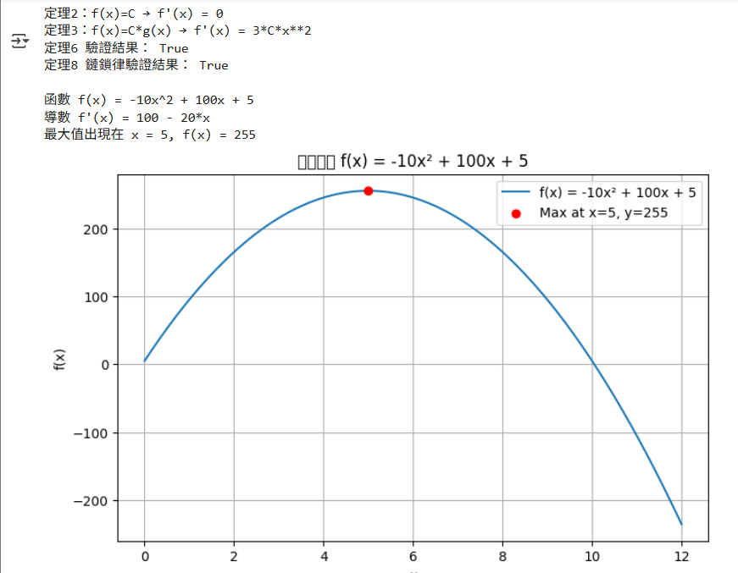

Q2: 二元分類練習：請參照下面連結網頁的說明，試以「Adult」數據集建立多層感知器模型，來預測（識別）年收入（i.e. income欄位）是否超過$50K。
https://archive.ics.uci.edu/dataset/2/adult

程式碼如下:
import pandas as pd
from sklearn.model_selection import train_test_split
from sklearn.preprocessing import OneHotEncoder, StandardScaler
from sklearn.compose import ColumnTransformer
from sklearn.pipeline import Pipeline
from sklearn.neural_network import MLPClassifier
from sklearn.metrics import accuracy_score, classification_report, confusion_matrix

# 載入資料集
columns = [
"age", "workclass", "fnlwgt", "education", "education-num",
"marital-status", "occupation", "relationship", "race", "sex",
"capital-gain", "capital-loss", "hours-per-week", "native-country", "income"
]

train_path = "/content/drive/MyDrive/Adult/adult.data" # 訓練資料
test_path = "/content/drive/MyDrive/Adult/adult.test" # 測試資料

train_df = pd.read_csv(train_path, names=columns, sep=r'\s*,\s*', engine="python")
test_df = pd.read_csv(test_path, names=columns, sep=r'\s*,\s*', skiprows=1, engine="python")

# 測試資料的 income 標籤多了一個 "."（例如 ">50K."），需移除
test_df["income"] = test_df["income"].apply(lambda x: x.replace(".", ""))

# 將 "?" 視為缺失值並刪除整列
train_df = train_df.replace("?", pd.NA).dropna()
test_df = test_df.replace("?", pd.NA).dropna()

# 特徵與標籤分離
X_train = train_df.drop("income", axis=1)
y_train = train_df["income"]
X_test = test_df.drop("income", axis=1)
y_test = test_df["income"]

# 特徵工程（數值標準化 + 類別編碼）
# 數值特徵欄位
numeric_features = ["age", "fnlwgt", "education-num", "capital-gain", "capital-loss", "hours-per-week"]

# 類別特徵欄位（排除數值欄位）
categorical_features = [c for c in X_train.columns if c not in numeric_features]

# ColumnTransformer 用於同時處理不同型態欄位
preprocessor = ColumnTransformer(
transformers=[
("num", StandardScaler(), numeric_features), # 對數值特徵進行標準化 (Z-score)
("cat", OneHotEncoder(handle_unknown="ignore"), categorical_features) # 類別特徵進行 One-Hot 編碼
]
)

# 建立MLP(多層感知器)模型
mlp = MLPClassifier(
hidden_layer_sizes=(64, 32), # 兩層隱藏層：第一層64個神經元，第二層32個
activation='relu', # 使用 ReLU 激活函數
solver='adam', # 使用 Adam 最佳化器
max_iter=300, # 最多訓練 300 次迭代
random_state=42 # 設定隨機種子以確保結果可重現
)

# 使用 Pipeline 串接「前處理」與「分類器」
model = Pipeline(steps=[
("preprocessor", preprocessor),
("classifier", mlp)
])

# 模型訓練
model.fit(X_train, y_train)

# 模型評估
y_pred = model.predict(X_test)

print("\n=== 模型評估 ===")
print(f"準確率 (Accuracy): {accuracy_score(y_test, y_pred):.4f}") # 模型整體準確率
print("\n分類報告 (Classification Report):\n")
print(classification_report(y_test, y_pred)) # 各類別 Precision / Recall / F1-score
print("\n混淆矩陣 (Confusion Matrix):\n")
print(confusion_matrix(y_test, y_pred)) # 顯示預測 vs 實際結果的分佈

程式碼執行結果:
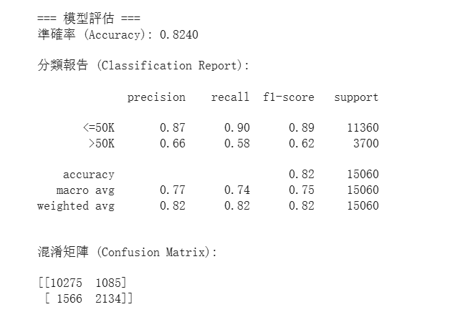

Q3: 多元分類練習：請參照下面連結網頁的說明，試以「Cover type」數據集建立多層感知器模型，來預測（識別）森林覆蓋（i.e. Cover_Type欄位）的類型。
https://archive.ics.uci.edu/dataset/31/covertype

程式碼如下:
import pandas as pd
from sklearn.model_selection import train_test_split
from sklearn.preprocessing import StandardScaler
from sklearn.neural_network import MLPClassifier
from sklearn.metrics import classification_report, accuracy_score

# 讀取資料並設定欄位名稱
col_names = [
'Elevation', 'Aspect', 'Slope',
'Horizontal_Distance_To_Hydrology', 'Vertical_Distance_To_Hydrology',
'Horizontal_Distance_To_Roadways',
'Hillshade_9am', 'Hillshade_Noon', 'Hillshade_3pm',
'Horizontal_Distance_To_Fire_Points'
]

# 四種荒野區類別One-Hot編碼
col_names += [f'Wilderness_Area{i}' for i in range(1, 5)]

# 40種土壤類型One-Hot編碼
col_names += [f'Soil_Type{i}' for i in range(1, 41)]
col_names += ['Cover_Type']

# 讀取壓縮檔案
df = pd.read_csv("/content/drive/MyDrive/Cover type/covtype.data.gz",
header=None, names=col_names)

print("資料形狀：", df.shape)
print("欄位示例：", df.columns[:10].tolist(), "...")

# 分離特徵與標籤
X = df.drop(columns=['Cover_Type']) # 特徵（輸入變數）
y = df['Cover_Type'] # 標籤（輸出類別）

# 拆分訓練與測試資料
# stratify=y →依照類別比例分層抽樣，確保訓練集與測試集比例一致
X_train, X_test, y_train, y_test = train_test_split(
X, y, test_size=0.2, random_state=42, stratify=y
)

# 特徵標準化
# 對數值特徵做 Z-score 標準化，使每個特徵均值為0、標準差為1
scaler = StandardScaler()
X_train = scaler.fit_transform(X_train) # 根據訓練資料擬合並轉換
X_test = scaler.transform(X_test) # 使用同樣的參數轉換測試資料

# 建立MLP神經網路模型
mlp = MLPClassifier(
hidden_layer_sizes=(128, 64), # 兩層隱藏層：128與64個神經元
activation='relu', # 使用 ReLU 激活函數
solver='adam', # 使用 Adam 最佳化器
max_iter=100, # 訓練迭代次數上限（可調大）
random_state=42, # 固定隨機種子，確保可重現
verbose=True # 顯示訓練過程（損失收斂資訊）
)

# 訓練模型
mlp.fit(X_train, y_train)

# 模型預測與評估
y_pred = mlp.predict(X_test)
acc = accuracy_score(y_test, y_pred)

print(f"\n模型準確率：{acc:.4f}")
print("\n分類報告：")
print(classification_report(y_test, y_pred))

程式碼執行結果:
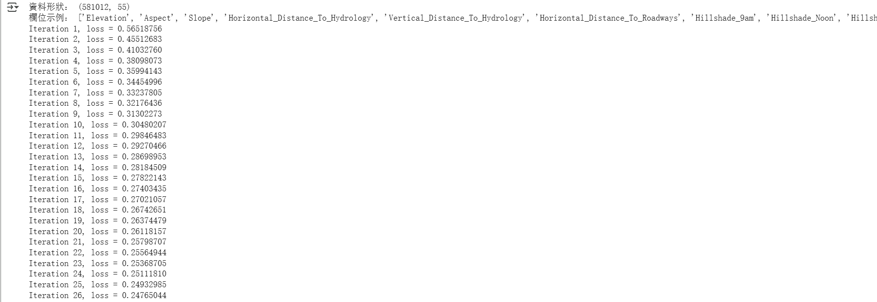
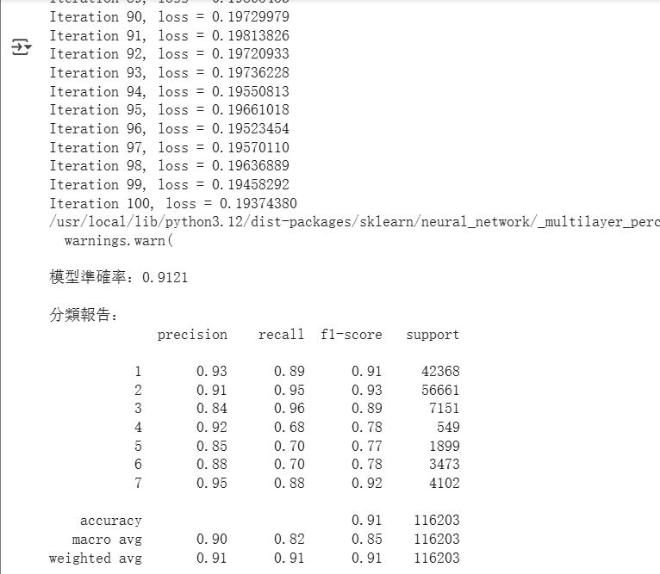

Q4: 迴歸分析練習：請參照下面連結網頁的說明，試以「Bike Sharing」數據集建立多層感知器模型，來輸出（預測）租賃自行車（i.e. cnt欄位）的總數。
https://archive.ics.uci.edu/dataset/275/bike+sharing+dataset

程式碼如下:
import pandas as pd
from sklearn.model_selection import train_test_split
from sklearn.preprocessing import StandardScaler
from sklearn.neural_network import MLPRegressor
from sklearn.metrics import mean_squared_error, r2_score

# 讀取資料
df = pd.read_csv("/content/drive/MyDrive/BikeSharing/day.csv")

# 選擇特徵與目標欄位
X = df.drop(["instant", "dteday", "casual", "registered", "cnt"], axis=1)
y = df["cnt"]

# 資料分割
X_train, X_test, y_train, y_test = train_test_split(X, y, test_size=0.2, random_state=42)

# 標準化
scaler = StandardScaler()
X_train_scaled = scaler.fit_transform(X_train)
X_test_scaled = scaler.transform(X_test)

# 建立多層感知器模型
mlp = MLPRegressor(hidden_layer_sizes=(100, 50),
activation='relu', # ReLU 激活函數
solver='adam',
max_iter=1000,# 最大迭代次數（允許充分收斂）
random_state=42)

# 模型訓練
mlp.fit(X_train_scaled, y_train)

# 模型預測
y_pred = mlp.predict(X_test_scaled)

# 模型評估
# 均方誤差（MSE）：預測誤差的平方平均值，越小越好
mse = mean_squared_error(y_test, y_pred)
# R²（決定係數）：衡量模型解釋資料變異的能力，越接近1越好
r2 = r2_score(y_test, y_pred)

print(f"均方誤差 (MSE): {mse:.2f}")
print(f"決定係數 (R²): {r2:.3f}")
程式碼執行結果:


