主要程式碼:
import math
from typing import List, Tuple, Optional
from dataclasses import dataclass
import heapq
import matplotlib.pyplot as plt
import matplotlib.patches as patches
from matplotlib.patches import Rectangle
import itertools

@dataclass
class Point:
"""表示2D空間中的點"""
id: str
x: float
y: float

def distance_to(self, other: 'Point') -> float:
"""計算兩點之間的歐氏距離"""
return math.sqrt((self.x - other.x)**2 + (self.y - other.y)**2)

def __repr__(self):
return f"P{self.id}({self.x},{self.y})"

@dataclass
class MBR:
"""最小邊界矩形 (Minimum Bounding Rectangle)"""
min_x: float
min_y: float
max_x: float
max_y: float

def __init__(self, min_x=float('inf'), min_y=float('inf'),
max_x=float('-inf'), max_y=float('-inf')):
self.min_x = min_x
self.min_y = min_y
self.max_x = max_x
self.max_y = max_y

def area(self) -> float:
"""計算矩形面積"""
if self.min_x > self.max_x or self.min_y > self.max_y:
return 0
return (self.max_x - self.min_x) * (self.max_y - self.min_y)

def enlarge_to_include(self, point: Point) -> 'MBR':
"""將矩形擴展以包含某個點"""
return MBR(
min(self.min_x, point.x),
min(self.min_y, point.y),
max(self.max_x, point.x),
max(self.max_y, point.y)
)

def enlarge_to_include_mbr(self, other: 'MBR') -> 'MBR':
"""將矩形擴展以包含另一個MBR"""
return MBR(
min(self.min_x, other.min_x),
min(self.min_y, other.min_y),
max(self.max_x, other.max_x),
max(self.max_y, other.max_y)
)

def enlargement_needed(self, point: Point) -> float:
"""計算為包含新點所需增加的面積"""
new_mbr = self.enlarge_to_include(point)
return new_mbr.area() - self.area()

def min_distance_to_point(self, point: Point) -> float:
"""計算矩形到點的最短距離 (用於最近鄰搜尋)"""
dx = max(self.min_x - point.x, 0, point.x - self.max_x)
dy = max(self.min_y - point.y, 0, point.y - self.max_y)
return math.sqrt(dx*dx + dy*dy)

def __repr__(self):
return f"({self.min_x:.1f},{self.min_y:.1f})-({self.max_x:.1f},{self.max_y:.1f})"

class RTreeNode:
"""R-tree節點"""
_id_counter = itertools.count() # 節點ID自動遞增

def __init__(self, is_leaf: bool = True):
self.is_leaf = is_leaf
self.points: List[Point] = [] # 存放資料點（葉節點）
self.children: List['RTreeNode'] = [] # 存放子節點（非葉節點）
self.mbr = MBR()
self.parent: Optional['RTreeNode'] = None
self.node_id = next(RTreeNode._id_counter)

def update_mbr(self):
"""更新節點的MBR"""
if self.is_leaf:
if not self.points:
self.mbr = MBR()
else:
self.mbr = MBR(
min(p.x for p in self.points),
min(p.y for p in self.points),
max(p.x for p in self.points),
max(p.y for p in self.points)
)
else:
if not self.children:
self.mbr = MBR()
else:
self.mbr = MBR(
min(child.mbr.min_x for child in self.children),
min(child.mbr.min_y for child in self.children),
max(child.mbr.max_x for child in self.children),
max(child.mbr.max_y for child in self.children)
)

def size(self) -> int:
"""返回節點內元素數量"""
return len(self.points) if self.is_leaf else len(self.children)

class RTree:
"""R-tree主結構"""
def __init__(self, max_entries: int = 3, split_strategy: str = 'quadratic'):
self.root = RTreeNode(is_leaf=True)
self.max_entries = max_entries
self.split_strategy = split_strategy # 分割策略: 'linear' 或 'quadratic'
self.counter = itertools.count()
RTreeNode._id_counter = itertools.count() # 每棵樹重新計數節點ID

def insert(self, point: Point):
"""插入一個點"""
leaf = self._choose_leaf(self.root, point) # 選擇適合的葉節點
leaf.points.append(point)
leaf.update_mbr()

if leaf.size() > self.max_entries:
self._split_node(leaf) # 超過容量則分割
else:
self._adjust_tree(leaf) # 向上調整MBR

def _choose_leaf(self, node: RTreeNode, point: Point) -> RTreeNode:
"""選擇插入的葉節點"""
if node.is_leaf:
return node

min_enlargement = float('inf')
best_child = None

# 找到對應點加入後，增大面積最少的子節點
for child in node.children:
enlargement = child.mbr.enlargement_needed(point)
if enlargement < min_enlargement:
min_enlargement = enlargement
best_child = child
elif enlargement == min_enlargement:
if best_child is None or child.mbr.area() < best_child.mbr.area():
best_child = child

return self._choose_leaf(best_child, point)

def _split_node(self, node: RTreeNode):
"""節點分割"""
if self.split_strategy == 'linear':
new_node = self._linear_split(node) # 線性分割
else:
new_node = self._quadratic_split(node) # 二次分割

# 若節點是根，則生成新根
if node.parent is None:
new_root = RTreeNode(is_leaf=False)
new_root.children = [node, new_node]
node.parent = new_root
new_node.parent = new_root
new_root.update_mbr()
self.root = new_root
else:
parent = node.parent
new_node.parent = parent
parent.children.append(new_node)
parent.update_mbr()

if parent.size() > self.max_entries:
self._split_node(parent)
else:
self._adjust_tree(parent)

# ===================== 線性分割 =====================
def _linear_split(self, node: RTreeNode) -> RTreeNode:
"""
線性分割策略:
1. 找出在x或y維度上分布最遠的兩個條目作為種子(seed)
2. 其他條目依照對兩組MBR的面積增加量分配
"""
entries = node.points if node.is_leaf else node.children
# 選種子（具體細節略，可參考原程式碼）
# ...
return self._distribute_entries(node, entries, seed1, seed2)

# ===================== 二次分割 =====================
def _quadratic_split(self, node: RTreeNode) -> RTreeNode:
"""
二次分割策略:
1. 計算所有兩兩條目組合，找出增加空間最大的一對作為種子
2. 其他條目依對兩組MBR增大面積分配
"""
entries = node.points if node.is_leaf else node.children
max_waste = -1
seed1, seed2 = 0, 1

for i in range(len(entries)):
for j in range(i + 1, len(entries)):
if node.is_leaf:
mbr1 = MBR(entries[i].x, entries[i].y, entries[i].x, entries[i].y)
mbr2 = MBR(entries[j].x, entries[j].y, entries[j].x, entries[j].y)
else:
mbr1 = entries[i].mbr
mbr2 = entries[j].mbr

combined_mbr = mbr1.enlarge_to_include_mbr(mbr2)
waste = combined_mbr.area() - mbr1.area() - mbr2.area()

if waste > max_waste:
max_waste = waste
seed1, seed2 = i, j

return self._distribute_entries(node, entries, seed1, seed2)

def _distribute_entries(self, node: RTreeNode, entries: List,
seed1: int, seed2: int) -> RTreeNode:
"""將條目分配到兩組節點"""
new_node = RTreeNode(is_leaf=node.is_leaf)
# 初始化兩組
group1 = [entries[seed1]]
group2 = [entries[seed2]]
remaining = [e for i, e in enumerate(entries) if i not in [seed1, seed2]]

for entry in remaining:
# 計算加入各組後需要增加的面積
# 根據面積增量或現有面積分配條目
# ...
# 更新節點內條目及MBR
if node.is_leaf:
node.points = group1
new_node.points = group2
else:
node.children = group1
new_node.children = group2
for child in group2:
child.parent = new_node

node.update_mbr()
new_node.update_mbr()
return new_node

def _adjust_tree(self, node: RTreeNode):
"""向上更新MBR，直到根節點"""
current = node
while current.parent is not None:
current.parent.update_mbr()
current = current.parent

# 最近鄰搜尋
def nearest_neighbor(self, query_point: Point, k: int = 1) -> List[Tuple[Point, float]]:
"""利用優先隊列進行K最近鄰搜尋"""
max_heap = []
min_heap = [(0, next(self.counter), self.root)]

while min_heap:
_, _, node = heapq.heappop(min_heap)

if node.is_leaf:
for point in node.points:
dist = query_point.distance_to(point)
if len(max_heap) < k:
heapq.heappush(max_heap, (-dist, point))
elif dist < -max_heap[0][0]:
heapq.heapreplace(max_heap, (-dist, point))
else:
for child in node.children:
min_dist = child.mbr.min_distance_to_point(query_point)
if len(max_heap) < k or min_dist < -max_heap[0][0]:
heapq.heappush(min_heap, (min_dist, next(self.counter), child))

result = [(-dist, point) for dist, point in max_heap]
result.sort()
return result

執行結果:
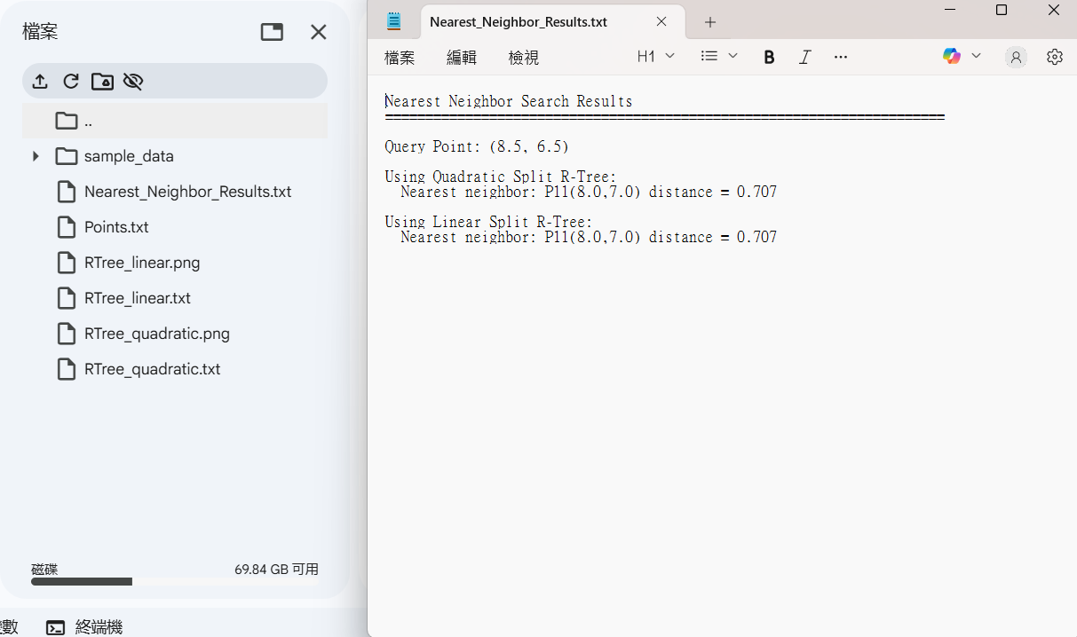

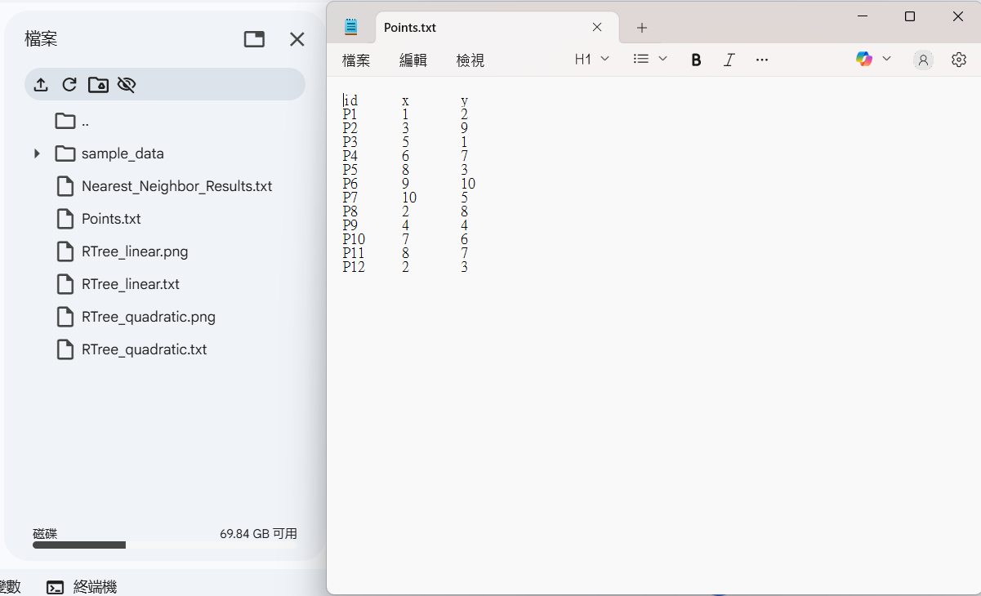
RTree_quadratic:
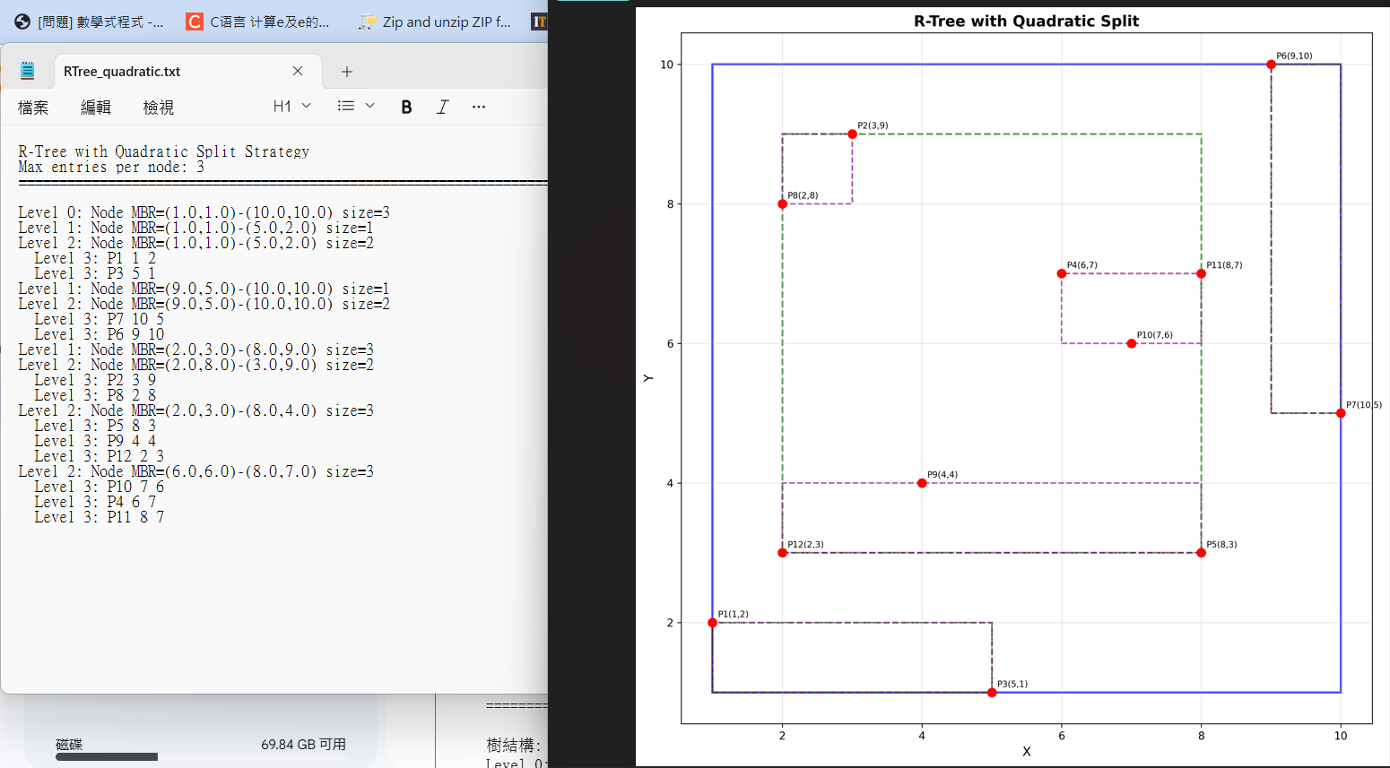

RTree_linear:
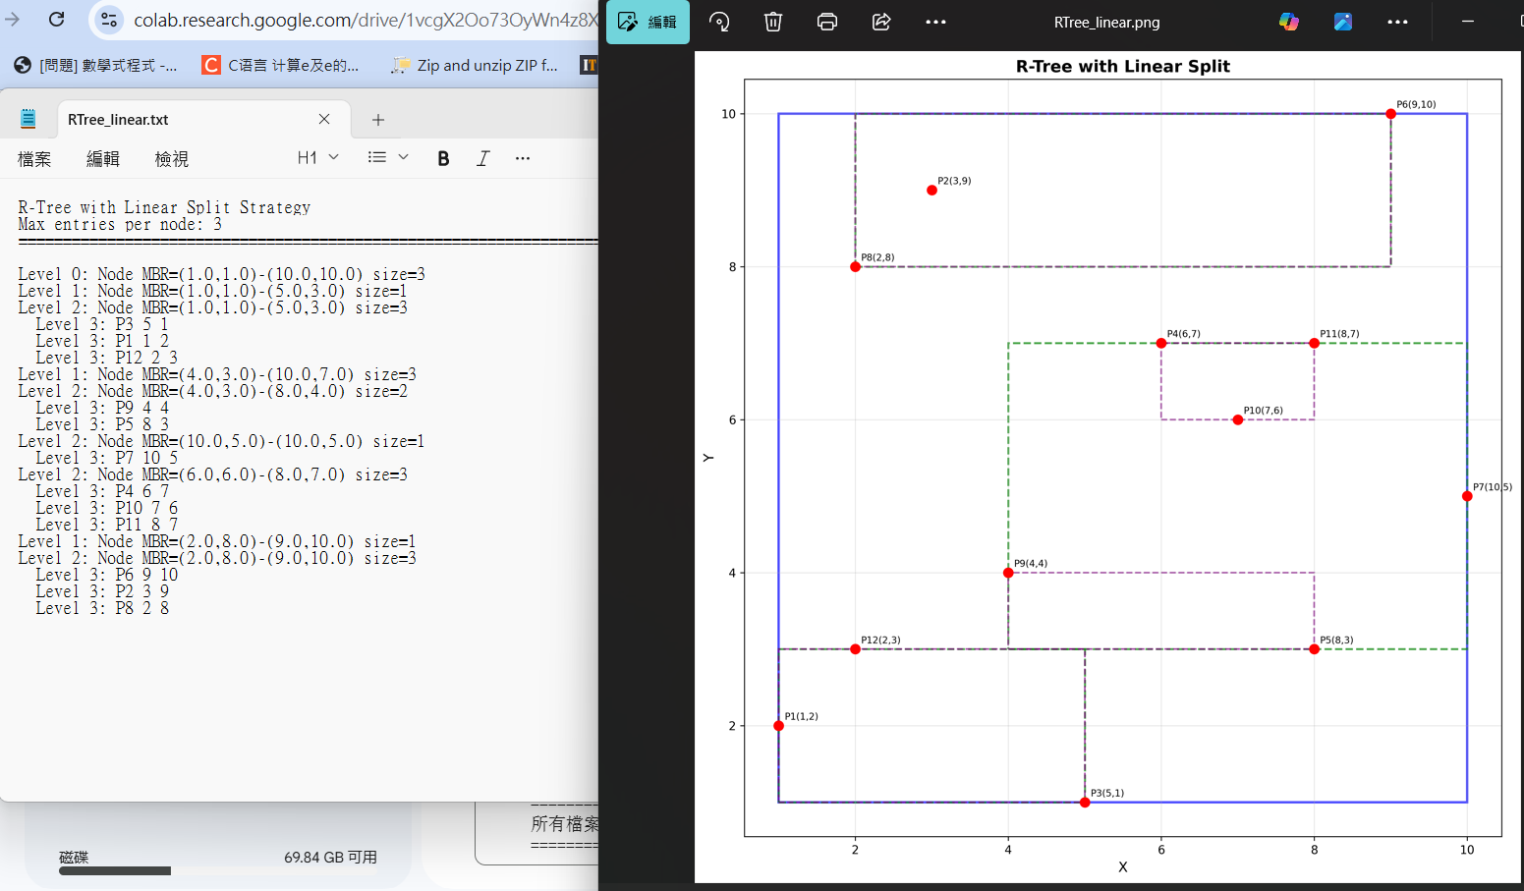

Linear split：比較簡單、快速的策略，概念是先找在 x 或 y 方向上距離最遠的兩個 entry 當種子，剩下的再依「加入哪一組增加面積比較少」去分配。​

Quadratic split：會看所有成對的 entry，算「兩個合在一起浪費多少面積（waste）」，選浪費最大的那一對當種子，之後一樣把剩下的 entry 分配到兩組。

完整程式碼:
https://colab.research.google.com/drive/1vcgX2Oo73OyWn4z8XMfqVtRl-xZIcysO?usp=sharing

