Snapshot Week 6 of Group CONT8

**How do we build an ideal CI/CD pipeline deployment solution for software at scale - CONTINUOUS**

a1774020 Chao-Chung Chuang a1777315 Jinchen Song a1778478 Runtao Zhuge a1782077 Yunfan Han a1788058 Yifei Xu

a1791407 Kwok Chung Kwan a1778829 Zishun Chen a1806522 Zhuofan Zhang a1839458 Benedict Xu

**Product Backlog and Task Board:**

**Sprint Backlog and User Stories:**

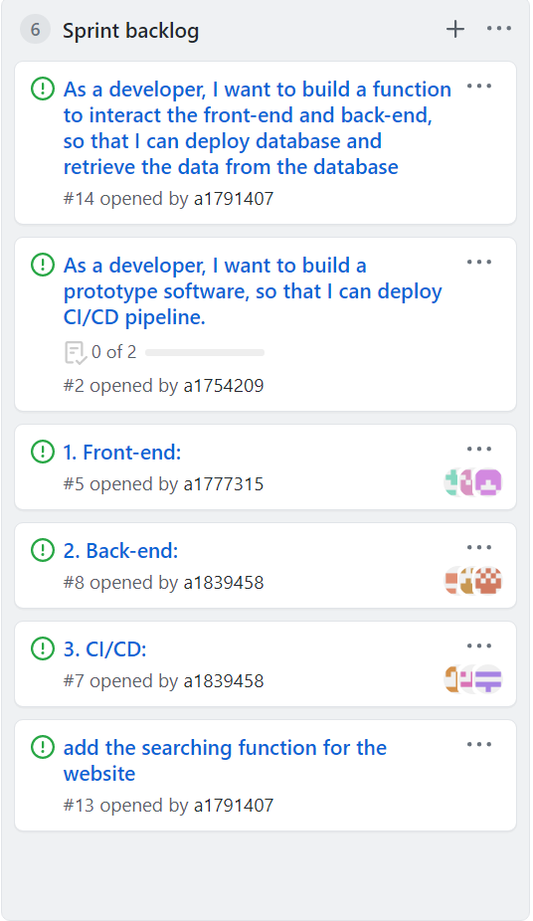

**Provide a screenshot of the sprint backlog**

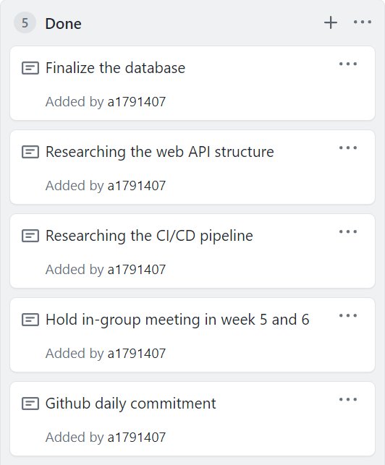

**Definition of Done**



There is a list of tasks that have completed already

* Finalize the database
* Research the web API structure
* Research the CI/CD pipeline
* Hold in-group meeting in week 5 & week 6
* GitHub daily commitment

# Summary of Changes:

During the group meeting in week 6, our team have reviewed each’s team (front-end/back-end/CI&CD) current progress and discuss about the implementation of the pipelining. In this week, the back-end team has already developed a controller that is used to receive the user requests and deliver the HTTP response back to them. In this week, our team have changed and finalized the database table because of missing important properties and invalid data type for properties.

In aspect of the GitHub Page, we create two section which are Done, Sprint 2. Once the members finish their assigned work, they should move their work into the DONE section. When the next sprint start, our team will move all the work from DONE section to Sprint 2 column.

In the next snapshot, our team aims to accomplish the code for interacting backend and frontend and develop an approach to connect the website with the CI/CD. For example, our team would upload the web files into the GitHub and make use of the Jenkins to test the files automatically and process further tasks.