LiDAR point classification thresholds: ground, low vegetation and canopy
PhenoFuse 4.0.3 - class-threshold study on the Muresk NUE trial (NUE_I_DPIRD_Muresk_F_Gobi), flights 2025-09-30 (anthesis) and 2025-11-21 (maturity). Generated 2026-10-16.

1. Question
PhenoFuse classifies every point of a plot by its height h above the plot-local ground plane: ground |h| <= 8 cm (class 2), low vegetation 8-10 cm (class 3), canopy h > 10 cm (class 5). Which thresholds give the most useful features and predictions, and how sensitive are the features and the pretrained models to them?

2. How the thresholds act in the pipeline
- The ground plane is fitted through the alley ring (25 cm cells, 5th percentile) and refined with in-plot points within the ground band; h = z - plane. The plane-fit RMS on these flights is 1.7 cm median (max 3.5 cm) at anthesis and 2.6 cm median (max 4.1 cm) at maturity.
- Canopy-only metrics (H_mean, H50, H95, H99, H999, H_sd, density layers, voxel volume, cover, canopy intensity) use only points with h > canopy threshold. Gap fraction, LAI proxy and ground visibility use the ground class (|h| <= ground threshold) against all points.
- The low-vegetation class is only the band between the two thresholds. No feature uses it directly; its points count in the 'all points' denominators. With 8/10 cm it holds 2-4 % of the points and is effectively a dead band.
- The canopy-top surface features (cth_p95, cth_p99, tip_thin, roughness, rumple) are computed from 5 cm cell maxima of all points and are therefore independent of both thresholds.

3. Design of the study
For each flight the per-plot classified LAS files (noise rule 'gap', plane fits as extracted) were re-classified at nine (ground / canopy) settings and every v3 feature was recomputed; the ground plane itself was kept fixed, so only the classification moves. Features were compared through their means, their correlation with the measured plant height (ruler, 128 plots) and quadrat biomass at maturity (128 plots), and through the bundled pretrained models (height LiDAR-core GPR, biomass Muresk anthesis / maturity LiDAR top-3 ensembles), which were trained on features extracted at 8 / 10 cm.
Settings (ground / canopy, cm): 3 / 5, 5 / 8, 5 / 10, 8 / 10, 8 / 15, 10 / 15, 10 / 20, 15 / 30, 20 / 40

4. Point shares per class
flight | ground / canopy (cm) | ground % | low veg % | canopy %
2025-09-30 anthesis | 3 / 5 | 3.9 | 2.0 | 93.6
2025-09-30 anthesis | 5 / 8 | 6.3 | 3.4 | 90.2
2025-09-30 anthesis | 5 / 10 | 6.3 | 5.9 | 87.7
2025-09-30 anthesis | 8 / 10 | 9.8 | 2.5 | 87.7
2025-09-30 anthesis | 8 / 15 | 9.8 | 9.3 | 80.9
2025-09-30 anthesis | 10 / 15 | 12.3 | 6.8 | 80.9
2025-09-30 anthesis | 10 / 20 | 12.3 | 14.3 | 73.4
2025-09-30 anthesis | 15 / 30 | 19.1 | 25.1 | 55.9
2025-09-30 anthesis | 20 / 40 | 26.6 | 39.2 | 34.2
2025-11-21 maturity | 3 / 5 | 8.8 | 3.7 | 85.6
2025-11-21 maturity | 5 / 8 | 13.7 | 5.6 | 80.0
2025-11-21 maturity | 5 / 10 | 13.7 | 9.2 | 76.4
2025-11-21 maturity | 8 / 10 | 19.9 | 3.6 | 76.4
2025-11-21 maturity | 8 / 15 | 19.9 | 11.2 | 68.8
2025-11-21 maturity | 10 / 15 | 23.6 | 7.6 | 68.8
2025-11-21 maturity | 10 / 20 | 23.6 | 14.0 | 62.4
2025-11-21 maturity | 15 / 30 | 31.2 | 18.2 | 50.6
2025-11-21 maturity | 20 / 40 | 37.6 | 24.3 | 38.1

5. Feature sensitivity
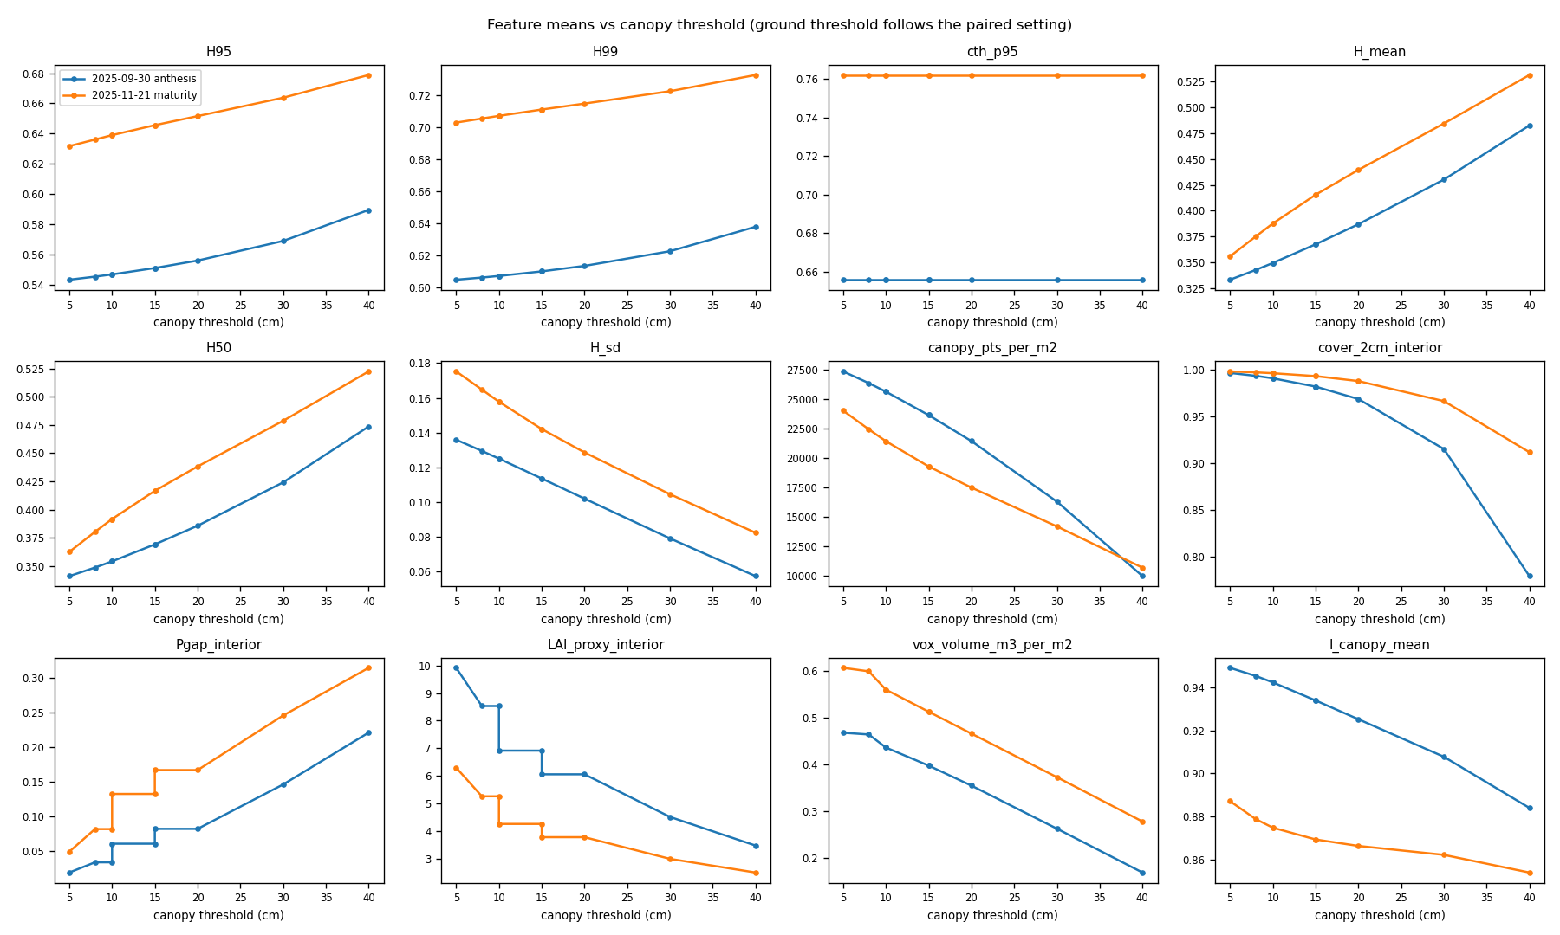
Figure 1. Feature means against the canopy threshold on both flights. Top-of-canopy percentiles (H95, H99) and the canopy-top surface (cth_p95) barely move; canopy-mass features (H_mean, H50, cover, gap fraction, LAI proxy, voxel volume) change by 30-100 %.
Table 2. Feature means (m, fractions, m3/m2, points/m2).
flight | ground / canopy | H95 | cth_p95 | H | H_sd | cover_2cm_interior | Pgap_interior | vox_volume_m3_per_m2 | canopy_pts_per_m2
2025-09-30 | 3 / 5 | 0.543 | 0.656 | 0.333 | 0.136 | 0.997 | 0.019 | 0.468 | 27379.887
2025-09-30 | 5 / 8 | 0.545 | 0.656 | 0.343 | 0.129 | 0.994 | 0.034 | 0.464 | 26385.804
2025-09-30 | 5 / 10 | 0.547 | 0.656 | 0.349 | 0.125 | 0.991 | 0.034 | 0.436 | 25659.980
2025-09-30 | 8 / 10 | 0.547 | 0.656 | 0.349 | 0.125 | 0.991 | 0.061 | 0.436 | 25659.980
2025-09-30 | 8 / 15 | 0.551 | 0.656 | 0.367 | 0.113 | 0.982 | 0.061 | 0.397 | 23664.136
2025-09-30 | 10 / 15 | 0.551 | 0.656 | 0.367 | 0.113 | 0.982 | 0.082 | 0.397 | 23664.136
2025-09-30 | 10 / 20 | 0.556 | 0.656 | 0.387 | 0.102 | 0.969 | 0.082 | 0.355 | 21456.221
2025-09-30 | 15 / 30 | 0.569 | 0.656 | 0.430 | 0.079 | 0.915 | 0.146 | 0.263 | 16306.155
2025-09-30 | 20 / 40 | 0.589 | 0.656 | 0.483 | 0.057 | 0.779 | 0.221 | 0.169 | 9975.872
2025-11-21 | 3 / 5 | 0.632 | 0.762 | 0.356 | 0.175 | 0.998 | 0.049 | 0.606 | 24044.853
2025-11-21 | 5 / 8 | 0.636 | 0.762 | 0.375 | 0.165 | 0.997 | 0.082 | 0.599 | 22456.927
2025-11-21 | 5 / 10 | 0.639 | 0.762 | 0.388 | 0.158 | 0.996 | 0.082 | 0.560 | 21446.763
2025-11-21 | 8 / 10 | 0.639 | 0.762 | 0.388 | 0.158 | 0.996 | 0.133 | 0.560 | 21446.763
2025-11-21 | 8 / 15 | 0.646 | 0.762 | 0.415 | 0.142 | 0.993 | 0.133 | 0.513 | 19299.152
2025-11-21 | 10 / 15 | 0.646 | 0.762 | 0.415 | 0.142 | 0.993 | 0.167 | 0.513 | 19299.152
2025-11-21 | 10 / 20 | 0.652 | 0.762 | 0.440 | 0.129 | 0.988 | 0.167 | 0.466 | 17503.215
2025-11-21 | 15 / 30 | 0.664 | 0.762 | 0.485 | 0.104 | 0.966 | 0.246 | 0.373 | 14199.130
2025-11-21 | 20 / 40 | 0.679 | 0.762 | 0.532 | 0.082 | 0.912 | 0.314 | 0.278 | 10691.270

6. Relation to the ground truth
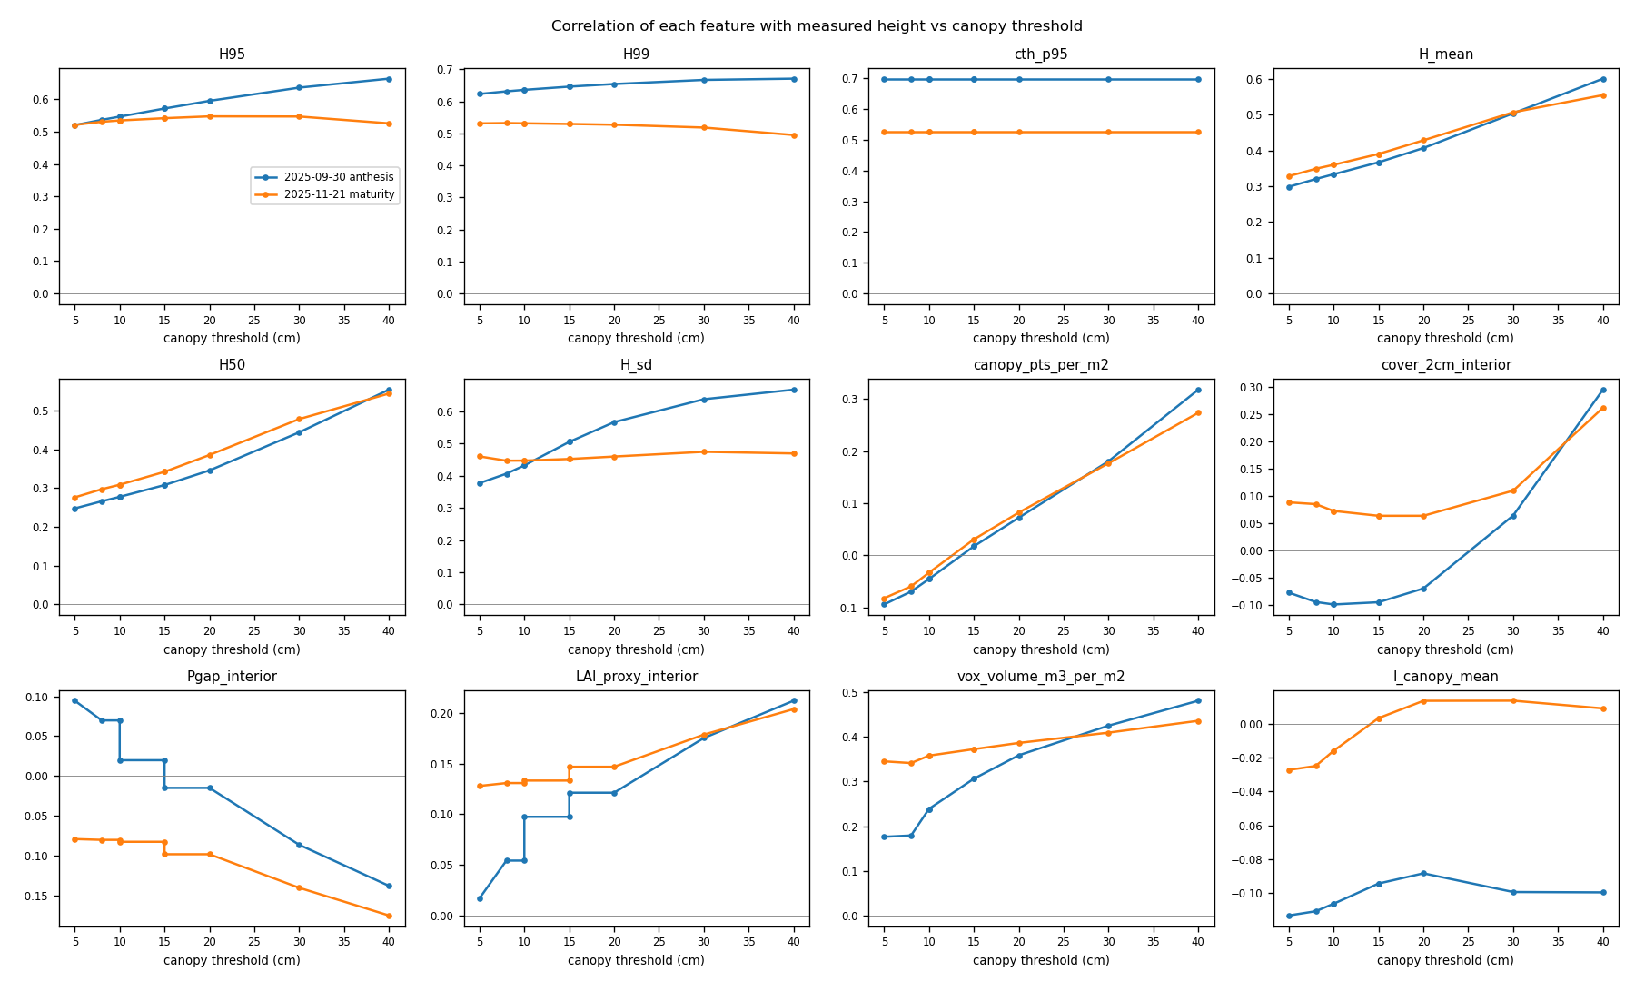
Figure 2. Correlation of each feature with the ruler height. cth_p95 (threshold-free) stays the best single height feature; H95 / H99 gain slightly with a higher cutoff because lower leaves drop out of the percentile.
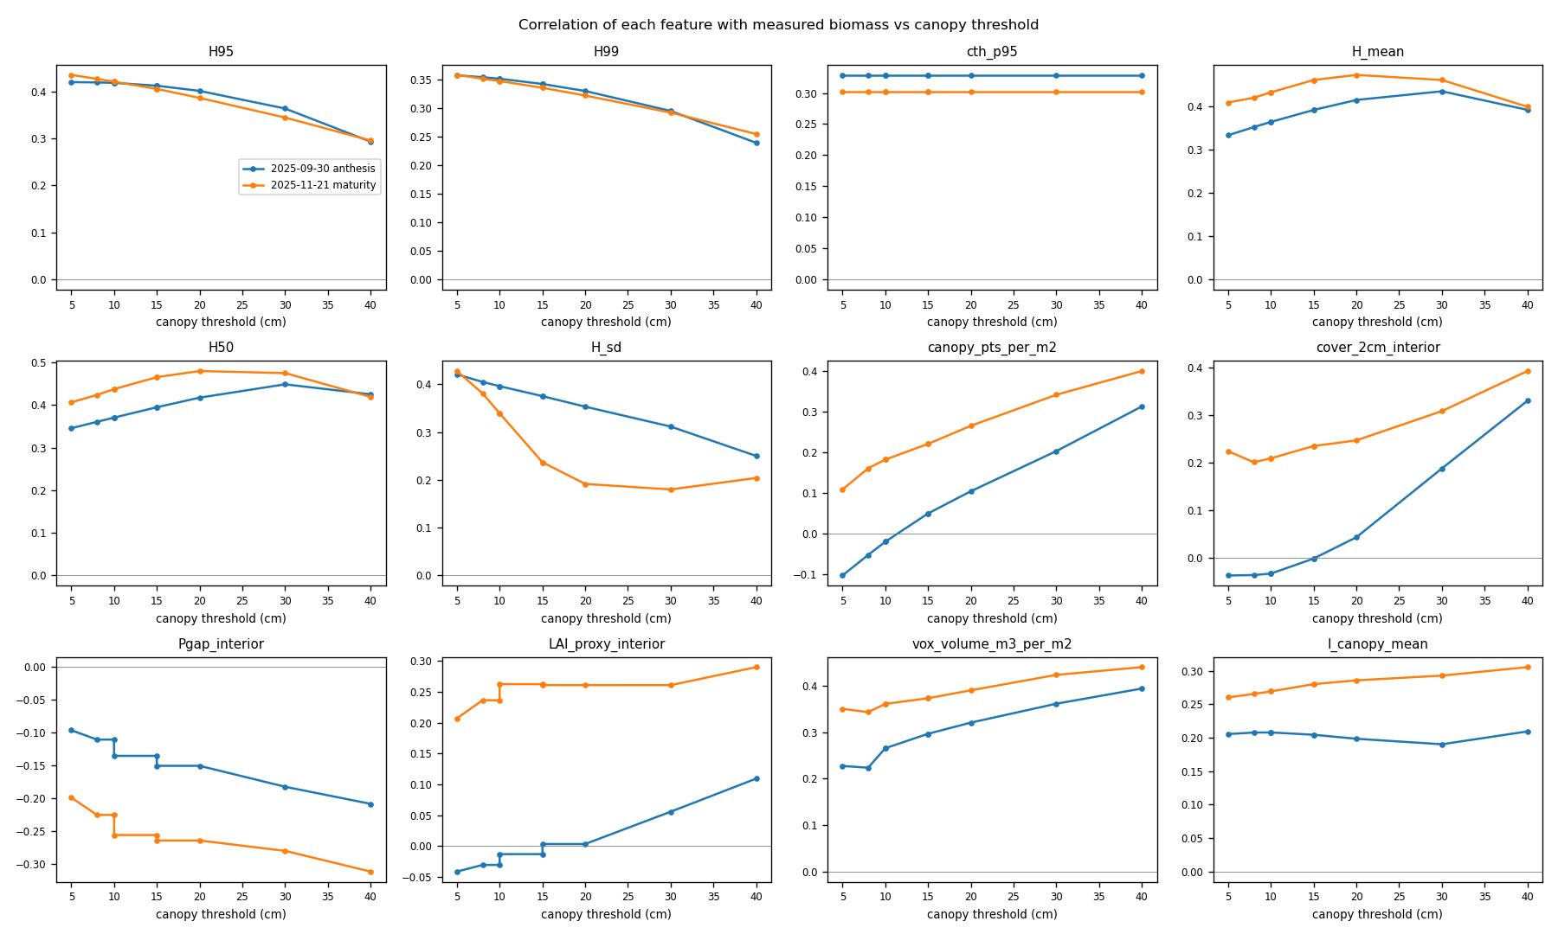
Figure 3. Correlation with maturity quadrat biomass. H_mean / H50 become more informative at 20-30 cm cutoffs, H95 / H_sd slightly less; the ground-truth sampling noise limits every correlation to about 0.4-0.5.
Table 3. Correlation r with ruler height (left block) and maturity biomass (right block).
flight | ground / canopy | H95 (h) | cth_p95 (h) | H_mean (h) | H_sd (h) | vox_volume_m3_per_m2 (h) | H95 (b) | cth_p95 (b) | H_mean (b) | H_sd (b) | vox_volume_m3_per_m2 (b)
2025-09-30 | 3 / 5 | 0.520 | 0.699 | 0.298 | 0.377 | 0.176 | 0.420 | 0.329 | 0.333 | 0.421 | 0.227
2025-09-30 | 5 / 8 | 0.537 | 0.699 | 0.320 | 0.406 | 0.179 | 0.419 | 0.329 | 0.352 | 0.405 | 0.223
2025-09-30 | 5 / 10 | 0.547 | 0.699 | 0.333 | 0.432 | 0.239 | 0.418 | 0.329 | 0.364 | 0.396 | 0.265
2025-09-30 | 8 / 10 | 0.547 | 0.699 | 0.333 | 0.432 | 0.239 | 0.418 | 0.329 | 0.364 | 0.396 | 0.265
2025-09-30 | 8 / 15 | 0.572 | 0.699 | 0.367 | 0.505 | 0.307 | 0.412 | 0.329 | 0.391 | 0.375 | 0.296
2025-09-30 | 10 / 15 | 0.572 | 0.699 | 0.367 | 0.505 | 0.307 | 0.412 | 0.329 | 0.391 | 0.375 | 0.296
2025-09-30 | 10 / 20 | 0.595 | 0.699 | 0.407 | 0.566 | 0.359 | 0.401 | 0.329 | 0.414 | 0.353 | 0.320
2025-09-30 | 15 / 30 | 0.636 | 0.699 | 0.503 | 0.637 | 0.425 | 0.363 | 0.329 | 0.434 | 0.312 | 0.361
2025-09-30 | 20 / 40 | 0.664 | 0.699 | 0.600 | 0.667 | 0.481 | 0.293 | 0.329 | 0.391 | 0.250 | 0.394
2025-11-21 | 3 / 5 | 0.521 | 0.525 | 0.328 | 0.460 | 0.345 | 0.435 | 0.302 | 0.408 | 0.428 | 0.350
2025-11-21 | 5 / 8 | 0.531 | 0.525 | 0.349 | 0.446 | 0.342 | 0.427 | 0.302 | 0.419 | 0.381 | 0.343
2025-11-21 | 5 / 10 | 0.535 | 0.525 | 0.360 | 0.446 | 0.358 | 0.421 | 0.302 | 0.432 | 0.339 | 0.361
2025-11-21 | 8 / 10 | 0.535 | 0.525 | 0.360 | 0.446 | 0.358 | 0.421 | 0.302 | 0.432 | 0.339 | 0.361
2025-11-21 | 8 / 15 | 0.542 | 0.525 | 0.390 | 0.452 | 0.373 | 0.405 | 0.302 | 0.460 | 0.237 | 0.373
2025-11-21 | 10 / 15 | 0.542 | 0.525 | 0.390 | 0.452 | 0.373 | 0.405 | 0.302 | 0.460 | 0.237 | 0.373
2025-11-21 | 10 / 20 | 0.547 | 0.525 | 0.428 | 0.459 | 0.387 | 0.386 | 0.302 | 0.472 | 0.192 | 0.390
2025-11-21 | 15 / 30 | 0.547 | 0.525 | 0.507 | 0.474 | 0.410 | 0.344 | 0.302 | 0.460 | 0.180 | 0.423
2025-11-21 | 20 / 40 | 0.526 | 0.525 | 0.554 | 0.469 | 0.436 | 0.295 | 0.302 | 0.399 | 0.204 | 0.440

7. Pretrained models
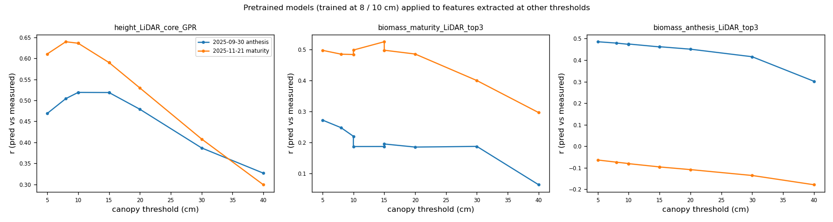
Figure 4. The bundled models were trained with features at 8 / 10 cm. Moving the thresholds shifts their inputs out of the training distribution: the anthesis biomass ensemble falls from r ~0.48 to ~0.30 and the height model from ~0.52 to ~0.33 at 20 / 40 cm, while going lower (3 / 5, 5 / 8) costs little because few points lie below 10 cm.
Table 4. Pretrained models: r and RMSE (cm for height, kg/ha for biomass) against the measurements.
flight | ground / canopy | heightGPR_r | biomass_maturity_r | biomass_anthesis_r | heightGPR_RMSE | biomass_maturity_RMSE | biomass_anthesis_RMSE
2025-09-30 | 3 / 5 | 0.469 | 0.273 | 0.485 | 16.060 | 1425.570 | 1317.686
2025-09-30 | 5 / 8 | 0.504 | 0.248 | 0.479 | 15.353 | 1445.049 | 1343.977
2025-09-30 | 5 / 10 | 0.519 | 0.220 | 0.473 | 14.812 | 1466.241 | 1381.328
2025-09-30 | 8 / 10 | 0.519 | 0.187 | 0.475 | 14.812 | 1482.386 | 1362.694
2025-09-30 | 8 / 15 | 0.519 | 0.188 | 0.462 | 13.255 | 1490.913 | 1464.625
2025-09-30 | 10 / 15 | 0.519 | 0.196 | 0.462 | 13.255 | 1485.464 | 1450.077
2025-09-30 | 10 / 20 | 0.479 | 0.186 | 0.451 | 11.530 | 1507.498 | 1579.263
2025-09-30 | 15 / 30 | 0.387 | 0.188 | 0.416 | 7.992 | 1563.655 | 1871.791
2025-09-30 | 20 / 40 | 0.327 | 0.064 | 0.302 | 5.814 | 1605.424 | 2161.682
2025-11-21 | 3 / 5 | 0.610 | 0.498 | -0.064 | 7.562 | 1253.212 | 4128.939
2025-11-21 | 5 / 8 | 0.639 | 0.485 | -0.074 | 6.076 | 1259.508 | 4156.272
2025-11-21 | 5 / 10 | 0.636 | 0.484 | -0.080 | 5.315 | 1259.474 | 4188.974
2025-11-21 | 8 / 10 | 0.636 | 0.499 | -0.081 | 5.315 | 1249.162 | 4182.996
2025-11-21 | 8 / 15 | 0.590 | 0.525 | -0.096 | 4.657 | 1241.610 | 4260.722
2025-11-21 | 10 / 15 | 0.590 | 0.498 | -0.096 | 4.657 | 1265.021 | 4256.942
2025-11-21 | 10 / 20 | 0.530 | 0.486 | -0.108 | 5.346 | 1296.760 | 4338.946
2025-11-21 | 15 / 30 | 0.408 | 0.400 | -0.135 | 7.946 | 1428.791 | 4577.108
2025-11-21 | 20 / 40 | 0.299 | 0.297 | -0.178 | 10.591 | 1505.394 | 4898.762

8. Recommendation
- Keep ground 8 cm / canopy 10 cm as the default and whenever a bundled (pretrained) model is applied: the models are tied to those values, and the ground band is 3-5 times the plane-fit RMS of these flights, so ground noise and stubble stay in class 2.
- The ground threshold may be lowered to 5 cm on flat, well-fitted flights (plane RMS < 2 cm) and should be raised to 10-12 cm on cloddy seedbeds or when the per-plot RMS exceeds 3 cm (the provenance file records it). It changes the ground-based features (Pgap, LAI proxy, ground visibility) and barely anything else.
- The canopy threshold is a modelling choice: 10 cm is the convention of UAV-LiDAR crop studies and right for early season; for a mature cereal canopy a 15-20 cm cutoff gives cleaner canopy-mass features (H_mean, H50, cover, voxel volume) for models trained from scratch, at no cost to the top-of-canopy features. Use the same value for training and prediction.
- The low-vegetation class as defined (8-10 cm) carries no information. If a low-vegetation layer is wanted (weeds, tillers, lodged leaves) define it as a band that means something, e.g. 8-30 cm, and add its point share as a feature; today it only labels points in the classified LAS files for visual QC.
- Use cth_p95 / cth_p99 for plant height wherever possible: they are threshold-free, correlate best with the ruler, and are what the height models rely on.

9. Files
thr_sweep_0930.csv / thr_sweep_1121.csv: every number of this report (feature means, correlations, model scores per setting). Figures: fig_feature_means.png, fig_corr_height.png, fig_corr_biomass.png, fig_models.png. Inputs: per-plot classified LAS files of the two flights (plots_lidar), plant_height_ground_truth.csv, biomass_maturity_kg_ha.csv, bundled models of PhenoFuse 4.0.3.

