**Exercise 1: Control Structures**

**Code:**

BEGIN

FOR i IN 1..5 LOOP

IF MOD(i, 2) = 0 THEN

DBMS_OUTPUT.PUT_LINE(i || ' is even');

ELSE

DBMS_OUTPUT.PUT_LINE(i || ' is odd');

END IF;

END LOOP;

END;

/

**Output:**

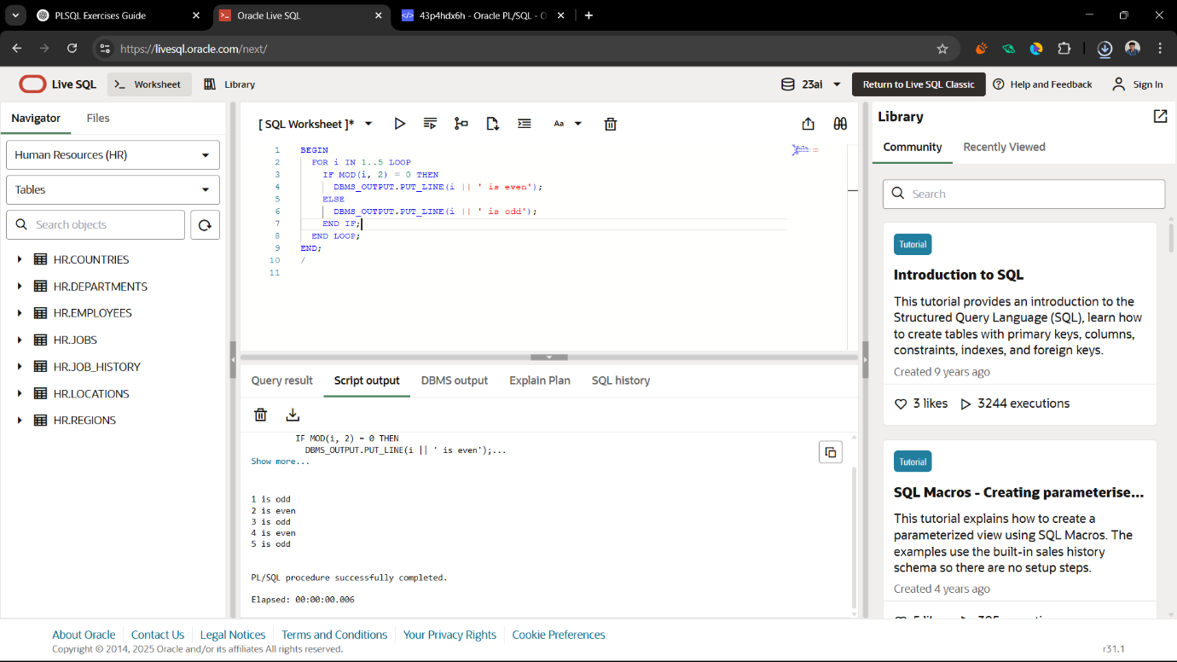

**Exercise 3: Stored Procedures**

**Code:**

CREATE TABLE students (

id NUMBER PRIMARY KEY,

name VARCHAR2(100),

grade VARCHAR2(10)

);  
  
CREATE OR REPLACE PROCEDURE add_student (

p_id IN NUMBER,

p_name IN VARCHAR2,

p_grade IN VARCHAR2

) IS

BEGIN

INSERT INTO students (id, name, grade)

VALUES (p_id, p_name, p_grade);

DBMS_OUTPUT.PUT_LINE('Student ' || p_name || ' added successfully.');

END;

/  
BEGIN

add_student(1, 'A P Prajwal', 'A');

add_student(2, 'Ravi Kumar', 'B');

END;

/  
SELECT * FROM students;

**Output:**

