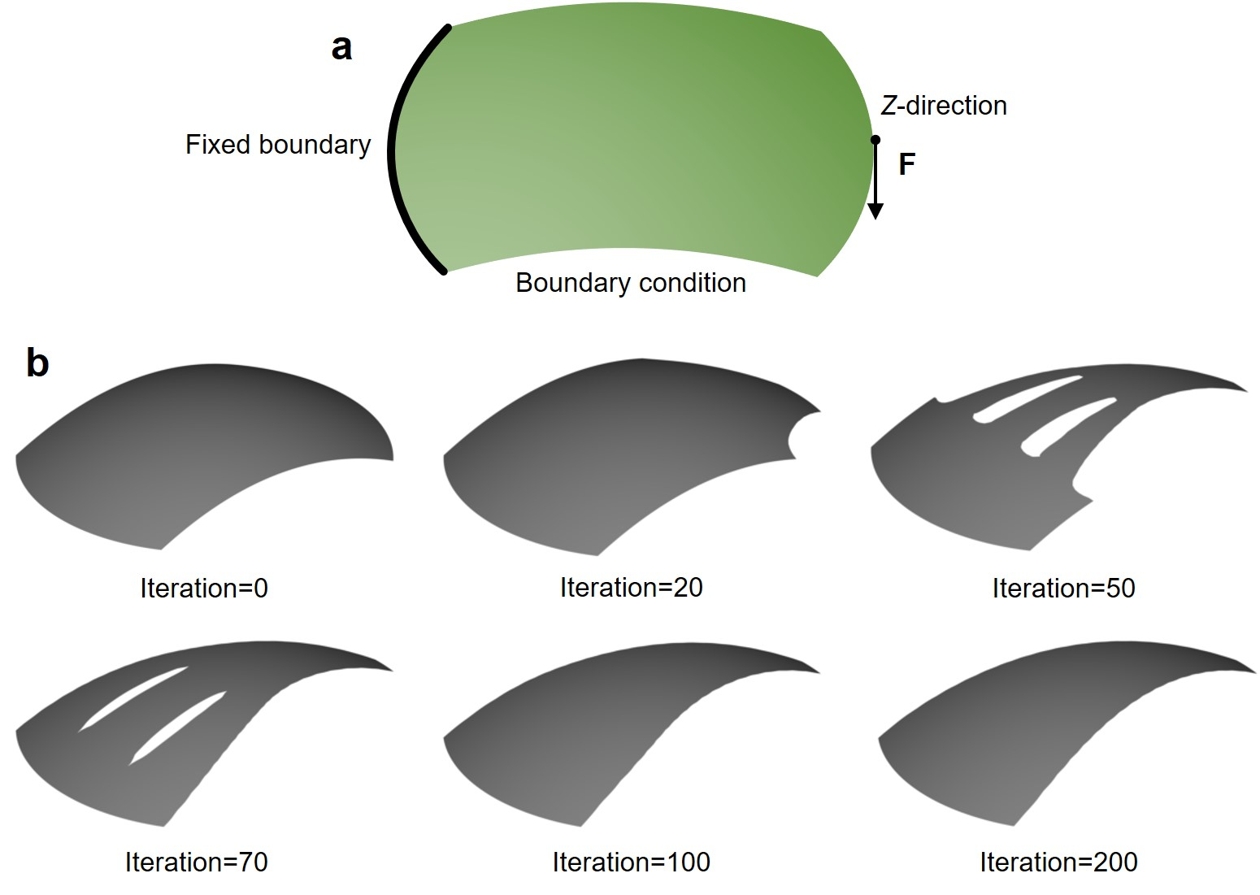

**Fig. 1 | An example demonstration for topology optimization of shell structures using the ODE-driven level-set density method [1]**. **a**,boundary condition definition for a shell structure. **b**,some intermediate results during the optimization process.

[1] Liu Y, Yang C, Wei P, Zhou P, Du J. An ODE-driven level-set density method for topology optimization. Computer Methods in Applied Mechanics and Engineering 387, 114159 (2021). <https://doi.org/10.1016/j.cma.2021.114159>