

APPRIS Technical Document

Version | Author(s) | Date
v1 | Jose Manuel Rodríguez | May 21, 2012

Characteristics of the pipeline

We have created a system, APPRIS (http://appris.bioinfo.cnio.es/) that aims to fill this gap by annotating alternative protein isoforms with functional information. APPRIS integrates biologically significant evidence from a range of reliable data sources and employs a display system that allows annotators and researchers alike to investigate and make decisions about the functional potential of the transcripts generated by alternative splicing.

APPRIS makes use of a wide range of complementary prediction tools to combine protein structural and functional information, signal peptides and trans-membrane helices, conservation of related species, the conservation of exonic structure and a measure of non-neutral evolution of exons. Each of the prediction tools APPRIS is organized as a separate prediction server.

The selection of a single representative for a gene is difficult to automate. Most databases ignore this problem by selecting the longest isoform as the main variant. While this is a safe choice and is often correct, we have shown that it is not always the best strategy - only 75% of constitutive isoforms selected by this strategy are likely to be correct. It is important to designate one of the isoforms as the constitutive functional isoform in order to predict changes in function, structure or localisation brought about by alternative splicing.

The APPRIS system is composed of eight separate computational methods. The output of all individual methods is used by APPRIS to annotate alternative variants to select a constitutive isoform for a gene. The range of complementary computational methods is the following:

- Functionally important residues, firestar
- Protein structural information, Matador3D
- Neutral evolution of exons, INERTIA
- Conservation against vertebrates, CORSAIR
- Presence of whole protein domains, SPADE
- Conservation of exonic structure, CExonic
- Prediction of signal peptide and sub-cellular location, CRASH
- Presence of whole trans-membrane helices, THUMP

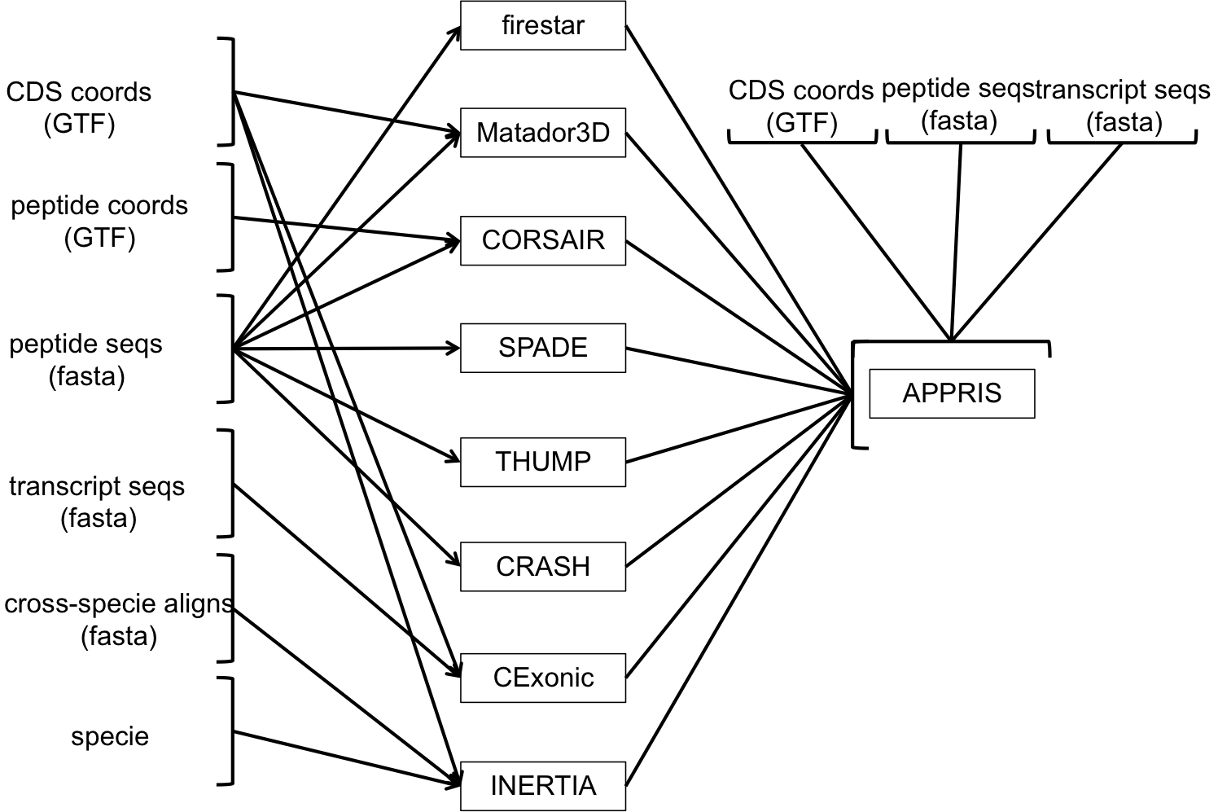

Figure 1 - Diagram Pipeline of APPRIS (IMPROVE THE DIAGRAM)

System description

APPRIS programs are executed within compute farms and every job is submitted to a queue system in each cluster. Programs are based on flat files for input and output that initially are written in local storage, where finally they are parsed and stored in the APPRIS relational database.
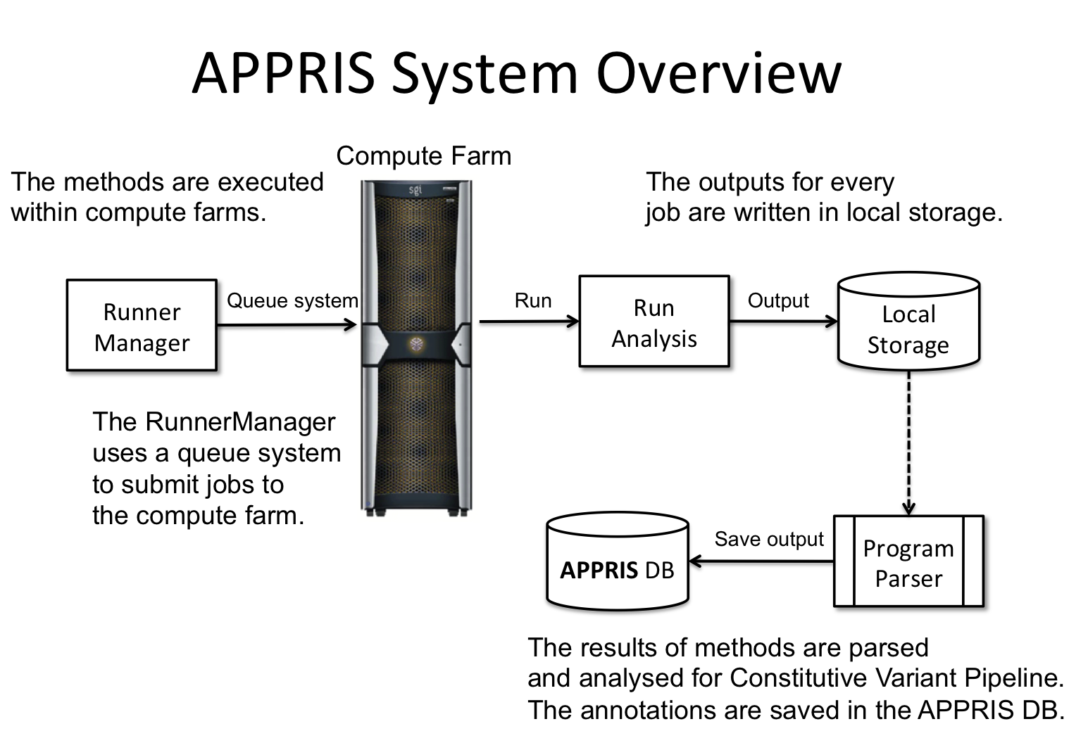

Figure 2 - APPRIS System Overview

- firestar predicts functionally important residues in protein sequences. firestar uses PSI-BLAST and HHBLITS to align transcript sequences against sequence profiles that are pre-generated for a set of PDB structures. Biologically relevant functional residues are mapped onto the transcript sequences from the PDB via the alignments and the conservation of these potential functionally important residues is evaluated with SQUARE.

Its web server is http://firedb.bioinfo.cnio.es/Php/FireStar.php.

  - Inputs:
    - Peptide sequences (FASTA format).
  - Outputs:
    - Functional important residues (Text format).
  - Language programming:
    - Perl.
  - API requirements:
Getopt::Long
FindBin
DBI
POSIX
APPRIS::Utils::Logger
APPRIS::Utils::File
  - External software:
    - Blastpgp 2.2.20
    - HHblits 2.2.17
    - PSIPRED
  - Database design:
    - MySQL.
  - Databases:
    - sprot_clean_trembl_clean_70
    - fdbTptDB_[release_date] (specific db)
    - hhblits_[release_date] (specific db)

- Matador3D is a locally implemented method that checks for similarity to known structures in the PDB. Matador3D employs a simple BLAST search to align the annotated transcripts to the PDB structures.

  - Inputs:
    - Peptide sequence of variants (FASTA format).
    - CDS coordinates for each variant (GTF format).
  - Outputs:
    - Protein structural information (Text format).
  - Language programming:
    - Perl.
  - API requirements:
Getopt::Long
Bio::SeqIO
Bio::SearchIO
FindBin
APPRIS::Utils::Logger
APPRIS::Utils::File
  - External software:
    - Blastpgp 2.2.20
  - Databases:
    - PDB

- SPADE uses a version of the program Pfamscan to identify the effect of alternative splicing on the conservation of protein functional domains. Isoforms with large indels with respect to Pfam domains are likely to have damaged functional domains and are likely to be alternative variants. Also variants that are found to have “lost” whole functional domains are unlikely to be the constitutive isoform.
For more information: ftp://ftp.sanger.ac.uk/pub/databases/Pfam/Tools/README

  - Inputs:
    - Peptide sequence (FASTA format).
  - Outputs:
    - Presence of whole protein domains (Text format).
  - Language programming:
    - Perl.
  - API requirements:
Getopt::Long
Bio::SeqIO
FindBin
APPRIS::Utils::Logger
APPRIS::Utils::File
  - External software:
    - pfam_scan 1.3
  - Databases:
    - Pfam-A
    - Pfam-B

- CORSAIR is another locally implemented method. CORSAIR counts the number of orthologous protein sequences that align correctly to each alternative transcript from BLAST searches against a locally installed version of the vertebrate sequences from the UniProt database.
The number of orthologous transcripts that align correctly in CORSAIR can be used to help select constitutive isoforms because the constitutive variant is likely to be conserved over greater evolutionary distances than the alternative variants.

  - Inputs:
    - Peptide sequence of variants (FASTA format).
    - Peptide coordinates for each variant (GTF format).
  - Outputs:
    - Conservation against vertebrates (Text format).
  - Language programming:
    - Perl.
  - API requirements:
Getopt::Long
Bio::SeqIO
FindBin
  - External software:
    - Blastpgp 2.2.20
  - Databases:
    - Vertebrate database (specific db)

- CRASH makes conservative predictions of signal peptides and mitochondrial signal sequences by using locally installed versions of the SignalP and TargetP programs. Predicted signal sequences are tagged as either reliable or potential, based solely on the output of the two programs. Signal sequences predicted as reliable are unlikely to have arisen by chance, so transcripts that have reliable signal sequences are more likely to code for the principal functional variants and transcripts that have “lost” signal sequences are more likely to be alternative variants.

  - Inputs:
    - Peptide sequences (FASTA format).
  - Outputs:
    - Prediction of signal peptide and sub-cellular location (Text format).
  - Language programming:
    - Perl.
  - API requirements:
Getopt::Long
FindBin
  - External software:
    - SignalP 3.0
    - TargetP 1.1

- THUMP is a trans-membrane helix prediction web service. THUMP makes conservative predictions of trans-membrane helices by analyzing the output of three locally installed trans-membrane prediction methods, MemSat, PHOBIUS and PRODIV. Trans-membrane helices are predicted based on the output of the three programs and THUMP predicts reliable trans-membrane helices when all three prediction methods agree.

  - Inputs:
    - Peptide sequences (FASTA format).
  - Outputs:
    - Presence of whole trans-membrane helices (Text format).
  - Language programming:
    - Perl.
  - API requirements:
Getopt::Long
Bio::SeqIO
FindBin
  - External software:
    - Memsat3 v3
    - Phobius 1.01
    - Prodiv 0.92b
    - PSI-Blast 2.2.20

- CExonic determines the conservation of exonic structure between human and mouse. The method determines the orthologous gene in the mouse genome using tblastx with an E-value of 1E-10 and then the human transcript is aligned to the mouse genomic DNA using exonerate. Subsequently, the human and predicted mouse transcripts are aligned using MUSCLE and the exon/intron coordinates are superimposed on the alignment. Exonic structure is regarded as conserved if all human and mouse intron positions in the transcripts can be aligned.

  - Inputs:
    - Transcript sequences (FASTA format).
    - CDS coordinates for each variant (GTF format).
  - Outputs:
    - Conservation of exonic structure (Text format).
  - Language programming:
    - Perl.
  - API requirements:
Getopt::Long
Bio::Seq
Bio::SeqIO
FindBin
Bio::Tools::BPlite
  - External software:
    - fastasubseq 2.2.0
    - indexfasta
    - tblastx (local) - TBLASTX 2.0MP-WashU -
    - getfasta
    - exonerate 2.0.0
    - formatdb 2.2.18
    - pressdb
  - Databases:
    - H.sapiens/golden_path (formatdb for mouse genome and pressdb for mouse genome)
    - M.musculus/golden_path

- INERTIA detects exons with non-neutral evolutionary rates. Transcripts are aligned against related species using the 46-way alignments of orthologues species in the UCSC Browser and three different alignment methods, multiz, Kalign, and PRANK. INERTIA uses three different alignment methods in order to minimize the effect of alignment errors.

Evolutionary rates for individual exons are contrasted using SLR, which computes position-specific selection. SLR detects non-neutral evolution through statistical tests that can identify unusually conserved and unusually variable positions.

INERTIA flags exons as non-neutrally evolving if the SLR results from all three alignment methods agree that the exon is subject to non-neutral evolution. Transcripts with exons that have unusual substitution patterns are unlikely to be the constitutive isoforms, since the constitutive isoform is not likely to contain exons that are evolving abnormally quickly or under unusual selective pressures.

  - Inputs:
    - Specie
    - Cross-specie alignments (FASTA format).
    - CDS coordinates for each variant (GTF format).
  - Outputs:
    - Neutral evolution of exons (Text format).
  - Language programming:
    - Perl.
  - API requirements:
Getopt::Long
POSIX
Statistics::Descriptive
FindBin
APPRIS::Utils::Logger
  - External software:
    - KAlign 2.04
    - Prank v.100802
    - SLR 1.3

- APPRIS selects a constitutive isoform from among the isoforms annotated for each gene. In order to make this selection APPRIS assumes that most genes have a single constitutive isoform that has the principal gene function, or that is expressed in more tissues or more stages of development, and any number of alternative isoforms that may perform distinct roles. It also assumes that alternative variants will have evolved more recently and that highly conserved protein features will not have evolved by chance.

The methods that make up APPRIS detect unusual, missing or non-conserved features and will flag these transcripts as alternative. The selection of a constitutive isoform is based on a jury of the eight methods that make up the pipeline. Four methods (SPADE, CORSAIR, Matador3D and firestar) make up the core of the jury system, with the other methods becoming more important in cases where these four methods are not able to make a decision.

  - Inputs:
    - Peptide sequences (FASTA format).
    - Transcript sequences (FASTA format).
    - CDS coordinates for each variant (GTF format).
    - firestar result
    - Matador3D result
    - INERTIA result
    - CORSAIR result
    - SPADE result
    - CExonic result
    - CRASH result
    - THUMP result
  - Outputs:
    - Selects the constitutive isoform (Text format).
  - Language programming:
    - Perl.
  - API requirements:
Getopt::Long
FindBin
APPRIS::Parser
APPRIS::Utils::Logger
APPRIS::Utils::File

