***(Page 1)***

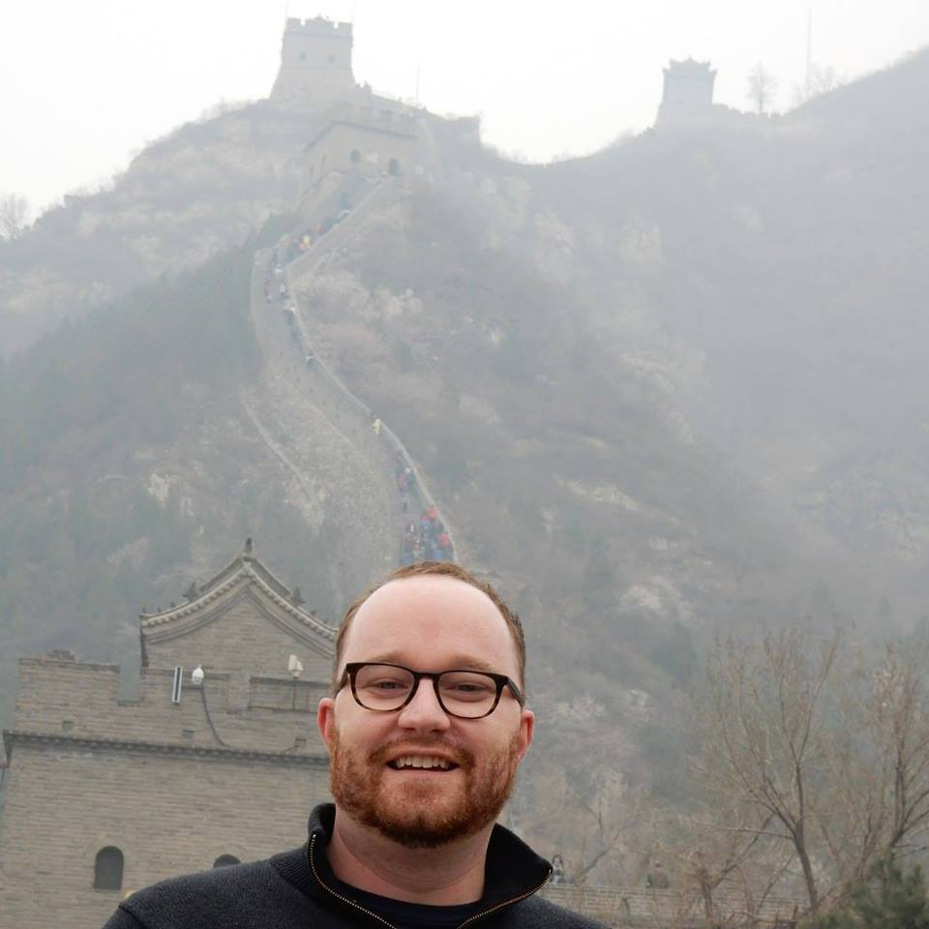

Michael Gleeson’s Homepage

Michael Gleeson is a 10-year Washington veteran with experience on Capitol Hill as a staffer and reporter, as a director on a Congressional Campaign, and in public relations.

***(Page 2)***

Michael is the Tax Legislative Assistant for Congressman Jim McDermott. Congressman McDermott is a senior member of both the Ways & Means Committee and the House Budget Committee. Michael manages the Congressman’s committee work relating to tax, trade, and the federal budget.

Michael responsibilities include attending hearings and mark-ups, analyzing legislation, articulating and advocating policy position, working with Committee and Member staff to progress positions and legislation, and draft and advance Member's key legislative initiatives.

Michael successfully spearheaded several legislative efforts for the Congressman, including H.R.2429 - Student Loan Tax Debt Relief Act. The bill has more than 50 cosponsors, or the support of just less than one-in-three House Democrats. Michael worked to get outside stakeholders involved in the process, and the bill has 20 outside organizations supporting it.

***(page 3)***

Michael worked as a Capitol Hill reporter for four years, working for The Hill newspaper and Tax Notes. From his time as a journalist, Michael gained a broad and deep knowledge of tax and budget policy, and has demonstrated an ability to take complex tax and budget concepts and translate them into accessible language for readers. Michael covered the House Ways & Means Committee and Senate Finance Committee mark ups, tax reform hearings.

Michael wrote a highly influential story that undercut liberal opposition to the President Obama’s attempt to move forward with reauthorizing the tax cuts. [See story here](http://thehill.com/homenews/house/133569-liberals-giving-up-fight-on-tax-package).

During his career as a reporter, Michael covered the 2010 reauthorizing of the Bush era tax cuts, the debt ceiling debate 2011, the Super Committee, the highway bill of 2012 (MAP-21), the FAA Modernization and Reform Act of 2012, the American Jobs Act, and the fiscal cliff, and.

***(Page 4)***

Michael worked as the director of paid canvassing for Gerry Connolly’s 2010 reelection campaign. Michael managed more than 100 staffers, implementing procedures to effectively manage the large number of people. Michael created new processes to streamline the voluminous amounts of data the campaign received each day. In addition, Michael oversaw the third largest budget the Democratic Congressional Campaign Committee was spending on any race in the Southern Region, which stretched from Texas to Virginia.

Connolly won reelection by 981 votes, one of the tightest margins of any congressional race in the 2010 cycle. Connolly later attributed his successful reelection, in part, bid to the efforts of the paid canvas program.

***(Page 5)***

Michael began his career in media relations, working for the U. S. Chamber of Commerce. Michael’s talent for pitching stories to reporters and ability to build relations quickly become realized. Michael help lead the efforts to get media to major briefings for the Chamber, including a Labor Day briefing where 45 members of the press showed up on the Friday before Labor Day, shattering the previous attendance record for the briefing.

Michael moved on to work in the media relations department of TRICARE. At TRICARE, Michael collaborated in the development of communications plans and the preparation of written material for the web and other communications channels.

|  |  |
| --- | --- |
| ***(Page 6)***  **Education** |  |
| Fall 2015  Fall 2015   Summer 2014  August 2006 | **American University**  Washington, D.C. Master of Science, Taxation  **Johns Hopkins University** Washington, D.C. Master of Arts, Public Management  **Harvard University John F. Kennedy School of Government** Cambridge, Mass. Executive Education, Comparative Tax and Administration  **University of Washington** Seattle, Wash. Bachelor of Arts, Political Science and History |