Office Hours

How to Install

1. Install the Wampserver2.2c-X64 which you can found in the CD.

2. Once the Wamp is installed, launch it and copy OfficeHours folder from the CD to the www folder on the Wampserver which is the localhost.

3. Create the Office Hours Database:

3.1. Launch the phpAdmin

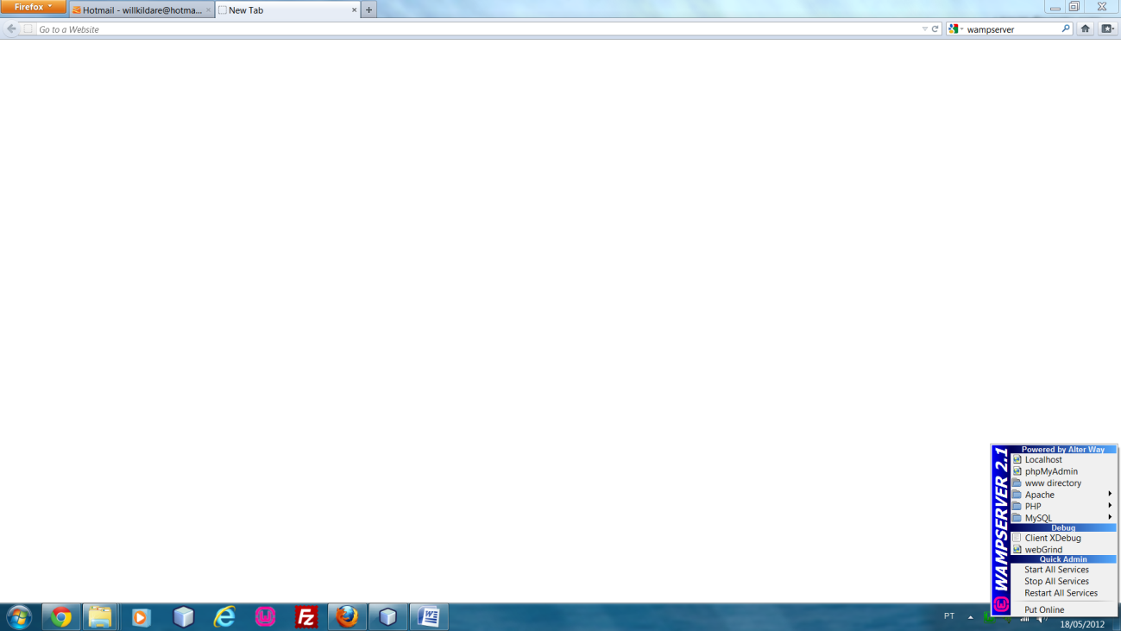

3.2. Import the file scheduling.sql found on the CD.

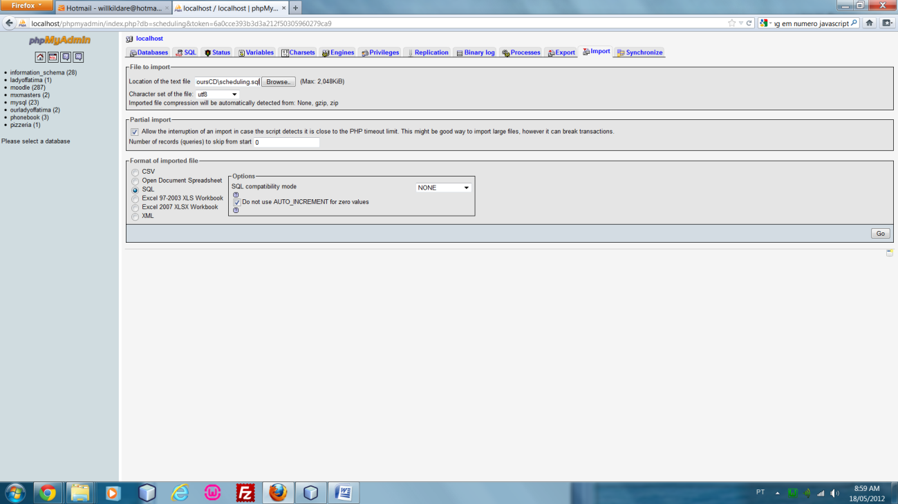

3.3. After you hit Go button... The database with all tables are created and ready to be used.

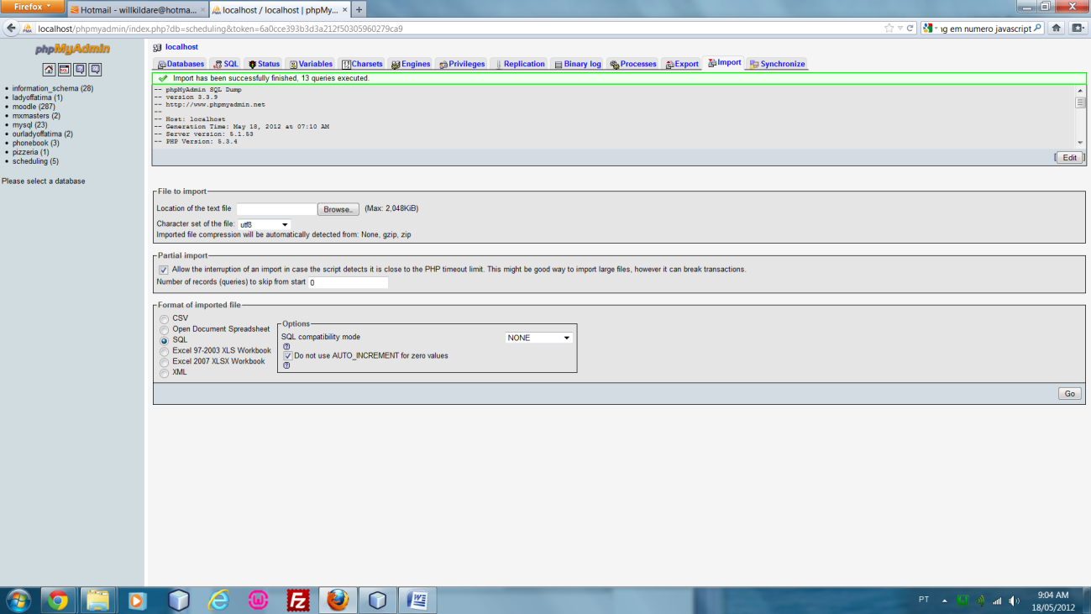

Office Hours Tables.

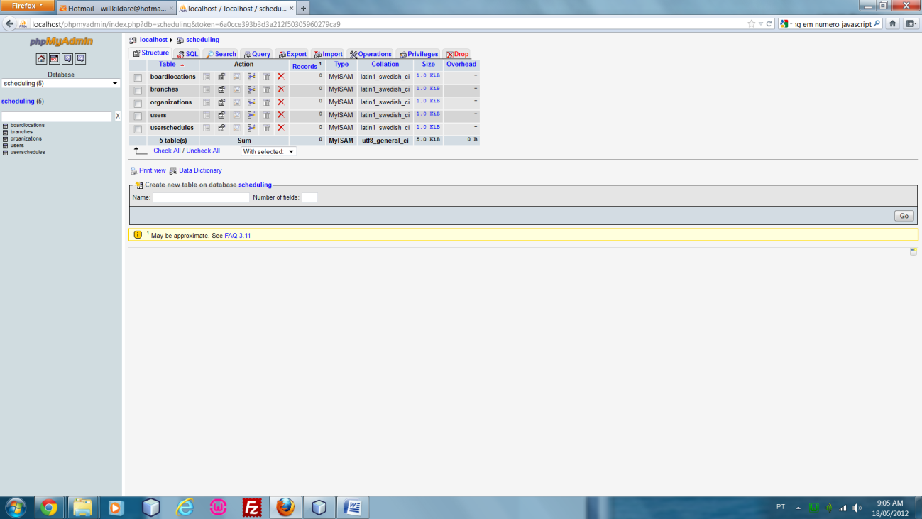

4. Modify the Connection parameters from the file dbConnetion.php found under includes folder. Please contact your IT people to help you.

Parameters: host name, database name, user name and password.

For this project we used default parameters as shown. However for security reasons your IT people will set this with the right information.

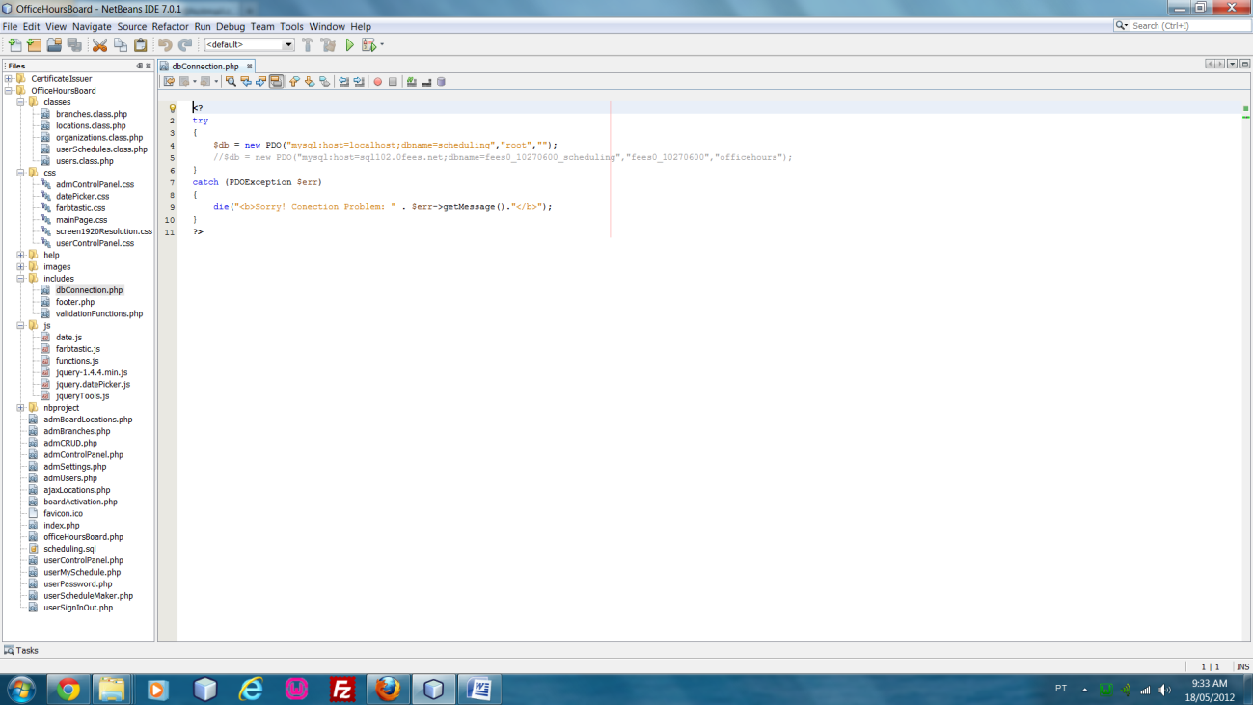

5. If no error message pops up when you launch the application, create your company and do not forget to set the Access Code as soon as you have access to the Administrator Panel.

6. Please read provided Help to fully understand how to use the application.