**This is an essay about the young population in the world**

**The current world population is 7.9 billion people in April of 2023 and it is expected to reach 8 billion people by the beginning May. In this essay there will be information stating why the population is changing everyday more towards a younger group of people per country population rather than older.**

**At the present time, the population of some countries includes a relatively large number of young adults, compared with the number of older people. Some of these countries include: Afghanistan, Niger, Jordan, Mali, Uganda, etc.**

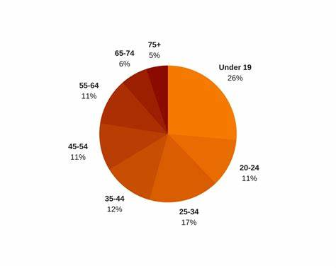

**There are two factors that cause this phenomenon: -The first factor is that, in a lot of these countries (the ones that where stated in the first paragraph) there is almost zero to no form of birth control or protective measures for that matter, besides the knowledge about reproductive health and the consequences of it is very little, because most of this part of the population from these countries, is very poor and they don´t have the time or money for education. For that reason these countries have a very high rate of young adults rather than old people.**

**-The second factor is, a lot of the younger population of countries such as: Poland, Italy, Portugal, etc, want to move to other countries like: Japan, U.S.A. Luxembourg, Australia, etc, because here they can have a better future, starting with a better minimum salary, more work oportunities, in some of these countries the weather is also more to their liking but most important of all is that these countries are more modern and they fit the younger generation better than other countries would.**

**That´s why the countries where the younger adults have moved from, stay with such an old population and the countries where they have moved in, have such a young population.**

**In conclusion the two main reasons for the more increasingly younger population rates are, -number one: lack of knowledge and resources. -number two: migration from one country to another.**