React Admin Module (Demo Application)

Application with React and Redux With Chart JS

**Purpose:**

We have built this demo application with React and Redux. The purpose of the demo application is mainly to demonstrate the capability of implementing the code in React JS. In addition, implementing charts and page design.

**Technical Details:**

React JS:

**Version**- 16.7.0

**React Rendering-** We have used client side react implementation where it gives the benefit of fast website rendering after the initial load and rich site interactions.

Redux:

**Version**- 4.0.1

**Usage**- Redux is a predictable state container for JavaScript apps. It is based on the idea that there should be only a single source of data for your application state.

ES6 With Babel:

**Version**- 6.8.0

**Usage**- Babel has become the de-facto standard to compile ECMAScript 6 applications to a version of ECMAScript that can run in current browsers.

React Router:

**Version** – 3.2.0

**Usage** - React Router is a collection of navigational components that compose declaratively with the application.

Webpack:

**Version** – 2.7.0

**Usage** - Webpack is a popular module bundling system built on top of Node.js. It can handle not only combination and minification of JavaScript and CSS files, but also other assets such as image files with plugins.

NPM Scripts:

**Version** – 6.7.0

**Usage** - Npm is a great package manager and it is a great tool for build scripts. npm’s scripts directive can do everything that the build tools can, with less package dependencies and less maintenance overhead.

Node JS:

**Version**- 11.8.0

**Usage**- Node.js acts as an efficient and responsive web server, it allows for the creation of real-time web applications that can run smoothly. Node.js uses an event-driven, non-blocking I/O model that makes it lightweight and efficient.

**Application Development Steps to follow:**

Step 01: Select the preferable IDE

We would suggest going for Visual Studio Code IDE for the application development, which is available for free.

Link - <https://code.visualstudio.com/>

Step 02: Installation

Ensure you have installed node.js along with NPM – node package manager in your system.

Link - <https://nodejs.org/en/download/>

Step 03: Load the source code

Open the project with open folder option in the IDE.

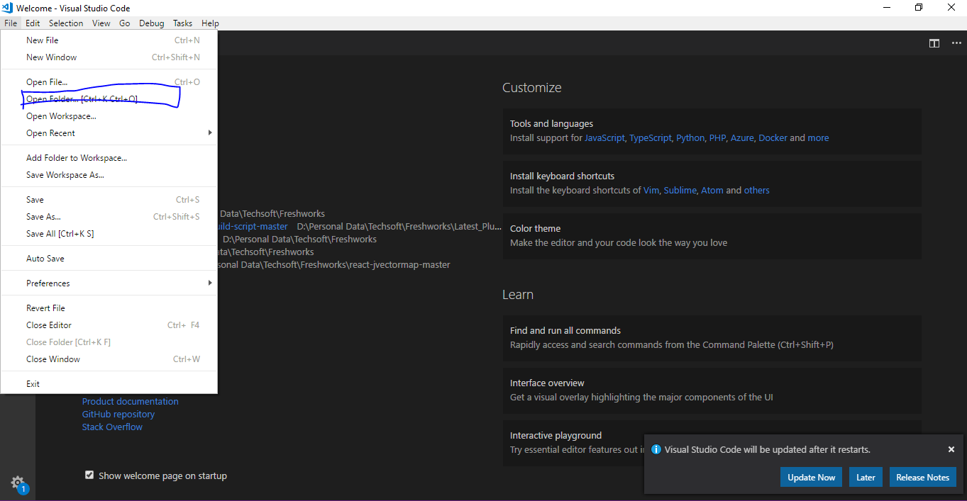

Step 04:

Execute “npm install” command to restore the node modules.

Step 05:

Execute “npm run prebuild” and then “npm run build” to take the build for deployment version.

Step 06:

Execute “npm run postbuild” to test in your localhost.

Coding Screen shoot:

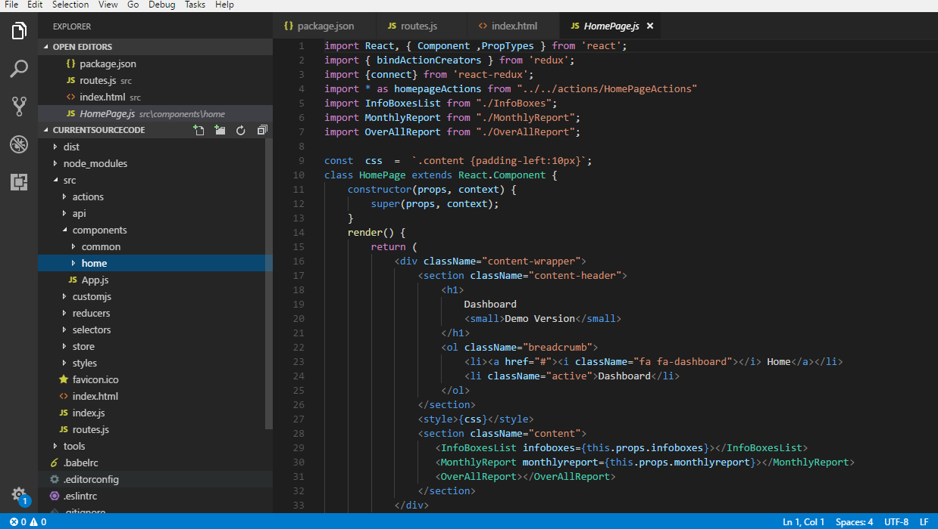

Stub API Details:

**Message Notification** => <https://api.myjson.com/bins/iyuw8.json>

**Alert Notification** => <https://api.myjson.com/bins/akmhs.json>

**Task Notification** => <https://api.myjson.com/bins/jk9q8.json>

**User Profile** => <https://api.myjson.com/bins/kr5pk.json>

**Info Boxes** => <https://api.myjson.com/bins/14me60.json>

**Monthly Report (Sales Chart, Goal Completion, Total Figures)** => <https://api.myjson.com/bins/wgr6g.json>

**Visitor Report Chart** => <https://api.myjson.com/bins/suodw.json>

**Chat Data** => <https://api.myjson.com/bins/1dy1i0.json>

**Latest Members** => <https://api.myjson.com/bins/smxrc.json>

**30 Days Report** => <https://api.myjson.com/bins/kd0g8.json>

**Browser Usage** => <https://api.myjson.com/bins/81ksk.json>