**1. INTRODUCTION**

The Hotel Industry like any other business opens up socio-Economic opportunities for both owner and customer. Customers are mostly constrained in trying to get a room to pass the night, as the usual practice is to look for a hotel when you have arrived In the particular location, walk in and find out whether there is a vacant room. In the case that there is no vacant Room, you have to move to next closest hotel to enquire once more. There is no system in place that bonds the hotel and the Customer that the customer has actually booked a room and for that matter he is guaranteed a room.

A typical luxury Hotel requires a management system to control its various operations such as maintaining account of all the people in its domain of services, attending to various needs of customers and also archieving increased efficiency in the overall working of the Hotel itself.

**2.OBJECTIVES**

* **Access anywhere:** The online hotel reservation project can be reached at any time and anywhere from the world with great efficiency.
* **Easy booking:** The rooms in the particular hotel can be reserved easily through this site with great expertise.
* **Room availability:** The rooms that are open in the particular hotel must be refreshed in real time.
* **Category:** The hotels can be classified based on the appropriate region of your preference.
* **Price:** The price or rent of the appropriate rooms in the appropriate hotel in the chosen section will also be updated.
* **Payment options:** The clients will be having the option of paying the rent of the hotels through the online mode without any difficulty.

**3.LITERATURE SURVEY**

**Tools and Technology**

According to Tim Berners-Lee (1998), HTML which stands for Hypertext Markup Language is the predominant Markup language for web pages, a building block of web Pages. A web browser reads HTML documents and Compose them into visual or audio web pages (lamp.cse.fau.edu). The browser does not display the HTML tags but uses the tags to interpret the content of the

Page ([www.w3schools.com](http://www.w3schools.com))

Web browsers can also refer to Cascading Style Sheets(CSS) to define the appearance and layout of text and other(lamp.cse.fau.edu). According to Tim Berners-Lee (1998), HTML which and retrieval of data in a database management system javascript is an implementation of the ECMA script browser in order to enhance user interfaces and dynamic client-side javascript, implemented as part of a web compose them into visual or audio web pages designed for web development to produce dynamic web browsers can also refer to Cascading Style Sheets Editing system files that are to be used in a DOS or html environment (533507.weebly.com). Notepad supports both for managing data in RDMS and originally based onhp is a general-purpose scripting language originally html source document, a building block of web materials (Taylor, 2013). The W3C, maintainer of both no format tags or styles, making the program suitable for notepad is a common text-only (plain text) editor. The often referred to as Structured Query Language, designed over explicitly presentational HTML markup.A web browser reads HTML documents and pages. For this purpose, PHP code is embedded into the relational algebra and calculus (Ghosh, 2010).Resulting files typically saved with the .txt extension have SQL is a computer language designed for the management stands for Hypertext Markup Language is the predominant websites (mcfarland, 2008). This enables programmatic with a PHP processor module, which generates the web`

**3.1Existing System**

The Hotel currently runs a manual booking system and therefore requires customers to only book for rooms or any other service by walking to the receptionist or calling them on phone or using a third party option. Any enquiry to be made demanding feedback must usually be forwarded to The hotel in person. Sometimes management is given false Reports concerning the work flow of the hotel and Employees also give falsified pricing information to Customers from time to time. From an employee’s account, details of customers are hardly used in the workflow and that also, records are not Properly kept; books used to keep records are disposed of when they get filled up. Niyaz Hotel hardly advertises And depends on word of mouth adverts by some loyal Customers in and around its vicinity

**MANUAL TRANSACTION**

**CUSTOMER**

feedback

(Context Diagram)

**4.SYSTEM ARCHITECTURE**

**4.1Proposed System**

The proposed system is a web based application that allows customers to make enquiries online and book for services providing the required details. It adopts the virtual tour feature that was seen in the Niyaz Hotel in Belagavi.

The following are solutions the proposed system brings on

Board:

• Well laid out information about Niyaz hotel.

• The manual booking system is replaced with an online reservation system.

• Management can pull reports at anytime to tell the current situation in order to put

The necessary measures in place.

• The system helps secure customer Information since no information is disposed off.

A customer surfs through any of the items of the proposed system. An about us page is designed to allow customers get all necessary information about the hotel and its Facilities. A contact us page is provided where customers can send emails. More importantly, customers can make reservations at their own pace. This study has been categorized into four groups:

• System monitoring done by system administrator

• Filling forms to make enquiries and reservations

• Approving or deleting enquiries

• Vertual Tour

**CUSTOMER**

Online  
Reservation  
System

Reservation Details

Confirmation details

(Context Diagram of proposed System)

**4.2Hardware and Software Requirements**

**Software**

* Windows 10 OS
* Intel pentium processor
* Notepad++

**Languages are used**

* CSS
* HTML
* JAVA SCRIPT

**Hardware**

* Hard Disk:- 15GB
* RAM:- 1GB

**4.3CODE OF PROJECT**

**HOME**

<!DOCTYPE HTML>

<html>

<head>

<title>Hotel Website | Home</title>

<link href="css/style.css" rel="stylesheet" type="text/css" media="all" />

<link href='http://fonts.googleapis.com/css?family=PT+Sans+Narrow' rel='stylesheet' type='text/css'>

<link rel="stylesheet" href="css/responsiveslides.css">

<script src="http://ajax.googleapis.com/ajax/libs/jquery/1.8.3/jquery.min.js"></script>

<script src="js/responsiveslides.min.js"></script>

<script>

// You can also use "$(window).load(function() {"

$(function () {

// Slideshow 1

$("#slider1").responsiveSlides({

maxwidth: 1600,

speed: 600

});

});

</script>

</head>

<body>

<!---start-Wrap--->

<!---start-header--->

<div class="header">

<div class="wrap">

<div class="header-top">

<div class="logo">

<a href="index.html"><img src="images/logo2.jpg" width="130%" height="90%" title="logo" /></a>

</div>

<div class="contact-info">

<p class="phone">Call us : <a href="#">8970900929</a></p>

<p class="gpa">Gpa : <a href="#">View map</a></p>

<h3><b><marquee>Well Come To Niyaz Hotel </marquee> </b></h3>

</div>

<div class="clear"> </div>

</div>

</div>

<div class="header-top-nav">

<div class="wrap">

<ul>

<li class="active"><a href="index.html">Home</a></li>

<li><a href="about.html">About</a></li>

<li><a href="services.html">Services</a></li>

<li><a href="gallery.html">Gallery</a></li>

<li><a href="contact.html">Contact</a></li>

<div class="clear"> </div>

</ul>

</div>

</div>

</div>

<!---End-header--->

<div class="clear"> </div>

<!--start-image-slider---->

<div class="image-slider">

<!-- Slideshow 1 -->

<ul class="rslides" id="slider1">

<li><img src="images/slider3.jpg" alt=""></li>

<li><img src="images/slider1.jpg" alt=""></li>

<li><img src="images/slider3.jpg" alt=""></li>

</ul>

<!-- Slideshow 2 -->

</div>

<!--End-image-slider---->

<!---start-content----->

<div class="content">

<div class="quit">

<p><span class="start">Our </span> hotel's <span class="end">Niyaz.</span></p>

</div>

<div class="content-grids">

<div class="wrap">

<div class="content-grid">

<div class="content-grid-pic">

<a href="#"><img src="images/food.jpg" title="food" /></a>

</div>

<div class="content-grid-info">

<h3>Best food Ever</h3>

<p>"DESCRIPTION"</p>

<a href="#">Read More</a>

</div>

<div class="clear"> </div>

</div>

<div class="content-grid">

<div class="content-grid-pic">

<a href="#"><img src="images/icon2.png" title="image-name" /></a>

</div>

<div class="content-grid-info">

<h3>24x7 phone support</h3>

<p>"DESCRIPTION"</p>

<a href="#">Read More</a>

</div>

<div class="clear"> </div>

</div>

<div class="content-grid">

<div class="content-grid-pic">

<a href="#"><img src="images/slider1.jpg" title="image-name" /></a>

</div>

<div class="content-grid-info">

<h3>Best Room Services</h3>

<p>"DESCRIPTION"</p>

<a href="#">Read More</a>

</div>

<div class="clear"> </div>

</div>

<div class="clear"> </div>

</div>

</div>

<div class="clear"> </div>

<div class="content-box">

<div class="wrap">

<div class="content-box-left">

<div class="content-box-left-topgrid">

<h3>welcome to our Niyaz Hotel</h3>

<p> ' Feel Like Home :)</p>

<p> Hotel's Description</p>

<span>For more information about our Hotel, Call 8970900929</span>

</div>

<div class="content-box-left-bootomgrids">

<div class="content-box-left-bootomgrid">

<h3>Deluxe Rooms</h3>

<p> Your description about deluxe rooms</p>

<a href="#"><img src="images/slider1.jpg" title="2 BHK-2000" /></a>

</div>

<div class="content-box-left-bootomgrid">

<h3>Luxury Rooms</h3>

<p>Your description about Luxury rooms</p>

<a href="#"><img src="images/slider2.jpg" title="Garden" /></a>

</div>

<div class="content-box-left-bootomgrid lastgrid">

<h3>Executive Rooms</h3>

<p>Your description about Executive rooms</p>

<a href="#"><img src="images/slider3.jpg" title="3 BHK-4000" /></a>

</div>

<div class="clear"> </div>

</div>

<div class="clear"> </div>

</div>

<div class="content-box-right">

<div class="content-box-right-topgrid">

<h3>To days Specials</h3>

<a href="#"><img src="images/chicken.jpg" title="NIYAZ CHICKEN" /></a>

<h4>Super Discount Offer</h4>

<p>"DESCRIPTION"</p>

<a href="#">Read More</a>

</div>

<div class="content-box-right-bottomgrid">

</div>

</div>

<div class="clear"> </div>

</div>

<div class="clear"> </div>

<div class="boxs">

<div class="wrap">

<div class="box">

</div>

<div class="box center-box">

<ul>

<li><a href="https:www.code-projects.org">Leave a Feedback</a></li>

<li><a href="https:www.code-projects.org">Reviews and Ratings</a></li>

<li><a href="https:www.code-projects.org">Packages</a></li>

<li><a href="https:www.code-projects.org">Know about Moutaineering and trekking here</a></li>

<li><a href="https:www.skyhotel.org">www.niyazhotel.org</a></li>

</ul>

</div>

<div class="clear"> </div>

</div>

<!---start-box---->

</div>

<!---start-copy-Right----->

<div class="copy-tight">

<p>Niyaz HOTEL,Shetti Galli,Near CBT,Belagavi- 2018 <a href="http://www.niyazhotel.com/">Click Here</a></p>

</div>

<!---End-copy-Right----->

</div>

<!---End-content----->

</div>

<!---End-Wrap--->

</body>

</html>

**ABOUT**

<!DOCTYPE HTML>

<html>

<head>

<title> Niyaz Hotel Website | About</title>

<link href="css/style.css" rel="stylesheet" type="text/css" media="all" />

<link href='http://fonts.googleapis.com/css?family=PT+Sans+Narrow' rel='stylesheet' type='text/css'>

</head>

<body>

<!---start-Wrap--->

<!---start-header--->

<div class="header">

<div class="wrap">

<div class="header-top">

<div class="logo">

<a href="index.html"><img src="images/logo2.jpg" width="90%" height="60%" title="logo" /></a>

</div>

<div class="contact-info">

<p class="phone">Call us : <a href="#">8970900929</a></p>

<p class="gpa">Gpa : <a href=https://www.google.co.in/maps/place/https://www.google.co.in/search?rlz=1C1JZAP_enIN782IN782&q=niyaz+hotel+belgaum&npsic=0&rflfq=1&rlha=0&rllag=15850275,74511451,1593&tbm=lcl&ved=2ahUKEwiIk9SMh47fAhUSOisKHXz7DR4QtgN6BAgAEAQ&tbs=lrf:!2m1!1e2!2m1!1e3!3sIAE,lf:1,lf_ui:9&rldoc=1Belagavi/@16.0052896,74.5030211,17z/data=!3m1!4b1!4m5!3m4!1s0x3bc09e794ec93b9b:0x620c65b7e996a215!8m2!3d16.0052896!4d74.5052098">View map</a></p>

</div>

<div class="clear"> </div>

</div>

</div>

<div class="header-top-nav">

<div class="wrap">

<ul>

<li><a href="index.html">Home</a></li>

<li class="active"><a href="about.html">About</a></li>

<li><a href="services.html">Services</a></li>

<li><a href="gallery.html">Gallery</a></li>

<li><a href="contact.html">Contact</a></li>

<div class="clear"> </div>

</ul>

</div>

</div>

</div>

<!---End-header--->

<div class="clear"> </div>

<!---start-content----->

<div class="content">

<div class="wrap">

<!---start-about---->

<div class="about">

<div class="about-grids">

<div class="about-grid">

<h3>About Our Hotel</h3>

<a href="#"><img src="images/niyaz.jpg" title="about"></a>

<span>"Description about our hotel"</span>

<p> Feel like home.</p>

<a class="button1" href="#">Read More</a>

</div>

<div class="about-grid center-grid1">

<h3>WHY CHOOSE US?</h3>

<p>our Description Here</p>

<label>Label Heading </label>

<p>our Description</p>

<label>Label heading</label>

<p>our Description</p>

</div>

<div class="about-grid last-grid">

<h3>Our Hotel's Staff Info.</h3>

<div class="about-team">

<div class="client">

<div class="about-team-left">

<a href="#"><img src="images/basu11.jpg" title="Basavaraj"></a>

</div>

<div class="about-team-right">

<p> <b>MANAGER BASAVARAJ</b></p>

</div>

<div class="clear"> </div>

</div>

<div class="client">

<div class="about-team-left">

<a href="#"><img src="images/appu.jpg" title="Appu"></a>

</div>

<div class="about-team-right">

<p>CASHIER:-APPU BADIGER</p>

</div>

<div class="clear"> </div>

</div>

<div class="client">

<div class="about-team-left">

<a href="#"><img src="images/nikhil2.jpg" title="Nikhil"></a>

</div>

<div class="about-team-right">

<p>STAFF INCHARGE:-NIKHIL B</p>

</div>

<div class="clear"> </div>

</div>

<div class="client">

<div class="about-team-left">

<a href="#"><img src="images/shivu.jpg" title="Shivanand"></a>

</div>

<div class="about-team-right">

<p>ASST.MANAGER:-SHIVANAND. C</p>

</div>

<div class="clear"> </div>

</div>

</div>

</div>

<div class="clear"> </div>

</div>

</div>

</div>

<!---End-about---->

<div class="clear"> </div>

<div class="boxs">

<div class="wrap">

<div class="box">

</div>

<div class="box center-box">

<ul>

<li><a href="https:www.code-projects.org">Leave a Feedback</a></li>

<li><a href="https:www.code-projects.org">Reviews and Ratings</a></li>

<li><a href="https:www.code-projects.org">FAQs</a></li>

<li><a href="https:www.code-projects.org">Packages</a></li>

<li><a href="https:www.code-projects.org">Know about Moutaineering and trekking here</a></li>

<li><a href="https:www.code-projects.org">www.niyazhotel.com</a></li>

</ul>

</div>

<div class="box">

</div>

<div class="clear"> </div>

</div>

<!---start-box---->

</div>

<!---start-copy-Right----->

<div class="copy-tight">

<p> Niyaz HOTEL,Shetti Galli,Near CBT Belagavi 2018 <a href="http://www.niyazhotel.com/">Click Here</a></p>

</div>

<!---End-copy-Right----->

</div>

<!---End-content----->

</div>

<!---End-Wrap--->

</body>

</html>

**SERVICES**

<!DOCTYPE HTML>

<html>

<head>

<title> Sky Hotel Website | Services</title>

<link href="css/style.css" rel="stylesheet" type="text/css" media="all" />

<link href='http://fonts.googleapis.com/css?family=PT+Sans+Narrow' rel='stylesheet' type='text/css'>

</head>

<body>

<!---start-Wrap--->

<!---start-header--->

<div class="header">

<div class="wrap">

<div class="header-top">

<div class="logo">

<a href="index.html"><img src="images/logo2.jpg" width="130%" height="90%" title="logo" /></a>

</div>

<div class="contact-info">

<p class="phone">Call us : <a href="#">8970900929</a></p>

<p class="gpa">Gpa : <a href="https://www.google.co.in/maps/place/https://www.google.co.in/search?rlz=1C1JZAP_enIN782IN782&q=niyaz+hotel+belgaum&npsic=0&rflfq=1&rlha=0&rllag=15850275,74511451,1593&tbm=lcl&ved=2ahUKEwiIk9SMh47fAhUSOisKHXz7DR4QtgN6BAgAEAQ&tbs=lrf:!2m1!1e2!2m1!1e3!3sIAE,lf:1,lf_ui:9&rldoc=1Belagavi/@16.0052896,74.5030211,17z/data=!3m1!4b1!4m5!3m4!1s0x3bc09e794ec93b9b:0x620c65b7e996a215!8m2!3d16.0052896!4d74.5052098">View map</a></p>

</div>

<div class="clear"> </div>

</div>

</div>

<div class="header-top-nav">

<div class="wrap">

<ul>

<li><a href="index.html">Home</a></li>

<li><a href="about.html">About</a></li>

<li class="active"><a href="services.html">Services</a></li>

<li><a href="gallery.html">Gallery</a></li>

<li><a href="contact.html">Contact</a></li>

<div class="clear"> </div>

</ul>

</div>

</div>

</div>

<!---End-header--->

<div class="clear"> </div>

<!---start-content----->

<div class="content">

<div class="wrap">

<!-----start--services------>

<div class="services">

<div class="service-content">

<h3>Our Niyaz Hotel Services</h3>

<ul>

<li><span>1.</span></li>

<li><p><a href="#">CULTURE SHOW</a> Every Evening We <img src="images/bh.jpg" width="30%" height="30%" title="logo" /></p></li>

<div class="clear"> </div>

</ul>

<ul>

<li><span>2.</span></li>

<li><p><a href="#">SWIMMING POOL</a> You can enjoy Swimming in the pool and relax with a drink. . .<img src="images/swimm.jpg" width="30%" height="30%" title="logo" /> </p></li>

<div class="clear"> </div>

</ul>

<ul>

<li><span>3.</span></li>

<li><p><a href="#">RESTAURANT</a> You can have . .<img src="images/rest.jpg" width="30%" height="30%" title="logo" /> </p></li>

<div class="clear"> </div>

</ul>

<ul>

<li><span>4.</span></li>

<li><p><a href="#">CONFERENCE HALL</a>Here You . . . .<img src="images/conf.jpg" width="30%" height="30%" title="logo" /></p></li>

<div class="clear"> </div>

</ul>

<ul>

<li><span>5.</span></li>

<li><p><a href="#">SPA</a>Here . . . .</p></li>

<div class="clear"> </div>

</ul>

<ul>

<li><span>6.</span></li>

<li><p><a href="#">POOLSIDE BAR</a> To chill. . .. <img src="images/barr.jpg" width="30%" height="30%" title="logo" />. </p></li>

<div class="clear"> </div>

</ul>

</div>

<div class="services-sidebar">

<h3>WE PROVIDE</h3>

<ul>

<li><a href="#">other facility</a></li>

<li><a href="#">other facility</a></li>

<li><a href="#">other facility</a></li>

<li><a href="#">other facility</a></li>

<li><a href="#">other facility</a></li>

<li><a href="#">Niyaz</a></li>

<li><a href="#">other facility</a></li>

</ul>

</div>

<div class="clear"> </div>

</div>

<!-----End--services------>

</div>

<div class="clear"> </div>

<div class="boxs">

<div class="wrap">

<div class="box">

</div>

<div class="box center-box">

<ul>

<li><a href="https:www.code-projects.org">Leave a Feedback</a></li>

<li><a href="https:www.code-projects.org">Reviews and Ratings</a></li>

<li><a href="https:www.code-projects.org">FAQs</a></li>

<li><a href="https:www.code-projects.org">Packages</a></li>

<li><a href="https:www.code-projects.org">Know about Moutaineering and trekking here</a></li>

<li><a href="https:www.code-projects.org">www.niyazhotel,com</a></li>

</ul>

</div>

<div class="box">

</div>

<div class="clear"> </div>

</div>

<!---start-box---->

</div>

<!---start-copy-Right----->

<div class="copy-tight">

<p> Niyaz HOTEL,Shetti Galli,Near CBT Belagavi-2018 <a href="http://www.niyazhotel.com/">Click Here</a></p>

</div>

<!---End-copy-Right----->

</div>

<!---End-content----->

</div>

<!---End-Wrap--->

</body>

</html>

**GALLERY**

<!DOCTYPE HTML>

<html>

<head>

<title> Niyaz Hotel Website | Services</title>

<link href="css/style.css" rel="stylesheet" type="text/css" media="all" />

<link href='http://fonts.googleapis.com/css?family=PT+Sans+Narrow' rel='stylesheet' type='text/css'>

<script src="http://ajax.googleapis.com/ajax/libs/jquery/1.8.3/jquery.min.js"></script>

</head>

<body>

<!---start-Wrap--->

<!---start-header--->

<div class="header">

<div class="wrap">

<div class="header-top">

<div class="logo">

<a href="index.html"><img src="images/logo2.jpg" width="130%" height="90%" title="logo" /></a>

</div>

<div class="contact-info">

<p class="phone">Call us : <a href="#">8970900929</a></p>

<p class="gpa">Gpa : <a href="https://www.google.co.in/maps/place/https://www.google.co.in/search?rlz=1C1JZAP_enIN782IN782&q=niyaz+hotel+belgaum&npsic=0&rflfq=1&rlha=0&rllag=15850275,74511451,1593&tbm=lcl&ved=2ahUKEwiIk9SMh47fAhUSOisKHXz7DR4QtgN6BAgAEAQ&tbs=lrf:!2m1!1e2!2m1!1e3!3sIAE,lf:1,lf_ui:9&rldoc=1Belagavi/@16.0052896,74.5030211,17z/data=!3m1!4b1!4m5!3m4!1s0x3bc09e794ec93b9b:0x620c65b7e996a215!8m2!3d16.0052896!4d74.5052098">View map</a></p>

</div>

<div class="clear"> </div>

</div>

</div>

<div class="header-top-nav">

<div class="wrap">

<ul>

<li><a href="index.html">Home</a></li>

<li><a href="about.html">About</a></li>

<li><a href="services.html">Services</a></li>

<li class="active"><a href="gallery.html">Gallery</a></li>

<li><a href="contact.html">Contact</a></li>

<div class="clear"> </div>

</ul>

</div>

</div>

</div>

<!---End-header--->

<div class="clear"> </div>

<!---start-content----->

<div class="content">

<div class="wrap">

<!----start-image-gallery----->

<div class="gallerys">

<h3>gallery</h3>

<div class="gallery-grids">

<div class="gallery-grid">

<a href="images/slider1.jpg"><img src="images/slider1.jpg" alt=""></a>

<h4>Photo title</h4>

<p>Description</p>

<div class="gallery-button"><a href="#">Read More</a></div>

</div>

<div class="gallery-grid grid2">

<a href="images/slider3.jpg"><img src="images/slider3.jpg" alt=""></a>

<h4>Photo title</h4>

<p>Description</p>

<div class="gallery-button"><a href="#">Read More</a></div>

</div>

<div class="gallery-grid">

<a href="images/slider1.jpg"><img src="images/slider1.jpg" alt=""></a>

<h4>Photo title</h4>

<p>Description</p>

<div class="gallery-button"><a href="#">Read More</a></div>

</div>

<div class="clear"> </div>

</div>

<div class="clear"> </div>

<div class="gallery-grids">

<div class="gallery-grid">

<a href="images/slider3.jpg"><img src="images/slider1.jpg" alt=""></a>

<h4>Photo title</h4>

<p> Description</p>

<div class="gallery-button"><a href="#">Read More</a></div>

</div>

<div class="gallery-grid grid2">

<a href="images/slider3.jpg"><img src="images/slider3.jpg" alt=""></a>

<h4>Photo title</h4>

<p>Description</p>

<div class="gallery-button"><a href="#">Read More</a></div>

</div>

<div class="gallery-grid">

<a href="images/slider1.jpg"><img src="images/slider1.jpg" alt=""></a>

<h4>Photo title</h4>

<p>Description</p>

<div class="gallery-button"><a href="#">Read More</a></div>

</div>

</div>

<script type="text/javascript" src="js/jquery.lightbox.js"></script>

<link rel="stylesheet" type="text/css" href="css/lightbox.css" media="screen">

<script type="text/javascript">

$(function() {

$('.gallery-grid a').lightBox();

});

</script>

<div class="clear"> </div>

<div class="projects-bottom-paination">

<ul>

<li class="active"><a href="#">1</a></li>

<li><a href="#">2</a></li>

</ul>

</div>

</div>

<!----start-image-gallery----->

</div>

<div class="clear"> </div>

<div class="boxs">

<div class="wrap">

<div class="box">

</div>

<div class="box center-box">

<ul>

<li><a href="https:www.code-projects.org">Leave a Feedback</a></li>

<li><a href="https:www.code-projects.org">Reviews and Ratings</a></li>

<li><a href="https:www.code-projects.org">FAQs</a></li>

<li><a href="https:www.code-projects.org">Packages</a></li>

<li><a href="https:www.code-projects.org">Know about Moutaineering and trekking here</a></li>

<li><a href="https:www.code-projects.org">www.niyazhotel.org</a></li>

</ul>

</div>

<div class="box">

O

</div>

<div class="clear"> </div>

</div>

<!---start-box---->

</div>

<!---start-copy-Right----->

<div class="copy-tight">

<p> Niyaz HOTEL,Shetti Galli,Belagavi 2018 <a href="http://www.niyazhotel.com/">Click Here</a></p>

</div>

<!---End-copy-Right----->

</div>

<!---End-content----->

</div>

<!---End-Wrap--->

</body>

</html>

**CONTACT**

<!DOCTYPE HTML>

<html>

<head>

<title> Niyaz Hotel Website | Services</title>

<link href="css/style.css" rel="stylesheet" type="text/css" media="all" />

<link href='http://fonts.googleapis.com/css?family=PT+Sans+Narrow' rel='stylesheet' type='text/css'>

</head>

<body>

<!---start-Wrap--->

<!---start-header--->

<div class="header">

<div class="wrap">

<div class="header-top">

<div class="logo">

<a href="index.html"><img src="images/logo2.jpg" width="60%" height="90%" title="logo" /></a>

</div>

<div class="contact-info">

<p class="phone">Call us : <a href="#">8970900929</a></p>

<p class="gpa">Gpa : <a href="https://www.google.co.in/maps/place/https://www.google.co.in/search?rlz=1C1JZAP_enIN782IN782&q=niyaz+hotel+belgaum&npsic=0&rflfq=1&rlha=0&rllag=15850275,74511451,1593&tbm=lcl&ved=2ahUKEwiIk9SMh47fAhUSOisKHXz7DR4QtgN6BAgAEAQ&tbs=lrf:!2m1!1e2!2m1!1e3!3sIAE,lf:1,lf_ui:9&rldoc=1Belagavi/@16.0052896,74.5030211,17z/data=!3m1!4b1!4m5!3m4!1s0x3bc09e794ec93b9b:0x620c65b7e996a215!8m2!3d16.0052896!4d74.5052098">View map</a></p>

</div>

<div class="clear"> </div>

</div>

</div>

<div class="header-top-nav">

<div class="wrap">

<ul>

<li><a href="index.html">Home</a></li>

<li><a href="about.html">About</a></li>

<li><a href="services.html">Services</a></li>

<li><a href="gallery.html">Gallery</a></li>

<li class="active"><a href="contact.html">Contact</a></li>

<div class="clear"> </div>

</ul>

</div>

</div>

</div>

<!---End-header--->

<div class="clear"> </div>

<!---start-content----->

<div class="content">

<div class="wrap">

<!-------start-contatct------>

<div class="contact">

<div class="section group">

<div class="col span_1_of_3">

<div class="contact_info">

</div>

<div class="company_address">

<h3>Company Information :</h3>

<p>Belagavi</p>

<p>Shetti Galli<br>Near CBT<br>590001</p>

<p>Niyaz HOTEL</p>

<p>Phone: 8970900929</p>

<p>Email: <span>lakkappaB@niyazhotel.com</span></p>

</div>

</div>

</div>

</div>

</div>

</div>

<!-------start-contatct------>

</div>

<div class="clear"> </div>

<div class="boxs">

<div class="wrap">

<div class="box">

</div>

<div class="box center-box">

<ul>

<li><a href="https:www.code-projects.org">Leave a Feedback</a></li>

<li><a href="https:www.code-projects.org">Reviews and Ratings</a></li>

<li><a href="https:www.code-projects.org">FAQs</a></li>

<li><a href="https:www.code-projects.org">Packages</a></li>

<li><a href="https:www.code-projects.org">Know about Moutaineering and trekking here</a></li>

<li><a href="https:www.code-projects.org">www.niyazhotel.in</a></li>

</ul>

</div>

<div class="box">

</div>

<div class="clear"> </div>

</div>

<!---start-box---->

</div>

<!---start-copy-Right----->

<div class="copy-tight">

<p> Niyaz HOTEL,Shetti Galli,Belagavi 2018 <a href="http://www.niyazhotel.com/">Click Here</a></p>

</div>

<!---End-copy-Right----->

</div>

<!---End-content----->

</div>

<!---End-Wrap--->

</body>

</html>

**4.4Screenshots  
HOME**  
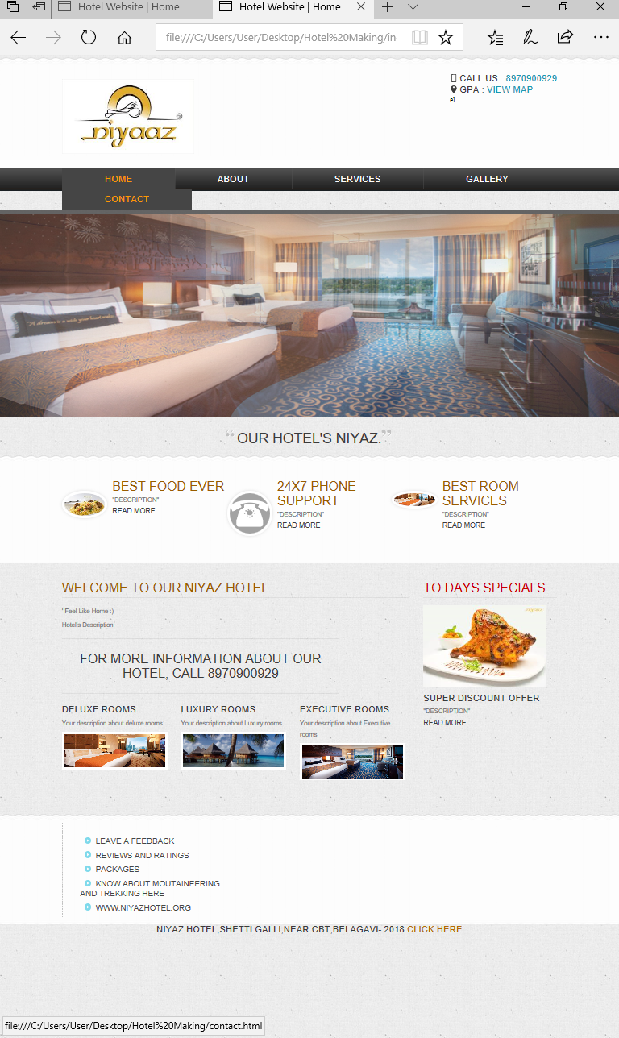

**ABOUT  
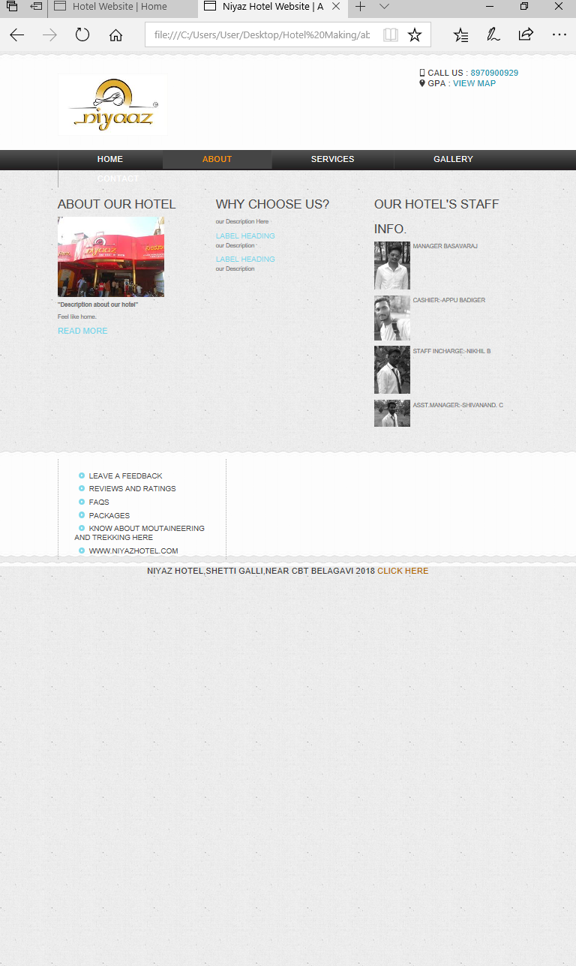**

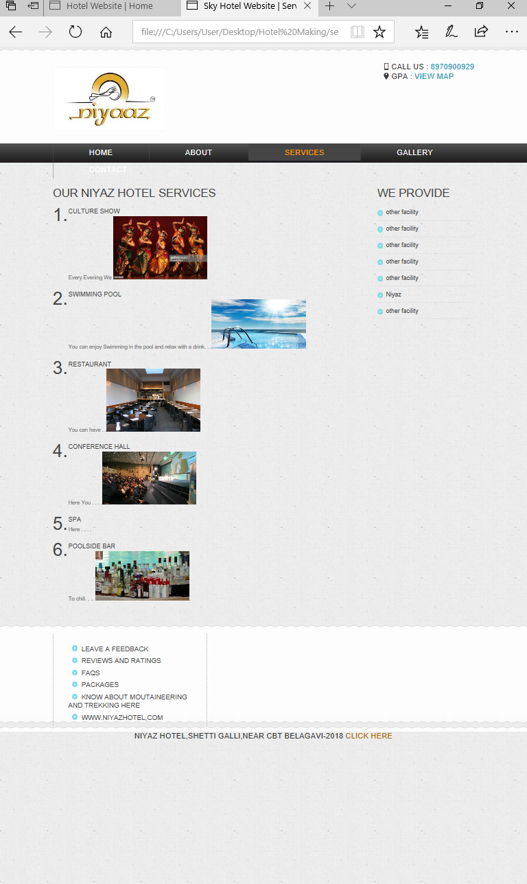**SERVICES**

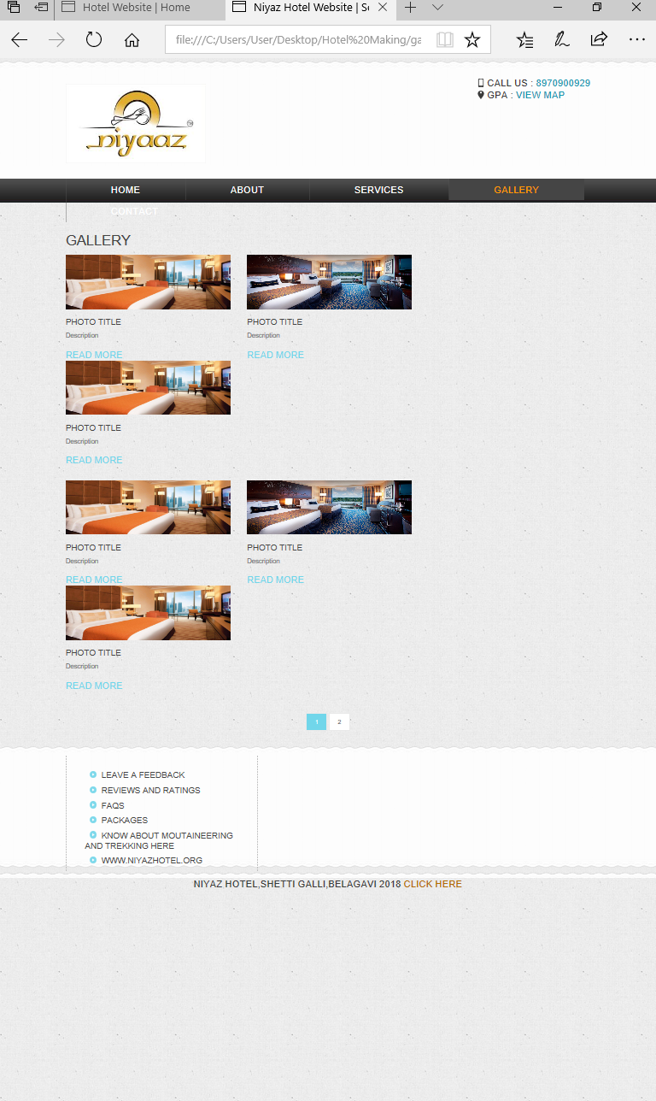**GALLERY**

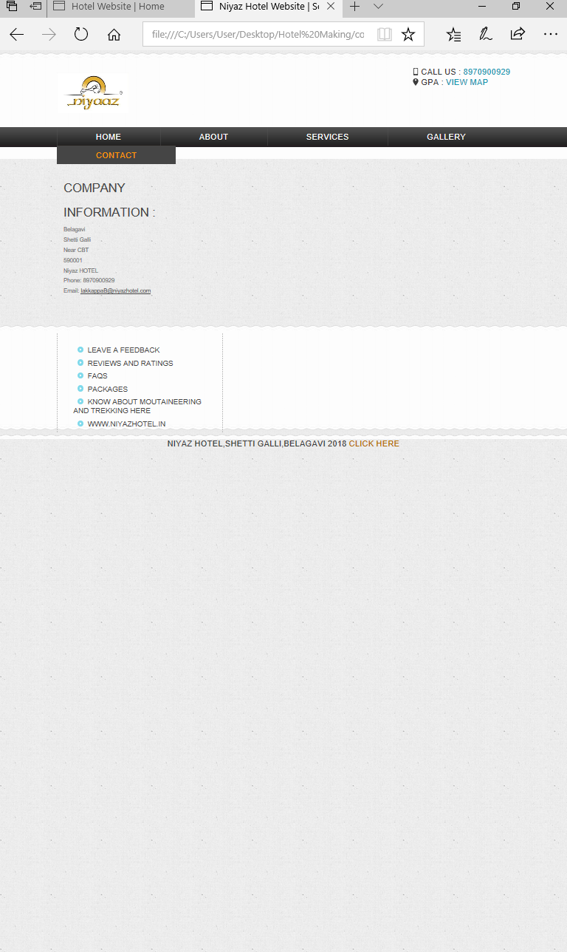**CONTACT**

**4.5REFERENCES**

**BOOKS**

1. System Analysis and Design
2. Sumitabha Das, Java scripting, 4th Edition Tata McGaw Hill.
3. The Complete Reference HTML & CSS, 5th Edition Thomas A.Powell.

**WEB SITES**

[**https://www.w3schools.com/**](https://www.w3schools.com/)

[**http://www.niyazhotel.com/**](http://www.niyazhotel.com/)

[**https://www.w3schools.com/js/default.asp**](https://www.w3schools.com/js/default.asp)