**Abstarct :**

**Example-1:**

**Gst.java**

**package** com.xworkz.xworkzapp.gst;

**public** **abstract** **class** Gst {

**public** **double** gst;

**public** **double** cost;

**public** **double** gstCaluculate() {

**return** gst*cost/100;

}

}

**GstUtil.java**

**package** com.xworkz.xworkzapp;

**import** com.xworkz.xworkzapp.gst.MobileShop;

**import** com.xworkz.xworkzapp.gst.Skcomputer;

**public** **class** GstUtil {

**public** **static** **void** main(String[] args) {

Skcomputer skc = **new** Skcomputer();

skc.saleService();

System.***out***.println("total Price : "+skc.gstCaluculate());

System.***out***.println();

MobileShop mobileShop = **new** MobileShop();

mobileShop.salesService();

mobileShop.setBrandName("Redmi");

System.***out***.println("Brand Name: "+mobileShop.getBrandName());

System.***out***.println("Grand Total Price: "+mobileShop.gstCaluculate());

mobileShop.salesService();

}

}

Skcomputer.java

**package** com.xworkz.xworkzapp.gst;

**public** **class** Skcomputer **extends** Gst {

**private** **int** hddPrice;

**private** **int** keyBoard;

**private** **int** motherBoard;

**int** total;

**public** **int** getHddPrice() {

**return** hddPrice;

}

**public** **void** setHddPrice(**int** hddPrice) {

**this**.hddPrice = hddPrice;

}

**public** **int** getKeyBoard() {

**return** keyBoard;

}

**public** **void** setKeyBoard(**int** keyBoard) {

**this**.keyBoard = keyBoard;

}

**public** **int** getMotherBoard() {

**return** motherBoard;

}

**public** **void** setMotherBoard(**int** motherBoard) {

**this**.motherBoard = motherBoard;

}

**public** **void** saleService() {

System.***out***.println("Welcome to SKcomputers \nSale and service ");

}

@Override

**public** **double** gstCaluculate() {

**int** hddPrice = 2500, keyBoard = 300, motherBoard = 3500;

**int** cost = hddPrice + keyBoard + motherBoard;

System.***out***.println("Total cost : " + cost);

total = (cost * 18) / 100;

System.***out***.println("Gst Price : " + total);

total = total + cost;

**return** total;

}

}

Mobileshop.java

**package** com.xworkz.xworkzapp.gst;

**public** **class** MobileShop **extends** Gst {

**private** String brandName;

**private** **double** mobilePrice = 29999;

**public** **void** salesService() {

System.***out***.println("welcom to our shop \nSales and Service ");

}

**public** String getBrandName() {

**return** brandName;

}

**public** **void** setBrandName(String brandName) {

**this**.brandName = brandName;

}

**public** **double** getMobilePrice() {

**return** mobilePrice;

}

**public** **void** setMobilePrice(**double** mobilePrice) {

**this**.mobilePrice = mobilePrice;

}

@Override

**public** **double** gstCaluculate() {

System.***out***.println("Mobile Price: " + mobilePrice);

**double** gstPrice = (mobilePrice * 18) / 100;

System.***out***.println("Gst Price: " + gstPrice);

**double** total = gstPrice + mobilePrice;

**return** total;

// return super.gstCaluculate();

}

}

**Output:** 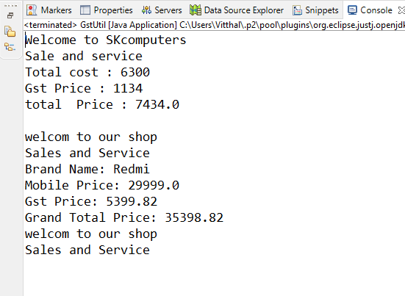

**Example-2:**

AtmUtil.java

package com.xworkz.xworkzapp;

import com.xworkz.xworkzapp.abstract1.SBIBank;

import com.xworkz.xworkzapp.abstract1.interstRate;

public class AtmUtil {

public static void main(String[] args) {

interstRate bank = new SBIBank();

System.out.println("Bike Loan is "+bank.getBikeloan());

System.out.println("Home Loan is "+bank.getHomeloan());

System.out.println("Personal Loan is "+bank.getPersonalloan());

Atm atm = new Atm();

atm.setBankCode(125);

atm.setBranchName("ICICI");

atm.setLocation("Belagavi");

System.out.println("Branch Name "+atm.getBranchName());

System.out.println("Bank Code "+atm.getBankCode());

System.out.println("Location "+atm.getLocation());

}

}

interstRate.java

**package** com.xworkz.xworkzapp.abstract1;

**public** **abstract** **class** interstRate {

**int** Bankcode;

**static** **int** *BranchCode*;

**public** **abstract** **double** getHomeloan();

**public** **abstract** **double** getPersonalloan();

**public** **abstract** **double** getBikeloan();

**public** **int** EducationLoan()

{

**return** 10;

}

**public** **static** **void** test() {

System.***out***.println(" Hi im static method");

}

}

**SBIBank.java**

**package** com.xworkz.xworkzapp.abstract1;

**public** **class** SBIBank **extends** interstRate {

@Override

**public** **double** getHomeloan() {

**return** 7.5;

}

@Override

**public** **double** getPersonalloan() {

**return** 10.0;

}

@Override

**public** **double** getBikeloan() {

**return** 9;

}

}

**Atm.java**

**package** com.xworkz.xworkzapp;

**public** **class** Atm {

**private** String branchName;

**private** **int** bankCode;

**private** String location;

**public** String getBranchName() {

**return** branchName;

}

**public** **void** setBranchName(String branchName) {

**this**.branchName = branchName;

}

**public** **int** getBankCode() {

**return** bankCode;

}

**public** **void** setBankCode(**int** bankCode) {

**this**.bankCode = bankCode;

}

**public** String getLocation() {

**return** location;

}

**public** **void** setLocation(String location) {

**this**.location = location;

}

}

**Output:**

