**1.Introduction**:

This project aims to develop sales management web application for a wholesale business to improve the efficiency and security of the business. The lightweight nature of the web application makes it ideal for small businesses which cannot afford the expensive alternates present in the market.

The Wholesale Management System (WMS) has an administrator login for the wholesaler with built-in features to keep a check on the sales and the inventory so as to efficiently run the sales division. The customers and suppliers of the wholesale business can also be registered so as to ensure the smooth functioning of sales. There is also a customer login option which helps the customer in monitoring his purchases from the wholesaler. By having the above features, the WMS greatly simplifies the daily functioning of the business. Since, many developed countries already use such software to speed up daily business activities; a lot of information is available in the public domain regarding the desirable structure of such software. We have used this information to design and model our project.

**2.Objective:**

The Main objective of this project is to develop software to show the details of stock like their id, name, quantity and details of customer i.e name, id, address. Registration, Updating, transaction.

This project can be divided into five major categories:

1. New customer: In this we can creates a new customer.
2. New transaction: In this we can new transaction.
3. Defaulters Table: It shows default customer information(previously entered customer information).
4. Updating stock: In this we can enter stock and we can update it.
5. Add supplier: In this supplier information can be entered.

**3.Literature Survey:**

**3.1.Existing System:**

The present system is totally dependent on manual data management for different activities such as maintaining details. And all details handled manually. It is manual and time consuming. It utilizes a large amount of space for student transaction information in paper files. Damage of papers may happens which contains the information. Lastly, it does not offer a user friendly work environment.

**4.System Architecture:**

**4.1.Proposed System:**

In our proposed system we have the provision for adding the details of the wholesale Management related to New customer entry ,transactions, stock, supplier information through the software. So it reduces paper work and saves time. And also it is user friendly.

**4.2.Software And Hardware Requirements**

Software requirements :

Language :HTML , JAVA SCRIPT,CSS.

* Editor :Notepad++.

Operating system :windows 7.

Hardware requirements :

Processor :intel corei5 processor.

Hard disk :2GB

RAM :1GB

**3.Code Of the Project**

**3.1Wholesaler:**

|  |
| --- |
| <!doctype html> |
| <html> |
| <head> |
| <meta http-equiv="Content-Type" content="text/html; charset=iso-8859-1" /> |
| <title>WholeSaler-Login</title> |
| <link rel="stylesheet" href="WholeSaler/styles.css" type="text/css" /> |
| <meta name="viewport" content="width=device-width, minimum-scale=1.0, maximum-scale=1.0" /> |
| </head>  <script>  function alrt1()  {  alert("New Customer Created");  }  </script> |
|  |
| <body> |
|  |
| <section id="body" class="width"> |
| <aside id="sidebar" class="column-left"> |
|  |
| <header> |
| <h1><a href="#">WholeSaler</a></h1> |
|  |
| <h2>The Complete Info</h2> |
|  |
| </header> |
| <!--THE LEFT SIDE MENU IS DUE TO THE ABOVE CODE...!!--> |
| <nav id="mainnav"> |
| <ul> |
| <li class="selected-item"><a href="WholeSaler-Login.html">Home</a></li> |
| <li><a href="Add _Transaction.htm">New Transaction</a></li> |
| <li><a href="Defaulters_Table.htm">Defaulters Table</a></li> |
| <li><a href="Updating_Stocks.htm">Updating Stocks</a></li> |
| <li><a href="Add_Supplier.htm">Add Supplier</a></li> |
| <!--<li><a href="#">AboutUs</a></li>--> |
| </ul> |
| </nav> |
|  |
|  |
|  |
| </aside> |
|  |
| <section id="content" class="column-right"> |
|  |
| <article> |
|  |
| <blockquote><p>WholeSalerlogin contain 1.Add Customer 2.Add Transaction 3.Depleted Stocks 4.Profits for every month 5.Defaulters Table 6. Updating the stocks 7.Adding about the buyer</p></blockquote> |
| <p>&nbsp;</p> |
|  |
| <!-- <a href="#" class="button">Read more</a> |
| <a href="#" class="button button-reversed">Comments</a> --> |
| <!--IN THIS FIELD WE CAN ADD THE CUSTOMER..--> |
| <fieldset> |
| <!--YOU NEED TO WRITE AN ACTION HERE...--> |
| <!--NEVER USE KEY WORDS AS THE VARIABLES AND NAMES... --> |
| <legend><strong>NEW CUSTOMER</strong></legend> |
| <!--<form action="Addcustomer.php" method="POST">--> |
| <p><label for="name"><strong>Name:</strong></label> |
| <input type="text" name="Cname" id="name" placeholder = "Name" required/><b/></p> |
|  |
| <p><label for="CustomerID">Customer-ID:</label> |
| <input type="text" name="CustomerID" id="CustomerID" required/><br /></p> |
|  |
| <p><label for="LoginID">Login-ID:</label> |
| <input type="text" name="LoginID" id="LoginID" required/><br /></p> |
|  |
| <p><label for="password">Password:</label> |
| <input type="text" name="Password" id="password" required/><br /></p> |
|  |
| <p><label for="Address">Address:</label> |
| <textarea cols="60" rows="8" name="Address" id="Address" required></textarea><br /></p> |
|  |
| <p>  <p><input type="submit" name="OK" class="formbutton" value="OK"onclick="alrt1()" /></p> |
| </form> |
|  |
| </fieldset> |
|  |
| </article> |
|  |
|  |
|  |
|  |
| <footer class="clear"> |
| <p>&copy; WholeSale Business Managment by Shivanand</p> |
| </footer> |
|  |
| </section> |
|  |
| <div class="clear"></div> |
|  |
| </section> |
|  |
|  |
| </body> |
| </html> |

|  |  |
| --- | --- |
|  | <!doctype html> |
|  | <html> |
|  | <head> |
|  | <meta http-equiv="Content-Type" content="text/html; charset=iso-8859-1" /> |
|  | <title>WholeSaler-Login</title> |
|  | <link rel="stylesheet" href="WholeSaler/styles.css" type="text/css" /> |
|  | <meta name="viewport" content="width=device-width, minimum-scale=1.0, maximum-scale=1.0" /> |
|  | </head>  <script>  function alrt1()  {  alert("Transaction Saved");  }  </script> |
|  |  |
|  | <body> |
|  |  |
|  | <section id="body" class="width"> |
|  | <aside id="sidebar" class="column-left"> |
|  |  |
|  | <header> |
|  | <h1><a href="#">WholeSaler</a></h1> |
|  |  |
|  | <h2>The Complete Info</h2> |
|  |  |
|  | </header> |
|  | <!--THE LEFT SIDE MENU IS DUE TO THE ABOVE CODE...!!--> |
|  | <nav id="mainnav"> |
|  | <ul> |
|  | <li><a href="WholeSaler-Login.html">Home</a></li> |
|  | <li class="selected-item"><a href="Add _Transaction.htm">New Transaction</a></li> |
|  | <li><a href="Defaulters_Table.htm">Defaulters Table</a></li> |
|  | <li><a href="Updating_Stocks.htm">Updating Stocks</a></li> |
|  | <li><a href="Add_Supplier.htm">Add Supplier</a></li> |
|  | <!--<li><a href="#">AboutUs</a></li>--> |
|  | </ul> |
|  | </nav> |
|  |  |
|  |  |
|  |  |
|  | </aside> |
|  |  |
|  | <section id="content" class="column-right"> |
|  |  |
|  | <article> |
|  |  |
|  | <blockquote><p>WholeSalerlogin contain 1.Add Customer 2.Add Transaction 3.Depleted Stocks 4.Profits for every month 5.Defaulters Table 6. Updating the stocks 7.Adding about the buyer</p></blockquote> |
|  | <p>&nbsp;</p> |
|  |  |
|  | <!-- <a href="#" class="button">Read more</a> |
|  | <a href="#" class="button button-reversed">Comments</a> --> |
|  | <!--IN THIS FIELD WE CAN ADD THE CUSTOMER..--> |
|  | <fieldset> |
|  | <!--YOU NEED TO WRITE AN ACTION HERE...--> |
|  | <legend><strong>NEW TRANSACTION</strong></legend> |
|  | <form action="Add_Transaction.php" method="POST"> |
|  | <p><label for="name"><strong>Name:</strong></label> |
|  | <input type="text" name="name" id="name" Placeholder="Customer Name" required/><b/></p> |
|  |  |
|  | <p><label for="CustomerID">Customer-ID:</label> |
|  | <input type="text" name="CustomerID" id="CustomerID" Placeholder="CustomerID" required/><br /></p> |
|  |  |
|  | <p><label for="StockID">Stock-ID:</label> |
|  | <input type="text" name="StockID" id="StockID" Placeholder="Stock ID" required /><br /></p> |
|  |  |
|  | <p><label for="Quantity">Quantiy:</label> |
|  | <input type="text" name="Quantity" id="Quantity" Placeholder="How Much??" required /><br /></p> |
|  |  |
|  | <p><label for="TotalAmount">Total-Amount:</label> |
|  | <input name="TotalAmount" id="TotalAmount" required></input><br /></p> |
|  |  |
|  | <p><label for="AmountPaid">Amount-Paid:</label> |
|  | <input name="AmountPaid" id="AmountPaid" required></input><br /></p> |
|  |  |
|  | <p><label for="BalanceAmount">Balance-Amount:</label> |
|  | <input name="BalanceAmount" id="BalanceAmount" required></input><br /></p> |
|  |  |
|  | <p><input type="submit" name="send" class="formbutton" value="Submit" onclick="alrt1()"/></p> |
|  |  |
|  | </form> |
|  |  |
|  |  |
|  | </fieldset> |
|  |  |
|  | </article> |
|  |  |
|  |  |
|  |  |
|  |  |
|  |  |
|  | <footer class="clear"> |
|  | <p>&copy; WholeSale Business Managment by Shivanand</p> |
|  | </footer> |
|  |  |
|  | </section> |
|  |  |
|  | <div class="clear"></div> |
|  |  |
|  | </section> </body> |
|  |  |
|  |  |
|  | </html> |
|  |  |
| <!doctype html> | |
| <html> | |
| <head> | |
| <meta http-equiv="Content-Type" content="text/html; charset=iso-8859-1" /> | |
| <title>WholeSaler-Login</title> | |
| <link rel="stylesheet" href="WholeSaler/styles.css" type="text/css" /> | |
| <meta name="viewport" content="width=device-width, minimum-scale=1.0, maximum-scale=1.0" /> | |
| </head>  <script>  function alrt1()  {  alert("New Supplier Entered");  }  </script> | |
|  | |
| <body> | |
|  | |
| <section id="body" class="width"> | |
| <aside id="sidebar" class="column-left"> | |
|  | |
| <header> | |
| <h1><a href="#">WholeSaler</a></h1> | |
|  | |
| <h2>The Complete Info</h2> | |
|  | |
| </header> | |
| <!--THE LEFT SIDE MENU IS DUE TO THE ABOVE CODE...!!--> | |
| <nav id="mainnav"> | |
| <ul> | |
| <li> <a href="WholeSaler-Login.html">Home</a></li> | |
| <li> <a href="Add _Transaction.htm">New Transaction</a></li> | |
| <li class="selected-item" > <a href="Defaulters_Table.htm">Defaulters Table</a></li> | |
| <li> <a href="Updating_Stocks.htm">Updating Stocks</a></li> | |
| <li> <a href="Add_Supplier.htm">Add Supplier</a></li> | |
| <!--<li> <a href="#">AboutUs</a></li>--> | |
| </ul> | |
| </nav> | |
|  | |
|  | |
|  | |
| </aside> | |
|  | |
| <section id="content" class="column-right"> | |
|  | |
| <article> | |
|  | |
| <blockquote><p>WholeSalerlogin contain 1.Add Customer 2.Add Transaction 3.Depleted Stocks 4.Profits for every month 5.Defaulters Table 6. Updating the stocks 7.Adding about the buyer</p></blockquote> | |
| <p>&nbsp;</p> | |
|  | |
| <!-- <a href="#" class="button">Read more</a> | |
| <a href="#" class="button button-reversed">Comments</a> --> | |
| <!--IN THIS FIELD WE CAN ADD THE CUSTOMER..--> | |
| <!--THE ABOVE CREATES THE TABLE VIEW WHICH YOU WILL BE NEEDING...--> | |
| <h3>Table</h3> | |
| <table> | |
| <tr> | |
| <th>ID</th> | |
| <th>Name</th> | |
| <th>Age</th> | |
| </tr> | |
| <?php | |
| $conn = new mysqli("localhost", "root", ""); | |
| while() | |
| { | |
| ?> | |
| <tr> | |
| <td>1</td> | |
| <td>Rahul</td> | |
| <td>28</td> | |
|  | |
| </tr> | |
| <tr | |
| <?php }?> | |
| <td>2</td> | |
| <td>Ramesh</td> | |
| <td>49</td> | |
| </tr> | |
| <tr> | |
| <td>3</td> | |
| <td>Rachel</td> | |
| <td>19</td> | |
| </tr> | |
|  | |
| </table> | |
| <p>&nbsp;</p> | |
|  | |
| </article> | |
|  | |
|  | |
|  | |
|  | |
|  | |
| <footer class="clear"> | |
| <p>&copy; WholeSale Business Managment by Shivanand</p> | |
| </footer> | |
|  | |
| </section> | |
|  | |
| <div class="clear"></div> | |
|  | |
| </section> | |
|  | |
|  | |
| </body> | |
| </html> | |

|  |  |
| --- | --- |
|  | <!doctype html> |
|  | <html> |
|  | <head> |
|  | <meta http-equiv="Content-Type" content="text/html; charset=iso-8859-1" /> |
|  | <title>WholeSaler-Login</title> |
|  | <link rel="stylesheet" href="WholeSaler/styles.css" type="text/css" /> |
|  | <meta name="viewport" content="width=device-width, minimum-scale=1.0, maximum-scale=1.0" /> |
|  | </head>  <script>  function alrt1()  {  alert("New Supplier Entered");  }  </script> |
|  |  |
|  | <body> |
|  |  |
|  | <section id="body" class="width"> |
|  | <aside id="sidebar" class="column-left"> |
|  |  |
|  | <header> |
|  | <h1><a href="#">WholeSaler</a></h1> |
|  |  |
|  | <h2>The Complete Info</h2> |
|  |  |
|  | </header> |
|  | <!--THE LEFT SIDE MENU IS DUE TO THE ABOVE CODE...!!--> |
|  | <nav id="mainnav"> |
|  | <ul> |
|  | <li> <a href="WholeSaler-Login.html">Home</a></li> |
|  | <li> <a href="Add _Transaction.htm">New Transaction</a></li> |
|  | <li> <a href="Defaulters_Table.htm">Defaulters Table</a></li> |
|  | <li class="selected-item"> <a href="Updating_Stocks.htm">Updating Stocks</a></li> |
|  | <li> <a href="Add_Supplier.htm">Add Supplier</a></li> |
|  | <!--<li> <a href="#">AboutUs</a></li>--> |
|  | </ul> |
|  | </nav> |
|  |  |
|  |  |
|  |  |
|  | </aside> |
|  |  |
|  | <section id="content" class="column-right"> |
|  |  |
|  | <article> |
|  |  |
|  | <blockquote><p>WholeSalerlogin contain 1.Add Customer 2.Add Transaction 3.Depleted Stocks 4.Profits for every month 5.Defaulters Table 6. Updating the stocks 7.Adding about the buyer</p></blockquote> |
|  | <p>&nbsp;</p> |
|  |  |
|  | <!-- <a href="#" class="button">Read more</a> |
|  | <a href="#" class="button button-reversed">Comments</a> --> |
|  | <!--IN THIS FIELD WE CAN ADD THE CUSTOMER..--> |
|  | <fieldset> |
|  | <!--YOU NEED TO WRITE AN ACTION HERE...--> |
|  | <legend><strong>NEW STOCK</strong></legend> |
|  | <!--<form action="New_Stock.php" method="post">--> |
|  |  |
|  | <p><label for="StockID">Stock-ID:</label> |
|  | <input type="text" name="StockID" id="StockID" value="" required/><br /></p> |
|  |  |
|  | <p><label for="Quantity">Quantiy:</label> |
|  | <input type="text" name="Quantity" id="Quantity" value="" required/><br /></p> |
|  |  |
|  | <p><label for="Price">Price-Per-Unit:</label> |
|  | <input type="text" name="Price" id="Price" value="" required/><br /></p> |
|  |  |
|  | <p><label for="Date">Expiry-Date:</label> |
|  | <input type="text" name="Date" id="Date" value="" required/><br /></p> |
|  |  |
|  | <p><input type="submit" name="send" class="formbutton" value="OK" onclick="alrt1()"/></p> |
|  |  |
|  | </form> |
|  |  |
|  |  |
|  | </fieldset> |
|  | <br> <br> <br> <br> <br> <br> <br> |
|  | <fieldset> |
|  | <!--YOU NEED TO WRITE AN ACTION HERE...--> |
|  | <legend><strong>UPDATE STOCK</strong></legend> |
|  | <form action="Updating_Stocks.php" method="POST"> |
|  |  |
|  | <p><label for="Stock-ID1">Stock-ID:</label> |
|  | <input type="text" name="Stock-ID1" id="Stock-ID1" value="" /><br /></p> |
|  |  |
|  | <p><label for="Quantity1">Quantiy:</label> |
|  | <input type="text" name="Quantity1" id="Quantity1" value="" /><br /></p> |
|  |  |
|  | <p><label for="Price1">Price-Per-Unit:</label> |
|  | <input type="text" name="Pric1" id="Price1" value="" /><br /></p> |
|  |  |
|  |  |
|  | <p><input type="submit" name="send" class="formbutton" value="OK" onclick="alrt1()"/></p> |
|  |  |
|  | </form> |
|  |  |
|  |  |
|  | </fieldset> |
|  |  |
|  | </article> |
|  |  |
|  |  |
|  |  |
|  |  |
|  |  |
|  | <footer class="clear"> |
|  | <p>&copy; WholeSale Business Managment by Shivanand</p> |
|  | </footer> |
|  |  |
|  | </section> |
|  |  |
|  | <div class="clear"></div> |
|  |  |
|  | </section> |
|  |  |
|  |  |
|  | </body> |
|  | </html> |
|  |  |

|  |  |
| --- | --- |
|  | <!doctype html> |
|  | <html> |
|  | <head> |
|  | <meta http-equiv="Content-Type" content="text/html; charset=iso-8859-1" /> |
|  | <title>WholeSaler-Login</title> |
|  | <link rel="stylesheet" href="WholeSaler/styles.css" type="text/css" /> |
|  | <meta name="viewport" content="width=device-width, minimum-scale=1.0, maximum-scale=1.0" /> |
|  | </head>  <script>  function alrt1()  {  alert("New Supplier Entered");  }  </script> |
|  |  |
|  | <body> |
|  |  |
|  | <section id="body" class="width"> |
|  | <aside id="sidebar" class="column-left"> |
|  |  |
|  | <header> |
|  | <h1><a href="#">WholeSaler</a></h1> |
|  |  |
|  | <h2>The Complete Info</h2> |
|  |  |
|  | </header> |
|  | <!--THE LEFT SIDE MENU IS DUE TO THE ABOVE CODE...!!--> |
|  | <nav id="mainnav"> |
|  | <ul> |
|  | <li> <a href="WholeSaler-Login.html">Home</a></li> |
|  | <li> <a href="Add _Transaction.htm">New Transaction</a></li> |
|  | <li> <a href="Defaulters_Table.htm">Defaulters Table</a></li> |
|  | <li> <a href="Updating_Stocks.htm">Updating Stocks</a></li> |
|  | <li class="selected-item"> <a href="Add_Supplier.htm">Add Supplier</a></li> |
|  | <!--<li> <a href="#">AboutUs</a></li>--> |
|  | </ul> |
|  | </nav> |
|  |  |
|  |  |
|  |  |
|  | </aside> |
|  |  |
|  | <section id="content" class="column-right"> |
|  |  |
|  | <article> |
|  |  |
|  | <blockquote><p>WholeSalerlogin contain 1.Add Customer 2.Add Transaction 3.Depleted Stocks 4.Profits for every month 5.Defaulters Table 6. Updating the stocks 7.Adding about the buyer</p></blockquote> |
|  | <p>&nbsp;</p> |
|  |  |
|  | <!-- <a href="#" class="button">Read more</a> |
|  | <a href="#" class="button button-reversed">Comments</a> --> |
|  | <!--IN THIS FIELD WE CAN ADD THE CUSTOMER..--> |
|  | <fieldset> |
|  | <!--YOU NEED TO WRITE AN ACTION HERE...--> |
|  | <legend><strong>NEW Supplier</strong></legend> |
|  | <!--<form action="Add_Supplier.php" method="Post">--> |
|  |  |
|  | <p><label for="Name">Name:</label> |
|  | <input name="Name" id="Name" required></input><br /></p> |
|  |  |
|  | <p><label for="IndustryID">Industry-ID:</label> |
|  | <input type="text" name="IndustryID" id="IndustryID" value="" required/><br /></p> |
|  |  |
|  | <p><label for="StockID">Stock-ID:</label> |
|  | <input type="text" name="StockID" id="StockID" value="" required/><br /></p> |
|  |  |
|  | <p><label for="Address">Address:</label> |
|  | <textarea cols="60" rows="8" name="Address" id="Address"></textarea><br /></p> |
|  |  |
|  | <p><input type="submit" name="send" class="formbutton" value="OK" onclick="alrt1()"/></p> |
|  |  |
|  | </form> |
|  |  |
|  |  |
|  | </fieldset> |
|  |  |
|  | </article> |
|  |  |
|  |  |
|  |  |
|  |  |
|  |  |
|  | <footer class="clear"> |
|  | <p>&copy; WholeSale Business Managment by Shivanand</p> |
|  | </footer> |
|  |  |
|  | </section> |
|  |  |
|  | <div class="clear"></div> |
|  |  |
|  | </section> |
|  |  |
|  |  |
|  | </body> |
|  | </html> |

**4.4.Screen Shots**

**Home Page:**

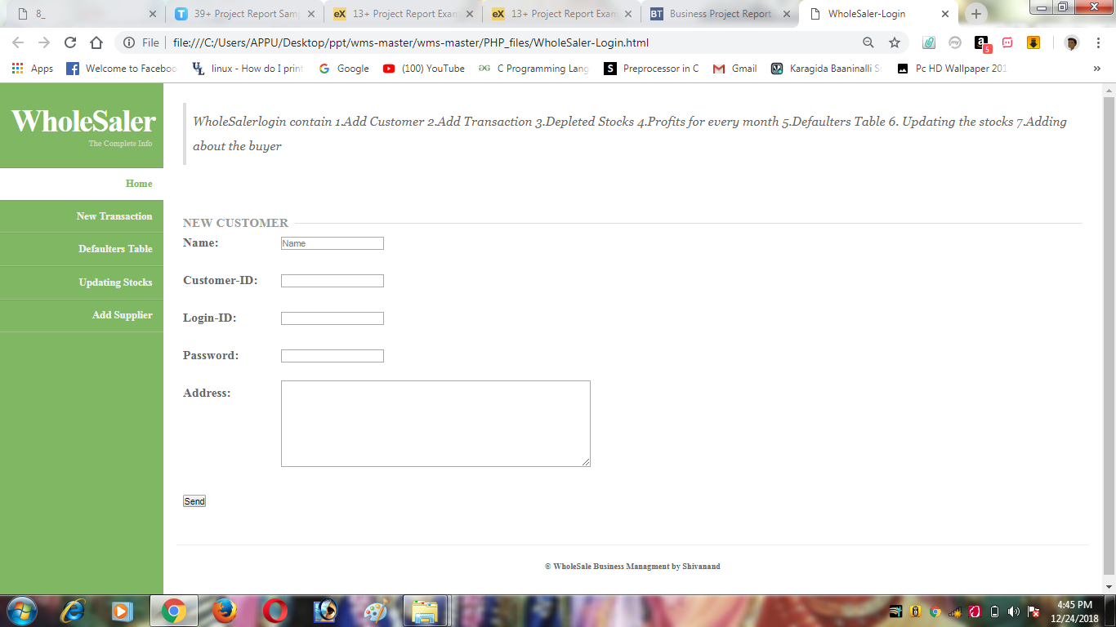

**New Transaction**:

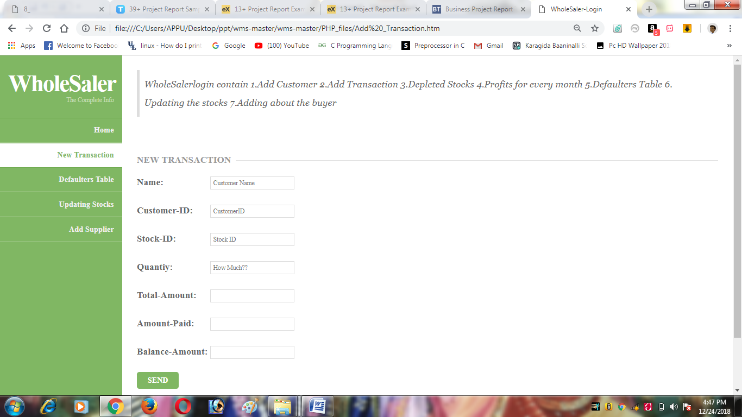

**Updating stocks:**

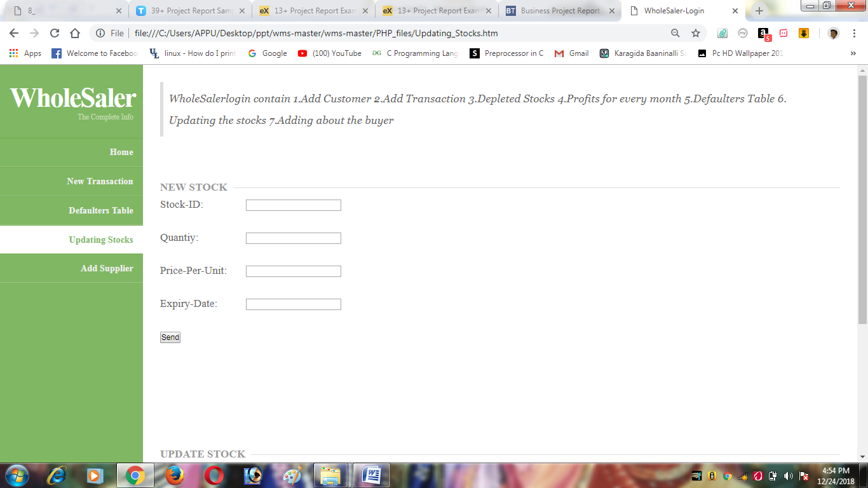

**Defaulters Table :**

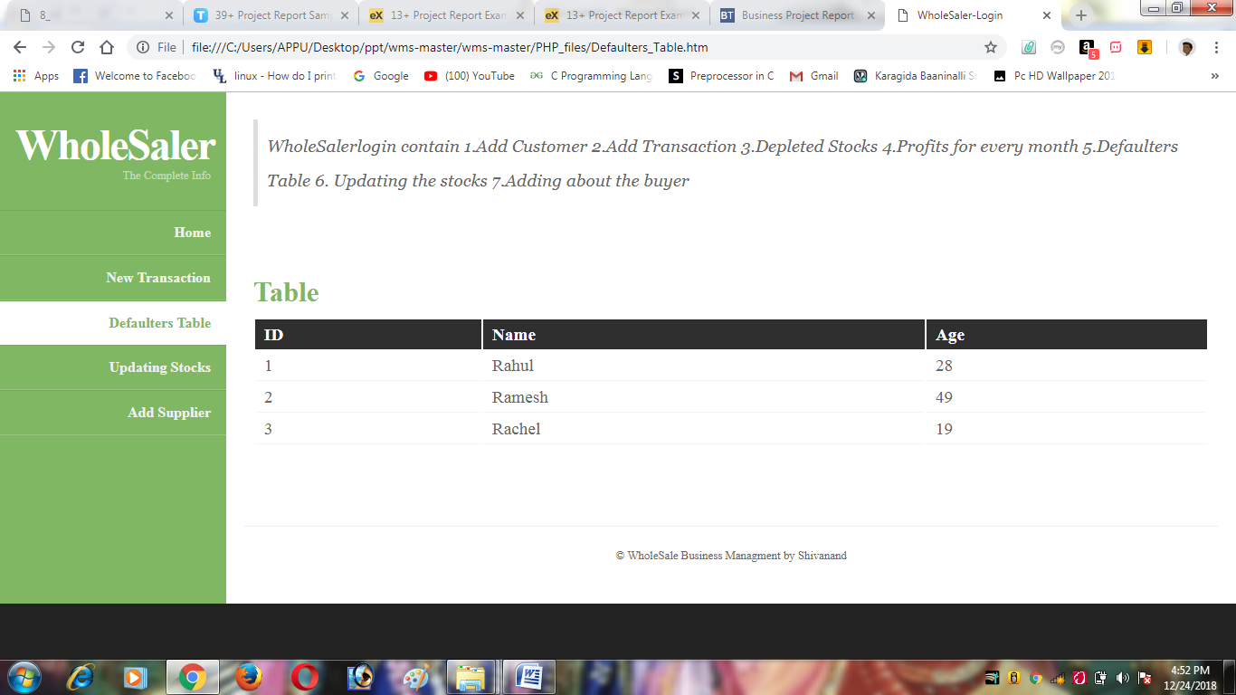

**Add supplier**



1. **Reference:**

* <https://www.tutorialspoint.com/sales_and_distribution_management/sales_and_distribution_management_marketing_channel.htm>
* <https://www.w3schools.com>
* [Eloquent JavaScript: A Modern Introduction to Programming](https://www.amazon.com/Eloquent-JavaScript-Modern-Introduction-Programming/dp/1593275846/)