**DFD-ONLINE TIMBER MILL**

LEVEL 0 DFD

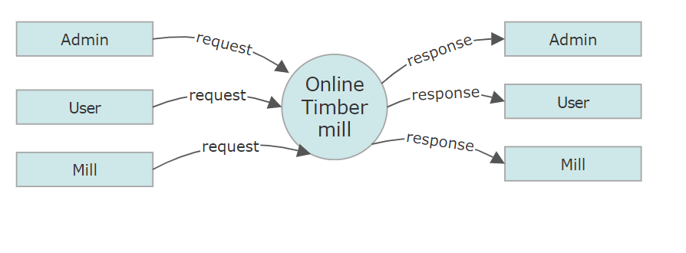

LEVEL 1 DFD ADMIN

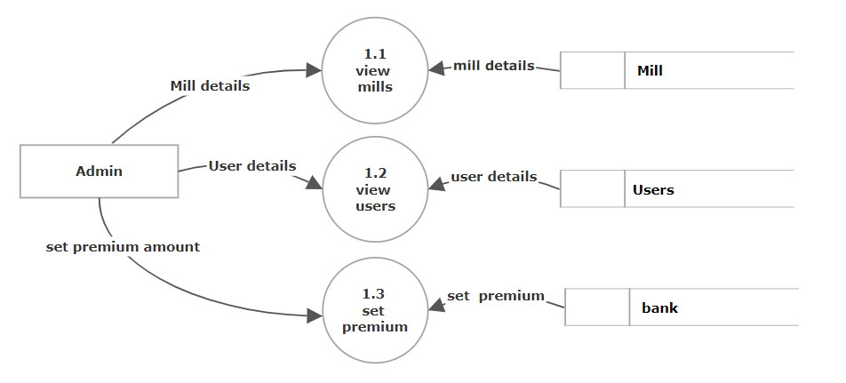

LEVEL 1 DFD USER

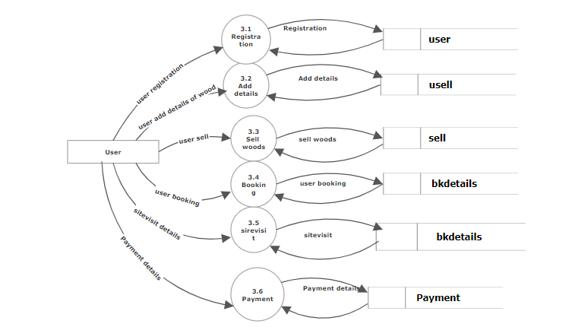

LEVEL 1 DFD MILL

