DATA SCIENCE TOOL MASTERY
RETAIL ANALYTICS PORTFOLIO
Python • NumPy • Pandas • MySQL • Power BI design • Machine Learning
Professional Internship Evaluation Project
UCI Online Retail (real historical transaction dataset)
Built 1 November 2026
Data source attribution: Daqing Chen, UCI Machine Learning Repository, Online Retail, DOI 10.24432/C5BW33. Licensed CC BY 4.0.

Contents
- Abstract
- Introduction and business problem
- Objectives and technology stack
- Dataset and source
- Python and NumPy implementation
- Pandas implementation
- SQL and database
- Data cleaning methodology
- EDA and statistical exploration
- Visual analytics
- Power BI dashboard
- Machine learning
- Ten evidence-based insights
- Tool comparison
- Challenges and learning outcomes
- Limitations and ethics
- Conclusion
- References

1. Abstract
This portfolio demonstrates a repeatable analytics workflow using the real UCI Online Retail transaction dataset. The source workbook contains 541,909 transaction lines and eight source fields across 2010-12-01 through 2011-12-09. The project removes 5,268 exact duplicated rows, retains a 536,641-row audit-clean ledger, profiles missing identity data, generates 16 figures, creates 26 MySQL 8 analytical queries, and evaluates a chronological daily-revenue forecasting model against a weekly-naive baseline. Positive sales lines total £10,642,110.80; this is gross sales, not profit. The forecasting model did not beat the baseline, an important honest result. Power BI requirements, DAX and a static preview are included; a native PBIX cannot be produced or validated in this environment.

2. Introduction and Business Problem
Retail analysts need reliable methods to reconcile line items, monitor sales trends, understand geographic/product concentration, and distinguish invoice-level from customer-level measures. This project models those tasks on UCI’s historical gift-retailer transaction data. It does not establish causal drivers or current market performance.

3. Objectives and Technology Stack
Objectives: demonstrate Python control flow and file operations; use NumPy for vectorized computation; clean and aggregate with Pandas; author relational/analytical MySQL SQL; calculate descriptive statistics with SciPy; visualize with Matplotlib/Seaborn; design a Power BI dashboard with DAX; and evaluate a basic scikit-learn regression against a naive benchmark.
Area | Tools used / artifact
Data processing | Python 3, pandas, NumPy
Statistics/visuals | SciPy, Matplotlib, Seaborn
Machine learning | scikit-learn HistGradientBoostingRegressor
Database | MySQL 8 DDL + 26 query examples; MySQL server not installed here
BI/Spreadsheet | Power BI design/DAX + static preview; Excel summary workbook
Development/docs | Jupyter Notebook, Git, GitHub-ready project, python-docx

4. Dataset Description and Provenance
Source: UCI Machine Learning Repository, Online Retail (https://archive.ics.uci.edu/dataset/352/online+retail). UCI describes a UK-based non-store retailer and 541,909 transaction rows spanning 1 Dec 2010 to 9 Dec 2011. The variables are invoice identifier, product code/description, quantity, timestamp, unit price in GBP, customer ID, and country. UCI indicates six predictive features (with identifier fields also present in the delivered file) and CC BY 4.0. The source archive and extracted workbook are retained under datasets/raw; this project does not redistribute a modified claim about the source.
Source column | Type | Use/quality note
InvoiceNo | Categorical ID | C-prefixed cancellation marker
StockCode | Categorical ID | Product/item key
Description | Text | Missing values filled with neutral Unknown Product
Quantity | Integer | Negative values can denote returns/adjustments
InvoiceDate | Datetime | Parsed to timestamp
UnitPrice | Decimal GBP | Gross line revenue uses Quantity × UnitPrice
CustomerID | Nullable identifier | 135,037 missing values retained, not imputed
Country | Category | Whitespace/casing standardized

5. Python Fundamentals and NumPy
The executed notebook demonstrates variables and data types, if/else, loops, functions, collection types, exception handling, and pathlib file read/write. NumPy examples show 2-D array creation, indexing/slicing, NaN-aware column means, vectorized imputation/transforms, reductions, and matrix multiplication. The purpose is to practice portable constructs before applying Pandas to the transactional data.

6. Pandas Implementation
The workflow loads the Excel source with pandas, checks shape/dtypes/missingness/duplicates, filters the analytical cohort, sorts by line revenue, aggregates country and customer summaries, joins a country dimension for demonstration, and exports clean CSV and daily feature tables. The reusable source code is src/run_analysis.py.

7. SQL and Database Management
04_SQL/01_schema_mysql.sql defines a MySQL 8 database/table and indexes. 02_analytical_queries_mysql.sql contains 26 queries covering SELECT, WHERE, ORDER BY, aggregates, GROUP BY/HAVING, joins, subqueries, CTEs, CASE expressions, windows, views, cancellation and null audits. Query intent is documented inline. MySQL Workbench/server were unavailable in this execution runtime; these scripts are MySQL-targeted but not claimed as executed against a live MySQL server. Follow README import steps to run them locally.

8. Data Cleaning and Preprocessing
Original dimensions: 541,909 × 8; exact duplicates removed: 5,268; clean audit table: 536,641 rows. 1,454 descriptions were filled with an explicit unknown label. 135,037 missing customer IDs were not imputed because identities cannot be reconstructed. Cancellation and return rows remain in the audit table; positive gross-sales KPIs exclude cancellation, nonpositive quantity, and nonpositive unit price. Outlier values are retained; plot clipping affects presentation only. See 05_Data_Cleaning/DATA_QUALITY_REPORT.md.

9. Exploratory Data Analysis and Statistics
The analytical sales subset has 524,878 positive sales lines, 19,960 invoices, 4,338 identified customers, and 38 countries. Gross line sales are £10,642,110.80; average daily gross sales across the calendarized period are £28,454.84. The Spearman heatmap summarizes transaction metrics; customer order frequency and revenue Pearson r=0.553 is descriptive and influenced by scale/bulk ordering, not causal. Missing IDs lead to partial customer coverage.
KPI | Observed result | Definition
Gross sales | £10,642,110.80 | Sum positive non-cancelled quantity × price
Orders | 19,960 | Distinct invoices in sales subset
Top-country sales share | 84.59% | United Kingdom sales / total gross sales
Repeat identified-customer share | 65.58% | Customers with >1 invoice / customers with an ID
Average order value | £533.17 | Gross sales / distinct orders; not margin

10. Data Visualizations
Sixteen charts are generated from the cleaned cohort. Titles and axes identify units/cohort; violin, scatter, and pair plots sample or clip only for rendering. Every figure is saved in visualizations/.
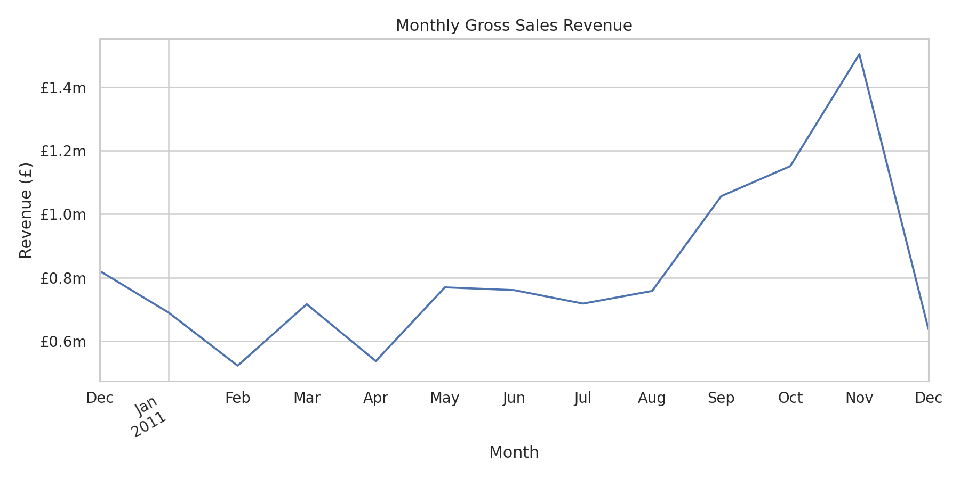
Monthly gross line-sales trend.
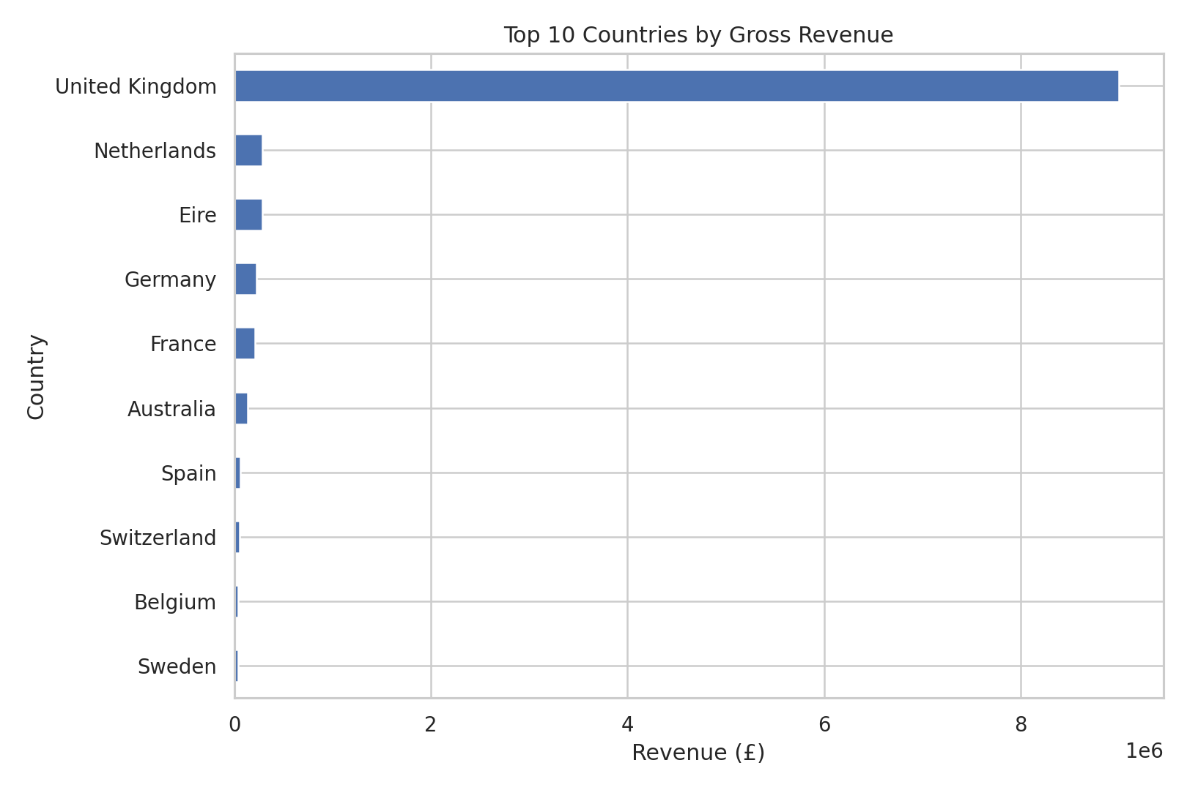
Top countries by gross sales.

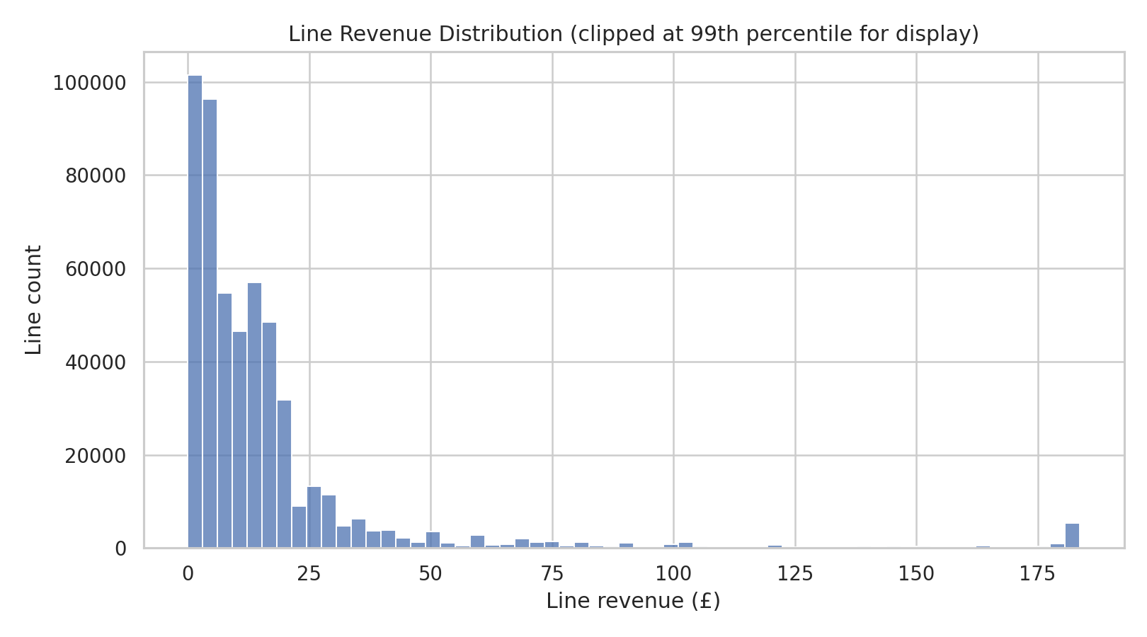
Line revenue distribution; display capped at 99th percentile.
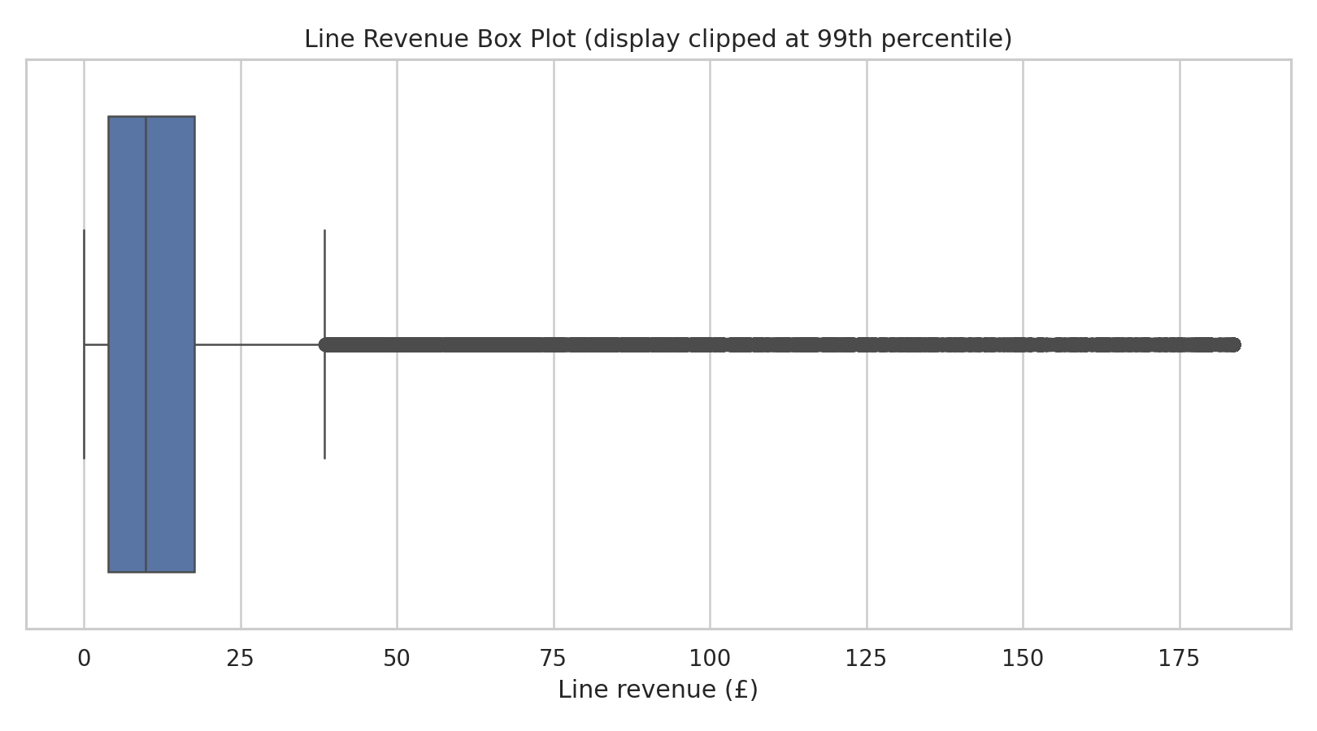
Line revenue outlier display cap.

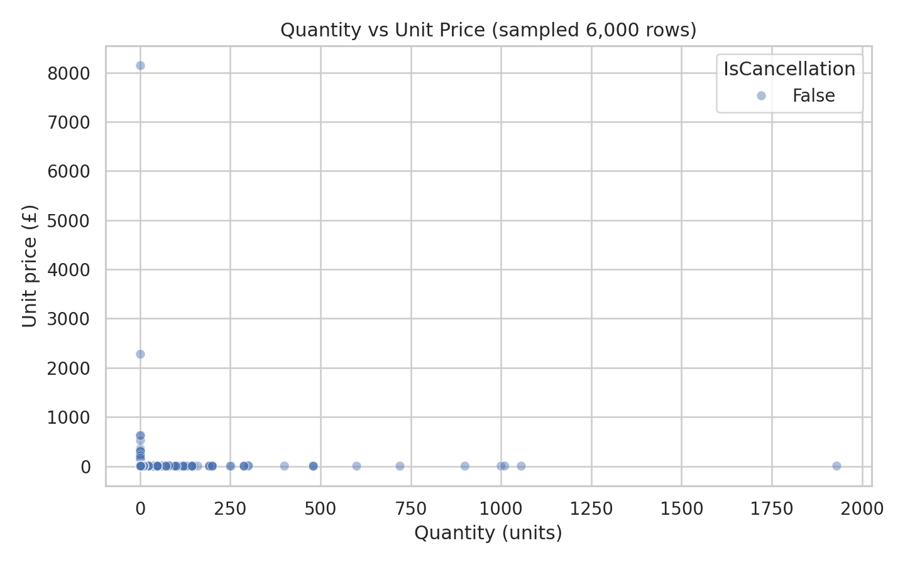
Transaction-line quantity versus price.
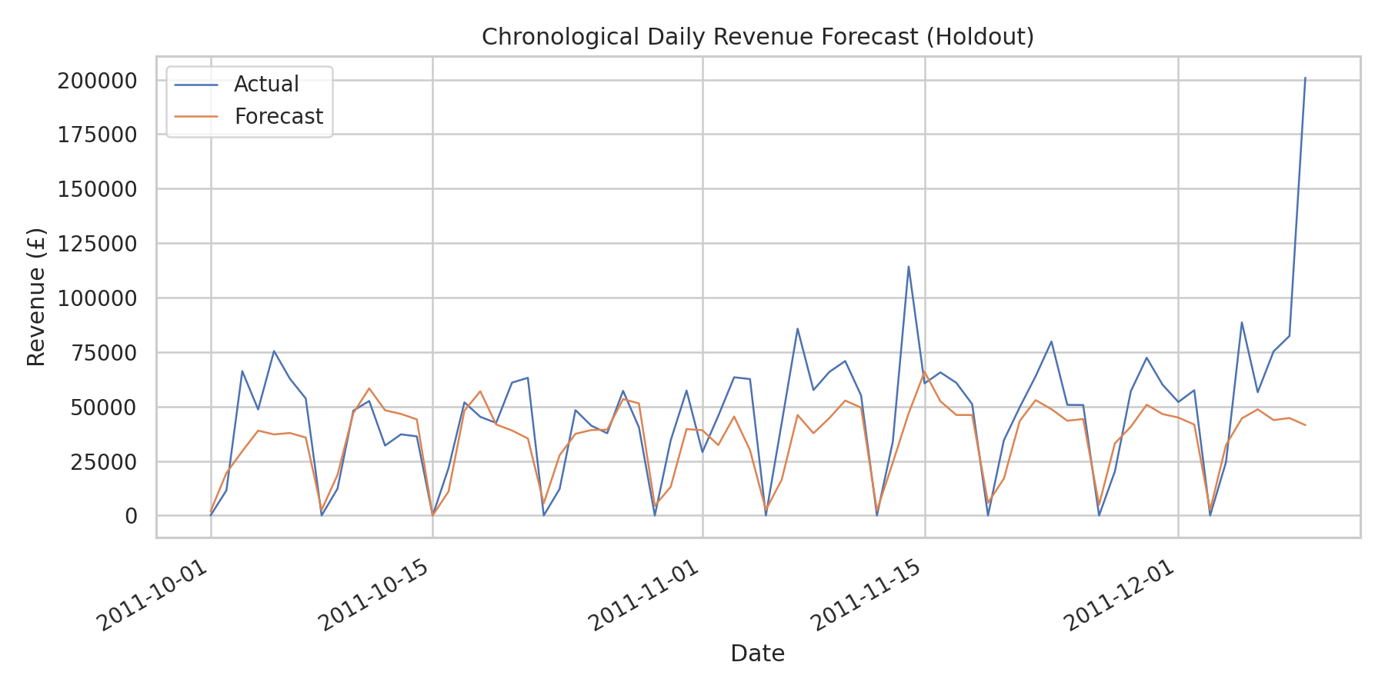
Chronological holdout actual versus model prediction.

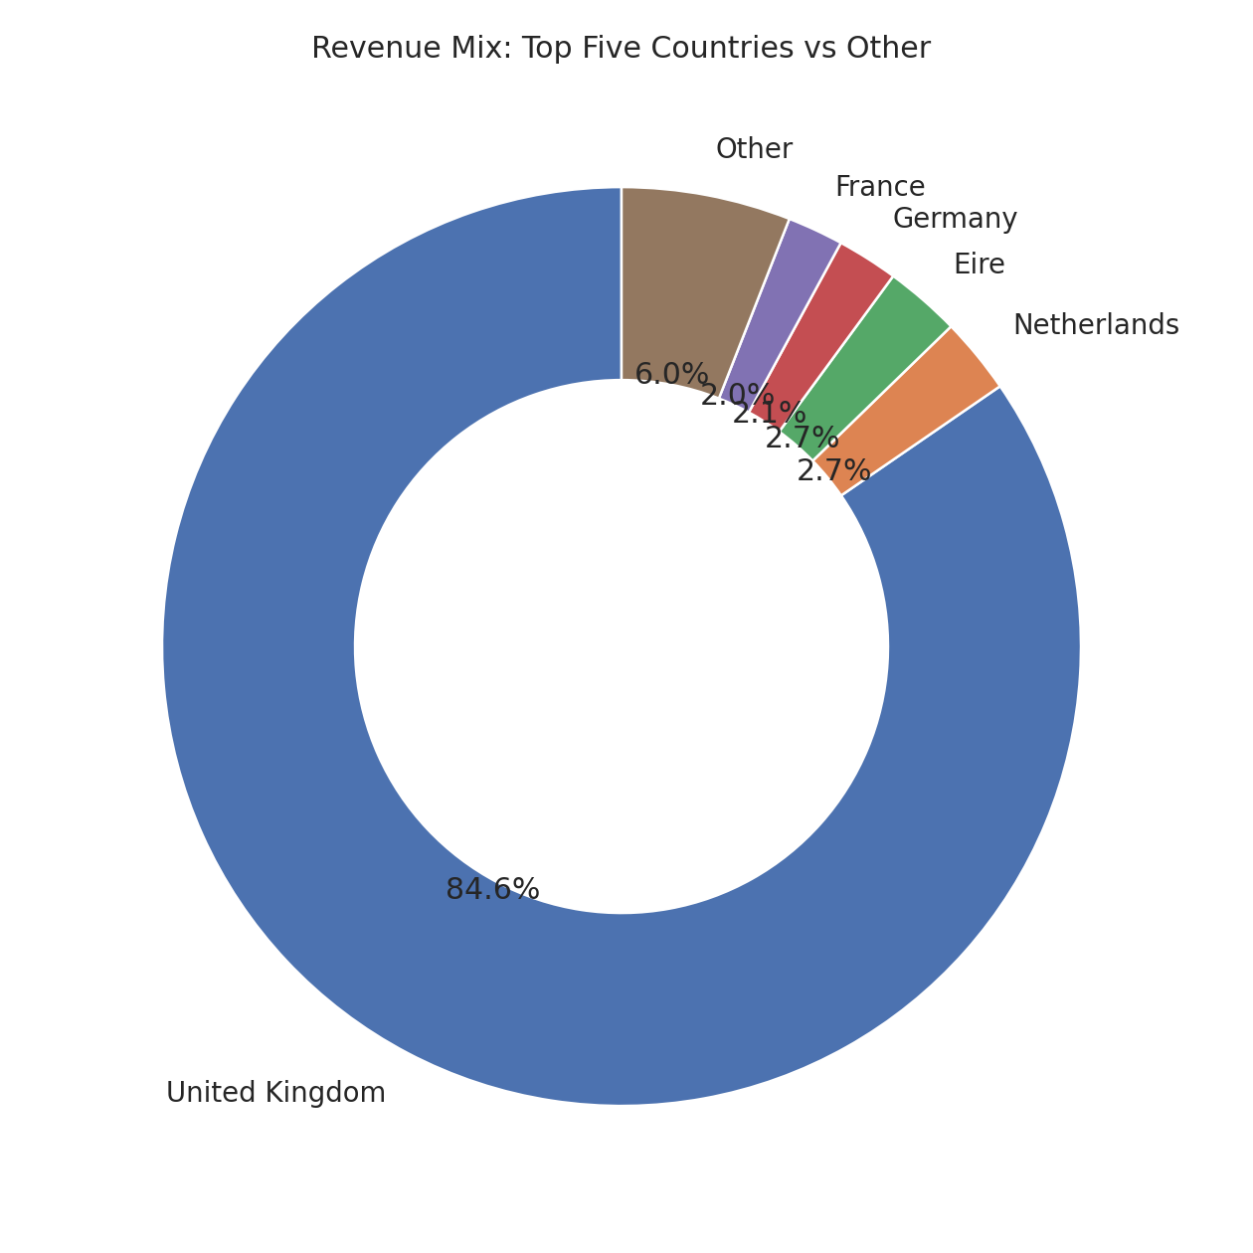
Revenue concentration by country.
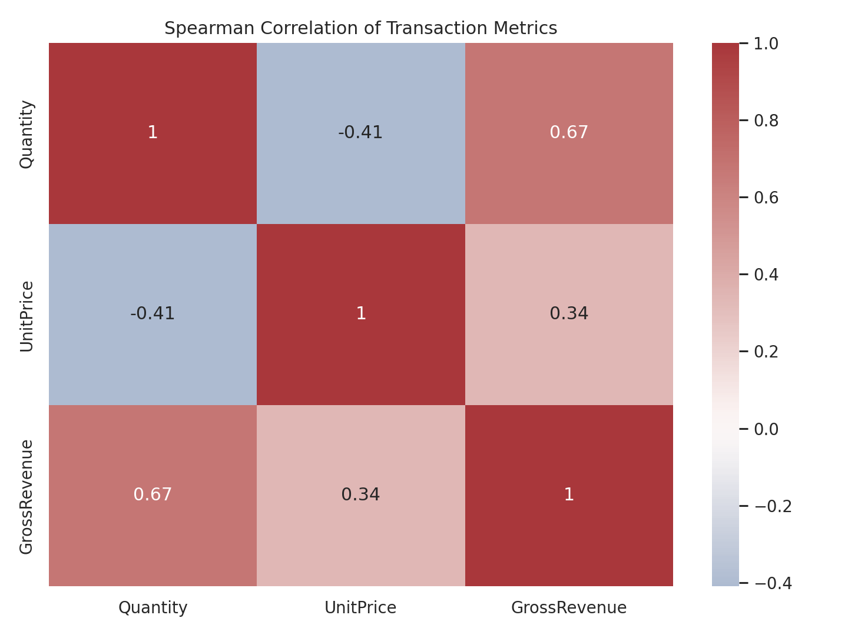
Spearman correlation matrix.

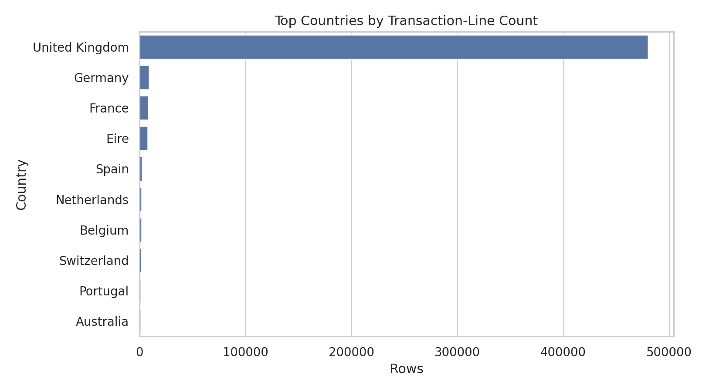
Countries by transaction-line count.
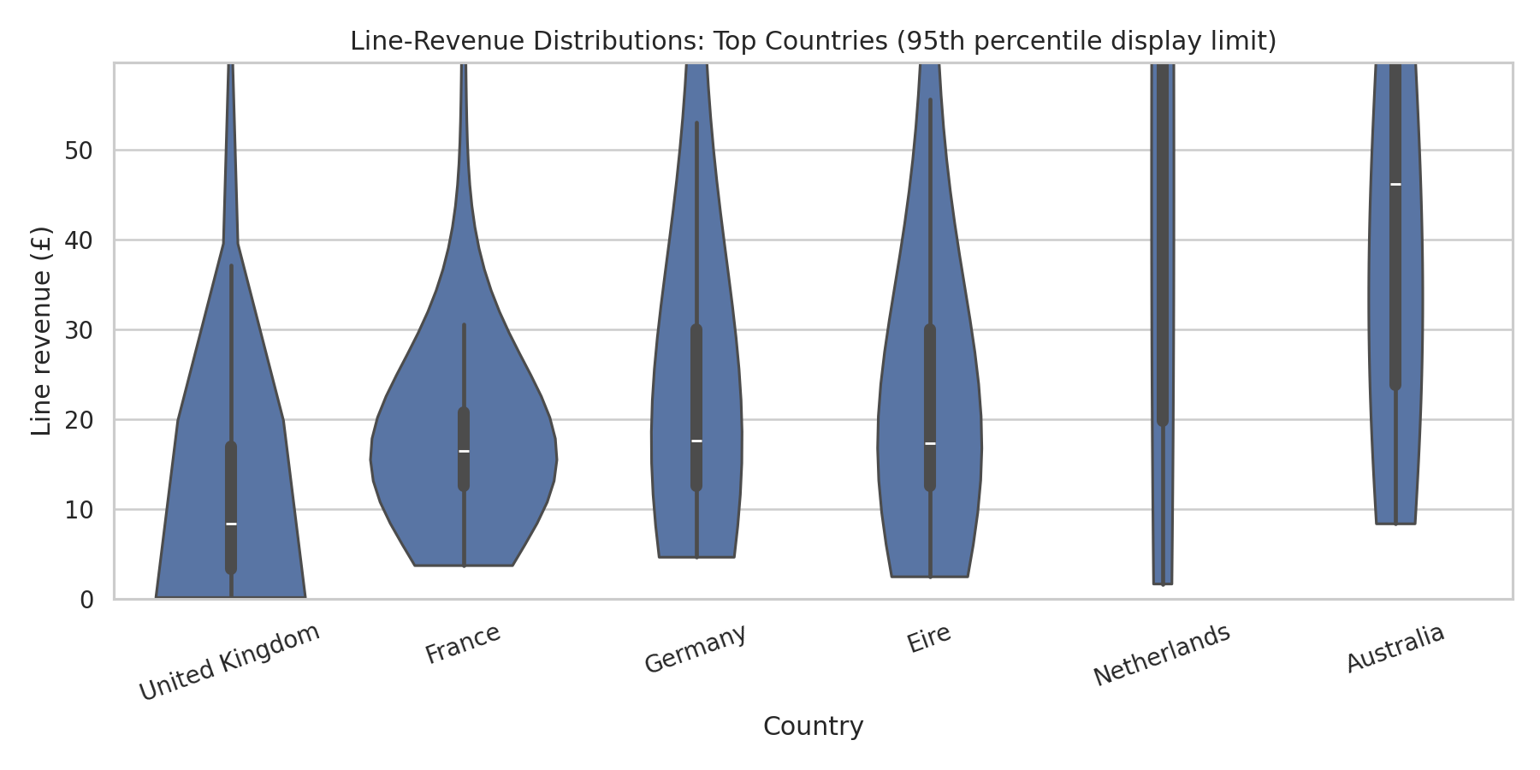
Country line-sales distributions.

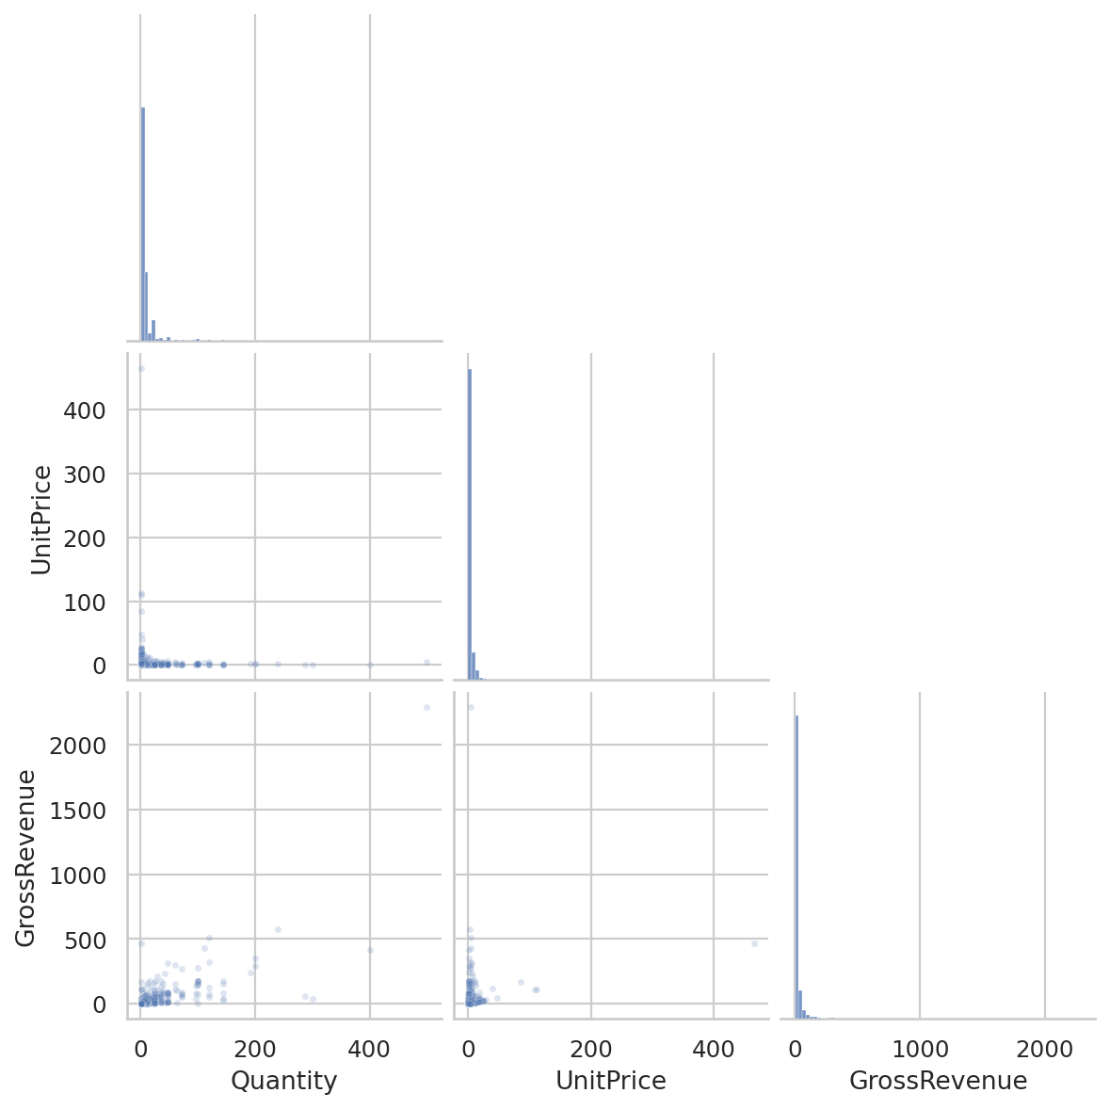
Pairwise transaction metrics.
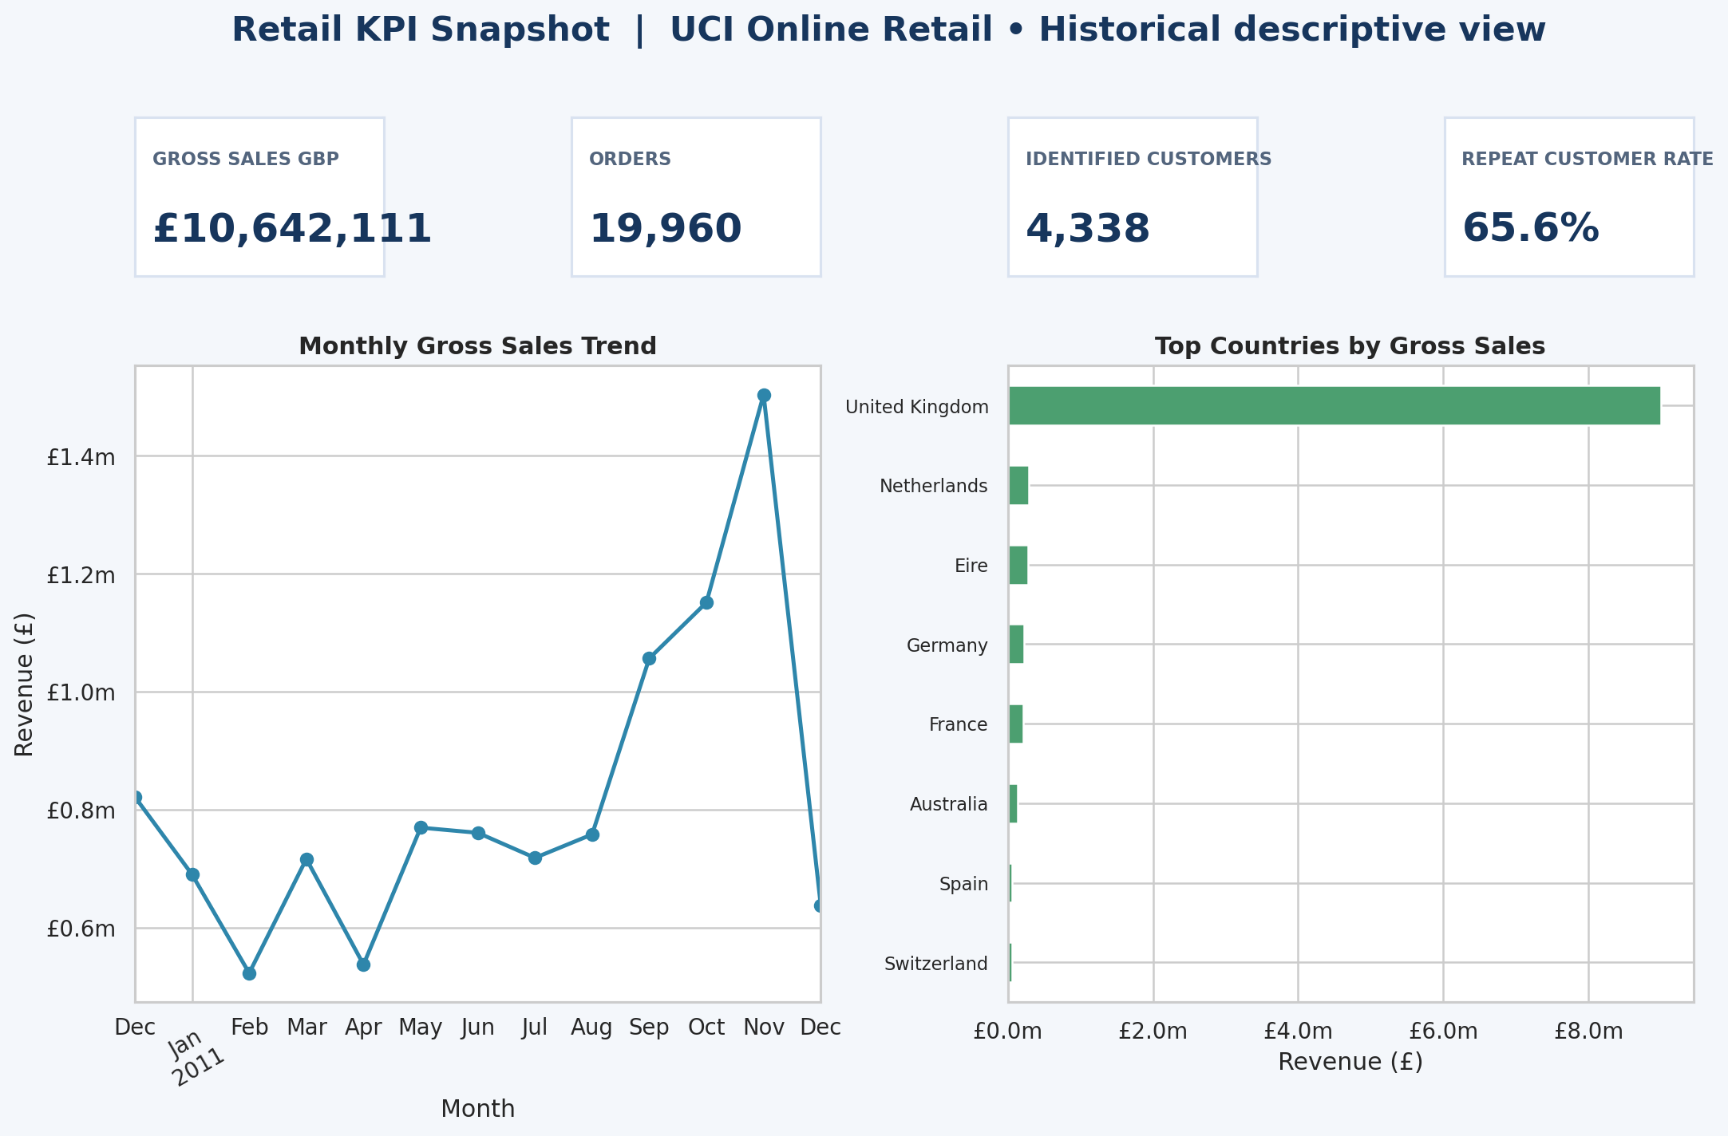
Static dashboard preview; not interactive PBIX.

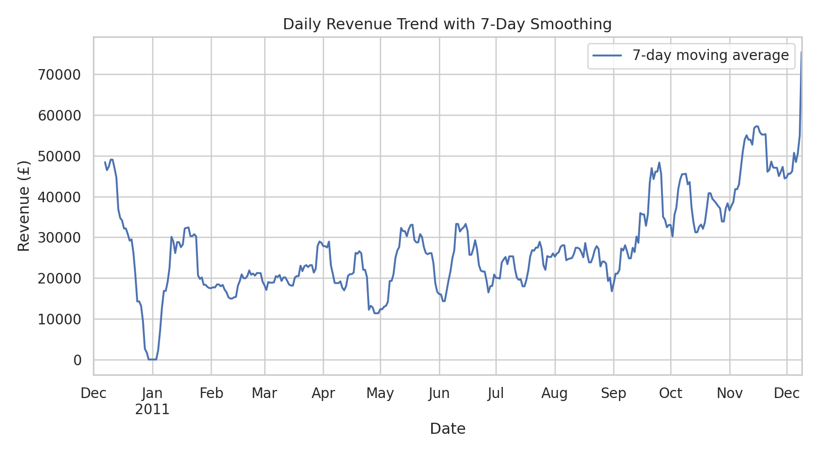
Daily sales and 7-day smoothing.
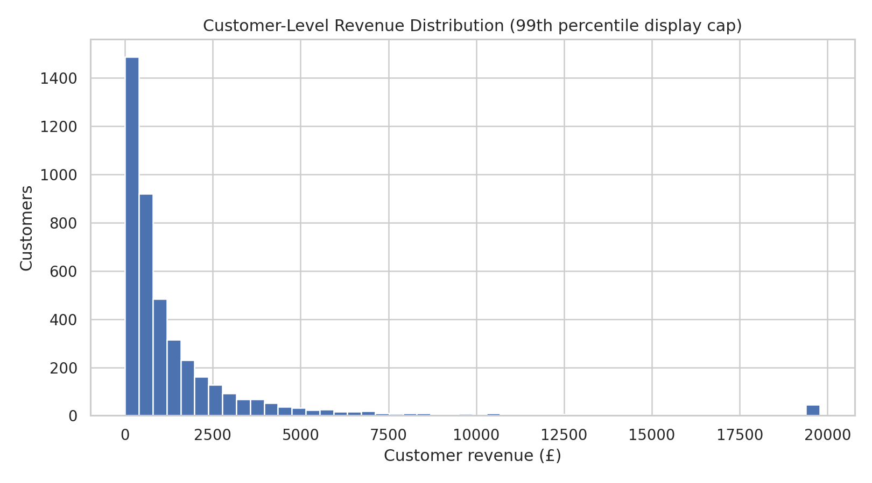
Identified-customer revenue distribution.

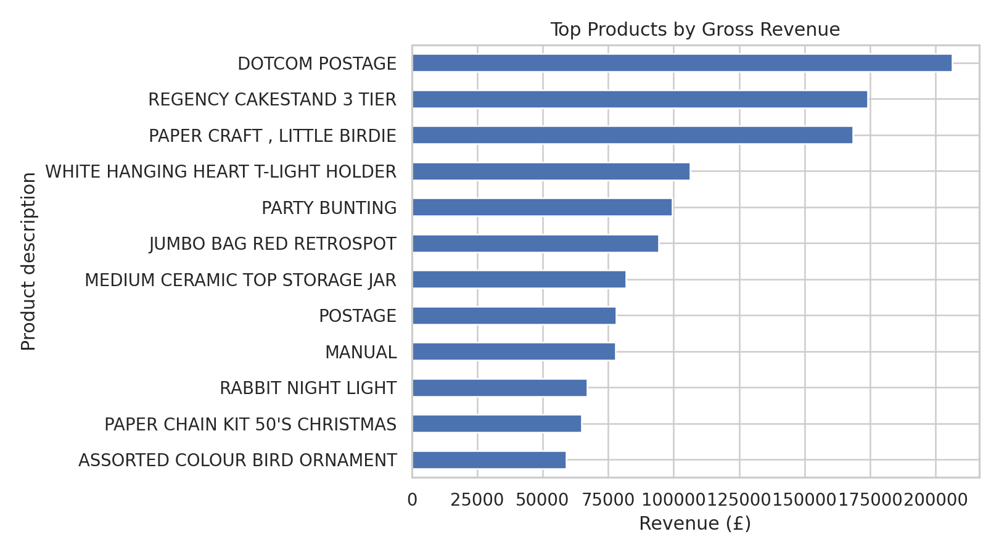
Highest gross-sales products.
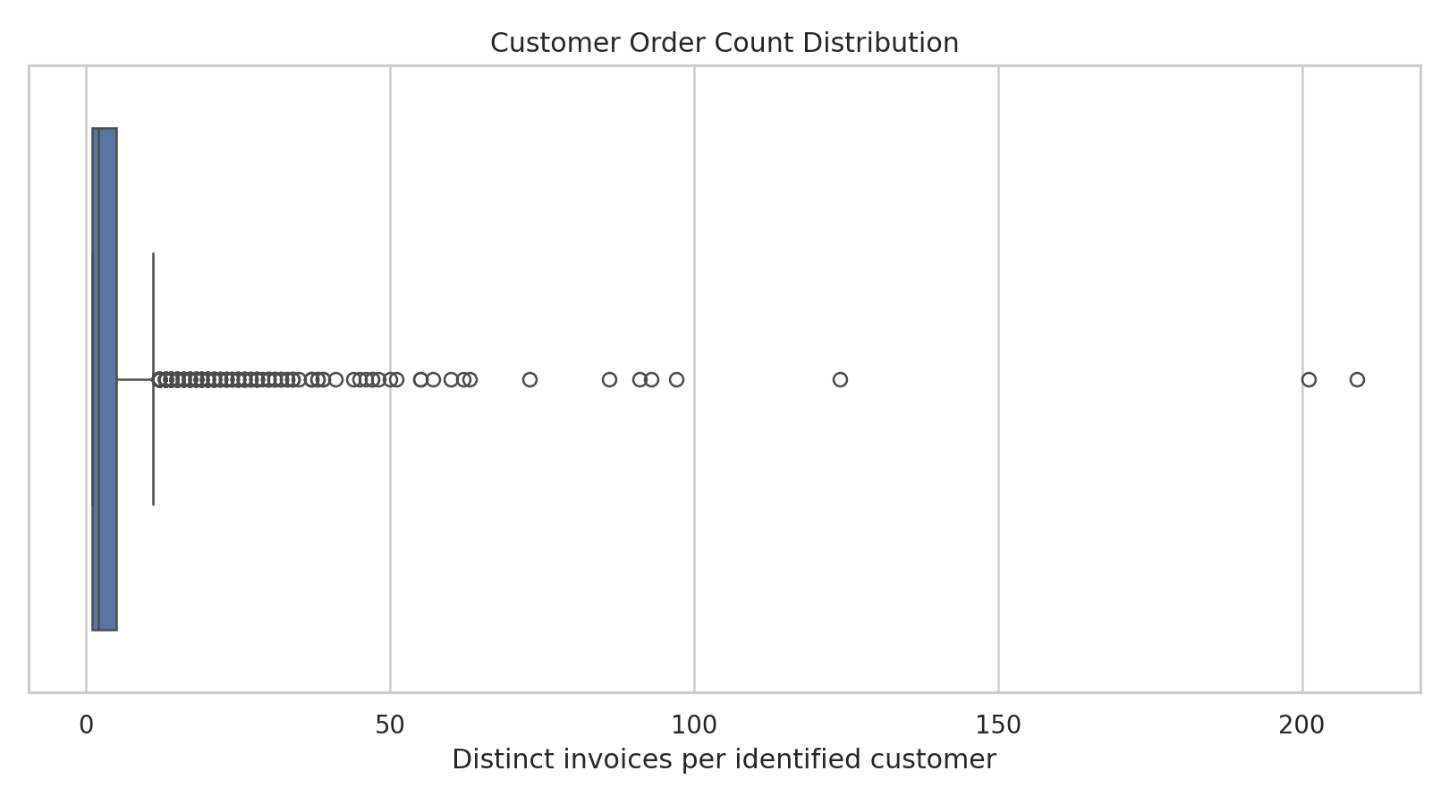
Order-frequency distribution by identified customer.

11. Power BI Dashboard
Power BI build guide defines Overview, Product & Geography, Customer Behavior, and Reconciliation pages, with date/country/product slicers, drill-through, KPI cards, and a calendar relationship. DAX measures cover gross sales, orders, units, identified customers, average order value, cancellations, and month-over-month change. No gross margin measure is invented because cost data are absent. Power BI Desktop is not available in this environment, so the deliverable is a detailed dashboard specification, executable DAX text, and a static dashboard PNG—not a .pbix file.

12. Machine Learning Fundamentals
Task: predict daily gross revenue as a regression exercise. HistGradientBoostingRegressor uses weekday, month, day of month, lagged revenue (1/7/14/28 days) and shifted rolling means (7/28 days). Chronological training ends 2011-09-30; 70-day holdout starts 2011-10-01. Forecast MAE is £16,429.54, RMSE £26,809.95, R² 0.278; weekly-naive MAE is £14,165.99, RMSE £24,334.25. This model loses to the baseline, so the recommendation is not to deploy it. Limited one-year history and holiday/stockout/customer dynamics are limitations; features are based only on available historical target lags.

13. Ten Evidence-Based Business Insights
Ten metric-backed observations, business interpretations, recommendations and limitations are documented in reports/BUSINESS_INSIGHTS.md. Key examples: UK is 84.59% of positive sales; top five countries are 94.05%; repeat order share among identified customers is 65.58%; 16.49% of positive sales revenue belongs to rows without customer ID; the model does not beat weekly-naive forecasting. All are historical descriptive results.

14. Practical Tool Comparison
Tool choice | Prefer when | Example in this portfolio
Python vs Excel | Python: reproducible, larger workflow; Excel: quick manual review | Pipeline and pivot-summary workbook
NumPy vs Pandas | NumPy numeric arrays; Pandas labeled/tabular joins | NaN-aware array demo vs transaction grouping
SQL vs Python | SQL set-based database access; Python modeling/orchestration | MySQL analytical queries vs scikit-learn forecast
Power BI vs Matplotlib | Power BI interactive governed dashboards; Matplotlib reproducible figures | DAX dashboard specification vs 16 static charts
Jupyter vs Colab | Local notebooks with data control vs cloud collaboration | Executed local notebook; Colab alternative only
Scikit-learn vs manual statistics | Scikit-learn predictive pipelines; SciPy explicit tests | Forecast model vs correlation/summary calculations

15. Challenges and Solutions
Missing customer IDs cannot be safely reconstructed, so the work preserves them and scopes customer metrics. Returns/cancellations require clear KPI definitions; separate audit ledger and positive-sales subset avoid mixing them. Extreme values may be legitimate wholesale orders, so no automatic outlier deletion was performed. The small single-year history makes forecasting difficult; a weekly-naive baseline prevents overstating model value. MySQL and Power BI desktop dependencies were unavailable; database scripts and BI design assets are provided, but native applications must run them locally.

16. Learning Outcomes
The artifacts practice real source attribution, quality profiling, careful cohort definitions, null-handling policy, numeric/date types, relational query patterns, visualization communication, temporal validation, baseline comparison, and transparent tool limitations. Reproducible scripts and saved outputs make review easier than isolated screenshots.

17. Limitations and Ethics
Dataset is historical (2010–2011), not representative of a current retailer. Observational correlations are not causal. Data lacks product cost, margin, marketing, inventory/stockout, and customer demographics. CustomerID missingness is material and may be nonrandom. Month-over-month patterns are based on a short period. The regression is a teaching exercise; model quality is inferior to a simple baseline. No personal identifiers should be used to re-identify customers; do not infer individual behavior beyond the dataset scope.

18. Conclusion
The project demonstrates a practical and reproducible workflow spanning raw data intake, cleaning, exploratory analytics, SQL, visualizations, dashboard design, Excel summaries, and a benchmarked ML exercise. Its strongest portfolio signal is honest scope: actual source data, traceable counts, explicit KPI definitions, and a model that is not oversold.

19. References
Chen, D. (2015). Online Retail [Dataset]. UCI Machine Learning Repository. https://doi.org/10.24432/C5BW33. Dataset information: https://archive.ics.uci.edu/dataset/352/online+retail. License: Creative Commons Attribution 4.0 International (CC BY 4.0). Cite the source when reusing the data.

