IVF TREATMENT OUTCOME ANALYSIS
& SUCCESS RATE OPTIMIZATION
Using Python • Synthetic data analytics project
Internship Assessment Submission
Prepared: 1 November 2026
IMPORTANT DISCLAIMER
All records and outcomes are fully synthetic. No actual patient data are used. This report is an educational analytics demonstration and must not be used to guide clinical decisions.

Contents
- Executive Summary
- Introduction and Business Background
- Problem Statement and Objectives
- Dataset Description and Generation
- Data Dictionary Summary
- Data Understanding and Quality Assessment
- Cleaning and Feature Engineering
- Exploratory Data Analysis
- Statistical Analysis
- Visualization Gallery
- Evidence-Based Findings
- Business Recommendations
- Limitations and Ethical Considerations
- Conclusion
- Tools, Reproducibility and Disclaimer

1. Executive Summary
This project builds a reproducible synthetic-data pipeline and examines 5,277 cleaned treatment cycles, 4,672 embryo transfers and 16,928 embryo records. Across initiated cycles, clinical pregnancy was 38.30% and live birth was 32.42%; among embryo transfers, the corresponding rates were 43.26% and 36.62%. These are calculated rates in generated data only. Embryo quality and age groups showed descriptive gradients; treatment differences require cautious, non-causal interpretation.

2. Introduction and Business Background
A fictional fertility clinic seeks descriptive performance indicators spanning patient cohorts, laboratory development, embryo morphology, outcomes, and costs. The analysis models a complete data lifecycle—from seeded data generation to transparent cleaning, testing and communication.

3. Problem Statement and Objectives
The practical question is how a clinic might organize operational monitoring while avoiding causal claims. Objectives: validate linked data; profile quality; describe treatment and outcome distributions; distinguish initiated-cycle and transfer denominators; test selected associations; summarize costs; and propose responsible monitoring.

4. Dataset Description and Generation
Six raw CSVs were generated using NumPy/Pandas and fixed seed 42. The raw cycle table contains 5,365 rows and includes 5,000+ synthetic cycle records before cleaning. Linked tables describe 3,925 patients, cycles, embryo morphology, outcomes, itemized costs and a data dictionary. Controlled missingness, duplicate rows, casing variations and deliberate anomalies were introduced solely to demonstrate cleaning. Valid records enforce biological count ordering and cost-sum consistency.
Table | Raw dimensions | Role
patients.csv | 3,925 × 9 | Patient characteristics
ivf_treatment_cycles.csv | 5,365 × 12 | Cycle and laboratory funnel
embryo_grading.csv | 17,072 × 9 | Embryo morphology
implantation_outcomes.csv | 5,340 × 7 | Follow-up outcomes
treatment_costs.csv | 5,338 × 8 | Cost components
data_dictionary.csv | 45 × 6 | Variable definitions

5. Data Dictionary Summary
Patient variables capture age, BMI, ovarian markers and history; cycle variables record modality, stimulation, laboratory funnel counts and transfer; embryo variables hold developmental day, expansion and ICM/TE grades; outcome variables record sequential pregnancy endpoints and follow-up; cost variables itemize components. Full field-level definitions and expected values are provided in docs/DATA_DICTIONARY.md.

6. Data Understanding and Quality Assessment
Initial profiling includes first/last records, shapes, types, summary statistics, missingness, duplicates, unique categories, primary/foreign keys and logical checks. Profiling evidence is preserved in docs/data_quality_summary.json and docs/DATA_QUALITY_REPORT.md. The cohort is synthetic and represents neither a population nor a clinic.
Dataset | Before | After | Key documented actions
Patients | 3,925 | 3,897 | 25 duplicates; 3 invalid ages; range corrections and imputation
Cycles | 5,365 | 5,277 | 45 duplicates; FK, funnel and contradictory-cascade exclusions
Embryos | 17,072 | 16,928 | 35 duplicates; orphan cycles; recovered missing grades
Outcomes | 5,340 | 5,277 | 20 duplicates; invalid cycles; follow-up resolution
Costs | 5,338 | 5,277 | 18 duplicates; component imputation and total reconciliation

7. Cleaning and Feature Engineering
Cleaning removes documented duplicate keys/records, invalid-age patients and dependent cycles, orphan foreign keys, contradictory biological funnels and invalid outcome cascades. Category labels and dates are standardized; missing values are imputed by documented context where appropriate; 173 cost-total discrepancies were reconciled to component sums. IQR flags identify distributional extremes but are retained unless logically invalid. Full removals and counts are itemized in the quality report.

8. Exploratory Data Analysis
The cleaned cohort has mean age 33.92 years (SD 4.56), mean BMI 25.06, and mean total cost $13,439.89 (median $13,446.29). Of all initiated cycles, 4,672 proceeded to transfer. Outcome funnel and subgroup analyses are descriptive.
Cost component | Mean USD | Share of total spend
Consultation | $611.29 | 4.55%
Medication | $3,690.97 | 27.46%
Laboratory | $4,365.88 | 32.48%
Procedure | $3,798.27 | 28.26%
Additional | $973.47 | 7.24%

9. Statistical Analysis
Binary outcomes were compared with Pearson chi-square tests, reporting Cramer’s V and expected-cell checks. Continuous skewed/counted outcomes use Kruskal–Wallis rank tests with epsilon-squared; Welch comparisons are complemented by nonparametric checks. Pearson and Spearman coefficients are both retained where relevant. The multivariable logistic model reports odds ratios and confidence intervals for selected covariates among transfers. Observations may include repeat cycles per patient, violating strict independence; residual confounding, model specification and synthetic data-generating assumptions limit inferential interpretation.
Test | N | Statistic | p value | Effect size
Best Transferred Embryo Quality vs Implantation (ET Cycles) | 4672 | 138.963 | 6.32e-30 | Cramer's V: 0.1725
Maternal Age Group vs Clinical Pregnancy (ET Cycles) | 4672 | 76.12 | 1.15e-15 | Cramer's V: 0.1276
Maternal Age Group vs Live Birth (Initiated Cycles) | 5277 | 128.957 | 6.51e-27 | Cramer's V: 0.1563
Embryo Day (Day 5 vs Day 3) vs Implantation (ET Cycles) | 4672 | 48.429 | 3.43e-12 | Cramer's V: 0.1023
Treatment Type vs Live Birth (Crude / Unadjusted, Initiated Cycles) | 5277 | 11.294 | 0.0102 | Cramer's V: 0.0463
Transfer Type (FET vs Fresh) vs Live Birth (ET Cycles) | 4672 | 1.164 | 0.281 | Cramer's V: 0.0162
Infertility Type (Primary vs Secondary) vs Live Birth (ET Cycles) | 4672 | 4.262 | 0.039 | Cramer's V: 0.0307
BMI Category vs Clinical Pregnancy (ET Cycles) | 4672 | 3.712 | 0.294 | Cramer's V: 0.0282
Total Treatment Cost across Treatment Types | 5277 | 3040.754 | 0 | Epsilon-squared (eps^2): 0.5763
Retrieved Oocytes across Stimulation Protocols | 5277 | 497.016 | 2.11e-107 | Epsilon-squared (eps^2): 0.0942
Maternal Age: Live Birth Yes vs No (ET Cycles) | 4672 | -10.011 | 2.6e-23 | Cohen's d: -0.2999
Consultation Cost: Live Birth Yes vs No (ET Cycles) | 4672 | 0.491 | 0.624 | Cohen's d: 0.0149

10. Visualizations
Eighteen 300-DPI charts cover demographics, lab funnel, morphology, outcome denominators, cost distribution, outliers, correlations, treatment stratification and model estimates. Captions describe the analytical purpose; charts are generated by src/statistical_analysis_and_charts.py.
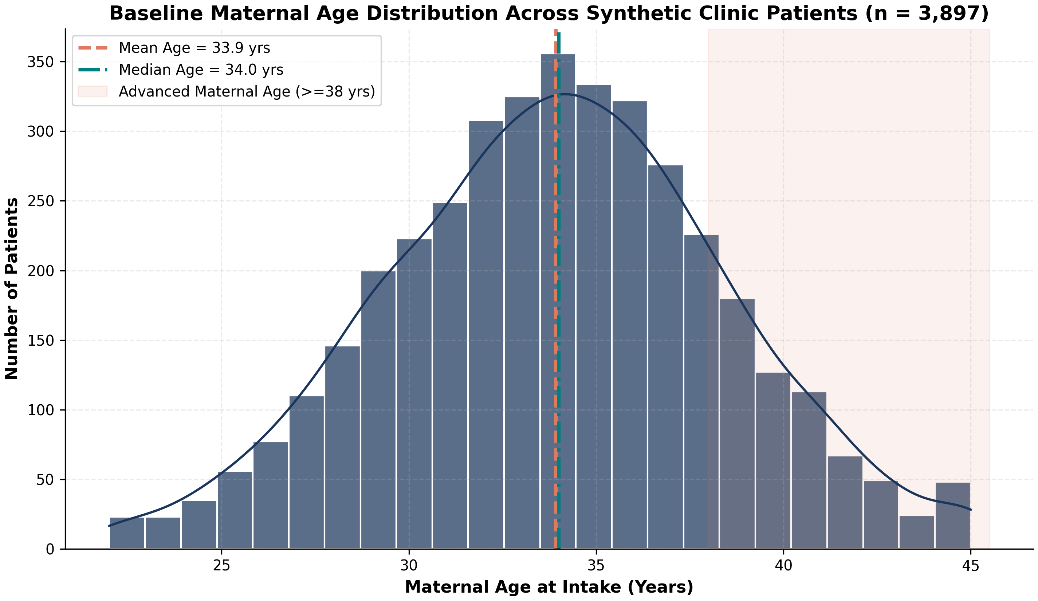
Figure 1. Synthetic patient age distribution.
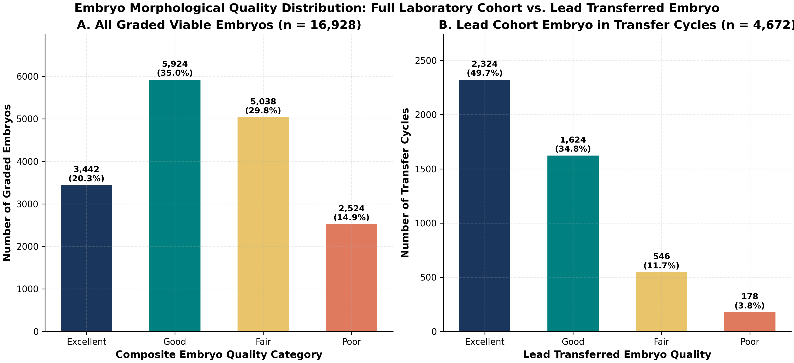
Figure 2. Embryo quality categories.
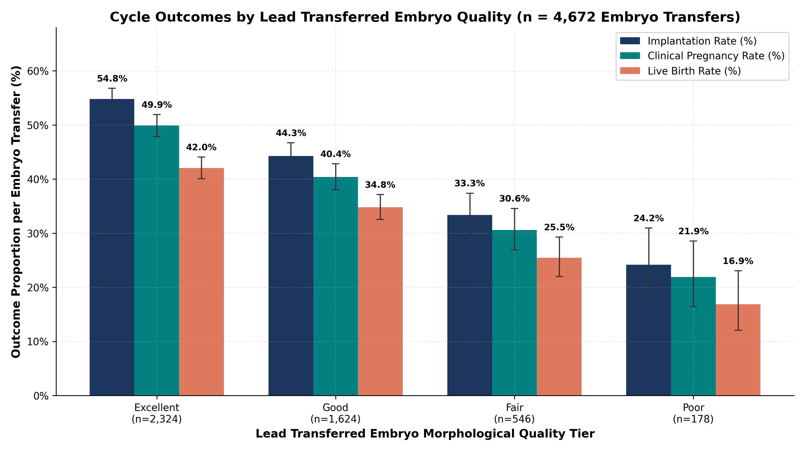
Figure 3. Cycle outcomes by best transferred embryo quality; denominator is transfers.

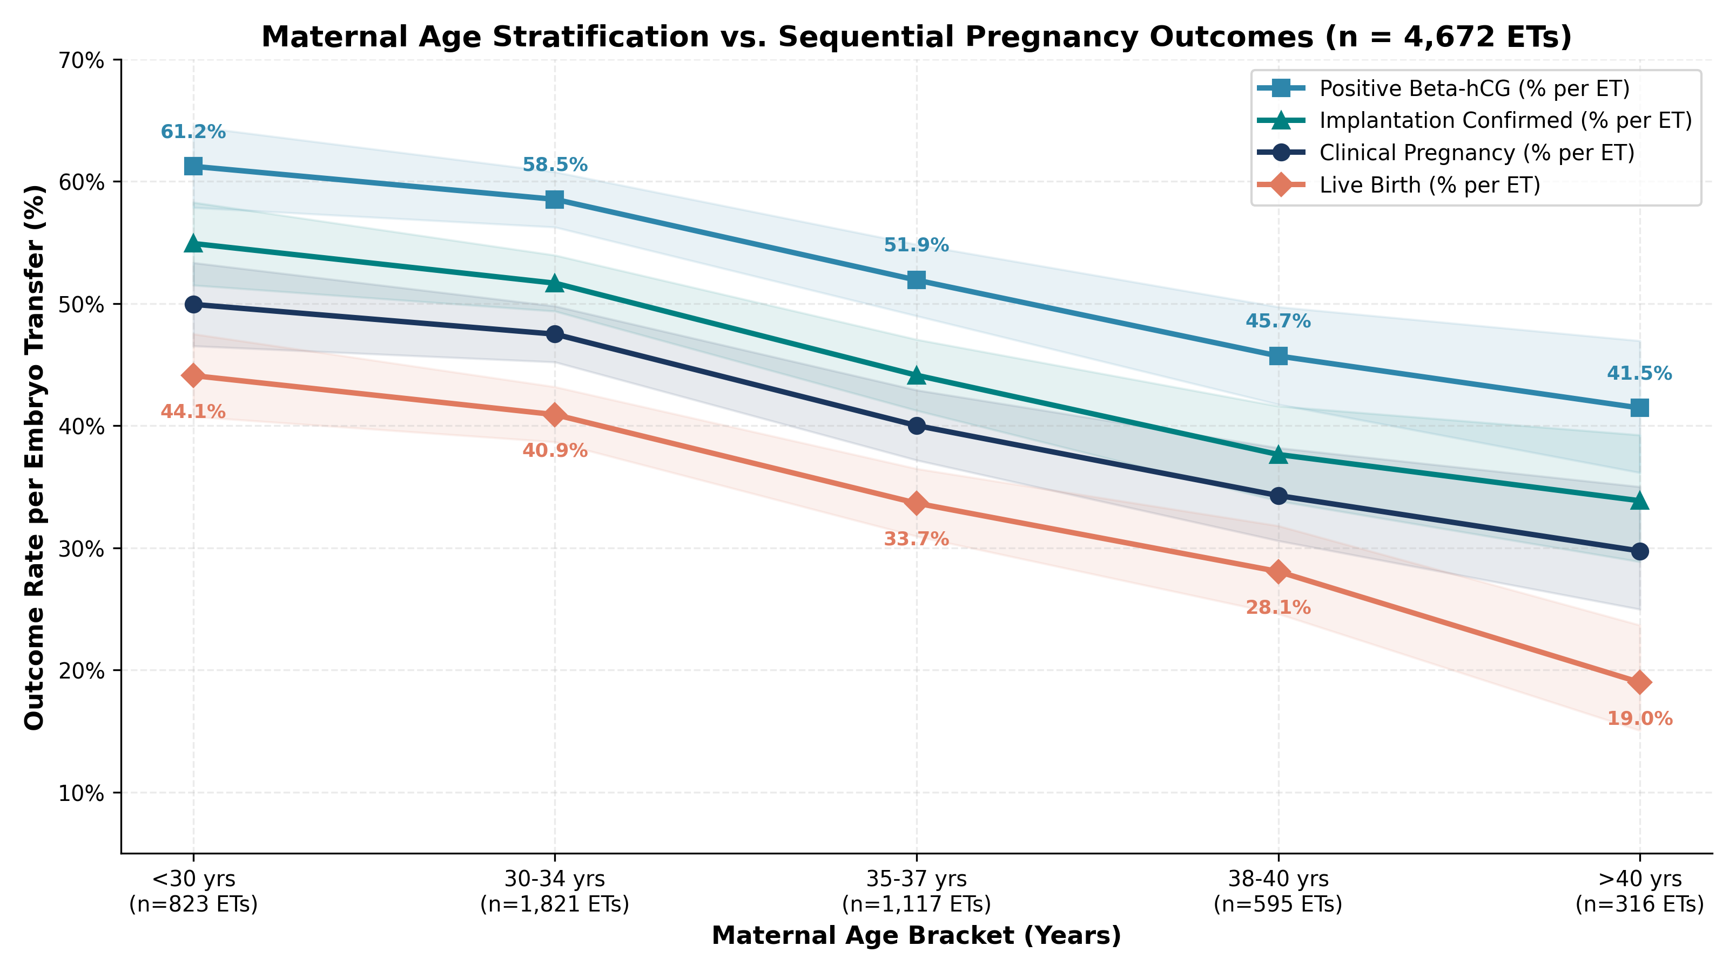
Figure 4. Sequential outcomes by age; denominator is embryo transfers.
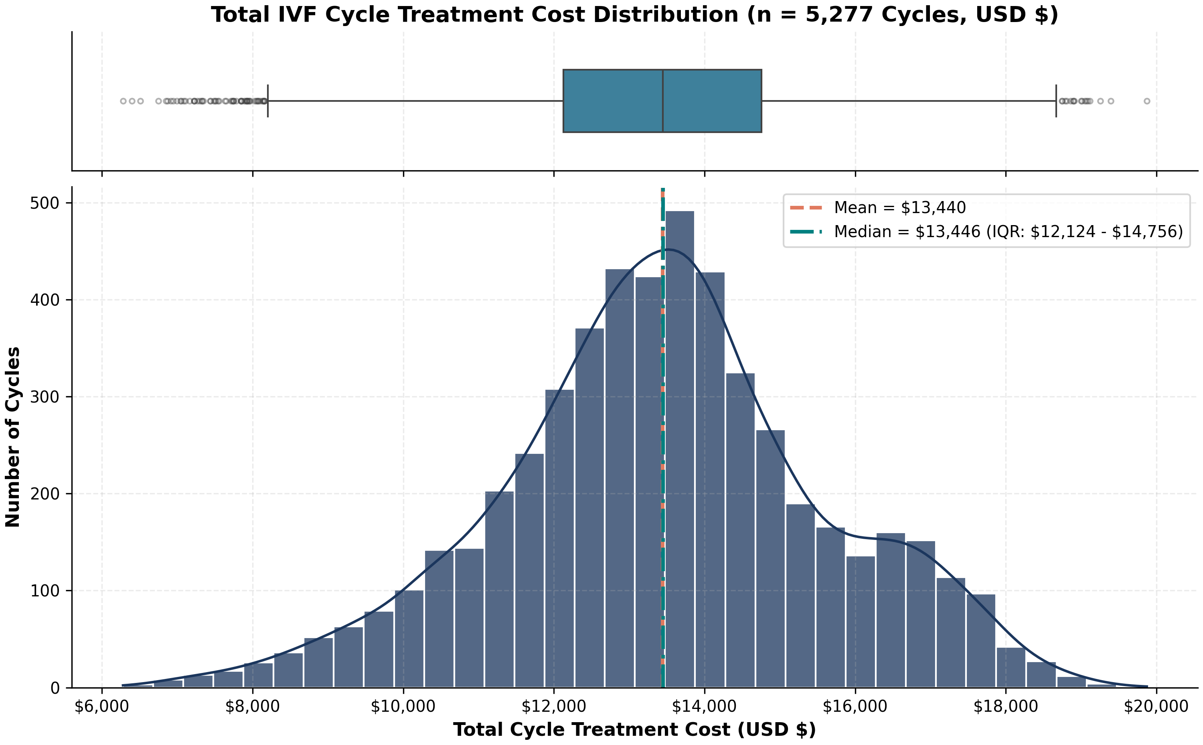
Figure 5. Synthetic treatment-cost distribution.

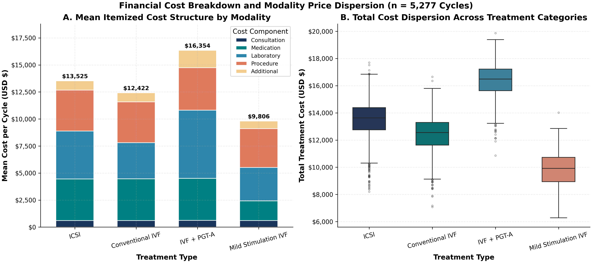
Figure 6. Itemized cost comparison by modality.
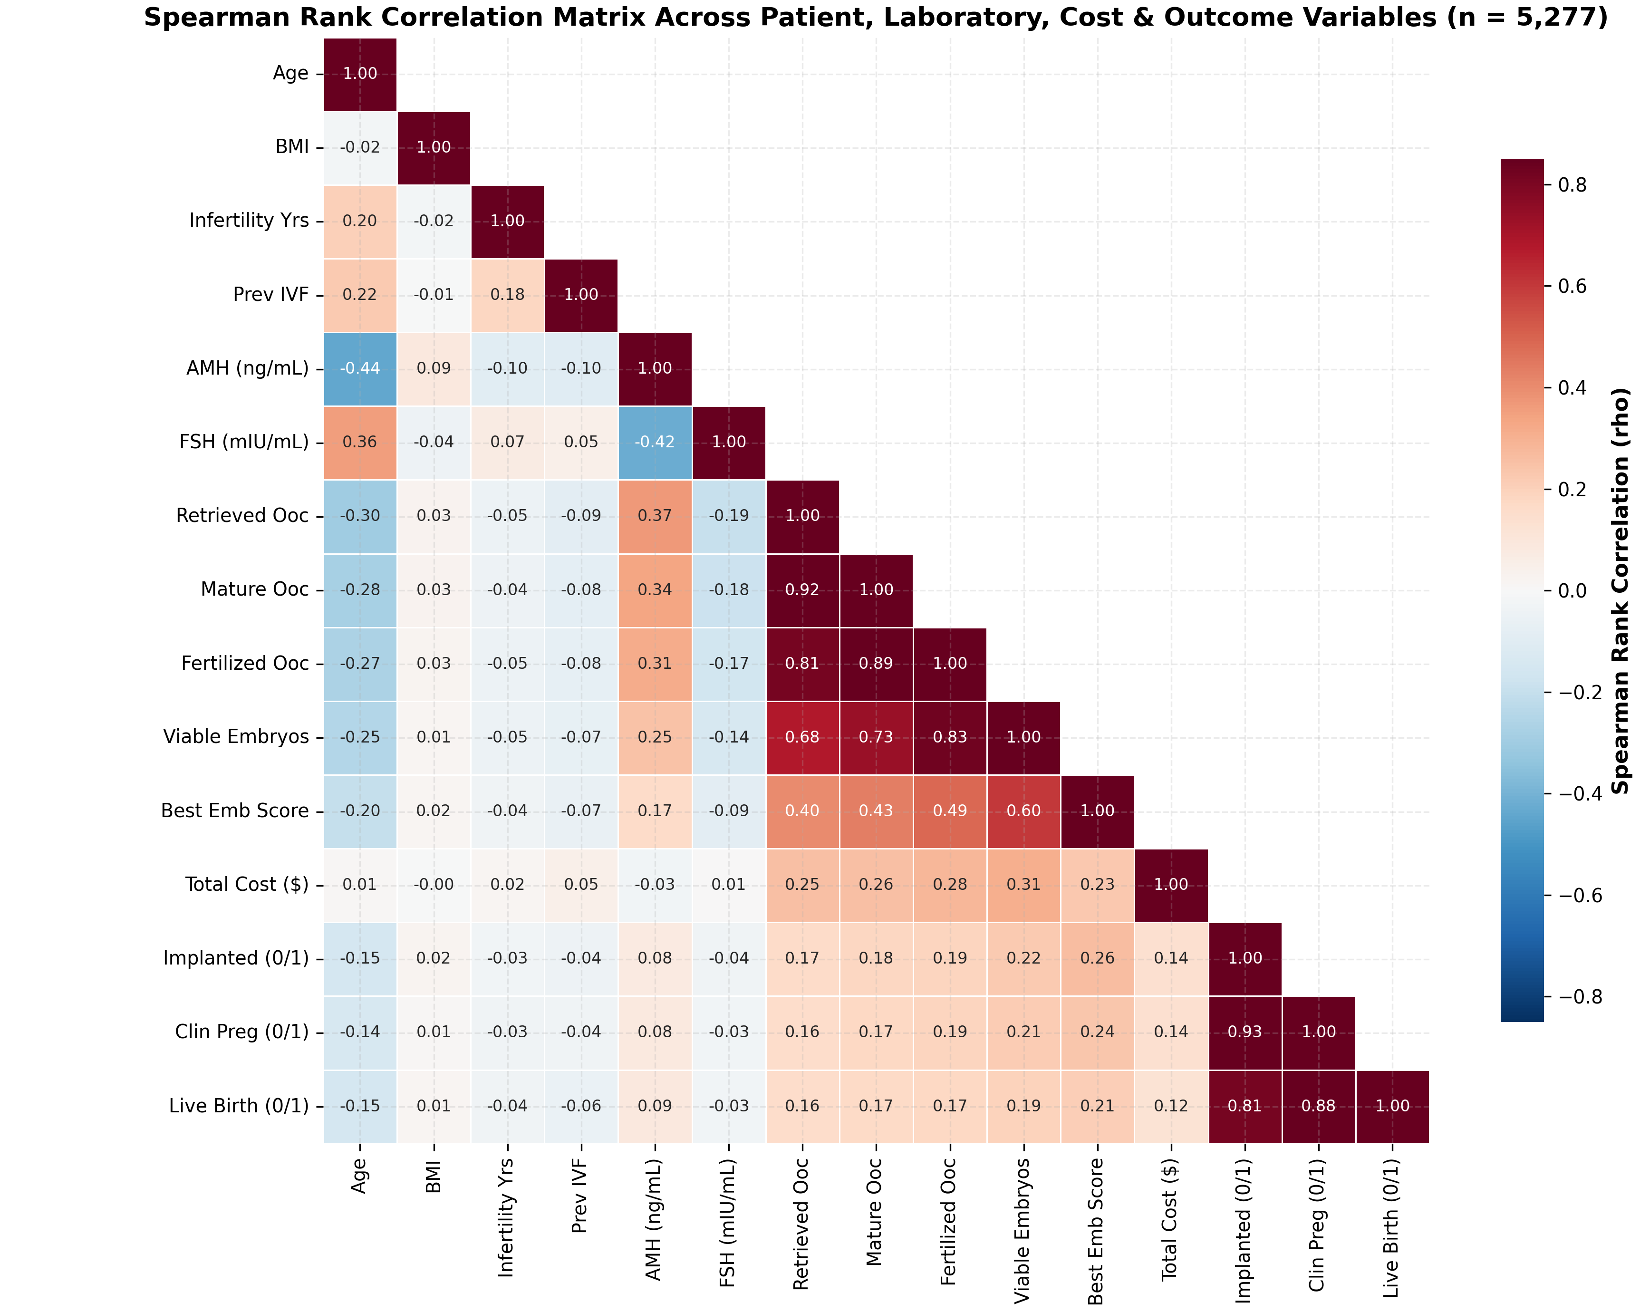
Figure 7. Spearman correlation matrix; association is not causation.

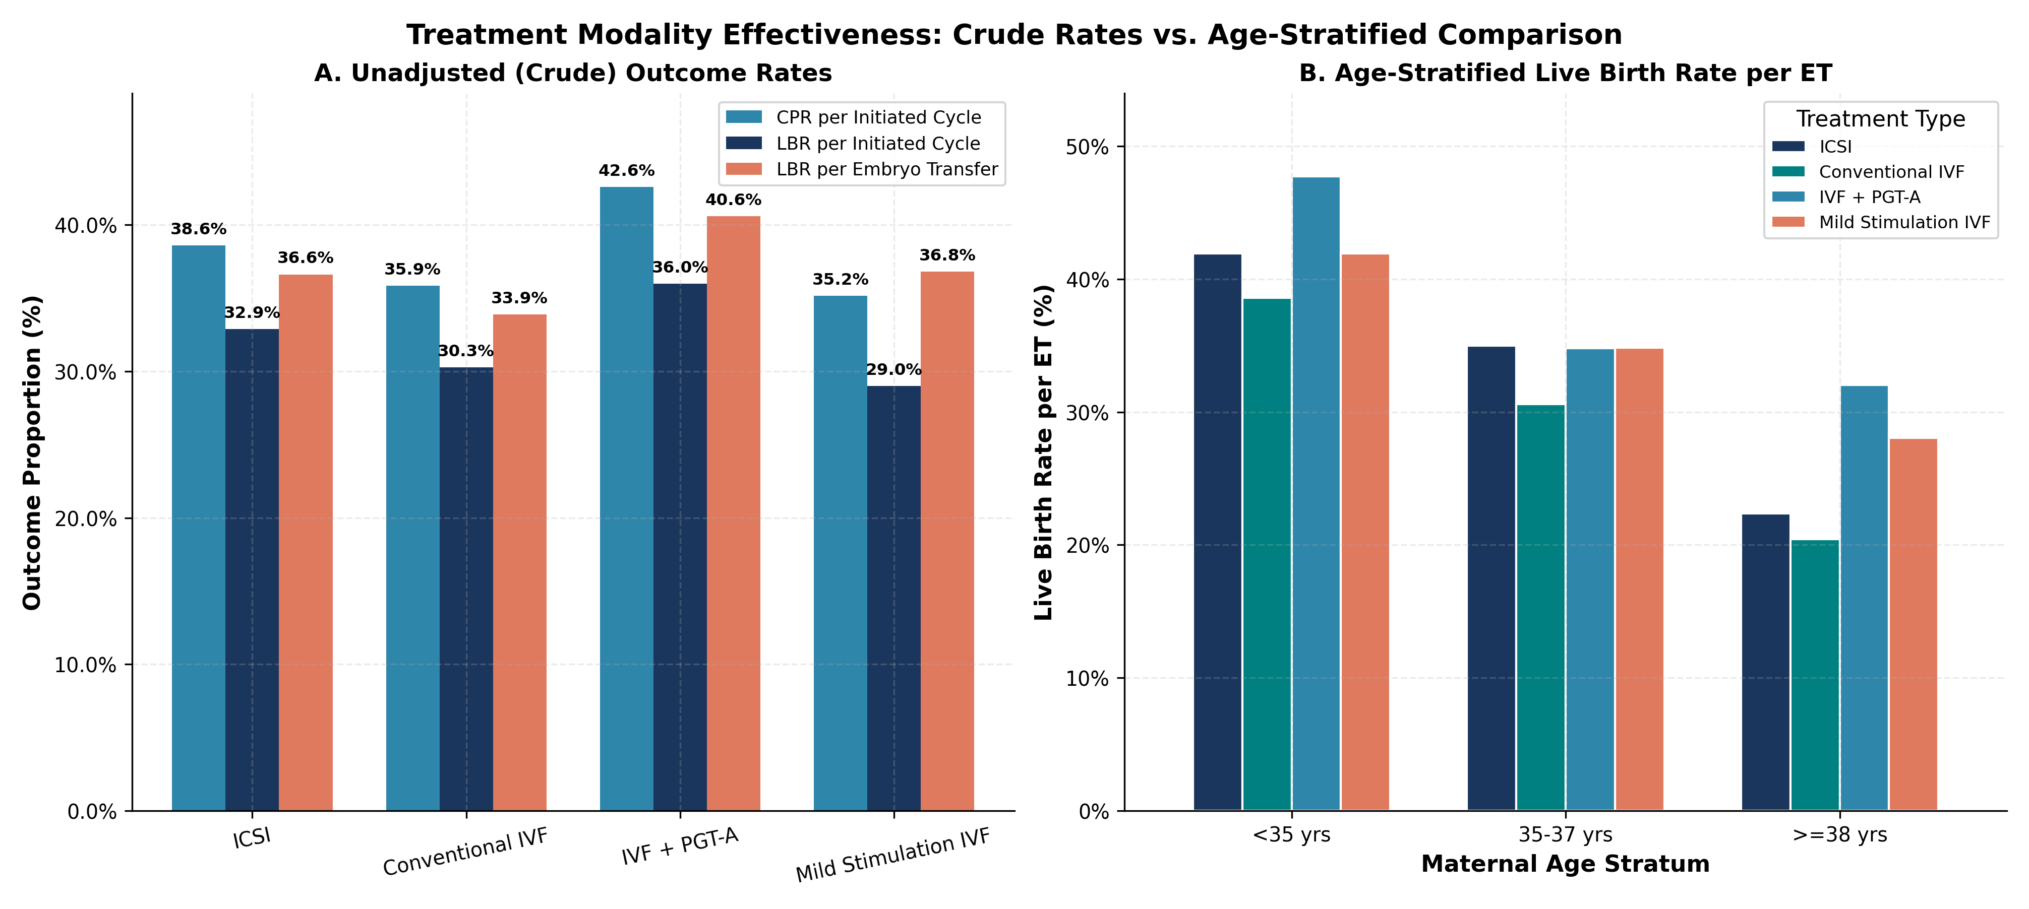
Figure 8. Crude and age-stratified modality comparison; not causal.
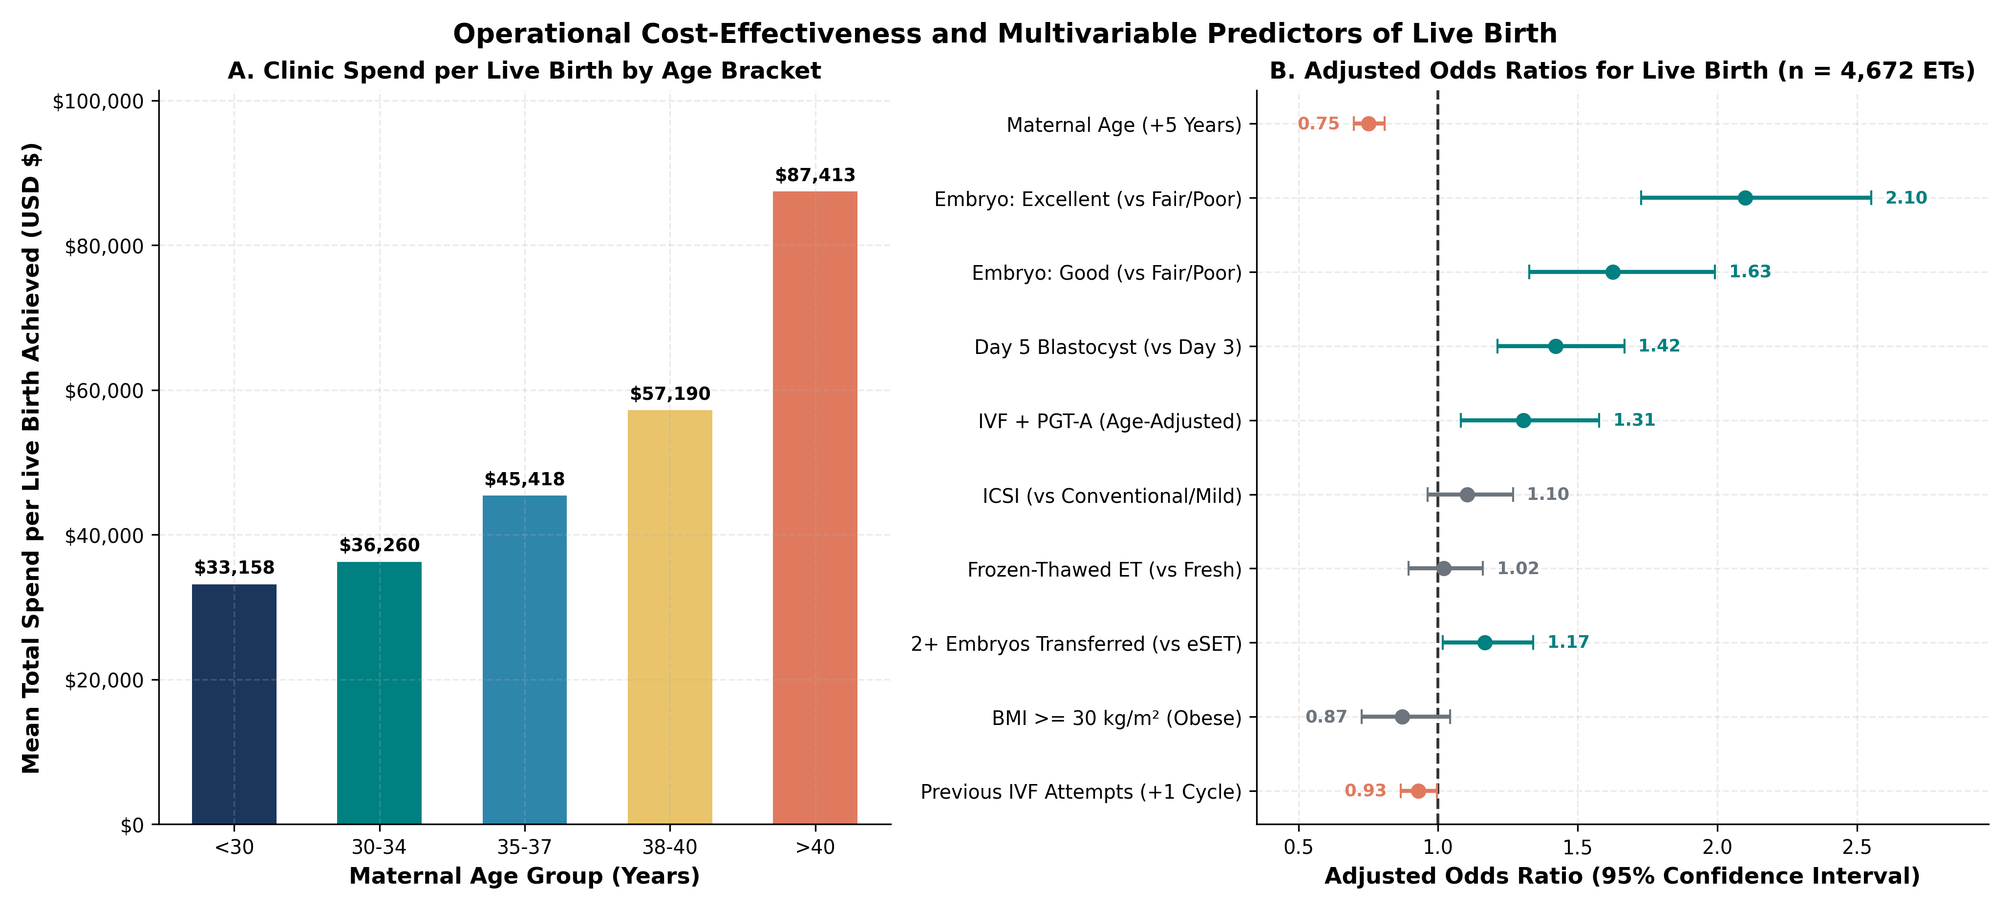
Figure 9. Cost-per-observed-live-birth and adjusted model associations; not decision guidance.

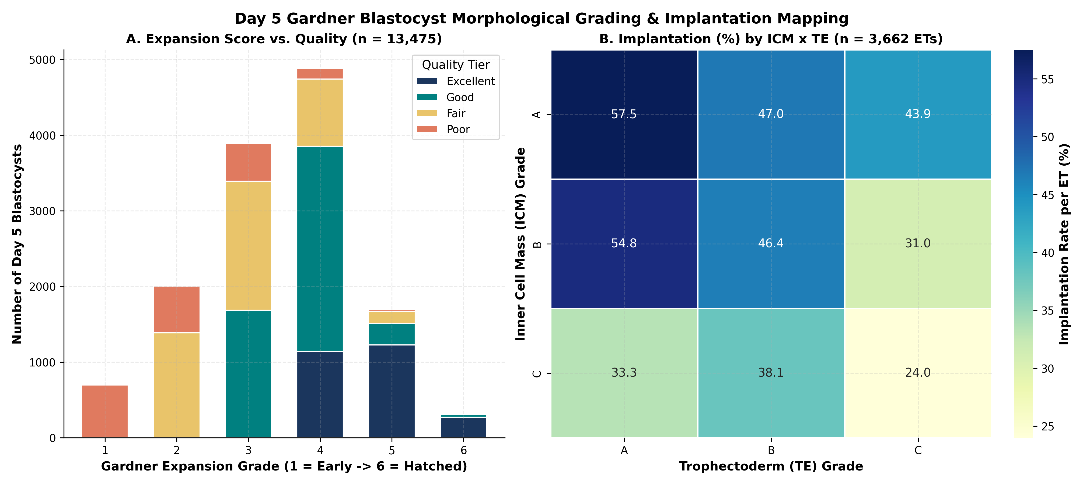
Figure 10. Day 5 morphology and implantation mapping.
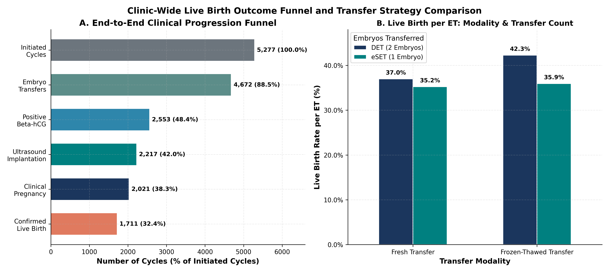
Figure 11. Outcome funnel and transfer strategy descriptions.
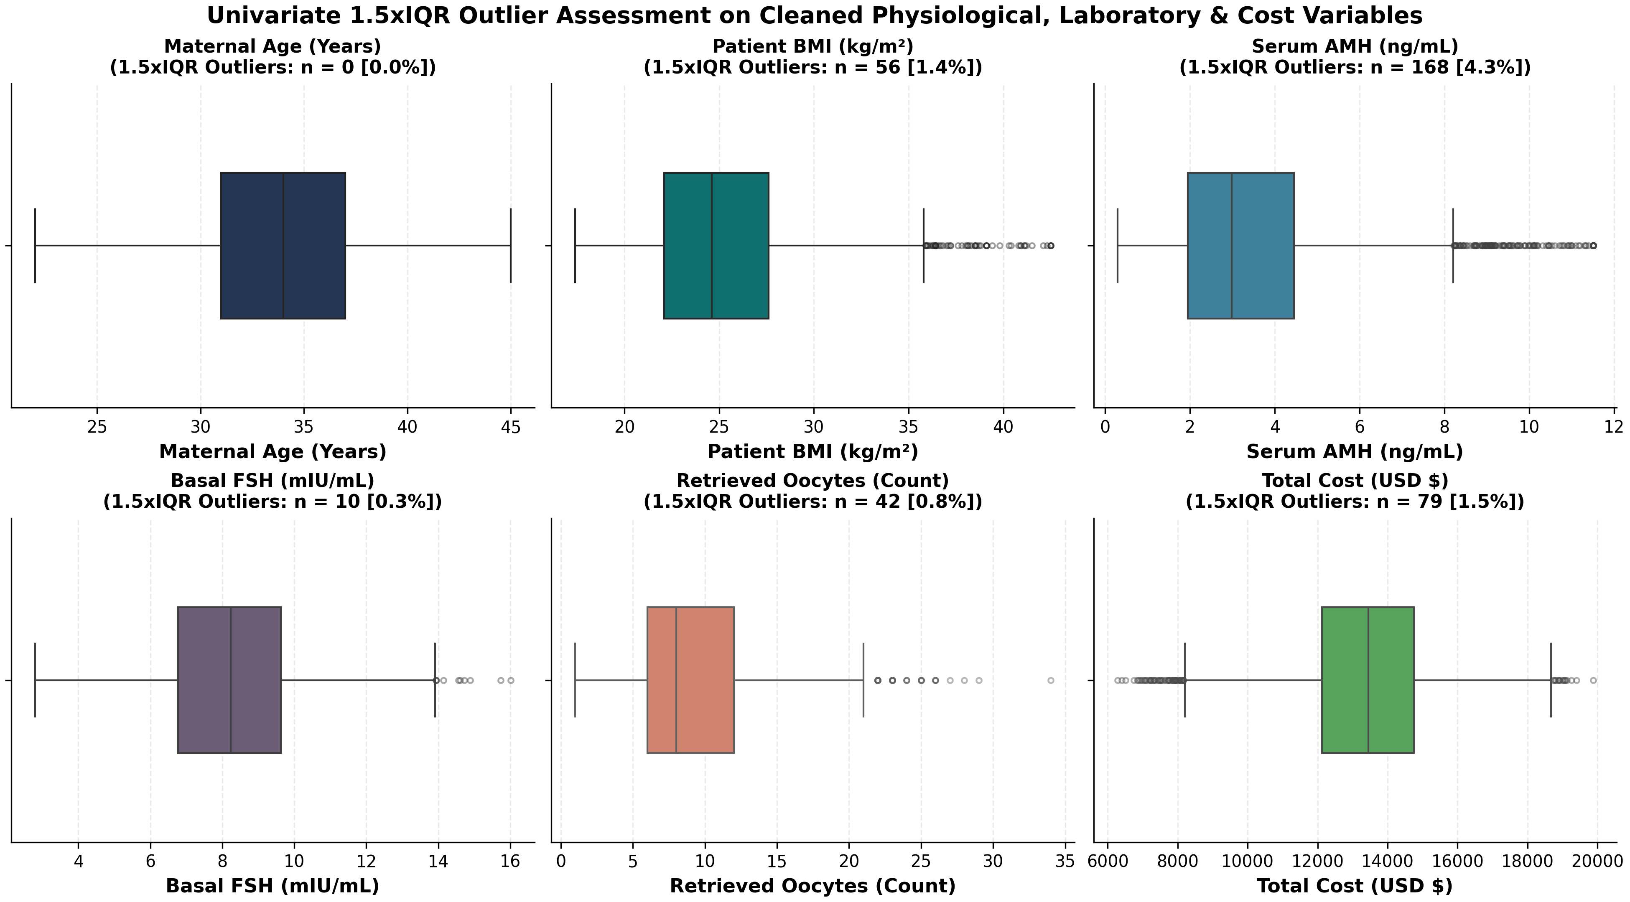
Figure 12. IQR outlier audit; statistical flags are not necessarily errors.

11. Evidence-Based Findings
(1) Lead-embryo quality gradient: excellent-quality transfer cycles show 42.04% live birth per transfer versus 16.85% for poor-quality transfers; this is an association in synthetic data, with subgroup selection and uncertainty. (2) Age gradient: transfer live-birth proportion is 44.11% below 30 and 18.99% above 40. (3) Day 5 versus Day 3 best-transfer groups show 38.67% versus 29.21% live birth per transfer. (4) BMI and live birth association is weak and nonsignificant in this generated cohort (Spearman rho 0.010, p=0.491). (5) IVF+PGT-A has higher crude cost and outcome rate than conventional IVF, but these unrandomized simulated groups do not estimate a treatment effect.

12. Business Recommendations
Use a transparent cycle funnel dashboard, reporting initiated-cycle and transfer denominators separately, follow-up completion, subgroup counts and uncertainty intervals. Monitor missingness, cancellations, laboratory conversion, itemized cost shares and distributions over time. For real operational evaluation, preregister a protocol, use appropriately governed real-world data, account for repeat patients and selection, and involve clinical/statistical review. Do not use these findings to select treatment.

13. Limitations and Ethical Considerations
This is entirely synthetic data and its distributions are chosen for demonstration. Artificial generation cannot establish external validity. Repeated patient cycles, eligibility/transfer selection, measurement and follow-up assumptions, residual confounding and multiple comparisons may distort association estimates. Some p-values are small because sample sizes are large; effect sizes must be considered. No individual prediction or medical recommendation is intended.

14. Conclusion
The project demonstrates reproducible generation, data auditing, cleaning, linked-table validation, descriptive/statistical analysis, visualization and responsible communication. Observed synthetic gradients can motivate questions for monitoring, not clinical conclusions.

15. Tools, Reproducibility and Disclaimer
Python 3; NumPy; pandas; SciPy; Matplotlib; Seaborn; scikit-learn; Jupyter; python-docx. From the project root install requirements and run `python src/generate_synthetic_data.py`, `python src/clean_and_preprocess.py`, `python src/statistical_analysis_and_charts.py`, then execute the notebook. The fixed seed is 42. The dataset contains no real patient records, and findings cannot guide clinical patient decisions.

References and Dataset Disclaimer
No external clinical references are cited; this report summarizes a generated educational dataset and locally executed code. Tool documentation may be consulted for software usage. Synthetic records and findings do not represent clinical evidence.

