Data Science Fundamentals Assessment
Python • Statistics • Data Analysis • Model Evaluation
Candidate: [Your name]
Institution: [Your institution]
Submission date: [Enter date]
Repository URL: https://github.com/appureddy1102-cloud/data-science-fundamentals-assessment-professional

Table of Contents
In Microsoft Word, right-click the field and select Update Field → Update entire table.

Executive Summary
This project builds a verified Python fundamentals and statistics workflow using a clearly labeled synthetic retail CSV and a separate eight-value worked example. The raw retail file contains 122 rows, including two exact duplicates and three missing unit values. Cleaning produces 120 records with $16,485 simulated gross revenue. Six figures and a machine-readable output summary are generated by the executed notebook. Statistical calculations are checked with NumPy and SciPy; classification and regression measures are calculated from fixed hypothetical labels and predictions, not from a trained model. Results are educational and cannot be generalized to actual retail activity. The project was executed in the listed Python environment; Windows setup remains untested.

Introduction and Objectives
The objectives are to explain executable Python, distinguish computational and analytical data types, develop statistical reasoning with explicit calculations, carry out reproducible data preparation and visualization, interpret machine-learning evaluation measures, and follow responsible engineering practices. The only supplied assessment guidance is the user’s instructions; no separate rubric was provided. QUALITY_AUDIT.md maps requirements to evidence. Recommendations beyond those instructions are best practices, not invented scoring requirements.

Python Fundamentals
A variable binds a name to an object. Python has no enforced constants; uppercase names such as TAX_RATE conventionally signal values that should not change. Use descriptive snake_case names and # comments to explain non-obvious intent. The complete script is executable; the following examples and outputs were verified during notebook execution.
Concept and definition | Syntax / example | Verified output / explanation
Basic types | type(3), type(12.5), type("x"), type(True), type(None) | int, float, str, bool, NoneType; None represents absence.
Conversion / checking | int("12"), float("2.5"), str(42), isinstance(3, int) | 12, 2.5, "42", True; invalid conversions can raise ValueError.
Arithmetic | 7+2, 7-2, 7*2, 7/2, 7//2, 7%2, 7**2 | 9, 5, 14, 3.5, 3, 1, 49; // is floor division.
Comparison, logic, assignment | count = 3; count += 2; count == 5; not True | count is 5; equality True; negation False.
Membership | 2 in [1, 2, 3] | True; membership tests whether a value is present.
Strings | " Data Science ".strip().lower(); "Data"[0:4] | "data science", "Data"; indexing is zero-based and slices exclude the end.
List | items = ["pen", "book"]; items.append("ruler") | ["pen", "book", "ruler"]; ordered and mutable.
Tuple, set, dict | (2,3); {"a","a","b"}; {"name":"Asha"}["name"] | Tuple is fixed; set removes duplicates (length 2); dict maps keys to values (Asha).
Conditionals | if count > 5: ...  elif count == 5: ...  else: ... | With count=5, the elif branch gives medium.
Loops | for n in range(6): ...; while counter < 3: ... | continue skips 2; break stops at 5; collected [0,1,3,4]; while counter ends at 3.
Functions and scope | def total_cost(units, unit_price): return units * unit_price | total_cost(3,12.5) → 37.5; parameters and local names belong to the function scope.
Comprehension | [x*x for x in range(5) if x%2 == 0] | [0, 4, 16]; concise transformation plus filter.
Exceptions | try: value=int(text)  except ValueError: ...  else: ...  finally: ... | "4" → 8, "bad" → invalid integer. else runs on success; finally runs in either case.
Files and modules | Path(...).write_text(...); Path(...).read_text(...); import math | Temporary UTF-8 file reads hello; math.sqrt(16) → 4.0.
Debugging and testing | assert total_cost(3, 12.5) == 37.5 | Assertion passes; use a debugger/breakpoints and inspect variable values for failures.
Virtual environments isolate project packages: python -m venv .venv creates one; install requirements using that environment’s Python. A module is an importable Python file or package. Avoid masking built-in modules with local filenames such as statistics.py.

Data Types and Data Structures
A Python data type describes how a value is represented and manipulated in code. A data-science type describes what the value means and which analyses are valid; a numeric-looking code can be a nominal category rather than a quantity.
Analytical type | Example / representation | Appropriate treatment and risk
Discrete numerical | Units = 3; nullable integer | Count; averaging is meaningful, but missing values must be represented explicitly.
Continuous numerical | Temperature 21.5 °C; float | Measures can take fractional values; floating-point rounding can occur.
Nominal categorical | Category = Books; string/category | Labels have no order; arbitrary numeric codes do not imply magnitude.
Ordinal categorical | Satisfaction: low, medium, high; ordered category | Order is meaningful, but equal spacing is not guaranteed.
Boolean / text | is_active=True; review="good" | Boolean is a flag; text may require cleaning and should not be blindly averaged.
Date / time | 2025-01-01; datetime64 | Allows time grouping; use a timezone for timezone-sensitive timestamps.
Structured / semi-structured / unstructured | CSV table / JSON object / image or free text | Schema is fixed / flexible / not readily tabular; use suitable storage and parsing.
NumPy arrays are homogeneous, compact and support vectorized operations; a Pandas Series is a labeled one-dimensional array and a DataFrame is a labeled table of Series with potentially different dtypes. Validate ranges and domain values, parse dates explicitly, use nullable integers for missing counts, and preserve IDs as strings to retain leading zeros. Missing is not zero; invalid (negative units) and inconsistent (" books ") values require distinct treatment.

Statistical Foundations and Worked Calculations
Separate illustrative dataset: x = [2, 4, 4, 4, 5, 5, 7, 9], n=8, sum=40. The results below are independently computed in the notebook. They do not describe the retail dataset. Definitions: xᵢ is an observation, x̄ its mean, n the number of observations; Σ denotes summation.

Descriptive measures
Measure / formula | Substitution and result | Interpretation
Mean x̄ = Σxᵢ/n | 40/8 = 5 | Arithmetic center.
Median | (4th + 5th)/2 = (4+5)/2 = 4.5 | Half of ordered values lie on either side.
Mode | 4 occurs 3 times | Most frequent value; there can be multiple modes.
Min, max, range | 2, 9; 9−2 = 7 | Total observed span.
Q1, Q3, IQR | Q1=4; Q3=5.5; IQR=5.5−4=1.5 | Pandas linear interpolation: positions (n−1)p yield Q1 at 1.75 and Q3 at 5.25, zero-based.
Population variance σ² = Σ(xᵢ−x̄)²/n | (9+1+1+1+0+0+4+16)/8 = 32/8 = 4 | Population SD = √4 = 2.
Sample variance s² = Σ(xᵢ−x̄)²/(n−1) | 32/7 = 4.5714 | Sample SD = √(32/7) = 2.1381; n−1 corrects for estimating the mean.
Frequency / proportion | 4 occurs 3 times; 3/8 = 0.375 | 37.5% of observations equal 4.
Skewness | Pandas adjusted Fisher–Pearson skew = 0.8185 | Positive skew indicates a longer right tail; skew estimates are unstable for n=8.
Percentile p is the value at or below which approximately p% of observations fall, subject to the chosen interpolation convention. Here the 25th percentile is Q1=4 and the 75th is Q3=5.5. The 1.5×IQR fences are 4−2.25=1.75 and 5.5+2.25=7.75, so 9 is flagged. A flag is not proof of error; avoid automatic removal.

Probability, sampling and inference
For an event A, P(A)=count(A)/count(all) when outcomes are equally likely; 0≤P(A)≤1, P(not A)=1−P(A), and P(A or B)=P(A)+P(B)−P(A and B). From the eight values, A = x≥5 has P(A)=4/8=0.5 and B = x≥7 has P(B)=2/8=0.25. Because B is contained in A, P(A and B)=2/8=0.25 and P(B|A)=P(A and B)/P(A)=0.25/0.5=0.5. These events are dependent because 0.5 differs from P(B)=0.25. For independent events, P(A and B)=P(A)P(B); two fair independent coin heads have probability 0.5×0.5=0.25.
Binomial X~Bin(n,p) counts successes in n independent trials with constant success probability p. P(X=k)=C(n,k)pᵏ(1−p)ⁿ⁻ᵏ. For n=4, k=2, p=0.5: 6×0.5²×0.5²=0.375. A normal distribution is continuous and symmetric, described by mean μ and standard deviation σ. Standardize z=(x−μ)/σ; for Z~N(0,1), P(Z≤1.96)=0.9750 (SciPy). These distributions are assumptions, not automatically appropriate for every dataset.
A population is the whole group of interest; a sample is the observed subset. Simple random sampling gives each unit equal selection probability; stratified sampling draws within defined subgroups; cluster sampling samples groups; convenience sampling recruits accessible units and can bias results. Nonresponse, selection and measurement bias threaten representativeness; increasing n alone does not correct systematic bias.
Standard error of the sample mean SE = s/√n = 2.1381/√8 = 0.7559. A two-sided 95% t interval is x̄ ± t₀.₉₇₅,₇ × SE = 5 ± 2.3646 × 0.7559 = [3.2125, 6.7875]. Under repeated independent random sampling and a suitable normal model, 95% of intervals generated by this method cover the fixed population mean; this specific illustrative array was not randomly sampled, so it is not a real population inference. For small samples, check independence and approximate normality; severe skew or outliers weaken this interval.
For a one-sample t test, H₀: μ=4 versus H₁: μ≠4; t=(x̄−μ₀)/(s/√n)=(5−4)/0.7559=1.3229, df=7, two-sided p=0.2275. At α=0.05 we fail to reject H₀; this does not prove H₀ true. The standardized mean difference Cohen’s d=(x̄−μ₀)/s=1/2.1381=0.4677; its practical importance depends on the measurement context. Inference assumptions are the same as for the interval. A p-value is the probability, under the null model, of a test statistic at least as extreme as observed, not the probability that H₀ is true.
For an illustrative chi-square test of independence, observed table [[8,2],[4,6]] has row totals 10 and column totals 12 and 8. Expected Eᵢⱼ=(row total×column total)/20 gives [[6,4],[6,4]]. χ²=Σ(O−E)²/E=4/6+4/4+4/6+4/4=3.3333, df=(2−1)(2−1)=1, p=0.0679, without Yates correction. At α=0.05 do not reject independence. Two expected cells are below 5; asymptotic approximation is questionable, so consider Fisher’s exact test and a larger independent sample. This is an illustrative contingency table, not a retail-data result.
A Type I error rejects a true null; its nominal probability is α when assumptions hold. A Type II error fails to reject a false null; power = 1−β depends on effect, sample size and design. Statistical significance is not the same as practical significance; report effect sizes and uncertainty alongside p-values.
Sample covariance cov(x,y)=Σ(xᵢ−x̄)(yᵢ−ȳ)/(n−1); Pearson r=cov(x,y)/(sₓsᵧ). For illustrative y=2x, cov(x,y)=64/7=9.1429 and r=1 because every point lies exactly on a positive straight line. Correlation measures linear association and can be sensitive to outliers; it does not establish causation. Confounding, reverse causation and selection bias are alternative explanations.

Practical Data Analysis and Methodology
The separately generated synthetic retail CSV has 122 rows × 5 columns, seed 2026. It has 120 unique daily transactions from January 1 through April 30, 2025; two exact duplicate records are appended, three unit counts are missing, and one category uses inconsistent whitespace/case. It is original simulated data released under CC0 1.0, not a real public transaction dataset. Dataset fields are sale_id, date, category, units and unit_price_usd. Fixed prices are $20 Books, $65 Electronics and $35 Home; gross revenue excludes costs, tax and discounts.
The notebook loads CSV with read_csv, inspects head, info, shape and describe, then counts raw missingness and duplicates. It removes exact duplicates, normalizes category labels, parses dates with errors="raise", validates category membership, positive prices and observed unit range, imputes the within-category median for missing units, rounds to integer, calculates units × price, and merges a three-row department lookup with many-to-one validation. Assertions check unique IDs, no missing values and row counts. Filtered and sorted examples, grouped category and monthly totals, CSV export, summary JSON, descriptive statistics and correlations are generated. Imputation assumes category medians are plausible; rounding is a deliberate choice and neither recovers true values nor eliminates uncertainty.
Quality or result | Verified value
Raw and clean shape | 122 × 5; 120 × 7 after enrichment
Duplicate rows / missing units | 2 / 3 (3/122 = 2.46% of raw rows)
Clean gross revenue / mean / median | $16,485 / $137.375 / $120
Revenue by category | Electronics $9,295; Home $4,550; Books $2,640
Monthly revenue | Jan $5,160; Feb $4,120; Mar $3,355; Apr $3,850
Units–price Pearson r | −0.1071, weak linear association
Global revenue IQR fences / flags | −$130 to $390, 0 observations strictly outside; $390 is on the fence

Data Visualization and Interpretations
All figures are produced from the same cleaned data as the summary. Bar charts start at zero; monthly periods have differing lengths. Each figure is descriptive, not causal.

Bar chart: category comparisons
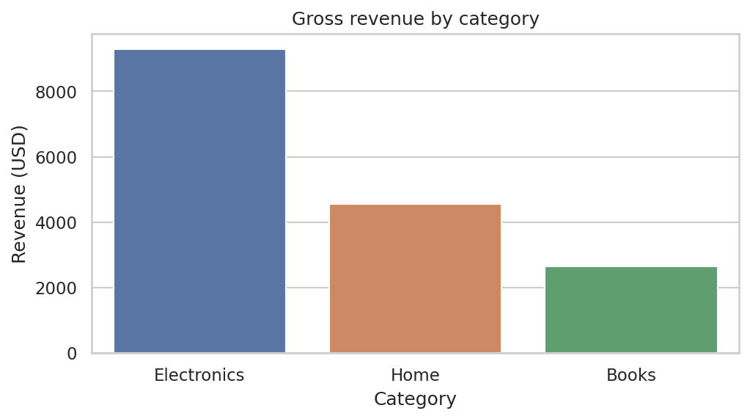
Electronics leads at $9,295. Bars compare totals clearly but hide within-category variation and transaction count.

Histogram: distribution
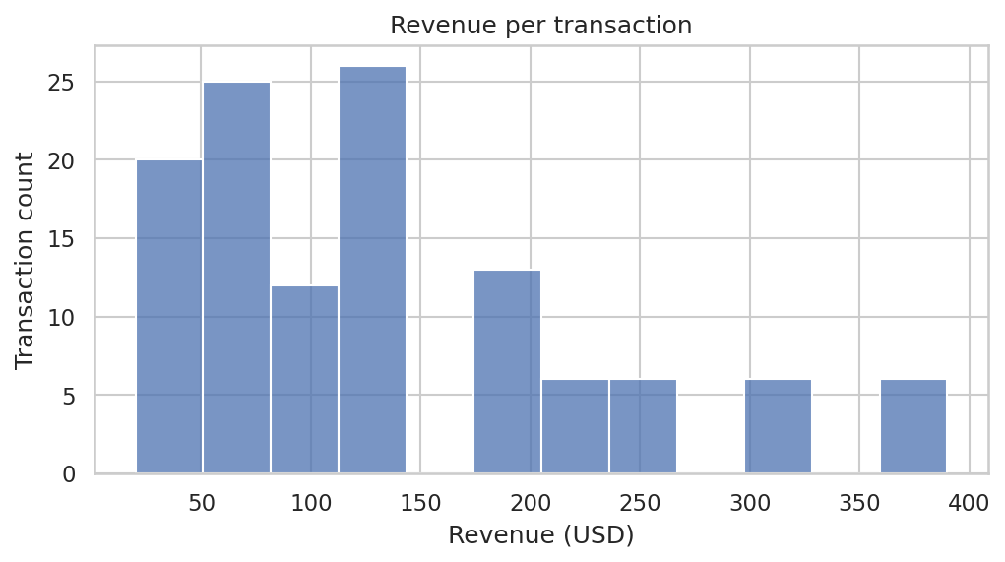
The histogram shows transaction counts across revenue bins; bin width changes the apparent shape.

Line chart: time
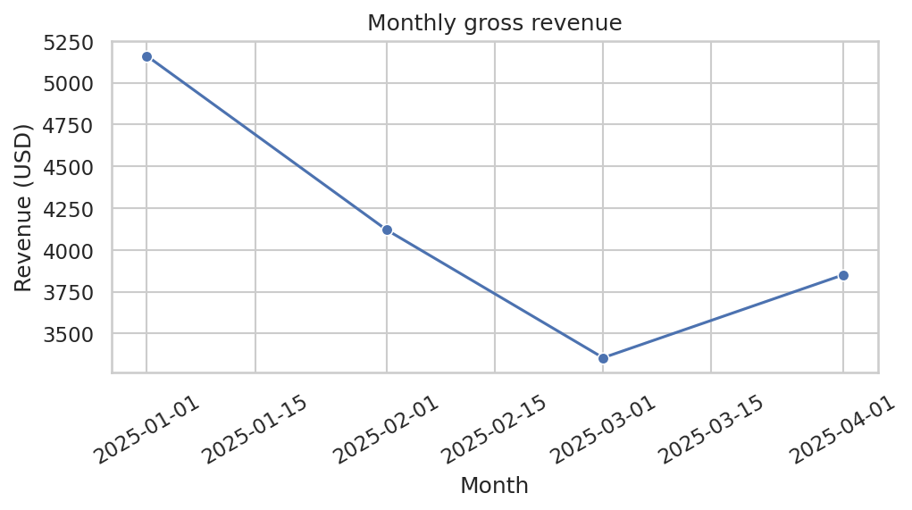
Totals fall from $5,160 in January to $3,355 in March, then rise to $3,850 in April. Connecting months highlights sequence but unequal month lengths and random generation limit interpretation.

Box plot: spread
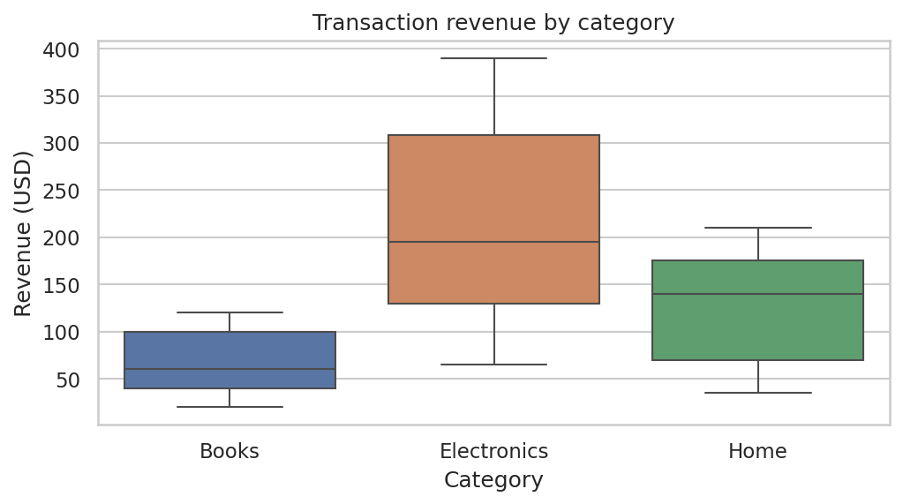
Boxes display medians, quartiles and category-specific whiskers; whiskers or points are not automatic evidence of bad data. Small samples and discrete prices can conceal detail.

Scatter plot: relationships
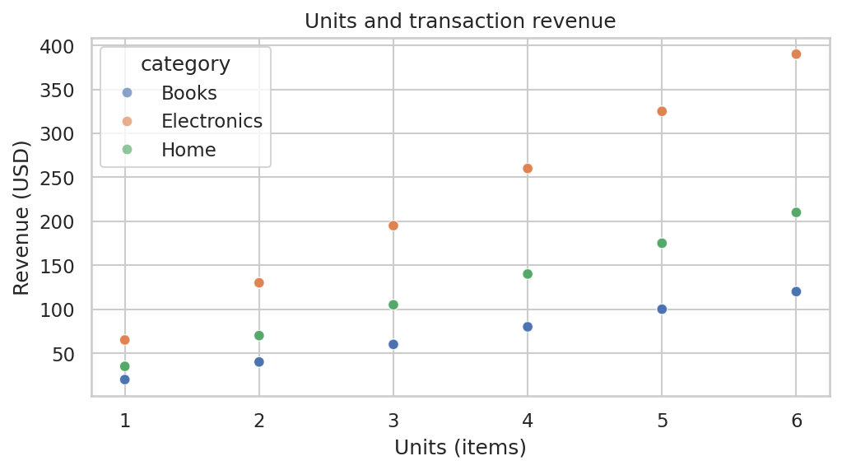
Units and revenue show category-specific bands because price is fixed by category. Overlapping points can hide counts; revenue is constructed from units and price.

Correlation heatmap
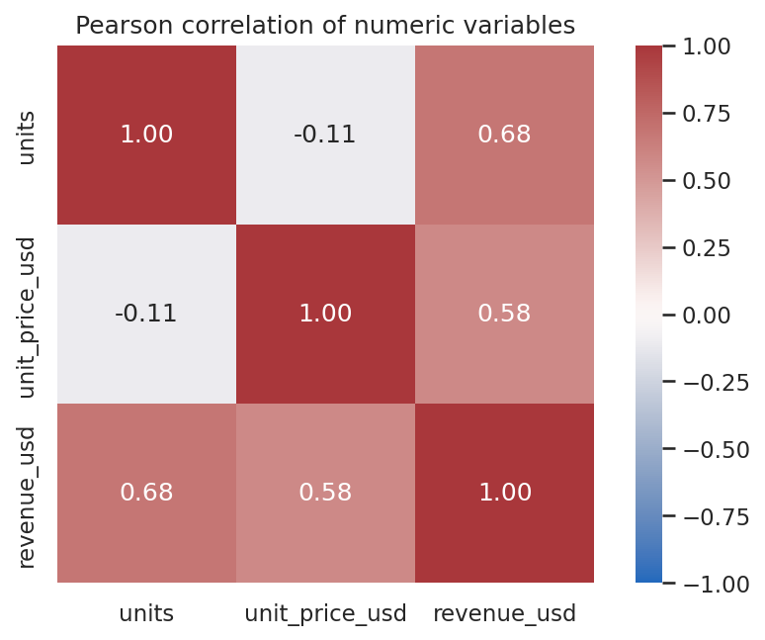
Heatmap summarizes linear Pearson associations. Units and price r≈−0.107; revenue correlations are partly mechanical and correlation is not causation.

Machine Learning Fundamentals and Evaluation
Supervised learning fits relationships between features X and known target y: classification predicts a class, regression predicts a number. Unsupervised learning (e.g., clustering) explores patterns without labeled targets. A training set fits model parameters; a validation set or cross-validation selects models and hyperparameters; an untouched test set estimates final performance once. Use group- or time-aware splits when records are dependent, and stratify classification splits where appropriate. Fit imputation, encoding and scaling only on training folds, preferably in a pipeline, to avoid leakage. Leakage also occurs if a feature contains future information or the target. A baseline such as majority class or mean prediction establishes a minimum benchmark.
Underfitting misses meaningful structure; overfitting learns training noise and performs worse on new data. The bias–variance trade-off balances overly restrictive models against sensitivity to training data. Cross-validation rotates training/validation folds and reports distribution of scores; use nested CV if both tuning and unbiased CV performance estimation are needed. A random seed helps reproduce stochastic splits, but versions, hardware and stochastic algorithms also matter. Generalization is performance on new, representative data, not the training score.

Classification: worked confusion matrix
Illustrative fixed labels and predictions, not a fitted model: 20 cases, TP=8, FN=2, FP=3, TN=7. Positive means the chosen target class. A false positive predicts positive when actually negative; false negative predicts negative when actually positive. Notebook verifies all metrics at threshold 0.5.
Metric and formula | Substitution | Interpretation
Accuracy = (TP+TN)/N | (8+7)/20 = 0.75 | Overall fraction correct.
Precision = TP/(TP+FP) | 8/(8+3) = 0.7273 | Among positive predictions, 72.73% are correct.
Recall / sensitivity = TP/(TP+FN) | 8/(8+2) = 0.80 | 80% of actual positives are found.
Specificity = TN/(TN+FP) | 7/(7+3) = 0.70 | 70% of actual negatives are correctly rejected.
F1 = 2PR/(P+R) | 2×0.7273×0.8/(0.7273+0.8) = 0.7619 | Harmonic mean of precision and recall.
Metrics with zero denominators require a defined convention; report it. Lowering the positive threshold often increases recall and false positives, but changes depend on the scores. A ROC curve plots true-positive rate against false-positive rate across thresholds; ROC-AUC is the probability a randomly chosen positive scores above a randomly chosen negative, with ties receiving half credit. Here eight positive scores 0.9 beat all 10 negatives, and two positive scores 0.4 beat seven negatives scored 0.2: (8×10+2×7)/100=0.94. The score ranking and the 0.5 threshold classification are distinct; AUC is not accuracy.
A precision–recall curve plots precision versus recall across thresholds; it is especially useful when positives are rare because precision directly reflects false alarms and prevalence. Average precision is a weighted summary of the precision–recall curve; it is not necessarily the trapezoidal area. For a 1% positive dataset, always predicting negative gives 99% accuracy but zero recall for positives. Choose thresholds using error costs and validation data, never by repeatedly tuning on the final test set.

Regression: worked metrics and residuals
Illustrative truth y=[3,5,7,9] and predictions ŷ=[2,5,8,8]. Residuals e=y−ŷ=[1,0,−1,1]; absolute errors [1,0,1,1], squared errors [1,0,1,1]. Here n=4 and ȳ=6.
Metric / formula | Worked result | Use and limitation
MAE = Σ|eᵢ|/n | (1+0+1+1)/4 = 0.75 | Typical absolute error in target units; less sensitive than MSE to large errors.
MSE = Σeᵢ²/n | 3/4 = 0.75 | Penalizes large errors more; units are squared.
RMSE = √MSE | √0.75 = 0.8660 | In target units; sensitive to large residuals.
R² = 1−Σeᵢ²/Σ(yᵢ−ȳ)² | 1−3/(9+1+1+9) = 0.85 | Relative to mean-prediction baseline; can be negative on poor predictions and is not a percentage of accuracy.
Plot residuals against predictions and time to inspect bias, nonlinear patterns, heteroscedasticity and outliers. A low aggregate error can hide subgroup failures; compare appropriate baseline metrics, scales and data slices. R² is undefined for a constant target in its ordinary mathematical form; software may apply special conventions.

Industry Best Practices
Practice | Bad example / risk | Better approach
Readable Python / PEP 8 | x1, unexplained hard-coded values | Descriptive snake_case names, small functions, clear docstrings; comment intent.
Testing and debugging | Ignore exceptions or test only success | Assertions/unit tests for edge cases, meaningful errors, debugger and logs without secrets.
Environment and versioning | Global unpinned dependencies | Use virtual environments, requirements and Git commits; document commands and versions.
Reproducibility | Unrecorded random split | Record seeds, data version, code and library versions; seeds alone do not guarantee identical hardware results.
Validation and privacy | Trust inputs; commit credentials | Validate schema/ranges, minimize personal data, encrypt and restrict access, exclude credentials from Git.
Ethics and integrity | Represent synthetic values as real, or infer causation | Label simulated data, check bias and limitations, cite sources and licenses, disclose tool assistance where required.

Practical Exercises and Verified Outputs
Exercise 1: Define a function calculating 3 × $12.50. Solution: total_cost(3, 12.5) → 37.5. Exercise 2: generate squares of even numbers from range(5): [x*x for x in range(5) if x%2==0] → [0, 4, 16]. Exercise 3: parse "bad" as an integer inside try/except: result → "invalid integer". Exercise 4: compute the mean and sample variance of the eight values: 5 and 32/7. Exercise 5: calculate precision for TP=8 and FP=3: 8/11≈0.7273. Script assertions and notebook metrics verified these solutions. Complete source and output are included in the repository.

Key Findings and Lessons Learned
Electronics contributes $9,295 of $16,485 simulated gross revenue, but the category has the highest fixed price by design. January total is $5,160 and March $3,355; daily rates and more periods are necessary before considering a seasonal conclusion. Mean transaction revenue $137.375 exceeds the $120 median, and the plotted distribution supplies useful context. Three missing values and two duplicates demonstrate why raw quality checks must precede aggregation. Global IQR fences flag zero records; category-level boxplots have their own whiskers. Units and price have a weak correlation of −0.1071, not evidence about price effects on demand. Use these findings to practice transparent checks, not to make real purchasing decisions.

Limitations and Challenges
The sales data are artificial, fixed-price and one record per day. No customers, refunds, costs or actual outcomes are observed. Median imputation and rounding can distort statistics. Correlation is partly mechanical where revenue is a product. The inference examples demonstrate formulas but have no genuine sampling design. Confusion matrix and regression examples are fixed, not model validation; no claim of predictive performance is warranted. Windows commands were not tested; paginated Word layout and the table of contents should be reviewed in Microsoft Word.

Conclusion
The executed exercises demonstrate core programming, transparent data cleaning, statistical reasoning, informative visualization and rigorous metric interpretation. Any application beyond the exercise requires representative data, domain-specific validation and an appropriately designed evaluation protocol.

References
Python Software Foundation. Python Tutorial: https://docs.python.org/3/tutorial/
Python Enhancement Proposal 8: https://peps.python.org/pep-0008/
NumPy documentation: https://numpy.org/doc/
Pandas documentation: https://pandas.pydata.org/docs/
SciPy stats reference: https://docs.scipy.org/doc/scipy/reference/stats.html
Matplotlib documentation: https://matplotlib.org/stable/
Seaborn documentation: https://seaborn.pydata.org/
scikit-learn model evaluation and cross-validation: https://scikit-learn.org/stable/modules/model_evaluation.html and https://scikit-learn.org/stable/modules/cross_validation.html
NIST/SEMATECH e-Handbook of Statistical Methods: https://www.itl.nist.gov/div898/handbook/
Synthetic dataset created for this project; CC0 1.0: https://creativecommons.org/publicdomain/zero/1.0/

Appendix: Selected Code and Verification
x = np.array([2,4,4,4,5,5,7,9], dtype=float)
print(x.mean(), x.var(ddof=0), x.var(ddof=1))
# 5.0, 4.0, 4.571428571428571
clean = raw.drop_duplicates().copy()
clean['category'] = clean['category'].str.strip().str.title()
clean['units'] = clean['units'].fillna(clean.groupby('category')['units'].transform('median')).round().astype(int)
clean['revenue_usd'] = clean['units'] * clean['unit_price_usd']
Actual execution versions: python 3.13.16, numpy 2.3.5, pandas 2.2.3, scipy 1.17.1, matplotlib 3.10.9, seaborn 0.13.2, scikit-learn 1.6.1. Notebook outputs and outputs/analysis_summary.json capture the computations. All code cells were run in order via nbclient; see the final quality audit for remaining manual checks.

