DATA SCIENCE
FUNDAMENTALS ASSESSMENT
INTERNSHIP PROJECT SUBMISSION

SUBMISSION DETAILS
Student name | Tallapureddy Aparna Reddy
Assessment | Data Science Fundamentals
GitHub username | appureddy1102-cloud
Practical exercise | Reproducible synthetic retail dataset (160 generated rows before quality issues)
Submission date | 2026

A beginner-friendly, evidence-led introduction to the data science lifecycle.

Contents & report guide
Section | Page
Cover | 1
Contents & report guide | 2
1. Introduction to Data Science | 3
2. Python Fundamentals | 4–5
3. Statistical Foundations | 6
4. Data Types & Data Structures | 7
5. Data Collection & Preprocessing | 8
6. Exploratory Data Analysis | 9
7. Essential Libraries | 10
8. Machine Learning & Industry Practices | 11
9. Practical Mini-Project | 12–14
10. Assessment Questions & Answers | 15–16
11. Conclusion & Learning Outcomes | 17
12. References | 17

How to use this report
Read the concepts first, then run the notebook and reusable script in the companion repository. Code examples are compact and designed to be copied into a Python 3 environment. The mini-project dataset is openly labeled synthetic and is included for educational reproducibility.
Practical evidence: the companion notebook and analysis script were executed in the available Python environment. The reported mini-project outputs below come from that deterministic run (seed 42).

1. Introduction to Data Science
Data science is an interdisciplinary practice that uses programming, statistics, domain knowledge and communication to turn data into useful evidence. It combines data preparation, analysis, modeling and responsible decision-making. A data scientist asks a question, obtains relevant data, evaluates its quality, analyzes patterns, and communicates what is supported—together with uncertainty and limitations.

Why it matters
Organizations collect data from transactions, sensors, surveys, applications and operations. Careful analysis can help forecast demand, detect defects, understand customer needs, prioritize resources and evaluate interventions. The value depends on fit-for-purpose data, appropriate methods and responsible use; a model or chart alone does not guarantee a good decision.

Applications
Domain | Example use
Retail | Demand planning, product mix and promotion evaluation
Healthcare | Care-pathway monitoring, subject to privacy and clinical oversight
Finance | Fraud detection, risk assessment and portfolio monitoring
Manufacturing | Predictive maintenance and defect analysis
Public services | Resource planning and trend monitoring with fairness safeguards

Data science lifecycle
Stage | Typical work
1. Define | Translate stakeholder need into a measurable question
2. Acquire | Collect appropriate, permitted data; document provenance
3. Prepare | Validate, clean, transform and protect data
4. Explore | Summarize distributions, compare groups and visualize
5. Model | Choose a suitable method; split, train and validate
6. Communicate | Explain findings, caveats and recommended actions
7. Monitor | Track impact, drift, quality and unintended effects

2. Python Fundamentals — core syntax
Python is a readable, general-purpose language. Names refer to objects; assignment binds a name to a value. Python is dynamically typed, but clear naming and type awareness remain important.

Variables, data types and operators
student = "Aparna" # str
orders = 4 # int
average_value = 31.375 # float
validated = True # bool
print(student, orders, average_value, validated)
print("per order:", 125.50 / orders)
print(7 // 2, 7 % 2, 2 ** 3) # floor, remainder, exponent
Verified output: `Aparna 4 31.375 True`; `per order: 31.375`; `3 1 8`. Arithmetic operators include `+ - * / // % **`; comparison operators include `== != < <= > >=`; logical operators include `and`, `or`, and `not`.

Conditional statements
revenue = 125.50
if revenue >= 100:
label = "large"
elif revenue >= 50:
label = "medium"
else:
label = "small"
print(label) # large

Iteration
for value in [45, 125]:
print("large" if value >= 100 else "standard")
# Output: standard, then large
A `for` loop iterates over a sequence. A `while` loop repeats while a condition remains true; update its state to avoid accidental infinite loops.

2. Python Fundamentals — functions & structures

Functions
def price_after_discount(price, rate=0.0):
"""Return price after a fractional discount."""
if price < 0 or not 0 <= rate <= 1:
raise ValueError("price and discount must be in valid ranges")
return price * (1 - rate)
print(price_after_discount(100, 0.10)) # 90.0

Lists, tuples, dictionaries and sets
Structure | Properties | Example use
List | Ordered, mutable, allows repeats | Rows to process, shopping basket
Tuple | Ordered, immutable sequence | Fixed coordinate or record
Dictionary | Key → value mapping | Configuration or lookup by ID
Set | Unique elements, unordered | Deduplication and membership

items = ["pen", "book"]
location = (17.4, 78.5)
prices = {"pen": 10, "book": 50}
regions = {"North", "South", "North"}
print(prices["book"], sorted(regions)) # 50 ['North', 'South']

Exception handling
try:
result = 10 / 0
except ZeroDivisionError as error:
print(type(error).__name__, "handled safely")
# ZeroDivisionError handled safely
Catch specific exceptions when a safe recovery is possible. Avoid a bare `except:` that hides programming errors. Use functions and modules to reduce duplication and make behavior testable.

3. Statistical Foundations
Descriptive statistics summarize a sample; inferential statistics use sample evidence to reason about a broader process under assumptions. Example data: x = [2, 4, 4, 6].
Concept | Definition / formula | Example
Mean | Σxᵢ / n | (2+4+4+6)/4 = 4
Median | Middle sorted value (average two middles) | (4+4)/2 = 4
Mode | Most frequent value | 4
Range | max(x) − min(x) | 6−2 = 4
Population variance | Σ(xᵢ−μ)² / N | 2.0
Sample variance | Σ(xᵢ−x̄)² / (n−1) | 8/3 ≈ 2.667
Standard deviation | Square root of variance | Population ≈ 1.414
Quartiles / IQR | Q1, Q2, Q3; IQR = Q3−Q1 | Linear Q1=3.5, Q3=4.5, IQR=1

Probability and correlation
Probability ranges from 0 to 1. For a fair six-sided die, P(even) = 3/6 = 0.5. Correlation measures association: Pearson r captures linear association; Spearman rho captures ranked monotonic association. Both range from −1 to +1. Correlation does not prove causation: confounding, selection and reverse causality may explain a pattern.

Hypothesis testing
State a null hypothesis H₀ (often no difference/association) and alternative H₁; choose a test and significance level α before analysis; calculate a statistic and p-value; compare p with α. A p-value is the probability, assuming H₀ and model assumptions, of results at least as extreme as observed. If p < 0.05, evidence is conventionally called statistically significant; this does not measure effect size or prove H₁. Report uncertainty and practical importance.

4. Data Types and Data Structures
Type | Meaning | Example
Numerical — discrete | Countable integer values | Units sold, number of visits
Numerical — continuous | Measured on a continuum | Weight, elapsed time
Categorical — nominal | Labels without order | Region, product type
Categorical — ordinal | Categories with order | Low / medium / high rating
Structured | Fixed schema in rows/columns | CSV, relational table
Semi-structured | Flexible schema with labels | JSON event record, XML
Unstructured | No fixed tabular structure | Image, audio, free-text document

Choosing a Python structure
Use a list when order and mutation matter; a tuple for a fixed sequence; a dictionary for lookup by meaningful keys; a set for uniqueness or membership tests. NumPy arrays efficiently store homogeneous numeric values. Pandas Series and DataFrames add labels, mixed columns and missing-value-aware operations. Data type choice influences valid operations: for example, a date stored as text must be parsed before time-based grouping.
Data type is not the same as measurement scale. A numeric code for a nominal category does not make its values quantitative.

5. Data Collection and Data Preprocessing
Data collection may use files, databases, APIs, sensors or surveys. Confirm permission, provenance, scope, grain (what one row represents), schema, time period and known sampling limitations before analysis.
Issue | Practical response
Missing values | Measure missingness; investigate why; drop, impute or flag with justification
Duplicates | Define duplicate keys; count and remove only true duplicate records
Inconsistent formats | Parse dates, units, labels and numeric strings; standardize categories
Outliers | Visualize/check source; correct errors, robustly model or retain valid extremes
Encoding | Convert nominal categories to indicator/one-hot variables when needed
Normalization | Often rescale feature ranges, e.g. [0,1]; useful for distance methods
Standardization | z=(x−mean)/SD; useful for scale-sensitive models

Pandas cleaning example
import pandas as pd
df = pd.read_csv("data/sample_dataset.csv")
df = df.drop_duplicates()
df["order_date"] = pd.to_datetime(df["order_date"], errors="coerce")
df["revenue"] = pd.to_numeric(df["revenue"], errors="coerce")
required = ["order_date", "region", "revenue"]
df = df.dropna(subset=required)
df = df[df["revenue"] >= 0]
print(df.shape)
The project uses exact duplicate checks, numeric/date parsing, required-field validation and range checks. More sophisticated imputation or outlier removal is not applied to the mini-project because the synthetic rows are not missing business outcomes; the intentionally incomplete core records are excluded transparently.

6. Exploratory Data Analysis (EDA)
EDA builds understanding before formal modeling. Start with row count, column names, data types, missingness, duplicates and valid-value ranges. Then use descriptive statistics and visual checks to identify distribution shape, unusual observations, group differences, time patterns and possible relationships.
Question | Useful technique
What is typical and how variable? | Mean, median, quantiles, standard deviation
How is a measure distributed? | Histogram/density plot; box plot for spread/outliers
How do measures change together? | Scatter plot, grouped summaries, correlation
How do groups compare? | Bar chart of transparent aggregate; box/violin for distributions
How do values change over time? | Time series line plot with clear date granularity

Pandas, Matplotlib and Seaborn example
import matplotlib.pyplot as plt
import seaborn as sns
print(df["revenue"].describe())
sns.histplot(data=df, x="revenue", bins=20, kde=True)
plt.title("Order revenue distribution")
plt.xlabel("Revenue")
plt.tight_layout()
plt.show()
Charts need clear titles, units, axis labels and readable scales. Bar charts should normally start at zero for magnitude comparison. Avoid interpreting correlation as a causal effect and distinguish raw counts from normalized rates.

7. Introduction to Essential Libraries
Library | Purpose | Small example
NumPy | Arrays, vectorized numerical operations | np.mean([2,4,6]) → 4
Pandas | Tabular data, cleaning and grouping | df.groupby("region")["revenue"].sum()
Matplotlib | Flexible plotting controls | plt.plot(months, sales)
Seaborn | Statistical visualization built on Matplotlib | sns.boxplot(data=df, x="category", y="profit")
Scikit-learn | Preprocessing, ML estimators, metrics and validation | train_test_split(X, y, random_state=42)

Mini examples
import numpy as np
import pandas as pd
values = np.array([2, 4, 6])
print(values.mean()) # 4.0
frame = pd.DataFrame({"region": ["N", "S"], "sales": [10, 20]})
print(frame.groupby("region")["sales"].sum())
Choose tools for the task, keep dependencies documented and use virtual environments to isolate project packages. A library call does not replace understanding the method or assumptions.

8. Basic Machine Learning Concepts
Concept | Description
Supervised | Learn from labeled input/output examples
Regression | Predict a continuous target, e.g. demand amount
Classification | Predict a category, e.g. complaint type
Unsupervised | Find structure without known target labels
Clustering | Group observations by similarity
Train/test split | Fit on training data; evaluate once on held-out examples
Overfitting | Model learns noise/training peculiarities and generalizes poorly

Use validation or cross-validation for model selection and keep the final test set isolated. Select metrics matched to the task; compare with a simple baseline; check leakage, class imbalance, bias and uncertainty. A predictive model can be statistically accurate yet inappropriate for a decision.

Industry best practices
• Write clean, readable code with meaningful names and focused functions.
• Document data source, transformations, assumptions, dependencies and execution steps.
• Fix random seeds for stochastic demonstrations; use version control and review changes.
• Keep credentials out of source control; limit personal data and access; follow retention rules.
• Check representation, fairness, consent, harms and downstream use; communicate limitations.
• Reproduce results before publishing; do not overstate exploratory or synthetic findings.

9. Practical Mini-Project — synthetic retail data
Question: what are the sample sales totals and how do revenue/profit vary by category, month and discount? Dataset: 160 generated order lines spanning January–June 2025, with order/customer IDs, region, segment, category, units, unit price, discount, revenue and profit. It is deterministic via NumPy seed 42 and is explicitly synthetic.

Load, inspect and clean
from src.data_analysis import load_and_clean, analyze, make_charts
df, audit = load_and_clean("data/sample_dataset.csv")
print(audit)
print(df.dtypes)
print(df.isna().sum().sum(), df.duplicated().sum())
Actual quality audit from the executed file: 161 raw rows (160 generated plus one duplicate), 3 missing cells, 1 exact duplicate, 3 incomplete core rows removed, 157 cleaned rows. Dates cover 2025-01-01 through 2025-06-30; no missing values or duplicate rows remain in the cleaned analytical frame.

Why these fields?
Revenue is unit price × units × (1 − discount). Profit is generated from a category-specific baseline margin, reduced by the discount and a small random cost factor. This creates a plausible teaching example with variation; it is a designed synthetic mechanism, not measured business economics.

9. Mini-Project — statistics & analysis code
kpis, numerical, category, monthly, rho = analyze(df)
print(kpis)
print(category.round(2))
print("Spearman discount-margin rho:", round(rho, 3))
Verified run outputs (rounded): 157 cleaned orders, 54 distinct customers, total revenue 46,034.09 units, total profit 7,614.86 units, average order value 293.21, overall profit margin 16.54%, and mean discount 7.74%. Currency is intentionally left as generic units because the synthetic dataset has no currency metadata.
Category | Revenue | Profit | Margin
Electronics | 30,078.10 | 4,521.26 | 15.0%
Home Goods | 8,691.87 | 1,463.67 | 16.8%
Office Supplies | 7,264.12 | 1,629.93 | 22.4%

Spearman association between discount and profit margin was approximately −0.843 in this generated sample. Because discount directly enters the synthetic profit-generation formula, this is an expected artifact of the data design—not evidence about real customer or business behavior.

Reproduce the outputs
python src/data_analysis.py
# or run all documented notebook cells
# generated tables and PNG charts are saved in outputs/

9. Mini-Project — EDA visuals, observations & conclusion
The accompanying notebook displays five generated plots: revenue histogram, category profit boxplot, monthly revenue line, numeric correlation heatmap and discount/profit-margin scatter. The same plots are saved in `outputs/` for review.
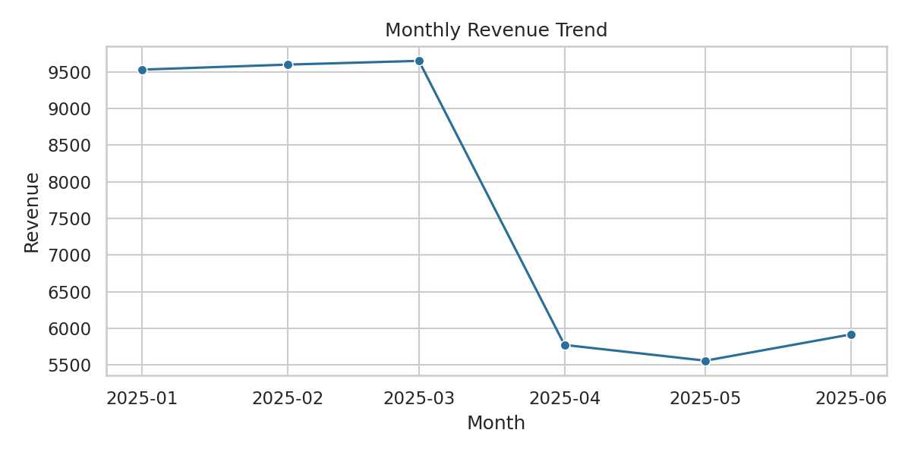
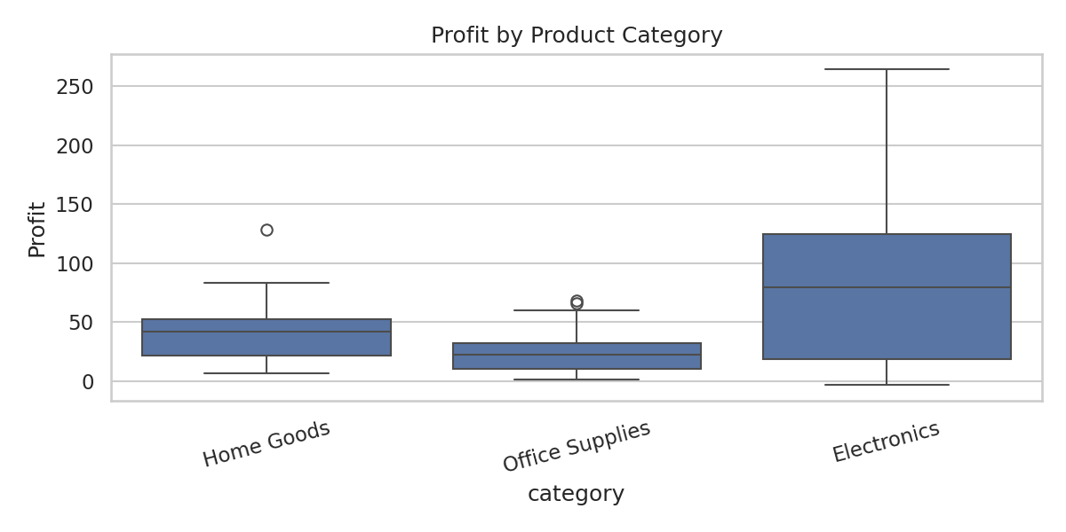
Observed in the executed synthetic sample: Electronics accounts for the largest revenue total (30,078.10), while Office Supplies has the highest aggregated category margin (about 22%). Monthly totals vary across the six-month interval. These are outputs of the seeded generator; the intentionally constructed discount/profit relationship should not be generalized.
Conclusion: the mini-project demonstrates a repeatable pipeline—generate/load → validate → clean → summarize → visualize → interpret cautiously. Real business decisions require representative real data, cost definitions and context.

10. Assessment Questions & Answers (1–8)
1. What is data science? A multidisciplinary process using data, computation, statistics and domain context to support decisions.
2. What is a Python variable? A name bound to an object/value; Python determines its type at runtime.
3. How do list and tuple differ? A list is mutable; a tuple is an immutable sequence.
4. What is a dictionary used for? Mapping keys to values for lookup, such as a product ID to its price.
5. What does a set guarantee? Unique elements; it supports membership checks and set operations.
6. Mean vs median? Mean is arithmetic average; median is the center of sorted values and is less sensitive to extreme values.
7. What does standard deviation measure? Spread around the mean in the same units as the observations.
8. Does correlation prove causation? No. Confounding, selection and reverse causality can produce association.

10. Assessment Questions & Answers (9–16)
9. What is a p-value? Under H₀ and its assumptions, the probability of a result at least as extreme as observed.
10. Nominal vs ordinal data? Nominal labels have no order; ordinal categories have a meaningful order.
11. Why handle missing values? They can invalidate computations or bias conclusions; investigate and document a suitable strategy.
12. What is an outlier? An observation far from much of a distribution; verify source/context before modifying it.
13. Normalization vs standardization? Normalization rescales, often to [0,1]; standardization usually maps to zero mean and unit SD.
14. What does EDA do? Inspects quality, distributions, patterns and relationships before modeling.
15. Regression vs classification? Regression predicts a continuous value; classification predicts a label/category.
16. What is overfitting? A model captures noise or training specifics and performs poorly on new data.

11. Conclusion and Learning Outcomes
This assessment demonstrates core Python syntax and structures, statistical summaries, data typing, preprocessing, EDA, visual communication, basic supervised learning and responsible analytical practice. The mini-project supplies executable evidence, while the report emphasizes reproducibility and transparent limitations. The most important habit is to connect every conclusion to checked data and a clearly stated method.

12. References & learning resources
Official documentation and primary learning resources:
- Python documentation: https://docs.python.org/3/
- Pandas documentation: https://pandas.pydata.org/docs/
- NumPy documentation: https://numpy.org/doc/stable/
- Matplotlib documentation: https://matplotlib.org/stable/
- Seaborn documentation: https://seaborn.pydata.org/
- Scikit-learn documentation: https://scikit-learn.org/stable/
- Jupyter documentation: https://docs.jupyter.org/en/latest/
- Git documentation: https://git-scm.com/doc

Submission files
The repository includes this Word report, a fully documented executed Jupyter notebook, reusable analysis code, a 161-row synthetic CSV including deliberate quality issues, generated output charts and tables, requirements, README, license and .gitignore. No personal credentials or business-confidential data are included.
End of assessment — Tallapureddy Aparna Reddy | GitHub: appureddy1102-cloud

