Hands-On Data Lab Implementation
Synthetic Retail Sales: Data Preparation, Descriptive Statistics and Visual Analysis
Internship assessment | Professional project report
Candidate: [Your name]
Institution / organization: [Your institution]
Submission date: [Enter date]
Repository URL: https://github.com/appureddy1102-cloud/hands-on-data-lab-implementation

Table of Contents
In Microsoft Word, right-click the table below and choose Update Field → Update entire table to populate page numbers.

Abstract / Executive Summary
This project demonstrates a complete, reproducible introductory data analysis workflow using a deliberately simulated retail sales dataset. The raw input contains 182 records and five fields, including two exact duplicates and four missing unit counts. After removing the duplicates, filling missing units with category medians and converting types, the analysis retains 180 transactions and derives a gross revenue column. Total simulated revenue is $22,910; electronics contributes $12,080. The mean and median transaction revenues are $127.28 and $80.00, respectively. Five visualizations and a machine-readable results snapshot are generated by the executed notebook. These findings describe the simulated data only and should not be treated as real market evidence.

Introduction
This project investigates an intentionally synthetic retail dataset to demonstrate how an analyst can move from a raw CSV file to a cleaned, documented dataset and defensible descriptive findings. The dataset was created for this assessment rather than collected from actual customers, stores or payment systems. It contains one simulated transaction per day over roughly six months, with three categories, fixed category prices and randomly generated unit counts. Deliberately inserted duplicate records and missing values create realistic opportunities to practice data quality checks without exposing private information. The business-style questions are: which category contributes the most gross revenue, how do monthly totals differ, what does the transaction revenue distribution look like, and are unit counts linearly associated with unit price?
The notebook first examines shape, types, missingness and descriptive summaries before changing the data. Exact duplicates are removed and missing unit counts are filled using the median for the corresponding category. Dates and units are converted to appropriate types, and gross revenue is calculated as units multiplied by unit price. Filtering, sorting, grouping and a validated lookup merge illustrate common Pandas operations. A set of statistics and five charts then summarize the cleaned records. The analysis explicitly distinguishes sample from population variance and uses the interquartile-range rule to flag unusual revenue values without automatically deleting them. All numerical findings are computed from the same cleaned data used for the figures. Since the data are synthetic and category prices are fixed by design, observed patterns are demonstrations of the methods, not estimates of real demand or evidence of causation. The resulting notebook, CSV, figures and report are intended to be rerun and inspected by a beginner or evaluator.

Objectives
Configure and verify a Python analysis environment; inspect, clean and transform tabular data; calculate and interpret descriptive statistics; create appropriate visualizations; and communicate reproducible, evidence-based conclusions.

Tools and Environment Setup
The notebook was executed in the available environment, not on Windows. Verified versions: python 3.13.16, pandas 2.2.3, numpy 2.3.5, matplotlib 3.10.9, seaborn 0.13.2, scikit-learn 1.6.1. Jupyter and the notebook kernel were also verified by successful execution. Scikit-learn is imported for environment verification only; no model is trained.
Windows PowerShell setup (Python 3.13 recommended):
py -3.13 -m venv .venv
.\.venv\Scripts\Activate.ps1
python -m pip install --upgrade pip
python -m pip install -r requirements.txt
python -m notebook
Check imports and versions in the first notebook cell. If activation is blocked, use .venv\Scripts\python.exe directly; if modules are missing, install into the interpreter used by the selected kernel. If the CSV cannot be found, launch from the project root or notebooks folder. See README for further Windows troubleshooting. These Windows commands have not been tested here.

Dataset Description
Original synthetic data, generated for this project using NumPy seed 42; released under CC0 1.0. It is not a public real-world dataset. The raw file has 182 rows × 5 columns, including 2 deliberately repeated rows. After cleaning: 180 × 6. Dates span 1 January to 29 June 2025. Each category has a fixed price, with random units from 1 to 6 before missing values were introduced. Revenue is gross, before costs, returns, tax and discounts.
Column | Raw type | Meaning
transaction_id | object | Synthetic transaction identifier
date | object | ISO calendar date
category | object | Accessories, Clothing or Electronics
units | float64 | Item count; missing allowed
unit_price_usd | float64 | Fixed category unit price in USD
Cleaned types: date datetime64[ns] in memory; units int64; revenue_usd float64; remaining types unchanged. CSV stores dates as text and does not preserve Pandas dtypes.

Methodology
Read the supplied CSV; inspect and quantify quality issues; remove exact duplicate rows; fill missing unit counts with the within-category median; convert types; calculate gross revenue; group and merge; compute descriptive measures and IQR flags; create five plots. All reported values are computed after cleaning unless labeled raw. Monthly sums reflect calendar months of differing length.

Data Manipulation Exercises
Exercise | Code / purpose | Observed output or interpretation
Read and inspect | read_csv; head; info; describe; shape | Raw: 182 rows, 5 columns; units float due to missing entries.
Select, filter, sort | loc; revenue >= 200; sort_values | Displays highest qualifying transactions; no records are removed from the cleaned dataset.
Clean / convert | drop_duplicates; groupby median; to_datetime; astype | 2 duplicates removed; 4 units imputed; 180 records remain.
Calculate / aggregate | units * unit_price; groupby().agg() | Gross revenue totals by category; electronics leads.
Merge | merge(..., validate="many_to_one") | Three-row category lookup adds department; row count remains 180.
Export | to_csv(index=False) | outputs/cleaned_dataset.csv; rerun overwrites outputs.

Data Cleaning and Quality Checks
Raw missingness is four units values (4/182 = 2.20%); all other fields have zero missing. Two rows are exact duplicates. After deduplication and median imputation, assertions confirm no remaining missing values and unique transaction identifiers. Median imputation is an assumption, not recovered truth, and may understate variability. Exact-row detection does not find all near duplicates.

Statistical Calculations and Results
For transaction revenue x, mean = Σx/n; range = max − min; IQR = Q3 − Q1; sample variance s² = Σ(x − mean)²/(n−1), while population variance σ² uses n. Standard deviation is the square root of the corresponding variance. Sample variance estimates variability from a sample; population variance describes the complete observed set. Quartiles use Pandas linear interpolation.
Measure | Result | Interpretation
Mean / median / mode | $127.28 / $80.00 / $60.00 | Mean above median suggests a high-value tail.
Minimum / maximum / range | $15.00 / $480.00 / $465.00 | Observed revenue spread.
Q1 / Q3 / IQR | $56.25 / $160.00 / $103.75 | Middle half lies between Q1 and Q3.
Sample variance / SD | 14,540.03 USD² / $120.58 | Sample denominator n−1.
Population variance / SD | 14,459.26 USD² / $120.25 | Population denominator n.
1.5×IQR fences | −$99.38 to $315.63 | 22 observations outside exact fences −99.375 to 315.625.
Units vs unit price Pearson r | 0.0133 | Almost no linear association; not evidence of causality.

Visualizations and Interpretations

Category revenue
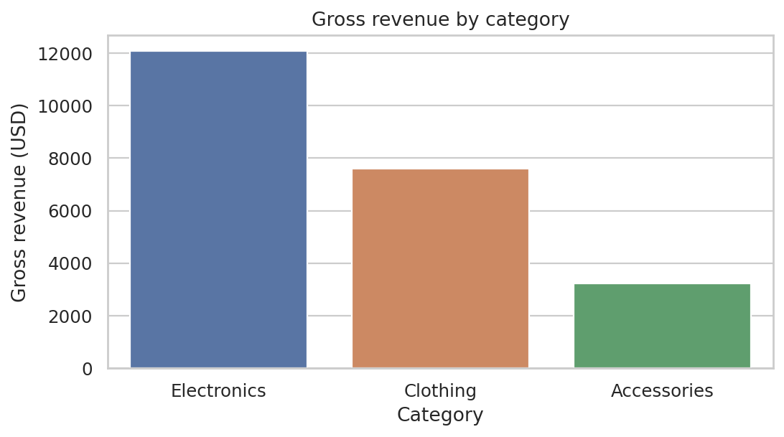
Electronics leads at $12,080; fixed price assumptions influence this comparison.

Monthly revenue
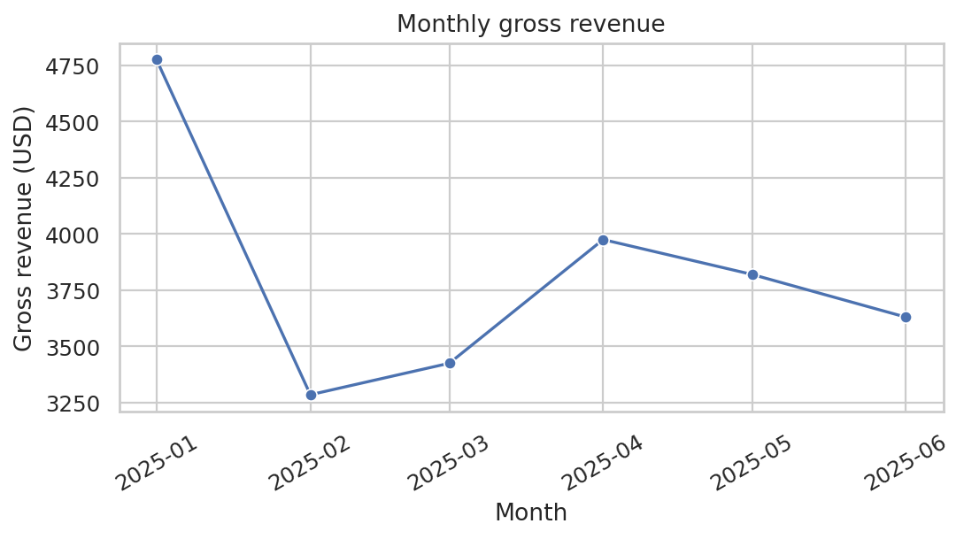
January is highest at $4,775; February lowest at $3,285. Month length differs, and there is no clear monotonic trend.

Revenue distribution
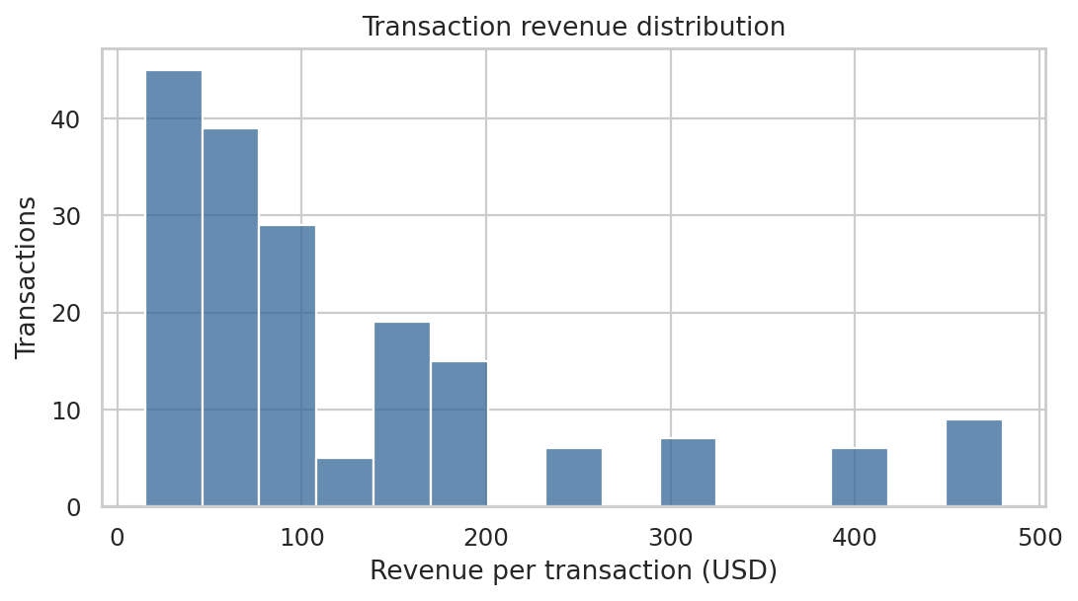
A concentration of lower values and a higher-value tail are consistent with the mean exceeding the median.

Category spread
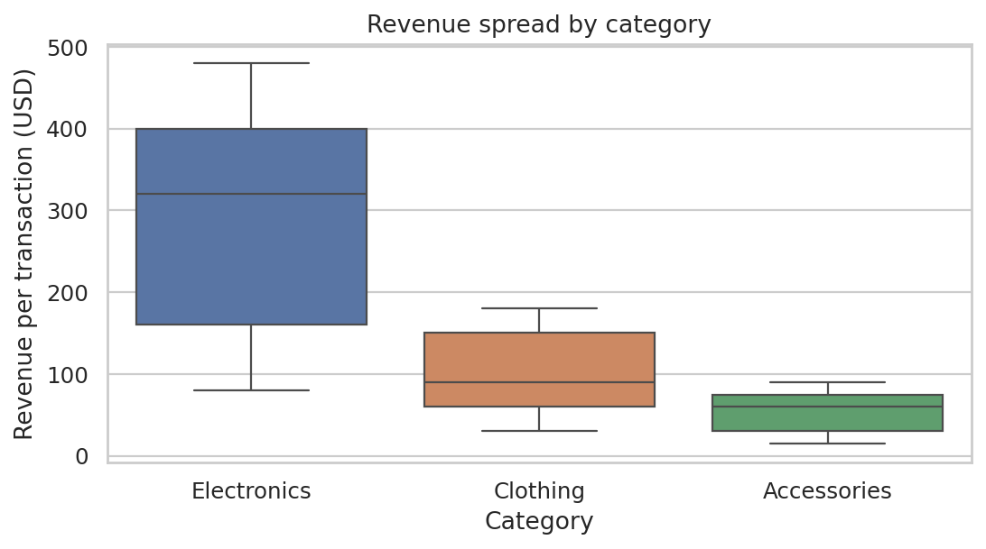
Category distributions differ substantially; the global outlier rule need not match the category-specific boxplot whiskers.

Numeric correlations
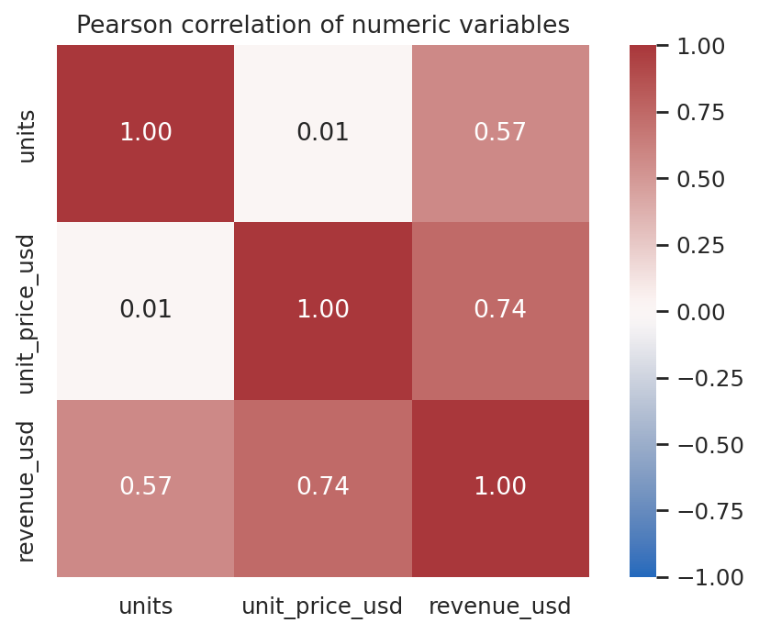
Units and price have near-zero correlation. Revenue is their product, so revenue correlations partly reflect its construction.

Key Findings and Recommendations
• Electronics: $12,080 from 43 transactions; clothing: $7,590 from 75; accessories: $3,240 from 62. In a real pilot, investigate category margins before allocating inventory; gross revenue alone is insufficient.
• January total is $4,775 and February $3,285. Compare daily averages and longer periods before planning seasonality.
• Mean revenue is $127.28 versus median $80.00; use both, not the mean alone, when describing a typical transaction.
• The IQR method flags 22 transactions above the upper fence; inspect records in context, rather than deleting automatically.
• Four raw unit values are missing (2.20%) and two rows are duplicates; improve source validation and track imputation in a real system.
• Units and price correlate at 0.0133; do not infer that changing price will not affect demand from this synthetic association.

Challenges and Solutions
Duplicate rows would inflate totals; remove exact duplicates before aggregation. Missing units prevent revenue calculation; category medians provide a transparent illustrative fill. CSV dates load as strings; parse explicitly. Notebook execution depends on working directory; the notebook accepts either project root or notebooks directory. See README for Windows-specific setup issues.

Limitations
Synthetic data have no external validity. One transaction per day and fixed category prices are unrealistic. No profit, taxes, discounts, returns or customer information is available. Median imputation may distort variation. Category composition and unequal month lengths confound simple comparisons. Pearson correlation measures linear association only; the global outlier rule may flag valid high-price-category transactions. No causal conclusions are justified.

Conclusion
The executed project demonstrates a complete data lab workflow from CSV inspection through cleaning, analysis, visualization and reporting. Reproducing the work requires the provided files and Python environment; applying the recommendations to actual retail decisions would require representative real data and additional validation.

References
Synthetic dataset: created for this project; CC0 1.0, https://creativecommons.org/publicdomain/zero/1.0/
Pandas user guide: https://pandas.pydata.org/docs/user_guide/
NumPy: https://numpy.org/doc/
Matplotlib: https://matplotlib.org/stable/
Seaborn: https://seaborn.pydata.org/
Python virtual environments: https://docs.python.org/3/library/venv.html
Jupyter Notebook: https://jupyter-notebook.readthedocs.io/
Scikit-learn: https://scikit-learn.org/stable/
Tukey, J. W. (1977). Exploratory Data Analysis. Addison-Wesley.

Appendix: Selected Code and Environment Verification
Selected code (complete runnable source and outputs are in the notebook):
raw = pd.read_csv(ROOT / 'data' / 'synthetic_sales.csv')
clean = raw.drop_duplicates().copy()
clean['date'] = pd.to_datetime(clean['date'], errors='raise')
clean['units'] = clean['units'].fillna(clean.groupby('category')['units'].transform('median'))
clean['units'] = clean['units'].round().astype(int)
clean['revenue_usd'] = clean['units'] * clean['unit_price_usd']
clean.to_csv(OUT / 'cleaned_dataset.csv', index=False)
Verification: notebook cells executed in order using nbclient and a Python 3 kernel. Recorded versions are listed in Tools and Environment Setup and in outputs/analysis_summary.json. The CSV and five PNGs were produced during the same run. Windows setup and publication to GitHub were not verified.

