PHARMACEUTICAL
SALES DATA ANALYTICS
End-to-End SQL, Excel and Business Intelligence Project
iNeuBytes Virtual Internship Program (VIIP)
Course ID: DAINB10926
Project type: Task 1 + Task 2 + Task 3 + Major Project
Prepared: 22 October 2026
Student field | Value to enter
Student name | Aparna Reddy
Registration number | INBT026297
Required repository name | internsAparnareddy_INBT026297_iNeuBytes
GitHub URL | https://github.com/appureddy1102-cloud/internsAparnareddy_INBT026297_iNeuBytes
Google Docs URL | https://docs.google.com/document/d/1amt9L8CzQ2ba_9tr_BHdGPSeUS9CUs2lT55A4ixpaKQ/edit?usp=sharing

COMPLETION NOTE: This report contains calculated results from the supplied CSVs. Before submission, add your real MySQL, Excel, Power BI and Tableau evidence, replace all placeholders, and remove/update any pending-status statements that no longer apply. No .pbix, .twbx, GitHub URL, Google Docs URL or portal submission is claimed as completed.

Dataset source
Pharma sales data — Milan Zdravković, Kaggle
https://www.kaggle.com/datasets/milanzdravkovic/pharma-sales-data

Contents
1. Executive Summary
2. Introduction and Business Problem
3. Dataset and Data Dictionary
4. Methodology
5. Data Quality and Cleaning Results
6. SQL Analytics
7. Excel Analysis and Dashboard
8. Power BI and Tableau Design
9. Exploratory Data Analysis and Findings
10. Inventory-Planning Recommendations
11. Limitations and Ethical Interpretation
12. Conclusion
13. Deliverables and Evidence Status
14. References and Appendices

1. Executive Summary
This project analyses historical pharmaceutical sales quantity for eight Anatomical Therapeutic Chemical (ATC) categories. The business aim is to understand demand by category and time, then provide cautious evidence for inventory-planning discussions. The analysis uses the supplied daily CSV as its canonical source and uses hourly data only for the separate hour-of-day view.
Key performance indicator | Calculated result
Observed daily records | 2,106
Observed period | 2 January 2014–8 October 2019
Total recorded quantity | 127,595.50
Average total quantity per observed day | 60.59
Peak daily quantity | 198.95 on 30 December 2016
Leading ATC category | N02BE — 63,005.40 (49.38%)
Highest complete calendar month | January 2019 — 2,875.16
Complete calendar months | 68

The most important category finding is that N02BE accounts for 49.38% of total recorded quantity. The three largest categories—N02BE, N05B and R03—together account for approximately 73.09%. January 2019 is the highest complete month, while July 2017 is the lowest complete month. Saturday has the highest average total quantity per observed weekday (65.67), but this descriptive pattern does not prove a cause.
Metric scope: “sales” means source-recorded quantity. The dataset has no price or revenue field, so none of these values is sales revenue.

2. Introduction and Business Problem

2.1 Business problem
A pharmacy must keep enough stock to meet demand while avoiding excess inventory, expiry and unnecessary working capital. Historical sales patterns can support that discussion, but only when the time coverage, category definitions and data limitations are understood.
The project problem is therefore: How can historical pharmaceutical sales quantity be cleaned, analysed and visualised to identify category and time-based demand patterns for inventory-planning review?

2.2 Objectives
- Inspect and clean hourly, daily, weekly and monthly source files without double-counting them.
- Use MySQL to calculate total quantity, category contribution, monthly trends and supporting metrics.
- Use Excel formulas, summaries, charts and an interactive dashboard for analysis practice.
- Define equivalent Power BI and Tableau dashboards using a consistent long-format data model.
- Explain findings, limitations and practical recommendations in language suitable for pharmacy inventory review.

2.3 Business questions
- What is the total and average daily recorded quantity?
- Which ATC categories contribute most and least?
- Which complete months are highest or lowest, and how do full years differ?
- Are there descriptive weekday or hour-of-day patterns?
- Which categories show intermittent or variable demand?
- What extra information is required before making a real purchasing decision?

3. Dataset and Data Dictionary

3.1 Source and scope
The dataset is “Pharma sales data” by Milan Zdravković on Kaggle. The source describes historical data from one pharmacy, derived from point-of-sale transactions and resampled to hourly, daily, weekly and monthly periods. It also states that preprocessing included outlier detection/treatment and missing-data imputation. The dataset page lists a CC BY-NC 4.0 licence; attribution and sharing conditions must be checked before public upload.
Supplied file | Rows | Time grain | Project use
saleshourly.csv | 50,532 | Hour | Hour-of-day summary and reconciliation
salesdaily.csv | 2,106 | Day | Canonical source for main analysis
salesweekly.csv | 302 | Week ending Sunday | Reconciliation
salesmonthly.csv | 70 | Month | Reconciliation; not the main monthly source

The four files are different aggregations of the same underlying series. They must not be added together. Adding hourly + daily + weekly + monthly values would count the same demand repeatedly.

3.2 ATC categories
Code | Category description
M01AB | Anti-inflammatory and antirheumatic products, non-steroids — acetic acid derivatives and related substances
M01AE | Anti-inflammatory and antirheumatic products, non-steroids — propionic acid derivatives
N02BA | Other analgesics and antipyretics — salicylic acid and derivatives
N02BE | Other analgesics and antipyretics — pyrazolones and anilides
N05B | Psycholeptics — anxiolytic drugs
N05C | Psycholeptics — hypnotics and sedatives
R03 | Drugs for obstructive airway diseases
R06 | Antihistamines for systemic use

The Kaggle description labels the N02BE group as N02BE/B, whereas the supplied CSV column is N02BE. This report follows the CSV field name and retains the source description.

3.3 Core analytical fields
Field | Meaning
Sale_Date | Observed calendar date
M01AB … R06 | Recorded quantity in each ATC category
Total_Quantity | Sum of all eight categories for a date
Month_Start | First day of the month, used for monthly grouping
Is_Complete_Month | True only when every calendar date in that month is observed
ATC_Category + Quantity | Long-format fields: one row per date and category

4. Methodology

4.1 Tools and outputs
Area | Method / output
SQL | MySQL 8.0 staging table, quality checks, clean table, long/monthly views and analytical queries
Excel | Raw/clean/long sheets, formulas, monthly/category summaries, charts and Year/Category drop-down dashboard
Power BI | Long CSV, Date-table design and DAX measures; .pbix to be built in Power BI Desktop
Tableau | Long CSV, calculated fields and dashboard design; .twbx to be built in Tableau
Major project | Cleaned CSVs, calculated result tables, charts, methods, report and submission documentation

4.2 Cleaning and preparation steps
- Parse source dates explicitly and validate Year, Month and Weekday against them.
- Check blank cells, exact duplicate rows, duplicate dates, invalid dates, negative quantities and timestamp continuity.
- Retain source decimal precision and avoid unnecessary imputation or outlier deletion.
- Exclude the daily Hour helper field because it contains only 190, 248 and 276, not valid time-of-day values.
- Create Total_Quantity and calendar fields; transform wide data to a long date/category table for BI.
- Derive monthly totals from daily data and flag partial calendar months.
- Reconcile source granularities rather than assuming that similarly named files always agree.

4.3 Metric definitions
Metric | Definition
Total quantity | Sum of the eight daily category quantities, or sum of Quantity in the long table
Average daily quantity | Total quantity divided by observed dates in the current selection
Category share | Category total ÷ all-category total × 100
Monthly quantity | Sum of daily totals within a calendar month
MoM growth | (Current complete month − previous complete month) ÷ previous complete month × 100
Coefficient of variation | Sample standard deviation ÷ mean; relative historical variability

5. Data Quality and Cleaning Results

5.1 Quality-check results
File | Rows | Missing cells | Duplicate rows | Duplicate dates | Invalid dates | Negative values
saleshourly.csv | 50,532 | 0 | 0 | 0 | 0 | 0
salesdaily.csv | 2,106 | 0 | 0 | 0 | 0 | 0
salesweekly.csv | 302 | 0 | 0 | 0 | 0 | 0
salesmonthly.csv | 70 | 0 | 0 | 0 | 0 | 0

The daily file contains one continuous sequence of 2,106 dates. No imputation or duplicate deletion was required. Decimal values were preserved because the source had already been preprocessed and resampled.

5.2 Why monthly results are derived from daily data
Only 37 of 70 supplied monthly rows match daily aggregation within 0.01 across every category. Hourly totals reconcile with daily data within floating-point tolerance, and all 302 weekly rows reconcile when treated as weeks ending Sunday.
January 2017 check | Total quantity
Supplied salesmonthly.csv | 1.00
Recalculated from salesdaily.csv | 2,699.60
Difference (supplied − derived) | -2,698.60

This discrepancy is reported rather than silently corrected. The main monthly results use daily aggregation throughout, giving one consistent and reproducible rule.

5.3 Partial-period handling
January 2014 has 30 observed days because the series begins on 2 January. October 2019 has eight observed days because the series ends on 8 October. Both remain in overall daily totals, but they are excluded from complete-month trend rankings. The year 2019 is also labelled partial and must not be interpreted as a full-year decline.

6. SQL Analytics
The file `Task-1-SQL/pharma_sales_analysis.sql` contains a complete MySQL 8.0 workflow: database creation, text staging, quality checks, type conversion, a clean daily table, long and monthly views, and ten business-query sections. The student must change the LOAD DATA path and run it in MySQL to produce application evidence.

6.1 Example overall query
SELECT
ROUND(SUM(total_quantity), 2) AS total_sales_quantity,
ROUND(AVG(total_quantity), 2) AS average_daily_quantity
FROM pharma_sales_daily;

6.2 Calculated query results
Metric | Result
Total quantity | 127,595.50
Average daily quantity | 60.59
Median daily quantity | 58.47
Peak daily quantity | 198.95 (2016-12-30)
N02BE total / share | 63,005.40 / 49.38%

Additional result CSVs cover category contribution, monthly trend, complete-month ranking, annual coverage, weekday patterns and the ten highest days. These tables were calculated from the supplied CSVs using the same business logic; they are not claimed as screenshots of a MySQL run.

7. Excel Analysis and Dashboard
The workbook `Pharma_Sales_Analysis.xlsx` includes raw, clean and long data; data-quality evidence; formula examples; monthly/category/weekday summaries; and a dashboard with Year and Category selectors. Formula cells include cached initial values and should be recalculated in desktop Excel.
Excel function | Project example | Business use
SUM | Sum all daily Total_Quantity values | Overall and category totals
AVERAGE | Average daily Total_Quantity | Typical arithmetic mean per observed day
COUNTIF | Count N05C days where quantity = 0 | Intermittent-demand check
SUMIFS | Sum Total_Quantity where Year = 2019 and Month = 1 | Conditional monthly total

The dashboard’s drop-down cells recalculate KPI cards and charts. With both selectors set to All, expected checks are Total Quantity 127,595.50, Average Daily Quantity 60.59 and Days in Selection 2,106.
Excel evidence still to finish: open and validate the workbook, insert native PivotTable objects if your mentor requires them, and capture actual Excel application screenshots. The supplied pivot-style summary sheets and generated chart previews are not mislabelled as native PivotTables or screenshots.

8. Power BI and Tableau Dashboard Design
Both BI tools use `pharma_sales_long.csv`, which has 16,848 rows (2,106 dates × 8 categories). The long shape allows one ATC_Category filter to control category and time visuals. Power BI uses a separate Date table and DAX measures; Tableau uses aggregate calculated fields and worksheet filters.
Dashboard element | Recommended field / measure
KPI cards | Total Quantity, Average Daily Quantity, Peak Daily Quantity
Monthly line chart | Month Start + Total Quantity; visual-level complete-month filter
Category bar chart | ATC_Category + Total Quantity; sort descending
Weekday column chart | Weekday + Average Daily Quantity; sort Monday–Sunday
Filters | Year and ATC_Category; optional Weekday

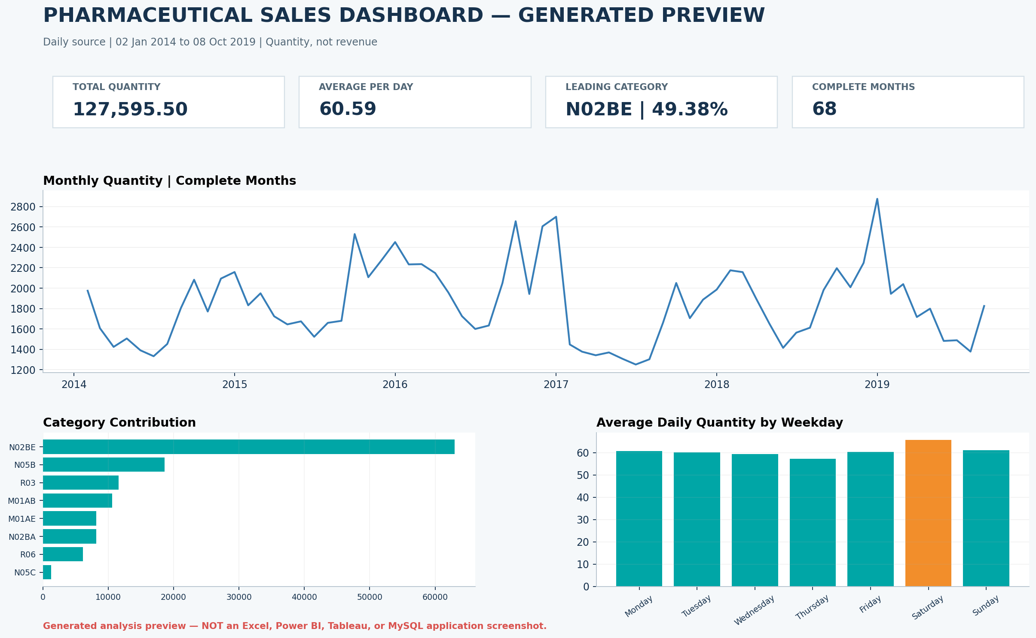
Figure 1. Generated analytical layout preview. This is not an Excel, Power BI, Tableau or MySQL application screenshot.
The actual Pharma_Sales_Dashboard.pbix and Pharma_Sales_Dashboard.twbx files remain to be created in their respective applications. Detailed build guides, DAX and Tableau calculated fields are supplied.

9. Exploratory Data Analysis and Findings

9.1 Category contribution
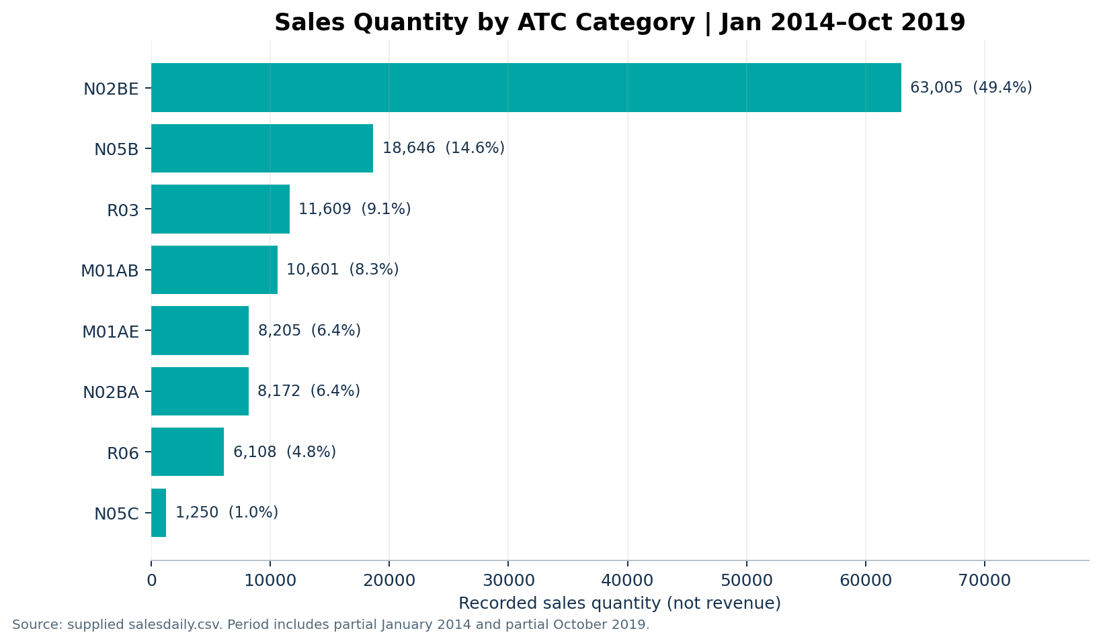
Figure 2. Total recorded quantity and percentage share by ATC category.
Rank | ATC | Total quantity | Share | Average/day | Zero days
1 | N02BE | 63,005.40 | 49.38% | 29.92 | 26
2 | N05B | 18,645.74 | 14.61% | 8.85 | 43
3 | R03 | 11,608.82 | 9.10% | 5.51 | 484
4 | M01AB | 10,600.94 | 8.31% | 5.03 | 40
5 | M01AE | 8,204.62 | 6.43% | 3.90 | 36
6 | N02BA | 8,172.21 | 6.40% | 3.88 | 78
7 | R06 | 6,107.82 | 4.79% | 2.90 | 256
8 | N05C | 1,249.96 | 0.98% | 0.59 | 1,430

N02BE is the dominant quantity category at 49.38%, followed by N05B at 14.61% and R03 at 9.10%. N05C contributes 0.98% and has the most zero-quantity days. Quantity share should not be interpreted as revenue share or clinical importance.

9.2 Monthly trend and seasonal description
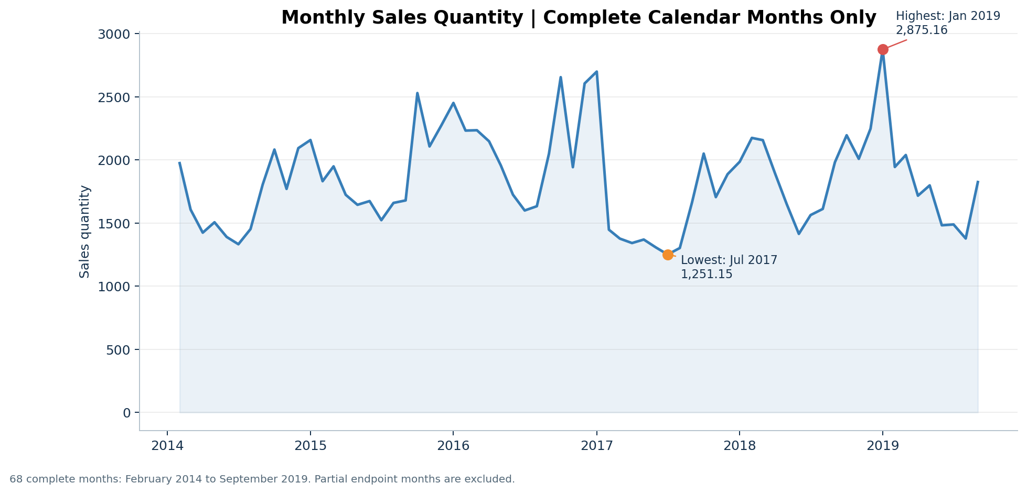
Figure 3. Monthly quantity for the 68 complete calendar months.
Complete-month observation | Month | Quantity
Highest | January 2019 | 2,875.16
Lowest | July 2017 | 1,251.15

Across complete months, January has the highest average monthly quantity (2,433.92 across 5 observations), while July has the lowest (1,459.75 across 6 observations). This is a descriptive calendar pattern based on only five to six observations per calendar month; it is not a validated forecasting model.

9.3 Annual coverage and totals
Year | Days | Coverage | Total quantity | Average/day
2014 | 364 | Partial calendar year | 20,238.34 | 55.60
2015 | 365 | Complete calendar year | 22,752.36 | 62.34
2016 | 366 | Complete calendar year | 25,234.93 | 68.95
2017 | 365 | Complete calendar year | 19,399.37 | 53.15
2018 | 365 | Complete calendar year | 22,884.56 | 62.70
2019 | 281 | Partial calendar year | 17,085.96 | 60.80

Among complete years 2015–2018, annual totals fluctuate rather than showing a consistent upward or downward pattern: 2016 rises, 2017 falls, and 2018 rises again. The 2014 and 2019 totals are coverage-labelled and should not be compared as complete calendar years.

9.4 Weekday demand
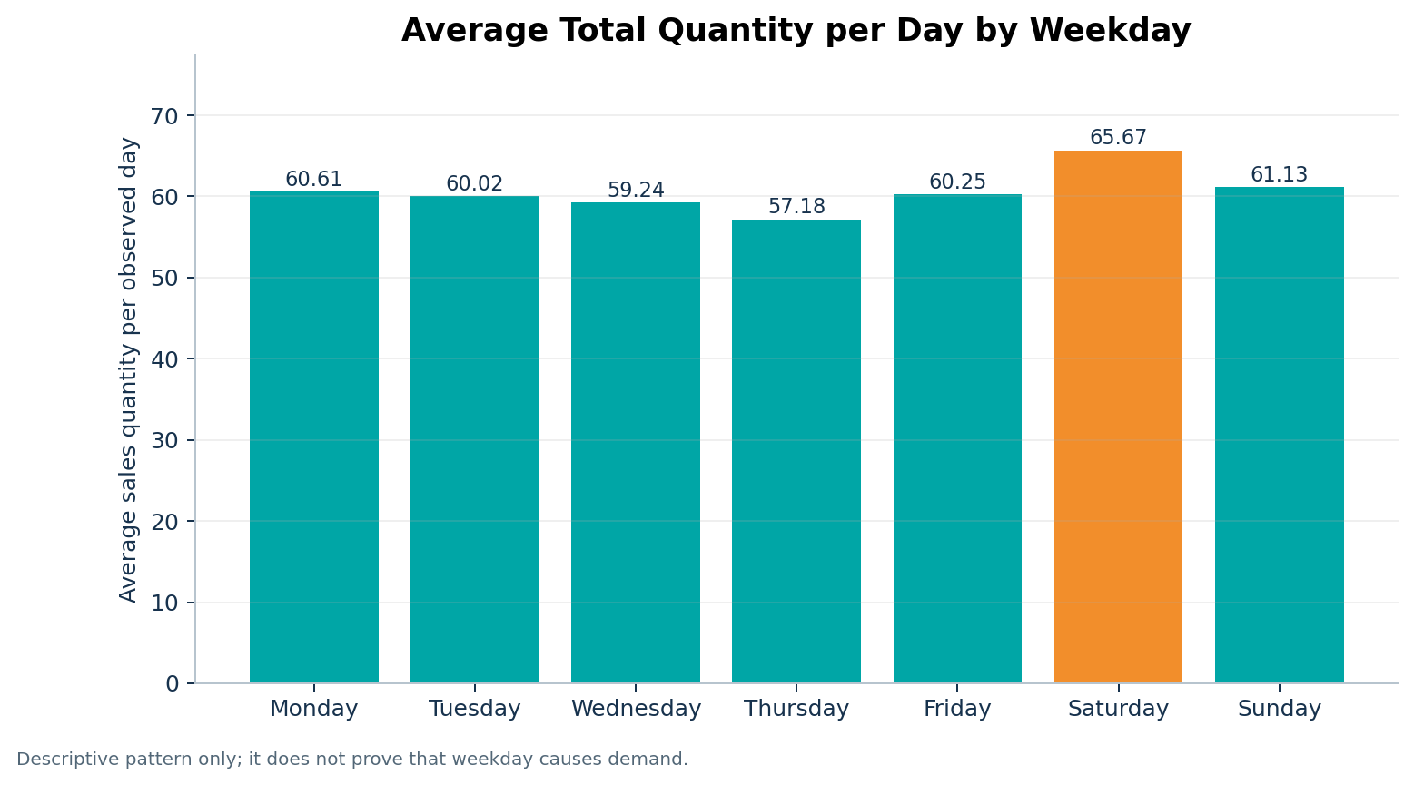
Figure 4. Average total quantity per observed day by weekday.
Saturday has the highest weekday average (65.67), while Thursday has the lowest (57.18). The Saturday average is approximately 14.85% higher. This finding can prompt an operational review, but the analysis does not establish why the difference occurs.

9.5 Hour-of-day pattern
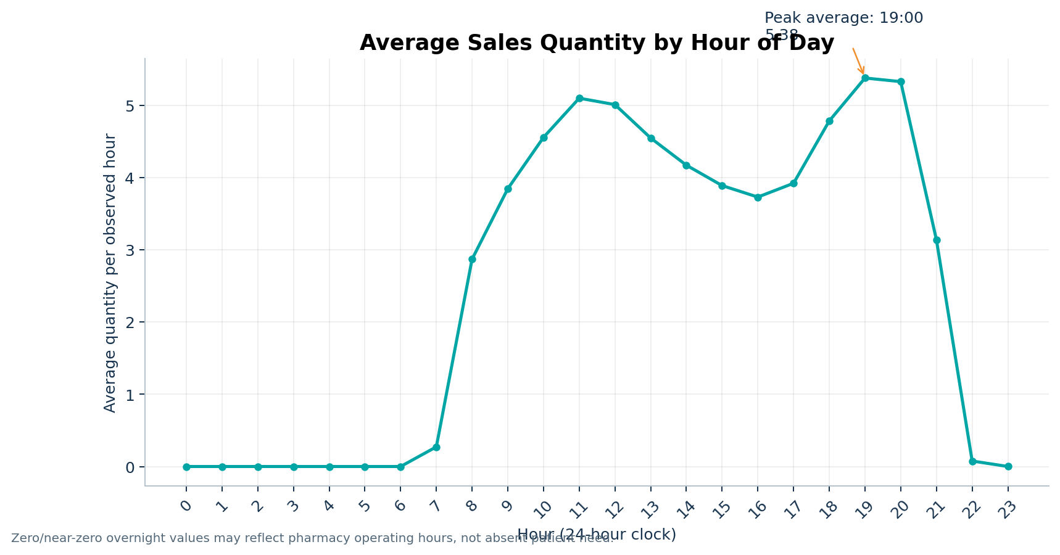
Figure 5. Average quantity by hour from the supplied hourly file.
The highest average occurs at 19:00 (5.38 quantity per observed hour). Overnight zero or near-zero values may reflect pharmacy operating hours rather than absence of patient need. Hourly findings should therefore be used cautiously for staffing review, not as a clinical demand estimate.

9.6 Variability and intermittent demand
ATC | Average/day | Std dev | 95th percentile | CV | Zero-day %
N02BE | 29.92 | 15.59 | 59.94 | 0.52 | 1.23%
N05B | 8.85 | 5.61 | 19.00 | 0.63 | 2.04%
R03 | 5.51 | 6.43 | 20.00 | 1.17 | 22.98%
M01AB | 5.03 | 2.74 | 10.00 | 0.54 | 1.90%
M01AE | 3.90 | 2.13 | 7.66 | 0.55 | 1.71%
N02BA | 3.88 | 2.38 | 8.00 | 0.61 | 3.70%
R06 | 2.90 | 2.42 | 8.00 | 0.83 | 12.16%
N05C | 0.59 | 1.09 | 3.00 | 1.84 | 67.90%

N05C has zero quantity on 67.90% of days and R03 on 22.98%. Their simple daily averages hide many zero observations. The 95th percentile describes a high historical day, but it is not automatically a safety-stock target.

10. Inventory-Planning Recommendations

Prioritise availability review for high-share categories
Begin with N02BE because it accounts for 49.38% of historical quantity, then review N05B and R03. Use this as a review priority, not a purchase quantity.

Use complete-month planning views
Use the 68 complete months for monthly comparisons and keep partial periods labelled. Do not compare eight days of October 2019 with a full month.

Treat intermittent categories differently
For N05C and R03, review zero-day frequency, variability, pack size and expiry. A simple average alone can hide the demand pattern.

Review calendar patterns with the pharmacist
Discuss the higher January average, Saturday average and early-evening hourly peak as historical signals. Confirm whether they still apply before changing stock or staffing.

Add operational data before calculating reorder rules
Capture current stock, stock on order, lead time, service-level target, pack size, minimum order quantity, expiry, price and supplier constraints.

Improve future data quality
Keep one documented source of truth, automate date-grain reconciliation, record individual product/ATC mappings where permitted, and validate new monthly extracts.

Use the dashboard for monitoring, not automatic ordering
Let filters support review by year and category. Any purchase or clinical decision requires authorised pharmacy judgement and current information.
No numerical reorder point, safety-stock quantity or purchase order is calculated because the required operational fields are absent. Providing such numbers would be invented and potentially unsafe.

11. Limitations and Ethical Interpretation
- Single-pharmacy scope: results may not generalise to other pharmacies, cities or patient populations.
- Historical period: the data ends in October 2019 and does not represent current 2026 demand.
- Incomplete last year: 2019 ends on 8 October and is not a complete year.
- Aggregated categories: eight ATC groups hide brand, strength, formulation and pack-level differences.
- No financial fields: quantity cannot establish revenue, margin or profitability.
- No inventory fields: current stock, lead time, expiry, service level and supplier constraints are unavailable.
- Source preprocessing: Kaggle states that missing-data imputation and outlier treatment were already performed, which can affect interpretation and explains some fractional quantities.
- Monthly-source inconsistency: supplied monthly rows do not always reconcile with daily data; this project uses a documented daily-derived rule instead.
- Descriptive, not causal: weekday, monthly and hourly associations do not prove why demand changed.
- No forecasting validation: no future forecast is claimed, and no model accuracy is invented.
- Clinical governance: ATC demand patterns are not prescribing advice. Pharmacist and regulatory review remain necessary.
- Privacy and sharing: keep the data aggregated, follow the dataset licence and never add patient or credential information.

12. Conclusion
The project converts the supplied pharmaceutical CSVs into a reproducible analytical workflow covering data quality, SQL, Excel and BI dashboard design. Across 2,106 observed days, total recorded quantity is 127,595.50, with an average of 60.59 per day. N02BE is the largest category at 49.38% of total quantity. Complete-month analysis identifies January 2019 as the highest month, while weekday and hourly views provide additional descriptive demand patterns.
The strongest technical lesson is that data preparation affects business conclusions. Reconciling time grains, preserving source precision and flagging partial periods prevent misleading comparisons. The strongest business lesson is that historical quantity is only one input to inventory planning; safe decisions also require current operational data and pharmacist review.

13. Deliverables and Evidence Status
Required item | Package status | Student action before submission
Cleaned dataset | Supplied: daily, derived monthly and long CSVs | Review and retain the cleaning explanation
SQL queries | Supplied: pharma_sales_analysis.sql | Run in MySQL and capture real results
Query results | Calculated CSV tables supplied | Export/compare actual MySQL results if required
Excel workbook | Pharma_Sales_Analysis.xlsx supplied | Validate, add native PivotTables if required, capture dashboard
Power BI file | Not generated; guide and DAX supplied | Build and save Pharma_Sales_Dashboard.pbix
Tableau workbook | Not generated; guide and calculations supplied | Build and save Pharma_Sales_Dashboard.twbx
Screenshots | Generated charts supplied and labelled | Add real MySQL/Excel/Power BI/Tableau screenshots
README | Supplied with actual results and honest status | Replace personal/link placeholders
Final report | This DOCX supplied | Personalise, add evidence and verify before Google Docs upload
GitHub/Google Docs/portal | Not claimed complete | Create, test and submit real links per official instructions

Use `Documentation/Submission_Checklist.md` as the final working checklist. Follow the exact current iNeuBytes portal and mentor instructions where they differ from general guidance.

14. References and Appendices

14.1 References
1. Zdravković, M. Pharma sales data. Kaggle. https://www.kaggle.com/datasets/milanzdravkovic/pharma-sales-data (dataset description, ATC category definitions and licence information).
2. Creative Commons. Attribution-NonCommercial 4.0 International. https://creativecommons.org/licenses/by-nc/4.0/
3. iNeuBytes project procedure supplied by the student for Course DAINB10926. Current portal and mentor instructions must be checked directly.

14.2 Screenshot insertion checklist
Evidence to insert | Suggested caption
MySQL overall/category/monthly results | SQL query and result grid for quantity analysis
Excel dashboard | Excel dashboard with KPI cards, charts and selectors
Power BI dashboard | Power BI sales overview with filters applied
Tableau dashboard | Tableau sales overview with filters applied

After inserting each real screenshot, add one sentence explaining what the viewer should learn. Do not replace application evidence with the generated preview.

14.3 Required repository structure
Task-1-SQL/
Task-2-Excel/
Task-3-PowerBI-Tableau/
Major-Project/
Documentation/
Screenshots/
README.md
Repository name: internsAparnareddy_INBT026297_iNeuBytes. Submit only real, tested GitHub and Google Docs URLs after completing the remaining application evidence.

