FOUNDATIONS / PHARMACY / ANALYTICS

Data Science
Fundamentals
Assessment
  - A practical, reproducible portfolio for a B.Pharm learner
entering Data Analytics and a beginner internship
SYNTHETIC PHARMACY OPERATIONS
From raw data to validated analysis, visual evidence and clear reporting

PRACTICAL WORK | QUALITY CHECKS | VISUAL EVIDENCE
16 executed exercises | 48 tests passed locally | 7 labeled EDA charts

Assessment level: Beginner | Domain: Pharmacy operations
Report date: 30 October 2026 | Format: Academic assessment + technical portfolio
Data integrity statement: All datasets are generated for education. No patient records, clinical findings or real pharmacy performance results are presented. Every quoted execution output is captured from working Python code.
GitHub repository (private): https://github.com/appureddy1102-cloud/pharmacy-data-science-assessment. Private repositories require owner sign-in or collaborator access. No access token is stored in the project; revoke any credential exposed in chat.

Reader guide and contents
This report combines beginner-friendly theory with reproducible practical evidence. The companion repository contains the original Python files, executed notebook, sample CSVs, generated charts, tests and upload documentation. File names identify exactly where a reviewer can reproduce each result.
Section | What to look for
1. Introduction and objectives | Scope, pharmacy context and success criteria
2. Python fundamentals | Core language concepts, NumPy and Pandas
3. Statistical foundations | Worked definitions, probability, models and inference
4. Understanding data types | Measurement types and data organization
5. Dataset and cleaning methodology | Provenance, validation and missing-data decisions
6. Practical exercises | 16 exact Python sources, captured outputs and explanations
7. Analysis results and visual evidence | Row audit, estimates, test, diagnostics and seven figures
8. Industry best practices | Code quality, documentation, validation, Git and privacy
9. Conclusion | Learning outcomes, limits and next steps
10. References | Authoritative sources and documentation
Appendices A–C | Run/upload instructions, dictionary, verification and file index

Navigation: use Word's Navigation Pane to jump between headings. This section guide intentionally avoids page numbers that may change across Word installations.
How to interpret evidence: a code block is the submitted executable source; a green-tinted output block is actual captured stdout. All paths are relative to the repository root. The report's date is an assessment date; precise execution times and package versions are stored in reports/execution_environment.json.
Submission identity: no student name, roll number or institution was supplied or invented. Add these to the cover only if required by your assessor; review the work and follow institutional attribution rules.

1. Introduction and assessment objectives

1.1 Context and scope
Data science turns data into useful, defensible information through programming, statistics, careful data management and communication. For a B.Pharm student, familiar examples include pharmacy stock monitoring, expiry tracking, prescription workload and service waiting times. This assessment uses those operational ideas without giving treatment, dispensing, dosage or medicine-storage advice.
The practical project investigates one summary observation per fictional pharmacy. It asks: What defects exist in the data? How do site mean waits vary? Is workload associated with waiting? How does a two-sided Welch test compare the two simulated workflows? The purpose is to learn an auditable analytical process, not to prove that a technology works in real pharmacies.
All data are synthetic. The generator creates 120 fictional independent sites and deliberately inserts missing cells, invalid values and five duplicate rows. Real district names provide context only; no business or patient data were collected. The wait-generating formula includes a workflow difference, so a small p-value cannot be interpreted as an external discovery.

1.2 Learning objectives
- Use Python variables, basic types, collections, conditions, loops, functions and exception handling.
- Use NumPy arrays and Pandas tables for reliable, readable numerical work.
- Explain mean, median, mode, variance, standard deviation, probability and normal models.
- Distinguish covariance, correlation, effect estimation and hypothesis testing.
- Classify numerical, categorical, nominal, ordinal, discrete, continuous, structured and unstructured data.
- Clean and validate data, document assumptions, conduct EDA and create labeled visualizations.
- Maintain a reproducible repository with tests, documentation, dependency versions and safe Git practices.

1.3 Success criteria
Every practical task has runnable Python source and captured output. Cleaning decisions have a machine-readable audit. Charts state units and which records were analyzed. Statistical conclusions identify the observational unit, denominator, missing-value policy and limitations. Automated tests and a fully executed notebook provide evidence instead of invented results.

2. Python fundamentals

2.1 Variables, values and basic types
A variable is a name referring to an object. Python is dynamically typed: the object has a type, while a name may later refer to a different object. Use descriptive snake_case names such as stock_units, not unexplained names such as x1. An int stores whole counts, a float stores approximate real-valued numbers, a str stores text, a bool stores True/False, and None represents the absence of a value. [R1, R7]
Examples include an integer number of expired packs, a floating-point site mean wait, a string pharmacy ID and a Boolean validation flag. Numeric-looking identifiers are still labels. Use explicit conversion such as int("12") only after considering validity: int("twelve") raises ValueError. Binary floating-point is approximate; use Decimal or integer paise for production accounting rather than treating float arithmetic as exact money.
= assigns a value; == compares values. Arithmetic operators include +, -, *, /, //, % and **. Division with / returns a floating-point result. Comparisons such as < and >= create Boolean values. Scalar Boolean expressions use and, or and not; Pandas elementwise conditions use parenthesized comparisons with & or |.

2.2 Lists, tuples, sets and dictionaries
Collection | Behavior | Pharmacy-learning example
List | Ordered, mutable; duplicates allowed; zero-based indexing | A list of stock items or daily observations
Tuple | Ordered, immutable sequence; elements may themselves be mutable | A fixed pair of teaching-example bounds
Set | Unique, hashable members; no dependable display order | Unique product categories
Dictionary | Unique keys mapped to values; insertion order preserved | Item name mapped to units in stock

A list slice such as items[:2] selects the first two elements. Use .append() to add one list element. A dictionary lookup uses a key, for example stock["ORS"]; .get() can supply a default when a key is absent. Sets are valuable for membership and deduplication but should not be used to remove repeated analytical observations without a justified record rule. Sort a set before printing if reproducible display order matters. [R1]

2.3 Conditions and loops
if, elif and else choose a path based on conditions. Order matters: first handle a special case such as zero stock, then a low-stock rule. Python uses indentation, conventionally four spaces, to define code blocks. A for loop traverses a collection; a while loop repeats while a condition is true. Always identify how a while loop will stop. [R1, R7]
range(3) yields 0, 1 and 2. break exits a loop; continue skips to its next iteration. A list comprehension is a compact way to produce a new list, such as low-stock item names. For numerical columns, NumPy vectorization or Pandas column operations are usually clearer than Python loops over individual rows.

2.4 Functions and exception handling
A function is a named, reusable operation defined with def. Parameters receive inputs; return sends a result back to the caller. Local variables belong to the function's scope. Use a docstring to explain purpose, expected inputs, units, outputs and errors. Type hints improve communication and tooling but do not enforce input types by themselves. Avoid mutable default arguments such as an empty list shared between calls. [R1]
Exceptions signal that an operation cannot proceed normally. In a try block, attempt a potentially failing operation; except ValueError handles that specific error. An else block runs when no exception occurs; finally runs whether the operation succeeded or failed. Use raise to report a meaningful domain validation failure. Do not use a bare except or silently ignore unexpected errors. [R1]
The practical inventory function demonstrates negative-input checks. The full analytical pipeline additionally checks finite numbers, valid categories, whole-number counts and column presence. Separating a small teaching example from production-grade validation prevents a beginner from assuming type hints alone make data safe.

2.5 NumPy and Pandas basics
NumPy supplies ndarray objects and efficient elementwise arithmetic. Most beginner arrays have one numeric dtype; .shape describes dimensions. For a two-dimensional array, aggregation along axis=0 produces column results, while axis=1 produces row results. Slicing often returns a view, so modifying it may change the original array; use .copy() when independence is intended. [R2]
Pandas supplies a one-dimensional labeled Series and a two-dimensional labeled DataFrame. Use read_csv() to load a table, .head() to inspect rows, .info() for schema, .describe() for numeric summaries, .loc for label/Boolean selection and .iloc for positions. groupby() summarizes groups. Prefer explicit .loc assignment or whole-column assignment over chained indexing. [R3]
Missing values require .isna() or .notna(), not equality with NaN. drop_duplicates() removes duplicate records according to an explicit key; dropna() removes selected missing cases; fillna() replaces missing values when justified. to_numeric(errors="coerce") and to_datetime(errors="coerce") expose invalid entries as missing, but this must be audited rather than silently hiding a data-quality problem. CSV files do not retain category ordering or date dtypes; load_cleaned() restores these explicitly. [R3]

3. Statistical foundations

3.1 Populations, samples and the unit of analysis
A population is the full collection of interest; a sample is a subset used to learn about it. A parameter describes a population; a statistic is computed from a sample. This assessment treats each fictional pharmacy as one independent observational unit. The wait column is a site mean, not an individual prescription's wait. Equal weighting of sites is not the same as a prescription-weighted average across all sites.
Descriptive statistics summarize the submitted data. Inferential methods quantify uncertainty under sampling and model assumptions. A simulated dataset can demonstrate inference mechanics, but it cannot establish facts about a real-world population. Real operational studies also require a sampling plan, valid measurement definitions and appropriate ethics and privacy controls.

3.2 Mean, median and mode
For observations x1 through xn, the arithmetic mean is x_bar = sum(xi) / n. The median is the central sorted value, or the mean of the two central values when n is even. A mode is any most frequent value; data can have one, several or no uniquely informative mode.
For [2, 4, 4, 4, 5, 5, 7, 9], the sum is 40 and n is 8, so the mean is 5. The middle values are 4 and 5, so the median is 4.5. The mode is 4. A few extreme waits can strongly affect a mean, whereas a median is more resistant. For nearly unique continuous observations, report a median or distribution rather than forcing a misleading single mode.

3.3 Variance and standard deviation
Population variance divides the squared deviations from the population mean by N. When estimating variation from an independent sample, the usual sample variance is s^2 = sum((xi - x_bar)^2) / (n - 1). The sample SD is s = sqrt(s^2). Variance has squared units, while SD has the units of the original measurement.
In the eight-value example, the squared deviations sum to 32. Treating those eight values as the complete population gives variance 32/8 = 4. Treating them as a sample gives variance 32/7 = 4.571429 and SD approximately 2.138090. NumPy's default is ddof=0; use ddof=1 for sample variance/SD. Pandas Series variance/SD normally default to ddof=1; this project still specifies it explicitly. [R2, R3]
SD describes variation between observations. The standard error describes uncertainty of an estimated mean; for independent observations it is estimated by SE(mean) = s / sqrt(n). These are not interchangeable. A large sample can have a precise mean while individual observations still vary widely.

3.4 Probability
Probability ranges from 0 to 1. For equally likely outcomes, P(A) = favorable outcomes / all outcomes. The complement rule is P(not A) = 1 - P(A). The addition rule is P(A or B) = P(A) + P(B) - P(A and B). Conditional probability is P(A | B) = P(A and B) / P(B) when P(B) is positive.
If 3 of 20 fictional packs are damaged, P(damaged) = 3/20 = 0.15. Two draws with replacement have probability (3/20)^2 = 0.0225 of both being damaged, under independent draws. Without replacement the second probability changes, so the probability is (3/20)*(2/19), approximately 0.015789. Independence and mutually exclusive events are different ideas.
An empirical probability uses observed frequencies. Here the event is that a pharmacy's observed mean wait is below 10 minutes, not that an individual person's wait is below 10 minutes. Records with missing outcomes cannot contribute to either the numerator or denominator. A conditional empirical probability restricts the denominator to an observed workflow group.

3.5 The normal distribution
A normal distribution is a symmetric, bell-shaped continuous probability model described by mean mu and SD sigma, written X ~ N(mu, sigma^2). In that model the mean, median and mode coincide. Approximately 68.27%, 95.45% and 99.73% of values lie within one, two and three SDs of the mean. [R6]
Standardize a value with z = (x - mu) / sigma. For a separate hypothetical model X ~ N(10, 2^2), x = 12 has z = 1. The cumulative probability P(X <= 12) is approximately 0.841345; P(8 <= X <= 12) is approximately 0.682689. These are model calculations, not claims that observed pharmacy waits follow this exact normal distribution.
The height of a probability density is not itself a probability; areas under the density over intervals are probabilities. A continuous model assigns probability zero to any single exact value. Actual waiting-time data may be right-skewed, clustered or nonnegative, so a normal model needs justification. The central limit theorem concerns the sampling distribution of averages under suitable conditions; it does not turn the original observations into normal data. [R6]

3.6 Covariance and correlation
Sample covariance is cov(X,Y) = sum((xi - x_bar)*(yi - y_bar)) / (n - 1) for paired observations. A positive covariance means above-average X tends to accompany above-average Y; its magnitude depends on the variables' units. Pearson correlation is r = cov(X,Y) / (sX*sY) when both SDs are positive. It is unitless and lies between -1 and 1.
Pearson r measures linear association. A near-zero value does not exclude a strong nonlinear relationship. Outliers, confounding, measurement error and pooling distinct groups can distort the association. Spearman rank correlation can be more appropriate for monotonic or ordinal relationships. Neither correlation nor covariance alone proves causation.
This assessment relates daily prescriptions per staff member to site mean wait using only records where the outcome and both workload inputs were observed. It does not treat median-filled predictors as fully observed evidence. The pooled association remains exploratory, because workflow and other variables can contribute to it.

3.7 Hypothesis testing and confidence intervals
A hypothesis test compares evidence against a null hypothesis, H0, using a test statistic and a reference distribution under H0. The alternative, H1, states the difference or association of interest. Prespecify the question, outcome, test, comparison direction and alpha rather than choosing them after inspecting p-values.
A p-value is the probability, assuming H0 and the test assumptions, of a test statistic at least as extreme as the observed value. It is not the probability that H0 is true. If p is below alpha, reject H0; otherwise do not reject H0. Failure to reject is not proof of equality. Alpha controls the long-run Type I error rate for the specified procedure under its assumptions; Type II error is failure to detect a specified true effect, and power is 1 minus its probability.
For this project's primary comparison, H0 is equal population mean site waits for Standard and Barcode-assisted workflows; H1 is a difference in either direction. Alpha is 0.05. The independent-samples Welch test uses t = (mean_A - mean_B) / sqrt(sA^2/nA + sB^2/nB) and Welch-Satterthwaite degrees of freedom. Unlike a pooled-variance t-test, it does not require equal population variances. [R4]
Important assumptions remain: independent observational units; an outcome with a meaningful mean; no dominant, uninvestigated anomalies; and a sampling distribution for the mean difference that is adequately approximated by the test. Review within-group Q-Q plots and Shapiro-Wilk diagnostics; a large Shapiro p-value does not prove normality, and a diagnostic should not be used as a mechanical test-selection switch. [R5]
A 95% confidence interval is difference ± t_critical * SE(difference). Under repeated suitable sampling, approximately 95% of intervals from that procedure contain the fixed population difference. This is not a 95% probability statement about the already fixed parameter after observing one interval. Report the difference and interval in minutes, not just a p-value. Statistical significance is not clinical or operational importance. Missing outcomes, multiple testing, selection bias and clustered observations can all change valid interpretation. [R4]

4. Understanding data types

4.1 Measurement types and analytical choices
Type | Meaning | Example | Suitable beginner summaries
Numerical | Quantities with meaningful arithmetic | Wait minutes; prescription counts | Mean, median, SD, histogram
Discrete | Numerical counts with separated possible values | Number of prescriptions or expired packs | Frequency table, count summary
Continuous | Conceptual measurements on a continuum, even if rounded | Site mean wait; stock percentage | Histogram, median, mean, SD
Categorical | Group membership rather than measured magnitude | Workflow or pharmacy type | Counts, proportions, mode
Nominal | Categories without a natural ranking | Region, workflow, pharmacy ID | Counts; do not average labels
Ordinal | Categories with a natural order but not equal spacing | Low < Medium < High stock risk | Ordered counts; ranks/median where appropriate

These distinctions overlap hierarchically: numerical data may be discrete or continuous; categorical data may be nominal or ordinal. They are not eight competing buckets. A Boolean can represent a two-category nominal variable. A date is a temporal variable. A currency amount recorded to paise is technically quantized but is treated as a numerical measurement in this educational analysis.
Do not compute a meaningful average of arbitrarily coded nominal groups. For ordinal categories, the gap from Low to Medium is not guaranteed to equal the gap from Medium to High; coding them 1, 2 and 3 does not make equal spacing true. Use Pandas ordered categories to preserve rank without pretending it is a precise interval scale.

4.2 Structured, semi-structured and unstructured data
Structured data follow an explicit row/column schema, as in the assessment CSV or a relational database. Unstructured data include narrative notes, scanned images and audio, whose content lacks a fixed tabular schema. Semi-structured formats, such as JSON with nested keys, contain some organization without requiring a simple rectangular table.
The CSV is structured even though its notes cells hold unstructured language. An ID stored as an integer would still be nominal; a continuous measurement stored as text would still be semantically numerical but require parsing. Storage type, measurement type and structural organization answer different questions.

5. Dataset design and cleaning methodology

5.1 Provenance and study design
The supplied generator uses numpy.random.default_rng(2026). It creates 120 fictional pharmacies with balanced randomized workflow labels before injecting data defects. Each pharmacy appears once before exact duplicate rows are appended. Counts, workload, stock levels and inventory values are simulated; labels that resemble places are contextual, not sampled locations. No personally identifiable or patient-level information is present.
The mean-wait formula is 7.0 + 0.035*(daily_prescriptions/staff_on_duty) - 1.1*(workflow == "Barcode-assisted") + noise, where the simulated noise is normal with mean 0 and SD 1.35, then rounded to two decimals. This deliberately built-in effect is why results must remain educational. The file retains only the deliberately corrupted input, not a hidden real-world ground truth.

5.2 Auditable cleaning decisions
- Verify that all required raw columns exist; otherwise raise a clear DataValidationError.
- Preserve the raw CSV and remove only exact duplicate records, not arbitrary repeated category values.
- Standardize case and whitespace, parse dates and check ID format. Quarantine invalid ID, date or workflow rows; keep rejection reasons and original CSV row numbers.
- Reject conflicting pharmacy IDs after exact deduplication rather than choosing one untrustworthy record.
- Convert numeric text, nonfinite values and invalid ranges to missing and count conversions. Prescription and expiry counts must be nonnegative whole numbers; staff must be a positive whole number; observed waits must be positive; stock percentages must be between 0 and 100.
- Fill only designated non-outcome numeric columns with the valid-data median; round count medians to whole numbers. Keep a Boolean imputation flag per column and record every fill value.
- Keep unknown regions as Unknown rather than guessing a genuine region. Preserve missing wait outcomes and exclude them only from analyses that require waits.
- Recalculate workload and teaching-only stock risk from the cleaned inputs; validate ranges, uniqueness and derived-value consistency.
stock_risk uses Low for availability >=95%, Medium for 90% to below 95%, and High for below 90%. These arbitrary teaching cutoffs are not validated healthcare quality standards. Four imputed stock values influence the descriptive risk counts; that limitation is disclosed wherever risk counts are used.

5.3 Missing-data limitations
Median imputation is simple and resistant to extreme observations, but it can reduce variance and distort associations. It does not recover unknown values. Flagging it improves transparency; it does not remove bias. Outcomes are never imputed for the primary hypothesis test, and the workload correlation excludes records whose workload inputs were imputed.
Missing completely at random means missingness is unrelated to observed or unobserved values; missing at random means dependence can be explained by observed information; missing not at random means it can still depend on the unseen value after conditioning on observed information. These mechanisms cannot be established from a missing-cell count alone. Complete-case analysis may be biased in real studies. The inserted teaching defects should not be used to assert that real pharmacy missingness is harmless.
A real predictive project would fit imputation on training data only and then apply it to validation/test data to avoid leakage. This assessment is descriptive and inferential, not a predictive machine-learning evaluation. The transparent workflow is deliberately more important than adding an unnecessary model.

6. Practical exercises: executed solutions
The following 16 tasks were run successfully. Each includes a task statement, complete short Python source, actual captured output and an explanation. Source files import the companion package where full production-style implementation is needed. Run setup and the pipeline before executing an individual file.
python -m pip install -r requirements.txt
python -m pip install -e . --no-deps
python scripts/run_assessment.py
python exercises/13_hypothesis_testing.py
Tasks | Skills demonstrated
01–04 | Variables, collections, control flow, functions and exceptions
05–06 | NumPy arrays and Pandas tables
07–09 | Cleaning, validation, data types and EDA
10–13 | Descriptive statistics, probability, correlation and Welch inference
14–16 | Visualization, intentional validation failures and actual local Git history

Verification principle: exercise_outputs.json stores the source text and captured output together, reducing the risk of presenting output from a different code version. The report builder reads that record instead of typing numerical examples by hand.

6.01 Variables and basic types
Task: Store a fictional medicine label, stock count, unit price and Boolean flag; compute inventory value.
Source file: exercises/01_variables.py
Working Python code
"""Task 01: variables, basic types and pharmacy stock arithmetic."""
medicine = "Paracetamol (fictional stock item)"
stock_units = 120
unit_price_inr = 2.50
requires_cold_chain = False
print(f"Medicine: {medicine}")
print(
f"Types: {type(medicine).__name__}, {type(stock_units).__name__}, "
f"{type(unit_price_inr).__name__}, {type(requires_cold_chain).__name__}"
)
print(f"Inventory value: INR {stock_units * unit_price_inr:.2f}")
print(f"After selling 15 units: {stock_units - 15} units")
Actual captured output
Medicine: Paracetamol (fictional stock item)
Types: str, int, float, bool
Inventory value: INR 300.00
After selling 15 units: 105 units
Explanation: Use a string for names, an integer for counts, a float for measurements or illustrative prices, and a Boolean for yes/no flags. Production financial calculations should use Decimal or integer paise to avoid binary floating-point rounding.

6.02 Lists, tuples, sets and dictionaries
Task: Organize stock items with four built-in collection types and inspect their behavior.
Source file: exercises/02_collections.py
Working Python code
"""Task 02: list, tuple, set and dictionary; print sets in a stable order."""
medicines = ["Antacid", "ORS", "Antacid"]
medicines.append("Bandage")
storage_range_c = (15, 25) # A fictional tuple, not storage advice.
unique_items = set(medicines)
stock = {"Antacid": 50, "ORS": 30, "Bandage": 20}
print("List:", medicines)
print("Tuple:", storage_range_c)
print("Unique items:", sorted(unique_items))
print("ORS stock:", stock["ORS"])
print("Dictionary keys:", sorted(stock))
print("List slice:", medicines[:2])
Actual captured output
List: ['Antacid', 'ORS', 'Antacid', 'Bandage']
Tuple: (15, 25)
Unique items: ['Antacid', 'Bandage', 'ORS']
ORS stock: 30
Dictionary keys: ['Antacid', 'Bandage', 'ORS']
List slice: ['Antacid', 'ORS']
Explanation: Lists are ordered and mutable; tuples are ordered and immutable; sets keep unique hashable members without a dependable display order; dictionaries map unique keys to values and preserve insertion order. The storage-range tuple is fictional, not product storage guidance.

6.03 Conditions and loops
Task: Assign stock status with if/elif/else and use for, while and a list comprehension.
Source file: exercises/03_control_flow.py
Working Python code
"""Task 03: if/elif/else, for and while loops with explicit stopping rules."""
stock = {"Antacid": 50, "ORS": 12, "Bandage": 0}
for item, units in stock.items():
if units == 0:
status = "Out of stock"
elif units < 20:
status = "Reorder"
else:
status = "Adequate"
print(f"{item}: {status}")
remaining = 12
steps = 0
while remaining > 0:
remaining -= min(5, remaining)
steps += 1
print(f"While loop: {steps} steps; {remaining} units remaining")
print("Low-stock items:", [item for item, units in stock.items() if units < 20])
Actual captured output
Antacid: Adequate
ORS: Reorder
Bandage: Out of stock
While loop: 3 steps; 0 units remaining
Low-stock items: ['ORS', 'Bandage']
Explanation: Condition order matters: zero stock is checked before the low-stock rule. The while loop decreases a counter every iteration, guaranteeing termination. The reorder threshold is a teaching rule, not a validated pharmacy policy.

6.04 Functions and exception handling
Task: Define a documented function, return a result, reject negative input, and catch conversion failures.
Source file: exercises/04_functions_and_errors.py
Working Python code
"""Task 04: a reusable function, a docstring and specific exception handling."""
def inventory_value(units: int, price: float) -> float:
"""Return INR stock value for non-negative units and unit price."""
if units < 0 or price < 0:
raise ValueError("Units and price cannot be negative.")
return units * price
print(f"Valid value: INR {inventory_value(120, 2.5):.2f}")
try:
inventory_value(-5, 2.5)
except ValueError as error:
print("Handled validation error:", error)
try:
units = int("twelve")
except ValueError:
print("Handled conversion error: enter a whole number, for example 12.")
finally:
print("Input check completed.")
Actual captured output
Valid value: INR 300.00
Handled validation error: Units and price cannot be negative.
Handled conversion error: enter a whole number, for example 12.
Input check completed.
Explanation: Functions reduce duplication. Type hints document intended types but do not enforce them at runtime. Catch specific expected exceptions; do not silently ignore invalid input. The small arithmetic function illustrates a concept; the data pipeline adds finite-number, integer and range validation.

6.05 NumPy basics
Task: Build and slice arrays, apply vectorized arithmetic, compute sample variation and aggregate over an axis.
Source file: exercises/05_numpy_basics.py
Working Python code
"""Task 05: array construction, slicing, vectorization, axes and ddof."""
import numpy as np
sales = np.array([10, 12, 8, 15, 5])
print("Array:", sales.tolist())
print("First three:", sales[:3].tolist())
print("After adding 2:", (sales + 2).tolist())
print(f"Mean={sales.mean():.2f}; sample SD={sales.std(ddof=1):.3f}")
matrix = np.array([[10, 12], [8, 15], [5, 10]])
print("Shape:", matrix.shape)
print("Column totals (axis=0):", matrix.sum(axis=0).tolist())
Actual captured output
Array: [10, 12, 8, 15, 5]
First three: [10, 12, 8]
After adding 2: [12, 14, 10, 17, 7]
Mean=10.00; sample SD=3.808
Shape: (3, 2)
Column totals (axis=0): [23, 37]
Explanation: NumPy arrays normally share a numeric dtype and support efficient elementwise operations. axis=0 aggregates down rows into column totals. NumPy defaults to population variance/SD (ddof=0); pass ddof=1 when estimating sample variation.

6.06 Pandas basics
Task: Create a DataFrame, select a Series, filter rows with .loc, calculate a column and group values.
Source file: exercises/06_pandas_basics.py
Working Python code
"""Task 06: DataFrame, Series, filtering, .loc, derived columns and groupby."""
import pandas as pd
stock = pd.DataFrame(
{
"item": ["Antacid", "ORS", "Bandage"],
"category": ["Medicine", "Medicine", "Supply"],
"units": [50, 12, 20],
"unit_price_inr": [3.0, 5.0, 8.0],
}
)
stock["value_inr"] = stock["units"] * stock["unit_price_inr"]
print("Shape:", stock.shape)
print("Units Series:", stock["units"].tolist())
print("Filtered rows:")
print(stock.loc[stock["units"] < 20, ["item", "units"]].to_string(index=False))
print("Value by category:")
print(stock.groupby("category")["value_inr"].sum().to_string())
Actual captured output
Shape: (3, 5)
Units Series: [50, 12, 20]
Filtered rows:
item units
ORS 12
Value by category:
category
Medicine 210.0
Supply 160.0
Explanation: A Series is one labeled column; a DataFrame is a labeled table. Boolean filtering and groupby avoid error-prone row-by-row loops. Use explicit .loc assignment rather than chained indexing.

6.07 Missing values, duplicates and cleaning
Task: Clean the supplied CSV, quarantine critical defects and inspect the imputation audit.
Source file: exercises/07_cleaning_and_validation.py
Working Python code
"""Task 07: run audited cleaning without changing the raw CSV."""
import pandas as pd
from pharmacy_ds.cleaning import clean_data
from pharmacy_ds.config import PROJECT_ROOT
raw = pd.read_csv(PROJECT_ROOT / "data/raw/pharmacy_operations_dirty.csv")
clean, rejected, audit = clean_data(raw)
print(f"Input rows: {len(raw)}")
print(f"Exact duplicates removed: {audit['exact_duplicates_removed']}")
print(f"Critical rows quarantined: {len(rejected)}")
print(f"Clean rows: {len(clean)}")
print("Imputed numeric cells (with flags):")
for column, count in audit["imputed_counts"].items():
print(f" {column}: {count}; fill={audit['imputation_values'][column]}")
print(f"Unknown regions: {audit['unknown_region_count']}")
print(f"Missing wait outcomes retained: {audit['missing_wait_outcomes_retained']}")
print("Validation passed; no outcome was imputed.")
Actual captured output
Input rows: 125
Exact duplicates removed: 5
Critical rows quarantined: 3
Clean rows: 117
Imputed numeric cells (with flags):
daily_prescriptions: 6; fill=147
staff_on_duty: 4; fill=4
stock_availability_pct: 4; fill=93.26
inventory_value_inr: 3; fill=37380.83
expired_units: 0; fill=2
Unknown regions: 3
Missing wait outcomes retained: 6
Validation passed; no outcome was imputed.
Explanation: Keep raw data unchanged. Remove only exact duplicate records. Unrecognized workflow, invalid date and invalid ID are not guessed. Numeric predictors use flagged median imputation; count medians are rounded to whole numbers. Missing wait outcomes remain missing. Full implementation: src/pharmacy_ds/cleaning.py.

6.08 Analytical data types
Task: Inspect storage dtypes and preserve a meaningful ordinal category order.
Source file: exercises/08_data_types.py
Working Python code
"""Task 08: analytical data types versus Python/Pandas storage types."""
from pharmacy_ds.cleaning import load_cleaned
from pharmacy_ds.config import PROJECT_ROOT
df = load_cleaned(PROJECT_ROOT / "data/processed/pharmacy_operations_clean.csv")
for column in [
"pharmacy_id",
"report_date",
"workflow",
"stock_risk",
"daily_prescriptions",
"mean_wait_minutes",
"notes",
]:
print(f"{column}: {df[column].dtype}")
print("Risk order:", df["stock_risk"].cat.categories.tolist())
print("Risk is ordered:", df["stock_risk"].cat.ordered)
print("CSV = structured table; notes content = unstructured text.")
print("An ID is nominal even when it contains digits.")
Actual captured output
pharmacy_id: string
report_date: datetime64[ns]
workflow: category
stock_risk: category
daily_prescriptions: int64
mean_wait_minutes: float64
notes: string
Risk order: ['Low', 'Medium', 'High']
Risk is ordered: True
CSV = structured table; notes content = unstructured text.
An ID is nominal even when it contains digits.
Explanation: Numerical versus categorical is a semantic distinction, not merely a storage dtype. Pharmacy identifiers are nominal labels; wait is continuous; prescriptions are discrete; risk is ordinal. A CSV is structured while natural-language notes within it contain unstructured content.

6.09 Exploratory data analysis
Task: Compare workflow summaries, count risk categories and flag possible outliers without deleting them.
Source file: exercises/09_eda.py
Working Python code
"""Task 09: explore groups, category counts and potential (not deleted) outliers."""
from pharmacy_ds.cleaning import load_cleaned
from pharmacy_ds.config import PROJECT_ROOT
df = load_cleaned(PROJECT_ROOT / "data/processed/pharmacy_operations_clean.csv")
print("Observed site waits by workflow:")
table = df.groupby("workflow", observed=True)["mean_wait_minutes"].agg(
["count", "mean", "median", "std"]
)
print(table.to_string(float_format=lambda number: f"{number:.3f}"))
print("Derived risk counts (include stock imputations):")
print(df["stock_risk"].value_counts(sort=False).to_string())
wait = df["mean_wait_minutes"].dropna()
q1, q3 = wait.quantile([0.25, 0.75])
iqr = q3 - q1
flag = (wait < q1 - 1.5 * iqr) | (wait > q3 + 1.5 * iqr)
print(f"IQR-fence potential wait outliers: {int(flag.sum())}; retained for analysis")
Actual captured output
Observed site waits by workflow:
count mean median std
workflow
Barcode-assisted 56 7.625 7.555 1.795
Standard 55 8.678 8.710 1.309
Derived risk counts (include stock imputations):
stock_risk
Low 36
Medium 74
High 7
IQR-fence potential wait outliers: 4; retained for analysis
Explanation: EDA examines distributions, missingness, relationships and surprising values before modeling. Summary denominators reflect observed outcomes. Risk counts are descriptive and include flagged stock imputations. An IQR flag is a prompt for investigation, not proof of an error.

6.10 Mean, median, mode, variance and SD
Task: Verify a small hand-checkable dataset and compute sample statistics for site mean waits.
Source file: exercises/10_descriptive_statistics.py
Working Python code
"""Task 10: a hand-checkable example plus statistics on observed site waits."""
import numpy as np
from scipy import stats
from pharmacy_ds.cleaning import load_cleaned
from pharmacy_ds.config import PROJECT_ROOT
values = np.array([2, 4, 4, 4, 5, 5, 7, 9])
print(f"Toy mean={np.mean(values):.3f}; median={np.median(values):.3f}")
print(f"Toy mode={int(stats.mode(values, keepdims=False).mode)}")
print(f"Toy population variance={np.var(values, ddof=0):.3f}")
print(f"Toy sample variance={np.var(values, ddof=1):.3f}")
print(f"Toy sample SD={np.std(values, ddof=1):.3f}")
df = load_cleaned(PROJECT_ROOT / "data/processed/pharmacy_operations_clean.csv")
y = df["mean_wait_minutes"].dropna()
print(f"Observed site waits: n={len(y)}, mean={y.mean():.3f}, median={y.median():.3f}")
print(f"Sample variance={y.var(ddof=1):.3f}; sample SD={y.std(ddof=1):.3f}")
print(
"Staff modes (descriptive; includes imputations):",
df["staff_on_duty"].mode().tolist(),
)
Actual captured output
Toy mean=5.000; median=4.500
Toy mode=4
Toy population variance=4.000
Toy sample variance=4.571
Toy sample SD=2.138
Observed site waits: n=111, mean=8.147, median=8.150
Sample variance=2.732; sample SD=1.653
Staff modes (descriptive; includes imputations): [4]
Explanation: The mean is sensitive to extreme values; the median describes the middle; the mode is most useful for categories or repeated discrete values. Sample variance uses n−1 and squared units; SD returns to the original units. Site mean wait is not the mean of all patient waiting times.

6.11 Probability and the normal distribution
Task: Calculate pack-selection probabilities, empirical site-level probabilities and a hypothetical normal-model probability.
Source file: exercises/11_probability_and_normal.py
Working Python code
"""Task 11: empirical, conditional and model-based probabilities."""
from scipy import stats
from pharmacy_ds.cleaning import load_cleaned
from pharmacy_ds.config import PROJECT_ROOT
print(f"3 damaged packs out of 20: P(damaged)={3 / 20:.4f}")
print(f"Two damaged, with replacement: {(3 / 20) ** 2:.4f}")
print(f"Two damaged, without replacement: {(3 / 20) * (2 / 19):.4f}")
df = load_cleaned(PROJECT_ROOT / "data/processed/pharmacy_operations_clean.csv")
observed = df.dropna(subset=["mean_wait_minutes"])
successes = int(observed["mean_wait_minutes"].lt(10).sum())
print(
f"P(site mean wait < 10 | observed)={successes}/{len(observed)}={successes / len(observed):.4f}"
)
for workflow in ["Standard", "Barcode-assisted"]:
group = observed.loc[observed["workflow"].eq(workflow), "mean_wait_minutes"]
print(f"P(site mean wait < 10 | {workflow})={group.lt(10).mean():.4f}")
print("Hypothetical normal model: X ~ N(10, 2^2); not fitted to these data")
print(f"z at X=12: {(12 - 10) / 2:.1f}")
print(f"P(X <= 12)={stats.norm.cdf(12, loc=10, scale=2):.4f}")
print(f"P(8 <= X <= 12)={stats.norm.cdf(12, 10, 2) - stats.norm.cdf(8, 10, 2):.4f}")
Actual captured output
3 damaged packs out of 20: P(damaged)=0.1500
Two damaged, with replacement: 0.0225
Two damaged, without replacement: 0.0158
P(site mean wait < 10 | observed)=99/111=0.8919
P(site mean wait < 10 | Standard)=0.8727
P(site mean wait < 10 | Barcode-assisted)=0.9107
Hypothetical normal model: X ~ N(10, 2^2); not fitted to these data
z at X=12: 1.0
P(X <= 12)=0.8413
P(8 <= X <= 12)=0.6827
Explanation: With-replacement draws can be independent; without-replacement draws change the second probability. Empirical probabilities use only records with observed outcomes. X ~ N(10, 2²) is a separate assumed model, not a normality claim about the pharmacy dataset.

6.12 Correlation and covariance
Task: Use observed workload inputs to calculate a paired sample covariance and Pearson r.
Source file: exercises/12_correlation_covariance.py
Working Python code
"""Task 12: observed-only sample covariance and Pearson correlation."""
from pharmacy_ds.cleaning import load_cleaned
from pharmacy_ds.config import PROJECT_ROOT
from pharmacy_ds.statistics import correlation_sample
df = load_cleaned(PROJECT_ROOT / "data/processed/pharmacy_operations_clean.csv")
observed = correlation_sample(df)
x = observed["workload_per_staff"]
y = observed["mean_wait_minutes"]
print(f"Complete observed workload/wait pairs: {len(observed)}")
print(f"Sample covariance: {x.cov(y, ddof=1):.4f}")
print("Covariance units: (prescriptions per staff member) * minutes")
print(f"Pearson correlation r: {x.corr(y):.4f}")
print("Correlation does not establish causation; workflow is a possible confounder.")
Actual captured output
Complete observed workload/wait pairs: 101
Sample covariance: 18.6331
Covariance units: (prescriptions per staff member) * minutes
Pearson correlation r: 0.4842
Correlation does not establish causation; workflow is a possible confounder.
Explanation: Covariance has product units and depends on scale; Pearson r is unitless in [−1, 1] and measures linear association. Neither establishes causation. Workflow differences, nonlinearity or outliers can affect the pooled association.

6.13 Hypothesis testing
Task: Compare independent pharmacy-level mean waits with a two-sided Welch test and a 95% confidence interval.
Source file: exercises/13_hypothesis_testing.py
Working Python code
"""Task 13: two-sided Welch test, confidence interval and normality diagnostics."""
from pharmacy_ds.cleaning import load_cleaned
from pharmacy_ds.config import PROJECT_ROOT
from pharmacy_ds.statistics import analyze
df = load_cleaned(PROJECT_ROOT / "data/processed/pharmacy_operations_clean.csv")
result = analyze(df)
test = result["welch_test"]
print("H0: Standard and Barcode-assisted population mean site waits are equal.")
print("H1: They differ. Prespecified alpha=0.05; two-sided Welch test.")
for name, group in result["workflow_summary"].items():
print(
f"{name}: n={group['n']}, mean={group['mean']:.3f}, SD={group['sample_sd']:.3f}"
)
print(f" Shapiro-Wilk W={group['shapiro_w']:.4f}, p={group['shapiro_p']:.4f}")
print(f"Difference (Standard - Barcode-assisted)={test['difference_minutes']:.3f} min")
print(f"95% CI=[{test['ci95_low']:.3f}, {test['ci95_high']:.3f}] min")
print(
f"Welch t={test['t_statistic']:.4f}; df={test['degrees_of_freedom']:.3f}; p={test['p_value']:.6g}"
)
print(f"Decision: {test['decision']}")
print(
"Independent simulated sites; no imputed outcomes. Simulation is not clinical evidence."
)
Actual captured output
H0: Standard and Barcode-assisted population mean site waits are equal.
H1: They differ. Prespecified alpha=0.05; two-sided Welch test.
Standard: n=55, mean=8.678, SD=1.309
Shapiro-Wilk W=0.9857, p=0.7558
Barcode-assisted: n=56, mean=7.625, SD=1.795
Shapiro-Wilk W=0.9668, p=0.1247
Difference (Standard - Barcode-assisted)=1.054 min
95% CI=[0.463, 1.644] min
Welch t=3.5375; df=100.657; p=0.000612561
Decision: Reject H0
Independent simulated sites; no imputed outcomes. Simulation is not clinical evidence.
Explanation: Prespecify H0, H1 and alpha. Welch does not require equal variances but still needs independent observations and an adequately behaved sampling distribution. Inspect within-group Q–Q plots and Shapiro diagnostics; a nonsignificant normality test does not prove normality. The simulated effect was built into the generator.

6.14 Data visualization
Task: Regenerate seven clearly labeled PNG charts and verify the saved file names.
Source file: exercises/14_visualization.py
Working Python code
"""Task 14: regenerate seven labeled chart files using Matplotlib and Seaborn."""
import pandas as pd
from pharmacy_ds.cleaning import load_cleaned
from pharmacy_ds.config import PROJECT_ROOT
from pharmacy_ds.visualization import create_figures
raw = pd.read_csv(PROJECT_ROOT / "data/raw/pharmacy_operations_dirty.csv")
df = load_cleaned(PROJECT_ROOT / "data/processed/pharmacy_operations_clean.csv")
paths = create_figures(raw, df, PROJECT_ROOT / "reports/figures")
print(f"Saved {len(paths)} figures:")
for path in paths:
print(" ", path.relative_to(PROJECT_ROOT).as_posix())
Actual captured output
Saved 7 figures:
reports/figures/01_wait_histogram.png
reports/figures/02_wait_by_workflow.png
reports/figures/03_workload_scatter.png
reports/figures/04_stock_risk_counts.png
reports/figures/05_raw_missingness.png
reports/figures/06_qq_standard.png
reports/figures/07_qq_barcode.png
Explanation: Choose a histogram for a distribution, a box plot for group spreads, a scatter plot for two numerical variables, and a bar chart for categories. Q–Q plots assess shape within each workflow. Label axes, units, sample definitions and imputation policy. Actual images appear in the EDA section and executed notebook.

6.15 Data validation and safe failure
Task: Introduce three common integrity errors and confirm they raise useful validation errors.
Source file: exercises/15_validation_errors.py
Working Python code
"""Task 15: deliberately break data and prove that validation rejects it."""
from pharmacy_ds.cleaning import DataValidationError, load_cleaned, validate_clean_data
from pharmacy_ds.config import PROJECT_ROOT
df = load_cleaned(PROJECT_ROOT / "data/processed/pharmacy_operations_clean.csv")
for scenario in ["negative inventory", "duplicate ID", "missing column"]:
bad = df.copy()
if scenario == "negative inventory":
bad.loc[0, "inventory_value_inr"] = -1
elif scenario == "duplicate ID":
bad.loc[1, "pharmacy_id"] = bad.loc[0, "pharmacy_id"]
else:
bad = bad.drop(columns=["workflow"])
try:
validate_clean_data(bad)
except DataValidationError as error:
print(f"Rejected {scenario}: {error}")
Actual captured output
Rejected negative inventory: inventory_value_inr cannot contain negative values.
Rejected duplicate ID: pharmacy_id must be unique.
Rejected missing column: Missing required columns: workflow
Explanation: Validation guards against silently producing misleading results. Production code checks required columns, valid IDs, dates, uniqueness, finite numbers, integer counts, ranges and consistency of derived variables. Expected failures are caught and explained; unexpected failures should stop the run.

6.16 Git version control
Task: Run staging, a local commit, history inspection and a clean-status check in a disposable repository.
Source file: exercises/16_git_workflow.py
Working Python code
"""Task 16: execute Git staging, a local commit and history in a disposable repo."""
from pharmacy_ds.git_demo import run_git_demo
print(run_git_demo(), end="")
Actual captured output
$ git init --quiet -b main
$ git add README.md
$ git diff --cached --stat
README.md | 1 +
1 file changed, 1 insertion(+)
$ git -c commit.gpgsign=false commit --quiet -m Add assessment README
$ git log -1 --oneline
2cd2c5e Add assessment README
$ git status --short
Clean working tree; local demonstration only. No GitHub repository was created.
Explanation: Git records local history; GitHub hosts remote repositories. This is a real local Git demonstration with a fixed demonstration identity/date, not an authenticated GitHub upload. Review staged changes, use focused commits and never commit credentials. The temporary repository is removed after the exercise.

7. Data analysis results and interpretation

7.1 Row accounting and data quality
Stage | Row count | Explanation
Raw CSV | 125 | 120 synthetic sites plus 5 exact duplicate records
After exact deduplication | 120 | Only identical records were removed
Critical rejected records | 3 | One invalid ID, one invalid workflow, one invalid date
Valid cleaned sites | 117 | One row per accepted fictional pharmacy
Observed wait outcomes | 111 | Required for wait summaries and Welch test
Missing wait outcomes | 6 | Five original missing values plus one invalid negative value; not imputed
Complete observed workload/wait pairs | 101 | Excludes imputed prescription/staff inputs and absent outcomes

Three region entries become Unknown (two missing, one unrecognized). Invalid numeric conversion counts and source CSV row numbers are recorded in the audit/rejection files. No raw rows are silently rewritten. The raw-missingness chart counts empty cells, not invalid but non-null strings/numbers; these are distinct quality problems.

7.2 Predictor imputation audit
Column | Imputed cells | Median fill used
daily_prescriptions | 6 | 147
staff_on_duty | 4 | 4
stock_availability_pct | 4 | 93.26
inventory_value_inr | 3 | 37380.83
expired_units | 0 | 2

Counts are filled with rounded whole-number medians. The expiry column required no replacements; its recorded median is a reproducible potential fill value. Boolean flags preserve which entries were estimated. Mean waits are never filled. Stock-risk counts include four imputed stock values and therefore remain descriptive only.

7.3 Descriptive statistics and EDA
Among 111 observed site mean waits, the mean is 8.147 minutes and the median is 8.150 minutes. Sample variance is 2.732 minutes squared and sample SD is 1.653 minutes. Minimum and maximum observed site means are 4.19 and 12.02 minutes; the first and third quartiles are 7.255 and 9.025 minutes.
The IQR-fence exercise flags four possible wait outliers in the pooled distribution; they are retained because an outlier flag is not evidence of a recording error. Inspect them and their workflow context instead of deleting them to change a p-value. The histogram and box plot show distributions of site summaries, not individual waits.
Workflow | Observed n | Missing waits | Mean (min) | Sample SD (min) | Shapiro p
Standard | 55 | 2 | 8.678 | 1.309 | 0.7558
Barcode-assisted | 56 | 4 | 7.625 | 1.795 | 0.1247

The descriptive stock-risk counts are Low=36, Medium=74 and High=7. Categories are ordered Low < Medium < High and are generated from teaching-only cutoffs. No validated risk or quality claim is implied.

7.4 Probability, covariance and correlation
Of the 111 sites with an observed mean wait, 99 have a mean below 10 minutes, giving an empirical probability of 0.8919. This is a site-level fraction, not the chance that a randomly selected individual waits less than 10 minutes. Unknown waits are excluded from both numerator and denominator.
Using 101 complete observed workload/wait pairs, Pearson r is 0.4842 and sample covariance is 18.6331 (prescriptions per staff member) × minutes. The positive association means higher workload tends to accompany higher site mean wait in this simulation. It is exploratory, scale-dependent for covariance, and not causal evidence. Workflow may contribute to the pooled relationship.
The separate assumed model X ~ N(10, 2²) gives P(X <= 12)=0.8413 and P(8 <= X <= 12)=0.6827. These model values are not estimates of the observed dataset's normality.

7.5 Primary hypothesis test: Welch comparison
H0: the two workflow population mean site waits are equal. H1: they differ. The prespecified procedure is a two-sided Welch independent-samples t-test at alpha=0.05, comparing Standard minus Barcode-assisted. Outcomes are observed only. [R4]
Test quantity | Executed value
Difference in means | 1.054 minutes
Standard error of difference | 0.2978 minutes
Welch t statistic | 3.5375
Welch-Satterthwaite degrees of freedom | 100.657
Two-sided p-value | 0.000612561
95% confidence interval | [0.463, 1.644] minutes
Decision at alpha=0.05 | Reject H0

The interval does not include zero, consistent with the small p-value. In this simulated sample, Standard has a higher mean site wait. This demonstrates the mechanics of comparison, uncertainty and reporting; it does not show that barcode systems improve a real pharmacy.

7.6 Assumption checks and limitations
- Each generator record is a distinct fictional pharmacy; duplicates are removed before analysis. Real clustered or repeated-site data would need a design-aware method rather than pretending every row is independent.
- Q-Q plots are examined separately by workflow. Shapiro-Wilk p-values are reported as diagnostics, not proof of normality. Neither group diagnostic rejects normality at 0.05 in this run, but that alone does not establish the assumption. [R5]
- Welch accommodates unequal variances; it does not remove dependence, selection bias, severe anomalies or measurement error.
- Six absent/invalid outcomes are excluded, not replaced. Complete-case analysis can be biased in real observational data. Predictors with imputed values are excluded from the workload correlation, but risk counts intentionally include flagged stock imputations.
- The workflow difference was deliberately built into the outcome-generating formula. Results have no external validity for a real business or patient population and no clinical interpretation.
- One primary mean-comparison test is specified. Correlation is exploratory; normality checks are diagnostics. No broad screening of subgroup p-values or post-hoc causal claims is presented.
- No actual intervention recommendation follows from a fictional dataset. A real study would require an appropriate sampling design, validated measurement definitions, power planning, missingness review and domain oversight.

7.7 Visual evidence — distributions and workflow comparison
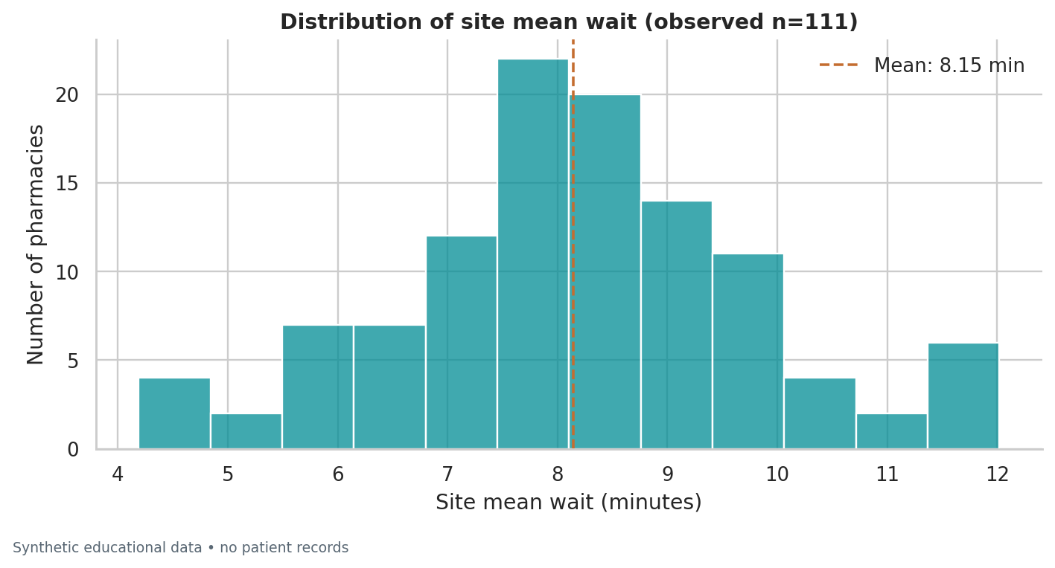
Figure 1. Histogram of 111 observed pharmacy-level mean waits. The dashed line is the sample mean. The unit is a pharmacy, not an individual patient.
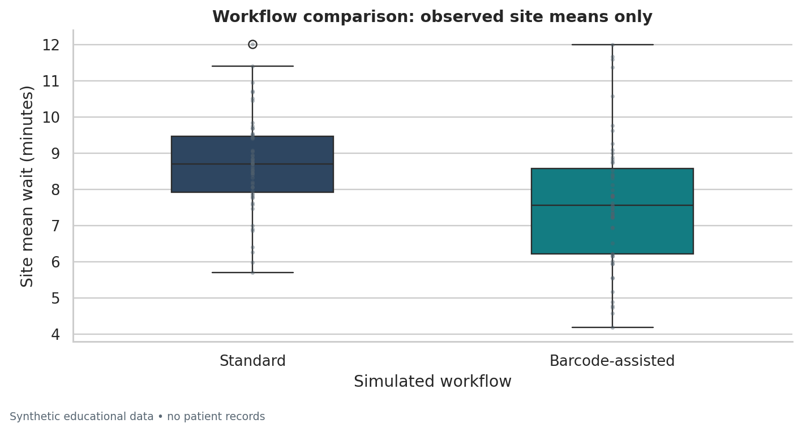
Figure 2. Workflow box plots with observed site means. Standard has a higher sample mean; the Barcode-assisted group has greater observed spread. No outcome is imputed.

7.8 Visual evidence — relationships and ordered categories
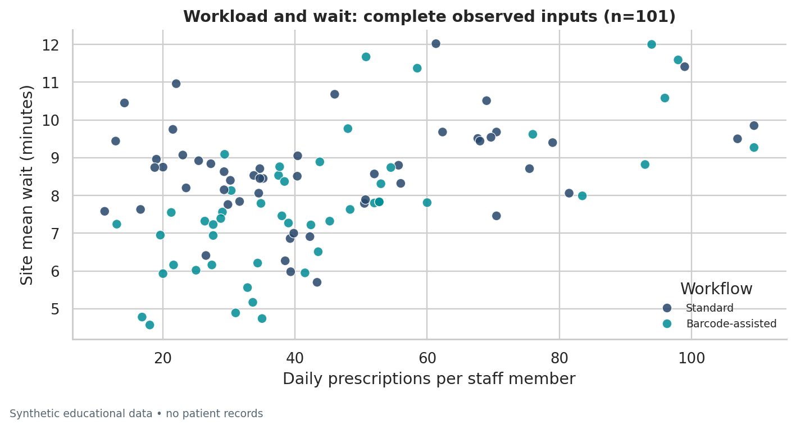
Figure 3. Workload versus observed site mean wait for 101 complete observed pairs. Imputed prescription/staff inputs are excluded. Colors identify workflow; association is not causation.
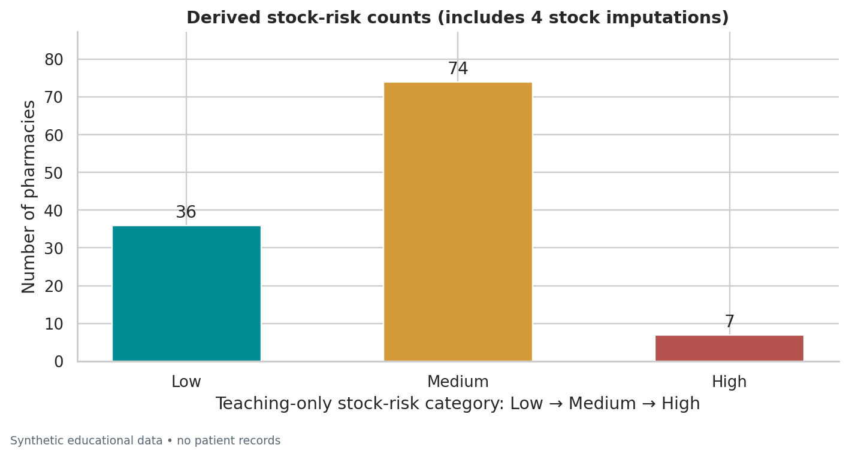
Figure 4. Ordered stock-risk counts: 36 Low, 74 Medium and 7 High. Four stock values are imputed. Cutoffs are teaching examples, not validated healthcare quality thresholds.

7.9 Visual evidence — quality and within-group diagnostics
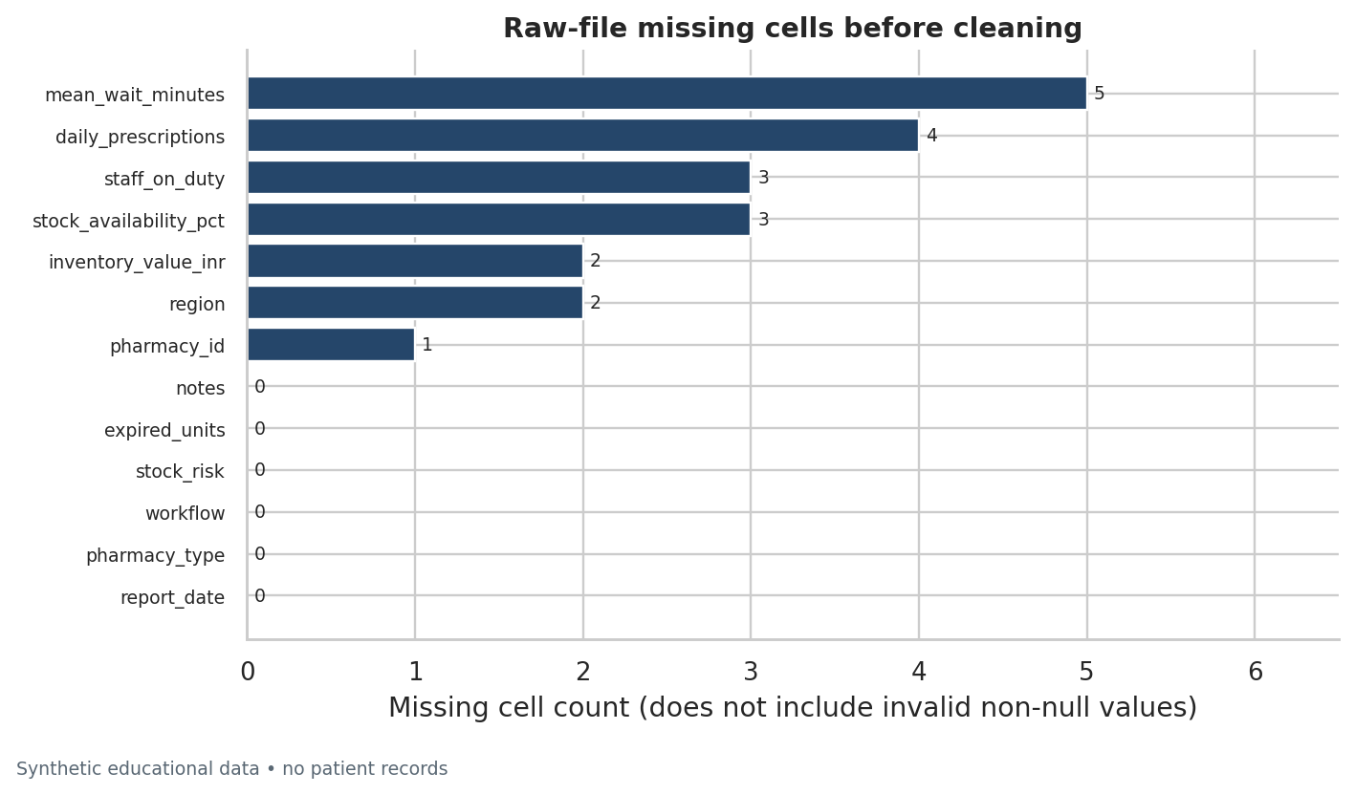
Figure 5. Missing cells in the raw 125-row CSV. Invalid but non-null values, such as a negative wait or an unrecognized workflow, are separately counted in the cleaning audit.
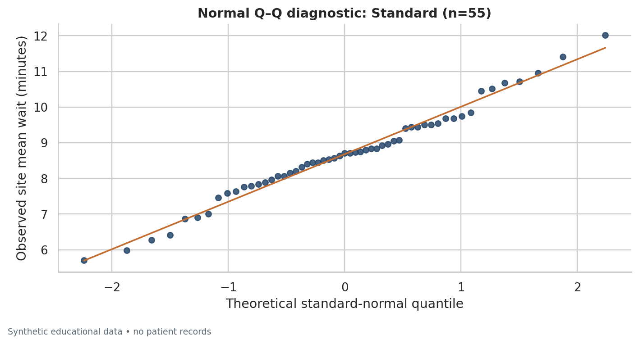
Figure 6. Standard workflow normal Q–Q diagnostic, n=55. Approximate alignment is a shape diagnostic, not proof of normality or independence.

7.10 Visual evidence — second workflow diagnostic
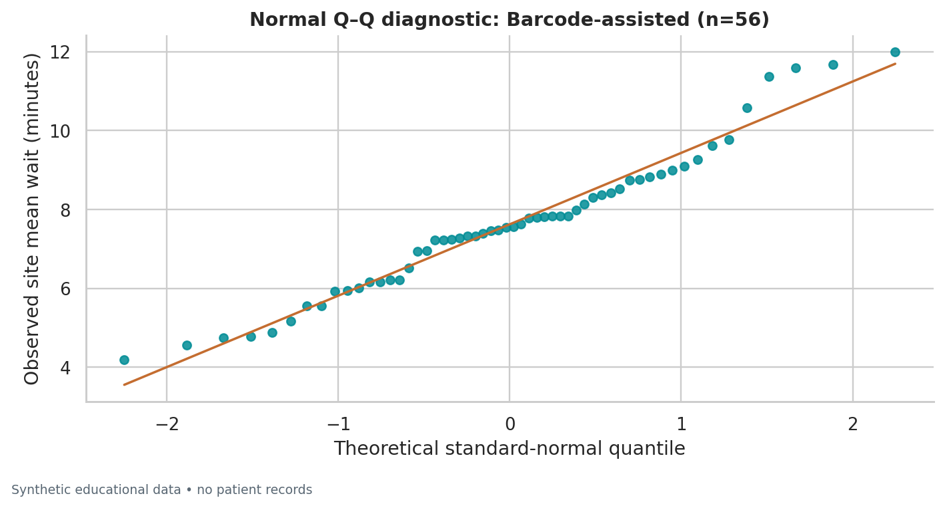
Figure 7. Barcode-assisted workflow normal Q–Q diagnostic, n=56. Examine tail departures and context alongside the reported Shapiro–Wilk diagnostic.
Reading Q–Q plots: points close to the reference line are consistent with an approximately normal shape. Departures, especially at the tails, require context. The reference line is fitted for visual comparison; it is not a regression model explaining pharmacy performance. No diagnostic establishes the independence of records.
Why not pool the Q–Q plot? Distinct workflow means can create a mixture. Inspecting groups separately is more relevant to a two-sample mean comparison. The Welch test still relies on assumptions and cannot transform simulated data into real-world evidence.

8. Industry best practices

8.1 Readable, maintainable Python
Use descriptive snake_case names, four-space indentation, focused functions, explicit units in names and a consistent formatter. Separate data generation, cleaning, statistics and visualization into modules rather than placing every operation in one notebook cell. Keep configuration in one place and avoid magic thresholds with no explanation. Follow PEP 8 while prioritizing clarity. [R7]
Use vectorized column operations where they make intent clearer. Avoid hidden global state, mutable default arguments and broad exception swallowing. Type hints and docstrings communicate contracts; tests and runtime checks verify them. Specify ddof, comparison direction, category order and random seeds explicitly when they affect meaning.

8.2 Documentation and provenance
A professional README explains the problem, installation, data provenance, how to run the work, actual results, limitations and repository structure. A data dictionary defines units, ranges, missingness rules and category meanings. Comments explain why a choice was made, not merely restate each line. Maintain raw data separately from derived data, and log file hashes and package versions.
The report, notebook, CSVs and code must agree. This submission generates its practical output directly from the source files. The executed notebook embeds its chart outputs, so a reviewer does not need external image links. Only locally executed checks are presented as local evidence. A GitHub location is recorded only when returned by the authenticated API; no cloud CI result or third-party review is implied.

8.3 Validation, errors and tests
Validate required columns, types, valid categories, record uniqueness, nonfinite numbers, sensible ranges and consistency of derived variables. Distinguish an exact duplicate record from a contradictory record sharing the same ID. Preserve rejected rows and reasons for review. Avoid deleting unusual but plausible observations merely to obtain a more attractive p-value.
Raise clear, specific errors when a valid analysis cannot continue. Catch only expected input errors and give the user an actionable message. Do not hide failures behind fabricated zeros or empty charts. Use unit tests for edge cases and independent numerical checks; include a reproducible end-to-end run and a notebook execution check. Use explicit runtime checks rather than Python assert for production validation, because assert can be disabled; assertions remain appropriate in tests.

8.4 Statistical and visualization integrity
State the observational unit, analysis denominator, missing-value policy, hypotheses and alpha. Report effect estimates and confidence intervals, not just whether p is below 0.05. Do not equate statistical with practical or clinical significance. Avoid causal language for an exploratory correlation. If many formal comparisons are performed, prespecify and justify a multiplicity strategy rather than cherry-picking small p-values.
Use clear titles, axis labels, units and sample definitions. Do not use 3D effects or misleading axes. Distinguish observed values from imputations. A chart of site means cannot establish the distribution of individual patient waits. Diagnose distributions within relevant groups instead of treating a pooled mixture as one homogeneous population.

8.5 Git, GitHub and security
Git is a local version-control system; GitHub is a remote hosting and collaboration service. A repository contains files, commits and branches. The staging area selects changes for the next commit. Use git status, inspect staged differences, make focused commits and write informative commit messages. Use a feature branch and pull request for review before merging to main. Resolve conflicts thoughtfully rather than overwriting another person's work. [R8]
Use a .gitignore for virtual environments, caches, local configuration and credentials. Small synthetic sample data and assessment figures are tracked intentionally. Real patient records, account secrets, access tokens, passwords and private keys must never be committed. Use approved secure storage, least privilege and time-limited access. If a credential is exposed, revoke it and inspect account activity; deleting it from a document or chat does not make it secret again. [R9, R10]
The provided Git exercise makes a real local commit in a disposable directory using an explicitly fictional demonstration identity and a fixed date for repeatability. It does not create a GitHub repository. The optional GitHub Actions configuration is supplied at docs/CI_WORKFLOW_TEMPLATE.yml rather than as an active workflow, because the authorized credential did not grant workflow-installation permission. The owner can enable it using GitHub's web editor or an appropriately authorized connection. No cloud execution is claimed. Safe publishing instructions use a browser authentication flow rather than embedding a token in a command, URL or file.

8.6 Pharmacy-specific professional conduct
Use only approved data and access controls. De-identification and authorization requirements still apply when real health data are available. Apply institutional policies and applicable law; a generic portfolio is not a compliance certification. Validate operational definitions with qualified domain staff before applying an analysis to a pharmacy workflow.
This project contains no patient records or clinical recommendations. Synthetic examples teach methods but do not establish medicine quality, safety, efficacy, dosing or validated stock thresholds. Review and understand the work before assessment submission and follow your institution's rules about permitted assistance and attribution.

9. Conclusion
This assessment demonstrates a complete beginner data-science workflow in a pharmacy-operations context: understanding the question, representing data correctly, writing readable Python, cleaning and validating records, exploring distributions, applying statistical methods and communicating results with evidence.
The verified project contains 16 practical exercises, seven labeled EDA figures, an executed notebook with 24 successful code cells and 48 passing automated tests. Cleaning reconciles 125 raw rows to 117 accepted fictional pharmacies, with rejected records and imputation decisions preserved for review.
The primary observed-outcome comparison estimates Standard minus Barcode-assisted at 1.054 minutes, with a 95% confidence interval of [0.463, 1.644] minutes. The small p-value demonstrates a Welch procedure on a dataset whose workflow difference was deliberately generated. It does not justify clinical, patient-level or real-business conclusions.
The most important professional outcome is traceability: raw inputs, schema definitions, source code, actual outputs, charts, tests and limitations agree. Numerical precision and a significant test are not substitutes for a sound study design, appropriate data access or domain validation.

9.1 Beginner internship learning roadmap
- Practice rebuilding the pipeline from a fresh environment and explain each cleaning decision without relying on memorized code.
- Extend the project with approved, non-sensitive data only after writing a data dictionary and identifying the observational unit.
- Learn SQL filtering, joins and aggregation; then compare SQL summaries with the Pandas results.
- Strengthen confidence intervals, sampling design, missing-data reasoning and visualization communication before adding predictive models.
- Use small Git branches, focused commits and reviewed pull requests; never trade credential security for a faster upload.
GitHub repository (private): https://github.com/appureddy1102-cloud/pharmacy-data-science-assessment. Private repositories require owner sign-in or collaborator access. No access token is stored in the project; revoke any credential exposed in chat.

10. References
Authoritative documentation consulted 30 October 2026. Online documentation may describe newer versions than the executed environment; Appendix C and execution_environment.json record the actual versions. All assessment-specific numerical results, test output and figures were generated locally from the included synthetic files.
[R1] Python Software Foundation. The Python Tutorial. Accessed 30 October 2026.
https://docs.python.org/3/tutorial/
Scope: Basic types, data structures, control flow, functions and exceptions.
[R2] NumPy Developers. NumPy: the absolute basics for beginners. Accessed 30 October 2026.
https://numpy.org/doc/stable/user/absolute_beginners.html
Scope: Arrays, shapes, numerical operations and beginner conventions.
[R3] pandas Development Team. 10 minutes to pandas (version 2.2.3). Accessed 30 October 2026.
https://pandas.pydata.org/pandas-docs/version/2.2.3/user_guide/10min.html
Scope: Series, DataFrame, selection, missing data and grouping.
[R4] SciPy Community. scipy.stats.ttest_ind. Accessed 30 October 2026.
https://docs.scipy.org/doc/scipy/reference/generated/scipy.stats.ttest_ind.html
Scope: Independent-samples and Welch t-tests, assumptions and confidence intervals.
[R5] SciPy Community. scipy.stats.shapiro. Accessed 30 October 2026.
https://docs.scipy.org/doc/scipy/reference/generated/scipy.stats.shapiro.html
Scope: Shapiro–Wilk normality diagnostic and limitations.
[R6] NIST/SEMATECH. e-Handbook of Statistical Methods: Normal Distribution. Accessed 30 October 2026.
https://www.itl.nist.gov/div898/handbook/eda/section3/eda3661.htm
Scope: Normal distribution, standardization and distribution properties.
[R7] van Rossum, G.; Warsaw, B.; Coghlan, A.. PEP 8 – Style Guide for Python Code. Accessed 30 October 2026.
https://peps.python.org/pep-0008/
Scope: Readability, indentation, naming and code layout.
[R8] GitHub Docs. Adding locally hosted code to GitHub. Accessed 30 October 2026.
https://docs.github.com/en/migrations/importing-source-code/using-the-command-line-to-import-source-code/adding-locally-hosted-code-to-github
Scope: Git initialization, commits and safe repository publishing.
[R9] GitHub Docs. Managing your personal access tokens. Accessed 30 October 2026.
https://docs.github.com/en/authentication/keeping-your-account-and-data-secure/managing-your-personal-access-tokens
Scope: Credential management, least privilege and token security.
[R10] GitHub Docs. Keeping your API credentials secure. Accessed 30 October 2026.
https://docs.github.com/en/rest/authentication/keeping-your-api-credentials-secure
Scope: Secure storage and remediation after credential exposure.

Appendix A. Reproduction and GitHub publication
Complete instructions: docs/RUN_GUIDE.md and docs/GITHUB_UPLOAD.md. The current repository location is listed on the cover when configured. Commands below show local reproduction and, separately, how to publish another copy. Do not create a duplicate repository merely to update the existing one. Activate a fresh virtual environment first.
python -m venv .venv
# Windows PowerShell: .\.venv\Scripts\Activate.ps1
# macOS/Linux: source .venv/bin/activate
python -m pip install -r requirements.txt
python -m pip install -e . --no-deps
python scripts/verify_submission.py
The full verification recreates only the synthetic sample, reruns lint/analysis/tests/notebook, refreshes documentation and rebuilds the report. It stops on failure. Run timestamps and elapsed times may change; the statistical calculations should reproduce at displayed precision.

A.1 Secure repository creation
- Revoke any token exposed in chat through GitHub Settings → Developer settings → Personal access tokens; inspect account activity. Do not reuse it or send another token to the assistant.
- Extract the complete repository ZIP. Upload extracted files and preserve their folder structure, rather than uploading only the ZIP.
- On your own computer, use GitHub CLI browser login or GitHub Desktop. Set your actual local commit identity, review staged changes and choose repository visibility deliberately.
gh auth login --hostname github.com --git-protocol https --web
gh auth setup-git
git init -b main
# Set your actual local name/email as explained in docs/GITHUB_UPLOAD.md.
git add .
git diff --cached --stat
git commit -m "Complete data science assessment"
gh repo create pharmacy-data-science-assessment --private --source=. --remote=origin --push
gh repo view --json url --jq .url
For a new copy, use an unused repository name; choose --public only if permitted and intended. The final command prints the genuine URL after a successful push. The current private repository requires assessor access. The optional configuration is supplied as docs/CI_WORKFLOW_TEMPLATE.yml, not an active workflow; no cloud CI run is claimed. [R8–R10]

Appendix B. Compact data dictionary
The full machine-readable dictionary is data/data_dictionary.csv; expanded definitions and missing-value rules are in docs/DATA_DICTIONARY.md. CSV does not preserve dtype metadata. The clean table has 21 columns: 13 raw columns, one original-row trace, one workload ratio, five imputation flags and one missing-outcome flag.
Column | Type / unit | Meaning and rule
pharmacy_id | Nominal identifier / none | PH001–PH120 fictional IDs; unique PH plus 3 digits. Critical: invalid or missing -> quarantine
report_date | Temporal / YYYY-MM-DD | Synthetic snapshot 2026-09-30. Critical: invalid or missing -> quarantine
region | Nominal categorical / none | Hyderabad; Warangal; Nalgonda; Unknown. Normalize whitespace/case; missing or unrecognized -> Unknown
pharmacy_type | Nominal categorical / none | Community; Hospital; Unknown. Normalize text; unrecognized -> Unknown
workflow | Nominal categorical / none | Standard; Barcode-assisted. Normalize text; invalid or missing -> quarantine
daily_prescriptions | Numerical discrete / prescriptions per site per day | Nonnegative whole count. Invalid -> missing; rounded median imputation with flag
staff_on_duty | Numerical discrete / staff members at site | Positive whole count. Invalid -> missing; rounded median imputation with flag
mean_wait_minutes | Numerical continuous outcome / minutes (site-level mean) | Positive finite observed values; may remain missing. Invalid -> missing; NEVER imputed; observed-only analysis
stock_availability_pct | Numerical continuous / percent | Finite 0–100. Invalid -> missing; median imputation with flag
inventory_value_inr | Numerical currency measurement / INR | Finite nonnegative illustrative inventory value. Invalid -> missing; median imputation with flag; not production accounting
expired_units | Numerical discrete / units | Nonnegative whole count. Invalid -> missing; rounded median imputation with flag
stock_risk | Ordinal categorical, derived / none | Low (>=95%); Medium (>=90% and <95%); High (<90%). Recomputed after cleaning; teaching-only thresholds
notes | Unstructured text content within structured CSV / none | Fictional operational notes; no patient information. Strip whitespace; missing -> empty string
raw_csv_row | Discrete provenance field, derived / 1-based CSV line including header | Original source row; first data row is 2. Preserved after exact deduplication
workload_per_staff | Numerical continuous ratio, derived / prescriptions per staff member per day | daily_prescriptions / staff_on_duty. Correlation excludes rows with imputed source inputs
*_was_imputed | Binary nominal flags, derived / none | One flag for each of 5 designated non-outcome numeric columns. True iff source numeric value was missing or invalid
mean_wait_minutes_missing | Binary nominal flag, derived / none | True iff wait outcome is absent after validation. No replacement of missing outcome

Appendix C. Execution evidence and file index
Actual local test run
................................................ [100%]
48 passed in 1.92s
Actual lint result
All checks passed!
Notebook verification
Check | Recorded result
Execution status | passed
Code cells executed | 24 / 24
Error outputs | 0
Embedded PNG outputs | 7
Notebook execution time (UTC) | 2026-10-30T13:49:39.098853+00:00
Python version | 3.13.16
Analysis execution time (UTC) | 2026-10-30T13:49:36.904383+00:00

Dependency | Executed version
numpy | 2.3.5
pandas | 2.2.3
scipy | 1.17.1
matplotlib | 3.10.9
seaborn | 0.13.2
python-docx | 1.1.2
nbformat | 5.11.1
nbclient | 0.11.0
ipykernel | 6.31.0
pytest | 9.0.3
ruff | 0.14.3

Input/output fingerprints (SHA-256)
RAW: 186124eeb450a14b214788d82e1754373910e60879dc1c015132e025da993977
CLEAN: e8beca33606e6fc25adc3923279bdece532fe5b2022d87cce00b042bdc5d8ef8
Hashes identify the exact data used; they are not a digital signature or external certification. reports/verification_summary.json records the full verification steps, and reports/submission_manifest.sha256 identifies the final repository files.

C.1 Where to find each implementation
Path | Responsibility
src/pharmacy_ds/generate.py | Deterministic synthetic data and controlled defects
src/pharmacy_ds/cleaning.py | Schema, normalization, quarantine, imputation and validation
src/pharmacy_ds/statistics.py | Observed-only summaries, covariance/correlation, Welch and CI
src/pharmacy_ds/visualization.py | Seven reproducible, labeled PNG figures
src/pharmacy_ds/pipeline.py | End-to-end orchestration and captured exercise outputs
tests/ | 48 local tests in this submission; count is recorded by pytest
notebooks/01_fundamentals_assessment.ipynb | Executed narrative, 16 practicals and seven embedded images
scripts/verify_submission.py | Fail-fast local reproduction of the full deliverable set
docs/ | Theory, dictionary, findings, references and upload/run guides

