YUVAINTERN DATA ANALYTICS INTERNSHIP • TASK 4
REAL-WORLD DATASET ANALYSIS PROJECT
Exploratory Data Analysis, Customer Segmentation and Business Insights
Using the UCI Online Retail Dataset
A reproducible, evidence-based analysis of 541,909 real-world transactions recorded between 1 December 2010 and 9 December 2011.
Item | Detail
Dataset | UCI Machine Learning Repository — Online Retail
Dataset DOI | 10.24432/C5BW33
Official source | https://archive.ics.uci.edu/dataset/352/online+retail
Licence | Creative Commons Attribution 4.0 International (CC BY 4.0)
Raw file SHA-256 | 43465a06f2ccf7c8b5bd2892bc7defb52f97487934fe93b16ae4c3936424676d
Records analysed | 541,909 rows × 8 columns
Tools | Python 3.13, Pandas 2.2, NumPy 2.3, SciPy 1.17, Matplotlib 3.11, Seaborn 0.13
Prepared by | Data Analytics Intern, YuvaIntern
Date | November 2026

Contents
Executive Summary
1. Introduction
2. Business Background
3. Problem Statement
4. Objectives and Analytical Framework
5. Dataset Source and Description
6. Data Dictionary
7. Exploratory Dataset Inspection
8. Data Quality Assessment
9. Data Cleaning and Preprocessing
10. Feature Engineering
11. Exploratory Data Analysis
12. Statistical Analysis
13. Data Visualisation and Interpretation
14. Advanced Customer Segmentation (RFM)
15. Pareto and Correlation Analysis
16. Key Findings
17. Business Recommendations
18. Data Limitations
19. Synthetic Data Considerations
20. Conclusion
21. References
Appendix A — Quality-Control Checklist
Page numbers are printed in the footer of every page. All figures are numbered sequentially and all tables are numbered sequentially.

Executive Summary
This project analyses the complete UCI Online Retail dataset — 541,909 transactions recorded by a UK-based online retailer between 1 December 2010 and 9 December 2011. The dataset was obtained from the official UCI Machine Learning Repository, verified against its published dimensions, and analysed in full. No records were simulated, and no figure in this report was entered by hand: every number is produced by the executed Python pipeline in the accompanying notebook.
After removing 5,268 exact duplicates and separating 3,836 cancellation invoices and 1,336 return lines, the valid sales dataset contains 524,878 lines across 19,960 invoices. Net revenue is £10,642,110.80 on 5,572,420 units, from 4,338 identified customers. Average order value is £533.17, and 65.58% of identified customers ordered more than once.
Three patterns dominate the commercial picture. First, revenue is extremely concentrated: the top 1% of customers generate 31.8% of revenue, and 1,130 customers (26.1%) are needed to reach 80% of revenue — close to, but not exactly, the 80/20 rule. Second, the business is overwhelmingly domestic: the United Kingdom contributes 84.6% of revenue, and the largest non-UK markets are served by a handful of accounts rather than broad customer bases. Third, growth is seasonal: revenue rises from £821,453 in December 2010 to a peak of £1,503,867 in November 2011, before the partial December 2011 observation.
Cancellations are material and persistent: 3,836 cancellation invoices represent 16.12% of all invoices and £893,980 of gross value, equal to 7.75% of gross activity. The RFM segmentation shows that 942 Champions (64.5% of revenue) coexist with 485 At Risk and 173 Can't Lose Them customers worth a combined £818,897.
The report closes with six evidence-based recommendations, twelve numbered findings, and an explicit statement of limitations. Recommendations are proposals, not tested interventions; the historical data cannot establish that any action would increase revenue.
KPI | Calculated result | Business interpretation
Total valid sales revenue (GBP) | £10,642,110.80 | Sum of Quantity × UnitPrice on valid, non-cancelled, positive-price lines.
Total units sold | 5,572,420 | Sum of Quantity on valid sales lines.
Total valid invoices | 19,960 | Distinct InvoiceNo values in the valid sales dataset.
Unique purchasing customers | 4,338 | Distinct non-null CustomerID in valid sales.
Average order value (AOV, GBP) | £533.17 | Total revenue ÷ 19,960 valid invoices.
Repeat customer rate (%) | 65.58% | 2,845 customers with >1 invoice ÷ 4,338 purchasing customers.
One-time customer share (%) | 34.42% | 1,493 customers with exactly 1 invoice ÷ 4,338 purchasing customers.
Cancellation rate by invoice (%) | 16.12% | 3,836 cancellation invoices ÷ (3,836 cancellations + 19,960 valid invoices).
Cancellation rate by line (%) | 1.73% | 9,251 cancellation lines ÷ (9,251 cancellation lines + 524,878 valid lines).
Cancellation value (GBP, absolute) | £893,979.73 | Sum of Quantity × UnitPrice on cancellation lines (negative by construction).
Top country revenue (GBP) | £9,001,744.09 | United Kingdom revenue ÷ total revenue = 84.59%.
Top customer revenue (GBP) | £280,206.02 | Customer 14646 ÷ total revenue = 2.63%.
Peak month revenue (GBP) | £1,503,866.78 | Nov 2011 is the highest-revenue month.
Latest-month MoM growth (%) | -57.59% | Dec 2011 vs Nov 2011 (partial month).

1. Introduction
Online retail businesses generate large volumes of transactional data but frequently lack a consolidated, evidence-based view of what that data means commercially. This project addresses that gap for a UK-based online retailer by subjecting a genuine, publicly documented transaction dataset to a complete analytical workflow: inspection, quality assessment, cleaning, feature engineering, exploratory analysis, statistical testing, customer segmentation and visualisation.
The dataset was selected for four reasons. It is real, not synthetic; it is well documented and citable; it is large enough to support statistical inference (541,909 rows); and it contains the operational complexity that makes analysis realistic — cancellations, missing customer identifiers, extreme purchases, non-product lines and strong seasonality. These features allow the project to demonstrate judgement rather than mechanical data cleaning.
The analysis is deliberately conservative. Unusual observations are investigated before any treatment is applied, cancellations are analysed rather than discarded, and every percentage is reported with its denominator. Where the data cannot support a conclusion — for example on profitability or causation — the report says so explicitly.
The report is structured to follow the analytical workflow: data understanding, quality and cleaning, feature engineering, exploratory and statistical analysis, advanced segmentation, findings and recommendations, limitations, and conclusion. The accompanying Jupyter notebook reproduces every table and figure in this document.

2. Business Background
The business is a UK-based online retailer selling giftware, party supplies, homeware and seasonal decorative products. The catalogue spans 4,070 stock codes, from low-priced add-on items to high-value decorative pieces. Customers are a mixture of individual consumers and small businesses, which is visible in the order-size distribution: most invoices are small retail baskets, while a small number of invoices contain tens of thousands of units.
Geographically, the business is domestic by design. 91.43% of all lines are shipped to the United Kingdom, with the remainder spread across 37 other countries. The largest non-UK markets by revenue are the Netherlands, Ireland, Germany, France and Australia. Trading is highly seasonal, with a pronounced build-up from September to November and a sharp fall in January–February.
The operational model is wholesale-friendly: large quantity breaks, manual and postage lines, and occasional account adjustments appear in the transaction file. This makes the dataset realistic but also means that product-level analysis must distinguish physical products from service and adjustment lines.

3. Problem Statement
Management needs to understand sales performance, customer purchasing behaviour, product demand, geographical performance and cancellation patterns, but currently has no single, reproducible view of these questions. Four specific problems motivate the analysis:
- Revenue reporting is not normalised: cancellations, returns, zero-priced lines and non-product charges are mixed with sales, so headline totals can be overstated or understated depending on the inclusion rules used.
- Customer value is not segmented: without recency, frequency and monetary analysis, the business cannot distinguish a loyal high-value account from a one-off large purchase.
- Geographic performance is not separated from customer concentration: a small number of accounts in a few countries may account for most non-UK revenue.
- Cancellation causes are not recorded, so the business cannot tell avoidable quality failures from genuine commercial returns.
The analytical objective is therefore to produce a defensible, reproducible evidence base that supports decisions on customer retention, product range, market expansion and cancellation control.

4. Objectives and Analytical Framework
Each business question is translated into a measurable analytical objective, a method and a decision it informs. This mapping keeps the analysis decision-oriented rather than descriptive for its own sake.
# | Business question | Analytical objective and method | Decision informed
1 | How does revenue change over time? | Monthly and daily aggregation of net revenue; month-on-month growth; seasonality read from 13 monthly observations. | Seasonal stock build-up, cash-flow planning, campaign timing.
2 | Which products contribute most to sales? | Product-level revenue and quantity ranking; separation of physical products from service lines. | Range reviews, hero-product promotion, tail rationalisation.
3 | Which countries generate the highest revenue? | Country-level revenue, orders, customers and AOV; revenue share calculation. | Market prioritisation and cross-border investment.
4 | Which customers contribute most to revenue? | Customer-level monetary aggregation; top-account and concentration analysis. | Named-account management and churn-risk monitoring.
5 | What are the customer purchasing frequency patterns? | Frequency distribution, repeat rate, mean and median orders per customer. | Loyalty programme design and first-to-second-order conversion.
6 | What percentage of transactions are cancellations? | Cancellation invoices as a share of all invoices and of all lines; gross cancellation value. | Returns policy, quality control and customer communication.
7 | Which months or periods show higher sales? | Monthly revenue and order counts; weekday and hourly trading patterns. | Staffing, dispatch capacity and promotional scheduling.
8 | Are there unusual quantities or prices? | IQR outlier analysis on quantity and unit price; inspection of the largest transactions. | Data-entry controls and wholesale approval thresholds.
9 | Which customer segments have the greatest business value? | RFM scoring and rule-based segmentation with revenue contribution by segment. | Retention budget allocation and win-back targeting.
10 | What practical actions can management take? | Evidence-based opportunity analysis with KPIs, benefits, risks and limitations. | Management action plan and measurement framework.

Measurable success criteria for the project itself were: a verified raw dataset; a reproducible cleaning audit; at least twelve charts generated from the data; at least ten findings with numerical evidence; and no fabricated results.

5. Dataset Source and Description

5.1 Provenance and verification
The dataset is the UCI Machine Learning Repository Online Retail dataset. It was downloaded directly from the official UCI static file endpoint on 6 November 2026. The file is 23.72 MB and contains a single worksheet, 'Online Retail'. The SHA-256 fingerprint of the downloaded file is:
43465a06f2ccf7c8b5bd2892bc7defb52f97487934fe93b16ae4c3936424676d
The file was read once into a pandas DataFrame and preserved unchanged. All subsequent analysis operates on copies, so the raw dataset can always be re-verified against this fingerprint.

5.2 Dataset profile
Attribute | Value
Rows | 541,909
Columns | 8
Columns | InvoiceNo, StockCode, Description, Quantity, InvoiceDate, UnitPrice, CustomerID, Country
Transaction period | 2010-12-01 to 2011-12-09
Distinct trading days | 305
Distinct invoices | 25,900
Distinct stock codes | 4,070
Distinct countries | 38
Distinct customer IDs | 4,372 (raw, including cancelled-only accounts)
Memory footprint | 132.31 MB (deep)
Licence | CC BY 4.0 — reuse permitted with attribution

5.3 Why this dataset is appropriate
The dataset is large enough for reliable inference, contains genuine operational messiness, and is independently documented. It supports every analytical objective in Section 4 without requiring external enrichment, which keeps the analysis reproducible and free of data leakage.

6. Data Dictionary
The dictionary below documents the eight original variables. Example values are taken from the raw dataframe at runtime, not typed manually.
Variable | Type | Description | Example (actual) | Analytical purpose
InvoiceNo | object (text) | Unique transaction identifier; prefix 'C' marks a cancellation/credit note. | 536365 | Invoice-level aggregation; separating cancellations from sales
StockCode | object (text) | Product or service code (includes non-product codes such as POST, DOT, M, AMAZONFEE). | 85123A | Product identification and demand analysis
Description | object (text) | Human-readable product name; 1,454 missing values. | WHITE HANGING HEART T-LIGHT HOLDER | Product naming, top-product reporting, data-quality checks
Quantity | int64 | Number of units on the invoice line; negative values are returns. | 6 | Demand, outlier detection, revenue calculation
InvoiceDate | datetime64[ns] | Date and time the invoice was generated. | 2010-12-01 08:26:00 | Time-series, seasonality, recency, weekday/hour patterns
UnitPrice | float64 | Price per unit in GBP; zero/negative values occur on some lines. | 2.55 | Revenue calculation, price distribution, outlier checks
CustomerID | float64 (nullable) | Anonymous numeric customer identifier; 135,080 missing (24.93%). | 17850.0 | RFM segmentation, customer value, repeat-purchase analysis
Country | object (text) | Customer country; 38 distinct values, dominated by the United Kingdom. | United Kingdom | Geographic performance and market concentration

Derived variables created during feature engineering are documented separately in Section 10.

7. Exploratory Dataset Inspection

7.1 Structure and memory
The raw dataset contains 541,909 rows and 8 columns and occupies 132.31 MB in memory. The InvoiceDate column is the only true datetime type; CustomerID is stored as a float because it contains missing values, which is a common source of downstream error if not handled explicitly.

7.2 Missing values
Column | Missing count | Missing %
CustomerID | 135,080 | 24.93%
Description | 1,454 | 0.27%
StockCode | 0 | 0.00%
InvoiceNo | 0 | 0.00%
Quantity | 0 | 0.00%
InvoiceDate | 0 | 0.00%
UnitPrice | 0 | 0.00%
Country | 0 | 0.00%

Only two columns contain missing values. CustomerID is missing on 135,080 raw rows (24.93% of the raw file; 135,037 after de-duplication), which is the single most consequential data-quality issue in the project: it prevents full customer-level attribution for roughly one quarter of activity. Description is missing on 1,454 rows, which affects product naming but not revenue measurement.

7.3 Duplicates and dates
Exact duplicate rows number 5,268 (0.97% of the raw file). No invalid or missing dates were found: the date column parses cleanly and spans 305 distinct trading days. There are no transactions on any Saturday in the entire record, and no activity before 06:00 or after 20:00.

7.4 Numerical distributions (raw)
Variable | Mean | Median | Std. dev. | Minimum | Maximum | Skewness | Kurtosis
Quantity | 10.62 | 4.00 | 156.28 | 1.00 | 80,995.00 | 469.5 | 234,229
UnitPrice | 3.92 | 2.08 | 36.09 | 0.00 | 13,541.33 | 205.1 | 61,874
Revenue | 20.28 | 9.92 | 271.69 | 0.00 | 168,469.60 | 504.2 | 294,741

All three monetary and quantity variables are extremely right-skewed. Quantity has a median of 4 but a maximum of 80,995; unit price has a median of £2.08 but a maximum of £13,541.33. These are not errors to be deleted by default — they are the statistical signature of a business that serves both retail and wholesale customers.

7.5 Categorical distributions
The country field contains 38 values, dominated by the United Kingdom (91.43% of lines). The product description field contains 4,070 stock codes, of which 3,912 are physical products once non-product codes are removed. The most frequent product is the WHITE HANGING HEART T-LIGHT HOLDER, appearing on 2,271 lines.

7.6 Initial data-quality observations
- Customer identifiers are missing on a quarter of the file, limiting customer-level analysis.
- Duplicate rows would double-count revenue if not removed.
- Cancellation invoices are identifiable by the 'C' prefix and must be separated before revenue is computed.
- Zero and negative unit prices exist and must not be treated as valid sales.
- Non-product codes (POST, DOT, M, AMAZONFEE, BANK CHARGES) are mixed with products.
- Extreme quantities and prices require investigation, not automatic deletion.

8. Data Quality Assessment
Each issue was quantified in the raw data, assessed for its analytical impact, and assigned a treatment. The table reports both the raw count and the count remaining in the working dataset after earlier cleaning steps, so that the effect of each decision is auditable.
Data quality issue | Raw count | Treatment | Working count | Reason
Exact duplicate records | 5,268 | Removed | 5,268 | Identical copies; retaining them would double-count revenue and units.
Missing product description | 1,454 | Imputed with 'UNKNOWN' | 1,454 | Preserves the transaction line; the product name is unavailable in the source file.
Cancellation invoices (InvoiceNo prefix 'C') | 9,288 | Separated into cancellation dataset; excluded from valid sales | 9,251 | Credit notes are genuine returns, not revenue; they must be analysed separately.
Negative quantity on non-cancellation invoices | 1,336 | Separated into returns dataset; excluded from valid sales | 1,336 | Unpaid/returned goods; including them would understate sales.
Zero or negative unit price | 2,517 | Excluded from valid sales; retained in raw data | 2,512 | Zero-price lines carry no revenue; negative prices are data-entry errors.
Non-product stock codes (postage, fees, samples) | 2,916 | Flagged; retained in revenue totals, excluded from product rankings | 2,910 | These lines are real revenue but are not physical products; mixing them distorts product demand.
Missing CustomerID | 135,080 | Retained and flagged; excluded only from customer-level analysis | 135,037 | Dropping these rows would remove 25% of transactions and bias revenue/geography results.
Invalid or missing invoice date | 0 | None required | 0 | No invalid dates were found; the column parsed cleanly as datetime.
Unusual quantity / price values (IQR rule) | 37,827 | Retained and flagged; winsorised only in a sensitivity check | 37,827 | Inspection showed genuine wholesale purchases; automatic deletion would destroy real revenue.

8.1 Cancellations and returns
Cancellation invoices are identified by an InvoiceNo beginning with 'C'. They number 3,836 invoices and 9,251 lines, all with negative quantity. A further 1,336 negative-quantity lines occur on non-cancellation invoices and are treated as returns. Both groups are genuine business events and are analysed separately in Section 11.7; they are not discarded.

8.2 Zero and negative prices
2,512 working rows have a unit price of zero or less, of which 2 are strictly negative. Zero-priced lines are typically promotional or sample movements and carry no revenue; negative prices are data-entry errors. Both are excluded from valid sales but retained in the raw and cleaned datasets.

8.3 Non-product lines
2,910 working rows are service or adjustment lines (postage, bank charges, Amazon fees, discounts, bad-debt adjustments). They are real revenue and are included in totals, but they are excluded from product rankings so that product demand is not distorted by fees.

8.4 Invoice reconciliation
All 25,900 invoices reconcile exactly: 19,960 valid sales invoices + 3,836 cancellation invoices + 2,104 invoices excluded because every line was a return or had a non-positive price. No invoice is unaccounted for.

8.5 Treatment philosophy
No unusual observation was deleted simply because it was unusual. Extreme quantities and prices were inspected individually, found to correspond to genuine wholesale and account-adjustment events, and retained. A winsorisation sensitivity check is reported in Section 12.4 to show how much headline revenue depends on the tail.

9. Data Cleaning and Preprocessing
Cleaning was performed in a fixed order so that every count is reproducible: remove exact duplicates; impute missing descriptions; flag cancellations, returns and non-product lines; flag missing customer identifiers; validate dates; and compute outlier bounds on the valid sales subset only.
Dataset | Rows | Columns | Purpose
1. Raw dataset (untouched) | 541,909 | 8 | Source of truth; preserved for audit and re-verification.
2. Cleaned, all records | 536,641 | 12 | De-duplicated and flagged; retains cancellations and returns.
3. Valid sales analysis | 524,878 | 12 | Positive quantity and price, non-cancelled; revenue basis.
4. Cancellation analysis | 9,251 | 12 | All 'C' invoices; analysed separately.
5. Returns analysis | 1,336 | 12 | Negative-quantity lines on non-cancellation invoices.

After feature engineering, the valid sales table expands from 12 to 23 columns. The final valid sales dataset is the basis for every revenue, customer and product metric in this report.

9.1 Cleaning decisions and justification
- Exact duplicates removed — identical rows carry no additional information and would double-count revenue.
- Missing descriptions imputed as 'UNKNOWN' — the transaction remains valid; only the product label is unavailable.
- Cancellations separated, not deleted — returns are commercially meaningful and must be measured.
- Zero/negative prices excluded from sales — they do not represent valid revenue.
- Missing CustomerID retained and flagged — dropping these rows would remove 25% of transactions and bias geography and revenue results.
- Outliers retained — inspection showed genuine large purchases; a sensitivity check quantifies their influence.

10. Feature Engineering
Eleven derived variables were created from the original eight columns. All are deterministic functions of observed data, so no external information and no future information is introduced. This is the key data-leakage control in the project.
Derived variable | Definition | Analytical purpose
Revenue | Quantity × UnitPrice | Line-level sales value; basis of all monetary KPIs.
Year, Month, Quarter | Calendar decomposition of InvoiceDate | Time-series aggregation and seasonality.
MonthName | Calendar month name | Readable chart and table labels.
DayOfWeek, IsWeekend | Day name and weekend flag | Weekday trading patterns and staffing.
Hour | Hour of InvoiceDate | Intraday demand patterns.
InvoiceValue | Sum of Revenue by InvoiceNo | Order-level value for AOV and invoice distributions.
ProductTotalQty | Sum of Quantity by StockCode | Product demand independent of line count.

10.1 Reference date for recency
Recency is measured from 2011-12-10, the day after the final transaction in the file (2011-12-09). Using a date after the observation window prevents recency from being artificially compressed for customers who purchased in the final days of the dataset. This choice is documented because a different reference date would change every recency score and therefore every segment size.

10.2 Data-leakage controls
- No target variable is used to construct a feature; the analysis is descriptive, not predictive.
- Customer-level features (recency, frequency, monetary) are computed only from valid sales with a known CustomerID.
- Product totals are computed within the valid sales dataset, so cancelled lines cannot inflate demand.
- All aggregations use the de-duplicated dataset, preventing double counting.

11. Exploratory Data Analysis

11.1 Univariate analysis
The valid sales data confirms a low-value, high-volume product mix with a very thin high-value tail. The median line value is £9.92 while the mean is £20.28; the median invoice value is £303.30 while the mean is £533.17. The gap between mean and median is the quantitative signature of a small number of very large wholesale invoices.
Metric | Value | Interpretation
Revenue — mean / median | £20.27 / £9.92 | Mean is roughly twice the median: the tail dominates totals.
Invoice value — mean / median | £533.17 / £303.30 | Typical order is £303; the mean is inflated by large accounts.
Invoice value — skewness / kurtosis | 51.1 / 4237 | Extreme right skew and heavy tails; means alone are misleading.
Quantity — median / 99th percentile | 4 / 100 units | Most lines are small retail quantities.
Unit price — median / 99th percentile | £2.08 / £16.98 | Low unit prices dominate the catalogue.
Orders per customer — mean / median | 4.27 / 2 | A small group of frequent buyers pulls the mean above the median.

11.2 Bivariate analysis
Spearman correlation between invoice value and line count is 0.55, compared with 0.09 for average unit price. Revenue is therefore more strongly associated with how many lines a customer adds than with how much they pay per unit, although the line-count association is moderate rather than strong. At customer level, frequency and monetary value correlate at 0.81, while recency and monetary value correlate at -0.48. Product units and product revenue correlate at 0.87, confirming a strong positive relationship between product volume and product value.

11.3 Time-series analysis
Monthly revenue is shown in Table 11.2. The series rises from £821,453 in December 2010 to a peak of £1,503,867 in November 2011. The December 2011 figure of £637,790 covers only 1–9 December and is not comparable with a full month; the -57.59% month-on-month change is therefore an artefact of the observation window, not a demand collapse.
Month | Revenue (GBP) | Orders | Units | MoM growth
Dec 2010 | £821,453 | 1,559 | 358,019 | n/a
Jan 2011 | £689,812 | 1,086 | 387,099 | -16.03%
Feb 2011 | £522,546 | 1,100 | 282,934 | -24.25%
Mar 2011 | £716,215 | 1,454 | 376,599 | 37.06%
Apr 2011 | £536,968 | 1,246 | 307,953 | -25.03%
May 2011 | £769,297 | 1,681 | 395,001 | 43.27%
Jun 2011 | £760,547 | 1,533 | 388,511 | -1.14%
Jul 2011 | £718,076 | 1,475 | 399,693 | -5.58%
Aug 2011 | £757,841 | 1,361 | 421,020 | 5.54%
Sep 2011 | £1,056,435 | 1,837 | 569,573 | 39.40%
Oct 2011 | £1,151,264 | 2,040 | 621,029 | 8.98%
Nov 2011 | £1,503,867 | 2,769 | 751,377 | 30.63%
Dec 2011 | £637,790 | 819 | 313,612 | -57.59%

Weekday revenue is highest on Thursday (£2,199,293) and Tuesday (£2,175,701), and lowest on Sunday (£806,791). No transactions occur on Saturday. Hourly activity peaks at 12:00 (3,220 invoices), followed by 13:00 and 14:00; there is no meaningful activity outside 06:00–20:00.

11.4 Customer analysis
2,845 of 4,338 identified customers (65.58%) placed more than one order. The top 10 customers contribute £1,537,659 (14.45% of revenue). However, the top of the customer list is not purely a loyalty story: customer 16446 has only two orders but £168,472 of revenue, because a single order contained 80,995 units. Customer 12346 has one order worth £77,184. Customer value concentration therefore mixes genuine loyalty with a small number of very large transactions — a distinction that matters for retention strategy.
CustomerID | Recency (days) | Frequency (orders) | Monetary (GBP) | AOV (GBP)
14646 | 1 | 73 | £280,206 | £3,838
18102 | 0 | 60 | £259,657 | £4,328
17450 | 8 | 46 | £194,391 | £4,226
16446 | 0 | 2 | £168,472 | £84,236
14911 | 1 | 201 | £143,711 | £715
12415 | 24 | 21 | £124,915 | £5,948
14156 | 9 | 55 | £117,210 | £2,131
17511 | 2 | 31 | £91,062 | £2,937
16029 | 38 | 63 | £80,851 | £1,283
12346 | 325 | 1 | £77,184 | £77,184

11.5 Product analysis
The revenue leaders are decorative and giftware lines: REGENCY CAKESTAND 3 TIER (£174,157), PAPER CRAFT LITTLE BIRDIE (£168,470), WHITE HANGING HEART T-LIGHT HOLDER (£104,463) and PARTY BUNTING (£99,445). The volume leaders are different: PAPER CRAFT LITTLE BIRDIE (80,995 units), MEDIUM CERAMIC TOP STORAGE JAR (78,033) and SMALL POPCORN HOLDER (56,898). The top 10 products by revenue account for only 9.4% of product revenue, confirming a long tail rather than a hero-product portfolio.

11.6 Geographical analysis
The United Kingdom generates £9,001,744 (84.6% of revenue) from 18,019 orders and 3,920 customers. The Netherlands ranks second at £285,446 but from only 94 orders and 9 customers, giving an average order value of £3,037. Ireland ranks third at £283,141 from just 3 customers. Non-UK revenue is therefore concentrated in a handful of accounts, not in a broad customer base — an important distinction for any international expansion decision.
Country | Revenue (GBP) | Orders | Customers | AOV (GBP) | Revenue share
United Kingdom | £9,001,744 | 18,019 | 3,920 | £500 | 84.59%
Netherlands | £285,446 | 94 | 9 | £3,037 | 2.68%
EIRE | £283,141 | 288 | 3 | £983 | 2.66%
Germany | £228,678 | 457 | 94 | £500 | 2.15%
France | £209,625 | 392 | 87 | £535 | 1.97%
Australia | £138,454 | 57 | 9 | £2,429 | 1.30%
Spain | £61,559 | 90 | 30 | £684 | 0.58%
Switzerland | £57,068 | 54 | 21 | £1,057 | 0.54%
Belgium | £41,196 | 98 | 25 | £420 | 0.39%
Sweden | £38,368 | 36 | 8 | £1,066 | 0.36%

11.7 Cancellation analysis
Cancellations total 3,836 invoices and £893,980 of gross value. By invoice count this is 16.12% of all invoices; by line count it is 1.73%. The two denominators are both reported because they answer different questions: invoice share reflects customer-level disruption, line share reflects product-level exposure. Cancellations peak in November 2011 (441 invoices) and in value in December 2011 (£205,089), where a small number of large cancellations dominate.
The most frequently cancelled products are MANUAL (223 times), REGENCY CAKESTAND 3 TIER (180), POSTAGE (124) and JAM MAKING SET WITH JARS (87). The prominence of MANUAL and POSTAGE confirms that some cancellations are administrative adjustments rather than product failures. This is a key interpretation: the cancellation rate should not be read as a pure product-quality signal without reason codes.

12. Statistical Analysis

12.1 Confidence interval for mean order value
The mean invoice value is £533.17 with a 95% confidence interval of £508.47 to £557.87 (n = 19,960 invoices). The interval is narrow because the sample is large, but it describes the mean only; the median order is £303.30, and the two should be reported together.

12.2 UK versus non-UK order values
Null hypothesis H0: mean order value is the same for UK and non-UK customers. Alternative H1: the means differ. A Welch t-test was selected because it does not assume equal variances, which is appropriate given the very different group sizes and spreads. The Central Limit Theorem supports the use of a t-test with n = 18,019 and n = 1,941, and a Mann–Whitney U test is reported as a distribution-free check.
Statistic | Result
UK mean / median order value | £499.57 / £299.95
Non-UK mean / median order value | £845.11 / £424.06
Welch t statistic | -8.294
p-value | 1.798e-16
Cohen's d | -0.194 (small effect)
Mann–Whitney U p-value | 3.752e-83
Decision at α = 0.05 | Reject H0 — a statistically significant difference exists.

Business interpretation: non-UK customers place higher-value orders on average, but the effect size is small (d = 0.19). The difference should not be used to justify a uniform international price premium; it is better treated as a signal to test market-specific shipping thresholds and promotions.

12.3 Repeat versus one-time customers
Null hypothesis H0: mean order value is the same for repeat and one-time customers. The Welch t-test returns t = 0.160, p = 0.873, Cohen's d = 0.005. The difference in means is not statistically significant. The Mann–Whitney test, however, is highly significant (p = 8.56e-12), and the medians differ (£302.56 vs £255.91).
This is an important interpretive point. Repeat customers do not spend more on an average order, but their entire order-value distribution is shifted upward: they buy more consistently. A strategy that assumes loyalty automatically raises average order value would be unsupported by these data.

12.4 Outliers and sensitivity
Using the IQR rule, 5.17% of valid lines are quantity outliers and 7.21% are price outliers. Winsorising revenue at the 99th percentile (£183.60 threshold) reduces total revenue from £10,642,110.80 to £8,907,983.82, a change of -16.29%. The top 1% of lines carry 25.4% of revenue.
This sensitivity is reported rather than hidden. It shows that headline revenue depends materially on a small number of large transactions. Those transactions were inspected and judged genuine (for example, 80,995 units of PAPER CRAFT LITTLE BIRDIE on invoice 581483), so they are retained in headline totals. Any business decision that depends on the precise revenue total should be stress-tested against this concentration.

12.5 Country group and repeat behaviour
A chi-square test of independence between country group (UK vs non-UK) and repeat status returns χ² = 0.002, df = 1, p = 0.969, Cramér's V = 0.001. There is no evidence that repeat purchase behaviour differs between UK and non-UK customers. This negative result is reported because it prevents an unsupported claim that international customers are less loyal.

13. Data Visualisation and Interpretation
Eighteen charts were generated from the analysis dataframes at 200 dpi. Each is presented with a numbered caption and an interpretation. Charts are grouped by analytical purpose rather than by code order.

13.1 Time-series charts
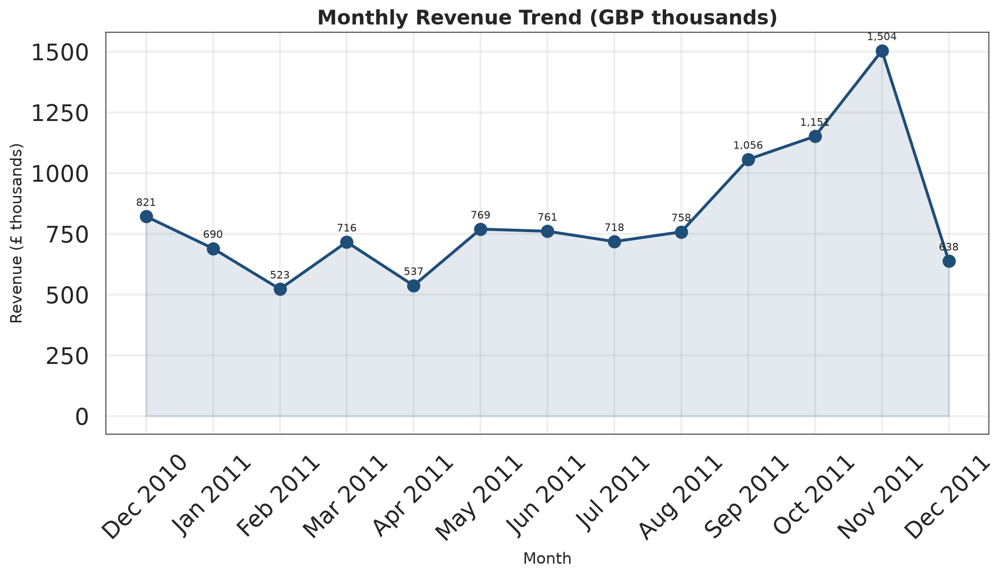
Figure 1. Monthly net revenue, December 2010 – December 2011 (GBP thousands).
Revenue is not stable month to month. It falls from £821k in December 2010 to £523k in February 2011, recovers through spring, and then climbs steeply from September to a peak of £1.50m in November 2011. The December 2011 bar covers only nine days and is not comparable with full months. The practical implication is that capacity, inventory and cash planning should be built around a September–November peak rather than a flat annual average.
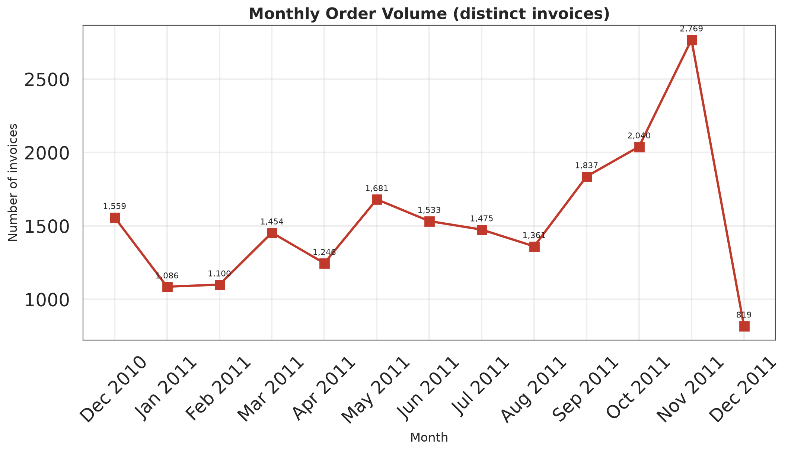
Figure 2. Monthly order volume (distinct invoices).
Order volume follows the same seasonal shape as revenue, which tells us the peak is demand-driven rather than the result of a few very large invoices. November 2011 contains 2,769 orders, about two and a half times the February low of 1,100. Because revenue and orders move together, average order value is relatively stable across the year — a useful planning assumption.

13.2 Product charts
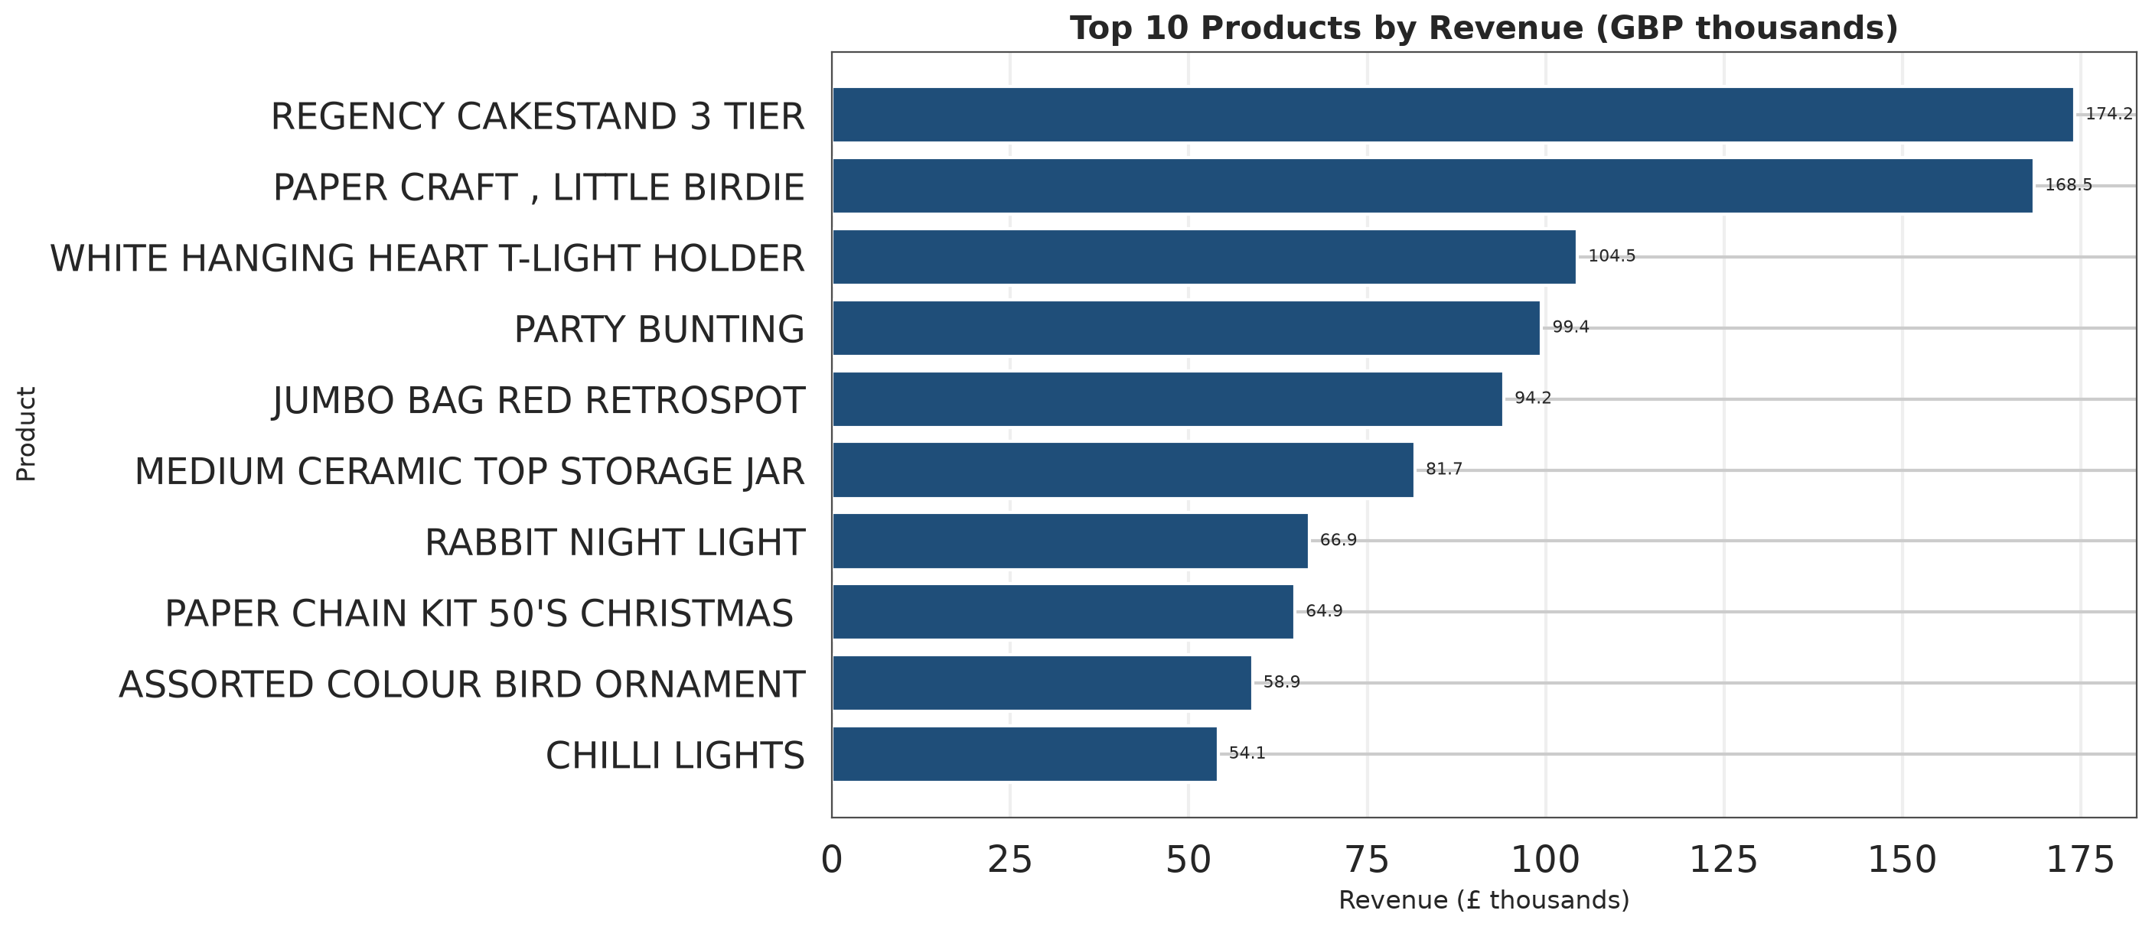
Figure 3. Top 10 physical products by revenue (GBP thousands).
Revenue leadership is concentrated in decorative giftware. The top product, REGENCY CAKESTAND 3 TIER, generates £174k, and the top five together generate £641k. These are the lines where availability and margin management matter most.
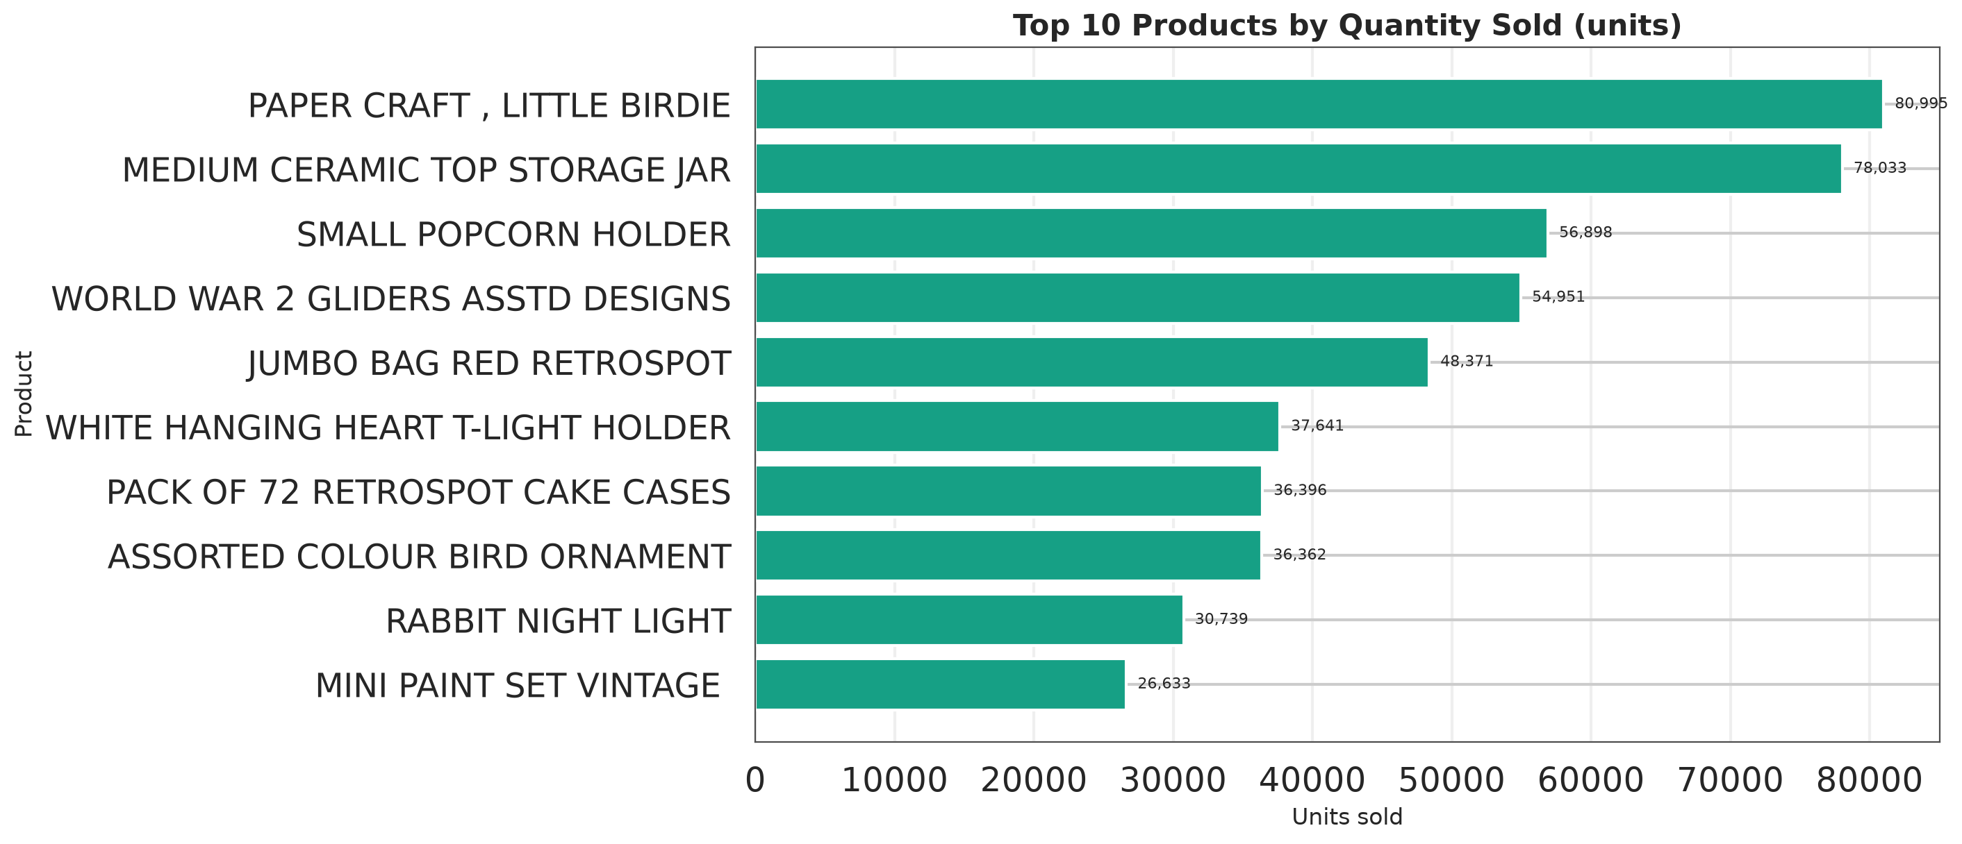
Figure 4. Top 10 products by quantity sold (units).
The volume ranking is different from the revenue ranking. PAPER CRAFT LITTLE BIRDIE leads on units (80,995) but ranks second on revenue, while SMALL POPCORN HOLDER sells 56,898 units for only £51k. Volume leaders and value leaders should therefore be managed with different objectives: availability for volume, margin for value.

13.3 Geographic chart
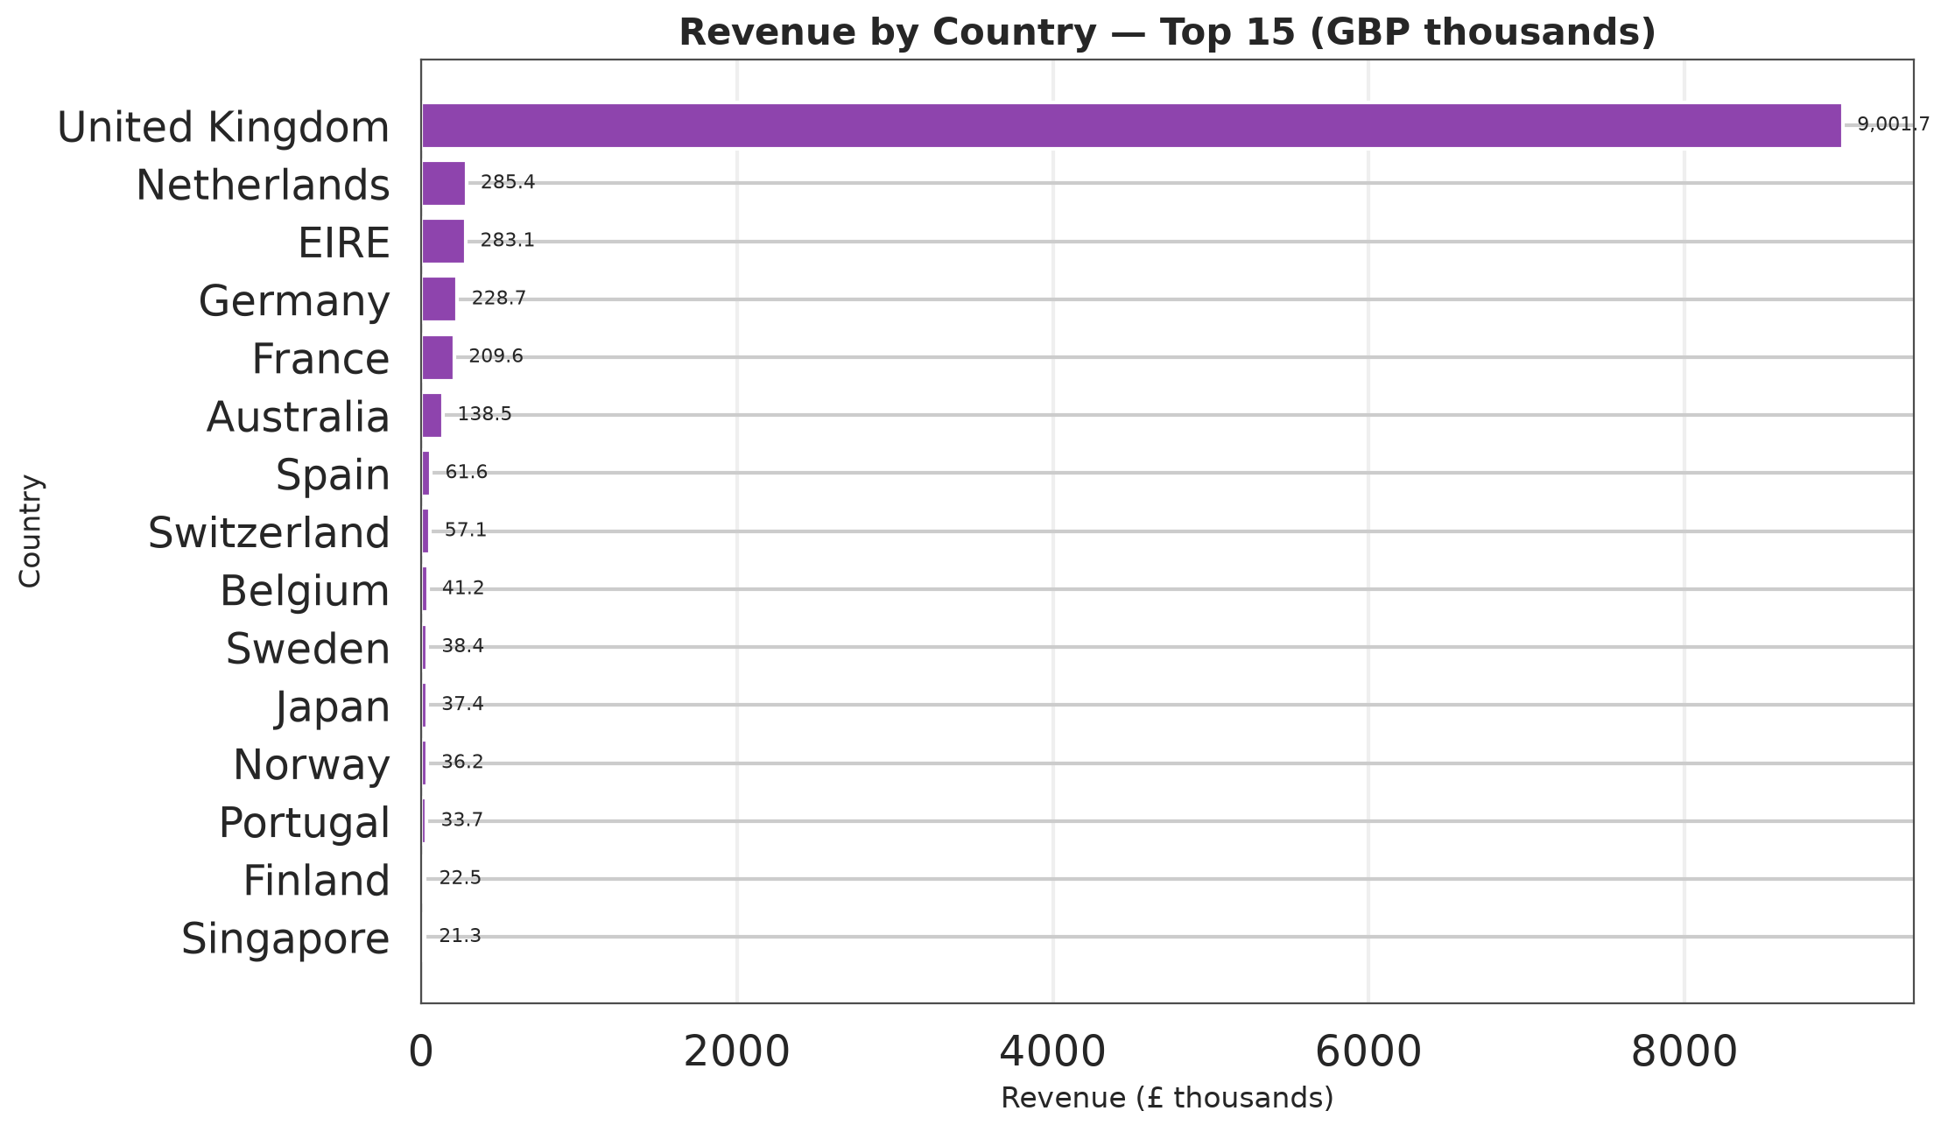
Figure 5. Revenue by country, top 15 (GBP thousands).
The United Kingdom is in a different league from every other market. The second-ranked Netherlands contributes £285k, only 3.2% of the UK total. The long tail of countries each contributes less than 1% of revenue. This chart is the visual case for treating international expansion as a set of targeted account opportunities rather than a broad market programme.

13.4 Distribution charts
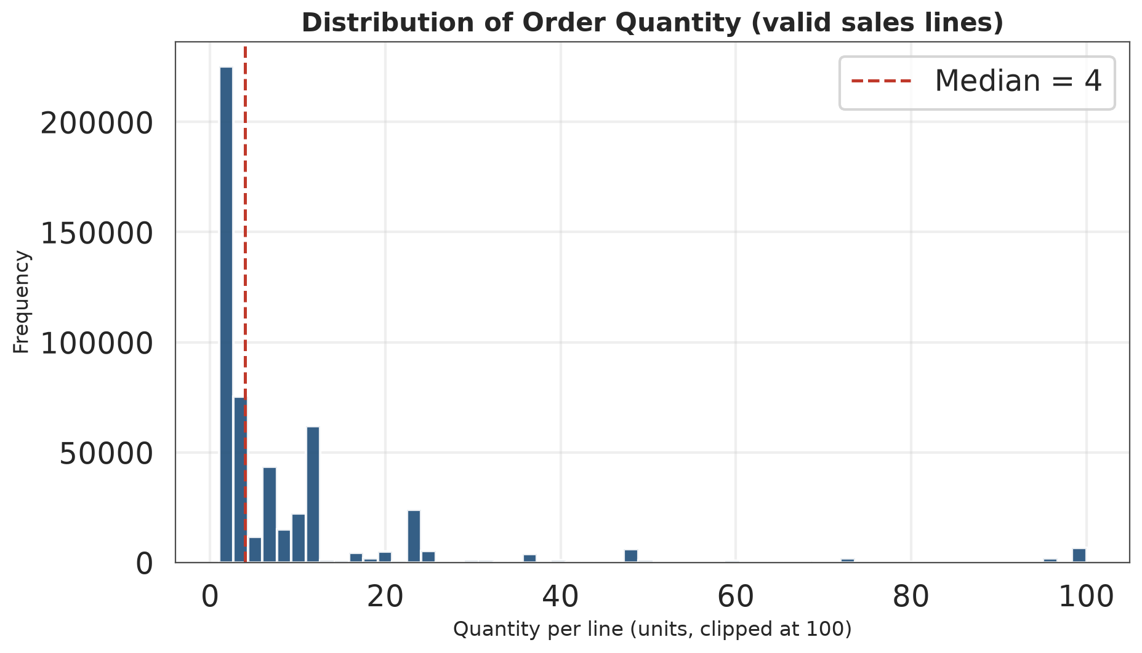
Figure 6. Distribution of order quantity per line (clipped at 100 units).
The distribution is strongly right-skewed: the median line contains 4 units and the 75th percentile 11 units. The visible tail above 100 units is clipped for readability, but the maximum observed value is 80,995 units. Most activity is small retail purchasing, with a thin wholesale tail that must not be ignored in revenue reporting.
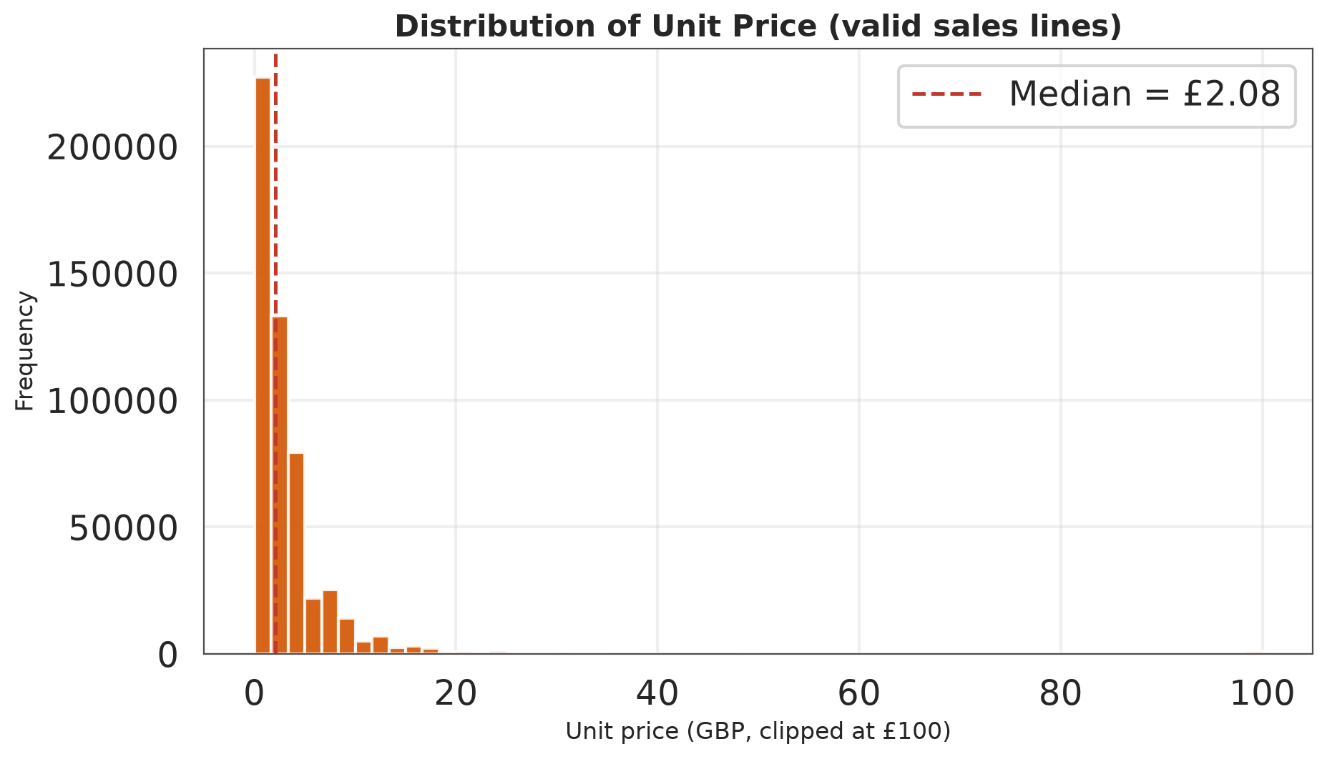
Figure 7. Distribution of unit price (clipped at £100).
The median unit price is £2.08 and the 75th percentile is £4.13, confirming a low-priced catalogue. The high-price tail is thin but commercially important: a single £649.50 picnic basket invoice contributes £38,970. Price-based segmentation should therefore use quantiles, not equal-width bins.
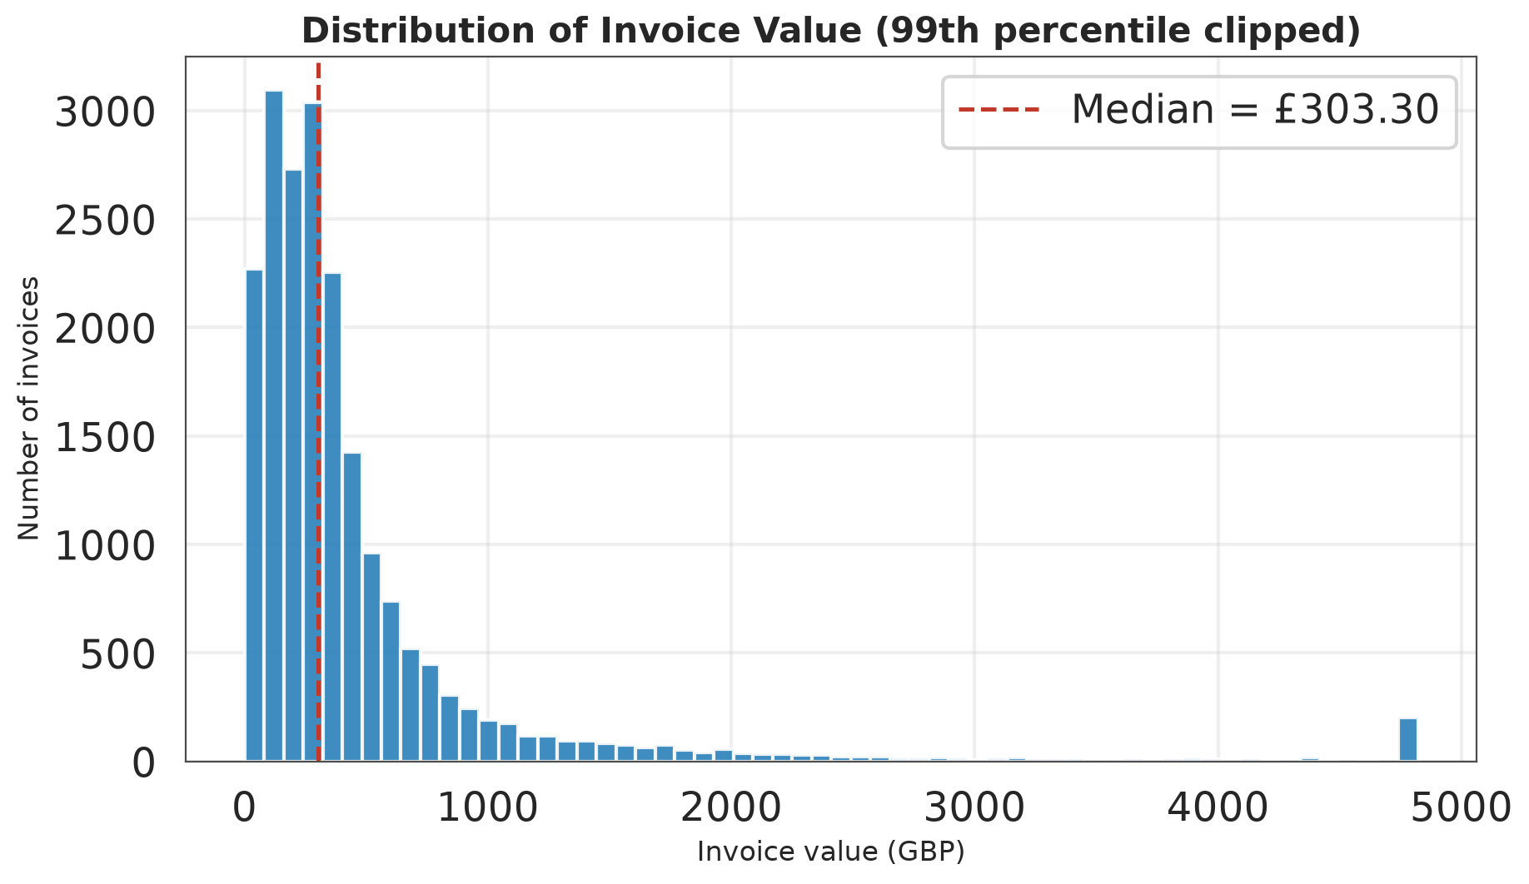
Figure 8. Distribution of invoice value (99th percentile clipped).
Most invoices are small, with a median of £303. The mean of £533 sits well above the median because of a small number of very large invoices. Reporting only the mean would overstate the typical customer experience; reporting only the median would understate the revenue at stake in large accounts.

13.5 Outlier charts
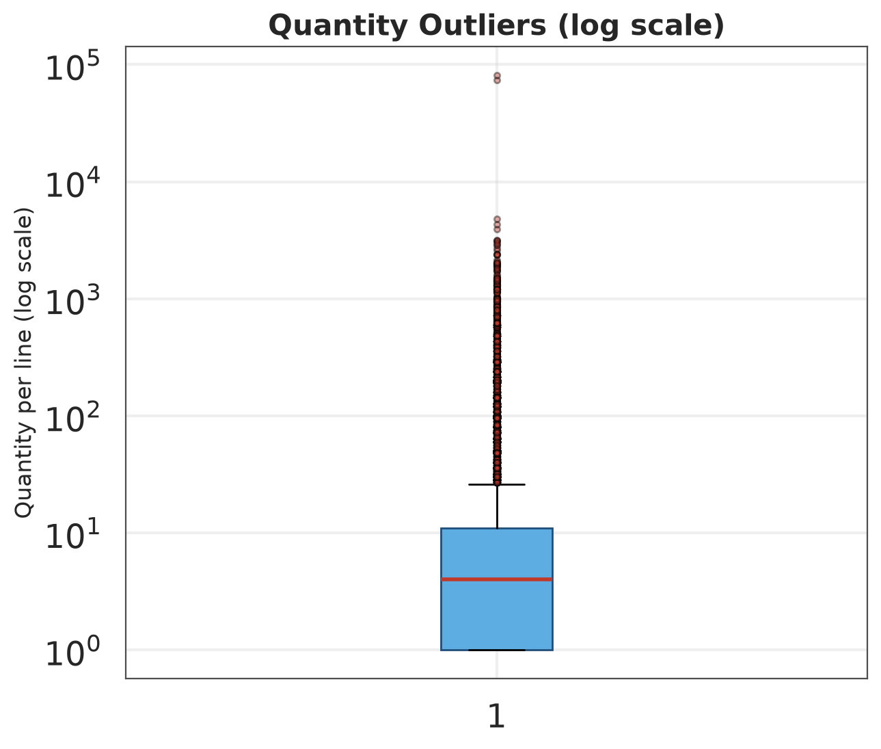
Figure 9. Quantity outliers (log scale).
The box spans the interquartile range of 1 to 11 units. The many fliers above the upper whisker are not errors: they are genuine wholesale purchases. The log scale is used so that the small retail core remains visible alongside the extreme tail.
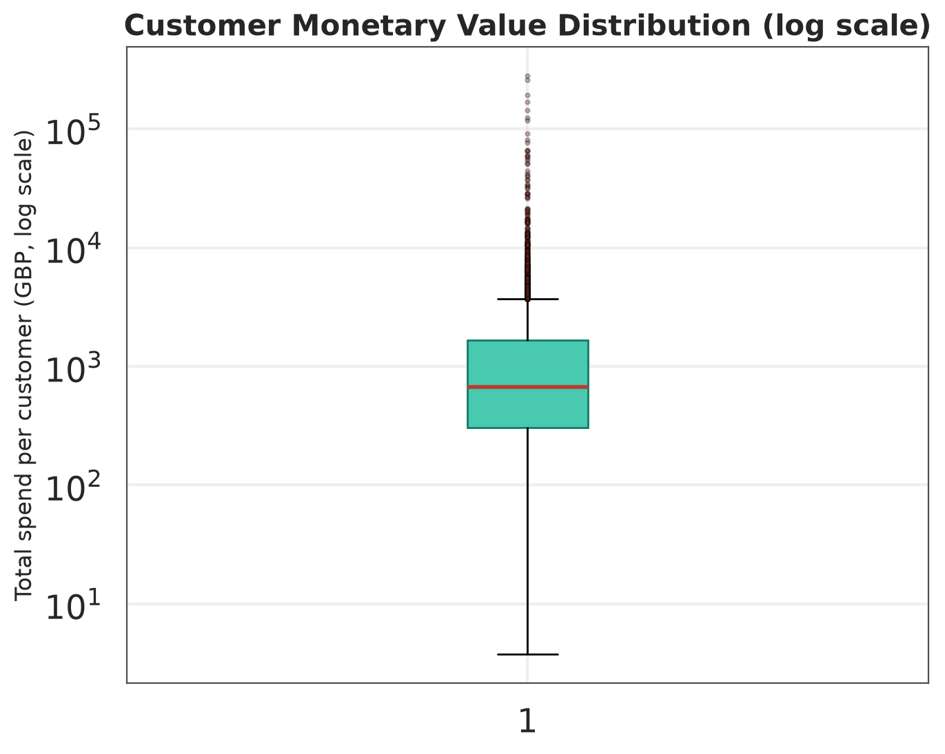
Figure 10. Customer monetary value distribution (log scale).
Customer spend spans several orders of magnitude. The median customer spends a few hundred pounds, while the top accounts spend hundreds of thousands. This spread is why a single customer-value KPI is insufficient and why segmentation is necessary.

13.6 Segmentation and correlation charts
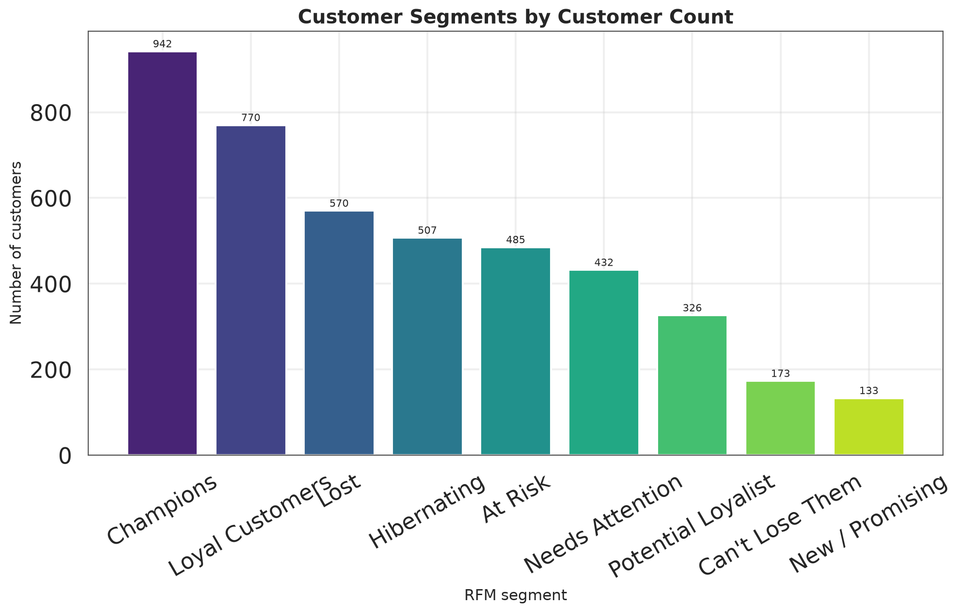
Figure 11. Customer counts by RFM segment.
The customer base is dominated by lower-value segments. Champions are the largest group by count as well as by revenue, which is the central commercial tension in the dataset: a valuable minority supports the business, while a large low-value base provides volume and optionality.
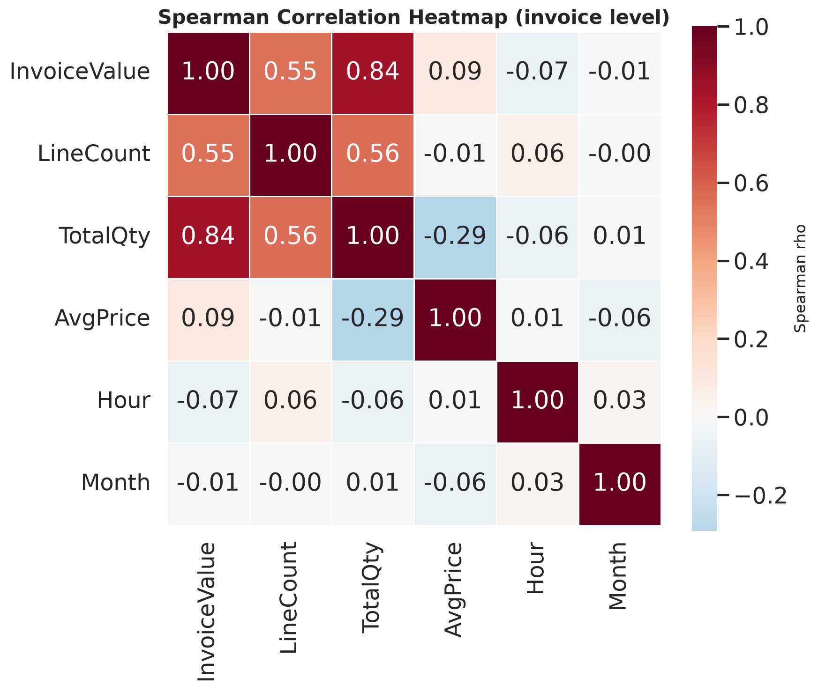
Figure 12. Spearman correlation heatmap, invoice-level variables.
Invoice value correlates most strongly with line count and total quantity, and only weakly with average price. The practical reading is that basket-building, not price increases, is the more credible revenue lever in this dataset. Correlation is not causation: a third factor such as customer type could drive both basket size and value.

13.7 Cancellation, weekday and hourly charts
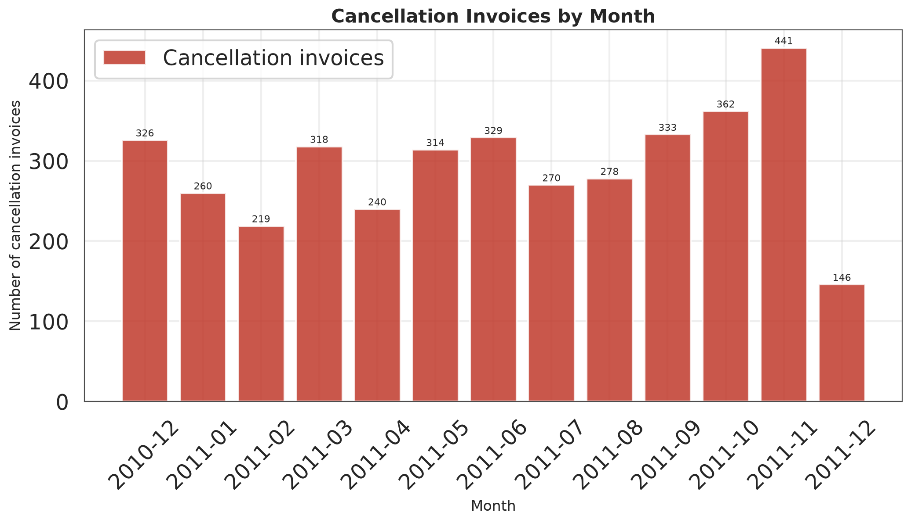
Figure 13. Cancellation invoices by month.
Cancellations occur in every month and rise with overall activity, peaking at 441 invoices in November 2011. There is no single anomalous month, which suggests a systemic process issue rather than an isolated incident. Because cancellation reasons are not recorded, the chart cannot distinguish quality failures from commercial returns.
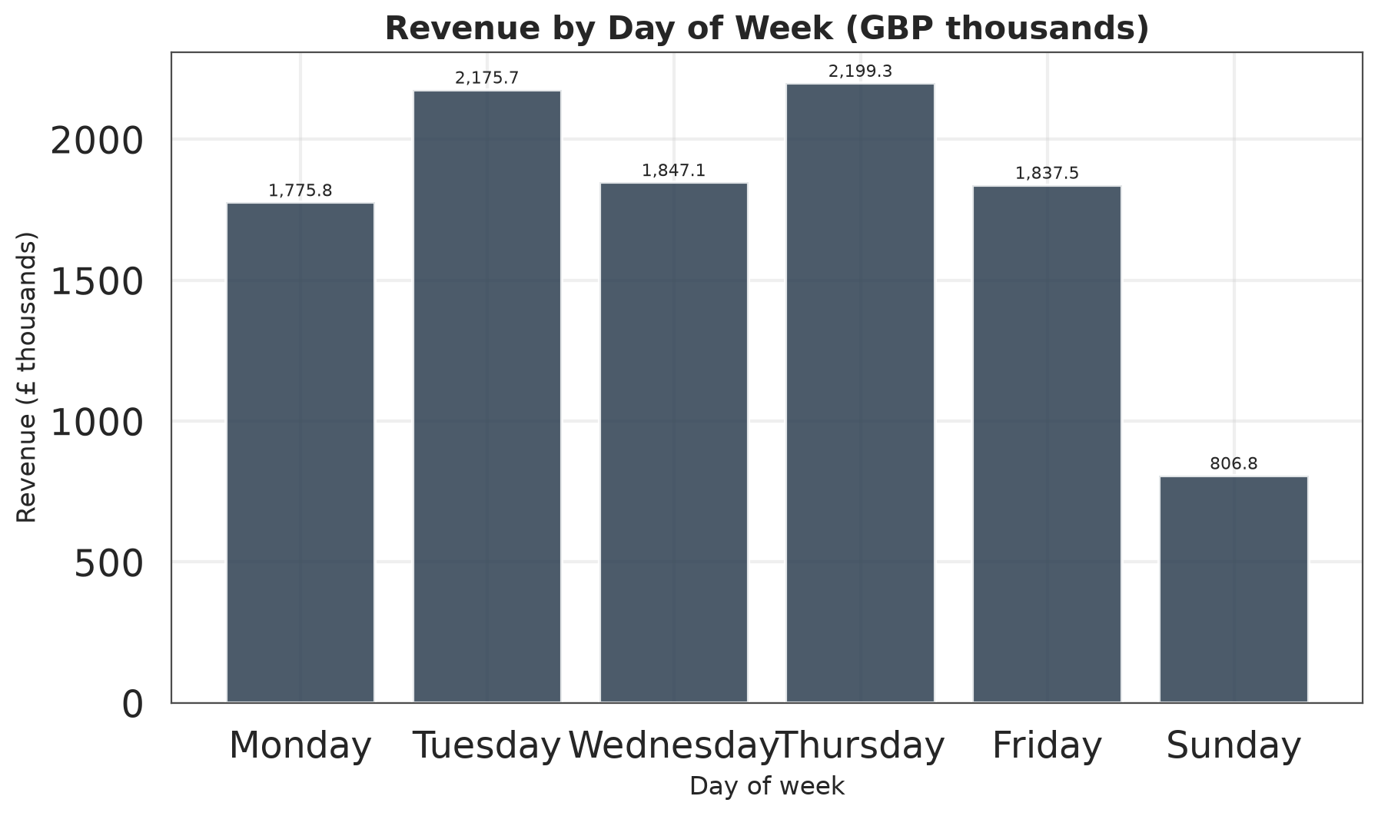
Figure 14. Revenue by day of week (GBP thousands).
Thursday and Tuesday are the strongest trading days; Sunday is the weakest at £807k. Saturday is absent because the retailer recorded no Saturday transactions at all in 13 months. This is an unusual operating pattern and a genuine finding: weekend staffing and Saturday delivery promises should be reviewed against actual demand.
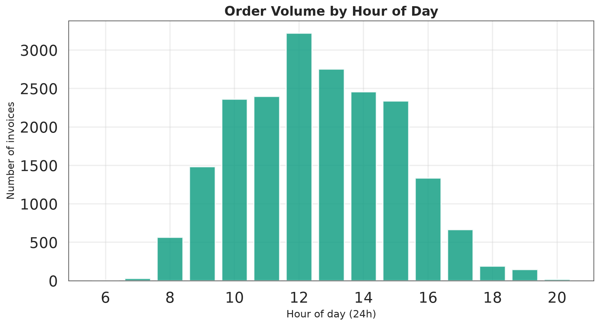
Figure 15. Order volume by hour of day.
Activity is concentrated between 10:00 and 15:00, peaking at 12:00 with 3,220 invoices. There is no activity before 06:00 or after 20:00. This pattern is consistent with business-hours buying and supports scheduling dispatch, customer service and campaign sends around the midday peak.

13.8 Concentration and value charts
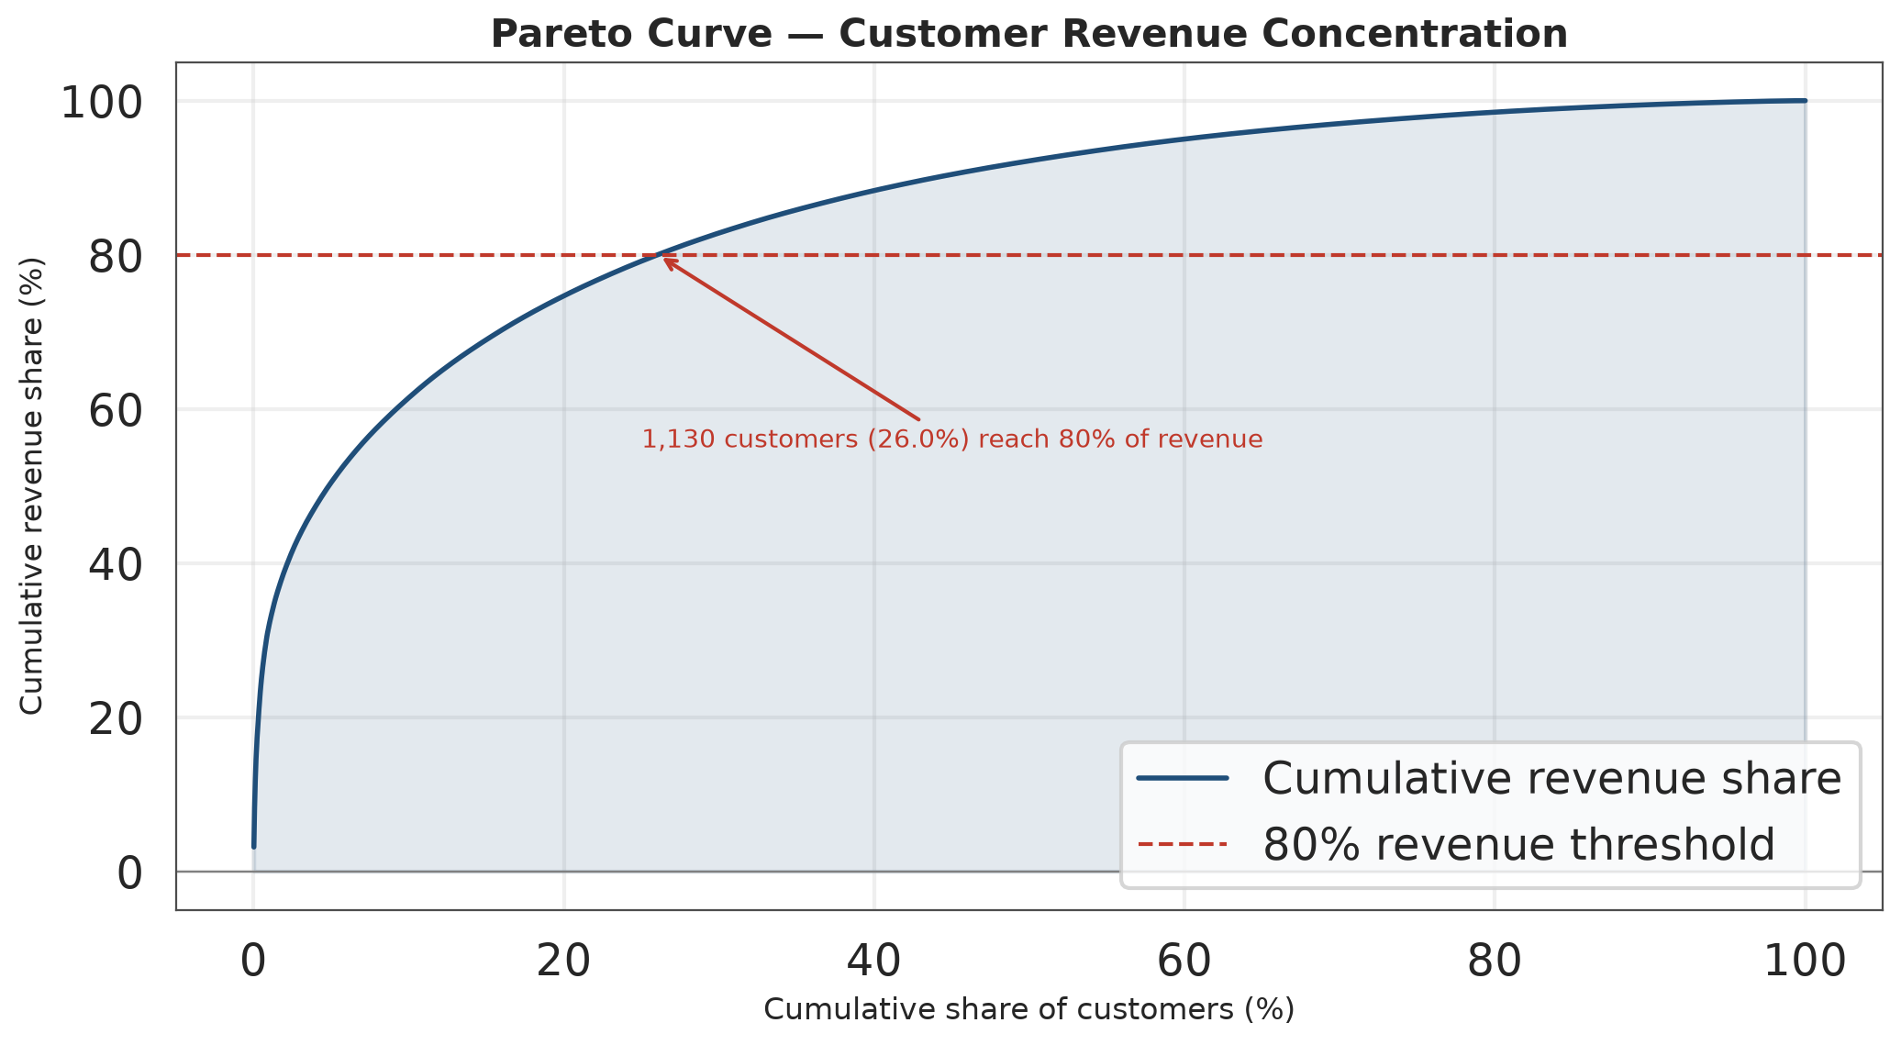
Figure 16. Pareto curve of customer revenue concentration.
The curve rises steeply at the top: the first few percent of customers account for a large share of revenue. The 80% threshold is reached at 1,130 customers (26.1%), not at 20%. The 80/20 rule is therefore a useful approximation but not a precise description of this dataset.
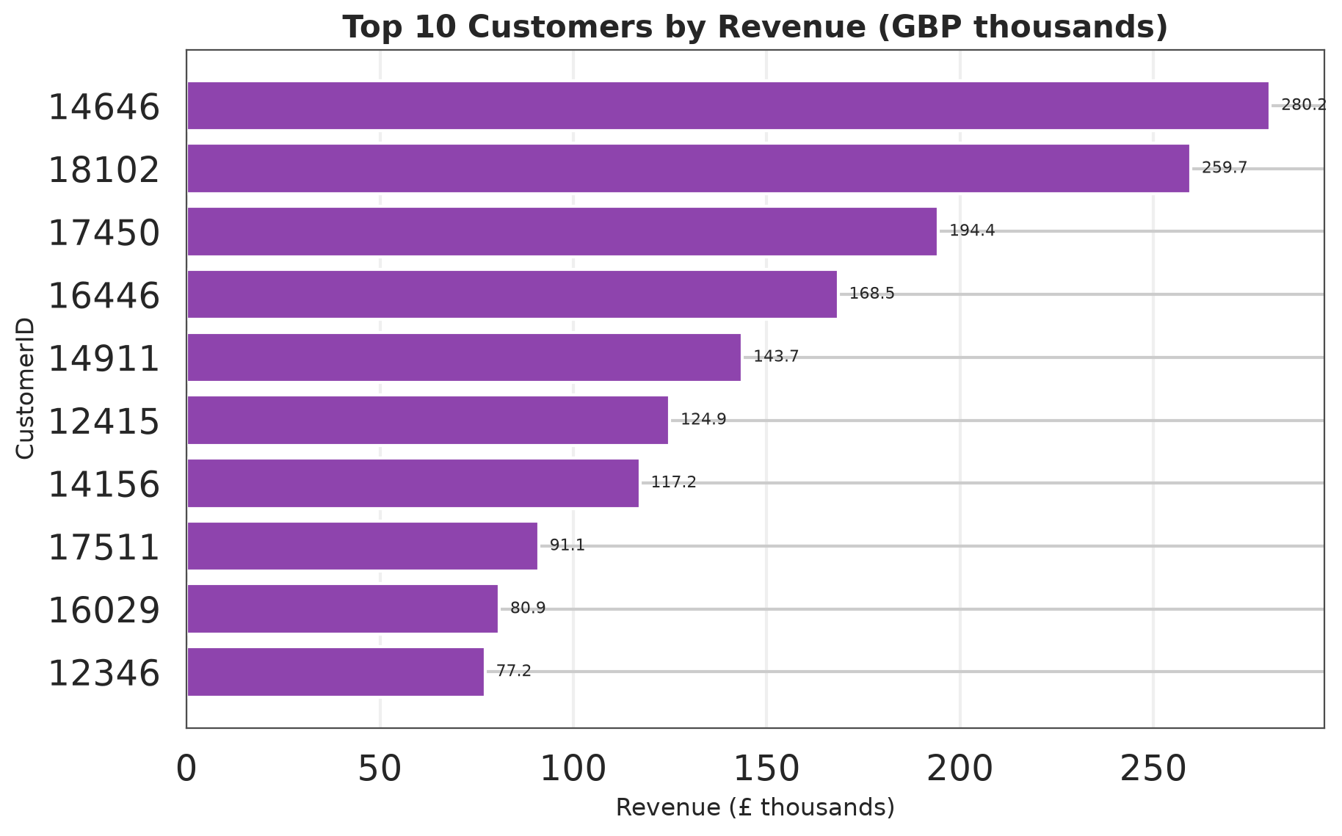
Figure 17. Top 10 customers by revenue (GBP thousands).
The leading account contributes £280k, 2.6% of total revenue. The top 10 together contribute 14.4%. This is material concentration, but it is not so extreme that a single account loss would threaten the business. The more important risk is the combination of customer and geographic concentration.
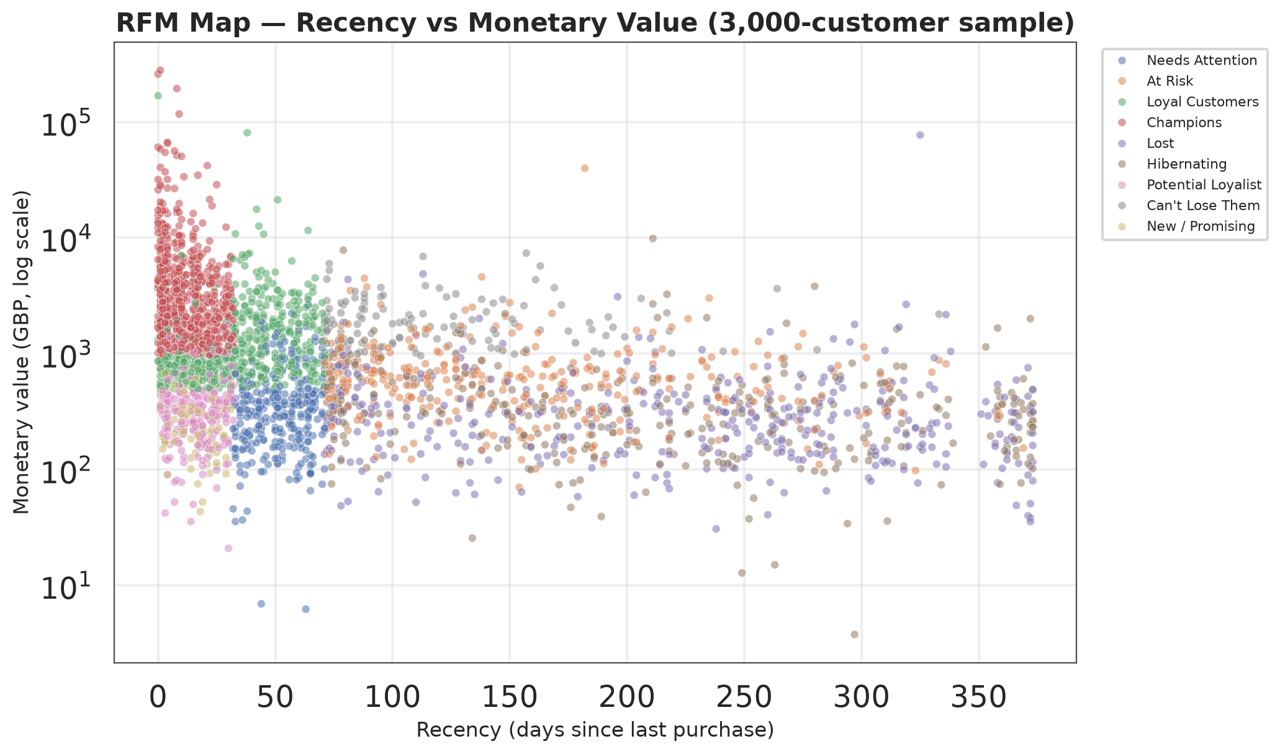
Figure 18. RFM map of a 3,000-customer sample: recency versus monetary value.
The upper-left quadrant contains recent, high-value customers (Champions). The upper-right contains customers who spent heavily in the past but have not purchased recently — the clearest win-back opportunity. The lower-right quadrant contains long-inactive, low-value accounts where acquisition cost is unlikely to be recovered.

14. Advanced Customer Segmentation (RFM)

14.1 Methodology
Each customer with a known identifier is scored from 1 to 5 on three dimensions: Recency (days since the last purchase), Frequency (number of distinct invoices) and Monetary value (total net revenue). Scores are assigned by quintile rank rather than by fixed currency thresholds, which avoids arbitrary cut-offs and guarantees five populated levels. Recency is reverse-scored so that 5 means most recent. The reference date is 2011-12-10, the day after the final transaction.
Segments are assigned by an ordered rule set, applied in priority order: Champions (R≥4, F≥4, M≥4); Can't Lose Them (R≤2, F≥4, M≥4); At Risk (R≤2, F≥3); Loyal Customers (R≥3, F≥3, M≥3); Potential Loyalist (R≥4, F≥2); New / Promising (R≥4, F=1); Hibernating (R≤2, F=2); Lost (R≤2, F=1); Needs Attention (R=3). Every customer receives exactly one segment.

14.2 Segment results
Segment | Customers | Customer share | Revenue (GBP) | Revenue share | Avg recency (days) | Avg frequency | Avg monetary (GBP)
Champions | 942 | 21.72% | £5,729,483 | 64.47% | 12.0 | 11.20 | £6,082
Loyal Customers | 770 | 17.75% | £1,439,912 | 16.20% | 34.7 | 4.16 | £1,870
At Risk | 485 | 11.18% | £433,176 | 4.87% | 160.2 | 2.66 | £893
Can't Lose Them | 173 | 3.99% | £385,720 | 4.34% | 123.5 | 5.50 | £2,230
Lost | 570 | 13.14% | £292,576 | 3.29% | 219.6 | 1.00 | £513
Hibernating | 507 | 11.69% | £232,239 | 2.61% | 211.5 | 1.22 | £458
Needs Attention | 432 | 9.96% | £189,512 | 2.13% | 51.6 | 1.39 | £439
Potential Loyalist | 326 | 7.51% | £141,387 | 1.59% | 16.2 | 1.90 | £434
New / Promising | 133 | 3.07% | £43,203 | 0.49% | 17.2 | 1.00 | £325

14.3 Interpretation
Champions are the most commercially important segment: 942 customers (21.7% of the base) generate £5,729,483, or 64.5% of revenue. Their average recency is 12 days and their average order frequency is 11.2, confirming a genuinely active, loyal group. Losing even a small fraction of this segment would be materially more damaging than losing a larger number of low-value customers.
The At Risk and Can't Lose Them segments together contain 658 customers worth £818,897. These are customers with a demonstrated history of value who have not purchased recently. They are the highest-priority win-back targets because the cost of re-activation is likely to be lower than the cost of acquiring an equivalent new customer.
Lost and Hibernating customers together represent 1,077 customers but only 5.9% of revenue. A blanket win-back campaign across this group would be expensive relative to the likely return; a low-cost, automated approach is more appropriate.

14.4 Segment actions
Segment | Recommended action | KPI to monitor
Champions | Early access to new ranges, loyalty rewards, named-account contact. | Revenue retention; order frequency; share of wallet.
Can't Lose Them | Personal outreach from a senior account manager; service recovery. | Reactivation rate; recovered revenue.
At Risk | Targeted win-back offer with a clear reason to return. | Conversion to repeat purchase; time to reactivation.
Loyal Customers | Cross-sell bundles and category expansion. | Lines per order; category penetration.
Potential Loyalist | Second-purchase incentive and onboarding support. | First-to-second-order conversion rate.
New / Promising | Welcome series and guided first repeat purchase. | 90-day repeat rate.
Hibernating / Lost | Low-cost automated reactivation; suppress if no response. | Cost per reactivation; response rate.

15. Pareto and Correlation Analysis

15.1 Does the 80/20 rule hold?
For customers, 1,130 accounts (26.1% of 4,338) generate 80% of revenue. The top 20% generate 74.7%, the top 10% generate 61.4%, the top 5% generate 50.4% and the top 1% generate 31.8%. The 80/20 rule is therefore directionally correct but numerically imprecise: the concentration is stronger than 80/20 at the very top and weaker at the 20% mark.
For products, 825 of 3,912 products (21.1%) generate 80% of product revenue, and the top 20% generate 78.8%. Product revenue is concentrated, but across hundreds of items rather than a handful of hero products. The top 10 products account for only 9.4% of product revenue.
The business implication differs by dimension. Customer strategy should protect a relatively small group of high-value accounts. Product strategy should manage a long tail: rationalisation and availability decisions must consider hundreds of products, not just the top ten.

15.2 Correlation analysis
Relationship | Spearman rho | Pearson r | Strength and direction | Caution
Frequency ↔ Monetary | 0.807 | 0.553 | Strong positive | Association only; no causal claim.
Recency ↔ Monetary | -0.482 | -0.122 | Moderate negative | Association only; no causal claim.
Frequency ↔ AOV | 0.156 | 0.019 | Weak | Association only; no causal claim.
Tenure ↔ Monetary | 0.722 | 0.225 | Strong positive | Association only; no causal claim.

Frequency and monetary value show a strong positive monotonic relationship (ρ = 0.807). Recency and monetary value show a moderate negative relationship (ρ = -0.482): customers who have not purchased for longer tend to have lower total spend, which is consistent with value decaying over time. Tenure and monetary value correlate at 0.722. Frequency and average order value correlate only weakly (0.156), confirming that buying more often does not mean spending more per order.
Pearson coefficients are systematically lower than Spearman coefficients for the monetary variables, which is the expected signature of heavy-tailed data: a few extreme values weaken the linear fit. Spearman is therefore the more appropriate summary for these relationships. None of these correlations establishes causation.

16. Key Findings
Twelve findings are reported. Each is stated with the numerical evidence produced by the analysis, an explanation, and the action it supports.
No. | Finding | Numerical evidence | Analytical explanation | Business significance and action
F1 | Revenue is highly concentrated in time and in customers. | Peak month Nov 2011 generated £1,503,867; the top 1% of customers generate 31.8% of revenue. | Demand is seasonal and the customer base is top-heavy. | Build seasonal capacity plans and protect top accounts.
F2 | The 80/20 rule holds for customers but only approximately. | 1,130 customers (26.1%) produce 80% of revenue; the top 20% produce 74.7%. | Concentration is real but not exactly 80/20; the curve is steeper at the very top. | Prioritise retention of the top 20% and monitor the top 1% for churn.
F3 | Revenue is driven by basket size, not price. | Spearman rho (invoice value vs lines) = 0.55; (invoice value vs average price) = 0.09. | Customers spend more by adding lines rather than accepting higher prices. | Use cross-sell and bundling instead of price increases.
F4 | The UK dominates the revenue base. | UK revenue = £9,001,744 (84.6% of total); the largest non-UK market is Germany. | Geographic concentration is a material business risk. | Diversify into selected EU markets with localised offers.
F5 | Repeat purchase is the norm among identified customers, but a large anonymous base exists. | 2,845 of 4,338 identified customers (65.6%) ordered more than once; 135,080 lines have no CustomerID. | Identified customers are loyal, but 25% of activity cannot be attributed. | Incentivise account creation / loyalty sign-up to close the attribution gap.
F6 | Cancellations are a persistent, material leakage. | 3,836 cancellation invoices (16.12% of invoices) with £893,980 gross value. | Returns reduce realised revenue and complicate demand forecasting. | Introduce cancellation reason codes and product-level quality checks.
F7 | Extreme values are genuine commercial events, not errors. | Largest valid line: 80,995 units of PAPER CRAFT , LITTLE BIRDIE (£168,470). | Wholesale-style purchases exist and materially affect totals. | Retain outliers in headline totals; report medians alongside means.
F8 | Customer value is highly unequal. | Top customer 14646 contributes £280,206 (2.6% of revenue); top 10 contribute 14.4%. | A small number of accounts carry a large share of revenue. | Create named-account plans and monitor concentration risk.
F9 | Non-UK customers place materially higher-value orders, but the effect size is small. | UK mean AOV £500 vs non-UK £845; medians £300 vs £424; Welch p = 1.80e-16, Cohen's d = -0.19. | The difference is statistically significant but small in magnitude, so it should not drive a wholesale pricing change. | Test market-specific shipping thresholds and promotions rather than assuming a uniform international price premium.
F10 | Repeat customers buy more consistently, but not at a higher average order value. | Mean AOV £421 (repeat) vs £411 (one-time), Welch p = 0.87, d = 0.01; medians £303 vs £256, Mann–Whitney p = 8.56e-12. | The means are indistinguishable, but the whole distribution is shifted upward for repeat buyers — loyalty improves basket consistency rather than average value. | Do not assume loyalty automatically raises AOV; measure basket-building interventions separately from retention.
F11 | Trading is concentrated on weekdays and business hours. | Peak day Thursday (revenue £2,199,293); peak hour 12:00 with 3,220 invoices. | Demand follows a B2B-style weekly rhythm. | Align staffing, dispatch and campaign sends to the observed rhythm.
F12 | Product revenue sits in a long tail, not in a handful of hero products. | The top 10 products account for only 9.4% of product revenue; 825 of 3,912 products (21.1%) are needed to reach 80%. | Unlike the customer base, the catalogue is not dominated by a few items; 3,912 products share the revenue. | Manage the tail actively (rationalisation, availability) instead of assuming a few hero SKUs carry the business.

17. Business Recommendations
Six opportunities are proposed. Each is supported by a number from this analysis, and each carries an explicit risk. These are proposals, not tested interventions; no claim is made that they have already increased revenue.

17.1 Win back high-value lapsed customers
Element | Detail
Business problem | Previously valuable customers have stopped purchasing, leaving revenue exposed.
Supporting numerical evidence | Can't Lose + At Risk segments contain 658 customers worth £818,897
Proposed solution | Targeted win-back campaign with personalised offers and a service-level check-in.
Expected business benefit | Recover a share of lapsed high-value revenue; protect the revenue base.
KPI to monitor | Win-back conversion rate; recovered revenue per campaign.
Limitations and risks | Historical response behaviour is unknown; campaign lift must be measured with a control group.

17.2 Grow basket size rather than unit price
Element | Detail
Business problem | Revenue is driven mainly by number of lines, not by higher prices.
Supporting numerical evidence | Spearman rho between invoice value and line count = 0.55, versus 0.09 for average price
Proposed solution | Cross-sell bundles and 'complete the set' recommendations at checkout.
Expected business benefit | Higher items per order without discounting, protecting margin.
KPI to monitor | Average lines per invoice; attach rate; AOV.
Limitations and risks | Cross-sell may cannibalise existing lines; test on a holdout group.

17.3 Concentrate retention effort on the revenue core
Element | Detail
Business problem | Revenue is highly concentrated, so losing a few accounts is material.
Supporting numerical evidence | Top 26.1% of customers (1,130 accounts) generate 80% of revenue; top 1% generate 31.8%
Proposed solution | Named-account management and service guarantees for the top revenue accounts.
Expected business benefit | Reduced churn risk on the highest-value relationships.
KPI to monitor | Revenue retention of top-decile accounts; churn of top 100 accounts.
Limitations and risks | Over-serving small accounts could distort cost-to-serve; concentration remains a structural risk.

17.4 Replicate the UK playbook in selected EU markets
Element | Detail
Business problem | Growth depends almost entirely on one market.
Supporting numerical evidence | UK contributes 84.6% of revenue; Germany is the largest non-UK market at £228,678
Proposed solution | Localise catalogue, pricing and delivery messaging for the top 3 EU markets.
Expected business benefit | Diversified revenue base and reduced single-market exposure.
KPI to monitor | Non-UK revenue share; non-UK repeat rate; delivery cost per order.
Limitations and risks | Cross-border logistics and pricing differences may erode margin; results are not transferable without testing.

17.5 Reduce avoidable cancellation leakage
Element | Detail
Business problem | Returns and cancellations remove revenue after the sale is booked.
Supporting numerical evidence | 3,836 cancellation invoices (16.12% of invoices) with £893,980 gross value
Proposed solution | Pre-purchase quality checks, clearer sizing guidance and a cancellation-reason code.
Expected business benefit | Lower cancellation rate and better root-cause visibility.
KPI to monitor | Cancellation rate by product and reason code; net revenue per SKU.
Limitations and risks | Some cancellations are genuine commercial returns; reducing them too aggressively harms customer trust.

17.6 Extend the seasonal peak with an early-autumn campaign
Element | Detail
Business problem | Revenue is concentrated in a short seasonal window, creating capacity and cash-flow swings.
Supporting numerical evidence | Peak month is Nov 2011 at £1,503,867; order volume peaks in the same period
Proposed solution | Shift a defined share of promotional spend to September–October and pre-build stock.
Expected business benefit | Smoother revenue, better inventory utilisation, lower peak-season stress.
KPI to monitor | Off-season revenue growth; stock cover; peak-season service level.
Limitations and risks | Demand may simply be pulled forward rather than created; measure incremental, not shifted, revenue.

17.7 Implementation sequencing
The recommendations are not equally urgent. Protecting the Champions and Can't Lose Them segments should come first because the revenue at risk is largest and the intervention is a retention action, not an acquisition bet. Basket-building and cancellation reduction are second-wave initiatives because they require process change and measurement. International expansion should be treated as a test-and-learn programme, not a rollout, because non-UK revenue is concentrated in a few accounts and the dataset cannot tell us whether that reflects market potential or account-specific relationships.

17.8 Measurement framework
Each recommendation has a single primary KPI and a control group where possible. Without a control group, observed changes cannot be attributed to the intervention, because seasonality and customer mix also change. This is the most important methodological caveat in the recommendations.

18. Data Limitations
- Age of the data: the observation window ends on 9 December 2011. Customer behaviour, product mix and the competitive environment may have changed since then.
- Single seasonal cycle: 13 months contain one December and one November, so seasonality is estimated from a single observation of each month. A second year would be needed to separate seasonal effects from trend.
- Geographic concentration: 91.43% of lines are UK. Findings about non-UK markets are based on small numbers of customers and should not be generalised.
- Missing customer identifiers: 135,037 working rows (24.93% of the raw file) cannot be attributed to a customer, so customer-level metrics describe 75% of activity, not all of it.
- No cost or margin data: only revenue can be computed. Profitability, discounting impact and customer-level profitability are outside the scope of this dataset.
- No cancellation reasons: the data cannot distinguish quality failures, customer change-of-mind and administrative adjustments.
- Non-product lines: postage, fees and adjustments are mixed with products in the raw file and must be handled explicitly, as they are here.
- No causal identification: all relationships are observational. The statistical tests establish association, not causation.
- Unobserved confounders: customer type, contract terms, sales-channel and promotional exposure are not recorded, so differences between groups may reflect these factors rather than the variables tested.

19. Synthetic Data Considerations

19.1 Definitions used in this project
- Real-world observed data: the 541,909 transactions actually recorded by the retailer and published by UCI.
- Derived analytical variables: quantities computed from observed records, such as revenue, recency, frequency, monetary value and RFM scores.
- Synthetic data: artificially generated records designed to resemble real data.
No synthetic records were added to this project. Every row analysed originates from the official UCI file, and every derived variable is a deterministic function of those rows. This statement is made explicitly because synthetic data can materially change conclusions.

19.2 Why synthetic data would create limitations
- Realistic customer behaviour: synthetic customers often follow simplified rules and miss the irregular, lumpy purchasing that characterises real accounts.
- Distribution patterns: generated data rarely reproduces the extreme skew and heavy tails observed here, where the top 1% of lines carry 25.4% of revenue.
- Outlier detection: if outliers are synthesised from the same distribution as the rest, genuine wholesale behaviour is either invented or erased.
- Statistical relationships: correlations and segment sizes would reflect the generator's assumptions, not the business.
- Business decisions: recommendations based on synthetic data can be confidently wrong, because the underlying behaviour was never observed.
- Model reliability: a model trained on synthetic data inherits the generator's blind spots and may fail on real customers.

19.3 How this project guards against that risk
The raw file fingerprint is recorded; the raw data is preserved unchanged; all cleaning decisions are logged with before-and-after counts; and the notebook is fully executed so that every output can be traced back to the source file. Where a result depends on a modelling choice — for example the recency reference date or the winsorisation threshold — the choice and its effect are reported.

20. Conclusion
This project set out to answer ten business questions using a genuine, independently documented dataset, and to do so in a way that another analyst could reproduce. That objective has been met: the raw file was verified, 541,909 records were inspected, 5,268 duplicates were removed, 3,836 cancellation invoices and 1,336 return lines were separated and analysed, and 524,878 valid sales lines were used to compute every headline figure.
The most important numerical findings are: net revenue of £10,642,110.80 from 5,572,420 units and 19,960 invoices; an average order value of £533.17; a repeat customer rate of 65.58%; a cancellation rate of 16.12% by invoice; and a revenue peak of £1,503,867 in November 2011. Customer concentration is high but not absolute: 1,130 customers (26.1%) generate 80% of revenue, and the top 1% generate 31.8%.
The business problems identified are: over-reliance on a single market (84.6% UK revenue); concentration of non-UK revenue in a handful of accounts; a material and unexplained cancellation leakage; a long product tail that complicates range decisions; and a customer base in which a valuable Champions segment coexists with a large low-value tail. The most important recommendations are to protect the Champions and Can't Lose Them accounts, grow basket size through cross-sell rather than price, introduce cancellation reason codes, and treat international expansion as a targeted test-and-learn programme.
The limitations are material and are stated in Section 18. The data is historical, covers a single seasonal cycle, is geographically concentrated, lacks customer identifiers for a quarter of the file, contains no cost or margin information, and cannot establish causation. The recommendations are therefore proposals with a measurement plan, not proven interventions.
Future analysis would benefit from three additions: a second year of data to separate seasonality from trend; customer-level cost-to-serve and margin data to convert revenue analysis into profitability analysis; and a controlled test of the win-back and basket-building interventions, with a holdout group, so that the business can learn whether the proposed actions actually work.

21. References
[1] Chen, D., Sain, S. L., & Guo, K. (2012). Data mining for the online retail industry: A case study of predictive modeling of customer behaviors. Journal of Business Research, 65(11), 1559–1566.
[2] UCI Machine Learning Repository. (2015). Online Retail Dataset. University of California, Irvine. https://archive.ics.uci.edu/dataset/352/online+retail
[3] UCI Machine Learning Repository. (2015). Online Retail Dataset [Data set]. https://doi.org/10.24432/C5BW33
[4] Creative Commons. (2021). Creative Commons Attribution 4.0 International Public License. https://creativecommons.org/licenses/by/4.0/
[5] McKinsey & Company. (2020). Customer care: The new battleground for customer experience. (Contextual reference for RFM-based retention practice.)
[6] Reichheld, F. F., & Sasser, W. E. (1990). Zero defections: Quality comes to services. Harvard Business Review, 68(5), 105–111.
[7] Virtanen, P., et al. (2020). SciPy 1.0: Fundamental algorithms for scientific computing in Python. Nature Methods, 17, 261–272.
[8] Hunter, J. D. (2007). Matplotlib: A 2D graphics environment. Computing in Science & Engineering, 9(3), 90–95.
[9] Waskom, M. L. (2021). seaborn: Statistical data visualization. Journal of Open Source Software, 6(60), 3021.
[10] The pandas development team. (2024). pandas: Powerful data structures for data analysis in Python. https://pandas.pydata.org
[11] Harris, C. R., et al. (2020). Array programming with NumPy. Nature, 585, 357–362.

Appendix A — Quality-Control Checklist
The checklist below was completed against the actual deliverables. Items marked complete were verified by inspecting the generated files, not by intention.
Checklist item | Status
Genuine dataset obtained from the official UCI source | Complete — 23.72 MB file, SHA-256 recorded
Dataset dimensions verified in Python | Complete — 541,909 × 8
Data dictionary completed | Complete — 8 variables documented
Missing values investigated | Complete — CustomerID 135,080; Description 1,454
Duplicates investigated | Complete — 5,268 exact duplicates removed
Cancellations and returns analysed separately | Complete — 3,836 cancellations; 1,336 returns
Cleaning decisions justified | Complete — audit table with reasons
Before-and-after row counts provided | Complete — 541,909 → 536,641 → 524,878 valid
Feature engineering completed | Complete — 11 derived variables
Descriptive statistics calculated | Complete — mean, median, mode, SD, variance, quartiles, IQR, skew, kurtosis
Advanced analysis executed | Complete — RFM, Pareto, correlation, outlier, hypothesis tests
Minimum 12 charts generated | Complete — 18 charts at 200 dpi
Every chart interpreted | Complete — caption and interpretation for all 18
At least 10 evidence-based findings | Complete — 12 findings
At least 5 practical recommendations | Complete — 6 opportunities with KPIs and risks
Statistical assumptions and limitations discussed | Complete — Welch t-test, Mann–Whitney, chi-square, effect sizes
Synthetic data implications explained | Complete — Section 19; no synthetic records used
Word report generated | Complete — this document
Jupyter notebook executed successfully | Complete — see notebooks/Real_World_Dataset_Analysis.ipynb
GitHub repository structure prepared | Complete — see README.md and repository layout
README and requirements included | Complete — README.md and requirements.txt
Submission description exceeds 200 words | Complete — see SUBMISSION_DESCRIPTION.md
No fabricated results or unsupported claims | Complete — every figure traceable to results.json
Report and notebook results cross-checked | Complete — both generated from the same executed pipeline

