**1. Familiarization of Hardware Components of a Computer**

Computer hardware refers to the physical parts or components of a computer such as the monitor, mouse, keyboard, computer data storage, hard drive disk (HDD), system unit (graphic cards, sound cards, memory, motherboard and chips), etc. all of which are physical objects that can be touched.

The main hardware components are listed below:-

● Microprocessor

● Motherboard

● RAM

● Hard Disk Drive

● Optical disc drive [CD / DVD Drive]

● Keyboard

● Mouse

● Monitor

● Computer case and SMPS

● Computer Speaker

● Uninterrupted power supply (UPS)

Microprocessor

A microprocessor is an electronic component that is used by a computer to do its work. It is a central processing unit on a single integrated circuit chip containing millions of very small components including transistors, resistors, and diodes that work together.

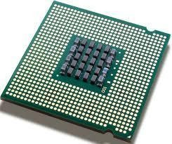

A microprocessor incorporates most or all of the functions of a central processing unit

(CPU) on a single integrated circuit (IC).

Motherboard

A motherboard is the central or primary printed circuit board (PCB) making up a complex electronic system, such as a modern computer. It is also known as a main board,

baseboard, system board, planar board, or, on Apple computers, logic board, and is sometimes abbreviated casually as mobo.

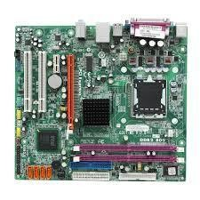

RAM

Random access memory (usually known by its acronym, RAM) is a type of computer data storage. Today it takes the form of integrated circuits that allow the stored data to be accessed in any order, i.e. at random.

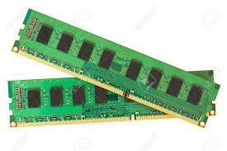

Hard Disk Drive

A hard disk drive (HDD), commonly referred to as a hard drive, hard disk, or fixed disk drive, is a non-volatile storage device which stores digitally encoded data on rapidly rotating platters with magnetic surfaces. Strictly speaking, "drive" refers to a device distinct from its medium, such as a tape drive and its tape, or a floppy disk drive and its floppy disk. Early HDDs had removable media; however, an HDD today is typically a sealed unit.

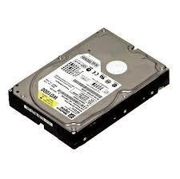

Optical disc drive [CD / DVD Drive]

An optical disc drive (ODD) is a disk drive that uses laser light or electromagnetic waves near the light spectrum as part of the process of reading and writing data. It is a computer's peripheral device that stores data on optical discs. Some drives can only read from discs, but commonly drives are both readers and recorders. Recorders are sometimes called burners or writers.

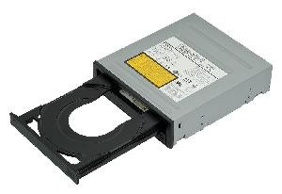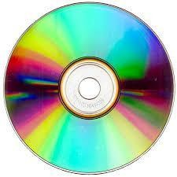

Keyboard

A keyboard is an arrangement of buttons, or keys. A keyboard typically has characters engraved or printed on the keys; in most cases, each press of a key corresponds to a single written symbol.

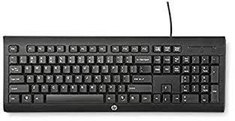

Mouse

A mouse (plural mice, mouse devices, or mouses) is a pointing device that functions by detecting two-dimensional motion relative to its supporting surface. Physically, a mouse consists of a small case, held under one of the user's hands, with one or more buttons.

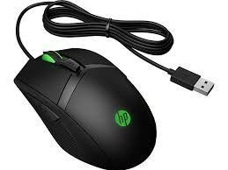

Monitor

A monitor is a piece of computer hardware that displays the video and graphics information generated by a connected computer through the computer's video card.

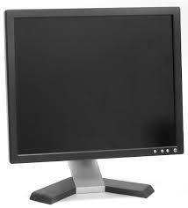

Computer case and SMPS

A computer case is the enclosure that contains the main components of a computer. Cases are usually constructed from steel, aluminum, or plastic, although other materials such as wood, plexiglas or fans have also been used in case designs. Cases can come in many different sizes, or form factors.

A switched-mode power supply, switching-mode power supply or SMPS, is an electronic power supply unit (PSU) that incorporates a switching regulator. While a linear regulator maintains the desired output voltage by dissipating excess power in a "pass" power transistor, the SMPS rapidly switches a power transistor between saturation (full on) and cutoff (completely off) with a variable duty cycle whose average is the desired output voltage.

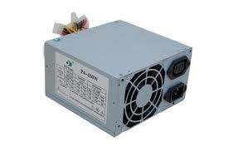

Computer Speaker

Computer speakers, or multimedia speakers, are external speakers, commonly equipped with a low-power internal amplifier. The standard audio connection is 3.5mm (1/8 inch) stereo jacks plug often colour-coded lime green (following the PC 99 standard) for computer sound cards.

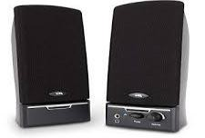

Uninterrupted power supply (UPS)

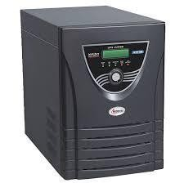An uninterruptible power supply (UPS), also known as a continuous power supply (CPS) or a battery backup is a device which maintains a continuous supply of electric power to connected equipment by supplying power from a separate source when utility power is not available.

­­­­

Small UPS systems provide power for a few minutes; enough to power down the computer in an orderly manner, while larger systems have enough battery for several hours.