Table of Contents
Prepare for the interview. 3
Mock Interview 3
Interview Platform/Syllabus 3
ARM : Oral Questions 4

Prepare for the interview.

Mock Interview
Consider doing a practice interview with friends or family members (especially if they have experience interviewing employees themselves). The practice will be helpful and give you more confidence. Ask for feedback on your answers, your body language, and your preparedness. Have the mock interviewer ask both common questions as well as offbeat ones to see how well you can think on your feet.

Taking the time to review typical interview questions will help give you a framework for your responses. It will also reduce stress because you won't be scrambling for an answer during the interview. Practice interviewing with a friend or family member ahead of time, and it will be much easier when you're actually in a job interview.

Interview Platform/Syllabus

ARM : Oral Questions

1. ARM Vector Table
0x00- Reset Handler
0x04 -Undefined Instruction
0x08 - SWI
0x0C - Prefetch Abort
0X10 -Data Abort
0X14- Reserved
0X18-IRQ Handler
0X1C-FIQ Handler

2. ARM Modes
Privileged Modes (six)
1. system
2. supervisor
3. IRQ
4. FIQ
5. ABORT
6. Undefined

non-privileged Mode
1. user

3. CPSR
N Z C V Q → Flags
I F ---> Interrupt Flags
T --- ARM / THUMB Mode
MODES

reset:
/* * set the cpu to SVC32 mode */
mrs r0,cpsr
bic r0,r0,#0x1f
orr r0,r0,#0xd3
msr cpsr,r0

4. Registers ( R0- R15)
R15-PC
R14-LR
R13-SP
R11-FP
R0-R3 = Arguments

5. ARM - RISC
1. Single Cycle Instructions
2. Register Based operations , not memory
3. Performance Based

6. ARM -Pipeline
ARM7: FETCH - DECODE - EXECUTE
ARM9: FETCH - DECODE - EXECUTE - MEMORY - WRITE
ARM10: FETCH - ISSUE - DECODE - EXECUTE - MEMORY - WRITE

7. ARM -CP15: CO-PROCESSOR 15
1. MMU
2. CACHE
3. TLB / TCM
4. VECTOR TABLE ADDRESS

8. LOAD, STORE
LDR ==> LOAD TO REGISTER
STR ==> STORE TO MEMORY

9. ADDRESSING MODE

PRE INDEX WITH WRITE BACK | MEM[REG + BASE] | REG=REG+BASE | LDR R0,[R1,#4]!
PRE INDEX | MEM[REG + BASE] | NOT UPDATED | LDR R0,[R1,#4]
POST INDEX | MEM[REG] | REG=REG+BASE | LDR R0,[R1],#4

10. LDM,STM [IA,IB,DA,DB]
LDMIA | LDMIA R0!,{R2-R4}
STDIA | STMIA R0!,{R2-R4}

11. FULL STACK, EMPTY STACK
FULL STACK | SP pointer points to the last used or full location
EMPTY STACK | SP pointer points to the first unused or empty location

12 .What is harward and vonumen architecture
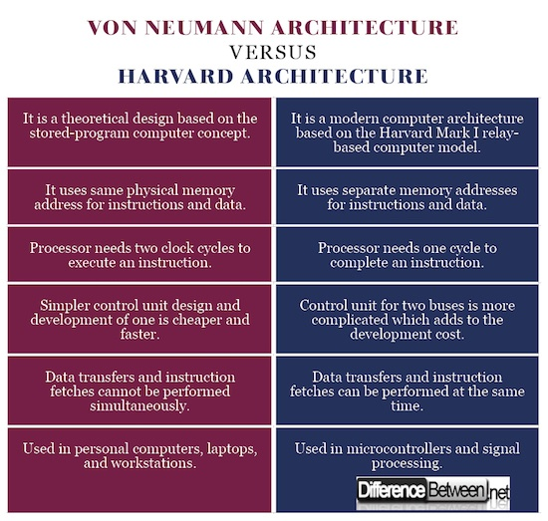

13.What is RISC and CISC instruction set?

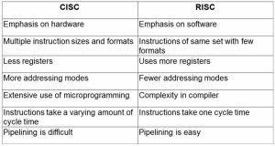

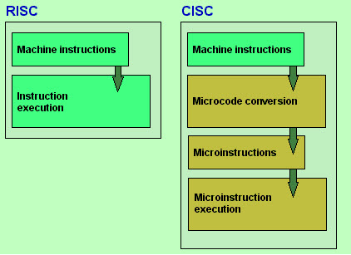

Memory Unit: RISC has no memory unit and uses a separate hardware to implement instructions. CISC has a memory unit to implement complex instructions
Program : RISC has a hard-wired unit of programming. CISC has a microprogramming unit
Design : RISC is a complex compiler design. CISC is an easy compiler design
Calculations : RISC calculations are faster and more precise. CISC calculations are slow and precise
Decoding: RISC decoding of instructions is simple. CISC decoding of instructions is complex
Time: Execution time is very less in RISC. Execution time is very high in CISC.
External memory: RISC does not require external memory for calculations. CISC requires external memory for calculations.
Pipelining: RISC Pipelining does function correctly. CISC Pipelining does not function correctly.
Stalling:RISC stalling is mostly reduced in processors. CISC processors often stall.
Code Expansion : Code expansion can be a problem in RISC whereas, in CISC, Code expansion is not a problem.

14.What is THUMB, THUMB-2 and ARM mode?
ARM and Thumb are two different instruction sets supported by ARM cores with a “T” in their name. For instance, ARM7 TDMI supports Thumb mode. ARM instructions are 32 bits wide, and Thumb instructions are 16 wide. Thumb mode allows for code to be smaller, and can potentially be faster if the target has slow memory.

There are no Thumb coprocessor instructions, no Thumb semaphore instructions, and no Thumb instructions to access the CPSR or SPSR

Thumb-2 technology was introduced in the ARM1156 core, announced in 2003. Thumb-2 extends the limited 16-bit instruction set of Thumb with additional 32-bit instructions to give the instruction set more breadth, thus producing a variable-length instruction set. A stated aim for Thumb-2 was to achieve code density similar to Thumb with performance similar to the ARM instruction set on 32-bit memory.

15.what is difference between FIQ/IRQ in arm?
ARM treats FIQ(Fast interrupt request) at a higher priority as compared to IRQ(interrupt request). When an IRQ is executing an FIQ can interrupt it while vice versa is not true.

16.what is mean of ARM CORTEX architecture?
ARM Cortex-A5, ARM Cortex-A7, ARM Cortex-A8, ARM Cortex-A9, ARM Cortex-A12, ARM Cortex-A15, ARM Cortex-A17
1. Single-issue, in-order micro-architecture with an 8-stage pipeline

ARM Cortex-A9
Designed by | ARM Holdings
Max. CPU clock rate | 0.8 GHz to 2 GHz
Microarchitecture | ARMv7-A
Cores | 1–4
L1 cache | 32 KB I, 32 KB D
L2 cache | 128 KB–8 MB (configurable with L2 cache controller)

17.Difference of CORTEX A8,A9,A15?

18. What is the use of 'SWI' in ARM assembly?
The SWI instruction causes a SWI exception. This means that the processor state changes to ARM, the processor mode changes to Supervisor, the CPSR is saved to the Supervisor Mode SPSR, and execution branches to the SWI vector.

19. What is called 'pipeline bubble' in ARM?
A pipelined processor may deal with hazards by stalling and creating a bubble in the pipeline, resulting in one or more cycles in which nothing useful happens.
Because of the bubble (the blue ovals in the illustration), the processor's Decode circuitry is idle during cycle 3. Its Execute circuitry is idle during cycle 4 and its Write-back circuitry is idle during cycle 5.

When the bubble moves out of the pipeline (at cycle 6), normal execution resumes. But everything now is one cycle late. It will take 8 cycles (cycle 1 through 8) rather than 7 to completely execute the four instructions shown in colors.

20. Tell the 2 software methods available to remove interlocks following load instructions.

21. Tell about 'Load Scheduling by Preloading' and 'Load Scheduling by unrolling'?

22. List the issues when porting C code to the ARM processor?

23. If the pipeline is wider, the instruction throughput is high – True/False?

24. What is out of order execution? Have you considered it in selection of processor?

out-of-order execution, OoOE, is a technique used in most high-performance microprocessors to make use of cycles that would otherwise be wasted by a certain type of costly delay. Most modern CPU designs include support for out of order execution.

The key concept of OoO processing is to allow the processor to avoid a class of delays (termed: "stalls ") that occur when the data needed to perform an operation are unavailable.

In earlier In-order processors, the processing of instructions is normally done in these steps:
- Instruction fetch.
- If input operands are available (in registers for instance), the instruction is dispatched to the appropriate functional unit. If one or more operands is unavailable during the current clock cycle (generally because they are being fetched from memory), however, the processor stalls until they are available.
- The instruction is executed by the appropriate functional unit.
- The functional unit writes the results back to the register.

Out-of-order processors breaks up the processing of instructions into these steps:
- Instruction fetch.
- Instruction dispatch to an instruction queue (also called instruction buffer or reservation stations).
- The instruction waits in the queue until its input operands are available. The instruction is then allowed to leave the queue before earlier, older instructions.
- The instruction is issued to the appropriate functional unit and executed by that unit.
- The results are queued (Re-order Buffer).
- Only after all older instructions have their results written back to the register file, then this result is written back to the register. This is called the graduation or retire stage.
In the examples outlined above, the OoO processor avoids the stall that occurs in step (2) of the in-order processor when the instruction is not completely ready to be processed due to missing data.

25. What is branch prediction?
Branch prediction is a technique used in CPU design that attempts to guess the outcome of a conditional operation and prepare for the most likely result. A digital circuit that performs this operation is known as a branch predictor. It is an important component of modern CPU architectures, such as the x86

Branch prediction is required in the design to reduce the core CPU loss that arises from the longer pipeline. To improve the branch prediction accuracy, a combination of static and dynamic techniques is employed.

26. What is pipeline shutdown

27. What is interrupt pipelining?

28.What are 1st/ 2nd/3rd/4th generation processors?
The processors made of PMOS, NMOS, HMOS, HCMOS technology are called 1st/ 2nd/3rd/4th generation processor’s and are made up of 4, 8, 16, 32-bits

29. What is machine cycle?
The steps performed by computer processor for each machine language instruction received. The machine cycle is 4 process cycle.
- Fetch: Retrieve an instruction from memory
- Decode: Translate the retrieved instruction into series of computer commands.
- Execute: Execute the computer command.
- Store: Send and write the result back into memory.

30. What is called scratch pad of computer?
Cache memory is scratch pad of computer.

31. What is instruction set?
The set of instructions that the microprocessor can execute.

32. ARM Family attributes
 | ARM7 | ARM9 | ARM10 | ARM11
Pipe line -depth | 3 | 5 | 6 | 8
Typical Clock MHZ | 80 | 150 | 260 | 335
Architecture | Von Neumann | Harvard | Harvard | Harvard

33. What is physical cache vs Virtual Cache ?
Physical Cache is located between MMU and Main Memory
Virtual Cache is located between CPU and MMU

34. What is write-through and write-back policy on cache?
write-through: It writes to both cache and main memory,when there is a cache hit on write, so that cache and main memory are coherent

Write-back:It writes to valid cache data memory and not to main memory, hence cache line and main memory are not sync, it sets the dirty bit. Once it will update the main memory and clear the dirty bit.

35. Page tables used by the ARM: MMU
 | TYPE | Memory Consumed(kb) | Page size(kb) | Number of entries
Master/Section | LEVEL-1 | 16 | 1024 | 4096
Fine | LEVEL-2 | 4 | 1(tiny),4(small),64(large) | 1024
Coarse | LEVEL-2 | 1 | 4,64 | 256

36. what is Arm CoreSight ?
Arm CoreSight technology is a set of tools that can be used to debug and trace software that runs on Arm-based SoCs.
CoreSight, ARM’s debug and trace product family, is the most complete on-chip debug and trace solution for the entire System-On-Chip (SoC), making ARM-based SoCs the easiest to debug and optimize.

CoreSight DAP
The CoreSight Debug Access Port provides software debugger access
to the debug and trace subsystem within a SoC. The DAP supports
access through JTAG or, for pin limited applications, Serial Wire Debug
(SWD) offers the same functionality over two pins.

Sources : Generate trace data for output through the Advanced Trace Bus (ATB). Examples include:
- Program Trace Macrocell (PTM).
- System Trace Macrocell (STM),
- CoreSight Embedded Trace Macrocells (ETMs),
Links: Provide connection, triggering, and flow of trace data. Examples include:
- Synchronous 1:1 ATB bridge.
- Replicator.
- Trace funnel.
Sinks: End points for trace data on the SoC. Examples include:
- Trace Port Interface Unit (TPIU) for output of trace data off-chip.
- ETB for on-chip storage of trace data in RAM.

Instruction fetch
The instruction fetch unit predicts the instruction stream, fetches instructions from the L1 instruction cache, and places the fetched instructions into a buffer for consumption by the decode pipeline. The instruction fetch unit also includes the L1 instruction cache

Instruction decode
The instruction decode unit decodes and sequences all ARM and Thumb-2 instructions including debug control coprocessor, CP14, instructions and system control coprocessor, CP15, instructions.

Instruction execute
The instruction execute unit consists of two symmetric Arithmetic Logical Unit (ALU) pipelines, an address generator for load and store instructions, and the multiply pipeline. The execute pipelines also perform register write back.

Load/store
The load/store unit encompasses the entire L1 data side memory system and the integer load/store pipeline.

Processor operating states
The processor has the following operating states controlled by the T bit and J bit in the CPSR.
ARM state : 32-bit, word-aligned ARM instructions are executed in this state.
T bit is 0 and J bit is 0.

Thumb state : 16-bit and 32-bit, halfword-aligned Thumb-2 instructions.
T bit is 1 and J bit is 0.

ThumbEE state :16-bit and 32-bit, halfword-aligned variant of the Thumb-2 instruction set designed as a target for dynamically generated code. This is code compiled on the device either shortly before or during execution from a portable bytecode or other intermediate or native representation.
T bit is 1 and J bit is 1

Switching state
You can switch the operating state of the processor between:
ARM state and Thumb state using the BX and BLX instructions, and loads to the PC.
Thumb state and ThumbEE state using the ENTERX and LEAVEX instructions.

