Table of Contents
I2C Introduction: 2
Clock Stretching 3
SPI Introduction 3
SPI Device : Driver 4
Modes: 4
SPI Mode: Polarity and Clock Phase 4
Why UART is used? 5
Protocol Format 5
Transmission 6
DWC Mobile Storage host controller Description 7
SD/MMC: 7
SD protocol: 9

I2C Introduction:

The I2C bus, invented by Philips (now NXP) is a two-wire, Serial Data (SDA), Serial Clock (SCL) asynchronous serial bus. It is a multi-master bus, though multi-master mode is not widely used. Both SDA and SCL are open drain/open collector, meaning that each of these can drive its output low but neither of them can drive its output high without having pull-up resistors. SCL is generated by the master in order to synchronize data transfer(carried by SDA) over the bus. Both slave and master can send data (not at the same time of course), thus making SDA a bidirectional line. That said, the SCL signal is also bidirectional, since the slave can stretch the clock by keeping the SCL line low. The bus is controlled by the master, which in our case is a part of the SoC. This bus is frequently used in embedded systems to connect serial EEPROM, RTC chips, GPIO expander, temperature sensors, and so on:

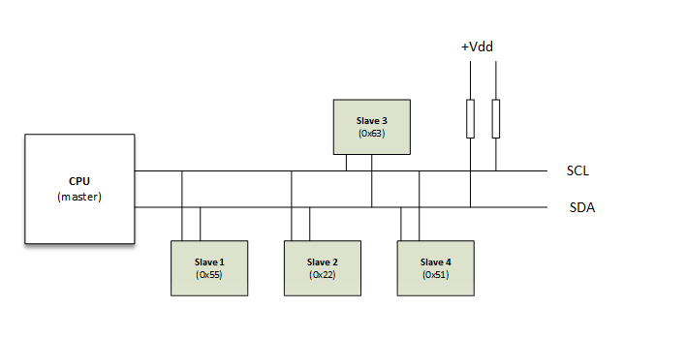
The speed grades (standard mode: 100 kbit/s, full speed: 400 kbit/s, fast mode: 1 mbit/s, high speed: 3,2 Mbit/s) are maximum ratings
The start and stop sequences mark the beginning and end of a transaction with the slave device.
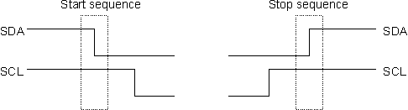

Clock Stretching
I2C client devices can slow down communication by stretching SCL: During an SCL low phase, any I2C device on the bus may additionally hold down SCL to prevent it from rising again, enabling it to slow down the SCL clock rate or to stop I2C communication for a while. This is also referred to as clock synchronization.

SPI Introduction

SPI (Serial Peripheral Interface) is an interface bus commonly used for communication with flash memory, sensors, real-time clocks (RTCs), analog-to-digital converters, and more. The Serial Peripheral Interface (SPI) bus was developed by Motorola to provide full-duplex synchronous serial communication between master and slave devices.

A standard SPI connection involves a master connected to slaves using the serial clock (SCK), Master Out Slave In (MOSI), Master In Slave Out (MISO), and Slave Select (SS) lines. The SCK, MOSI, and MISO signals can be shared by slaves while each slave has a unique SS line.
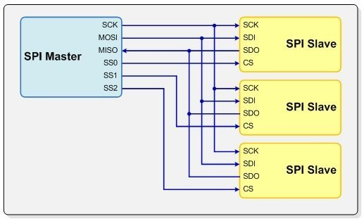

SPI Device : Driver

include/linux/spi/spi.h

Modes:
#define SPI_CPHA 0x01
#define SPI_CPOL 0x02

#define SPI_MODE_0 (0|0)
#define SPI_MODE_1 (0|SPI_CPHA)
#define SPI_MODE_2 (SPI_CPOL|0)
#define SPI_MODE_3 (SPI_CPOL|SPI_CPHA)

SPI Mode: Polarity and Clock Phase
The SPI interface defines no protocol for data exchange, limiting overhead and allowing for high speed data streaming. Clock polarity (CPOL) and clock phase (CPHA) can be specified as ‘0’ or ‘1’ to form four unique modes to provide flexibility in communication between master and slave as shown in Figure .
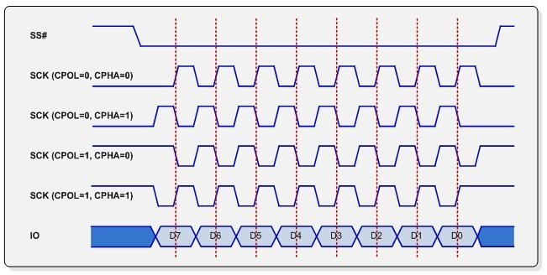

Why UART is used?
Protocols like SPI (serial peripheral interface) and USB (Universal Serial Bus) are used for fast communication. When high-speed data transfer is not required UART is used. It is a cheap communication device with a single transmitter/receiver. It requires a single wire for transmitting the data and another wire for receiving.
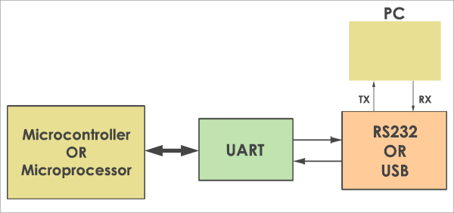

Protocol Format
The UART starts the communication with a start bit ‘0’. The start bit initiates the transfer of serial data and stop bit ends the data transaction.
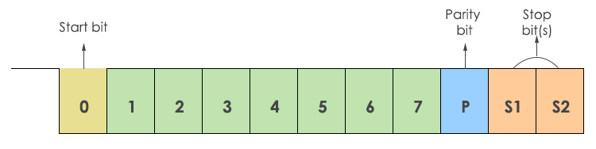

Transmission
The transmission of data is done using a single transmission line (TxD). Here ‘0’ is considered as space and ‘1’ is known as mark state.
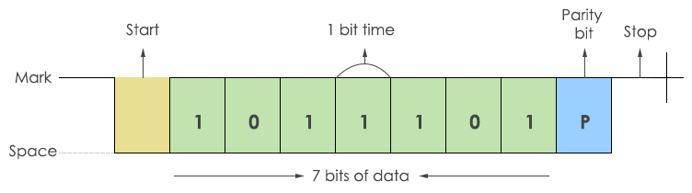

DWC Mobile Storage host controller Description
- An SD_MMC memory card is typically a device for FLASH mass storage.
- The SDIO card usually functions in I/O applications, which can also have optional FLASH memory.
- The CE-ATA card functions in mobile device applications.
Internal Block Diagram of SD/MMC controller
- The DWC_mobile_storage consists of the following main functional blocks,
- Bus Interface Unit (BIU) – Provides AMBA AHB and DMA interfaces for register and data read/writes.
- Card Interface Unit (CIU) – Takes care of the SD_MMC_CEATA protocols and provides clock management.

Operating Description
This section provides an overview of the DWC_mobile_storage architecture.
The blocks are:
- “Bus Interface Unit (BIU)”
- “Card Interface Unit (CIU)”

The BIU provides the host interface to the registers and the data FIFO through the Host Interface Unit (HIU). Additionally, it provides independent data FIFO access through a DMA interface. The DWC_mobile_storage CIU controls the card-specific protocols. Within the CIU, the command path control unit and data path control unit interface the controller to the command and data ports of the SD_MMC_CEATA cards. The CIU also provides clock control.

SD/MMC:
MMC and SD-card share many common features and have the same physical and electrical specifications. The differences between the two standards are mainly on the software level commands.

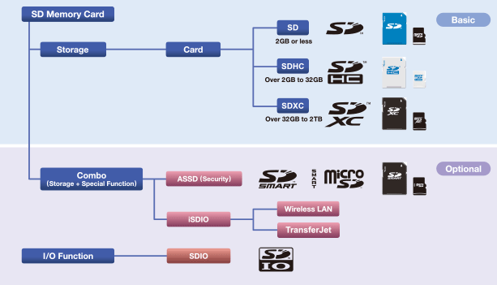

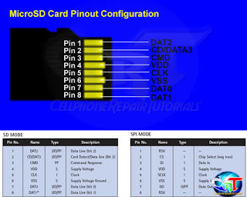

microSD Pinout, SD Mode
Pin # | Pin Name | Signal Function
1 | DAT2 | Data Bit 2
2 | CD/DAT3 | Card Detect / Data Bit 3
3 | CMD | Command Line
4 | Vdd | Supply Voltage 2.7v / 3.6v
5 | CLK | Clock
6 | Vss | Ground
7 | DAT0 | Data Bit 0
8 | DAT1 | Data Bit 1

SD protocol:
Command is transferred to and fro via bidirectional CMD in form of discrete packets of 48 bits. These command packets include command index, argument and CRC bits. Command is always sent via host and received via sd card. Response packets are also of 48 bits. During data transfer, basic unit of transfer is called block, which is usually of 512 bytes and is transferred via all 4 data pins. Also, after each block transfer, 16 bit of CRC data is also sent.

Comparison of SD card capacity standards[64]
 |  | SD | SDHC | SDXC | SDUC
Logo |  |  |  |  | 
Capacity | Min | 128MiB | 2GiB | 32GiB | 2TiB
Capacity | Max | 2GiB | 32GiB | 2TiB | 128TiB
Typical FS |  | FAT16 | FAT32 | FAT32/exFAT | exFAT

All commands have a fixed code length of 48 bits
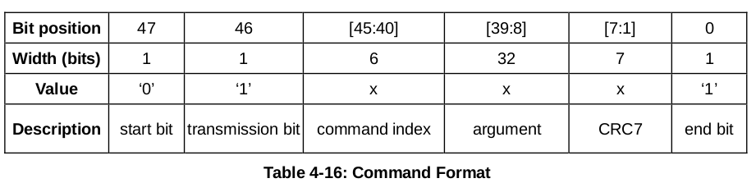

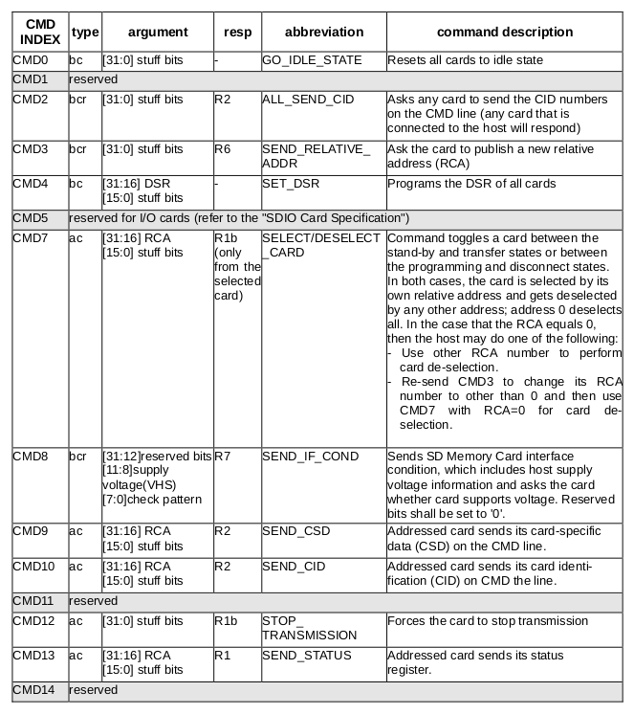

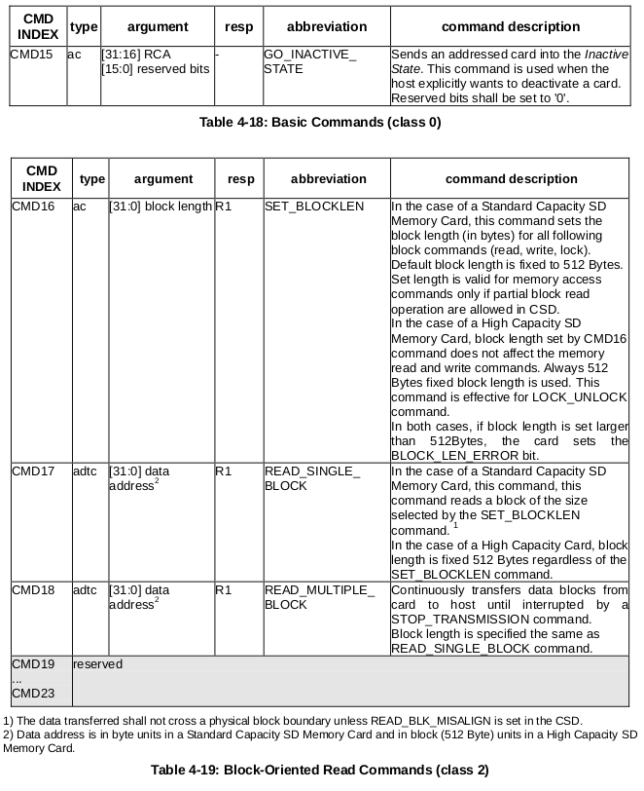
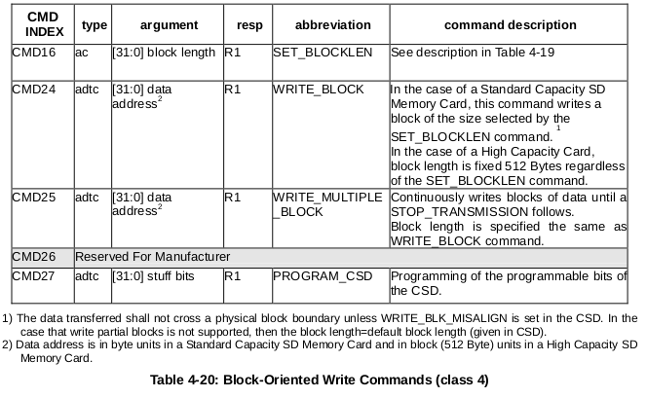

R1 (normal response command):
Code length is 48 bits. The bits 45:40 indicate the index of the command to be responded to, this value being interpreted as a binary coded number (between 0 and 63). The status of the card is coded in 32 bits.

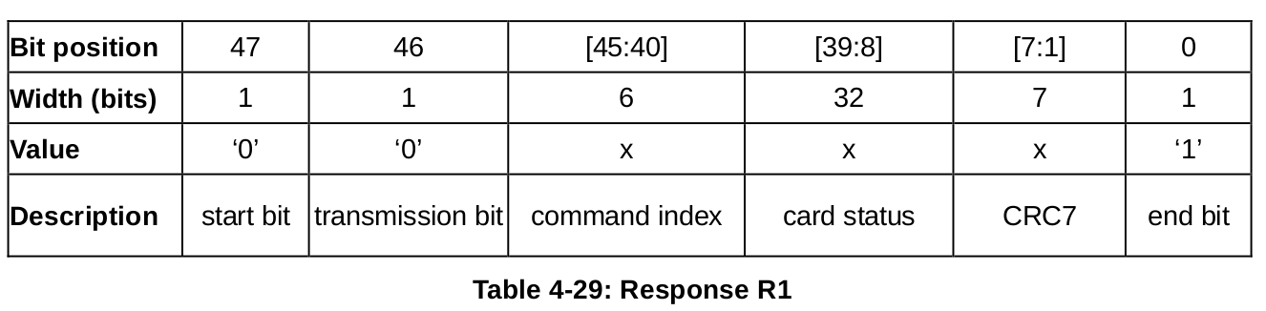

R2 (CID, CSD register)
Code length is 136 bits. The contents of the CID register are sent as a response to the commands CMD2 and CMD10. The contents of the CSD register are sent as a response to CMD9. Only the bits [127…1] of the CID and CSD are transferred, the reserved bit 1 of these regisers is replaced by the end bit of the response.

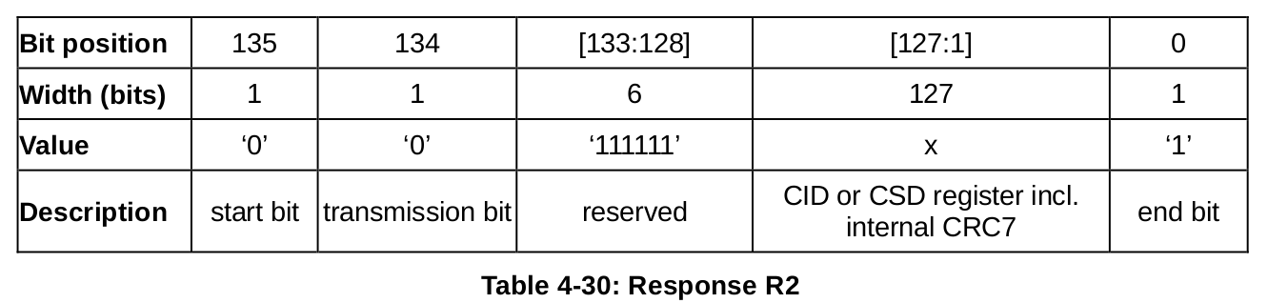
R3 (OCR register)
Code length is 48 bits. The contents of the OCR register are sent as a response to ACMD41.

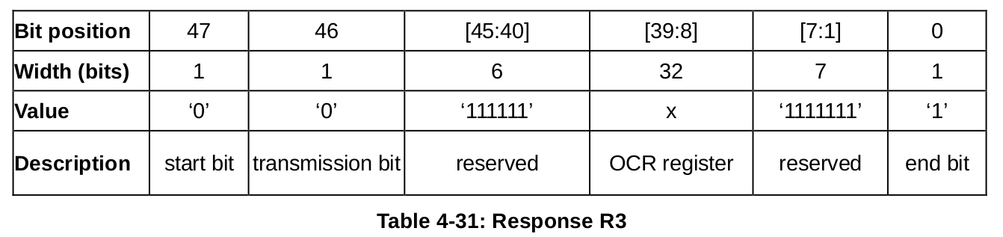
R6 (Published RCA response)
Code length is 48 bit. The bits 45:40 indicate the index of the Command to be responded to - in that case, it will be '000011'(together with bit 5 in the status bits it means = CMD3). The 16 MSB bits of the argument field are used for the Published RCA number.

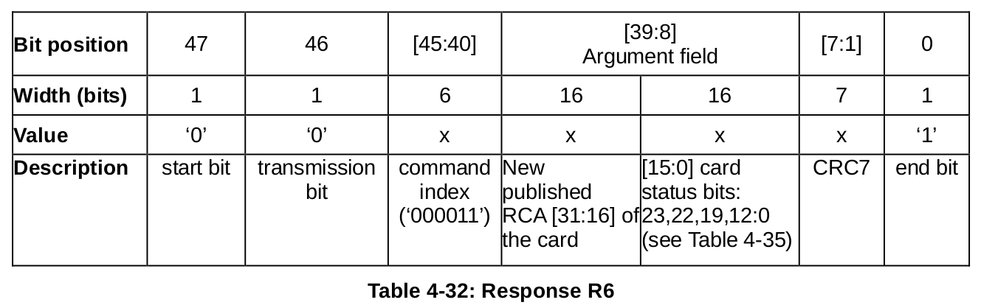
R7 (Card interface condition)
Code length is 48 bits. The card support voltage information is sent by the response of CMD8. Bits 19-16 indicate the voltage range that the card supports. The card that accepted the supplied voltage returns R7 response. In the response, the card echoes back both the voltage range and check pattern set in the argument.
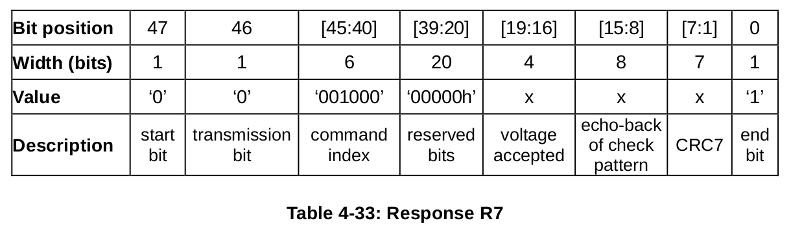

Card Initialization and Identification
The initialization process starts with SDSENDOPCOND (ACMD41) by setting its operational conditions and the HCS bit in the OCR. The HCS (Host Capacity Support) bit set to 1 indicates that the host supports High Capacity SD Memeory card. The HCS (Host Capacity Support) bit set to 0 indicates that the host does not support Hight Capacity SD Memory card.

