Table of Contents
Prepare for the interview. 3
Mock Interview 3
Interview Platform/Syllabus 3
DEVICE TREE 4

Prepare for the interview.

Mock Interview
Consider doing a practice interview with friends or family members (especially if they have experience interviewing employees themselves). The practice will be helpful and give you more confidence. Ask for feedback on your answers, your body language, and your preparedness. Have the mock interviewer ask both common questions as well as offbeat ones to see how well you can think on your feet.

Taking the time to review typical interview questions will help give you a framework for your responses. It will also reduce stress because you won't be scrambling for an answer during the interview. Practice interviewing with a friend or family member ahead of time, and it will be much easier when you're actually in a job interview.

Interview Platform/Syllabus

DEVICE TREE

1) what is a device tree
device tree is a data structure describing the hardware components of a particular computer so that the operating system's kernel can use and manage those components, including the CPU or CPUs, the memory, the buses and the peripherals.

The device tree was derived from SPARC-based workstations and servers via the Open Firmware project

2) device tree format

A device tree can hold any kind of data as internally it is a tree of named nodes and properties. Nodes contain properties and child nodes, while properties are name–value pairs.

Device trees have both a binary format for operating systems to use and a textual format for convenient editing and management

3) what is the device tree

The primary purpose of Device Tree in Linux is to provide a way to describe non-discoverable hardware. This information was previously hard coded in source code(board file)

4) device tree tools

dtc (Device Tree Compiler) - converts between the human editable device tree source "dts" format and the compact device tree blob "dtb"

The Linux version of dtc is located in scripts/dtc/ in the kernel source directory. New versions are periodically pulled from the upstream project

fdtdump
fdtdump is a tool to convert an FDT (flattened device tree, aka device tree blob) to source.

5) device tree file convention
- .dtb - File name suffix, by convention, for compiled device tree.
- .dts - File name suffix, by convention, for device tree source.
- .dtsi - File name suffix, by convention, for device tree source to be included by a .dts or .dtsi file.

6)Debugging the device tree
For newer kernels where the CONFIG_PROC_DEVICETREE option does not exist, /proc/device-tree will be created if CONFIG_PROC_FS is set to 'Y'

7) generated script in build directory

After a .dtb has been built by the Linux kernel make system, files containing the precise build commands will remain in the build directory:
- arch/arm/boot/dts/.*.dtb.cmd
- arch/${ARCH}/boot/dts/.*.dtb.cmd

make dtbs

8) what is address-cells and size-cells?
Devices that are addressable use the following properties to encode address information into the device tree:
- reg
- #address-cells
- #size-cells
Each addressable device gets a reg which is a list of tuples in the form
reg = <address1 length1 [address2 length2] [address3 length3] ... >. Each tuple represents an address range used by the device. Each address value is a list of one or more 32 bit integers called cells. Similarly, the length value can either be a list of cells, or empty.

9) sample device tree

/dts-v1/;
/ {
compatible = "acme,coyotes-revenge";
cpus {
cpu@0 {
compatible = "arm,cortex-a9";
};
cpu@1 {
compatible = "arm,cortex-a9";
};
};
chosen {
bootargs = "root=/dev/nfs rw nfsroot=192.168.1.1 console=ttyS0,115200";
};
memory {
device_type=”memory”;
reg=<0x80000000 0x20000000>;
};
};

10) write AM335X – Bone Black Device tree

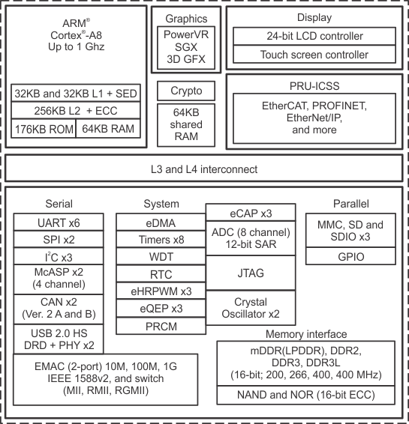
S.NO | IP Controller | Details
1 | CPU | ARM CORTEX A8, 1GHZ, Single Core, RISC, 32 Bit Processor
2 | Cache (L1) | 32 KB Instruction + 32 KB Data Cache
3 | Cache (L2) | 256 KB
4 | Serial | UART x6
5 | SPI | SPI X2
6 | I2C | I2C X3
7 | GPIO
8 | Timers | Timer X8
9 | RTC | RTC
10 | WDT | WDT
11 | EDMA | EDMA
12 | MMC, SD | MMC,SD X3
13 | USB 2.0 | USB 2.0 HOST,DRD
14 | LCD CONTROLLER
15 | TUCH CONTROLLER
16 | 16 BIT DDR : DDR2,DDR3,DDR3L | 200,266,400 MHZ

/ {
model = "TI AM335x BeagleBone Black";
compatible="ti,am335x-bone-black", "ti,am335x-bone", "ti,am33xx";
interrupt-parent = <&intc>;
#address-cells = <1>;
#size-cells = <1>;

memory@80000000 {
device_type = "memory";
reg = <0x80000000 0x10000000>; /* 256 MB */
};

ocp {
intc: interrupt-controller@48200000 {
compatible = "ti,am33xx-intc";
interrupt-controller;
#interrupt-cells = <1>;
reg = <0x48200000 0x1000>;
};
gpio0: gpio@44e07000 {
compatible = "ti,omap4-gpio";
ti,hwmods = "gpio1";
gpio-controller;
#gpio-cells = <2>;
interrupt-controller;
#interrupt-cells = <2>;
reg = <0x44e07000 0x1000>;
interrupts = <96>;
};
uart0: serial@44e09000 {
compatible = "ti,am3352-uart", "ti,omap3-uart";
ti,hwmods = "uart1";
clock-frequency = <48000000>;
reg = <0x44e09000 0x2000>;
interrupts = <72>;
status = "disabled";
dmas = <&edma 26 0>, <&edma 27 0>;
dma-names = "tx", "rx";
};
i2c0: i2c@44e0b000 {
compatible = "ti,omap4-i2c";
#address-cells = <1>;
#size-cells = <0>;
ti,hwmods = "i2c1";
reg = <0x44e0b000 0x1000>;
interrupts = <70>;
status = "disabled";
};
mmc1: mmc@48060000 {
compatible = "ti,omap4-hsmmc";
ti,hwmods = "mmc1";
ti,dual-volt;
ti,needs-special-reset;
ti,needs-special-hs-handling;
dmas = <&edma_xbar 24 0 0
&edma_xbar 25 0 0>;
dma-names = "tx", "rx";
interrupts = <64>;
reg = <0x48060000 0x1000>;
status = "disabled";
};
timer1: timer@44e31000 {
compatible = "ti,am335x-timer-1ms";
reg = <0x44e31000 0x400>;
interrupts = <67>;
ti,hwmods = "timer1";
ti,timer-alwon;
clocks = <&timer1_fck>;
clock-names = "fck";
};
rtc: rtc@44e3e000 {
compatible = "ti,am3352-rtc", "ti,da830-rtc";
reg = <0x44e3e000 0x1000>;
interrupts = <75 76>;
ti,hwmods = "rtc";
clocks = <&l4_per_clkctrl AM3_CLKDIV32K_CLKCTRL 0>;
clock-names = "int-clk";
};
spi0: spi@48030000 {
compatible = "ti,omap4-mcspi";
#address-cells = <1>;
#size-cells = <0>;
reg = <0x48030000 0x400>;
interrupts = <65>;
ti,spi-num-cs = <2>;
ti,hwmods = "spi0";
dmas = <&edma 16 0
&edma 17 0
&edma 18 0
&edma 19 0>;
dma-names = "tx0", "rx0", "tx1", "rx1";
status = "disabled";
};
};
am33xx_pinmux: pinmux@800 {
compatible = "pinctrl-single";
reg = <0x800 0x238>;
#address-cells = <1>;
#size-cells = <0>;
#pinctrl-cells = <1>;
pinctrl-single,register-width = <32>;
pinctrl-single,function-mask = <0x7f>;
};
};

dsti
&am33xx_pinmux {
pinctrl-names = "default";
pinctrl-0 = <&clkout2_pin>;

user_leds_s0: user_leds_s0 {
pinctrl-single,pins = <
AM33XX_IOPAD(0x854, PIN_OUTPUT_PULLDOWN | MUX_MODE7) /* gpmc_a5.gpio1_21 */
AM33XX_IOPAD(0x858, PIN_OUTPUT_PULLUP | MUX_MODE7) /* gpmc_a6.gpio1_22 */
AM33XX_IOPAD(0x85c, PIN_OUTPUT_PULLDOWN | MUX_MODE7) /* gpmc_a7.gpio1_23 */
AM33XX_IOPAD(0x860, PIN_OUTPUT_PULLUP | MUX_MODE7) /* gpmc_a8.gpio1_24 */
>;
};

i2c0_pins: pinmux_i2c0_pins {
pinctrl-single,pins = <
AM33XX_IOPAD(0x988, PIN_INPUT_PULLUP | MUX_MODE0) /* i2c0_sda.i2c0_sda */
AM33XX_IOPAD(0x98c, PIN_INPUT_PULLUP | MUX_MODE0) /* i2c0_scl.i2c0_scl */
>;
};
};

&i2c0 {
pinctrl-names = "default";
pinctrl-0 = <&i2c0_pins>;
status = "okay";
clock-frequency = <400000>;
tps: tps@24 {
reg = <0x24>;
};

baseboard_eeprom: baseboard_eeprom@50 {
compatible = "atmel,24c256";
reg = <0x50>;

#address-cells = <1>;
#size-cells = <1>;
baseboard_data: baseboard_data@0 {
reg = <0 0x100>;
};
};
};
&mmc1 {
status = "okay";
bus-width = <0x4>;
pinctrl-names = "default";
pinctrl-0 = <&mmc1_pins>;
cd-gpios = <&gpio0 6 GPIO_ACTIVE_LOW>;
};

10) write I.MX6 – (SOLO/DUAL/DUALLITE/QUARD) Device tree
The i.MX 6 series are based on the ARM Cortex A9 solo, dual or quad cores n CMOS 40 nm process. i.MX 6 Solo, Dual and Quad were announced in January 2011, during Consumer Electronics Show in Las Vegas.

Name | Clock speed | CPU cores | L2 cache  in kB | Embedded  SRAM in kB | 3D GPU / shaders /  shader clock in MHz | 2D GPU | Vector GPU | VPU | other graphics cores | other cores
i.MX 6 Solo | 1.0 GHz | 1 | 512 | 128 | Vivante GC880 / 1 / 528 | Vivante GC320 |  | Full HD (1080p decode) | 1× IPUv3, 1× PXP | security
i.MX 6 DualLite | 1.0 GHz | 2 | 512 | 128 | Vivante GC880 / 1 / 528 | Vivante GC320 |  | Full HD (1080p decode) | 1× IPUv3, 1× PXP | security
i.MX 6 Dual | 1.2 GHz | 2 | 1024 | 256 | Vivante GC2000 / 4 / 594 | Vivante GC320 | Vivante GC355 | Full HD (1080p decode) | 2× IPUv3 | security
i.MX 6 Quad | 1.2 GHz | 4 | 1024 | 256 | Vivante GC2000 / 4 / 594 | Vivante GC320 | Vivante GC355 | dual Full HD (1080p decode) | 2× IPUv3 | security

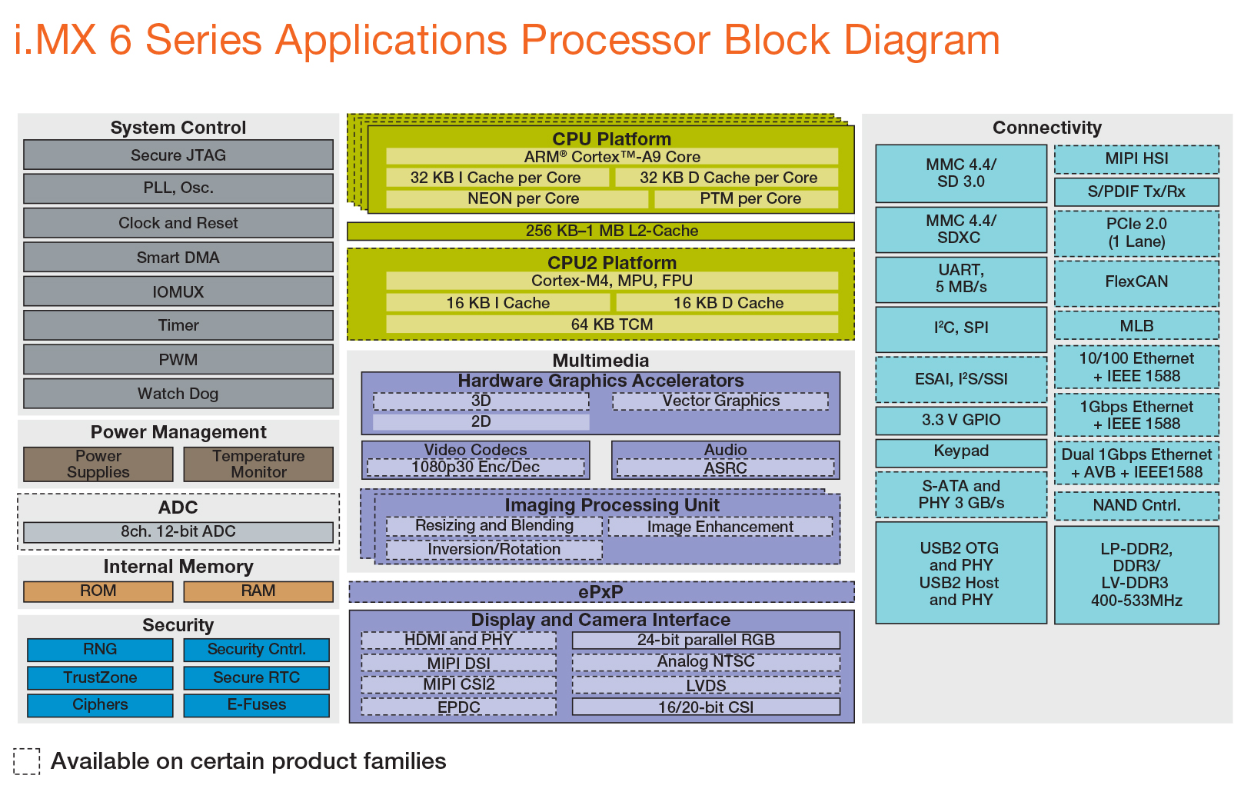

cpus {
#address-cells = <1>;
#size-cells = <0>;
cpu@0 {
compatible = "arm,cortex-a9";
device_type = "cpu";
reg = <0x0>;
next-level-cache = <&L2>;
operating-points = <
/* kHz uV */
996000 1275000
792000 1175000
396000 975000
>;
};
};

intc: interrupt-controller@a01000 {
compatible = "arm,cortex-a9-gic";
#interrupt-cells = <3>;
interrupt-controller;
reg = <0x00a01000 0x1000>,
<0x00a00100 0x100>;
interrupt-parent = <&intc>;
};
soc {
#address-cells = <1>;
#size-cells = <1>;
compatible = "simple-bus";
interrupt-parent = <&gpc>;
ranges;
uart1: serial@2020000 {
compatible = "fsl,imx6sl-uart",
"fsl,imx6q-uart", "fsl,imx21-uart";
reg = <0x02020000 0x4000>;
interrupts = <0 26 IRQ_TYPE_LEVEL_HIGH>;
clocks = <&clks IMX6SL_CLK_UART>,
<&clks IMX6SL_CLK_UART_SERIAL>;
clock-names = "ipg", "per";
dmas = <&sdma 25 4 0>, <&sdma 26 4 0>;
dma-names = "rx", "tx";
status = "disabled";
};
ssi1: ssi@2028000 {
#sound-dai-cells = <0>;
compatible = "fsl,imx6sl-ssi",
"fsl,imx51-ssi";
reg = <0x02028000 0x4000>;
interrupts = <0 46 IRQ_TYPE_LEVEL_HIGH>;
clocks = <&clks IMX6SL_CLK_SSI1_IPG>,
<&clks IMX6SL_CLK_SSI1>;
clock-names = "ipg", "baud";
dmas = <&sdma 37 1 0>,
<&sdma 38 1 0>;
dma-names = "rx", "tx";
fsl,fifo-depth = <15>;
status = "disabled";
};
pwm1: pwm@2080000 {
#pwm-cells = <2>;
compatible = "fsl,imx6sl-pwm", "fsl,imx27-pwm";
reg = <0x02080000 0x4000>;
interrupts = <0 83 IRQ_TYPE_LEVEL_HIGH>;
clocks = <&clks IMX6SL_CLK_PWM1>,
<&clks IMX6SL_CLK_PWM1>;
clock-names = "ipg", "per";
};
gpio1: gpio@209c000 {
compatible = "fsl,imx6sl-gpio", "fsl,imx35-gpio";
reg = <0x0209c000 0x4000>;
interrupts = <0 66 IRQ_TYPE_LEVEL_HIGH>,
<0 67 IRQ_TYPE_LEVEL_HIGH>;
gpio-controller;
#gpio-cells = <2>;
interrupt-controller;
#interrupt-cells = <2>;
gpio-ranges = <&iomuxc 0 22 1>, <&iomuxc 1 20 2>,
<&iomuxc 3 23 1>, <&iomuxc 4 25 1>,
<&iomuxc 5 24 1>, <&iomuxc 6 19 1>,
<&iomuxc 7 36 2>, <&iomuxc 9 44 8>,
<&iomuxc 17 38 6>, <&iomuxc 23 68 4>,
<&iomuxc 27 64 4>, <&iomuxc 31 52 1>;
};
kpp: kpp@20b8000 {
compatible = "fsl,imx6sl-kpp", "fsl,imx21-kpp";
reg = <0x020b8000 0x4000>;
interrupts = <0 82 IRQ_TYPE_LEVEL_HIGH>;
clocks = <&clks IMX6SL_CLK_DUMMY>;
status = "disabled";
};

wdog1: wdog@20bc000 {
compatible = "fsl,imx6sl-wdt", "fsl,imx21-wdt";
reg = <0x020bc000 0x4000>;
interrupts = <0 80 IRQ_TYPE_LEVEL_HIGH>;
clocks = <&clks IMX6SL_CLK_DUMMY>;
};
i2c1: i2c@21a0000 {
#address-cells = <1>;
#size-cells = <0>;
compatible = "fsl,imx6sl-i2c", "fsl,imx21-i2c";
reg = <0x021a0000 0x4000>;
interrupts = <0 36 IRQ_TYPE_LEVEL_HIGH>;
clocks = <&clks IMX6SL_CLK_I2C1>;
status = "disabled";
};
usdhc1: usdhc@2190000 {
compatible = "fsl,imx6sl-usdhc", "fsl,imx6q-usdhc";
reg = <0x02190000 0x4000>;
interrupts = <0 22 IRQ_TYPE_LEVEL_HIGH>;
clocks = <&clks IMX6SL_CLK_USDHC1>,
<&clks IMX6SL_CLK_USDHC1>,
<&clks IMX6SL_CLK_USDHC1>;
clock-names = "ipg", "ahb", "per";
bus-width = <4>;
status = "disabled";
};
iomuxc: iomuxc@20e0000 {
compatible = "fsl,imx6sl-iomuxc";
reg = <0x020e0000 0x4000>;
};

csi: csi@20e4000 {
reg = <0x020e4000 0x4000>;
interrupts = <0 7 IRQ_TYPE_LEVEL_HIGH>;
};

dtsi:
&iomuxc {
pinctrl-names = "default";
pinctrl-0 = <&pinctrl_hog>;

imx6sl-evk {
pinctrl_hog: hoggrp {
fsl,pins = <
MX6SL_PAD_KEY_ROW7__GPIO4_IO07 0x17059
MX6SL_PAD_KEY_COL7__GPIO4_IO06 0x17059
MX6SL_PAD_SD2_DAT7__GPIO5_IO00 0x17059
MX6SL_PAD_SD2_DAT6__GPIO4_IO29 0x17059
MX6SL_PAD_REF_CLK_32K__GPIO3_IO22 0x17059
MX6SL_PAD_KEY_COL4__GPIO4_IO00 0x80000000
MX6SL_PAD_KEY_COL5__GPIO4_IO02 0x80000000
MX6SL_PAD_AUD_MCLK__AUDIO_CLK_OUT 0x4130b0
>;
};

pinctrl_audmux3: audmux3grp {
fsl,pins = <
MX6SL_PAD_AUD_RXD__AUD3_RXD 0x4130b0
MX6SL_PAD_AUD_TXC__AUD3_TXC 0x4130b0
MX6SL_PAD_AUD_TXD__AUD3_TXD 0x4110b0
MX6SL_PAD_AUD_TXFS__AUD3_TXFS 0x4130b0
>;
};

pinctrl_ecspi1: ecspi1grp {
fsl,pins = <
MX6SL_PAD_ECSPI1_MISO__ECSPI1_MISO 0x100b1
MX6SL_PAD_ECSPI1_MOSI__ECSPI1_MOSI 0x100b1
MX6SL_PAD_ECSPI1_SCLK__ECSPI1_SCLK 0x100b1
MX6SL_PAD_ECSPI1_SS0__GPIO4_IO11 0x80000000
>;
};

11) ov5640 : device tree node in sabresd (I.mx6) (imx6qdl-sabresd.dtsi)
ov5640: camera@3c {
compatible = "ovti,ov5640";
pinctrl-names = "default";
pinctrl-0 = <&pinctrl_ov5640>;
reg = <0x3c>;
clocks = <&clks IMX6QDL_CLK_CKO>;
clock-names = "xclk";
DOVDD-supply = <&vgen4_reg>; /* 1.8v */
AVDD-supply = <&vgen3_reg>; /* 2.8v, rev C board is VGEN3
rev B board is VGEN5 */
DVDD-supply = <&vgen2_reg>; /* 1.5v*/
powerdown-gpios = <&gpio1 19 GPIO_ACTIVE_HIGH>;
reset-gpios = <&gpio1 20 GPIO_ACTIVE_LOW>;

port {
ov5640_to_mipi_csi2: endpoint {
remote-endpoint = <&mipi_csi2_in>;
clock-lanes = <0>;
data-lanes = <1 2>;
};
};
};

&mipi_csi {
status = "okay";

port@0 {
reg = <0>;

mipi_csi2_in: endpoint {
remote-endpoint = <&ov5640_to_mipi_csi2>;
clock-lanes = <0>;
data-lanes = <1 2>;
};
};
};

mipi_csi: mipi@21dc000 {
compatible = "fsl,imx6-mipi-csi2";
reg = <0x021dc000 0x4000>;
#address-cells = <1>;
#size-cells = <0>;
interrupts = <0 100 0x04>, <0 101 0x04>;
clocks = <&clks IMX6QDL_CLK_HSI_TX>,
<&clks IMX6QDL_CLK_VIDEO_27M>,
<&clks IMX6QDL_CLK_EIM_PODF>;
clock-names = "dphy", "ref", "pix";
status = "disabled";
};

12) device tree node for xilinx sdirx source ?

SDI Rx SS ==> Framebuffer Write ==> Memory

v_smpte_uhdsdi_rx_ss: v_smpte_uhdsdi_rx_ss@80000000 {
compatible = "xlnx,v-smpte-uhdsdi-rx-ss";
interrupt-parent = <&gic>;
interrupts = <0 89 4>;
reg = <0x0 0x80000000 0x0 0x10000>;
xlnx,include-axilite = "true";
xlnx,include-edh = "true";
xlnx,include-vid-over-axi = "true";
xlnx,line-rate = "12G_SDI_8DS";
clocks = <&clk_1>, <&si570_1>, <&clk_2>;
clock-names = "s_axi_aclk", "sdi_rx_clk", "video_out_clk";

ports {
#address-cells = <1>;
#size-cells = <0>;

port@0 {
reg = <0>;

xlnx,video-format = <XVIP_VF_YUV_422>;
xlnx,video-width = <10>;

sdirx_out: endpoint {
remote-endpoint = <&vcap_in>;
};
};
};
};

v_frmbuf_wr_0: v_frmbuf_wr@80000000 {
#dma-cells = <1>;
compatible = "xlnx,axi-frmbuf-wr-v2.1";
interrupt-parent = <&gic>;
interrupts = <0 92 4>;
reset-gpios = <&gpio 80 1>;
reg = <0x0 0x80000000 0x0 0x10000>;
xlnx,dma-addr-width = <64>;
xlnx,vid-formats = "bgr888","yuyv","nv16","nv12";
xlnx,pixels-per-clock = <2>;
xlnx,dma-align = <16>;
clocks = <&vid_stream_clk>;
clock-names = "ap_clk"
};

video_cap {
compatible = "xlnx,video";
dmas = <&v_frmbuf_wr_0 0>;
dma-names = "port0";
ports {
#address-cells = <1>;
#size-cells = <0>;
port@0 {
reg = <0>;
direction = "input";
vcap_in: endpoint {
remote-endpoint = <&sdirx_out>;
};
};

};
};

