ACKNOWLEDGEMENT
It gives me enormous pleasure to submit a report on “Karmapatro”. Special thanks and deepest sense of gratitude to my college New Summit College for giving me the opportunity to present myselves on this report within the scheduled time. My report wouldn’t have been possible without the support and guidance of our respected teachers. Special thanks to project coordinator Mr. Pawesh Dhungana for his uncreditable support and guidance and thanks for believing on me. I hope that this project has been prepared for the fulfillment of the course requirement.
Yours Sincerely,
Aparajita Subedi

ABSTRACT
Karmapatro is a web-based payroll management system developed using PHP, HTML, CSS, and JavaScript. The main aim of this project is to help organizations manage their daily operations more easily and efficiently.
This system allows employers to keep complete records of employees, including their attendance, leaves, salaries, bonuses, and deductions. It also helps in calculating employee wages, overtime, provident funds, and taxes automatically. In addition, Karmapatro can generate salary certificates, experience letters, and manage various office expenses.
In short, Karmapatro is designed to make payroll and employee management faster, more accurate, and paperless making the overall workflow smoother and easier for organizations.

Keywords: paperless work, payroll, smoother

CHAPTER 1. INTRODUCTION

Introduction
Payroll is a critical function in any organization, as it involves paying employees, calculating taxes, and maintaining records. Traditionally, payroll was managed manually, which could be time-consuming and prone to errors. To simplify this, we have developed Karmapatro, a payroll management system using PHP, HTML, CSS, and JavaScript. This system helps organizations manage employee data, attendance, salaries, taxes, leaves, and other payroll-related tasks efficiently and accurately.

Problem Statement
Managing payroll manually or using outdated systems can lead to errors, delays, and difficulties in record-keeping. Organizations often struggle with tracking employee attendance, calculating salaries, handling bonuses and deductions, and maintaining proper documentation for tax compliance. These challenges can cause financial losses, employee dissatisfaction, and compliance issues. Karmapatro addresses these problems by automating payroll processes, reducing errors, and saving time for organizations.

Objectives
The main objectives of Karmapatro are:
- To automate employee salary calculations including wages, bonuses, overtime, and provident funds.
- To manage employee records, attendance, leaves, and holidays efficiently.
- To generate salary slips, reports, and other necessary documents easily.

Scope and Limitation
Scope:
- Karmapatro handles payroll management for small to medium-sized organizations.
- It manages employee data, attendance, salaries, bonuses, leaves, expenses, and reports.
- It provides tools for generating certificates, letters, and payroll reports.
Limitations:
- The system is limited to organizational payroll and cannot manage non-payroll financial tasks.
- Internet connection is required for features like report sharing or notifications.
- It depends on accurate data input; errors in data entry may affect calculations.

Development Methodology
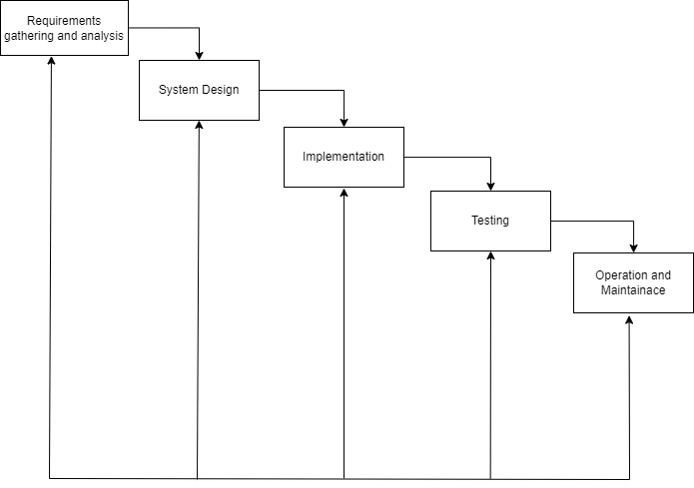
Since, All the requirement are clear prior the development of the system and sometimes some small changes can be done so, iterative waterfall model is suitable. The iterative waterfall model can be illustrate as:

Figure 1.1: Iterative waterfall model

Report Organization
This report is divided into four chapter. Each chapter is further divided into different headings.
Chapter 1 gives an introduction to Karmapatro system. The problem definition, objectives, scopes, and limitation of this system are discussed here.
Chapter 2 focuses on the background study. It consists a literature review section where the research works done in the field of existing payroll system.
Chapter 3 focuses on the analysis part. It contain a requirement analysis, feasibility analysis and diagram like class diagram, sequence diagram, activity diagram and flowchart. Discusses in detail the design of the system. This chapter also discusses database design, interface design, and flowchart of the system built. This chapter also includes feasibility study, requirement analysis, and diagram like ER, DFD, and flowchart.
Chapter 4 gives information about the implementation and testing process. It discusses how the system is implemented and what tools and software are used to implement this system. The testing process is also include detail in this chapter.
Chapter 5 includes the conclusion of the whole project. This chapter shows major achievement in the system and also shows how it can be enhances later in the future

CHAPTER 2

BACKGROUND STUDY AND LITERATURE REVIEW

2.1 Background
Payroll management is an essential part of any organization, as it ensures employees are paid accurately and on time while maintaining proper financial records and complying with government regulations. Manual payroll processes are often time-consuming and prone to errors, which can lead to penalties and employee dissatisfaction.
Karmapatro is a payroll management system designed to simplify and automate payroll tasks. It helps organizations manage employee records, calculate wages, bonuses, and overtime, track attendance, handle leaves, process payroll taxes, and maintain reports. It also manages events, notices, holidays, expenses, and awards, providing a complete solution for smooth organizational operations. By automating these processes, Karmapatro reduces errors, saves time, and improves efficiency, ensuring both employees and employers benefit from accurate and transparent payroll management.

2.2 Literature Review
This chapter reviews existing literature, studies, and systems relevant to the development of the project “Karmapatro: A Payroll Management System.” Several payroll systems currently available are described below.
Hamro-Hajiri: Hamro-Hajiri is a web-based attendance management system that allows users to manage multiple time and attendance terminals remotely via LAN, WAN, Wi-Fi, or mobile networks. It features an easy-to-use interface for scheduling shifts, generating attendance reports, and automatic data synchronization between devices and servers. The system also offers an optional payroll module to simplify employee hour and wage calculations [1].
E-Payroll Online Payroll System: E-Payroll is an online payroll software designed to reduce errors and ensure compliance with government tax regulations. It provides a simple, user-friendly interface and online document processing, allowing businesses to manage payroll efficiently while focusing on core operations [2].
ByzKit HR: ByzKit HR is part of the ByzKit software suite, aimed at HR management for Nepali businesses. Developed by Cloudy Fox Technology, it is available as a web and mobile app. The system allows unlimited employee management within the company’s domain, although it requires an internet connection and does not support offline use [3].
Computerized Payroll System of the Department of Health (DOH): This Windows-based system is designed to simplify payroll processing for DOH offices. It allows faster and more accurate calculation of salaries, deductions, and reports, while maintaining the security and integrity of employee data. The system features a menu-driven interface and organized employee record management [4].
Attendance Monitoring with Biometric Payroll System: Modern payroll systems increasingly use biometric technology to improve efficiency and accuracy. A study at Cavite State University highlighted the benefits of computer-based payroll and attendance management, showing that biometrics can reduce manual work and ensure reliable authentication for staff [5].

CHAPTER 3
The Internet has been favored by more and more people for its high efficiency and
richness, and e-commerce has emerged. The online bookstore is a form of e-commerce
and book sales industry in one form, it has many advantages, such as: Bookstore size is
relatively small, cost savings; transaction activities can be anytime, anywhere, improve
service efficiency, The information is complete, more convenient retrieval, the new book
information on the new, consumers can see in a timely manner, trading activities can be
launched immediately, so online bookstore in today's era of development is extremely
rapid. Online bookstore system is the main function of the trading platform for the site,
consumers can connect to the Internet through the computer into the online bookstore and
then check the book information, if you need to purchase should be registered landing,
select their own books, submit orders and pay Operation to complete the entire book
ordering process, to achieve online transactions.[CITATION Yun17 \l 1033
The Internet has been favored by more and more people for its high efficiency and
richness, and e-commerce has emerged. The online bookstore is a form of e-commerce
and book sales industry in one form, it has many advantages, such as: Bookstore size is
relatively small, cost savings; transaction activities can be anytime, anywhere, improve
service efficiency, The information is complete, more convenient retrieval, the new book
information on the new, consumers can see in a timely manner, trading activities can be
launched immediately, so online bookstore in today's era of development is extremely
rapid. Online bookstore system is the main function of the trading platform for the site,
consumers can connect to the Internet through the computer into the online bookstore and
then check the book information, if you need to purchase should be registered landing,
select their own books, submit orders and pay Operation to complete the entire book
ordering process, to achieve online transactions.[CITATION Yun17 \l 1033
The Internet has been favored by more and more people for its high efficiency and
richness, and e-commerce has emerged. The online bookstore is a form of e-commerce
and book sales industry in one form, it has many advantages, such as: Bookstore size is
relatively small, cost savings; transaction activities can be anytime, anywhere, improve
service efficiency, The information is complete, more convenient retrieval, the new book
information on the new, consumers can see in a timely manner, trading activities can be
launched immediately, so online bookstore in today's era of development is extremely
rapid. Online bookstore system is the main function of the trading platform for the site,
consumers can connect to the Internet through the computer into the online bookstore and
then check the book information, if you need to purchase should be registered landing,
select their own books, submit orders and pay Operation to complete the entire book
ordering process, to achieve online transactions.[CITATION Yun17 \l 1033

SYSTEM ANALYSIS AND DESIGN

3.1 System Analysis
System analysis is the process of understanding and comparing the functional impacts of subsystem to the total system. It identifies the problem and organizes the facts and details of the system.

3.1.1 Requirement Analysis
As the system design evolves, requirement analysis activities support allocation and derivation of requirement down to the system elements representing the lowest level of the design. The functional and non-functional requirement are necessary to analyze the system requirement before developing and implementing.
3.1.2 Functional Requirement
Use case diagram is the primary form of system/software requirements for a new software program underdeveloped. Use cases specify the expected behavior, and not the exact method of making it happen. Use cases once specified can be denoted both textual and visual representation (i.e. use case diagram). A key concept of use case modeling is that it helps us to design a system from the end user's perspective. It is an effective technique for communicating system behavior in the user's terms by specifying all externally visible system behavior.
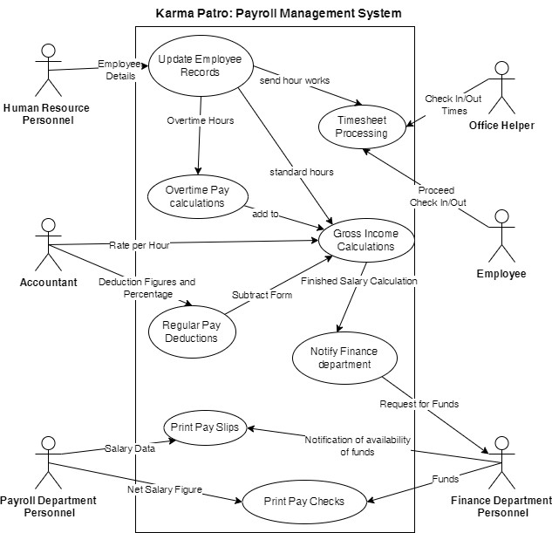

Figure 3.1: Use Case Diagram of Karmapatro
3.1.3 Non-Functional Requirement
- Easy to use
The function and UI are similar other to other e-commerce website making it easy to use and get familiar with the website.
- Security
User’s personal information can only be accessed by admin and won’t be available for others. Thus, making system secure.
- Usability
This system can be used 24/7 by anyone who is familiar with English language.
- Responsive
The system should respond to user actions and requests within a reasonable timeframe, ensuring a seamless and smooth user experience.
- Maintainability
The system will be coded and maintained using HTML, CSS, JavaScript and PHP.

3.1.4 Feasibility Analysis
The feasibility study shows that the “Karmapatro” project is practical and achievable from technical, operational, economic and schedule perspectives.

i)Technical Feasibility
The project uses popular and reliable technologies like HTML, CSS, and JavaScript for the frontend and MYSQL as database, ensuring the site is user-friendly and engaging. The backend uses PHP, which is known for being strong, secure, and capable of handling large amounts of data and users so, it is technically feasible.

ii) Economic Feasibility
The project is economically viable, because we used all free technology. Hence, the project is economically feasible.

iii) Operational Feasibility
The design and structure of the platform are easy for both users and the development team to manage. The platform is simple to navigate, making it accessible for people of all technical skill levels. Clear processes are in place for things like user registration and project submission, ensuring smooth daily operations. The platform is also built to handle high traffic and data, provide reliable performance with accurate data. So, it is operationally feasible.

iv) Schedule Feasibility
The project, being small in scale and dependent on various components, will adopt an iterative development methodology. During the process, the system will undergo continuous small-scale modifications.
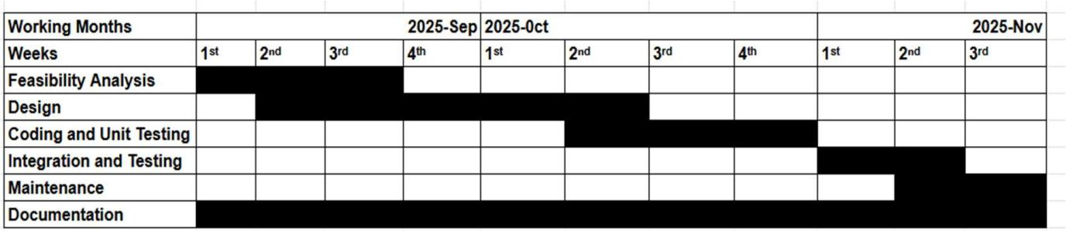
Table 1: Gantt chart

3.2 Object Modeling using Class and Object Diagram

3.2.1 Class Diagram
The class diagram is the building block of object-oriented modeling. It is used for general Conceptual modeling of the structure of the application. The class diagram below shows the structure of the style hub with the dependencies.
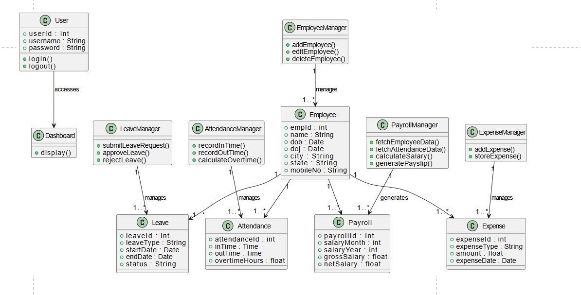
A Class Diagram represents the blueprint of the system. It defines the system's classes, their attributes, methods, and relationships. The main classes include user, product, category, cart and order. For example, the User class has attributes like UserID, Name, Email, password, role and phone with methods such as Register () and login (). The product class includes attributes like product id, name, quantity, price, description with methods to update () add (), and remove (). Relationships are defined as well, such as a User can search a product. While many product have a category .

Figure 3.2: Class Diagram KarmaPatro
The main purpose of class diagram for our project is to build a static view of a system. It is a blueprint of a system as it visualizes the particular working functionality of our system. The UML diagram of Style Hub only depicts the abstract view of diagram
The relationship between classes is justified below:
- Users & Cart (1-to-Many Aggregation)
A user can have multiple cart items, but each cart item belongs to a single user.
- Users & Orders (1-to-Many Aggregation)
A user can place multiple orders, but each order is linked to a single user.
- product & categories (Many-to-one)
Many product belongs to one categories.
- Products & Cart (1-to-Many Aggregation)
A product can be added to multiple carts, but each cart item represents a single product.
- Products & Orders (1-to-Many Association)
A product can be ordered multiple times, but an order contains one or more products.
- Cart & Orders (Many-to-One Association)
When a user places an order, their cart items are converted into an order.

3.2.2 ER Diagram
An ER diagram is a visual representation of the relationships between entities in a system. It is often used in database design to illustrate the structure of data and how data elements are related.
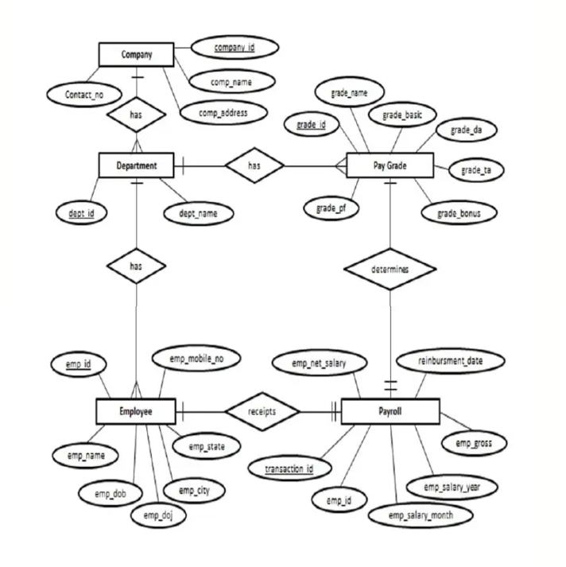
Figure 3.3: ER Diagram of KarmaPatro

3.2.3 Data Flow Diagram
A DFD is a graphical representation of the flow of data within a system. It illustrates how data is processed, stored, and transferred between different components of the system, making it a useful tool for analyzing and designing information systems.
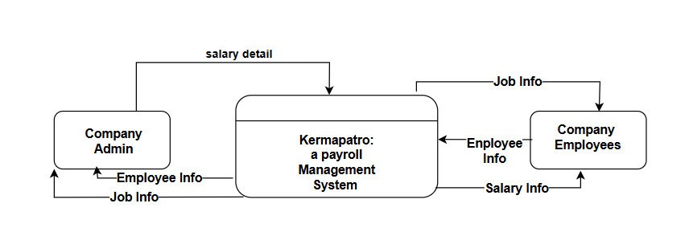
Context Diagram
Figure 3.4: Context Diagram of KarmaPatro
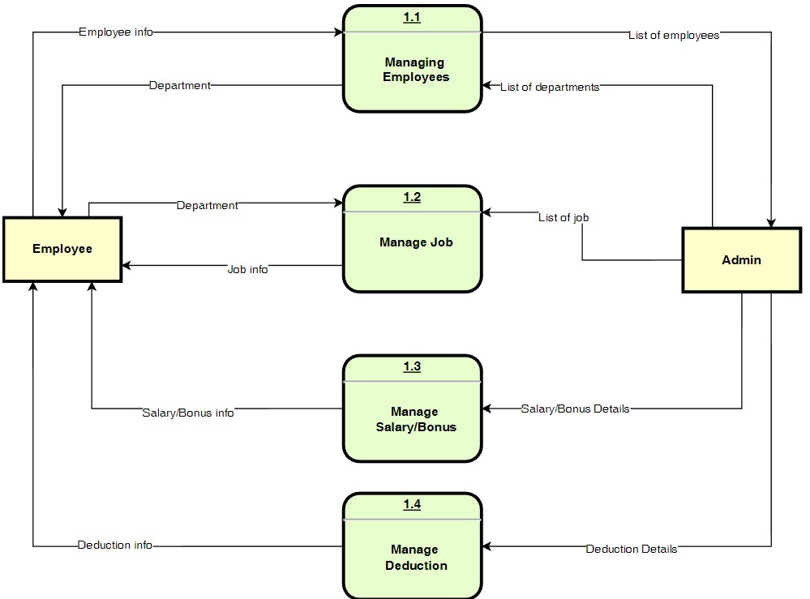
Level 0 DFD
Figure 3.5: level 0 DFD of Karma Patro

3.2.4 Sequence Diagram

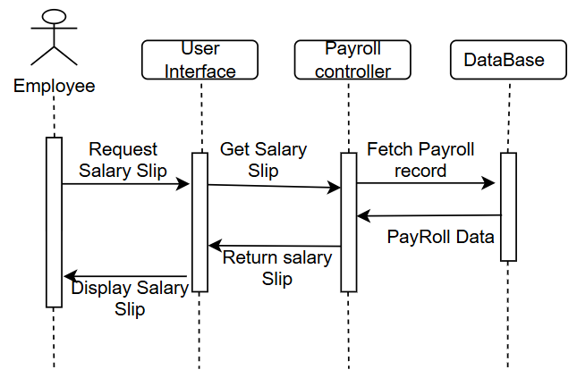
A sequence diagram is a dynamic model representing the time dependent aspects of the system. Here, this diagram simply depicts interaction between activities that takes place in system
Figure 3.6: Sequence Diagram of Employee Views Salary Slip
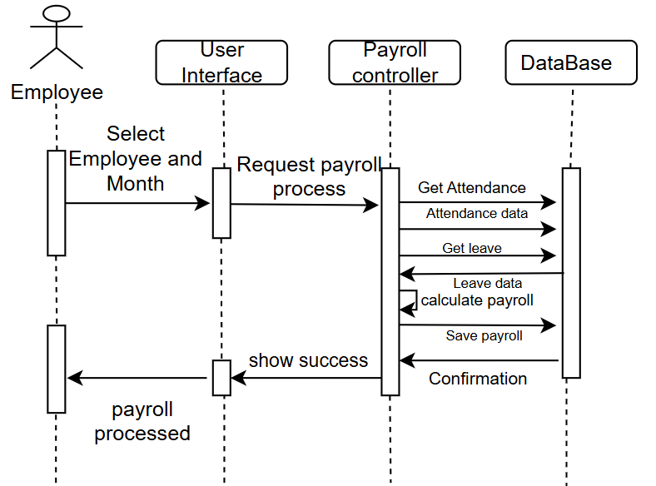
Figure 3.7: Sequence Diagram Admin Processes Payroll

3.2.5 Activity Diagram

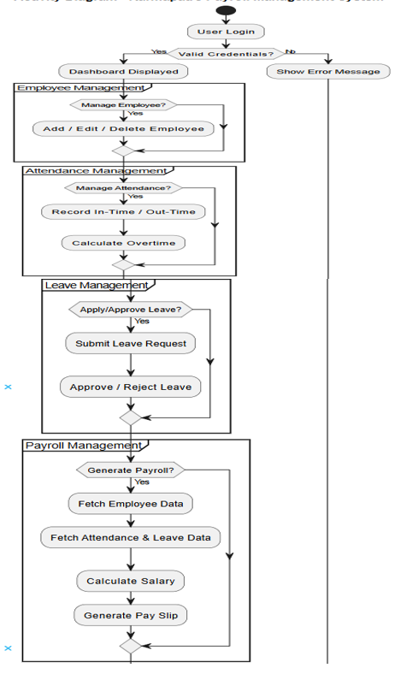
Activity diagram represents the flow of control among the activities of the system. In style Hub Management System, the activity diagram shows the user, admin and other activities.

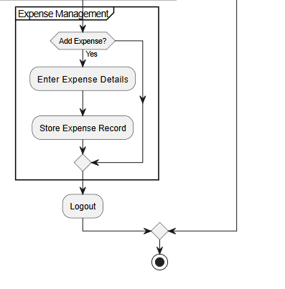
Figure 3.8: Activity Diagram of KarmaPatro

CHAPTER 4.

IMPLEMENTATION AND TESTING
4.1 Implementation
System Implementation is mainly concerned with the building of a properly working system. It was implemented using HTML, CSS and JavaScript as a front end, PHP was used as backend programming and MYSQL was used for the database and the text editor used was Visual Studio code and XAMPP was used as the offline local server. As planned in the designed phase, ITERATIVE WATERFALL model was used as the development methodology.

4.1.1 Tool Used
PHP
PHP is used as a programming language for this project. Back end of the system is designed with PHP. PHP version: 7.4
Html
In our system, Html is used for creating webpages. Version: HTML 5.
CSS
CSS is used for designing the HTML pages and to layout the HTML documents.
Bootstrap
We have used bootstrap as it is a compiled CSS and JavaScript source code.
JavaScript
JavaScript was also used during frontend development.
Visual Studio
Visual Studio was used as code editor.
MySQL
MySQL is an open-source relational database management system. It is used to store the information of admin as well as users.

4.2 TESTING, DEBUGGING AND RESULT

4.2.1 Testing
4.1 Testing This section will contain information about how testing will be conducted for application. Explanations will be given as to what testing actually is and why it should be done, along with the various ways to test a program. Testing, in software engineering, is defined as “the process of establishing confidence that a system does what it is intended to do.” The process here can refer to a number of methods that can be employed to carry out the actions of this stage in the software development life cycle. Although complete testing is not possible, it should be every project’s goal to produce and execute a test plan. Testing is the process of executing the program with the intention of finding out errors. During testing, the program to be tested is executed with a set of test cases and the output of the programs for the test case is evaluated to determine if the program is performing as it is expected to be. The success of testing in revealing errors in program depends critically on the test cases. In software system the use of testing is not limited to the testing phase. The results of testing are used later on during maintenance also. During testing a test suite can be used to see that modification doesn’t have any undesirable effect the basic levels of testing are: Unit testing, Integration testing System testing, Acceptance testing. These different levels of testing attempt to detect different types of faults. They are briefly explained as below (the testing we have used are briefly explained in conclusion):
i. Unit Testing The level of testing is called unit testing. In this, different modules are tested against the specifications produced during design for the modules. Unit testing is essential for verification of the code produced during the coding phase, and hence the goal is set to test the internal logic of the modules.
ii. Integration Testing The next level of testing is often called the integration testing. In this, many tested modules are combined into subsystems, which are then tested. The goal here is to see if the modules can be integrated properly, the emphasis being on testing interface between modules. This testing activity can be considered as testing design, and hence the emphasis on testing modules interactions.
iii. System Testing During system testing, the system is used experimentally to ensure that the software doesn’t fail, i.e., it will run according to its specifications and in the way users expect, special test data input for processing, and the results examined. A limited number of users may be allowed to use the system to see whether they try to use it in unforeseen ways.
iv. Acceptance Testing It is sometimes performed with realistic data of the client to demonstrate that the software is working properly. Testing here focuses on the external behavior of the system. The internal logic of the program is not emphasized. v. Validation Check During testing section validations checks are made. Appropriate actions are taken after testing.
4.2.2 Conclusion – Testing
We initially started testing of our system from unit testing. After each and every changes we made in the system, we checked whether it is performing as intended or not. Then we performed an integrated testing of a whole module to insure it functionality and acceptance. After each units and modules are tested separately, we used the system testing to check overall functionality of our system. From the testing that has taken place, it can be seen that the majority of features work as they are intended, without giving malicious users the opportunity to carry out well-known web application attacks as well as testing some scenarios where the user may or may not supply certain information. The testing that took place for this application does not however mean that there will not be any more testing needed, quite the contrary is true. Software testing is an art that requires the tester to get creative and find different ways around the application in order to conduct professional tests. Overall, we believe the system has been tested in terms of what is possible for the application to do in terms of functionality, using our limited creativity to come up with 16 scenarios that a user might face when using the system. It’s hard to test as the developer of the system because you are prone to being biased towards not finding errors, thus it would have been wise if we used the others personnel (i.e., lecturers who know about testing applications) available to me, as well as involve potential users to see if they come up with other scenarios for me to test.
4.2.3 Debugging
Any Software Application is needs to be error-free before going out in the market. Customer satisfaction is of utmost importance for any organization and only a bug-free product can keep your customer happy. Debugging is the process of fixing a bug in the software. It refers to identifying, analyzing and removing errors. This process begins after the software fails to execute properly and concludes by solving the problem and successfully testing the software. But, it is considered to be an extremely complex and tedious task because errors need to be resolved at all stages of debugging. Debugging can be done in two ways- Reactive debugging and print debugging. We performed print debugging so that we can write them to print out the values of the variables to the console or to the file to get a better sense of what is happening in the system. So, we performed the following processes while debugging our system: i. Identify the Error At first step, our debugging team member tried to identify the possible errors in Karmapatro on high priority basis. It is because bad identification of an error can lead to wasted developing time. It is usual that production errors reported by users are hard to interpret and sometimes the information we receive is misleading. It is important to identify the actual error. ii. Find the Error Location After identifying the error correctly, we focused to go through the code to find the exact spot where the error is located. In this stage, we need to focus on finding the error instead of understanding it.
iii. Analyze the Error In the third step, we used a bottom-up approach from the error location and analyze the code. This helps us in understanding the error. Analyzing a bug has two main goals; such as checking around the error for other errors to be found, and to make sure about the risks of entering any collateral damage in the fix. iv. Prove the Analysis Once we are done analyzing the original bug, we headed to find a few more errors that may appear on the system. This is about writing automated tests for these areas with the help of a test framework. v. Cover Lateral Damage In this stage, we had to create or gather all the unit tests for the code where we had made changes. After this, we run these unit tests, they all got pass. vi. Fix & Validate The final stage we performed at debugging is the fix of all the errors and run all the test scripts to check if they all pass.
4.3 Testing Results
The testing result shows what types of error we encountered in our testing phase? How we debugged them? And what are the changes we made at coding level after debugging to fix the errors. The following table shows the sample testing report that we performed in Karmapatro.
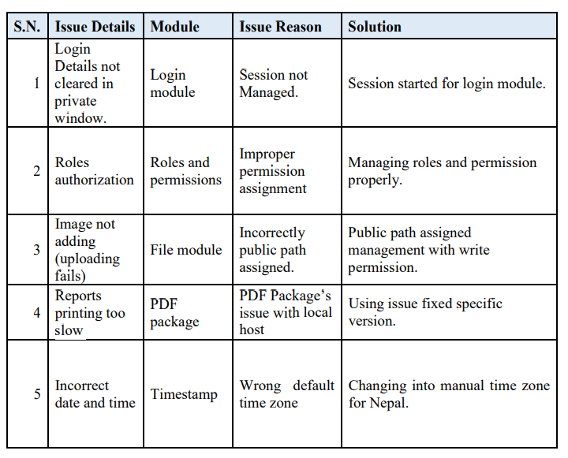
Table 2: Testing Results

CHAPTER 5

CONCLUSION AND FUTURE RECOMMENDATION
5.1 Conclusion
The purpose of this project was to make it easier for organizations by maintaining payroll of all the employees and departments of the organization. Based on the analysis we had done; it can be concluded that there are many unmanaged and improper payroll software available in the Nepalese organizations, they need a proper, user-friendly and better performing system that serve the organizations. So, the Karmapatro is all about proving the advanced payroll system that can be afford, use and maintain by all types of organization and employees.
5.2 Limitations
Similarly, there are some limitation of our system. They will be enhanced and integrated in near future: i) The user cannot interact with the other users and the admins. It means- we have not integrated internal chat system in this project. ii) Our system will only be applicable online. People and organization needs to have internet access to perform any kind of task in the system. iii) We do not have device synchronization system to maintain employees’ in/out records from smart attendance device.

5.3 Future Recommendation
There are a lot of features that can be implemented in the Karmapatro in near future. Some important features include: chat box for internal communication and resource exchange and sharing, synchronization with smart attendance devices, Offline functionality etc. Besides, the Karmapatro can be enhanced and upgraded as per technological and environmental changes and requirements.

Reference
[1] E. Hajiri, “Hamro-Hajiri: Web-based Time Attendance Software,” ehajiri, 2022. [Online].Available:http://www.ehajiri.com.np/
[2] Ezone, “E-Payroll Online Payroll Management Software Nepal,” ezone, 2022. [Online].Available:https://www.ezone.com.np
[3] Gadgetbyte, “ByzKit HR: A HR Management Tool for Nepali Businesses,” gadgetbyte,2022.[Online].Available:https://www.gadgetbyte.com
[4] Department of Health, “Computerized Payroll System,” www.doh.gov.ph. [Accessed:2022].
[5] Studymoose, “Attendance Monitoring using Biometric with Payroll System,” 2016. [Online]. Available: https://studymoose.com

Appendices

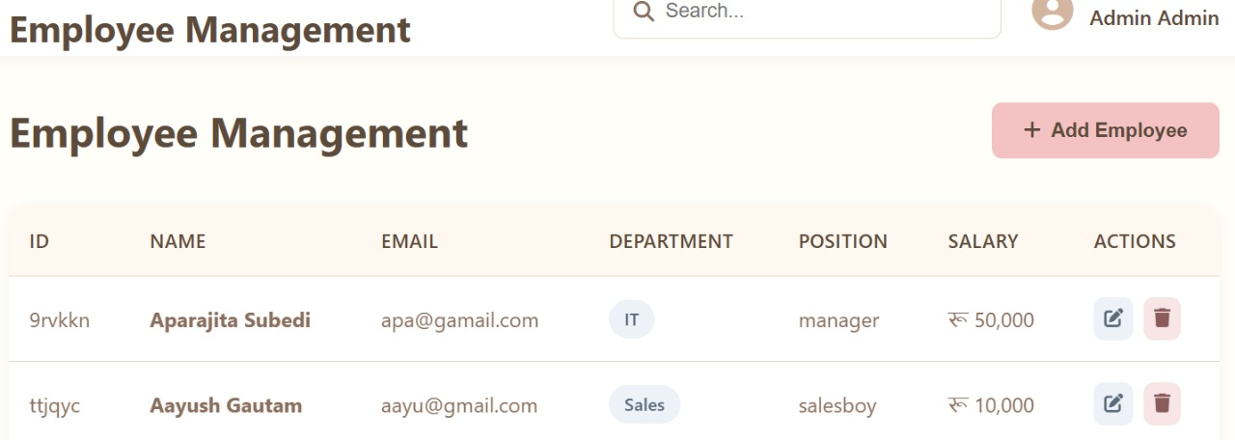
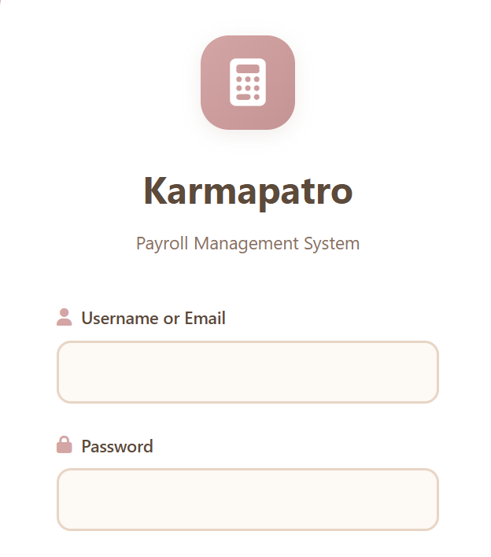
Appendices A: Snapshots
