Notes for 1 November

#### User Base

Who are the potential users of this application?

* + Students or junior doctors?
  + Experienced or senior doctors? (Login system and security; separate information?)
  + Teachers?
  + Those without medical expertise?

When and how would it be used?

* + Casual use as a glossary? (Priority: accessibility, convenience)
  + Training? (Priority: ease of use and navigation, comprehensive information)
  + Emergencies? (List of 'crisis' functions on app launch, with others in a 'More' tab)

As such, what would be the optimal methods of data presentation?

* + Articles? (status quo, improve layout)
  + Short directions with further information?
    - Cards / lists which can be expanded for details
  + Voice directions?

#### Status Quo

Issues with the current application: observations and possible solutions?

* + Data presentation (pdf and csv) not very readable etc.
    - Can be presented differently with downloadable files
  + Responsiveness issues; small glitches (e.g. About page on iOS)
    - Sliding down is unintuitive; 'X' button to close modal

What new features, etc. could be added?

* + Gesture support with documentation? e.g. slide to swap tabs
  + Addition of functions

#### Current Storyboard (annotation purposes)

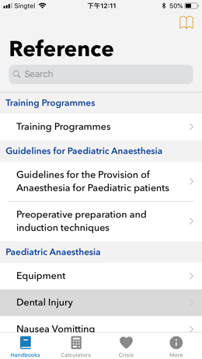

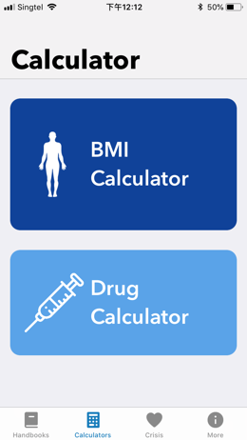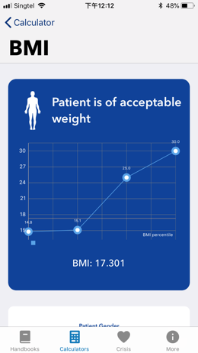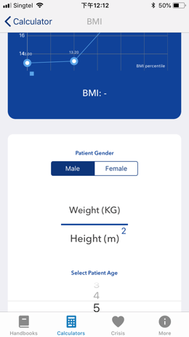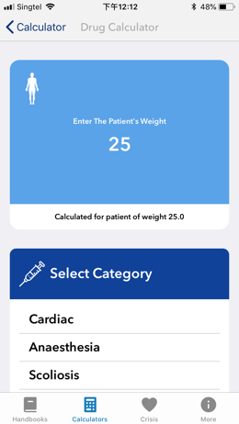

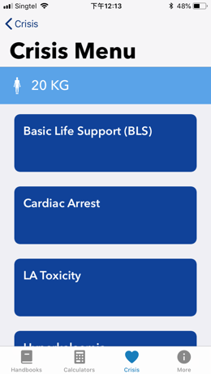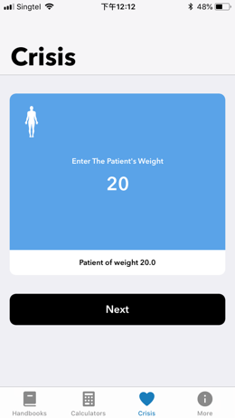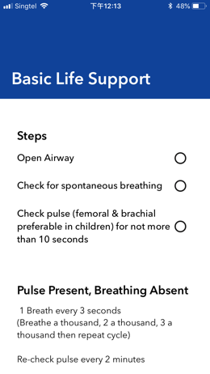

Consolidation of Meeting Content

#### Purpose

The potential users are all who work in the medical field; doctors, students and nurses alike. The content should be accessible and understandable to non-professionals but detailed with sufficient content and elaboration for experts.

The application serves as a glossary in the event of a crisis or emergency, but may also be used for training purposes. Speed of access is key.

#### Design

There will be two sections: a paediatric section and an adult section. The former will require entering a weight in order to calculate dosages. These will contain tabs to the relevant information (article). The article pages will contain a sidebar menu linking to the different sections (automatic scrolling), which show as collapsible cards. Some features (such as drug timers etc.) will be onscreen as circles, which can be expanded with a tap.

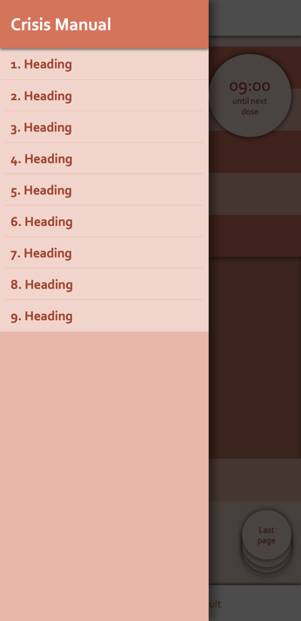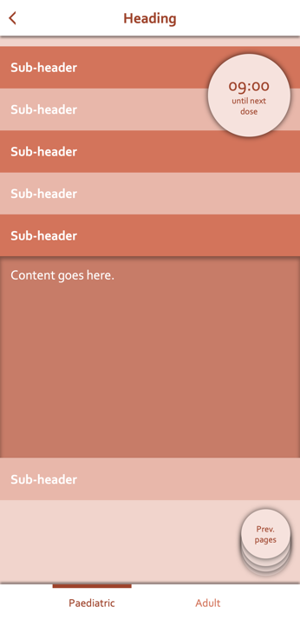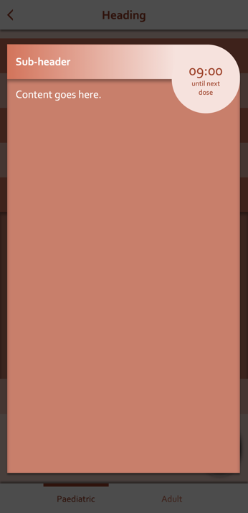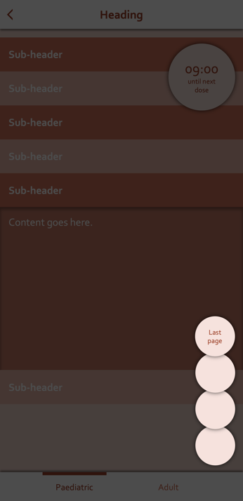

Some reflections of ideas

Horizontal swipes would toggle between paediatric and adult sections.

#### Use-Cases

Use Case: Accessing Resources

Actors: User, system

Triggers: The user launches the application.

Preconditions: A valid patient weight is specified. (Default 60kg)

Normal flow:

* 1. The user will indicate a chapter to navigate to.
  2. The system will present the previously specified patient weight.
  3. The user will verify the patient weight.
  4. The system will present the available topics of the chapter.
  5. The user will indicate a topic.
  6. The system will update the exact value of drug doses which are dependent on patient weight.
  7. The system will retrieve and present additional detailed information on the topic.

Alternate flows:

3A. The user desires to change the patient weight.

1. The user indicates for patient weight to be changed.
2. The user indicates the new patient weight.
3. The system verifies and stores the patient weight.
4. The use case continues.

Use Case: Drug Timer

Actors: User, system

Triggers: The user indicates that they want to begin timing.

Normal flow:

1. The user will indicate for timing to begin.
2. The system will begin and present a running timer.

Administration (when the user administers a given drug):

1. The user will indicate the nature of the event.
2. The system will record the time and nature of the event.
3. The system will indicate the nature of the event and how long ago it was.

Viewing logs (when the user indicates that they want to view the records):

1. The user will indicate that they want to view the records.
2. The system will display the event records from the beginning of timing.

End of crisis (when the user indicates for timing to stop):

1. The user will indicate for timing to end.
2. The system will end the running timer and indicate the total duration of the timer.
3. The system will present the event records to be viewed or exported.
4. The user will view the event records and/or save them to an external file.
5. The user will exit the system.

Use Case: Updating Information

Actors: System, server

Triggers: The system is connected to a wireless network and can access the server.

Preconditions: The server contains updated information not yet reflected in the system.

Normal flow:

1. The system requests the updated version number from the server.
2. The server returns the version number to the system.
3. The system compares the version number with the current version and verifies that the current version is outdated.
4. The system requests the updated manual from the server.
5. The server returns the manual to the system.
6. The system verifies the authenticity of the manual.
7. The system updates the current manual with the new manual, and changes the version number.
8. The use case ends.

Alternate flows:

3A. The current manual version is not outdated. The use case ends.

6A. The authenticity of the manual is not verified. The use case returns to step 4.