Skip to Main Content

REGIS MHC​
Manufactured home community
106 NW US HIGHWAY 24
TOPEKA, KS 66608
Phone/text: (785) 496-4322
Email: info (A) regismhc.com
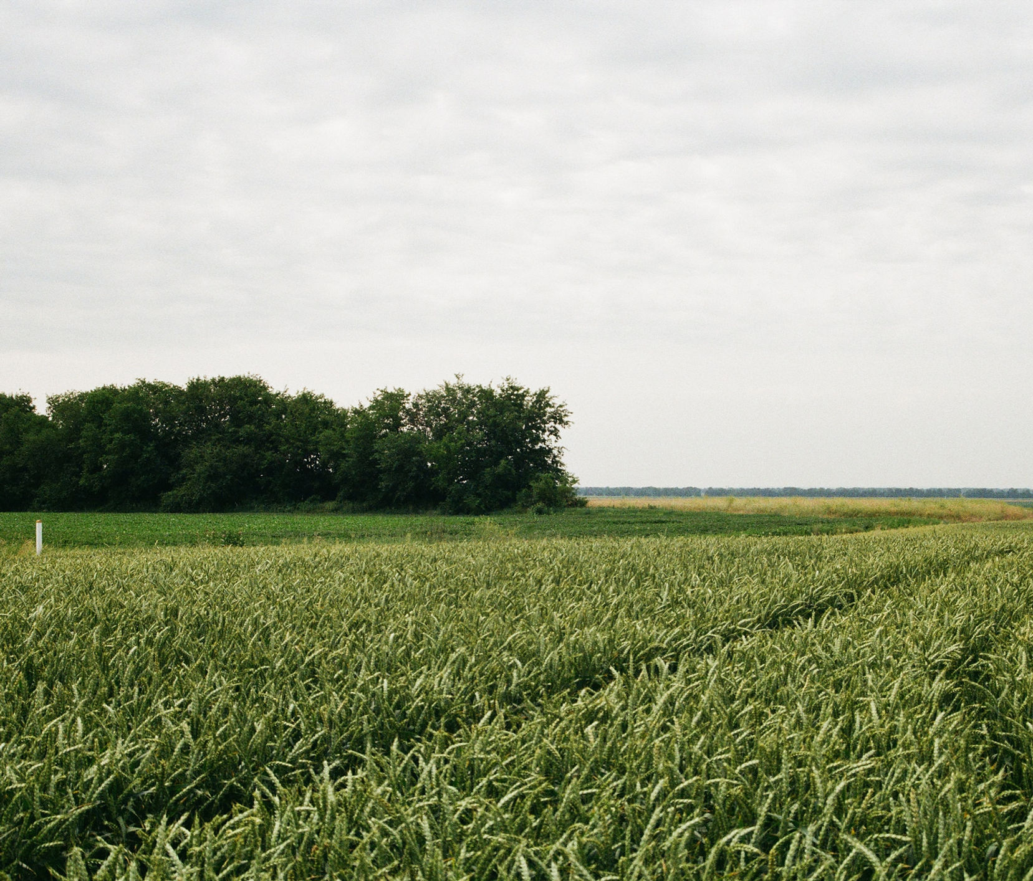
Moving forward ​​
We work with national lenders like 21st Mortgage (NMLS #2280) that offer programs for various credit profiles, including low down payment options for qualified buyers.
​
1. Estimate your potential monthly payments
Please note: Calculator estimates do not include lot rent, taxes, or insurance. All financing is subject to lender approval.​
​​​​
2. Home application
​​
3. Financing application
​​​
Tell Us about yourself
Safe, secure, and no impact on your credit score to start.

First name*
Last name*
Email*
Phone*
Monthly income before taxes*
Credit score range *
Employer
See If You Qualify

Discover Your New Home
Own a brand-new 3-bed, 2-bath home for less than many renters expect. Get the space that apartments do not offer: your own home, your own yard, and a pet-friendly community with outdoor green space for walking and play. Close to restaurants, shopping, banks, and everyday essentials, with the comfort of a home that is all your own.
​
If financed through a third-party lender like 21st Mortgage (NMLS #2280), a monthly loan payment is made instead of paying the full price upfront.
For many buyers, monthly payments may be similar to — or less than — renting a comparable apartment. But there is one critical difference: when you are ready to move, you can sell this home and recover value you have built.
​​
Home
​​
• 3 bedrooms, 2 full bathrooms
• Approximately 869 square feet
• 66' x 14' single-wide
• $49,999​​​
This home includes upgraded structural materials and enhanced insulation for improved durability, comfort, and energy efficiency year-round.
​
Monthly Costs & Requirements:
Lot Rent: $550/month (separate from home purchase).
Lease: Month-to-month lot lease.
Approval: Residency is subject to community application and approval.
Utilities: Homeowner is responsible for all utilities (electric, sewer, water, etc.).​
Close to: McDonald’s, Burger King, Goodcents, Capitol Federal Savings Bank, CoreFirst Bank & Trust, Kaw Valley Bank, Walgreens, Dollar General, Dollar Tree, Ace Hardware, and United States Postal Service, with Starbucks and Walmart a short drive away
​
​​​Equal Housing Opportunity
This community complies with the Federal Fair Housing Act. All qualified applicants are welcome.
​
​​

First name*
Last name*
Email*
Phone*
Monthly income before taxes*
Credit score range *
Employer
See If You Qualify

