DailyMealBox

PRODUCT REQUIREMENTS DOCUMENT
MASTER AMENDMENT DOCUMENT
Amendment 1

Document | Master Amendment
Date | 02 June 2026
Amends | Part 1 (Customer App) · Part 2 (Vendor App) · Part 3 (Driver App) · Part 4 (Admin Panel + Fleet Portal) · Admin Controls Matrix
Amendment v1 | 18 missing items identified after gap audit: card payment failure, cookie consent, legal pages, GDPR deletion, rating system, multi-language notifications, collection PIN spec, delivery PIN spec, credit notes, and more
Amendment v1 | Organic Pantry Box: 5th shift model, Shop Partner vendor type, ACM-123–130, 8 new notifications, 9 updated screens, MongoDB schemas, full API specification
New Screens | 9 updated/new mockups: CA-08, CA-09, CA-12, VM-03, VM-04, DA-03, DA-04, AP-03, AP-05
Total items | 26 total amendments (18 + 8 pantry items). All P0 items must be in Appzeto scope.
Status | FINAL — supersedes all previous amendment documents

HOW TO USE: HOW TO USE THIS DOCUMENT: Each section corresponds to one PRD part. Find the section for the relevant part (e.g. "Part 1 — Customer App"), read each numbered item, and add it to that part's FINAL document. Items are numbered sequentially ( items: #1–#18, v3/Pantry items: #PB-1 onwards). Every item includes: the screen it affects, priority, what to tell Appzeto, and updated mockup where applicable.

Master Index — All 26 Amendments

# | Title | Affects | Priority | Add to Part
1 | Card Payment Failure Retry Flow | CA-07, CA-15, AP-01 | P0 | Part 1 + Part 4
2 | Cookie Consent Banner (Web) | CA-01 Web | P0-LAW | Part 1
3 | Privacy Policy + ToS + Terms of Sale | CA-07, CA-15 | P0-LAW | Part 1
4 | Cancellation — End of Paid Period Policy | CA-15 | P0 | Part 1
5 | Multi-Language Push Notifications | All apps | P0 | Parts 1, 2, 3
6 | Rejection Reason Shown to Vendor | VM-02 | P1 | Part 2
7 | Customer Special Instructions on Order Card | VM-04 | P0 | Part 2
8 | Advance / Extra Order Indicator Badge | VM-04 | P1 | Part 2
9 | Collection PIN — Complete Specification | DA-05 | P0 | Part 3
10 | Delivery PIN + Photo Proof — Complete Spec | DA-06 | P0 | Part 3
11 | Driver Language Preference | DA-12 | P0 | Part 3
12 | Credit Note for Refunded B2B Invoices | AP-04, AP-07 | P0-LAW | Part 4
13 | Payment Failure Alert in Admin Dashboard | AP-01 | P0 | Part 4
14 | Dynamic Document Types — Fleet Manager | AP-06 | P1 | Part 4
15 | Driver Invitation Flow via Email | FP-01 | P0 | Part 4
16 | Fleet Partner Staff Accounts | FP-05 | P1 | Part 4
17 | GDPR Deletion Execution Flow | CA-15, AP-04 | P0-LAW | Parts 1 + 4
18 | Rating System Rules and Thresholds | CA-14, AP-05/06 | P1 | Parts 1 + 4
PB-1 | Organic Pantry Box — 5-Shift Day Model | All apps | P0 | All Parts
PB-2 | Shop Partner — 5th Vendor Type | VM-02, AP-05 | P0 | Parts 2 + 4
PB-3 | Pantry Tab in Customer App (CA-09) | CA-08, CA-09, CA-12 | P0 | Part 1
PB-4 | Shop Partner Dashboard (VM-03 variant) | VM-03, VM-04 | P0 | Part 2
PB-5 | Pantry Gap Shifts for Drivers (DA-03, DA-04) | DA-03, DA-04 | P0 | Part 3
PB-6 | Admin Shop Partner Management (AP-05) | AP-05, AP-06, AP-07 | P0 | Part 4
PB-7 | ACM-123 to ACM-130 (8 new OTA controls) | AP-03, ACM | P0 | Part 4 + ACM
PB-8 | Pantry Box — MongoDB Schemas + API | Backend | P0 | Technical Spec

PART 1 — Customer App — Part 1
8 additions in this section

#1 Card Payment Failure Retry Flow [P0] — Amendment v1
#2 Cookie Consent Banner (Web) [P0-LAW] — Amendment v1
#3 Privacy Policy + ToS + Terms of Sale [P0-LAW] — Amendment v1
#4 Cancellation — End of Paid Period Policy [P0] — Amendment v1
#5 Multi-Language Push Notifications [P0] — Amendment v1
#17 GDPR Deletion Execution Flow [P0-LAW] — Amendment v1
#18 Rating System Rules and Thresholds [P1] — Amendment v1
#PB-3 Organic Pantry Box — Customer App (CA-08, CA-09, CA-12) [NEW] — Amendment v1

#1 — Card Payment Failure Retry Flow
Screen: CA-07 Checkout + CA-15 Profile + AP-01 Admin Priority: P0 Source: Amendment v1
MISSING: Not documented anywhere. Subscription card failures happen every day. Without this logic the system has no defined behaviour when Przelewy24 returns a payment failure.
Aspect | Detail | What Appzeto Builds
Retry 1 (24h) | Silent retry 24 hours after first failure. No notification yet. | Przelewy24 retry API. Log attempt in payment_attempts collection. No FCM.
Retry 2 (48h) | FCM + email: "Your payment failed. Update your card to keep your subscription." Link to CA-15 payment methods. | FCM push + transactional email. Deep link to Payment Methods in CA-15.
Retry 3 (72h) | FCM + email: "Final attempt failed. Subscription paused." CS alerted in AP-01. | subscription.status → paused_payment_failure. New alert type in AP-01 dashboard.
Customer fixes card | Customer updates card in CA-15 → system retries immediately → on success: subscription resumes → FCM "Subscription resumed." | On card update: trigger immediate payment attempt. On success: status → active.
Grace period | Subscription continues delivering during 3-day retry window. Pause only after 3rd failure. | Vendor and driver unaffected during retry window.

#2 — Cookie Consent Banner — Web Version Only
Screen: CA-01 Welcome (Web) Priority: P0-LAW Source: Amendment v1
EU LAW: Required by EU ePrivacy Directive. Without this DailyMealBox cannot legally use analytics on the web version. iOS/Android apps do NOT need cookie banners — only the web app.
Aspect | Detail | What Appzeto Builds
When shown | First visit to dailymealbox.com only. Not shown on repeat visits if preference saved. Not in iOS/Android apps. | Detect first visit via localStorage flag. Show banner before non-essential scripts load.
3 options | Accept All / Reject Non-Essential / Manage Preferences (opens modal per category). | Cookie categories: Essential (always on), Analytics (optional), Marketing (optional). Default: Analytics + Marketing OFF.
Storage | Preference stored 12 months in localStorage. Links to Privacy Policy. | JSON: {essential:true, analytics:false, marketing:false, timestamp, expiry}

#3 — Legal Pages — Privacy Policy + ToS + Terms of Sale
Screen: CA-07 footer + CA-15 Profile Priority: P0-LAW Source: Amendment v1
Aspect | Detail | What Appzeto Builds
Privacy Policy | GDPR Articles 13+14. Data collected, retention, user rights, DPO contact. Web view inside app. | Link in CA-15 Profile → Legal section. Link in CA-07 checkout footer. Web Manager edits in AP-13.
Terms of Service | Platform terms, account rules, suspension conditions. | Same placement as Privacy Policy. URL: dailymealbox.com/terms
Terms of Sale | EU Consumer Directive 2011/83. Cancellation rights, refund policy, subscription renewal terms. MUST be accepted at CA-07 first subscription — checkbox, not pre-ticked. | Checkbox at CA-07: unchecked by default. Subscribe button disabled until checked. Log acceptance timestamp + version.

#4 — Cancellation — Subscription Continues to End of Paid Period
Screen: CA-15 Profile Priority: P0 Source: Amendment v1
Aspect | Detail | What Appzeto Builds
Policy | Customer cancels → subscription continues until end of current paid period. No pro-rata refund. No new charge after. | cancel_at_period_end = true. Deliveries continue until last day. Status: "Cancelling."
Customer sees | Confirmation screen: "Your subscription ends on [date]. You will receive [X] more deliveries." Green "Got it" button. | Show exact end date and remaining delivery count on cancellation confirmation.
Status display | CA-15 shows amber "Cancelling — last delivery [date]." CA-12 Calendar shows days after end date as locked. | Badge: amber "Cancelling." Calendar: days beyond end date show locked state.
Resubscription | Button: "Keep my subscription" shown in CA-15 while status is Cancelling. One tap to reverse. | cancel_at_period_end → false. No payment taken until next billing cycle.

#5 — Multi-Language Push Notifications
Screen: All notification types (Customer, Vendor, Driver) Priority: P0 Source: Amendment v1
Aspect | Detail | What Appzeto Builds
How it works | Before sending FCM: look up user.language_preference → select notification text from i18n language file. English fallback if translation missing. | Backend: const notifText = i18n[user.language][notification_key] || i18n.en[notification_key]
Keys format | Notification texts stored in same JSON files as app UI. Key format: notifications.arriving_soon, notifications.delivered, notifications.payout_processed. | Add notification text keys to en.json, pl.json, de.json, fr.json translation files managed via AP-13.
Critical for launch | Polish notifications must be validated before Warsaw launch. German before Berlin. Never send English-only push to German users. | Validate all notification keys present in pl.json before Warsaw go-live.

#17 — GDPR Deletion Execution Flow
Screen: CA-15 Profile (customer) + AP-04 Admin (CS) Priority: P0-LAW Source: Amendment v1
Aspect | Detail | What Appzeto Builds
Customer taps Delete | CA-15 → Delete My Account → 2-tap confirmation → request submitted. Warning shown: "PII deleted within 30 days. Financial records kept per EU tax law." | POST /api/gdpr/deletion-request. Creates GDPR_DELETION task in AP-04 inbox. 30-day countdown starts.
CS task in AP-04 | New task type in AP-04: GDPR_DELETION — red badge, 30-day counter. CS executes checklist: delete PII, anonymise orders, retain invoices, send confirmation email. | System API: DELETE /api/admin/gdpr/{user_id}/execute. Handles all field nullification automatically.
What gets deleted | Name, email, phone, addresses, payment methods, device tokens, loyalty points, profile photo. | Hard delete all PII fields from users collection.
What gets kept | Order records (anonymised: customer_id → ANON_8821). Invoice PDFs (7-year EU tax law). Ratings (anonymised). | order.customer_id → ANON_{random_8_digits}. Invoice PDF: name field → "Anonymous Customer."
Auto-escalation | If CS does not complete within 25 days: auto-escalate to Super Admin. System enforces 30-day EU deadline. | CRON daily: check GDPR requests > 25 days old. Alert Super Admin if not completed.

#18 — Rating System Rules and Thresholds
Screen: CA-14 (post-delivery) + AP-05/06 Admin Priority: P1 Source: Amendment v1
Aspect | Detail | What Appzeto Builds
Rating window | Customer can rate within 24h of confirmed delivery. After 24h: rating option disappears. | Timestamp check: now > delivered_at + 24h → hide rating prompt.
Edit once | Customer can edit their rating once within 24h of first submission. | Store original_rating and current_rating. Edit button visible 24h after submission.
Driver threshold | Driver avg < 3.5 over 20+ deliveries → City Manager alerted in AP-06. | CRON daily: check all drivers. If avg_rating < 3.5 AND delivery_count >= 20: alert.
Vendor threshold | Vendor avg < 3.8 over 50+ orders → City Manager alerted in AP-05. | Same CRON. If vendor avg_rating < 3.8 AND order_count >= 50: flag vendor profile.

#PB-3 — Organic Pantry Box — Customer App
Screen: CA-08 Home + CA-09 Plans + CA-12 Calendar Priority: NEW Source: Amendment v1
PANTRY — NEW FEATURE: The Organic Pantry Box adds a second delivery stream to the customer app. Same drivers, same zones, gap hours only. Teal colour scheme distinguishes pantry from meal content throughout the app.
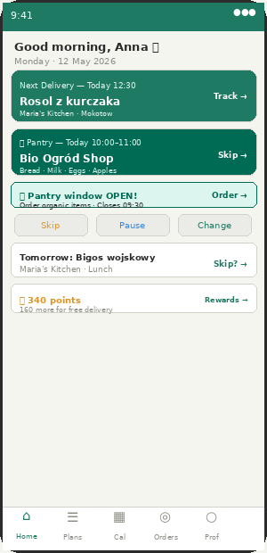  CA-08 — Home with Pantry card (teal) | 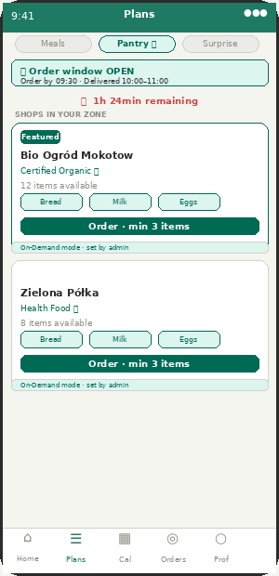  CA-09 — Plans with Pantry 🌿 tab

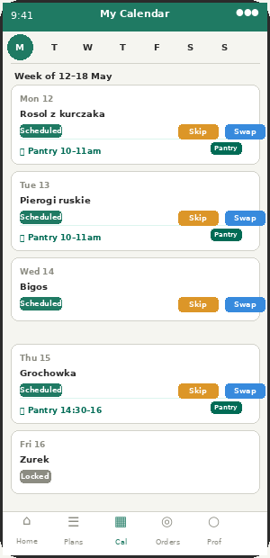
CA-12 — Calendar with teal pantry dots
Aspect | Detail | What Appzeto Builds
CA-08 Home — Pantry card | Second delivery card below meal card. Teal colour. "🌿 Pantry — Today 10:00–11:00." Shows shop name and items. Skip button same as meal. | Only shown if customer has active pantry subscription. card.type: pantry_subscription.
CA-08 Home — Window open banner | When order window is open (07:30–09:30 or 11:30–13:30): teal banner "🌿 Pantry window OPEN! Order closes at 09:30 →." | Banner appears only during order window. Deep links to CA-09 Pantry tab.
CA-09 Plans — Pantry tab | 3rd tab in Plans: "Pantry 🌿". When window open: shows approved shops in zone with item list. When closed: shows countdown to next window. | GET /api/pantry/shops?zone_id={id} returns [] outside window. Returns shop list inside window.
CA-09 — Shop card | Shop name + Organic certified badge + item count + 3 item preview chips + Order button (min 3 items) + mode indicator (On-Demand or Subscription). | Different card style from food vendors. Teal accent. order_mode shown as read-only badge.
CA-12 Calendar — Pantry days | Pantry subscription days shown as teal leaf dots on calendar. Tap day: shows pantry items for that delivery. Skip logic same as meals. Cutoff lock at 09:30 for Gap 1. | calendar day.has_pantry: boolean. If true: show teal dot. Tap: show pantry_order.items.
Order window push notifications | Push at 07:30: "🌿 Pantry window open! Order organic staples." Push at 09:00: "Last chance — closes in 30 min." | FCM sends at window open time per city. Only to customers in zones where shop partners are active.

PART 2 — Vendor App — Part 2
5 additions in this section

#5 Multi-Language Push Notifications (Vendor) [P0] — Amendment v1
#6 Rejection Reason Shown to Vendor on Application [P1] — Amendment v1
#7 Customer Special Instructions on Order Card [P0] — Amendment v1
#8 Advance / Extra Order Indicator Badge [P1] — Amendment v1
#PB-4 Shop Partner — New Vendor Type + Dashboard [NEW] — Amendment v1

#5 — Multi-Language Push Notifications — Vendor App
Screen: All VM notifications Priority: P0 Source: Amendment v1
Aspect | Detail | What Appzeto Builds
Language source | Vendor language set in VM-12 Profile. Defaults to city language (Warsaw=Polish, Berlin=German). | Backend FCM send: look up vendor.language_preference → select text from language file.
Critical notifications | "Driver assigned for pickup" and "Payout processed" and "Food licence expiring" MUST be in vendor language. These drive action. | Validate all 19 vendor notification keys in pl.json before Warsaw launch.

#6 — Rejection Reason Shown to Vendor
Screen: VM-02 Registration Priority: P1 Source: Amendment v1
Aspect | Detail | What Appzeto Builds
Admin side | Rejection reason is mandatory field in AP-05 Reject modal. Min 20 chars. Cannot reject without reason. | AP-05: rejection_reason required field. Stored on vendor application record.
Vendor side | FCM + email: "Application not approved. Reason: [reason]. Tap to resubmit." Pre-filled form with highlighted problem field. | VM-02 shows previous data pre-filled. Amber highlight on flagged field. New application created on resubmit.

#7 — Customer Special Instructions on Vendor Order Card
Screen: VM-04 Orders Priority: P0 Source: Amendment v1
FOOD SAFETY: Food safety issue. Customer allergen notes must reach vendor prominently. Currently VM-04 shows no special instructions.
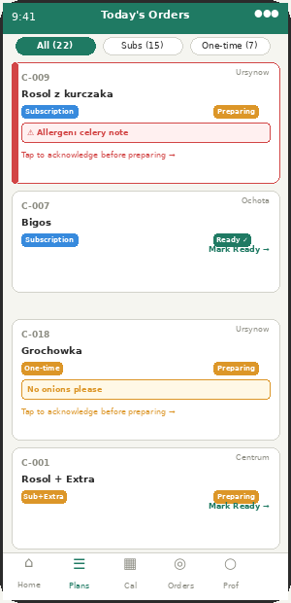  VM-04 — Order card with allergen note (red border) | 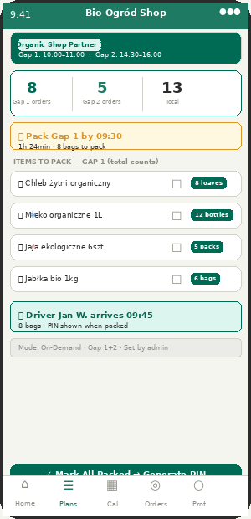  VM-03 — Shop Partner dashboard variant

Aspect | Detail | What Appzeto Builds
Display | Red "⚠ Note" badge on order card if note contains allergen keywords. Amber badge for other notes. Vendor taps to see full note. | Badge colour: RED if allergen keywords detected. AMBER for all other notes.
Acknowledge required | Vendor must tap "Acknowledged ✓" before order status can change to Preparing. Button disabled until acknowledged. | VM-05 Prep Board: if order has unacknowledged special_instructions → Preparing button disabled.
Audit trail | Acknowledgement logged: vendor_id + timestamp. CS can see in AP-04 if complaint filed. | order.special_instructions_acknowledged_at + acknowledged_by_vendor_id stored.

#8 — Advance / Extra Order Indicator
Screen: VM-04 Orders Priority: P1 Source: Amendment v1
Aspect | Detail | What Appzeto Builds
Badge | Order card shows amber "+Extra" badge when customer ordered add-on beyond subscription. | order.has_addon: boolean. Badge shows addon item name and quantity below meal name.
Driver manifest | DA-04 load manifest includes both subscription box AND extra item for same customer. | order.items: [{type:"subscription",...},{type:"addon",...}]. Both items in driver manifest.

#PB-4 — Shop Partner — New Vendor Type + Dashboard
Screen: VM-02, VM-03, VM-04, VM-06 Priority: NEW Source: Amendment v1
NEW VENDOR TYPE: Shop Partner is the 5th vendor type (alongside Home Cook, Cloud Kitchen, Restaurant, Catering). Different registration, different dashboard, different order flow. Operates ONLY during Pantry Gap shifts 1 and 2.
Aspect | Detail | What Appzeto Builds
Registration (VM-02) | Vendor type "Shop Partner" shows different form: organic certification upload instead of EU food licence. Trade licence required. Item submission for admin approval. | vendor_type: shop_partner. document_type: organic_certification (not food_licence). Max 20 items submitted for admin approval.
Dashboard (VM-03 variant) | Shop Partner home: Today orders split by Gap 1/Gap 2. Pack deadline countdown. Items to pack (total counts). Driver ETA. Mark All Packed → generates collection PIN. | VM-03 detects vendor_type === shop_partner → shows shop variant. No prep board, no menu calendar.
Orders (VM-04 variant) | Per gap shift: list of customer orders. Each: customer alias + zone + item list. Status: Packing → Packed (2 steps, not 3). One PIN per gap batch. | pantry_batch.status: packing | packed. One collection PIN per gap shift (not per order).
Items (VM-06 variant) | My Items list instead of weekly menu. Admin-approved items only. Mark item unavailable today if out of stock. | item.available_today: boolean. Resets each midnight. Shop can mark false if stock runs out.
NO cutoff settings | Shop Partners cannot set their own cutoff. Admin sets gap shift windows platform-wide. VM-14 Cutoff Settings hidden for shop_partner type. | Cutoff for shop_partner: always system-set gap shift cutoff (09:30 for Gap 1, 13:30 for Gap 2).
Commission | 15% (not 20%). Delivery fee: 4 PLN flat (not per-km formula). | vendor.commission_rate: 0.15 default for shop_partner. delivery_fee: 4.00 PLN flat stored on order.

PART 3 — Driver App — Part 3
5 additions in this section

#5 Multi-Language Push Notifications (Driver) [P0] — Amendment v1
#9 Collection PIN — Complete Specification [P0] — Amendment v1
#10 Delivery PIN + Photo Proof — Complete Spec [P0] — Amendment v1
#11 Driver Language Preference [P0] — Amendment v1
#PB-5 Pantry Gap Shifts for Drivers [NEW] — Amendment v1

#5 — Multi-Language Push Notifications — Driver App
Screen: All DA notifications Priority: P0 Source: Amendment v1
Aspect | Detail | What Appzeto Builds
Language source | Driver language preference set in DA-12 Profile. Defaults to city language. | Backend FCM: look up driver.language_preference → select text from language file.
Critical | Vendor ready + PIN push MUST be in driver language. Driver misses Polish push = missed pickup = failed deliveries. | Validate all 15 driver notification keys in pl.json before Warsaw launch.

#9 — Collection PIN — Complete Technical Specification
Screen: DA-05 Vendor Pickup Priority: P0 Source: Amendment v1
P0 CRITICAL
Aspect | Detail | What Appzeto Builds
PIN generation | 4-digit numeric PIN generated when vendor marks "All Ready." One PIN per batch. Redis key: "collection_pin:{batch_id}" with 2-hour expiry (EX:7200). Single-use. | redis.set("collection_pin:"+batch_id, pin, "EX", 7200). Random 4-digit: Math.floor(1000+Math.random()*9000).
Vendor shows PIN | VM-05 prep board and VM-10 delivery screen: "Batch A PIN: 7842 — Show to driver." Large font, centre of screen. | PIN shown prominently. No copy button — driver reads visually.
Driver enters PIN | DA-05: 4 input boxes. Numeric keypad auto-opens. Driver reads from vendor screen and types. | 4 individual digit boxes. Auto-advance after each digit. Submit triggers on 4th digit.
Validation | POST /api/collection/verify {batch_id, pin_entered, driver_id, gps}. Compare vs Redis. Correct: delete PIN, mark orders collected, FCM to vendor, proceed. | If correct: redis.del("collection_pin:"+batch_id). Update all orders in batch → status: collected.
Wrong PIN (3 attempts) | After 3 wrong: lock input, alert admin + vendor, vendor can generate new PIN from VM-05. | redis.incr("pin_attempts:"+batch_id). If attempts >= 3: return error, notify admin and vendor.
Expiry | If 2h expires before driver arrives: vendor generates new PIN. Old PIN invalid automatically. | On PIN entry: check Redis key exists. If not: return error("PIN expired — ask vendor for new PIN").

#10 — Delivery PIN + Photo Proof — Complete Specification
Screen: DA-06 Customer Delivery Priority: P0 Source: Amendment v1
P0 CRITICAL
Aspect | Detail | What Appzeto Builds
Method selection | Check ACM-25: if locked → use platform default. If not locked → use customer.proof_preference. Options: PIN / Photo / Customer choice. | remoteConfig.get("delivery_proof_locked") → if true: use platform default.
PIN — generation | 4-digit PIN generated when order status → "Out for Delivery." Sent via FCM + SMS. Redis: "delivery_pin:{order_id}" with 4-hour expiry. | redis.set("delivery_pin:"+order_id, pin, "EX", 14400). FCM + SMS: "PIN: 7234."
PIN — driver enters | DA-06: "Ask customer for their PIN." 4 input boxes. Customer reads their PIN to driver. | Same 4-box component as collection PIN. Single attempt (customer is present — no 3-attempt limit).
Photo — capture | DA-06: Camera button. Driver taps → native camera → photo of box at door → upload. | React Native ImagePicker. POST /api/delivery/verify-photo (multipart). Upload to Firebase Storage.
Confirm Delivered button | Large green button. DISABLED until proof captured (PIN entered OR photo taken). | Button enabled state: proof_captured = true. Set after PIN success or photo upload success.
GPS fraud check | If delivery GPS > 500m from customer address: flag for admin review. Does NOT block delivery. | After confirmDelivery: if haversineDistance > 500m: insert into fraud_flags collection.

#11 — Driver Language Preference
Screen: DA-12 Driver Profile Priority: P0 Source: Amendment v1
Aspect | Detail | What Appzeto Builds
Setting | DA-12 Profile → Language → dropdown shows languages active in driver's city. Defaults to city language. | On driver approval: set driver.language_preference = city.default_language.
What changes | All app UI text, error messages, DA-10 quick message templates, push notification text. | On language change: app reloads i18n context. DB updated: driver.language_preference.

#PB-5 — Organic Pantry Box — Driver App
Screen: DA-03 Home + DA-04 Route Priority: NEW Source: Amendment v1
Same drivers, same zones, same app. Pantry gap shifts use identical core flow (GPS, PIN, delivery proof) — just different shift type label and teal accent colour. Minimal new development needed on driver side.
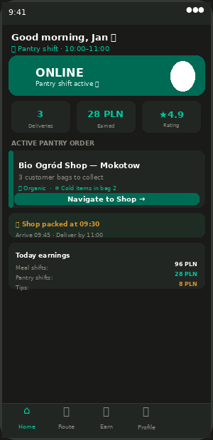  DA-03 — Pantry Gap shift (teal accent, dark theme) | 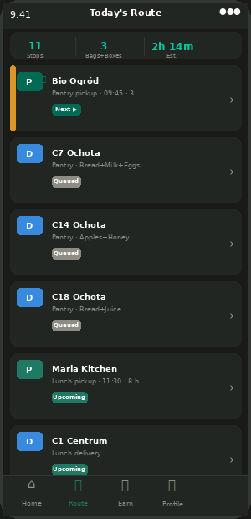  DA-04 — Route with P🌿 teal pantry stops

Aspect | Detail | What Appzeto Builds
5 shift types | Admin assigns drivers to: breakfast | obiad | dinner | pantry_gap1 | pantry_gap2. Any combination. Full-day driver has all 5. | driver.assigned_shifts: array. DA-03 reads current active shift and shows correct label + colour.
DA-03 Home — shift label | Changes to "🌿 Pantry shift · 10:00–11:00." Teal accent on online toggle. Active order card shows shop name + bag count. | shift_type determines label and accent colour. pantry_gap1/2 → teal. meal shifts → green.
DA-04 Route — pantry stops | Pantry pickup stops show "P🌿" (teal P badge). Customer deliveries show "D" (blue). Driver instantly sees difference. | stop.vendor_type === shop_partner → teal P badge. Tap stop: shows item list per customer bag.
Cold chain warning | If any item in batch has cold_chain=true: DA-05 and DA-06 show "❄ Cold items — keep cool" banner. | item.cold_chain_required: boolean. If any item true: show warning on pickup and delivery screens.
Fragile warning | If any item is fragile (eggs): DA-06 shows "⚠ Fragile — handle with care." | item.fragile: boolean. If any item true: show warning on delivery confirmation screen.
Same proof system | PIN or photo proof identical for pantry deliveries. Same GPS logging. Same fraud check. Same confirmDelivery() function. | No code changes to DA-06. Pantry orders use identical delivery confirmation flow.

PART 4 — Admin Panel
8 additions in this section

#1 Payment Failure Alert in Admin Dashboard (AP-01) [P0] — Amendment v1
#12 Credit Note for Refunded B2B Invoices (AP-04, AP-07) [P0-LAW] — Amendment v1
#13 Payment Failure Alert Detail [P0] — Amendment v1
#14 Dynamic Document Types — Fleet Manager (AP-06) [P1] — Amendment v1
#17 GDPR Deletion Task in CS Inbox (AP-04) [P0-LAW] — Amendment v1
#18 Rating Threshold Alerts in AP-05/06 [P1] — Amendment v1
#PB-6 Shop Partner Management in AP-05 [NEW] — Amendment v1
#PB-7 Pantry Feature Toggles ACM-123 to ACM-130 [NEW] — Amendment v1

#12 — Credit Note for Refunded B2B Invoices
Screen: AP-04 Complaints + AP-07 Financial Priority: P0-LAW Source: Amendment v1
EU VAT LAW — MANDATORY: EU VAT law: when a VAT invoice is refunded, a credit note must be issued. Currently refunds are processed but no credit note is generated.
Aspect | Detail | What Appzeto Builds
Trigger | When CS issues refund on B2B VAT invoice order: auto-generate credit note. B2C simple receipts do not need credit notes. | Refund flow: check order.invoice_type. If b2b_vat_invoice → trigger credit note generation.
Contents | References original invoice number. Negative amounts. Correct VAT applied. Both NIPs. Issue date. Credit note number: CN-PL-2026-05-XXXX. | Same PDF template as B2B invoice but negative amounts. Separate sequential numbering for credit notes.
Storage | 7-year storage alongside original invoices. Cannot be deleted. | Firebase Storage: same retention policy as invoices. retention_until = addYears(now(), 7).
Partial refunds | Partial credit note if partial refund. Pro-rata VAT correction. | Calculate credit_amount_ratio = refund_amount / original_invoice_total. Apply to all line items proportionally.

#13 — Payment Failure Alert in Admin Dashboard
Screen: AP-01 Main Dashboard Priority: P0 Source: Amendment v1
Aspect | Detail | What Appzeto Builds
Alert type | New alert in AP-01: "Payment failure — Anna K. — Attempt 2/3 — 89 PLN subscription renewal." Accountant and CS see it. City Manager does not. | Add payment_failure to alert_types in AP-01 alerts panel.
Click alert | Opens customer profile in CS view: failure count, last 4 card digits, subscription plan, amount owed. | Deep link from alert → CS customer search with customer pre-loaded.
AP-07 daily summary | Accountant sees: "Today: 3 payment failures, 2 resolved, 1 pending." | New card in AP-07: payment_failures_today, resolved_today, pending_today.

#14 — Dynamic Document Types — Fleet Manager
Screen: AP-06 Driver Management → Settings Priority: P1 Source: Amendment v1
Aspect | Detail | What Appzeto Builds
Where | AP-06 → Settings tab → Document Types. Fleet Manager only. | New sub-section. Fleet Manager and Super Admin access only.
Add new type | Fleet Manager adds: name, required for (all/car/scooter/bicycle), expiry tracking yes/no, city scope. | New document type appears immediately in FP-02 and DA-02 for that city.
Example use | Germany: "German courier permit (Genehmigung)" — scooter/car — expiry tracking yes. | document_types collection. Admin uses document_type_id internally.

#17 — GDPR Deletion Task in CS Inbox
Screen: AP-04 Complaint & Refund Management Priority: P0-LAW Source: Amendment v1
Aspect | Detail | What Appzeto Builds
Task in AP-04 | New task type: GDPR_DELETION. Red badge. 30-day countdown timer shown. Separate filter tab "GDPR Requests." | task_type: GDPR_DELETION. 30-day SLA enforced. CRON checks daily.
CS execution | Checklist: 1. Delete PII 2. Anonymise orders 3. Verify invoices retained 4. Send confirmation email 5. Mark complete. | System API: /api/admin/gdpr/{user_id}/execute. CS does not manually delete field by field.
Auto-escalation | If CS does not complete in 25 days → auto-escalate to Super Admin. | CRON: if days_since_request > 25 AND status != completed → notify Super Admin.

#18 — Rating Threshold Alerts in Admin
Screen: AP-05 Vendors + AP-06 Drivers Priority: P1 Source: Amendment v1
Aspect | Detail | What Appzeto Builds
Driver alert | Driver avg < 3.5 over 20+ deliveries → amber flag in AP-06 table → AP-01 alert → City Manager notified. | CRON daily: check all drivers. avg_rating < 3.5 AND delivery_count >= 20 → alert.
Vendor alert | Vendor avg < 3.8 over 50+ orders → AP-05 flag → AP-01 alert → City Manager notified. | Same CRON. vendor avg_rating < 3.8 AND order_count >= 50 → flag vendor profile.
Actions | City Manager can: Dismiss (with reason) / Contact vendor or driver / Escalate to Super Admin. | 3 action buttons. Each action logged in audit trail.

#PB-6 — Shop Partner Management in AP-05 + AP-06
Screen: AP-05 Vendors + AP-06 Drivers + AP-07 Financial Priority: NEW Source: Amendment v1
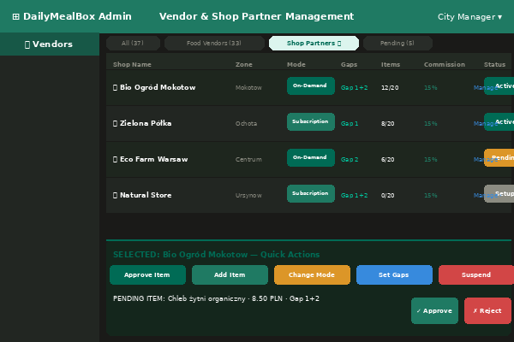  AP-05 — Vendors with Shop Partners 🌿 tab | 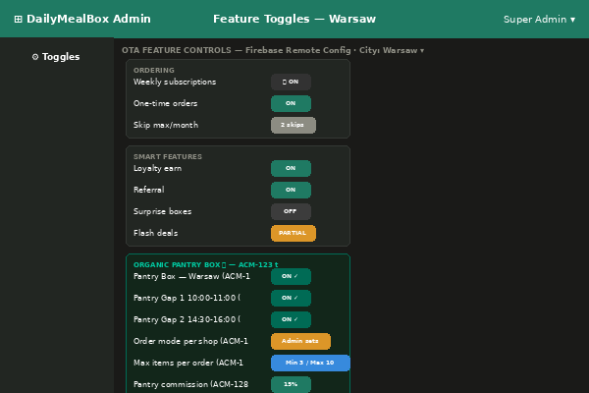  AP-03 — Feature Toggles with Pantry Box section

Aspect | Detail | What Appzeto Builds
AP-05 — New filter tab | AP-05 filter tabs: All / Food Vendors / Shop Partners 🌿 / Pending / Suspended. Shop Partners show teal colour coding. | vendor_type filter. Shop Partners tab: pre-filtered to vendor_type === shop_partner.
AP-05 — Mode selection | In Shop Partner profile panel: "Order Mode" toggle: On-Demand | Subscription. Admin-only. Shop cannot change. | shop_partner.order_mode: ondemand | subscription. Shown as read-only in VM-03.
AP-05 — Gap assignment | Admin assigns each shop to: Gap 1 only / Gap 2 only / Both gaps. Controls which windows shop appears in. | shop_partner.active_gaps: [1] | [2] | [1,2]. Vendor only visible during assigned gap window.
AP-05 — Item approval | Shop Partner profile: "Approved Items" section. Admin adds items with: name, photo, price, unit, gap availability, cold_chain, fragile, VAT rate (5%). Max 20 items. | admin_approved_items collection. Status: approved | pending | rejected. Max 20 per shop enforced.
AP-06 — Pantry shifts | Driver shift assignment: 5 types now. Admin adds pantry_gap1 / pantry_gap2 to driver.assigned_shifts. | driver.assigned_shifts array. Full-day driver: [breakfast, obiad, dinner, pantry_gap1, pantry_gap2].
AP-07 — Pantry revenue | Separate revenue KPI card: "Pantry Revenue MTD: 2,340 PLN." Shop partners in Settle All batch payout at 15% commission. | order.type field separates meal vs pantry revenue. Shop Partners included in batch payout query.
AP-07 — Pantry VAT | Packaged organic goods: 5% VAT (not 8%). Separate line in VAT report. | item.vat_rate: 0.05 for shop_partner items. VAT engine applies correct rate per item.

#PB-7 — Pantry Feature Toggles — ACM-123 to ACM-130
Screen: AP-03 Feature Toggles Priority: NEW Source: Amendment v1
8 new OTA controls for the Organic Pantry Box feature. All delivered via Firebase Remote Config. No reinstall needed. Admin can enable/disable pantry per city at any time.
ACM# | Feature | Who Can Change | Default | Notes
123 | Pantry Box — enable/disable per city | Super Admin | Disabled (Warsaw: enable on launch) | Master on/off. When off: Pantry tab hidden, no gap shifts, no shop partners visible.
124 | Pantry Gap 1 (10:00–11:00) | Super Admin, City Manager | Enabled when 123 on | Independent of Gap 2. Can run Gap 2 without Gap 1.
125 | Pantry Gap 2 (14:30–16:00) | Super Admin, City Manager | Enabled when 123 on | Independent of Gap 1. Disable if driver capacity insufficient.
126 | Shop Partner order mode | Super Admin, City Manager (per shop) | Admin decides per shop | On-Demand or Subscription. Per shop partner. Cannot be changed by shop.
127 | Max items per pantry order | Super Admin | Min 3 / Max 10 | Prevents tiny uneconomical orders.
128 | Pantry commission rate | Super Admin | 15% default | Lower than food (20%). Admin can override per shop.
129 | Pantry delivery fee | Super Admin | 4 PLN flat | Separate from meal delivery fee formula (which uses base + per km).
130 | Order window notifications | Super Admin, Marketing | Enabled | Push at 07:30 and 11:30. Disable if notification fatigue.

PART 4 — Fleet Partner Portal
2 additions in this section

#15 Driver Invitation Flow via Email (FP-01) [P0] — Amendment v1
#16 Fleet Partner Staff Accounts (FP-05) [P1] — Amendment v1

#15 — Driver Invitation Flow — Fleet Partner Invites by Email
Screen: FP-01 My Drivers Priority: P0 Source: Amendment v1
COMPLIANCE: Fleet partner "Add Driver" should create an INVITATION, not a driver record. Driver must self-register for EU compliance (driver must consent and provide own data).
Aspect | Detail | What Appzeto Builds
Fleet partner action | FP-01 → Add New Driver → enter: name, email, phone, vehicle type → Send Invitation. | POST /api/fleet/{fleet_id}/invite-driver. Creates invitation record. NOT a driver record.
Driver receives email | Email: "[Fleet Partner] invited you to join DailyMealBox. Register here: [link with 48h token]" | Link contains: invitation_token, fleet_partner_id, pre-filled vehicle_type. Opens DA-02 registration.
Driver registers | DA-02 opens with fleet_partner_id pre-assigned and locked. Driver enters own data and uploads own documents. | DA-02: fleet_partner_id field pre-filled and read-only. Driver completes rest.
Status in FP-01 | Fleet partner sees "Jan Wisniewski — Invited — Pending registration" (amber) until driver completes DA-02. | invitation.status: pending_registration | pending_review | active | declined | expired.
Invitation expiry | Link expires after 48 hours. FP-01 shows "Invitation expired — Resend" button. | invitation.expires_at = now() + 48h. After expiry: link invalid. Fleet partner can resend.

#16 — Fleet Partner Staff Accounts
Screen: FP-05 Company Information Priority: P1 Source: Amendment v1
Aspect | Detail | What Appzeto Builds
3 permission levels | Admin (full access), Finance only (invoices + earnings), Driver Manager (roster + documents, no invoices). | 3 roles within fleet partner view. No staff account can exceed fleet partner's own permissions.
Max 5 accounts | Maximum 5 staff accounts per fleet company. Fleet Partner Admin can deactivate any staff account instantly. | If 6th account attempted: error "Maximum 5 staff accounts reached."
Audit trail | All staff actions logged with individual name + email, not just company name. | Logs: "Marek Kowalski (Evelstar Finance)" not just "Evelstar."

PANTRY BOX — TECHNICAL SPECIFICATION (PB-8)
MongoDB schemas, API endpoints, order windows, and push notifications for Appzeto backend team

FOR APPZETO BACKEND TEAM: This section contains all backend technical details for the Organic Pantry Box feature. Database schemas, API endpoints, cutoff logic, and push notifications. Appzeto backend developers should read this alongside the screen specifications above.
Pantry Order Windows — Both Gaps
Gap Shift | Customer Orders | Shop Cutoff | Driver Pickup | Delivery Window
Pantry Gap 1  (10:00–11:00) | 07:30 – 09:30  (2 hour window) | 09:30  Shop packs | 09:45 – 10:00  Driver collects | 10:00 – 11:00  Customer receives
Pantry Gap 2  (14:30–16:00) | 11:30 – 13:30  (2 hour window) | 13:30  Shop packs | 14:15 – 14:30  Driver collects | 14:30 – 16:00  Customer receives

New MongoDB Collections
shop_partner vendor fields (addition to existing vendor collection)
// New fields on vendor document when vendor_type === "shop_partner":
{
vendor_type: "shop_partner", // 5th vendor type
order_mode: "ondemand"|"subscription", // admin-set (ACM-126)
active_gaps: [1, 2], // which gap shifts (ACM-124/125)
organic_certification_url: "drive://...",
trade_licence_url: "drive://...",
packing_start_time: "09:00",
commission_rate: 0.15, // ACM-128 default
delivery_fee_flat: 4.00, // ACM-129 flat fee
approved_items: [{
item_id, item_name, photo_url, price_pln,
unit: "1 loaf",
vat_rate: 0.05, // packaged food = 5% Poland
available_gaps: [1, 2],
cold_chain_required: false,
fragile: false,
available_today: true // shop marks false if out of stock
}],
min_items_per_order: 3, // ACM-127
max_items_per_order: 10, // ACM-127
kitchen_partner_id: null // always null for shop_partner
}
PantryOrder collection (new)
// pantry_orders collection — separate from orders collection
{
_id,
order_type: "pantry_ondemand" | "pantry_subscription",
gap_shift: 1 | 2,
vendor_id: ObjectId, // shop_partner vendor
customer_id: ObjectId,
driver_id: ObjectId, // assigned at shift start
zone_id: ObjectId,
items: [{ item_id, item_name, quantity, price_pln,
vat_rate: 0.05, cold_chain: false, fragile: false }],
order_window_deadline: ISODate, // 09:30 or 13:30
delivery_window_start: ISODate, // 10:00 or 14:30
delivery_window_end: ISODate, // 11:00 or 16:00
subtotal_pln, delivery_fee_pln: 4.00,
vat_items_pln, // 5% on items
vat_delivery_pln, // 23% on delivery fee
total_pln,
status: "pending"|"packed"|"collected"|"delivered"|"failed",
proof_method: "pin"|"photo",
delivered_at: ISODate,
delivery_gps: {lat, lng}
}
Key API endpoints
// Check current window status:
GET /api/pantry/window-status?city=warsaw
// Returns: { gap1: {status:"open"|"closed", opens_at, closes_at},
// gap2: {status:"open"|"closed", opens_at, closes_at} }
// Get available shops (returns [] outside order window):
GET /api/pantry/shops?zone_id={id}
// Place on-demand pantry order:
POST /api/pantry/orders
{ vendor_id, customer_id, items:[{item_id,quantity}],
gap_shift:1, zone_id, payment_method }
// Validates: within window, min 3 items, max 10 items
// Mark batch packed (generates collection PIN):
PATCH /api/pantry/batches/{batch_id}/packed
// Generates PIN in Redis, FCM to driver with PIN
// Admin: toggle shop partner mode:
PATCH /api/admin/vendors/{id}/pantry-mode
{ order_mode:"ondemand"|"subscription", active_gaps:[1,2] }
// Admin: approve item:
PATCH /api/admin/vendors/{id}/items/{item_id}
{ status:"approved"|"rejected", reason:"..." }
Pantry Push Notifications (8 additional — add to master catalogue)
Recipient | Trigger | Text | Channel | ACM
Customer | Gap 1 window opens (07:30) | 🌿 Organic pantry window open! Order fresh staples — delivered by 11am. Closes 09:30. | FCM Push | ACM-130
Customer | Gap 2 window opens (11:30) | 🌿 Afternoon pantry window open! Organic grocery delivered 14:30–16:00. Closes 13:30. | FCM Push | ACM-130
Customer | 30 min before cutoff | Last chance — pantry order closes in 30 min. Tap to order. | FCM Push | ACM-130
Customer | Pantry order confirmed | Your organic pantry order is confirmed! Delivery 10:00–11:00. Bio Ogród Shop. | FCM+Email | Cannot disable
Customer | Pantry delivered | Organic delivery complete! Enjoy. Rate your delivery → | FCM Push | Can disable
Shop Partner | New pantry order received | New order! Customer from Mokotow — 5 items. Pack by 09:30. Driver arrives 09:45. | FCM Push | Cannot disable
Shop Partner | Driver assigned | Driver Jan W. assigned. Arrives 09:45. Have all bags ready. | FCM Push | Cannot disable
Driver | Pantry shift starting (30 min) | 🌿 Pantry shift starts in 30 min (10:00). Bio Ogród — Mokotow. 3 bags. | FCM Push | Can disable

