DailyMealBox

PRODUCT REQUIREMENTS DOCUMENT
Part 1 — Customer App · FINAL

Document | FINAL merged version — supersedes all previous versions
Version | v3.0 Final
Date | 19 May 2026
Platforms | Android · iOS · Web (responsive)
Tech Stack | React Native · React.js · Node.js · MongoDB · Redis · Socket.io
Brand | #1F7A63 Deep Green · #F5F5F0 Soft Beige · #2B2B2B Dark Gray
Developer | Appzeto — Indore, India
Markets | Warsaw (PLN) → Berlin (EUR) → Paris (EUR)

1. App Overview — Platforms & Navigation

DailyMealBox Customer App is subscription-first. It is a control panel for recurring meals — not a marketplace. 3-tap maximum for any critical action. Admin-disabled features are completely hidden (not greyed out). All feature flags delivered via Firebase Remote Config (OTA) — no reinstall needed.
Navigation — 5 Tab Bar
⌂ Home | ☰ Plans | ▦ Calendar | ◎ Orders | ○ Profile
Dashboard, next delivery, quick actions, loyalty widget, OTA banner | Browse + filter plans, surprise boxes, flash deals, featured vendors | Weekly view, skip/reschedule/swap, cutoff lock, tomorrow preview | Upcoming + past, live tracking, refund status, receipts/invoices | Settings, diet, proof preference, loyalty, B2B, invoice prefs, GDPR

2. VAT & Tax Engine — Complete Implementation

The VAT engine is the core financial infrastructure. Every order, every invoice, every settlement flows through it. Customer sees ONE total price. Internally the system splits VAT ownership: food VAT belongs to vendor, delivery VAT belongs to fleet partner, commission VAT belongs to DailyMealBox.
2.1 VAT Rate Matrix — All Countries
Line Item | Poland | Germany | France | VAT Owner / Notes
Meal subscription (restaurant/processed) | 8% ⚠ CORRECTED | 7% | 10% | VENDOR. Home cooks use Kitchen Partner VAT. Admin configures per vendor type.
Basic food items (raw/unprocessed) | 5% | 7% | 5.5% | VENDOR. Only if vendor food qualifies. Admin sets per vendor type via Remote Config.
Delivery service fee | 23% | 19% | 20% | FLEET PARTNER. Fleet partner invoices DailyMealBox. DMB passes cost to customer.
Platform commission (from vendor) | 23% | 19% | 20% | DailyMealBox. Shown on vendor settlement, not customer receipt.
Driver tips | 23% | 19% | 20% | FLEET PARTNER. 100% goes to driver. Fleet partner declares tip VAT.
EU cross-border B2B invoice | 0% reverse charge | 0% reverse charge | 0% reverse charge | Buyer self-accounts. Invoice must state: "Art. 196 EU VAT Directive."
Discounted price (surprise box/coupon) | VAT on actual price | VAT on actual price | VAT on actual price | 50% off = VAT calculated on discounted price, not original.

2.2 VAT Ownership Split
VAT Engine — Core Calculation (Node.js)
// VAT rates from Remote Config (admin sets per city — OTA, no reinstall):
const VAT_RATES = {
warsaw: { food_restaurant:0.08, food_basic:0.05, delivery:0.23, service:0.23, tips:0.23 },
berlin: { food_restaurant:0.07, food_basic:0.07, delivery:0.19, service:0.19, tips:0.19 },
paris: { food_restaurant:0.10, food_basic:0.055, delivery:0.20, service:0.20, tips:0.20 }
}
function calculateOrderVAT(order, city, customerType, customerVatNumber) {
const rates = VAT_RATES[city]
// EU reverse charge: B2B buyer from different EU country:
const isReverseCharge = (customerType==="b2b" && customerVatNumber &&
getEuCountry(customerVatNumber) !== getEuCountry(city))
const foodRate = isReverseCharge ? 0 :
(order.vendor.food_category==="basic" ? rates.food_basic : rates.food_restaurant)
const deliveryRate = isReverseCharge ? 0 : rates.delivery
const foodNet = order.meal_price / (1 + foodRate)
const foodVat = order.meal_price - foodNet
const deliveryNet = order.delivery_fee / (1 + deliveryRate)
const deliveryVat = order.delivery_fee - deliveryNet
return {
// Customer sees:
total_gross: order.meal_price + order.delivery_fee + (order.tip || 0),
// Invoice breakdown:
food_net: foodNet.toFixed(2), food_vat_rate: foodRate*100+"%",
food_vat_amount: foodVat.toFixed(2), food_vat_owner: "vendor",
delivery_net: deliveryNet.toFixed(2), delivery_vat_rate: deliveryRate*100+"%",
delivery_vat_amount: deliveryVat.toFixed(2), delivery_vat_owner: "fleet_partner",
is_reverse_charge: isReverseCharge,
reverse_charge_notice: isReverseCharge ?
"Reverse charge — Art. 196 EU VAT Directive" : null,
// Internal settlement:
vendor_receives_net: foodNet,
fleet_receives_net: deliveryNet,
platform_commission: foodNet * order.vendor.commission_rate,
}
}
2.3 Document Types — Receipt vs Invoice
Document | Who Gets It | Contents | Legal Basis
B2C Simple Receipt | Individual customers (default) | Gross price per item, VAT rate noted, no full breakdown required | EU VAT Art.238 — simplified invoice permitted B2C under EUR 100
B2B Full VAT Invoice | Company/office accounts | All fields: both NIPs, sequential number, net+VAT rate+VAT amount+gross per line, payment terms | EU VAT Art.226 — mandatory for B2B. Store 7 years.
Monthly Consolidated | B2B office managers | All orders combined for billing period. One invoice per company per month. | Required by B2B contract. Auto-generated 1st of each month.
Reverse Charge Invoice | EU cross-border B2B | Net amounts at 0%. "Reverse charge — Art.196 EU VAT Directive" statement. | EU VAT Art.196 — buyer self-accounts for VAT.
Credit Note | Refunded customers | References original invoice. Negative amounts. VAT correction. | Required by EU law when VAT invoice is refunded.

3. Home Cook Legal Model — Kitchen Partner Entity

Home cooks in Poland often lack a registered company or VAT number. Without a legal entity they cannot issue food invoices or receive commercial bank payments. Solution: Home Cook links to a Kitchen Partner company — a registered Sp. z o.o. that handles all legal, invoicing, and financial aspects on their behalf. This mirrors the model used by catering platforms across Poland.
KitchenPartner MongoDB Schema (New Collection)
// New collection: kitchen_partners
{
_id, company_name: "FreshKitchen Partners Sp. z o.o.",
nip: "521-111-111-11", krs: "0000123456",
bank_iban: "PL61...", status: "active"|"suspended",
city, zones: ["zone_mokotow","zone_ochota"],
home_cooks: [{
cook_id, cook_name, cook_phone,
contract_signed_at, contract_url, // Google Drive link
settlement_split: 0.85, // cook gets 85% of food revenue
status: "active"
}],
management_fee_pct: 0.15, // Kitchen Partner keeps 15%
food_licence_url, // Sanepid certification — Google Drive
food_licence_expiry,
insurance_url,
approved_by_admin_id, created_at
}
// Vendor document — home cook gets new field:
{ _id, vendor_type: "home_cook",
kitchen_partner_id: ObjectId("..."), // NULL for restaurants/cloud kitchens
// When set: all invoicing via Kitchen Partner
// When null: vendor has own company
}
// Settlement flow for home cook order:
// DailyMealBox pays Kitchen Partner gross food amount (minus DMB commission)
// Kitchen Partner pays home cook: gross × settlement_split (e.g. 85%)
// Kitchen Partner keeps: gross × management_fee_pct (e.g. 15%)
// Kitchen Partner handles: VAT declaration, ZUS, income tax for cook

4. Onboarding Flow

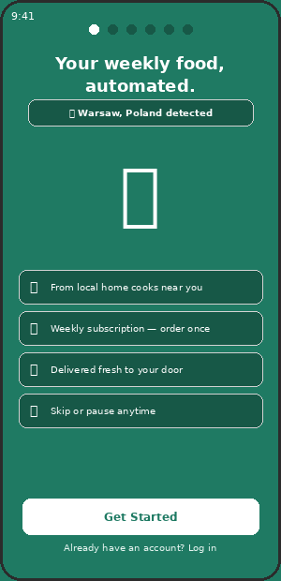  CA-01 — Welcome + City Auto-Detect | 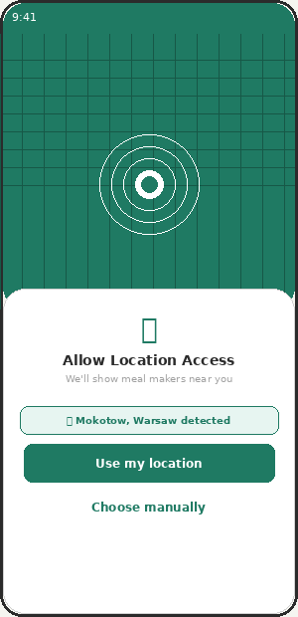  CA-02 — GPS Location Detection

CA-01 | Welcome Screen | ✅ INCLUDED | v2.0

Feature | Status | Admin Control | Notes
Brand splash with tagline "Your weekly food, automated" | ✅ INCLUDED | — | Green top, beige bottom. City auto-detected badge shown.
City auto-detected badge | ✅ INCLUDED | ACM-88 | GPS detects city on first open. Shows "Warsaw, Poland detected."
Get Started + Log in CTAs | ✅ INCLUDED | — | Routes to CA-03 Goal Selection or login.

CA-02 | GPS Location Detection | ✅ INCLUDED | v2.0

Feature | Status | Admin Control | Notes
Location permission request | ✅ INCLUDED | ACM-88 | iOS/Android/Web browser geolocation API.
Auto-detect city and zone via GeoJSON polygon match | ✅ INCLUDED | ACM-88 | Coords → reverse geocode → match zone polygon → "Mokotow, Warsaw detected."
Manual city override fallback | ✅ INCLUDED | ACM-88 | If GPS denied: city picker from admin-configured active cities.
Admin can disable GPS auto-detect | ⚙ ADMIN | ACM-88 | Falls back to city picker.

CA-03 | Goal Selection | ✅ INCLUDED | v2.0

Feature | Status | Admin Control | Notes
4 goal cards: Eat Healthy / Save Time / Family Meals / Fitness | ✅ INCLUDED | — | Stored as user.onboardingGoal. Affects plan recommendations throughout app.

CA-04 | Dietary Preferences | ✅ INCLUDED | v2.0

Feature | Status | Admin Control | Notes
Diet type: No preference / Vegan / Vegetarian / Keto | ✅ INCLUDED | — | Single select. Filters plan listings.
Allergy multi-select (EU 14 allergens + admin extras) | ✅ INCLUDED | ACM-46 (law) | EU Reg 1169/2011 — always present. Admin can add extras.
Budget range slider | ✅ INCLUDED | — | Sets price filter default on Plans screen.

CA-05 | Delivery Schedule | ✅ INCLUDED | v2.0

Feature | Status | Admin Control | Notes
Days: Mon–Fri / Full week | ✅ INCLUDED | — | Default Mon–Fri.
Delivery slot: Breakfast / Lunch / Dinner | ✅ INCLUDED | ACM-10/11/12 | Admin enables/disables slots per city.
Cutoff time explanation per slot | ✅ INCLUDED | ACM-55/56/57 | Admin configures cutoff per maker type.

CA-07 | Subscription Checkout | ✅ INCLUDED | v2.0 + v3.0

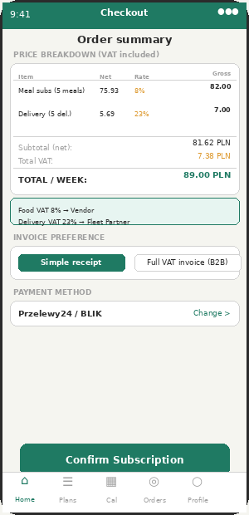  CA-07 Checkout with VAT (v3.0) | 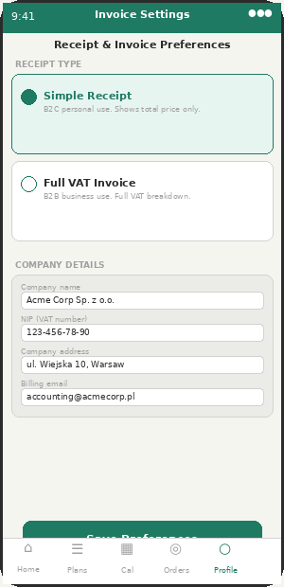  CA-07b Invoice Preference

Feature | Status | Admin Control | Notes
Plan details, vendor, schedule, start date | ✅ INCLUDED | — | Start date always next Monday.
VAT breakdown table: net / rate / tax amount / gross per line | ✅ INCLUDED | ACM-80 | NEW v3.0. Shows food (8%) and delivery (23%) as separate lines.
VAT info note: Food VAT → vendor, Delivery VAT → fleet partner | ✅ INCLUDED | — | NEW v3.0. Educates customer on split ownership.
Invoice preference selector: Receipt vs B2B VAT Invoice | ✅ INCLUDED | ACM-80 | NEW v3.0. Default: simple receipt. B2B adds NIP field.
Przelewy24 / BLIK payment | ✅ INCLUDED | ACM-16/17 | WhatsApp confirmed 10 Apr.
Cancel anytime (EU law) | ⚖ EU LAW | ACM-15 | Max 2-tap. Default min commitment: 2 days. EU max: 14 days.

5. Home Tab (CA-08)

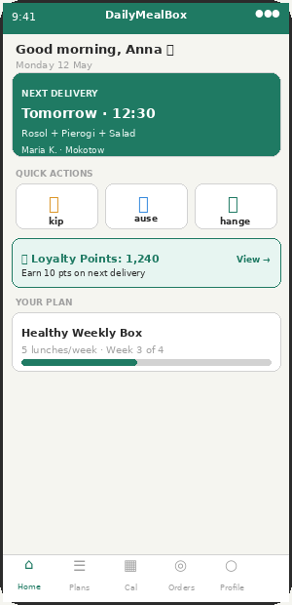  CA-08 — Home Dashboard | 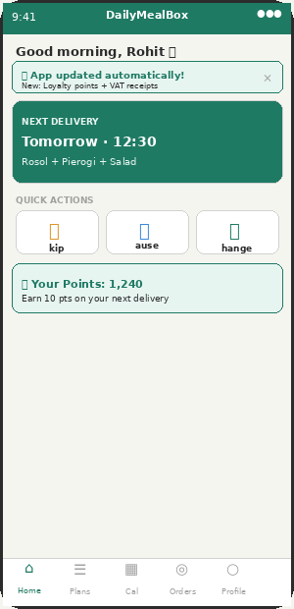  CA-08b — OTA Update Banner

CA-08 | Home Screen Dashboard | ✅ INCLUDED | v2.0 + v3.0

Feature | Status | Admin Control | Notes
Next delivery card (green, above fold, always visible) | ✅ INCLUDED | — | 3-tap rule from here to any action.
Live tracking shortcut on card (when Out for Delivery) | ✅ INCLUDED | ACM-23 | "Driver 1.2km away — Track Live →". Admin can disable per city.
OTA update banner (non-intrusive, dismissable) | ✅ INCLUDED | — | Appears when admin pushes update. Shows what is new.
Skip / Pause / Change quick actions | ✅ INCLUDED | ACM-13/14 | Skip: max 2/month. Pause: max 2 days. Limits enforced per admin config.
Loyalty points widget | ✅ INCLUDED | ACM-35 | Only shown if loyalty enabled. Hidden if admin disables.
Tomorrow menu preview + 7pm push notification | ✅ INCLUDED | ACM-30 | Admin sets notification time per maker type.
Churn prevention card (when 2+ skips detected) | ✅ INCLUDED | ACM-37 | NEW v3.0. AI detects skip pattern. Shows personalised retention offer.
Add-ons section | ✅ INCLUDED | — | Max 3 add-on suggestions.

6. Plans Tab

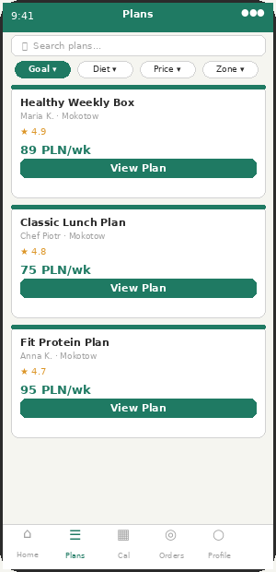  CA-09 — Plans Browse | 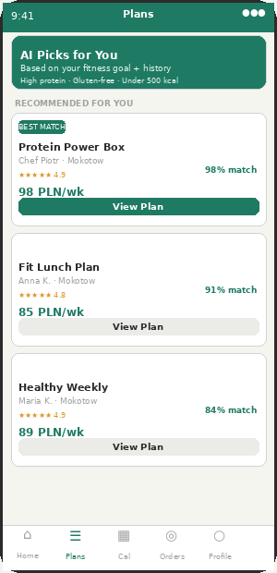  CA-09b — AI Recommendations

CA-09 | Plans Browse + AI Recommendations | ✅ INCLUDED | v2.0 + v3.0

Feature | Status | Admin Control | Notes
Search bar and filter chips (Goal / Diet / Price / Zone) | ✅ INCLUDED | ACM-44/45/46 | Allergen auto-filter applied.
Featured vendor badge (gold, top of results) | ✅ INCLUDED | ACM-42 | Admin sets featured listing price per slot.
Flash deal badge on plan cards | ✅ INCLUDED | ACM-41 | Admin approves each flash deal.
"AI Picks for You" recommendation banner | ✅ INCLUDED | ACM-45 | NEW v3.0. Rule-based Phase 1. Match % score shown.
Match % score per plan (diet + allergen + calorie) | ✅ INCLUDED | — | NEW v3.0. 98% match = all criteria met.
Surprise meal box tab | ✅ INCLUDED | ACM-39 | Admin enables per city. Max 60% off.

CA-10 | Surprise Meal Box Screen | ✅ INCLUDED | v2.0

Feature | Status | Admin Control | Notes
Time-limited anti-waste deals up to 60% off | ✅ INCLUDED | ACM-39/60 | Admin enables per city, sets max discount.
Countdown timer + "Only X left" urgency | ✅ INCLUDED | — | Real-time updates.
Admin can disable per city | ⚙ ADMIN | ACM-39 | Warsaw launch: enabled. Other cities: toggle.

CA-11 | Meal / Plan Detail with Nutrition | ✅ INCLUDED | v2.0

Feature | Status | Admin Control | Notes
Photo gallery, nutrition panel (cal/protein/carbs/fats) | ✅ INCLUDED | ACM-44 | Optional vendor data. "Not provided" fallback.
EU allergen tags (red badges — always shown) | ⚖ EU LAW | ACM-46 | Cannot be disabled. EU Reg 1169/2011.
Kitchen Partner notice on home cook listings | ✅ INCLUDED | — | NEW v3.0. "Certified Kitchen Partner" badge. FreshKitchen Partners Sp. z o.o.
"Matches your diet goal" green badge | ✅ INCLUDED | ACM-45 | If meal meets user calorie/macro targets.

7. Calendar Tab (CA-12) — Most Critical Screen

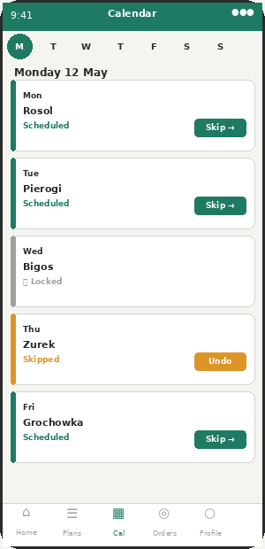
CA-12 — Calendar Screen
CA-12 | Calendar Screen | ✅ INCLUDED | v2.0

The subscriber control centre. Skip, pause, swap, reschedule — all from here. Admin-set cutoff locks days automatically. 3-tap maximum for any action.
Feature | Status | Admin Control | Notes
Weekly Mon–Sun grid. Current day highlighted. | ✅ INCLUDED | — | Tap day to expand and take action.
Cutoff lock — days past cutoff show locked icon | ✅ INCLUDED | ACM-55/56/57 | All action buttons disabled after cutoff. Next available slot shown.
Skip delivery (with limit enforcement) | ✅ INCLUDED | ACM-13 | Default 2/month. If at limit: "2/2 skips used this month." Credit to wallet.
Pause subscription (with duration limit) | ✅ INCLUDED | ACM-14 | Default max 2 days. Auto-resume.
Swap meal (same vendor, different dish) | ✅ INCLUDED | — | Before cutoff only. Shows available meals from same vendor.
Tomorrow meal preview on day card | ✅ INCLUDED | ACM-30 | Vendor must upload menu in advance.

Calendar Cutoff Lock Logic
function getDayState(order, vendorSettings) {
const now = new Date()
const cutoff = calculateCutoff(order.delivery_date, vendorSettings)
if (now > cutoff) return { state:"locked", icon:"🔒", actions:[] }
const skipsThisMonth = getSkipsThisMonth(user.id)
const maxSkips = remoteConfig.getNumber("max_skips_per_month") || 2
return {
state: "scheduled",
actions: [
skipsThisMonth < maxSkips ? "skip" : "skip_disabled",
"reschedule", "swap_meal"
]
}
}
// On skip: credit wallet, notify vendor to adjust production

8. Orders Tab + Live Tracking

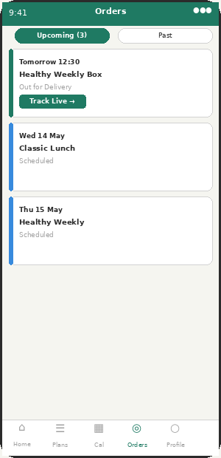  CA-13 — Orders Screen | 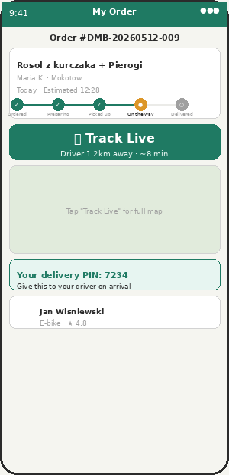  CA-14 — Order Detail + Live Tracking

CA-13 | Orders Screen | ✅ INCLUDED | v2.0

Feature | Status | Admin Control | Notes
Upcoming + past tabs | ✅ INCLUDED | — | Timeline. Upcoming: next 7 deliveries. Past: all history.
Track Live button (when Out for Delivery) | ✅ INCLUDED | ACM-23 | Routes to CA-14. Admin can disable per city.
Notification tap → order detail → auto-opens tracking | ✅ INCLUDED | — | Push notification deep-link. Both subscription and on-demand.
Refund status on past orders | ✅ INCLUDED | — | Shows "Refund PLN 18 — Processing" or "Completed."
Download receipt / invoice from order | ✅ INCLUDED | ACM-80 | NEW v3.0. Download B2C receipt or B2B VAT invoice per order.

CA-14 | Order Detail + Live GPS Tracking | ✅ INCLUDED | v2.0

Feature | Status | Admin Control | Notes
TRACK LIVE button (large, prominent green) | ✅ INCLUDED | ACM-23 | Must add. Opens full GPS map.
Driver moving dot on Google Maps (Socket.io, every 5s) | ✅ INCLUDED | ACM-23/78 | Must add. WebSocket GPS stream.
ETA badge (updates every 30s via Distance Matrix API) | ✅ INCLUDED | ACM-24 | Must add.
"Arriving Soon" auto-notification (500m trigger) | ✅ INCLUDED | ACM-24 | Must add. FCM push with PIN.
Delivery PIN displayed prominently | ✅ INCLUDED | ACM-25 | Must add. 4-digit PIN to customer.
Driver info card (name, vehicle, rating) | ✅ INCLUDED | — | Shows with masked call button.

9. Profile Tab

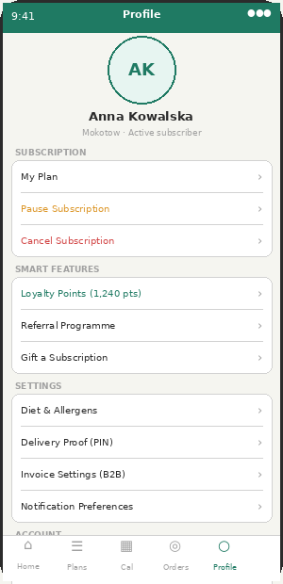  CA-15 — Profile Screen | CA-V3-07 — Invoice Preference (v3.0)

CA-15 | Profile Screen | ✅ INCLUDED | v2.0 + v3.0

Feature | Status | Admin Control | Notes
Personal info, subscription management | ✅ INCLUDED | — | Editable. Plan, schedule, billing date.
Pause + Cancel subscription (easy to find) | ⚖ EU LAW | ACM-14/15 | EU Consumer Law. Max 2-tap. Cannot hide.
Diet + allergen preferences | ✅ INCLUDED | ACM-44/45/46 | Updates filtering immediately across app.
Delivery proof preference (PIN / Photo) | ✅ INCLUDED | ACM-25 | Customer sets. Admin can lock platform-wide.
Payment methods | ✅ INCLUDED | ACM-15/16/17 | Shows admin-enabled payment types only.
In-app wallet (credits) | ✅ INCLUDED | ACM-18 | Skip credits + top-up. Hidden if admin disables.
Loyalty points link | ✅ INCLUDED | ACM-35 | Only shown if loyalty enabled.
Referral programme link | ✅ INCLUDED | ACM-37 | Only shown if referral enabled.
Invoice preference (Receipt vs B2B VAT Invoice) | ✅ INCLUDED | ACM-80 | NEW v3.0. Company NIP, billing email. VIES validation.
B2B — Switch to Office Account | ✅ INCLUDED | ACM-40 | If user has B2B account.
GDPR — Delete my account | ✅ INCLUDED | ACM-100 | EU Article 17. Must add.

CA-V3-07 | Invoice Preference Screen | ✅ INCLUDED | v3.0

Feature | Status | Admin Control | Notes
Receipt type: Simple vs Full VAT Invoice | ✅ INCLUDED | ACM-80 | Default: simple receipt. Switching to B2B shows NIP field.
Company name + NIP + billing address + billing email | ✅ INCLUDED | — | Used on all future B2B invoices. Validated NIP format.
EU VAT number validation via VIES API | ✅ INCLUDED | — | For cross-border EU B2B: validates VAT number is active in EU registry.
Invoice delivery: email + downloadable in-app | ✅ INCLUDED | — | Auto-sent to billing email. Also downloadable from Orders tab.

10. Receipt & Invoice Screens

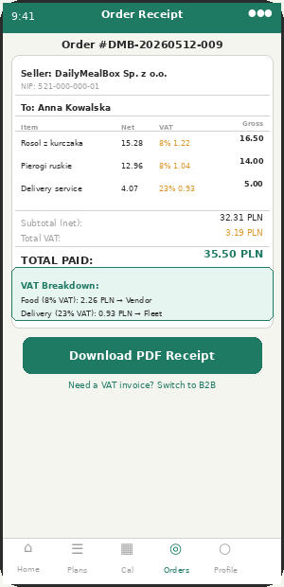  CA-V3-01 — B2C Receipt | 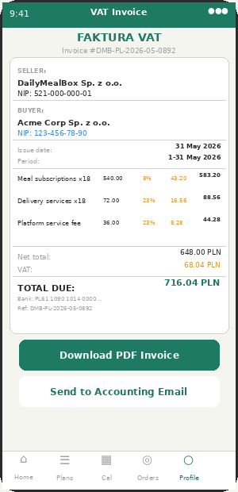  CA-V3-02 — B2B VAT Invoice

CA-V3-01 | B2C Order Receipt | ✅ INCLUDED | v3.0

Feature | Status | Admin Control | Notes
Auto-generated after confirmed delivery | ✅ INCLUDED | — | PDF via pdfkit/puppeteer. Email to customer. Available in Orders tab.
Seller: DailyMealBox Sp. z o.o. + NIP | ✅ INCLUDED | — | Platform is always invoice issuer. Never vendor or fleet partner.
Gross price per line. VAT rate noted per line. | ✅ INCLUDED | — | Simplified receipt — no full VAT breakdown required by EU law for B2C under EUR 100.
VAT summary note (food 8%, delivery 23%) | ✅ INCLUDED | — | Educates customer. Not legally required but builds trust.
"Need B2B invoice?" prompt links to invoice preference | ✅ INCLUDED | — | Upsell to B2B account for freelancers and small businesses.

CA-V3-02 | B2B Full VAT Invoice | ✅ INCLUDED | v3.0

Feature | Status | Admin Control | Notes
Sequential invoice number (DMB-PL-2026-05-XXXX) | ✅ INCLUDED | — | Per city per month. Resets monthly. Stored in invoiceSequences collection.
All EU-required fields (Art. 226 EU VAT Directive) | ⚖ EU LAW | — | Both NIPs, issue date, service period, line items with net+rate+tax+gross, payment terms.
Separate lines: food (8%) + delivery (23%) + platform fee (23%) | ✅ INCLUDED | — | Each line type has its own VAT rate clearly shown.
Reverse charge for EU cross-border B2B | ✅ INCLUDED | — | VAT = 0%. Invoice states "Reverse charge — Art. 196 EU VAT Directive."
7-year storage (EU tax law) | ⚖ EU LAW | — | Cannot be deleted. Firebase Storage /invoices/ folder. Retention policy enforced.
Monthly auto-generation via CRON (1st of month) | ✅ INCLUDED | — | Previous month orders consolidated. Sent to billing email.

B2B Invoice Generation — Monthly CRON
// Runs 1st of each month at 06:00 for previous month:
cron.schedule("0 6 1 * *", async () => {
const companies = await B2BAccount.find({ status: "active" })
for (const company of companies) {
const orders = await Order.find({
company_id: company._id,
delivery_date: { $gte: startOfLastMonth(), $lte: endOfLastMonth() },
status: "delivered"
})
const invoiceNumber = await getNextInvoiceNumber(company.city)
const isReverseCharge = isEUCrossBorder(company.vat_number, company.city)
const foodRate = isReverseCharge ? 0 : VAT_RATES[company.city].food_restaurant
const deliveryRate = isReverseCharge ? 0 : VAT_RATES[company.city].delivery
const pdfBuffer = await generateInvoicePDF({
invoice_number: invoiceNumber,
seller: { name:"DailyMealBox Sp. z o.o.", nip: PLATFORM_NIP },
buyer: { name: company.name, nip: company.vat_number,
address: company.billing_address },
line_items: buildLineItems(orders, foodRate, deliveryRate),
reverse_charge: isReverseCharge,
payment_terms: "14 days bank transfer"
})
const pdfUrl = await uploadToFirebase("/invoices/b2b/"+invoiceNumber+".pdf", pdfBuffer)
await email.send(company.billing_email, "Invoice "+invoiceNumber, { pdfUrl })
await Invoice.create({ invoice_number:invoiceNumber, company_id:company._id,
pdf_url:pdfUrl, status:"sent", retention_until: addYears(now(),7) })
}
}, { timezone: "Europe/Warsaw" })

11. Smart Features

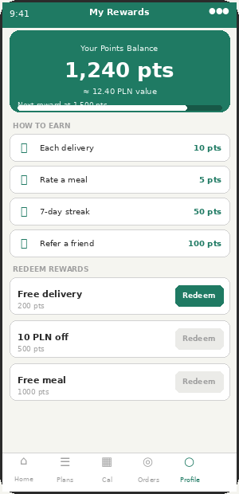  CA-16 — Loyalty Points | 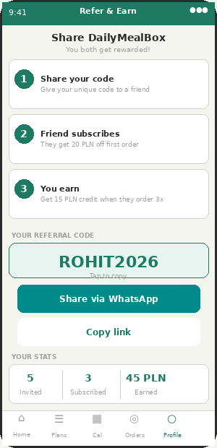  CA-17 — Referral Programme

CA-16 | Loyalty Points System | ✅ INCLUDED | v2.0

Feature | Status | Admin Control | Notes
Points balance card + earn actions + redeem rewards | ✅ INCLUDED | ACM-35/36 | 10 pts/delivery, 5 pts/rating, 50 pts streak, 100 pts referral. Admin sets.
Earn and redeem toggleable independently | ⚙ ADMIN | ACM-35/36 | Can enable earning only during launch phase.
Points widget on Home screen | ✅ INCLUDED | ACM-35 | Hidden if loyalty disabled by admin.

CA-17 | Referral Programme | ✅ INCLUDED | v2.0

Feature | Status | Admin Control | Notes
Unique code, share via WhatsApp / copy link | ✅ INCLUDED | ACM-37 | Referrer: 15 PLN credit. Referee: 20 PLN off. Admin sets amounts.
Referral stats: invited / subscribed / earned | ✅ INCLUDED | — | Motivates continued sharing.

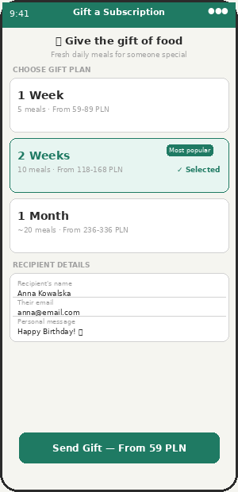  CA-18 — Gift Subscription | 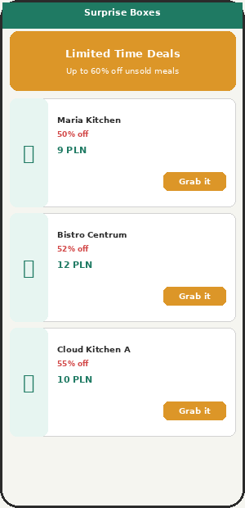  CA-10 — Surprise Box

CA-18 | Gift Subscription | ✅ INCLUDED | v2.0

Feature | Status | Admin Control | Notes
Choose plan duration: 1 week / 2 weeks / 1 month | ✅ INCLUDED | ACM-38 | Admin sets available options.
Recipient details + personal message | ✅ INCLUDED | — | System sends gift notification with redemption link.
Delivery: Email / WhatsApp / Print PDF | ✅ INCLUDED | — | All generate redemption code. Expires 90 days.

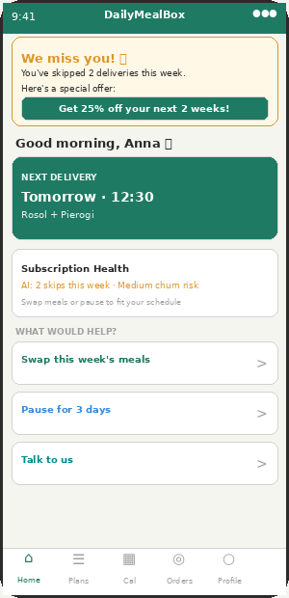  CA-V3-06 — Churn Prevention (v3.0) | CA-V3-05 — AI Recs (v3.0)

CA-V3-06 | Churn Prevention + Subscription Health | ✅ INCLUDED | v3.0

Feature | Status | Admin Control | Notes
"We miss you" card on Home when 2+ skips detected | ✅ INCLUDED | — | Rule-based trigger. Admin configures skip threshold.
Personalised retention offer (discount / free week) | ✅ INCLUDED | ACM-37 | Admin sets offer type and amount.
Subscription health score (Low / Medium / High risk) | ✅ INCLUDED | — | Rule-based Phase 1. ML Phase 2 after 3+ months data.
Recovery actions: Swap / Pause 3 days / Talk to us | ✅ INCLUDED | — | One-tap recovery paths. Talk to us opens live chat.
AI churn prediction (backend) | ✅ INCLUDED | — | Phase 1: skip_count >= 2 OR days_since_last > 7 OR avg_rating < 3.

CA-V3-05 | AI Meal Recommendations | ✅ INCLUDED | v3.0

Feature | Status | Admin Control | Notes
"AI Picks for You" section on Plans screen | ✅ INCLUDED | ACM-45 | Hidden if admin disables diet feature.
Match % score per recommendation | ✅ INCLUDED | — | Diet + allergen + calorie + rating weighted score.
Rule-based Phase 1: filter then rank | ✅ INCLUDED | — | Filter: diet/allergens/calories. Rank: rating × 0.6 + orders × 0.4.
RecommendationEvent data collection (Phase 2 prep) | ✅ INCLUDED | — | Every view/order/skip/rate stored with context. Powers future ML model.

12. B2B Office Manager Accounts

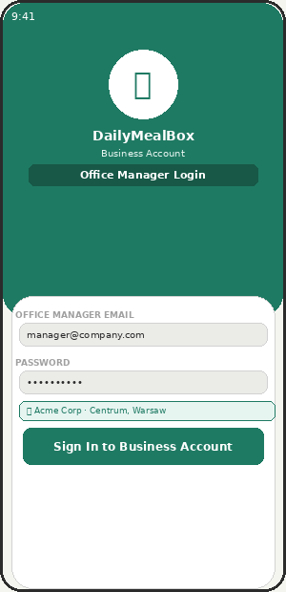  CA-19 — Office Login | 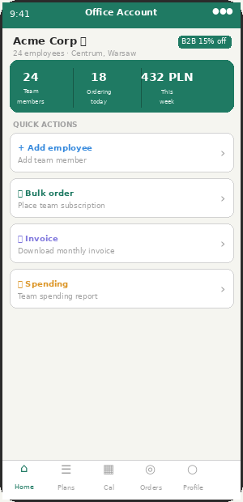  CA-20 — Office Dashboard

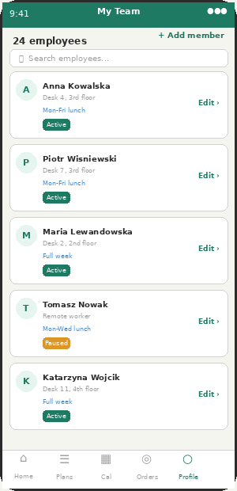  CA-21 — Team Management | CA-V3-02 — Consolidated Invoice (v3.0)

CA-19 | Office Manager Login | ✅ INCLUDED | v2.0

Feature | Status | Admin Control | Notes
Email + password login (not OTP) | ✅ INCLUDED | — | B2B accounts use email/password. OTP as 2FA option.
Company name + city shown on login | ✅ INCLUDED | — | Confirms correct business account.
Admin approves B2B applications (Super Admin) | ⚙ ADMIN | ACM-40 | Discount tier set per company.

CA-20 | Office Manager Dashboard | ✅ INCLUDED | v2.0

Feature | Status | Admin Control | Notes
Team stats: employees / ordering today / weekly spend | ✅ INCLUDED | — | Real-time.
B2B discount badge (e.g. "B2B 15% off") | ✅ INCLUDED | ACM-40 | Discount tiers: 10+ orders=10%, 20+=15%, 50+=20%. Admin sets.
Quick actions: Add employee / Bulk order / Invoice / Report | ✅ INCLUDED | — | All B2B tasks from dashboard.
Consolidated monthly VAT invoice download | ✅ INCLUDED | ACM-80 | NEW v3.0. Full EU VAT invoice. Company NIP. 7-year storage.

CA-21 | Team Management Screen | ✅ INCLUDED | v2.0

Feature | Status | Admin Control | Notes
Employee list with desk/address, plan, status | ✅ INCLUDED | — | Active / Paused / Pending badges.
Add / edit / remove employees | ✅ INCLUDED | — | Each employee can have different plan.
Bulk order for all employees | ✅ INCLUDED | — | One subscription per employee. System creates individual subscriptions.

13. OTA Updates & Admin Controls

OTA Update Banner — Appears without reinstall
All 100+ admin controls delivered via Firebase Remote Config (OTA). Admin changes a toggle → Remote Config updated → all installed apps update within 5–15 minutes. No App Store update needed. No reinstall needed. Works across all 3 apps simultaneously.
Key Admin Toggles (Customer App)
Feature | Default | Partial On? | Notes
VAT rate per city (food/delivery/service) | 8%/23%/23% | Yes — per vendor type | Admin changes → OTA → checkout recalculates. No code needed.
Weekly/monthly subscriptions | Always ON | No — core product | Cannot disable. Business model foundation.
One-time orders | ON | Per time window | Admin sets acceptance time window per slot.
GPS live tracking | ON | Per city | Admin disables for cities where Maps API cost is too high.
Loyalty points — earn | ON | Yes — earn on, redeem off | Earn-only phase during launch.
Referral programme | ON | No | On or off. Admin sets reward amounts.
Surprise meal box | OFF (Warsaw launch) | Per city | Test in Warsaw, enable in Berlin when ready.
B2B office accounts | ON | No | Admin approves each B2B application.
Flash deals | ON | Yes — on but require approval | Admin approves each vendor deal.
AI recommendations | ON | No | Admin disables if nutrition data coverage is too low.
Churn detection threshold | 2 skips/week | Value configurable | Admin sets: how many skips before retention card shows.
Invoice type lock | Customer choice | Yes — lock to one type | Admin can force all customers to use receipt or all to B2B invoice.

