DailyMealBox

PRODUCT REQUIREMENTS DOCUMENT
Part 2 — Vendor / Maker App · FINAL
Document | FINAL merged — supersedes all previous Vendor App versions
Version | v3.0 Final
Date | 22 May 2026
Platforms | Android + iOS (React Native)
Users | Home Cooks · Cloud Kitchens · Restaurants · Catering Companies
Brand | #1F7A63 Deep Green · #F5F5F0 Soft Beige · #2B2B2B Dark Gray
Developer | Appzeto — Indore, India
1. App Overview

The Vendor App is used by all meal providers: home cooks, cloud kitchens, restaurants, and catering companies. Key principle: all deliveries are handled by fleet partners — vendors NEVER self-deliver. Vendor role is: prepare food, mark ready, hand to driver. Everything else is handled by the platform.
1.1 Navigation — 5 Tab Bar
⌂ Home | 📋 Orders | 🍽 Menu | 💰 Earnings | ☰ More
Dashboard, alerts, forecast, ingredient plan, OTA banner | Today orders, preparation status board | Meals, nutrition, schedule, flash deals, surprise boxes | Wallet, VAT settlement, payouts, revenue forecast | Subscribers, analytics, featured listing, profile

2. Push Notification Catalogue — Vendor App (Complete)

All push notifications use Firebase Cloud Messaging (FCM). Every notification type is listed below with its trigger, text, channel, and admin control. Admin (Marketing Manager / Super Admin) can enable/disable each type via Admin Controls Matrix (ACM-27). OTP and legal notifications cannot be disabled.
Trigger Event | Notification Text | Recipient | Channel | Admin Control
Vendor application approved | Your kitchen is live! Welcome to DailyMealBox. Tap to complete your menu setup. | Vendor | FCM + Email | ACM-50 — cannot disable
Vendor application rejected | Your application was not approved. Reason: [reason]. Tap to resubmit. | Vendor | FCM + Email | ACM-50 — cannot disable
New subscriber joined | New subscriber! Anna K. from Centrum joined your plan. | Vendor | FCM Push | ACM-27 — admin can disable
Subscriber cancelled | A subscriber cancelled. Check your analytics for retention tips. | Vendor | FCM Push | ACM-27 — admin can disable
New order received (one-time) | New order from Centrum! Piotr M. ordered Rosol for tomorrow lunch. | Vendor | FCM Push | ACM-27 — admin can disable
Tomorrow order forecast ready | Tomorrow forecast ready: 19 orders expected. Rosol x14, Pierogi x10. Tap to see full plan. | Vendor | FCM Push | ACM-30 — time configurable per maker type
Cutoff approaching (2h warning) | Lunch cutoff in 2 hours (10:00). Accept orders and prepare your kitchen. | Vendor | FCM Push | ACM-27 — admin can disable
Driver assigned for pickup | Driver Jan W. (e-bike) assigned. Arrives ~11:45 for 22 boxes. Have orders ready with PIN. | Vendor | FCM Push | ACM-27 — cannot disable (ops critical)
Batch collected by driver | Batch A collected by Jan W. at 11:52. 8 boxes. PIN verified successfully. | Vendor | FCM Push | ACM-27 — admin can disable
Flash deal approved by admin | Your flash deal is live! Rosol 20% off — active until 14:00 today. | Vendor | FCM Push | ACM-41 — cannot disable
Flash deal rejected by admin | Flash deal rejected. Reason: [reason]. Edit and resubmit. | Vendor | FCM Push | ACM-41 — cannot disable
Payout processed | 2,480 PLN sent to your bank account. Arrives by next business day. | Vendor | FCM + Email | ACM-52 — cannot disable
Food licence expiring soon | Your EU food licence expires in 30 days. Upload renewal to avoid suspension. | Vendor | FCM + Email | ACM-49 — cannot disable (legal)
Food licence expired — suspended | Your account is suspended. Food licence expired. Upload renewal to reactivate. | Vendor | FCM + Email | ACM-49 — cannot disable (legal)
Customer complaint filed | A customer complaint was filed for order #DMB-009. CS team is reviewing. | Vendor | FCM Push | ACM-27 — admin can disable
Subscriber skip notification | Anna K. skipped tomorrow delivery. Update your preparation count. | Vendor | FCM Push | ACM-27 — admin can disable
Vacation mode activated | Your vacation mode is active 15–22 Jul. 34 subscribers paused and notified. | Vendor | FCM + Email | Auto — cannot disable
Kitchen returns from vacation | Welcome back! Your subscription resumes today. 19 orders expected. | Vendor | FCM Push | Auto — cannot disable
Commission rate changed | Your commission rate has been updated to 18%. Effective from next billing cycle. | Vendor | FCM + Email | ACM-51 — cannot disable

FCM Payload Examples — Vendor Notifications
// Example 1: New subscriber joined
FCM.send(vendor.device_token, {
title: "New subscriber! 🎉",
body: "Anna K. from Centrum joined your Healthy Weekly plan.",
data: {
screen: "subscribers", // deep link
subscriber_id: "user_anna_123",
event: "new_subscriber"
},
android: { priority: "high", notification: { sound: "default" } },
apns: { payload: { aps: { sound: "default", badge: 1 } } }
})
// Example 2: Driver assigned for pickup (CRITICAL — cannot be disabled)
FCM.send(vendor.device_token, {
title: "Driver assigned for pickup 🛵",
body: "Jan W. (e-bike ★4.9) arrives ~11:45. Prepare 22 boxes. Have PIN ready.",
data: {
screen: "delivery_assignment",
driver_id: "driver_jan_123",
driver_name: "Jan Wisniewski",
driver_vehicle: "ebike",
eta_time: "11:45",
box_count: 22,
event: "driver_assigned"
}
})
// Example 3: Tomorrow forecast ready (configurable time per maker type)
// Triggered by CRON at admin-configured time (default: home_cook=19:00, restaurant=20:00)
FCM.send(vendor.device_token, {
title: "Tomorrow forecast ready 📅",
body: "19 orders expected. Rosol x14, Pierogi x10. Tap to see ingredient plan.",
data: {
screen: "forecast",
date: "2026-05-13",
total_expected: 19,
event: "forecast_ready"
}
})
// Example 4: Flash deal approved
FCM.send(vendor.device_token, {
title: "Flash deal is live! 🔥",
body: "Rosol 20% off — active now until 14:00. Customers can see it.",
data: {
screen: "flash_deals",
deal_id: "deal_123",
event: "flash_deal_approved"
}
})
// Example 5: Payout processed
FCM.send(vendor.device_token, {
title: "Payment sent to your bank 💰",
body: "2,480 PLN transferred to PL61****. Arrives by next business day.",
data: {
screen: "earnings",
amount_pln: 2480,
event: "payout_processed"
}
})

3. Vendor Onboarding & Registration

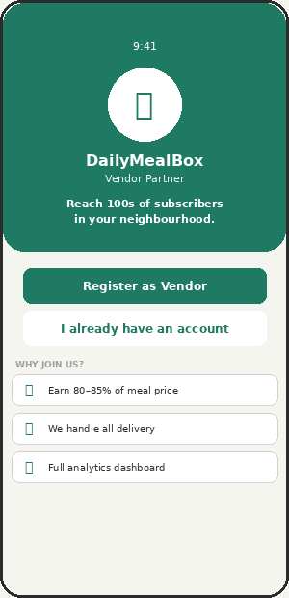  VM-01 — Vendor Welcome | 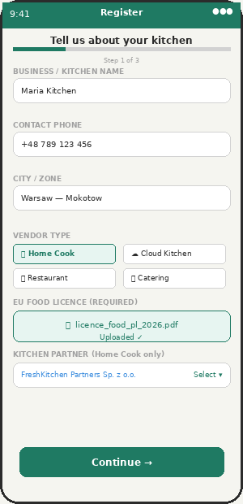  VM-02 — Registration

VM-01 | Vendor Welcome Screen | ✅ INCLUDED | v1.0

Feature | Status | Admin Control | Notes / Logic
DailyMealBox Vendor branding + 3 value propositions | ✅ INCLUDED | — | Earn 80-85% of meal price / Delivery handled / Full analytics.
Register CTA → VM-02 | ✅ INCLUDED | — | Starts registration flow.
Log in → vendor dashboard | ✅ INCLUDED | — | For returning vendors.
Admin can pause new vendor registrations per type | ⚙ ADMIN | ACM-47 | Per city / per vendor type / platform-wide.

VM-02 | Business Registration | ✅ INCLUDED | v1.0 + v3.0

Home cooks without a registered company must be linked to a Kitchen Partner company before going live. This is new in v3.0. The registration form detects vendor type "Home Cook" and shows the Kitchen Partner linking step.
Feature | Status | Admin Control | Notes / Logic
Business/kitchen name, phone, city, zone, vendor type | ✅ INCLUDED | ACM-47/48 | 4 types: Home Cook, Cloud Kitchen, Restaurant, Catering.
EU food business licence upload — MANDATORY | ✅ INCLUDED | ACM-49 (law) | Google Drive storage. Cannot go live without. 30-day expiry warning.
Owner ID document upload | ✅ INCLUDED | — | EU compliance. MISSING — must add to Appzeto scope.
Bank IBAN for payouts | ✅ INCLUDED | — | IBAN validation on input.
Kitchen Partner linking (Home Cook only) — NEW v3.0 | ✅ INCLUDED | — | If vendor_type = home_cook AND no company: must select Kitchen Partner from approved list. Kitchen Partner handles all invoicing and VAT.
VAT number (for restaurant/cloud kitchen/catering) | 💬 CONFIRMED | WhatsApp 11 Apr | Vendors with own company enter NIP/VAT number. Used on settlement statements.
Admin approval workflow | ✅ INCLUDED | ACM-50 | Pending → Approved/Rejected. Push + email notification.
Push: approved/rejected with reason | ✅ INCLUDED | ACM-50 | FCM + Email. Cannot disable. See notification catalogue Section 2.

4. Home Dashboard

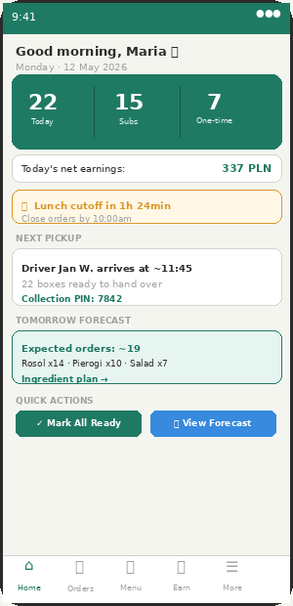  VM-03 — Dashboard | 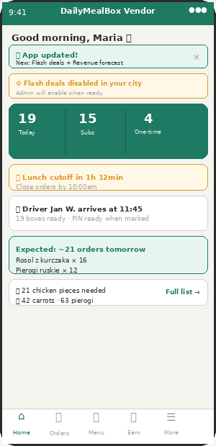  VM-03b — OTA + Admin Toggle Notice

VM-03 | Vendor Dashboard — Home Tab | ✅ INCLUDED | v1.0 + v2.0 + v3.0

Everything the vendor needs for today on one screen without scrolling. OTA banner appears when admin pushes a new feature. Admin-disabled features show amber notice — vendor never sees a broken button.
Feature | Status | Admin Control | Notes / Logic
Today order count (total / subscription / one-time) | ✅ INCLUDED | — | 3 stats in prominent green card. Real-time.
Today net earnings estimate (after commission + VAT) | ✅ INCLUDED | — | NEW v3.0: Shows net after 15% commission AND shows food VAT (8%) separately.
Cutoff countdown alert (amber — disappears after cutoff) | ✅ INCLUDED | ACM-55/56/57 | Admin sets cutoff per maker type.
Next driver pickup card (driver name, ETA, box count) | ✅ INCLUDED | — | Push notification sent when driver assigned — see notification catalogue.
Tomorrow forecast card + ingredient planning shortcut | 💬 CONFIRMED | ACM-30/WhatsApp 11 Apr | Push at admin-configured time per maker type.
OTA update banner (non-intrusive, dismissable) | ✅ INCLUDED | — | Green banner when admin pushes update.
Admin-disabled feature notice (amber) | ✅ INCLUDED | ACM toggles | If flash deals disabled in city: amber banner explains.
Mark all ready button → generates collection PINs + driver FCM push | ✅ INCLUDED | — | CRITICAL: push to driver with vendor address, box count, PIN.
New subscriber push notification | ✅ INCLUDED | ACM-27 | Push when new subscriber joins. See notification catalogue.

5. Order Management

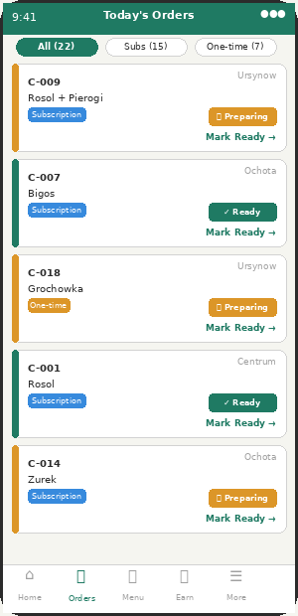  VM-04 — Orders Screen | 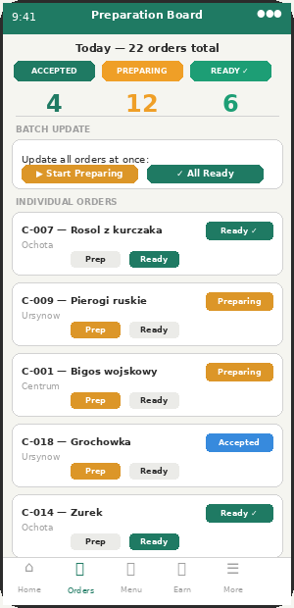  VM-05 — Preparation Board

VM-04 | Orders Screen | ✅ INCLUDED | v1.0

Feature | Status | Admin Control | Notes / Logic
Filter tabs: All / Subscription / One-time (count per tab) | ✅ INCLUDED | —
Order card: customer alias, zone, meal, type badge, status | ✅ INCLUDED | — | Never shows customer real name — alias only.
Accept/reject one-time orders | ✅ INCLUDED | — | Subscription = auto-accepted.
Customer special instructions on order card | ✅ INCLUDED | — | e.g. "no onions" — MISSING. Must add.
Push: new one-time order received | ✅ INCLUDED | ACM-27 | FCM push to vendor. See notification catalogue.
Push: subscriber skip notification | ✅ INCLUDED | ACM-27 | Vendor knows to reduce prep count.

VM-05 | Preparation Status Board | ✅ INCLUDED | v1.0 + v3.0

CRITICAL: MOST CRITICAL CROSS-APP DEPENDENCY: When vendor marks "All Ready", system must (1) generate collection PIN per batch, (2) FCM push to assigned driver with vendor address + box count + PIN. Without this, driver coordination requires phone calls every day.
Feature | Status | Admin Control | Notes / Logic
3 named statuses: Accepted → Preparing → Ready for Pickup | ✅ INCLUDED | — | Explicit names. Each triggers downstream actions.
Batch update: Start Preparing / All Ready | ✅ INCLUDED | — | One tap updates all orders.
Individual status change per order | ✅ INCLUDED | —
Collection PIN generation on mark-ready | ✅ INCLUDED | — | 4-digit PIN per batch. Redis, 2h expiry, single-use. MISSING.
Driver FCM push on Ready for Pickup | ✅ INCLUDED | — | FCM to driver: vendor name, address, box count, PIN. MISSING — most critical.
Status history log per order (timestamps) | ✅ INCLUDED | — | Used for admin dispute resolution.

Preparation Status → Collection PIN → Driver Push
// Vendor taps "Mark All Ready":
PATCH /api/orders/bulk/status { vendor_id, status:"ready_for_pickup" }
Backend:
1. UPDATE all orders for vendor today → preparation_status = "ready_for_pickup"
2. Log timestamp per order in status_history
3. Generate collection PIN per pickup batch:
const batches = groupOrdersByPickupTime(orders)
batches.forEach(async batch => {
const pin = Math.floor(1000 + Math.random() * 9000)
await redis.set("collection_pin:"+batch.id, pin, "EX", 7200) // 2h expiry
batch.collection_pin = pin
})
4. FCM push to assigned driver (CRITICAL — cannot be disabled):
FCM.send(driver.device_token, {
title: vendor.name + " is ready! 🟢",
body: batch.order_count + " boxes ready. PIN: " + pin + ". Tap to navigate.",
data: {
screen: "pickup_detail",
vendor_id, vendor_lat, vendor_lng, vendor_address,
batch_id, collection_pin: pin, box_count: batch.order_count
}
})
5. Vendor screen shows PIN per batch:
"Batch A PIN: 7842 — Show this to driver"
// Driver enters PIN in driver app → PATCH /api/collection/verify
// On correct PIN: orders → "collected", vendor notified via FCM:
FCM.send(vendor.device_token, {
title: "Batch A collected ✓",
body: "Jan W. collected 8 boxes at 11:52. PIN verified.",
data: { screen: "delivery_assignment", event: "batch_collected" }
})

6. Menu Management

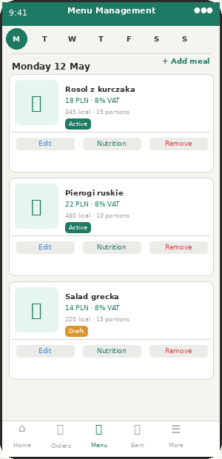  VM-06 — Menu Management | 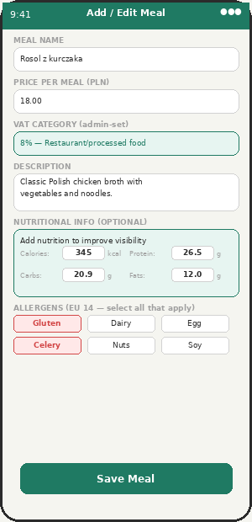  VM-07 — Add Meal + Nutrition

VM-06 | Menu Management Screen | ✅ INCLUDED | v1.0 + v2.0

Feature | Status | Admin Control | Notes / Logic
Weekly Mon–Sun calendar view | 💬 CONFIRMED | WhatsApp 11 Apr | Tap day to view/edit that day meals.
Meal cards: photo, price, nutrition summary, status badge | ✅ INCLUDED | — | Active / Draft / Archived.
Flash deal badge on active deals | ✅ INCLUDED | ACM-41 | If admin has enabled flash deals in city.
Surprise box badge on active boxes | ✅ INCLUDED | ACM-39 | If admin has enabled surprise boxes.
Add/Edit/Remove meals | ✅ INCLUDED | — | Routes to VM-07.
Draft mode (prepare before publishing) | ✅ INCLUDED | — | Draft = not visible to customers.
Push: menu uploaded → triggers tomorrow forecast push to subscribers | ✅ INCLUDED | ACM-30 | When vendor uploads tomorrow menu, system sends "Tomorrow menu" push to customers at configured time.

VM-07 | Add / Edit Meal + Nutrition | ✅ INCLUDED | v1.0 + v3.0

Feature | Status | Admin Control | Notes / Logic
Meal name, description, price, portions (capacity cap) | ✅ INCLUDED | ACM-58 | Required. Admin sets max per vendor type.
Meal photo upload (min 1) | ✅ INCLUDED | — | Firebase Storage or S3.
Calories (kcal) — optional | ✅ INCLUDED | ACM-44 | Admin sets which fields shown.
Protein (g) — optional | ✅ INCLUDED | ACM-44
Carbohydrates (g) — optional | ✅ INCLUDED | ACM-44
Fats (g) — optional | ✅ INCLUDED | ACM-44
EU allergen multi-select (14 standard + admin extras) | ✅ INCLUDED | ACM-46 (law) | Cannot remove EU 14. Admin can add extras.
Diet tags (vegan, gluten-free, keto) | ✅ INCLUDED | — | Used for customer filter.
VAT rate shown per meal (v3.0) | ✅ INCLUDED | ACM-80 | NEW v3.0. Shows: "This meal category: 8% VAT (restaurant/processed food)." Admin sets per vendor type.
Nutrition "not provided" fallback | ✅ INCLUDED | — | Meal still orderable. Shows note on customer screen.

7. Earnings, Wallet & VAT Settlement (v3.0)

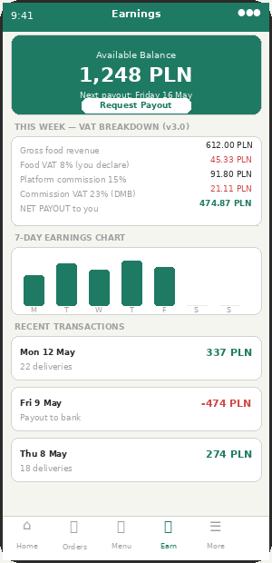  VM-08 — Earnings & Wallet | 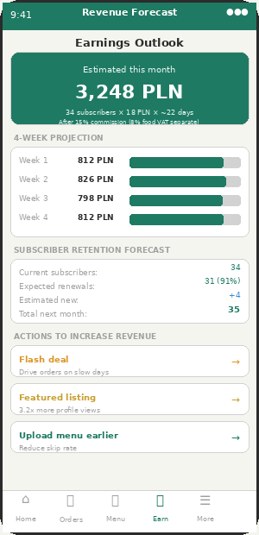  VM-NEW-07 — Revenue Forecast

VM-08 | Earnings & Wallet — with VAT Settlement | ✅ INCLUDED | v1.0 + v3.0

v3.0 adds full VAT breakdown to vendor earnings screen. Vendor sees: gross food revenue, food VAT (8%) that passes through to tax authority, platform commission, commission VAT (23%), and their actual net payout. This transparency is required for vendor accounting and EU VAT compliance.
Feature | Status | Admin Control | Notes / Logic
Available wallet balance (prominent green) | ✅ INCLUDED | — | After commission deductions.
Request payout button | ✅ INCLUDED | ACM-52 | Admin sets schedule. Vendor can request if admin allows.
Next payout date + estimated amount | ✅ INCLUDED | ACM-52 | Always shown. Default: every Friday 17:00.
VAT settlement breakdown (v3.0) | ✅ INCLUDED | ACM-80 | NEW. Shows per week: gross food revenue, food VAT 8% (vendor declares), platform commission, commission VAT 23% (DMB declares), net vendor payout.
This week earnings: gross / commission / net | ✅ INCLUDED | ACM-51 | Commission rate shown explicitly.
7-day earnings bar chart | ✅ INCLUDED | — | Visual trend.
Transaction log with type (delivery/payout/refund/commission) | ✅ INCLUDED | —
Push: payout processed | ✅ INCLUDED | ACM-52 | FCM + Email. Cannot disable. Amount, bank, expected arrival date.
Push: commission rate changed | ✅ INCLUDED | ACM-51 | FCM + Email if admin changes commission rate.

Vendor Settlement Statement — VAT Breakdown (v3.0)
// Weekly settlement calculation for vendor:
async function calculateVendorSettlement(vendorId, weekStart, weekEnd) {
const orders = await Order.find({
vendor_id: vendorId,
delivery_date: { $gte: weekStart, $lte: weekEnd },
status: "delivered"
})
const vendor = await Vendor.findById(vendorId)
const vatRate = await remoteConfig.get("food_vat_rate_" + vendor.city)
// e.g. 0.08 for Warsaw (8% — corrected from 5%)
let grossFoodRevenue = 0, commissionAmount = 0
orders.forEach(order => {
grossFoodRevenue += order.meal_price
commissionAmount += order.meal_price * vendor.commission_rate
})
// VAT calculations:
const foodNetRevenue = grossFoodRevenue / (1 + vatRate)
const foodVatAmount = grossFoodRevenue - foodNetRevenue
// Note: food VAT "belongs" to vendor — they declare it to tax authority
// DailyMealBox passes the gross food amount to vendor
const commissionNet = commissionAmount / 1.23 // 23% VAT on commission
const commissionVat = commissionAmount - commissionNet
// Commission VAT belongs to DailyMealBox
const vendorNetPayout = grossFoodRevenue - commissionAmount
// Vendor receives: gross food - commission (both inclusive of VAT)
// Settlement statement stored:
return {
period: { start: weekStart, end: weekEnd },
orders_count: orders.length,
gross_food_revenue_pln: grossFoodRevenue,
food_vat_rate: vatRate * 100 + "%", // 8%
food_vat_amount: foodVatAmount, // vendor declares this
food_vat_owner: "vendor",
platform_commission_gross: commissionAmount,
platform_commission_vat: commissionVat, // DailyMealBox declares this
platform_commission_net: commissionNet,
vendor_net_payout: vendorNetPayout,
kitchen_partner_id: vendor.kitchen_partner_id || null,
// If home cook: DailyMealBox pays Kitchen Partner, KP pays cook
}
}
// Home cook settlement (via Kitchen Partner):
if (vendor.kitchen_partner_id) {
// DailyMealBox pays Kitchen Partner:
const kpPayout = vendorNetPayout // full net goes to KP
// Kitchen Partner pays home cook:
const cookPayout = vendorNetPayout * kitchenPartner.settlement_split // e.g. 85%
const kpFee = vendorNetPayout * kitchenPartner.management_fee_pct // e.g. 15%
}

8. Smart Features (v2.0 + v3.0)

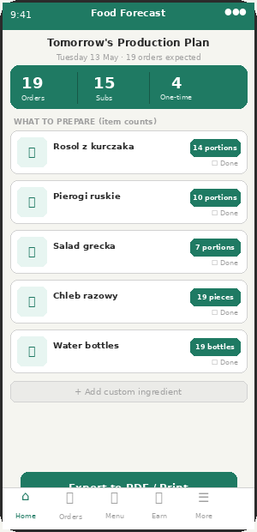  VM-NEW-01 — Food Forecast | 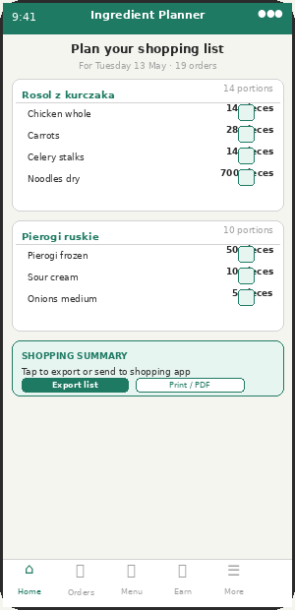  VM-NEW-02 — Ingredient Planner

VM-NEW-01 | Food Forecast Screen | ✅ INCLUDED | v2.0

Feature | Status | Admin Control | Notes / Logic
Tomorrow expected order count (subscriptions + estimated one-time) | 💬 CONFIRMED | ACM-30/WhatsApp 11 Apr | Algorithm: confirmed subs + 4-week average one-time × 1.1 buffer.
Per-meal item counts (what to prepare) | ✅ INCLUDED | — | Item count only (Phase 1 decision). kg/litre = Phase 2.
Checklist with mark-as-done per item | ✅ INCLUDED | — | Visual progress.
Export to PDF / Print | ✅ INCLUDED | — | Printable kitchen order sheet.
Push trigger: forecast ready at admin-set time | ✅ INCLUDED | ACM-30 | Home cook: 7pm. Restaurant: 8pm. Catering: 6pm. Configurable.

VM-NEW-02 | Ingredient Planner | ✅ INCLUDED | v2.0

Feature | Status | Admin Control | Notes / Logic
Per-meal ingredient breakdown (recipe × order count) | ✅ INCLUDED | — | Vendor sets recipe once. System multiplies by expected count.
Item count units only (Phase 1) | ✅ INCLUDED | — | e.g. "14 chicken pieces, 28 carrots." kg/litre in Phase 2.
Export shopping list (email / PDF / copy) | ✅ INCLUDED | — | Useful for market visits.

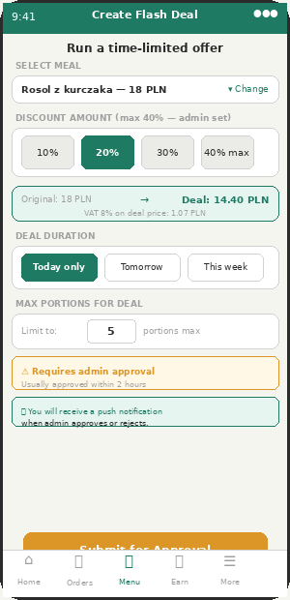  VM-NEW-03 — Flash Deal Creation | 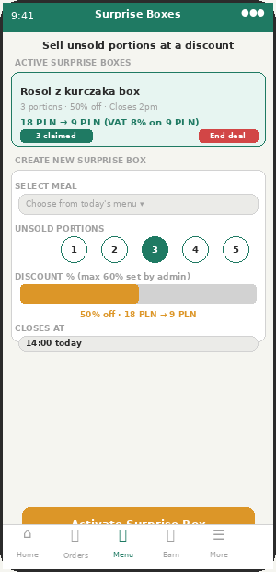  VM-NEW-04 — Surprise Box Vendor

VM-NEW-03 | Flash Deal Creation | ✅ INCLUDED | v2.0 + v3.0

Feature | Status | Admin Control | Notes / Logic
Select meal, set discount %, duration, max portions | ✅ INCLUDED | ACM-41/60 | Max discount: admin-set (default 40%).
Price preview: original → deal price + VAT note (v3.0) | ✅ INCLUDED | ACM-80 | NEW v3.0. Shows: "Deal price 14.40 PLN (incl. 8% VAT on discounted price)." VAT calculated on actual charged amount.
Admin approval required before going live | ✅ INCLUDED | ACM-41 | Dashboard + email alert to admin. 2h auto-escalation.
Push: flash deal approved | ✅ INCLUDED | ACM-41 | FCM to vendor. Cannot disable. See notification catalogue.
Push: flash deal rejected with reason | ✅ INCLUDED | ACM-41 | FCM to vendor. Cannot disable.

VM-NEW-04 | Surprise Meal Box (Vendor Side) | ✅ INCLUDED | v2.0

Feature | Status | Admin Control | Notes / Logic
List unsold portions at discount (up to admin max 60%) | ✅ INCLUDED | ACM-39/60 | No admin approval needed — self-serve within limits.
Set portion count, discount %, close time | ✅ INCLUDED | —
End deal early button | ✅ INCLUDED | — | Vendor can close early if sold out manually.
Admin can disable per city | ⚙ ADMIN | ACM-39 | If city not ready for surprise boxes.

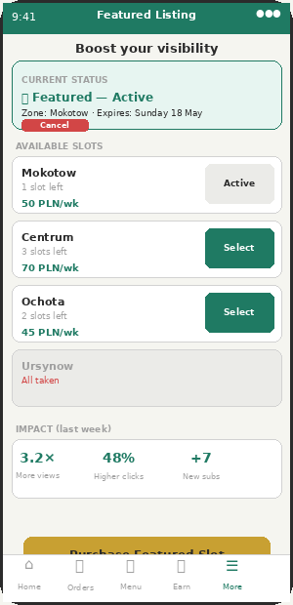  VM-NEW-05 — Featured Listing | 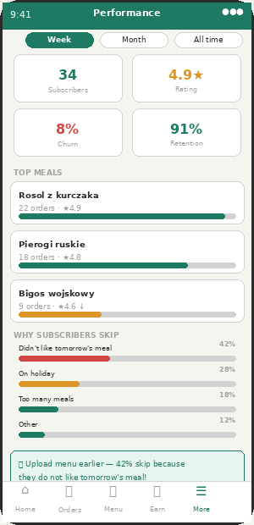  VM-NEW-08 — Analytics v2

VM-NEW-05 | Featured Listing Management | ✅ INCLUDED | v2.0

Feature | Status | Admin Control | Notes / Logic
Current featured status with zone + expiry | ✅ INCLUDED | ACM-42
Available slots per zone with price per week | ✅ INCLUDED | ACM-42/54 | Admin sets price per zone.
Purchase featured slot (deducted from wallet) | ✅ INCLUDED | ACM-42
Featured listing impact stats (views, clicks, new subs) | ✅ INCLUDED | — | Shows ROI from last active featured slot.

VM-NEW-08 | Enhanced Analytics v2 (with Skip Reasons) | ✅ INCLUDED | v2.0

Feature | Status | Admin Control | Notes / Logic
Period selector: Week / Month / All time | ✅ INCLUDED | —
KPIs: Subscribers / Rating / Churn / Retention | ✅ INCLUDED | ACM-62 | Admin restricts which metrics vendors see.
Skip reason breakdown (v2.0) | ✅ INCLUDED | ACM-62 | Why subscribers skip. Actionable insight for vendor.
Actionable insight panel ("Upload menu earlier!") | ✅ INCLUDED | — | Auto-generated text based on skip data.
Admin can restrict which metrics vendors see | ⚙ ADMIN | ACM-62 | Protects platform-sensitive data.

9. Cutoff, Vacation Mode & Delivery Assignment

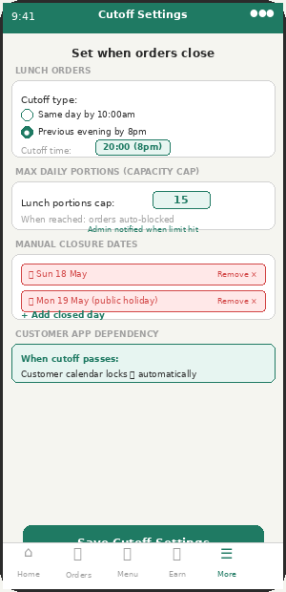  VM-14 — Cutoff Settings | 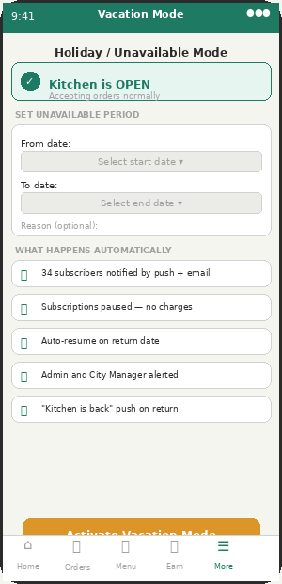  VM-13 — Vacation Mode

VM-14 | Order Cutoff & Capacity Settings | ✅ INCLUDED | v1.0

Feature | Status | Admin Control | Notes / Logic
Lunch cutoff type + time (prev evening or same day) | ✅ INCLUDED | ACM-55 | Home cook default: prev evening 20:00. Admin sets limits.
Dinner cutoff type + time | ✅ INCLUDED | ACM-56 | Restaurant default: same day 15:00.
Max daily portions capacity cap | ✅ INCLUDED | ACM-58 | Admin sets max per vendor type. System auto-closes when reached.
Manual closure dates (holidays) | ✅ INCLUDED | — | Specific day closures. Different from vacation mode.
Customer app cutoff lock dependency | ✅ INCLUDED | ACM-55/56/57 | VM-14 feeds CA-12 calendar lock. When cutoff passes: customer cannot order.
Admin alert when capacity reached | ⚙ ADMIN | ACM-58 | Signal to add more vendors in that zone.

VM-13 | Vacation / Holiday Mode | ✅ INCLUDED | v1.0 — MISSING from Appzeto scope

MISSING: MISSING FROM APPZETO SCOPE — MUST ADD. Full automation: subscribers auto-pause, no charges, auto-resume on return, subscriber notifications, admin alert.
Feature | Status | Admin Control | Notes / Logic
Date range picker (from → to) | ✅ INCLUDED | — | Must add.
Auto-pause all affected subscriptions (no charges) | ✅ INCLUDED | — | Must add.
Subscriber push + email notification on vacation activate | ✅ INCLUDED | — | Push + email to all 34 affected subscribers.
Admin/City Manager alert | ✅ INCLUDED | ACM-63 | Admin knows to find backup vendor coverage in zone.
Auto-resume on return date (CRON) | ✅ INCLUDED | — | Must add. Push to subscribers: "Kitchen is back!"
Push: vacation activated to subscribers | ✅ INCLUDED | — | FCM + Email to all affected subscribers.
Push: kitchen returns from vacation | ✅ INCLUDED | — | FCM push to all subscribers day of return.

VM-10 | Delivery Assignment | ✅ INCLUDED | v1.0

Feature | Status | Admin Control | Notes / Logic
Assigned driver card (name, vehicle, ETA) | ✅ INCLUDED | — | Visible from 10:30am after daily route generation.
Batch breakdown (time, box count, zones) | ✅ INCLUDED | — | Vendor knows exactly what to prepare per batch.
Collection PIN display per batch | ✅ INCLUDED | — | MISSING: 4-digit PIN shown when vendor marks Ready. Must add.
Confirm all ready button → generates PINs + driver FCM | ✅ INCLUDED | — | Must include FCM push to driver.
Driver quick messages received (toast) | ✅ INCLUDED | ACM-53 | Vendor sees: "On my way (5 min)" from driver.

10. Profile & Kitchen Partner Model

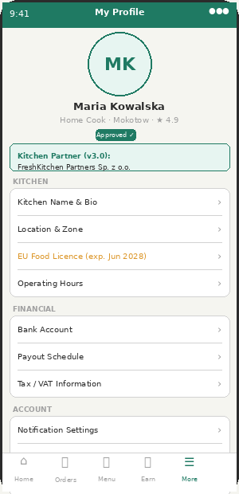
VM-12 — Vendor Profile
VM-12 | Vendor Profile & Settings | ✅ INCLUDED | v1.0 + v3.0

Feature | Status | Admin Control | Notes / Logic
Kitchen name, bio, zone, hours | ✅ INCLUDED | — | Public-facing listing details.
EU food licence view/update (with expiry) | ✅ INCLUDED | ACM-49 | 30-day warning push. Auto-suspend on expiry.
Vacation mode shortcut → VM-13 | ✅ INCLUDED | —
Bank account + payout schedule (if admin allows change) | ✅ INCLUDED | ACM-52
VAT/tax number (restaurant/cloud kitchen) | 💬 CONFIRMED | WhatsApp 11 Apr | NIP for vendor VAT registration.
Kitchen Partner details (Home Cook only) — v3.0 | ✅ INCLUDED | — | Shows linked Kitchen Partner name. Cannot change without admin approval. Kitchen Partner handles all VAT/invoicing.
Notification preferences | ✅ INCLUDED | — | Toggle per notification type.
Deactivate account (red, requires confirmation) | ✅ INCLUDED | — | Admin notified on deactivation.

10.1 Kitchen Partner Model for Home Cooks
Home cooks without a registered company must link to a Kitchen Partner before going live. The Kitchen Partner is a registered Sp. z o.o. that holds the EU food safety certification, issues food invoices on behalf of the home cook, receives payment from DailyMealBox, and pays the home cook their share (typically 85%).
Aspect | Restaurant (own company) | Home Cook (via Kitchen Partner)
Invoice issuer | Vendor issues own food invoice (or DMB self-invoices) | Kitchen Partner issues food invoice to DailyMealBox
VAT registration | Vendor has own NIP. Declares food VAT themselves. | Kitchen Partner has NIP. Declares food VAT for all linked cooks.
Payment flow | DMB pays vendor net (food minus commission) | DMB pays Kitchen Partner. KP pays cook 85% of net.
EU food safety | Restaurant has own Sanepid cert | Kitchen Partner holds Sanepid for the certified kitchen space
Customer sees | Vendor name on listing. DMB on invoice. | Home cook name on listing. DMB on customer invoice.

