DailyMealBox

PRODUCT REQUIREMENTS DOCUMENT
Part 3 — Driver / Delivery Partner App · FINAL

Document | FINAL merged — supersedes all previous Driver App versions
Version | v3.0 Final
Date | 23 May 2026
Platforms | Android + iOS (React Native) — DARK THEME throughout
Users | Bicycle · E-bike · Scooter · Car delivery partners
Brand colours | Dark theme: #1A1A18 background · #1F7A63 green · #FFFFFF text
Developer | Appzeto — Indore, India

1. App Overview & Architecture

The DailyMealBox Driver App guides drivers through their entire shift: from going online, receiving their optimised multi-stop route, collecting boxes from vendors (with PIN verification), delivering to customers (with PIN or photo proof), and managing their earnings and cash COD balance. All delivery logic runs on the backend — driver app only displays and navigates.
Navigation — 4 Tab Bar (Dark Theme)
⌂ Home | 🗺 Route | 💰 Earnings | 👤 Profile
Online/offline toggle, active order, bonus, cash, tips | Full day route, stop list, pickup/delivery sequence | Daily/weekly/monthly, tips, COD, payouts | Documents, vehicle, bank, shifts, fleet partner info

2. Push Notification Catalogue — Driver App (Complete)

All driver push notifications use Firebase Cloud Messaging (FCM). Driver app is dark-themed — notifications appear as bright green/amber alerts. Critical operational notifications (new order, route update, cash limit) cannot be disabled. Safety notifications (arriving soon to customer) are cross-app and handled by the backend.
Trigger Event | Notification Text | Recipient | Channel | Admin Control
Driver application approved | Welcome! You are approved. First shift: Monday. Tap to see your schedule. | Driver | FCM + Email | ACM-64 — cannot disable
Driver application rejected | Application not approved. Reason: [reason]. Tap to resubmit documents. | Driver | FCM + Email | ACM-64 — cannot disable
New order assigned to driver | New delivery! Pickup: Maria's Kitchen (Mokotow). 5 boxes. Tap to navigate. | Driver | FCM Push | Cannot disable — ops critical
Route updated (after reassignment) | 3 new deliveries added to your route. Route re-optimised. Tap to see. | Driver | FCM Push | Cannot disable — ops critical
Vendor ready for pickup (collection PIN) | Maria's Kitchen is ready! 8 boxes. PIN: 7842. Tap to navigate. | Driver | FCM Push | Cannot disable — ops critical
Customer notified: arriving soon | Customer C7 notified. Driver within 500m. PIN confirmed sent to customer. | Driver (internal) | In-app | ACM-24 — auto-trigger
Cash COD limit reached | Cash limit reached: 500 PLN. Please report to admin before next delivery. | Driver | FCM Push | ACM-73 — cannot disable
Cash COD approaching limit (80%) | Cash balance: 400 PLN (80% of 500 PLN limit). Contact admin soon. | Driver | FCM Push | ACM-73 — can disable
Bonus milestone unlocked | Bonus unlocked! 150 PLN added to your earnings. 30 deliveries completed. | Driver | FCM Push | ACM-71 — can disable
Shift starting reminder (30 min) | Lunch shift starts in 30 min (11:00). Go online when ready in your zone. | Driver | FCM Push | ACM-76 — can disable
Payout processed | 720 PLN sent to your bank. Cash netted: 85 PLN. Bank transfer: 635 PLN. | Driver | FCM + Email | ACM-68 — cannot disable
Driving licence expiring | Driving licence expires in 60 days. Upload renewal to avoid suspension. | Driver | FCM + Email | ACM-67 — cannot disable
Driving licence expired — suspended | Account suspended: licence expired. Upload renewal to reactivate. | Driver | FCM + Email | ACM-67 — cannot disable
Document approved by admin | Your [document name] has been approved. Account remains active. | Driver | FCM Push | ACM-64 — cannot disable
Document rejected — reupload required | Your [document] was rejected. Reason: [reason]. Please upload again. | Driver | FCM Push | ACM-64 — cannot disable
Admin force-offline (emergency) | You have been taken offline by admin. Reason: [reason]. Contact support. | Driver | FCM Push | Cannot disable — safety
Vendor quick message reply | Maria's Kitchen: "Orders ready at 11:50" — tap to view. | Driver | FCM Push | ACM-53 — can disable
Failed delivery: admin action required | Failed delivery reported for C7. Admin will arrange reattempt or refund. | Driver | In-app | Cannot disable

Key FCM Payloads — Driver Notifications
// 1. Vendor ready for pickup (CRITICAL — cannot disable):
FCM.send(driver.device_token, {
title: "Maria's Kitchen is ready! 🟢",
body: "8 boxes ready. Collection PIN: 7842. Tap to navigate.",
data: {
screen: "pickup_detail",
vendor_id, vendor_lat, vendor_lng, vendor_address,
batch_id, collection_pin: "7842", box_count: 8,
event: "vendor_ready"
},
android: { priority: "high" }
})
// 2. New order assigned:
FCM.send(driver.device_token, {
title: "New delivery assigned 📦",
body: "Pickup: Maria's Kitchen (Mokotow). 5 boxes. Navigate now.",
data: { screen: "route", event: "order_assigned" }
})
// 3. Cash limit reached (CRITICAL — cannot disable):
FCM.send(driver.device_token, {
title: "⚠ Cash limit reached!",
body: "You hold 500 PLN cash. Contact admin before next COD delivery.",
data: { screen: "earnings", event: "cash_limit_reached",
cash_amount: driver.cash_balance }
})
// 4. Bonus unlocked:
FCM.send(driver.device_token, {
title: "🎉 Bonus unlocked!",
body: "150 PLN bonus added! You completed 30 deliveries this week.",
data: { screen: "earnings", event: "bonus_unlocked", bonus_pln: 150 }
})
// 5. Shift reminder (30 min before):
// CRON: run 30 min before each city's shift start time
FCM.send(driver.device_token, {
title: "Shift starts in 30 minutes ⏰",
body: "Lunch shift 11:00–14:00. Go online when ready in Mokotow zone.",
data: { screen: "home", event: "shift_reminder", shift: "lunch" }
})

3. Driver Onboarding & Registration

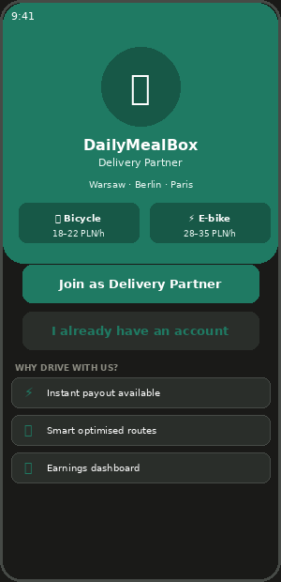  DA-01 — Driver Welcome | 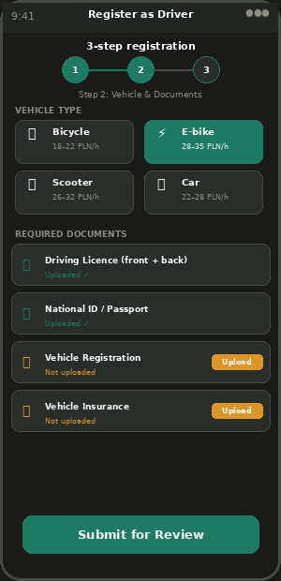  DA-02 — Registration (3 Steps)

DA-01 | Driver Welcome Screen | ✅ INCLUDED | v1.0

Dark-themed welcome screen. Shows earnings potential per vehicle type (Warsaw research 2025-26: e-bike = highest earner at 28–35 PLN/h). Earnings calculator converts hesitant drivers before they even sign up.
Feature | Status | Admin Control | Notes / Logic
DailyMealBox Delivery Partner branding | ✅ INCLUDED | — | Dark background, green accents. Shows "Warsaw · Berlin · Paris" coverage.
Earnings preview per vehicle type | ✅ INCLUDED | ACM-64/65 | Bicycle: 18–22 PLN/h. E-bike: 28–35 PLN/h. Scooter: 26–32 PLN/h. Admin enables vehicle types per city.
Key benefits: instant payout / routes / dashboard | ✅ INCLUDED | — | 3 feature highlights. Drives sign-up conversion.
Join as Driver CTA → Registration | ✅ INCLUDED | — | Starts 3-step registration flow.
Admin can pause new driver registrations | ⚙ ADMIN | ACM-64 | Per city / per vehicle type / platform-wide. Shows "Applications paused" message.
Push: application approved/rejected | ✅ INCLUDED | ACM-64 | FCM + Email. Cannot disable. See notification catalogue Section 2.

DA-02 | Driver Registration — 3 Steps | ✅ INCLUDED | v1.0

Feature | Status | Admin Control | Notes / Logic
Step 1: Personal details (name, phone, email, DOB) | ✅ INCLUDED | — | DOB required for age verification (minimum 18).
Step 2: Vehicle type selection | ✅ INCLUDED | ACM-65 | Admin enables/disables each vehicle type per city. Disabled types greyed out.
Step 3: Document upload | ✅ INCLUDED | — | Google Drive storage for all driver documents.
Driving licence (front + back) — MANDATORY | ✅ INCLUDED | ACM-67 | Stored on Google Drive. System checks expiry. 60-day warning push.
National ID (passport or national ID) — MANDATORY | ✅ INCLUDED | — | EU gig worker compliance. Front photo required.
Vehicle registration | ✅ INCLUDED | — | For scooter and car drivers only.
Bank account IBAN for earnings payouts | ✅ INCLUDED | — | Polish/EU IBAN. Validated on input.
Fleet Partner assignment (v3.0) | ✅ INCLUDED | — | Driver profile shows which fleet partner company they belong to. Set by admin on approval.
Admin approval required before going live | ✅ INCLUDED | ACM-64 | City Manager reviews. Push + email on decision.
Push: document approved / rejected | ✅ INCLUDED | ACM-64 | FCM + Email. Cannot disable.

4. Driver Home — Online / Offline Hub

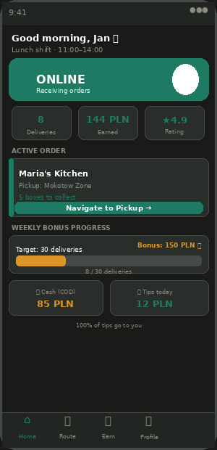
DA-03 — Driver Home (Online State)
DA-03 | Driver Home Screen | ✅ INCLUDED | v1.0

The driver command centre. Large online/offline toggle is the most important UI element. All key information visible without scrolling. Dark theme reduces screen glare outdoors.
Feature | Status | Admin Control | Notes / Logic
Large online/offline toggle (full-width, impossible to miss) | ✅ INCLUDED | ACM-76 | Green when online, dark when offline. Shift enforcement built in.
Today stats: deliveries / earned / rating | ✅ INCLUDED | — | Real-time. Updates after each confirmed delivery.
Active order card (vendor → navigate) | ✅ INCLUDED | — | Shows vendor name, zone, box count. One-tap navigate.
Weekly bonus progress bar (amber) | ✅ INCLUDED | ACM-71 | Only shown if admin has enabled bonus programme.
Cash balance (COD held) — amber card | ✅ INCLUDED | ACM-73 | Colour turns red when approaching cash limit (>80%).
Tips earned today (separate from earnings) | ✅ INCLUDED | ACM-50 | Only shown if admin enabled tips. "100% goes to you."
Shift time display | ✅ INCLUDED | ACM-76 | Shows current shift: "Lunch shift 11:00–14:00."
Admin-disabled feature notices | ✅ INCLUDED | All ACM | If COD disabled: cash section hidden. If tips off: tips section hidden.
Push: shift starting reminder (30 min before) | ✅ INCLUDED | ACM-76 | FCM push 30 min before shift. Can disable. See notification catalogue.

Online/Offline Toggle — Shift Enforcement
// Driver taps Go Online:
POST /api/drivers/{id}/online
Backend validation:
1. Check shift is active:
const shiftStart = remoteConfig.get("lunch_shift_start_warsaw") // "11:00"
const shiftEnd = remoteConfig.get("lunch_shift_end_warsaw") // "14:00"
if (now < shiftStart || now > shiftEnd)
return error("Your lunch shift starts at " + shiftStart)
2. Check driver active + documents not expired:
if (driver.status !== "active")
return error({ code: "account_suspended" })
3. Set online + start GPS streaming:
driver.is_online = true
redis.set("driver:" + driver.id + ":online", 1, "EX", 18000) // 5h max
// GPS streaming (5-second interval when online):
socket.emit("location_update", {
driver_id, lat, lng, timestamp: Date.now()
})
// Backend → Redis → Customer app + Admin live map

5. Route Display — Multi-Stop Optimised

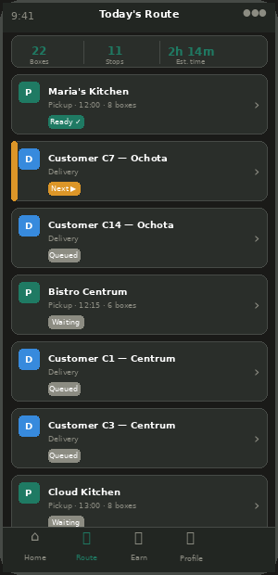
DA-04 — Today's Route (Full Stop List)
DA-04 | Route Display Screen | ✅ INCLUDED | v1.0

VRPTW algorithm runs on backend at 10:00am daily. Driver sees an ordered stop list — pickups (green P) and deliveries (blue D) interleaved. All routing logic on backend. Driver app only displays and navigates.
Feature | Status | Admin Control | Notes / Logic
Route summary: total boxes / stops / estimated time | ✅ INCLUDED | — | Header bar. Calculated by backend using Google Maps traffic data.
Ordered stop list (pickups + deliveries interleaved) | ✅ INCLUDED | ACM-77 | Colour-coded: P=green, D=blue. Next stop highlighted with NEXT badge.
NEXT badge on current stop + Navigate button | ✅ INCLUDED | — | One tap → opens Google Maps with vendor/customer address.
Pickup stop: vendor name, address, time window, box count | ✅ INCLUDED | — | Time window shown. If vendor not ready: shows waiting message.
Delivery stop: customer alias, zone, box number assigned | ✅ INCLUDED | — | Never shows full address on list (privacy). Full address shown when navigating only.
Load manifest per pickup (which box goes where) | ✅ INCLUDED | — | Tap any pickup stop → see box list: "Box 1 → C7 Ochota."
Admin sets route optimisation priority | ⚙ ADMIN | ACM-77 | Fastest / Most deliveries / Balanced. Admin switches per city.
Push: route updated (after reassignment) | ✅ INCLUDED | — | FCM push when admin reassigns orders to this driver.

6. Pickup from Vendor — Collection PIN

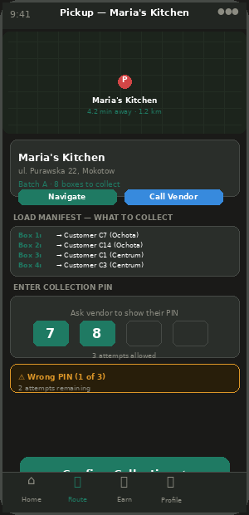
DA-05 — Vendor Pickup with Collection PIN
DA-05 | Vendor Pickup Screen | ✅ INCLUDED | v1.0

CRITICAL: Collection PIN creates a verified chain of custody. Vendor shows PIN on their screen, driver enters it here. MISSING from original Appzeto scope — must be confirmed included.
Feature | Status | Admin Control | Notes / Logic
Map showing route to vendor (dark themed) | ✅ INCLUDED | ACM-23 | Dark Google Maps. ETA countdown.
Vendor info card: name, address, batch, box count | ✅ INCLUDED | — | Shows which batch and how many boxes to collect.
Navigate + Call vendor buttons | ✅ INCLUDED | — | Navigate: Google Maps. Call: masked number via Twilio Proxy.
Collection PIN entry field (4 digits) | ✅ INCLUDED | — | MISSING — must add. Vendor shows PIN, driver enters here. 3 attempts then admin alerted.
Load manifest (which box → which customer) | ✅ INCLUDED | — | Driver knows before leaving vendor.
Wrong PIN handling (3 attempts + admin alert) | ✅ INCLUDED | — | MISSING. After 3 fails: admin alerted, vendor can regenerate PIN.
Vendor not ready: polling + wait screen | ✅ INCLUDED | — | App polls vendor status every 60s. Shows estimated wait.

7. Customer Delivery — PIN + Photo Proof

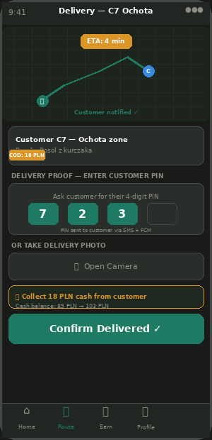
DA-06 — Delivery Screen with Proof
DA-06 | Customer Delivery Screen | ✅ INCLUDED | v1.0 + v3.0

Feature | Status | Admin Control | Notes / Logic
Dark map with customer as destination pin | ✅ INCLUDED | ACM-23 | Driver navigating to customer. Route shown in green.
ETA badge (updates every 30s) | ✅ INCLUDED | ACM-24 | Google Distance Matrix API.
"Arriving Soon" auto-sent to customer (500m trigger) | ✅ INCLUDED | ACM-24 | System auto-sends push to customer. Driver sees "Customer notified ✓."
Customer info card (alias, zone, meal, COD amount) | ✅ INCLUDED | — | Never shows full name or phone number (privacy).
Delivery PIN entry (if customer chose PIN) | ✅ INCLUDED | — | MISSING. Driver asks customer for 4-digit PIN. Backend validates. GPS + timestamp logged.
Delivery photo capture (if customer chose photo) | ✅ INCLUDED | — | MISSING. Driver taps camera, takes photo at door. Uploaded to Firebase/S3.
Masked calling via Twilio Proxy (v3.0) | ✅ INCLUDED | — | NEW. Driver taps Call → Twilio Proxy connects via masked number. Neither party sees real number.
Admin can lock proof method platform-wide | ⚙ ADMIN | ACM-25 | PIN / Photo / Customer choice.
COD cash collection (amber indicator) | ✅ INCLUDED | ACM-73 | Amber "Collect: 18 PLN cash" shown. After confirmed: driver.cash_balance updated.
GPS mismatch fraud detection (v3.0) | ✅ INCLUDED | — | NEW. If GPS at delivery > 500m from address: flagged for admin review.
Confirm Delivered CTA (only enabled after proof) | ✅ INCLUDED | — | Large green button. Disabled until PIN entered or photo taken.

Delivery Confirmation — PIN or Photo + Fraud Check
// Method A — PIN:
POST /api/delivery/verify-pin
{ order_id, pin_entered: "7234", driver_id, delivery_gps: {lat, lng} }
Backend:
const stored = redis.get("delivery_pin:" + order_id)
if (pin_entered !== stored) return error("Incorrect PIN")
// FRAUD CHECK (v3.0):
const distance = haversineDistance(delivery_gps, order.delivery_address)
if (distance > 500) {
flagForReview(driver_id, "GPS_MISMATCH", { distance, order_id })
// Still confirm delivery (driver may be in alley) but flag for admin
}
confirmDelivery(order_id, driver_id, "pin", delivery_gps)
// Method B — Photo:
POST /api/delivery/verify-photo (multipart)
{ order_id, photo: imageFile, driver_id, delivery_gps: {lat, lng} }
photo_url = await uploadPhoto(imageFile) // Firebase Storage
confirmDelivery(order_id, driver_id, "photo", delivery_gps, photo_url)
// confirmDelivery — shared function:
async function confirmDelivery(order_id, driver_id, method, gps, photo=null) {
// Update order:
order.status = "delivered"; order.delivered_at = now()
order.proof_method = method; order.proof_photo_url = photo
order.delivery_gps = gps
// COD cash (v3.0 — fleet partner owns tip VAT):
if (order.payment_method === "cod") {
driver.cash_balance += order.price_pln
if (driver.cash_balance >= driver.cash_limit_pln) {
FCM.send(driver, "Cash limit reached — contact admin")
notifyAdmin("CASH_LIMIT", driver)
}
}
// Tip VAT note (v3.0 correction):
// Tip gross amount goes 100% to driver via fleet partner
// Fleet partner declares 23% VAT on tips to tax authority
// Driver sees tip gross amount in earnings (VAT already handled by fleet)
FCM.send(customer, "Delivered! Enjoy your meal. Rate your experience →")
driver.earnings_today += order.delivery_fee_pln
driver.deliveries_today += 1
checkBonusProgress(driver_id)
}

8. Failed Delivery Flow

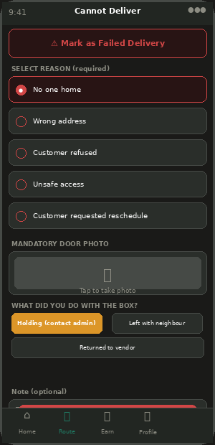
DA-07 — Failed Delivery Screen
DA-07 | Failed Delivery Screen | ✅ INCLUDED | v1.0

Feature | Status | Admin Control | Notes / Logic
Reason selection (5 options) — required | ✅ INCLUDED | — | No one home / Wrong address / Customer refused / Unsafe access / Rescheduled.
Mandatory door/location photo | ✅ INCLUDED | ACM-26 | Must take photo before marking failed. GPS + timestamp stored with photo.
Additional note field (optional) | ✅ INCLUDED | — | Free text. E.g. "Intercom broken, tried calling."
Box disposition: Holding / Left with neighbour / Returned to vendor | ✅ INCLUDED | — | Driver selects what happened to the box. Logged.
Auto-notify admin (CS dashboard alert) | ✅ INCLUDED | — | Admin sees failed delivery alert. Routes to AP-04 complaint inbox.
Customer push + SMS notification | ✅ INCLUDED | — | FCM + SMS: "Delivery attempted. Contact support for reattempt or refund."
Driver gets partial earnings (50% of delivery fee) | ✅ INCLUDED | — | Not penalised for genuine failures. Rating not affected for valid reasons.

9. Peak Hours Demand Heatmap

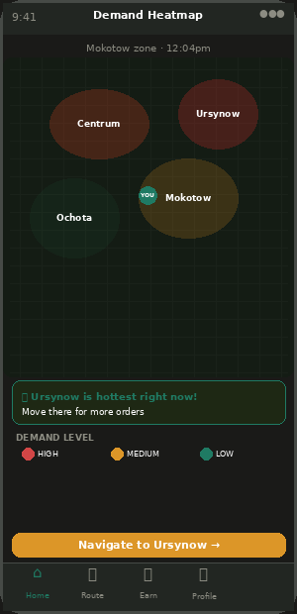
DA-08 — Peak Demand Heatmap
DA-08 | Peak Hours Heatmap | ✅ INCLUDED | v1.0

Feature | Status | Admin Control | Notes / Logic
Live colour heat map (dark themed) | ✅ INCLUDED | ACM-52 | Red = high demand, amber = medium, green = low. Admin can disable per city.
Driver current position on map | ✅ INCLUDED | — | Green dot "YOU". Updates every 5s when online.
Zone labels on heat map | ✅ INCLUDED | — | Zone names on each area. Matches admin-defined zones.
AI insight: "Go to X for more orders" | ✅ INCLUDED | — | System identifies hottest zone. One-line recommendation.
Navigate to hottest zone — one tap | ✅ INCLUDED | — | Opens Google Maps navigation to centre of hottest zone.
Admin controls refresh rate | ⚙ ADMIN | ACM-52 | Every 1 min / 5 min (default) / 15 min. Admin sets per city.

10. Earnings Screen

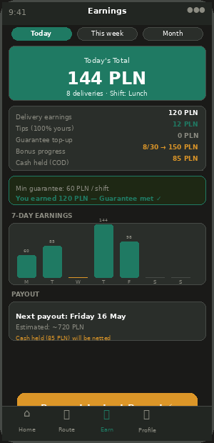
DA-09 — Earnings (Daily / Weekly / Monthly)
DA-09 | Earnings Screen | ✅ INCLUDED | v1.0 + v3.0

v3.0 correction: Tips show gross amount to driver (100%). Fleet partner handles 23% VAT on tips. Driver sees what they actually receive — VAT is fleet partner's responsibility, not driver's.
Feature | Status | Admin Control | Notes / Logic
Period tabs: Today / This week / This month | ✅ INCLUDED | — | All three always available.
Today total earnings (prominent) | ✅ INCLUDED | — | Online earnings + tips combined.
Cash balance (COD held) — amber card | ✅ INCLUDED | ACM-73 | Shows total cash from COD. "Report to admin" shortcut.
Earnings breakdown per type | ✅ INCLUDED | — | Delivery earnings / Tips (100% yours) / Guarantee top-up / Bonus / Cash held.
Tip VAT note (v3.0) | ✅ INCLUDED | — | NEW. Shows: "Tips shown at gross. Fleet partner handles 23% VAT declaration."
7-day earnings bar chart | ✅ INCLUDED | — | Green bars = earnings. Shows pattern and identifies slow days.
Minimum guarantee status | ✅ INCLUDED | ACM-70 | Shows: "Guarantee: 60 PLN. You earned 120 PLN. Met ✓"
Weekly bonus progress | ✅ INCLUDED | ACM-71 | Delivery count toward bonus target. Admin sets targets.
Next payout info + instant payout button | ✅ INCLUDED | ACM-68/69 | Next scheduled date + amount estimate.
Cash settlement reconciliation | ✅ INCLUDED | ACM-73 | When admin nets off cash: shows "85 PLN cash settled, 635 PLN bank transfer."
Push: payout processed | ✅ INCLUDED | ACM-68 | FCM + Email. Cannot disable. Shows bank amount + cash netted.
Push: cash limit approaching (80%) | ✅ INCLUDED | ACM-73 | FCM push. Can disable.
Push: bonus unlocked | ✅ INCLUDED | ACM-71 | FCM push when delivery target hit. Can disable.

11. Driver-to-Vendor Quick Messages

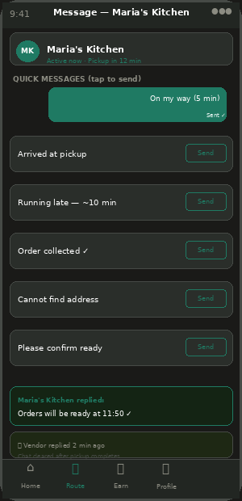
DA-10 — Quick Message Templates
DA-10 | Driver-to-Vendor Quick Chat | ✅ INCLUDED | v1.0

Feature | Status | Admin Control | Notes / Logic
Pre-set quick message templates (tap to send) | ✅ INCLUDED | ACM-53 | 6 default messages. Admin can edit text. Cannot add/remove without code change.
Chat only for current active pickup | ✅ INCLUDED | — | Cleared after pickup completed. No persistent chat history stored.
Vendor replies visible in driver app | ✅ INCLUDED | — | If vendor replies: driver sees reply as bubble.
Default templates | ✅ INCLUDED | ACM-53 | 1. On my way (5 min) 2. Arrived at pickup 3. Running late ~10 min 4. Order collected ✓ 5. Cannot find address 6. Please confirm ready.
Admin can disable chat + edit templates | ⚙ ADMIN | ACM-53 | If disabled: Message Vendor button hidden from route screen.
Push: vendor replied (FCM toast) | ✅ INCLUDED | ACM-53 | Shows vendor reply as push notification. Can disable.

12. Shift Management & Driver Profile

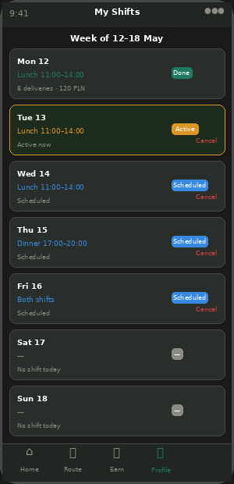  DA-11 — Shift Schedule | 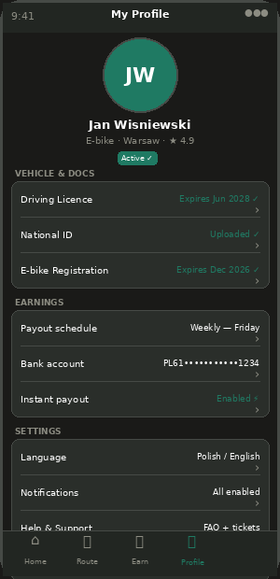  DA-12 — Driver Profile

DA-11 | Shift Management Screen | ✅ INCLUDED | v1.0

Feature | Status | Admin Control | Notes / Logic
This week shift schedule (Mon–Sun) | ✅ INCLUDED | — | Each day: shift type, status (Done/Active/Scheduled), earnings.
Cancel scheduled shift (2h notice min) | ✅ INCLUDED | — | Admin notified automatically.
Zone assignment display (admin-set) | ✅ INCLUDED | ACM-64 | Driver cannot change zones — must contact admin.
Payout schedule display + request change | ✅ INCLUDED | ACM-68 | Only shown if admin allows driver self-service.
Push: shift reminder (30 min before) | ✅ INCLUDED | ACM-76 | FCM push before each shift. Can disable.

DA-12 | Driver Profile Screen | ✅ INCLUDED | v1.0 + v3.0

Feature | Status | Admin Control | Notes / Logic
Personal info, vehicle, bank account | ✅ INCLUDED | — | Editable. Bank IBAN change requires re-verification.
Document management: licence, ID, vehicle reg | ✅ INCLUDED | ACM-67 | Each document shows expiry. Colour: green/>60 days, amber/30-60, red/<30.
Fleet Partner assignment (v3.0) | ✅ INCLUDED | — | NEW. Shows: "Fleet Partner: Evelstar Sp. z o.o." Cannot change — admin only.
Payout history + tax documents | ✅ INCLUDED | — | All past payouts. CSV export. Tax documents.
Cash settlement records | ✅ INCLUDED | ACM-73 | Full history of cash collections and settlements.
Language setting | ✅ INCLUDED | ACM-89 | Polish + English at launch. Admin adds via OTA.
Help & Support (driver support tickets) | ✅ INCLUDED | — | NEW. Driver can report issue on specific order. Routes to CS inbox with order context.

