

Web programming

L1+L2+L25+L26 - SJT218



APRAJITA NANDKEULIAR

22BCE0544

**First page:**

<!DOCTYPE html>

<html lang="en">

<head>

    <meta charset="utf-8">

    <title>My Portfolio</title>

    <link rel="icon" href="a-removebg-preview.png" type="image/png">

    <link rel="stylesheet" href="h1_.css">

</head>

<body bgcolor="#FFFFFF">

<div id="navbar" style="background-image: url('12.png'); border-radius: 5px;">

    <style>

        h1,nav

        {

          text-shadow: 2px 2px 5px #453f45;

        }

        button

        {

            float:right;

            margin-top: 150px;

            border-radius: 20px;

            border-color: #EB95A2 ;

            padding: 5px;

            background-color: #EB95A2 ;

            box-shadow: 2px 2px 5px #bd8cbd;

        }

        body

        {

            overflow-x: hidden;

        }

        button :hover

        {

            color: #161611;

        }

        aside

        {

            width: 150px;

            padding: 20px;

            float: right;

            font-style: italic;

            background-color: #EB95A2;

            border-radius: 40px;

            color: #e8e7e8;

        }

    </style>

    <nav>

        <ul class="links">

            <li><a href="#Myself">About Myself</a></li>

            <li><a href="nextpage.html">Education</a></li>

            <li><a href="nextpage.html">Projects</a></li>

            <li><a href="nextpage.html">Skills</a></li>

            <li><a href="nextpage.html">Certifications</a></li>

            <li><a href="next2next.html">Contact</a></li>

            <font face="Verdana" size="6"color="#e8e7e8">

            <br>

                <h1>Welcome to my portfolio!!</h1>

            </font>

        </ul>

    </nav>

</div>

<div  id="Myself" style="background-color: #dedaf4; width: 1360px; margin: 50px; border-radius: 40px; height: 500px;">

            <div class="container">

                <div class="item2">

                    <img src="ME-removebg-previewS.png" style="border-radius: 40%; width:200px; height:250; padding-left: 90px; padding-top: 50px;" alt="myself"/>

                    <font face="Cursive" color="#F97C7C">

                    <h2><i><center>I am </center> &nbsp;&nbsp;&nbsp;Aprajita Nandkeuliar</i></h2>

                    </font>

                </div>

                <div class="item3">

                    <font face="Single Day" color="#5C346A" size="4">

                        <article style="width:500px; padding-top: 100px;">I am a second year Computer Science and engineering student pursuing my Bachelor's Degree in Technology from Vellore Institute of TechnologyI have cultivated a robust foundation in web development and a keen interest in the dynamic field of UI/UX design. My academic journey has equipped me with a comprehensive understanding of computer science principles, coupled with hands-on experience in crafting efficient and user-friendly web solutions. I am passionate about creating seamless user experiences and am committed to expanding my expertise in UI/UX design to contribute meaningfully to innovative projects and technological advancements.</article>

                    </font>

                </div>

                <div class="item1">

                    <aside><b>"Believe you can and you are halfway there"</b></aside>

                </div>

            </div>

</div>

<div  id="Myself" style="background-color: #f2c6de; width: 1360px; margin: 50px; border-radius: 40px; height: 500px;">

    <div class="container2">

        <div class="item6">

            <img src="bad.png" style="width:250px; height:250px"alt="myself2"/>

        </div>

        <div class="item7">

            <img src="brush.png" style="width:150px; height:150px" alt="myself2"/>

        </div>

        <div class="item5">

            <font face="Single Day" color="#5C346A" size="4">

            <article style="width:500px; padding-top: 100px;">I'm someone who finds joy in exploring various facets of life, always eager to dive into new experiences and learn from them. I have a deep passion for swimming, finding solace and rejuvenation in the tranquil embrace of the water. Painting is another avenue through which I express myself, allowing my creativity to flow freely onto the canvas, capturing moments and emotions in vibrant hues.

            In my free time, you'll often find me on the badminton court, where I relish the thrill of competition and the camaraderie it fosters. Whether it's a gentle stroke of the brush or a swift rally on the court, I find fulfillment in unleashing my creativity and pushing my boundaries. These hobbies not only enrich my life but also provide me with a sense of balance and fulfillment in this ever-changing world.</article>

            </font>

        </div>

        <div class="item4">

            <img src="me2.png" style="border-radius: 40%; width:200px; height:250; padding-left: 90px; padding-top: 50px;" alt="myself2"/>

        </div>

</div>

<button>

    <font face="Sans-serif" color="#e8e7e8">

        <a href="nextpage.html">Know more about me -></a>

    </font>

</br>

</button>

</html>

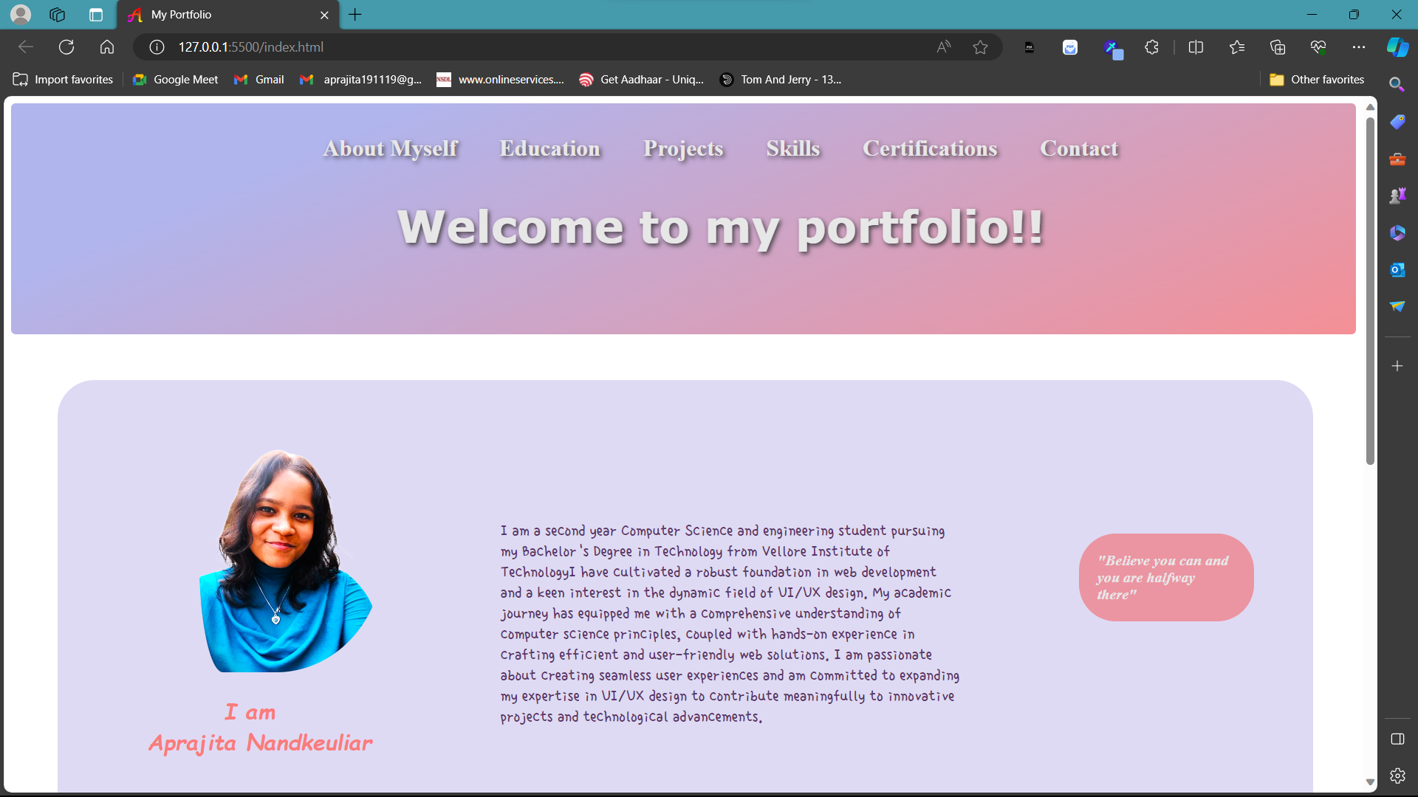

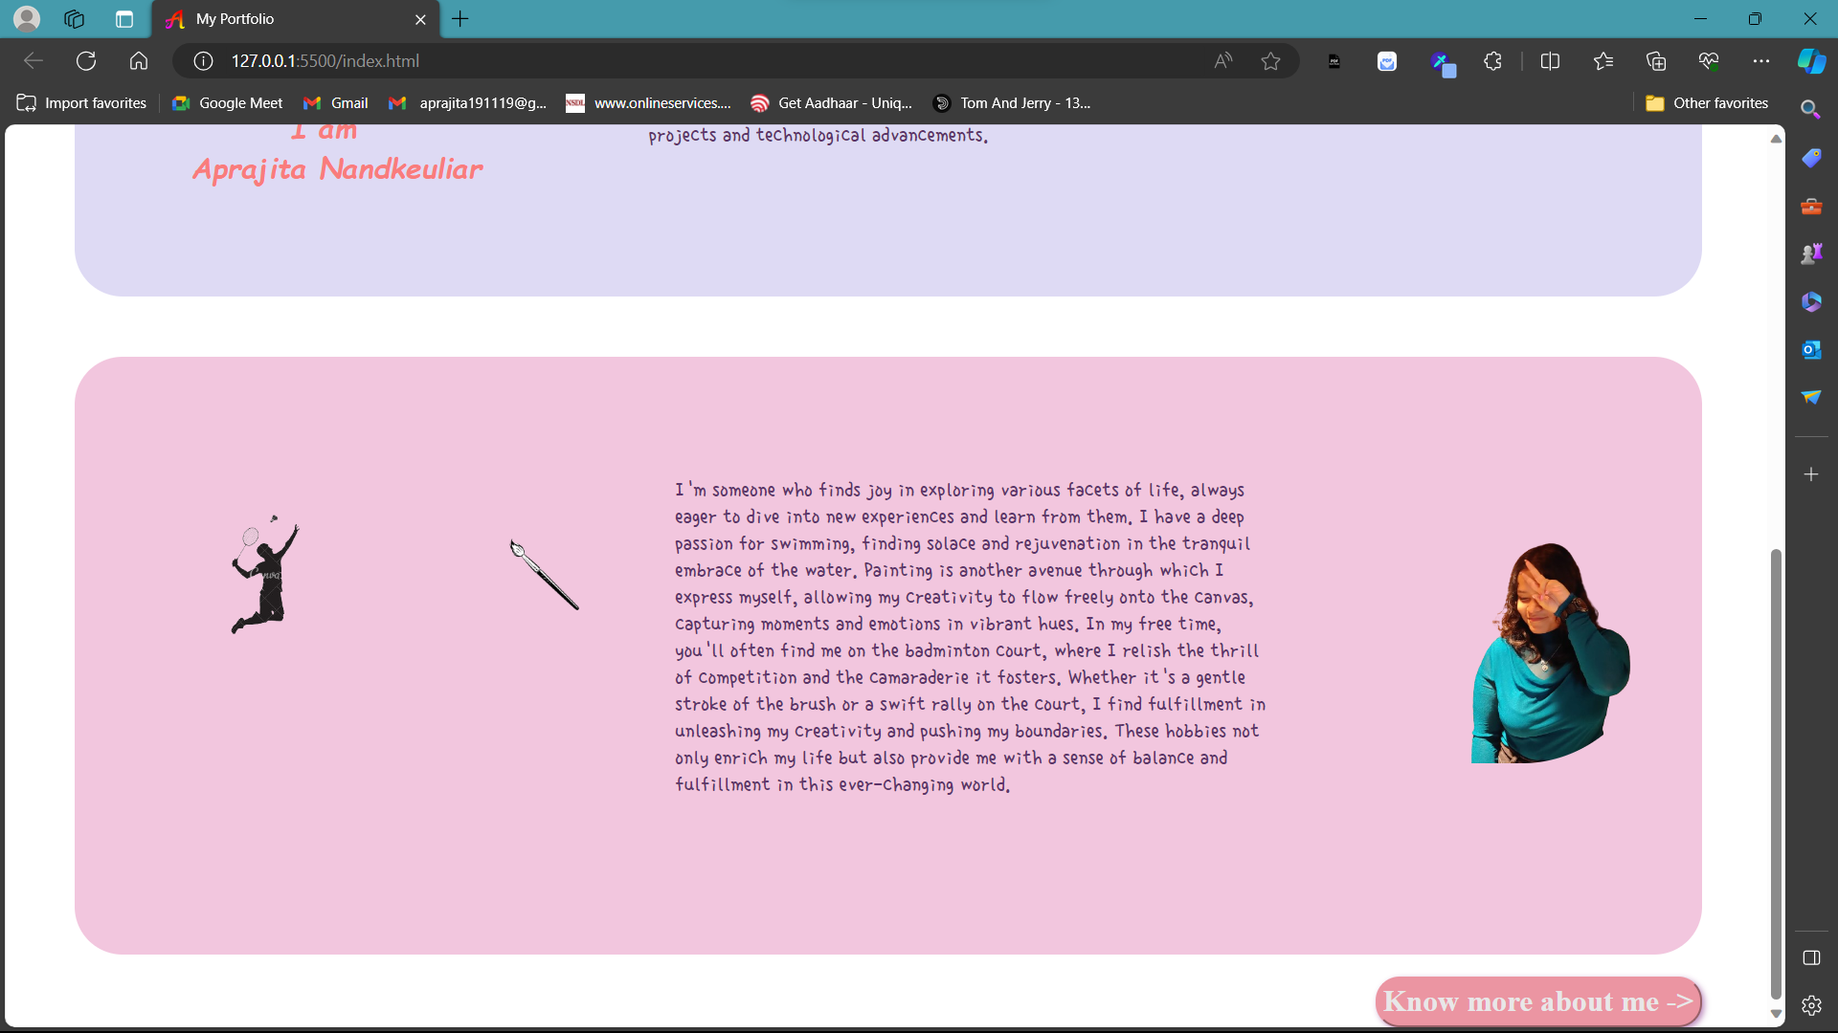

***Report:***

Below is a report on all the HTML tags used in the above provided HTML code:

1. `<!DOCTYPE html>`: This tag declares the document type and version of HTML being used.

2. `<html lang="en">`: This tag defines the root element of the HTML document and specifies the language of the content.

3. `<head>`: This tag contains meta-information about the HTML document, such as the title, character encoding, and links to external resources.

- `<meta charset="utf-8">`: Specifies the character encoding for the document.

- `<title>`: Sets the title of the HTML document.

- `<link rel="icon" href="a-removebg-preview.png" type="image/png">`: Links to the favicon image file.

- `<link rel="stylesheet" href="h1_.css">`: Links to an external CSS stylesheet file.

4. `<body bgcolor="#FFFFFF">`: This tag defines the body of the HTML document and sets the background color.

5. `<div>`: This tag defines a division or section in the HTML document.

- `id="navbar"`: Specifies the id attribute of the div element.

- `style="background-image: url('12.png'); border-radius: 5px;"`: Inline CSS styling for the div element.

6. `<style>`: This tag is used to define internal CSS styles within the HTML document.

7. `<nav>`: This tag defines a navigation section in the HTML document.

8. `<ul class="links">`: This tag defines an unordered list with the class attribute set to "links".

- `<li>`: This tag defines list items within the unordered list.

- `<a>`: This tag defines hyperlinks within list items.

9. `<font>`: This tag defines font characteristics for the enclosed text.

- `face="Verdana" size="6" color="#e8e7e8"`: Specifies font face, size, and color attributes.

10. `<h1>`: This tag defines a heading level 1.

11. `<img>`: This tag embeds images into the HTML document.

12. `<center>`: This tag is used to center-align content.

13. `<article>`: This tag defines an independent piece of content within the HTML document.

14. `<aside>`: This tag defines content aside from the main content, often used for tangentially related content or pull quotes.

15. `<button>`: This tag defines a clickable button.

16. `<a>`: This tag defines hyperlinks.

17. `<!-- -->`: This tag is a comment, used to add comments within the HTML code for documentation purposes.

These are the main HTML tags used in the provided code, along with their attributes and functionalities.

**Second page:**

<!DOCTYPE html>

<html lang="en">

<head>

    <meta charset="utf-8">

    <title>My Portfolio</title>

    <link rel="icon" href="a-removebg-preview.png" type="image/png">

    <link rel="stylesheet" href="h1_.css">

</head>

<body bgcolor="#FFFFFF">

<div id="navbar" style="background-image: url('12.png'); border-radius: 5px;">

    <style>

        h1,nav

        {

          text-shadow: 2px 2px 5px #453f45;

        }

        body

        {

            overflow-x: hidden;

        }

        button

        {

            border-radius: 20px;

            border-color: #EB95A2 ;

            padding: 5px;

            background-color: #EB95A2 ;

            box-shadow: 2px 2px 5px #bd8cbd;

        }

    </style>

    <nav>

        <ul class="links">

            <li><a href="index.html">About Myself</a></li>

            <li><a href="#Education">Education</a></li>

            <li><a href="#Projects">Projects</a></li>

            <li><a href="#Skills">Skills</a></li>

            <li><a href="#Certifications">Certifications</a></li>

            <li><a href="next2next.html">Contact</a></li>

            <font face="Sans-serif" size="6"color="#e8e7e8">

            </br></br>

                <a href="next2next.html"><h4>Click here to know more about my website!</h4></a>

            </font>

        </ul>

    </nav>

</div>

<div  id="Education" style="background-color: #dedaf4; width: 1360px; margin: 50px; border-radius: 40px; height: 300px;">

        <center>

            <font face="Sans-serif" color="#5C346A">

            </br>

                <h2><u>Education</u></h2>

            </font>

        </br></br>

            <table border="1" cellspacing="0" bordercolor="#5C346A">

            <tr>

                <td><font face="Sans-serif" color="#5C346A"><b>School/College</b></font></td>

                <td><font face="Sans-serif" color="#5C346A"><b>&nbsp;Marks&nbsp;</b></font></td>

                <td><font face="Sans-serif" color="#5C346A"><b>&nbsp;Graduation&nbsp;</b></font></td>

            </tr>

            <tr>

                <td><font face="Sans-serif" color="#5C346A">&nbsp;Gokuldham High School and Junior College&nbsp;</font></td>

                <td><font face="Sans-serif" color="#5C346A">&nbsp;91.67%&nbsp;</font></td>

                <td><font face="Sans-serif" color="#5C346A">&nbsp;2019&nbsp;</font></td>

            </tr>

            <tr>

                <td><font face="Sans-serif" color="#5C346A">&nbsp;Pace Junior Science College</font></td>

                <td><font face="Sans-serif" color="#5C346A">&nbsp;89%&nbsp;</font></td>

                <td><font face="Sans-serif" color="#5C346A">&nbsp;2021&nbsp;</font></td>

            </tr>

            <tr>

                <td><font face="Sans-serif" color="#5C346A">&nbsp;Vellore Institute of Technology</font></td>

                <td><font face="Sans-serif" color="#5C346A">&nbsp;8.20/10&nbsp;</font></td>

                <td><font face="Sans-serif" color="#5C346A">&nbsp;2026&nbsp;</font></td>

            </tr>

            </table>

        </center>

</div>

<div  id="Projects" style="background-color: #f2c6de; width: 1360px; margin: 50px; border-radius: 40px; height: 250px;">

        <font face="Sans-serif" color="#F97C7C">

        </br>

            <center>

                <h2><u>Projects</u></h2>

            </center>

        </font>

        </br>

            <center>

                <font face="Sans-serif" color="#5C346A">

                <p>I made a portfolio using HTML and CSS</p>

                <p>I have published a research paper on growing technology</p>

                <p>I have made an AI/ML model which can differentiate between different animals</p>

                </font>

            </center>

</div>

<div  id="Skills" style="background-color: #dedaf4; width: 1360px; margin: 50px; border-radius: 40px; height: 310px;">

    <font face="Sans-serif" color="#5C346A">

    </br>

        <center>

            <h2><u>Skills</u></h2>

        </center>

    </font>

<div class="c">

    <div class="c1">

        <font face="Sans-serif" color="#5C346A"><h4>Coding language:</h4></font>

        <font face="Sans-serif" color="#5C346A">

        <ul style="list-style: circle;">

            <li>Java</li>

            <li>Python</li>

            <li>C</li>

            <li>C++</li>

            <li>HTML</li>

            <li>CSS</li>

            <li>JavaScript</li>

        </ul></font>

    </div>

    <div class="c2">

        <font face="Sans-serif" color="#5C346A"><h4>Others</h4></font>

            <font face="Sans-serif" color="#5C346A"><ul style="list-style: circle;">

            <li>DBMS</li>

            <li>MySQL</li>

            <li>Reactjs</li>

        </ul></font>

    </div>

    <div  id="Certifications" style="background-color: #f2c6de; width: 1400px; margin: 50px; border-radius: 40px; height: 250px;">

    <section id="Certifications">

        <font face="Sans-serif" color="#F97C7C">

        </br>

            <center>

                <h2><u>Certifications</u></h2>

            </center>

        </font>

    </br><center>

                <font face="Sans-serif" color="#5C346A">

                    <p>HTML Certification from <i>LinkedIn</i></p>

                    <p>Public Speaking from <i>NPTEL</i></p>

                    <p>Spanish Completion Certification from <i>LinkedIn</i></p>

                </font></center>

    </section>

    </div>

    <button>

        <font face="Sans-serif" color="#e8e7e8">

            <a href="#navbar">Go up</a>

        </font>

    </br>

    </button>

    </body>

</html>

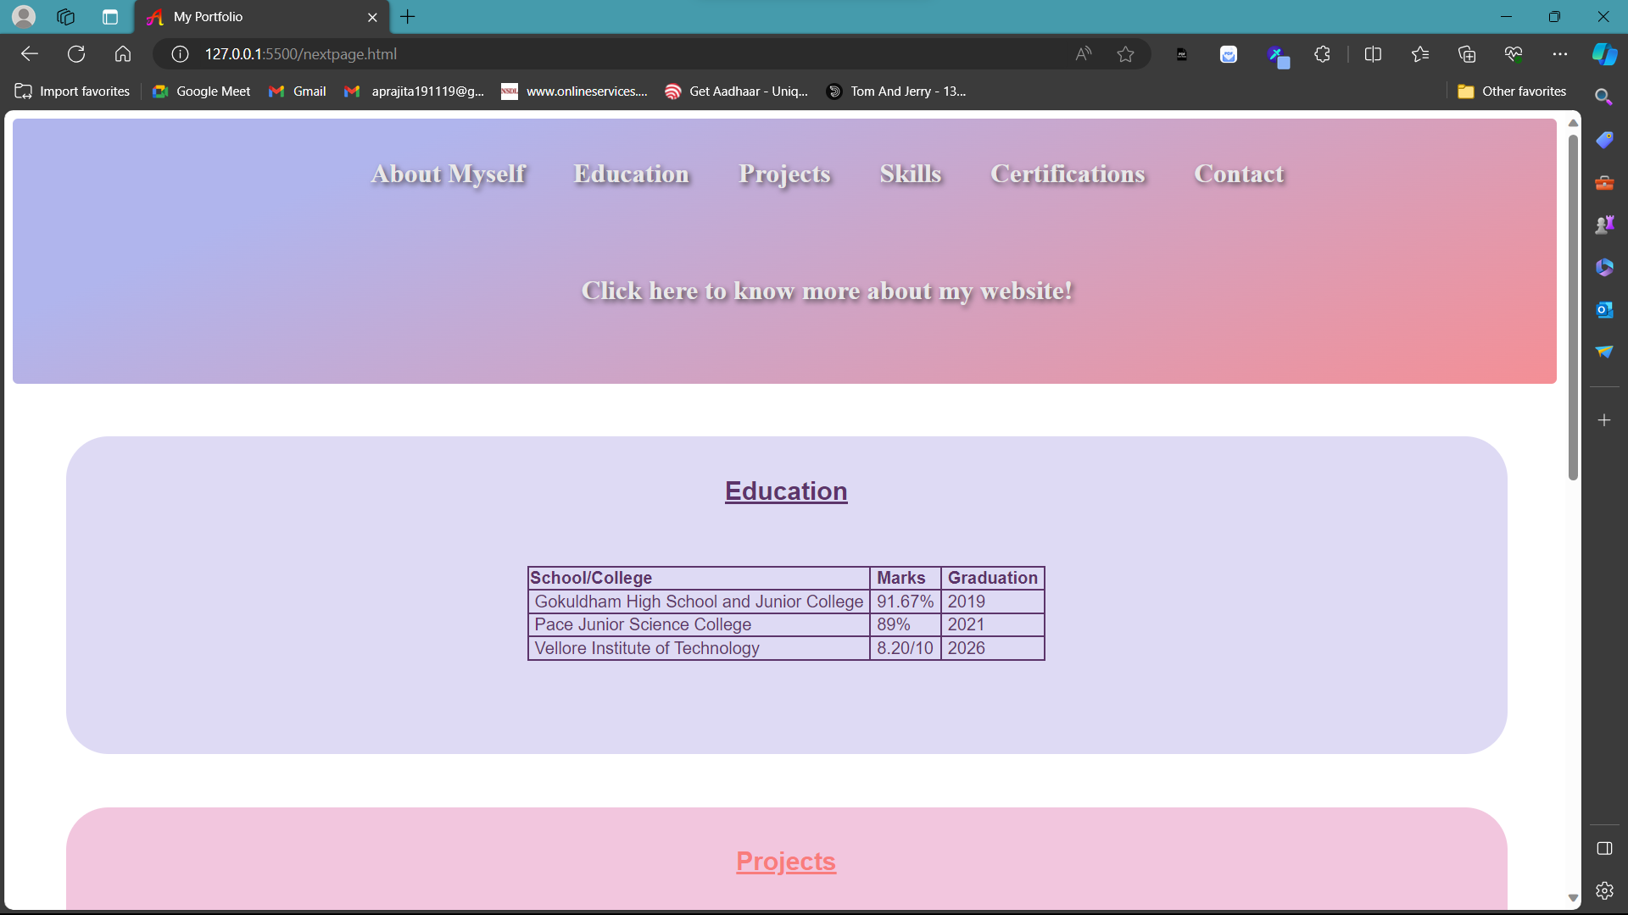

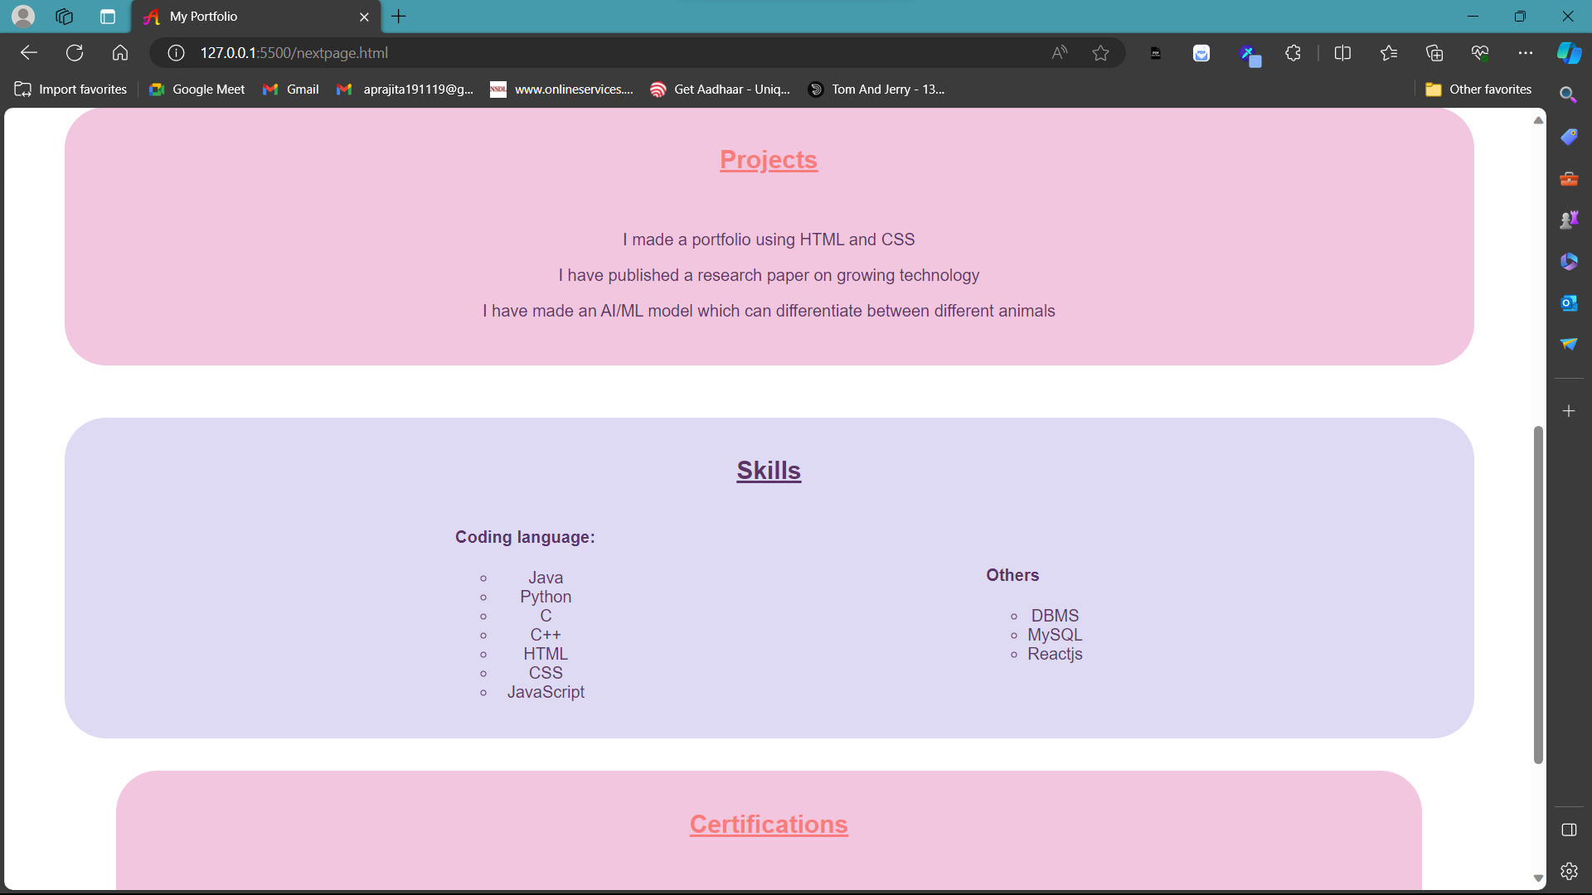

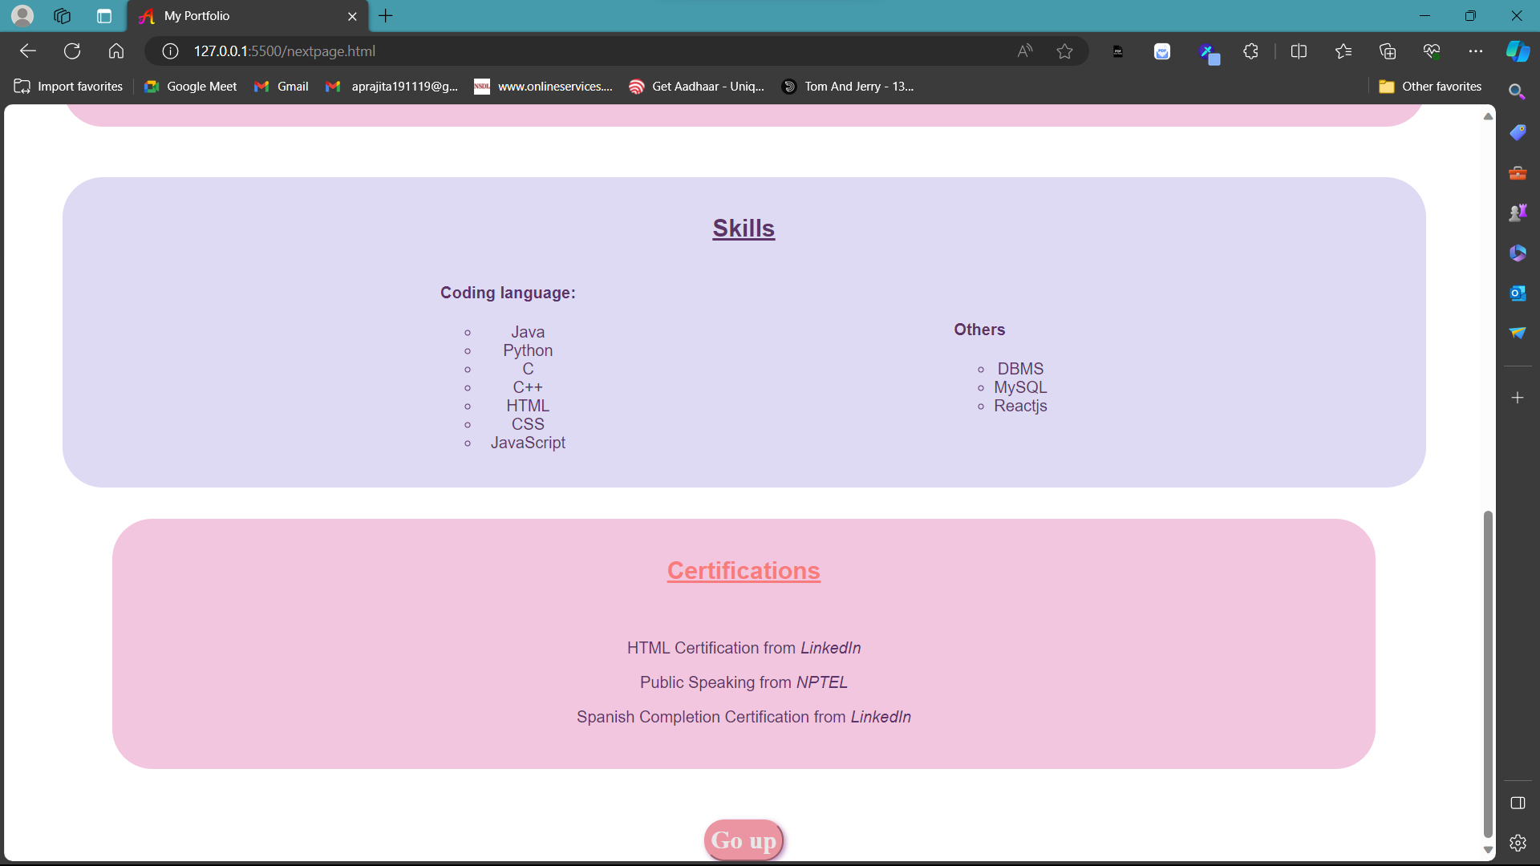

***REPORT:***

Below is a report on all the HTML tags used in the provided HTML code along with explanations for their usage:

1. `<!DOCTYPE html>`: Declares the document type and version of HTML being used.

2. `<html lang="en">`: Defines the root element of the HTML document and specifies the language of the content.

3. `<head>`: Contains meta-information about the HTML document, such as the title, character encoding, and links to external resources.

- `<meta charset="utf-8">`: Specifies the character encoding for the document.

- `<title>`: Sets the title of the HTML document.

- `<link rel="icon" href="a-removebg-preview.png" type="image/png">`: Links to the favicon image file.

- `<link rel="stylesheet" href="h1_.css">`: Links to an external CSS stylesheet file.

4. `<body bgcolor="#FFFFFF">`: Defines the body of the HTML document and sets the background color.

5. `<div>`: Defines a division or section in the HTML document.

- `id="navbar"`: Specifies the id attribute of the div element.

- `style="background-image: url('12.png'); border-radius: 5px;"`: Inline CSS styling for the div element.

6. `<style>`: Defines internal CSS styles within the HTML document.

7. `<nav>`: Defines a navigation section in the HTML document.

8. `<ul class="links">`: Defines an unordered list with the class attribute set to "links".

- `<li>`: Defines list items within the unordered list.

- `<a>`: Defines hyperlinks within list items.

9. `<font>`: Defines font characteristics for the enclosed text.

- `face="Verdana" size="6" color="#e8e7e8"`: Specifies font face, size, and color attributes.

10. `<a>`: Defines hyperlinks.

11. `<h1>`, `<h2>`, `<h4>`: Defines headings of different levels.

12. `<center>`: Used for center-aligning content.

13. `<table>`: Defines a table in the HTML document.

- `<tr>`: Defines a row in the table.

- `<td>`: Defines a cell in the table.

14. `<br>`: Inserts a single line break.

15. `<footer>`: Defines a footer section in the HTML document.

16. `<section>`: Defines a section in the HTML document.

17. `id`: Attribute used for uniquely identifying elements.

18. `bgcolor`: Attribute used to set the background color of an element.

19. `border`: Attribute used to set the border of an element.

20. `cellspacing`: Attribute used to specify the space between cells in a table.

These HTML tags are used to structure the document, define content sections, apply styling, and create links, tables, and headings for better organization and presentation of information.

**Third page:**

<!DOCTYPE html>

<html lang="en">

<head>

    <meta charset="utf-8">

    <title>My Portfolio</title>

    <link rel="icon" href="a-removebg-preview.png" type="image/png">

    <link rel="stylesheet" href="h2_.css">

</head>

<body bgcolor="#FFFFFF">

    <div id="navbar" style="background-image: url('12.png'); border-radius: 5px;">

        <style>

            h1,nav

            {

              text-shadow: 2px 2px 5px #453f45;

            }

            body

            {

                overflow-x: hidden;

            }

            button

        {

            float: right;

            border-radius: 20px;

            border-color: #dedaf4 ;

            padding: 5px;

            background-color: #dedaf4 ;

            box-shadow: 2px 2px 5px #bd8cbd;

        }

    </style>

        </style>

        <nav>

            <font face="Verdana" size="6"color="#e8e7e8">

            <br>

                <h1>About this website</h1>

            </font>

        </nav>

    </div>

    <div  id="website" style="background-color: #dedaf4; width: 1360px; margin: 50px; border-radius: 40px; height: 220px; padding:15px">

        <font face="Verdana" color="#5C346A" size="2">

    <p style="width:fit-content">I have made this website using the following.In the provided HTML code, various HTML tags are utilized to structure the document, define content sections, apply styling, create links, tables, and headings for better organization and presentation of information.

        The `DOCTYPE html` tag declares the document type and version of HTML being used, ensuring proper rendering by web browsers. The `html lang="en"` tag defines the root element of the HTML document and specifies the language of the content, enhancing accessibility and SEO.

        Within the `head` section, essential meta-information is included. The `meta charset="utf-8"` tag specifies the character encoding for the document, ensuring proper display of characters. The `title` tag sets the title of the HTML document, which appears in the browser tab. Additionally, `link` tags are used to link external resources such as favicon and CSS stylesheet files.

        The `body` tag encloses the main content of the HTML document. Inside the `body`, `div` tags are used to create divisions or sections, providing a way to structure and style content.

         Inline CSS styling is applied using the `style` attribute within the `div` tags.

        Semantic tags like `nav`, `ul`, `li`, and 'a` are employed to create navigation menus with hyperlinks. The `ul` tag defines an unordered list, while 'li` represents list items within the list. Hyperlinks are created using the `a` tag, facilitating navigation to different sections or external pages.

        Heading tags such as `h1`, `h2`, and `h4` are used to define headings of varying importance, aiding in content organization and hierarchy. Additionally, the `center` tag is utilized to center-align content within sections.

        Tables are constructed using the `table`, `tr`, and `td` tags to display tabular data neatly. Attributes like `border`, `cellspacing`, and `bgcolor` are employed to customize the appearance of the table.

        Finally, the `footer` tag defines a footer section containing contact information or additional details. The `section` tag helps in structuring the content, making it easier to navigate. Unique identifiers (`id` attributes) are assigned to elements for targeted styling or linking within the document.

        Together, these HTML tags play a crucial role in organizing, styling, and presenting content within the HTML document, ensuring a cohesive and user-friendly web experience.</p>

    </font>

    </div>

    <footer>

    <div  id="Contact" style="background-color: #f2c6de; width: 1360px; margin: 50px; border-radius: 40px; height: 250px;">

        <section id="Contact">

            <font face="Cursive" color="#F97C7C">

            </br>

            <center>

                <h2>Contact</h2>

            </center>

            </font>

                        <center><font face="Verdana" color="#5C346A">

                            <p><a href="https://www.linkedin.com/in/aprajita-n-747554274/i" target="_blank">Linkedin</a></p>

                            <p><a href="mailto:your.email@example.com">Mail</a></p>

                            <p>Phone No.:1234567890</p>

                            <p><a href="https://github.com/aprajita0401/Potfolio.git">GitHub</a></p>

                        </font></center>

            </section></div>

        </footer>

        <button>

            <font face="Sans-serif" color="#e8e7e8">

                <a href="index.html">Go back</a>

            </font>

        </br>

        </button>

    </html>

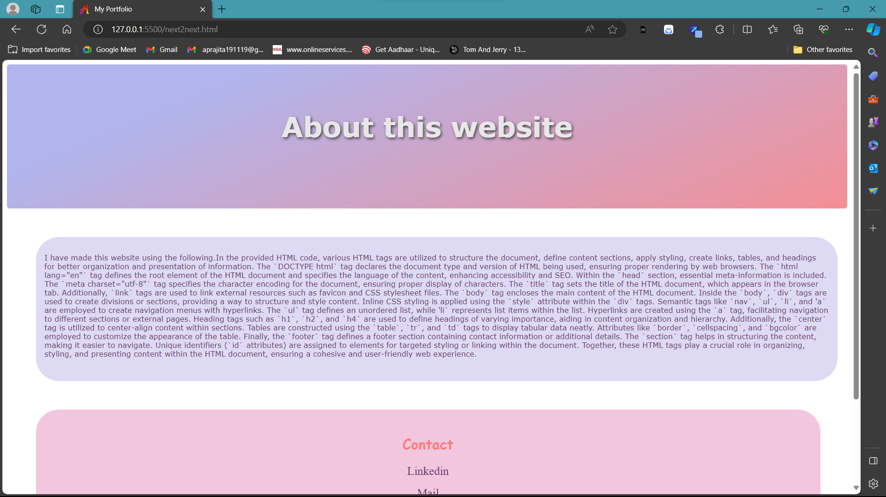

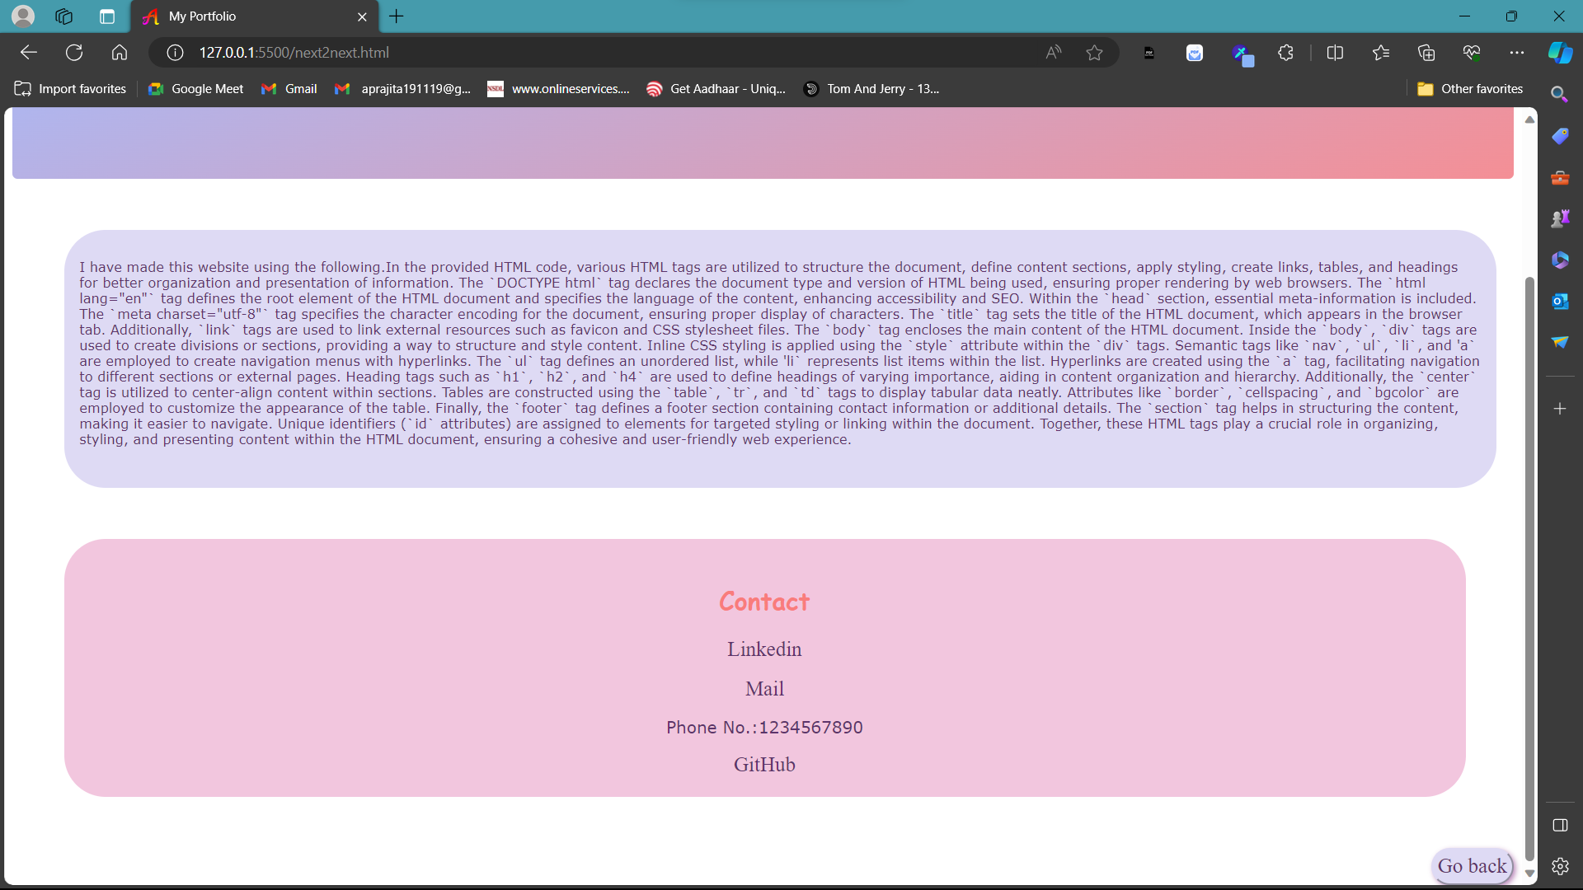

**CSS-1(h1.css):**

@import url('https://fonts.googleapis.com/css2?family=Single+Day&display=swap');

.links,a

{

    font-family: "Sans-Serif";

    font-weight: 1000;

    font-size: 25px;

    color: #e8e7e8;

    text-decoration: none;

}

li

{

    text-decoration: none;

    text-align: center;

}

header

{

    display: flex;

    justify-content: space-between;

    align-items: center;

    padding: 20px 10%;

}

.logo, .links

{

    cursor: pointer;

}

nav

{

    order: 1;

}

.links

{

    list-style: none;

}

.links li

{

    display: inline-block;

    padding: 0px 20px;

}

.links li, a

{

    transition: all 0.3s ease 0s;

}

.links li, a:hover

{

    color: #e3d272;

}

nav{

    border-width:1px 0;

    list-style:none;

    margin:0;

    padding:0;

    text-align:center;

    position:relative;

    height:250px;

}

nav ul {

    position:absolute;

    top:0;

    width:100%;

}

.container

{

    display:flex;

    justify-content: space-around;

    align-items: center;

}

.container2

{

    display:flex;

    justify-content: space-evenly;

    align-items: center;

    flex-wrap: wrap;

    align-content: space-around;

}

.c

{

    display:flex;

    justify-content: space-evenly;

    align-items: center;

    flex-wrap: wrap;

    align-content: space-around;

}

**CSS-2 (h2_.css):**

@import url('https://fonts.googleapis.com/css2?family=Single+Day&display=swap');

.links,a

{

    font-family: "Sans-Serif";

    font-size: 20px;

    color: #5C346A;

    text-decoration: none;

}

a:hover

{

    color: #7777d5;

}

li

{

    text-decoration: none;

    text-align: center;

}

header

{

    display: flex;

    justify-content: space-between;

    align-items: center;

    padding: 20px 10%;

}

.logo, .links

{

    cursor: pointer;

}

nav

{

    order: 1;

}

.links

{

    list-style: none;

}

.links li

{

    display: inline-block;

    padding: 0px 20px;

}

.links li a

{

    transition: all 0.3s ease 0s;

}

.links li a:hover

{

    color: #e3d272;

}

nav{

    border-width:1px 0;

    list-style:none;

    margin:0;

    padding:0;

    text-align:center;

    position:relative;

    height:250px;

}

nav ul {

    position:absolute;

    top:0;

    width:100%;

}