**CMPE 280 Sec 01– Web UI Design**

**Assignment# 7**

# GENERAL PRACTITIONER CHAT BOT

General practitioner (GP): In the medical profession, a general practitioner is a medical doctor who treats acute and chronic illnesses and provides preventive care and health education to patients. (Source: [https://en.wikipedia.org/wiki/General_practitioner (Links to an external site.)Links to an external site.](https://en.wikipedia.org/wiki/General_practitioner))

Learning Objective: Using Web Sockets, please create a simple GP Chatbot.

Chatbot functionality:

1. Patient Queries Clinical on general healthcare questions?

2. Clinician or Doctor: Using Web Sockets interface, response Queries.

## **DOCTOR’S CHAT SCREEN**

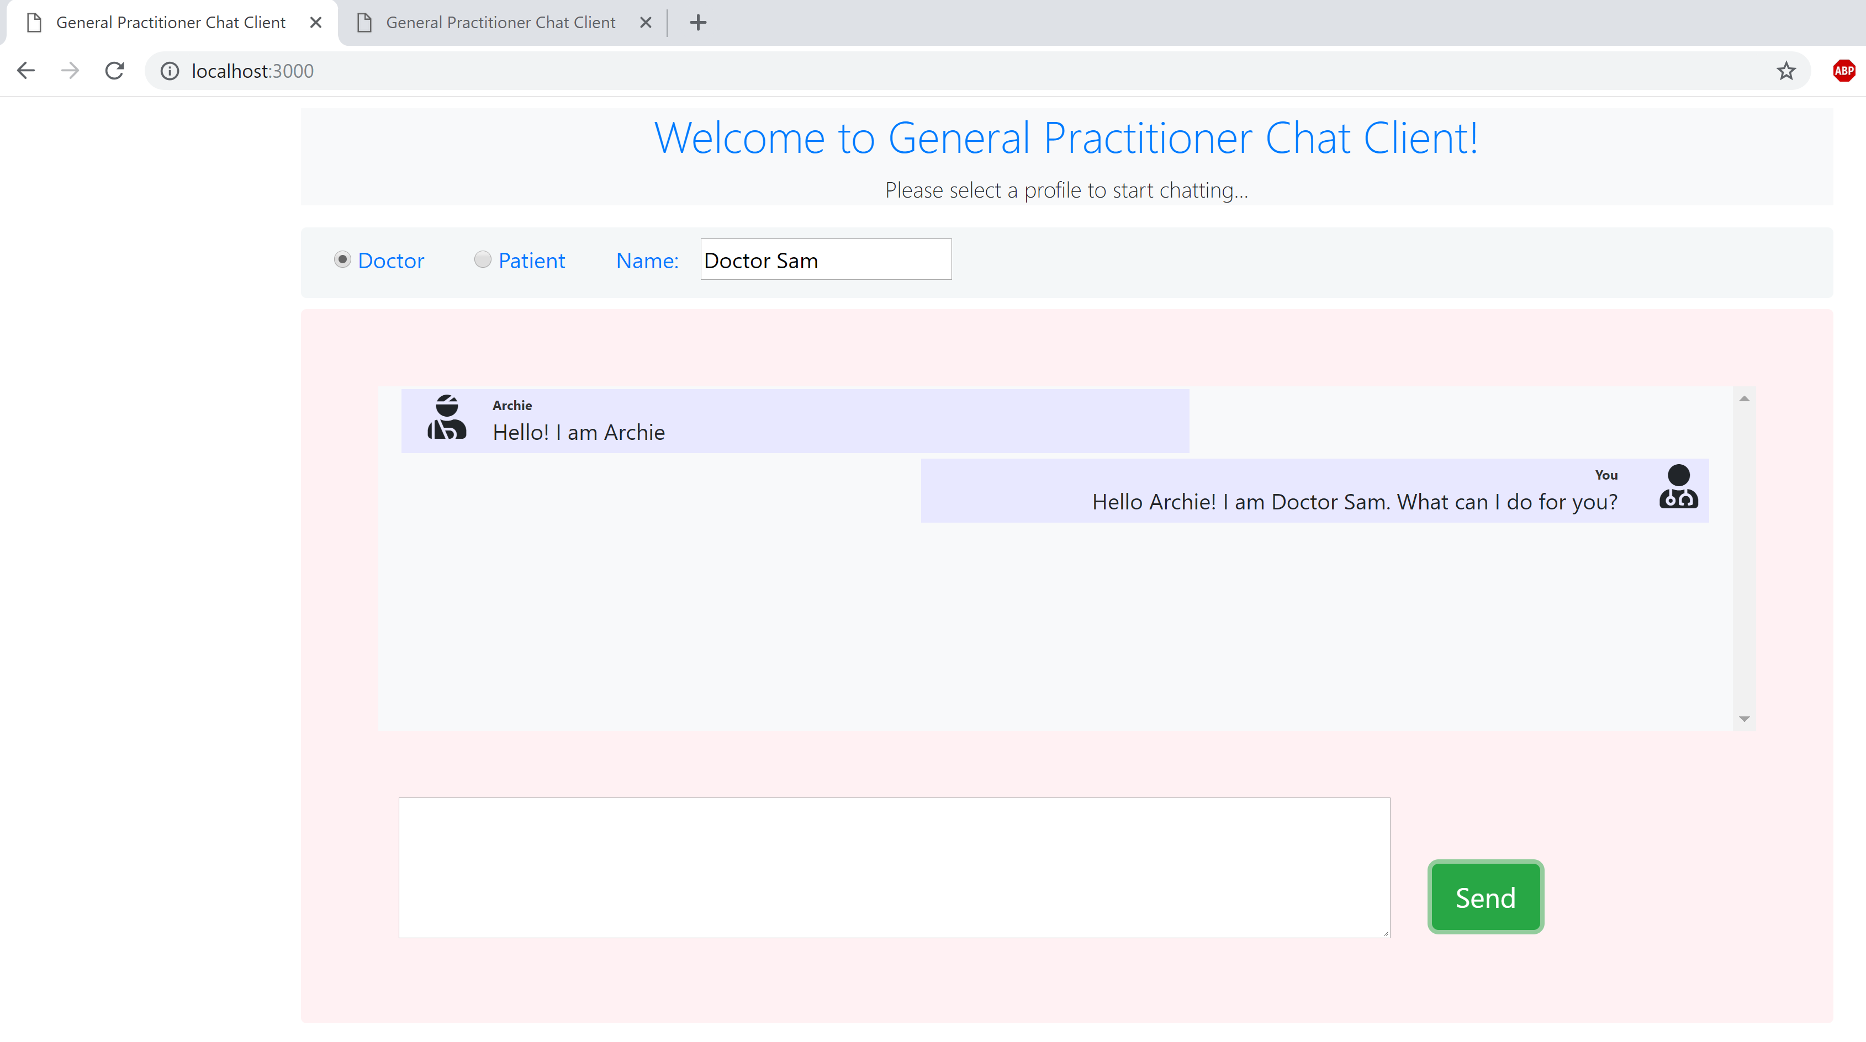

1-Doctor’s Chat Screen

## **PATIENT’S CHAT SCREEN**

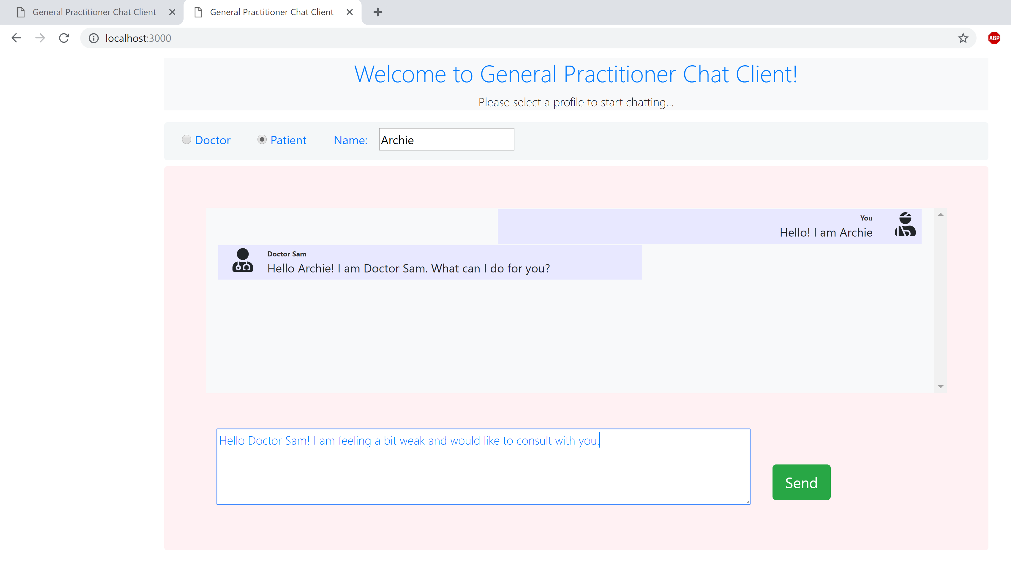

2 Patient’s Chat Screen

## **CONSOLE OUTPUT**

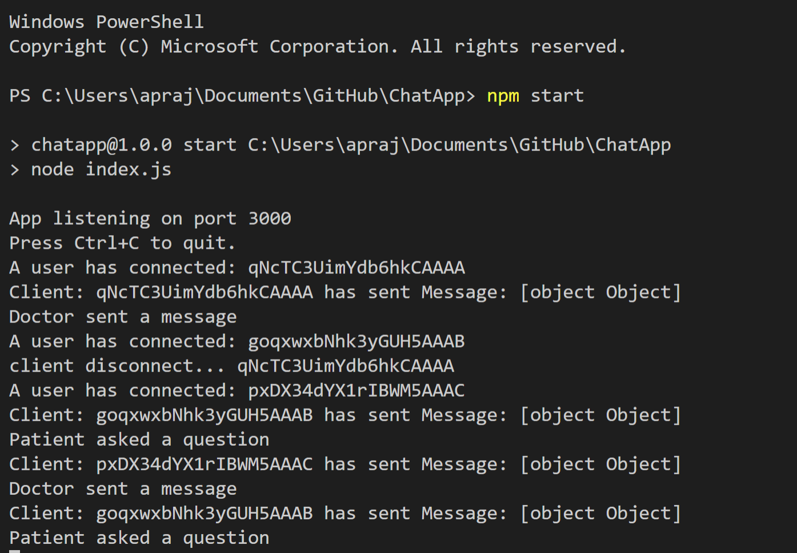

3 Console output