**Determination of Dominant Trends of Fish Populations Within Watersheds at Konza Prairie**

**Abstract:** The Konza Prairie in Manhattan, KS, is home to a variety of watersheds and unique populations within. Electrofishing techniques were used over a 23 year period to catch, analyze, and release fish populations for their further analysis. The Southern Redbelly Dace was found to be the most frequent species in the Konza Prairie, which tends to favor shallow bodies of water, especially creeks. The dace faces their primary threat from human activity and natural changes to their habitat, which have both increased as a result of global warming. The dace was found to occur relatively evenly across all watersheds surveyed, possibly indicating a maintained level of quality in habitats across the watersheds.

**Introduction/Background:** The Konza Prairie served as a surveying site for a 23-year study (Gido, 2019), which data could be made publicly available for analysis of the fish population. This study was conducted via handheld electrofishing survey, accompanied by dipnetting. Watersheds within the Konza prairie serve as the location for this survey, where watersheds could then be analyzed based on their nature as well (pool versus riffle). Konza Prairie is incredibly diverse in its fish species, with 22 species recorded in the study. Previous research in fish populations and their respective trends show that fish species within streams, similar to the watersheds of Konza Prairie, are all specifically structured as opposed to randomness (Gebrekiros, 2016). Abiotic environmental factors are crucial in understanding the organization of species structure, as these factors and their changes can influence how the populations inhabit their potential habitats. An example of abiotic influences was found among Andean freshwater fishes and their distributions as a result of geomorphology, where it was found that beta diversity is highly correlated to elevation of watersheds, with elevation leading the relative importance in the study (Herrera-Perez et al., 2019).

The top species in the Konza Prairie, identified through this study is the Southern Redbelly Dace. The dace is a small fish that is primarily local to the Great Plains region, where it is a highly common species. The dace is commonly found in headstreams and similar, shallow bodies of water. Primary threats to its existence are largely related to human activity, including landscape alterations and introduction of non-native species. The dace is also known for heavily preferring clear water, and will leave an area should the water no longer meet this condition. It should also be noted that the dace has an approximate life span just shy of two years (Stasiak, 2017).

Given the importance of abiotic environmental factors and the variety of fish populations within the Konza Prairie, it is my goal in this study to investigate how dominant fish species trend throughout the five watersheds. Dominance within ecological environments often carry similar characteristics among species determined to be dominant. For example, a study by Alcazar et al. investigated courting traits in Male African cichlid fish, *Astatotilapia burtoni* (Alcazar, 2016). This species is organized into categories of dominant or subordinate, which carry different traits both behaviorally and in their endocrine activities. Based on how the dominant species distributes itself throughout the Konza Prairie watersheds, I plan to answer questions regarding what factors may influence its population trends. Based on the similar habitat the Konza Prairie maintains within its boundaries and the need for resources for animals, the dace should maintain a relative abundance that is comparable across all watersheds studied.

**Methods:** Data collected from the Konza Prairie was a result of electrofishing and dipnetting to record fish in each watershed. Collections were made on a seasonal basis. Data is organized into two entities: CFP011, information on the different species collected, and CFP012, quantitative collection data from the watersheds. Based on the results of the collection, I plan to use methods in R to first aggregate the data into groups based on species and watersheds. Here is the approach I will take, by in order of objectives.

1. Find total counts of fish per species (table representation), focus study on top species (1000+ caught).
2. Find distribution of fish caught during study, by species.
3. Create comparison of total fish caught during study, by location.
4. Find the top catching location and create a visual distribution for it.
5. Create a comparison of species caught, by location, focusing on the top species.
6. Compare the ratio of the top species presence, per each respective location, to the total fish caught per location to calculate a ratio of composition.

The total counts of fish, per species, will be represented as a flextable of species and their total occurrences (Figure 1). Next, this table representation will be transformed into a bar graph representation to visually represent the distribution among the top five species (Figure 2). At this time, we will be able to definitively choose a top species and compare how the top species relates to the next four largest. Following this, we will begin an analysis of the catch frequency among the watersheds to determine a top catching site (Figure 4). Finally, the top species will be compared along all five watersheds to see how its presence is related across the catching sites (Figure 5). This will first be done as a sum, but then calculated a second time to see how the ratio of composition relates across each watershed (Figure 6). Once this data is gathered, a discussion can be had investigating how the results demonstrate potential interactions between species and environment.

Additionally, I was able to implement a colorblind friendly color palette obtained from an open-source website (Connelly, 2013), in order to make these results more accessible for readers.

**Results:**

Figure 1. Pictured is a flextable representation of the sums of each fish type caught. Each quantity directly to one catch of that species. These quantities are representative for the entire study duration, across all catching locations. For example, there were a total of 52, 037 Southern Redbelly Daces caught over the duration of this study.

Figure 2. Distribution of species, as reported in Figure 1, demonstrated via a bar graph form. Note that the x-labels are abbreviated for reading purposes but are correlated to the legend on the right side from top to bottom. Only the top 5 species were utilized for this comparison, as they are the only species to have greater than 1,000 encounters over the duration of the study.

Figure 3. Total cumulative catches made per watershed location. Here, we can see that all watersheds were relatively equal in their catch quantities, except for watershed NT.

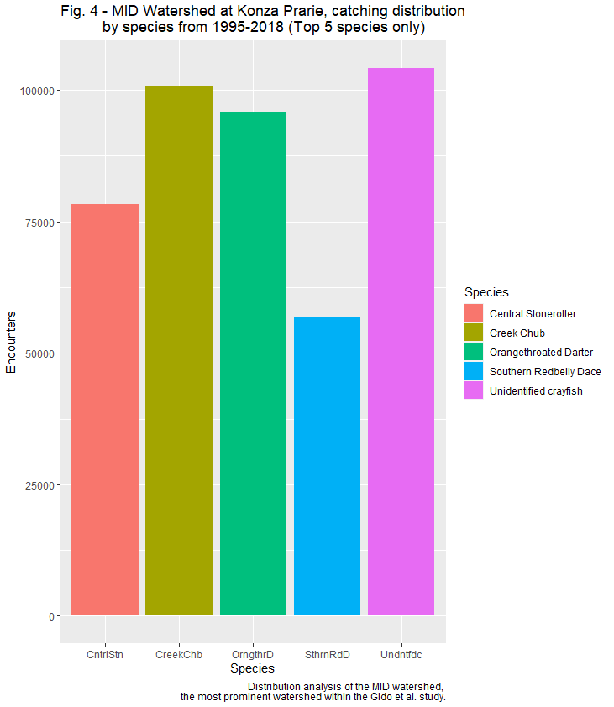

Figure 4. Displayed are the catch summaries per each species as they were caught in the MID watershed. The species are abbreviated below each bar, with the left-to-right orientation on the x-axis corresponding to the legend from top to bottom. Notably, in this figure we see that the Southern Redbelly Dace was the lowest frequency in this watershed, despite their dominance among all species studied.

Figure 5. Distribution of the Southern Redbelly Dace among the five watersheds. The dace demonstrates the highest frequency of being caught in the MID watershed, and the lowest in the NT. Because the distribution among the five watersheds and quantity of fish caught is not equal, a ratio of dace to total fish caught per watershed will now be employed.

Figure 6. A ratio analysis of the quantity of Southern Redbelly Dace compared to the total fish caught, per watershed. These ratios are all comparable to each other, with the dace composing about 0.5 to 0.55 (or 50 to 55%) of fish caught per watershed.

**Discussion:** Based on what is seen among the figures shown above,it is first concluded that the Southern Redbelly Dace is the most prominent species among the unique species found throughout the fish analysis of the Konza Prairie (Figures 1, 2). Additionally, the MID watershed is overall the most prominent catching site for this study (Figure 3). When comparing the raw quantity of the dace across all watersheds, it is seen that the dace largely varies in quantity among each watershed (Figure 5). However, when comparing the ratio of dace caught to total fish caught per watershed, it was seen that the dace comprises about 50 to 55% of the fish caught per each watershed. Referring back to the initial question of how the dace will distribute itself across watersheds, these results are in support of this conclusion.

Based on the previous information regarding abiotic factors within the watersheds, the presence of the dace among the watersheds and its equal distribution seems to point towards roughly equal quality habitats. However, another study conducted on the fish populations within the Konza Prairie hypothesized that pool area and species richness are correlated (Martin et al., 2013). The rationalization of pool type and species richness being correlated could absolutely be related to the data seen here, especially as it relates to Figure 3. A possible conclusion to this could be that the NT watershed in the Konza Prairie is not optimally configured, also connecting why there were far less occurrences of the dace in this watershed. Following this study, another result found that small stream fish, such as the dace, can have some control over their environment through both direct and indirect methods (Martin et al., 2016). Notably, the presence of grazer species in habitats increased both the reproductivity and respiration, overall improving quality of their habitat. Depending on the grazer population within any of these habitats, the overall presence of fish such as the dace is increased. It happens to be that these creeks also had massive populations of the Central Stoneroller, a grazer that assists in Nitrogen fixation among other chemical benefits. Specifically, certain chemical cycles and their relation to algae levels were seen to have improved in environments where the Stoneroller was present (Taylor, 2012). With the consistent presence of the dace among all watersheds that were studied, supporting studies show that the presence of the Stoneroller within the Konza Prairie watersheds likely cultivate a high-quality living environment for the dace. Because of the increased organic cycles taking place and algae being controlled by the Stoneroller, it seems that the dace may benefit from a proper environment for plant growth, given the dace’s herbivore status.

This data is limited in further analyzing abiotic factors that could have impacted life in the Konza Prairie watersheds. For example, investigating the Konza Prairie in terms of flooding and how it impacts the fish populations would be a proper question to investigate. Given the relative abundance of the dace and the flat nature of the Konza Prairie, flooding may carry species over from one habitat to another. Flooding was found to be a major factor in altering species richness, which could potentially force the dace away or attract them from other areas (Franssen, 2006). Alternatively, flooding could be a major role in the distribution of the dace across the prairie. Limitations to this dataset and analysis as it exists are concerning the repetitive nature of catching the fish. To gain a true estimation of the fish present in the watersheds, being able to determine repeat catches versus original would vastly help eliminating a repeat bias. Additionally, analyzing seasonal trends of fish prevalence to eliminate a potential seasonal collection bias would further improve this data analysis.

**References**:

Alcazar, R. M., Becker, L., Hilliard, A. T., Kent, K. R., &amp; Fernald, R. D. (2016, August 15). Two types of dominant male cichlid fish: Behavioral and hormonal characteristics. Biology open. Retrieved December 16, 2022, from <https://www.ncbi.nlm.nih.gov/pmc/articles/PMC5004607/>

Connelly, B. (2013, October 16). *Creating colorblind-friendly figures*. Brian Connelly. Retrieved December 16, 2022, from [https://bconnelly.net/posts/creating_colorblind-friendly_figures/](https://bconnelly.net/posts/creating_colorblind-friendly_figures/%20)

Franssen, N. R., Gido, K. B., Guy, C. S., Tripe, J. A., Shrank, S. J., Strakosh, T. R., Bertrand, K. N., Franssen, C. M., Pitts, K. L., & Paukert, C. P. (2006, October 2). *Effects of floods on fish assemblages in an intermittent prairie stream*. Wiley Online Library. Retrieved December 17, 2022, from [https://onlinelibrary.wiley.com/doi/abs/10.1111/j.1365-2427.2006.01640.x](https://onlinelibrary.wiley.com/doi/abs/10.1111/j.1365-2427.2006.01640.x%20)

Gebrekiros ST (2016) Factors Affecting Stream Fish Community Composition and Habitat Suitability. J Aquac Mar Biol 4(2): 00076. Retrieved December 15, 2022, from [10.15406/jamb.2016.04.00076](https://doi.org/10.15406/jamb.2016.04.00076)

Gido, K. B. 2019. CFP01 Fish population on selected watersheds at Konza Prairie . Environmental Data Initiative. Retrieved December 15, 2022, from <http://dx.doi.org/10.6073/pasta/be5ad393af83f9602aae96423a280875.>

Herrera-Pérez, J., Parra, J. L., Restrepo-Santamaría, D., & Jiménez-Segura, L. F. (2019, January 15). *The influence of abiotic environment and connectivity on the distribution of diversity in an Andean fish fluvial network*. Frontiers. Retrieved December 15, 2022, from [https://www.frontiersin.org/articles/10.3389/fenvs.2019.00009/full](https://www.frontiersin.org/articles/10.3389/fenvs.2019.00009/full%20)

Martin, E. C., Gido, K. B., Bello, N., Dodds, W. K., & Veach, A. (2016, April 6). *Increasing fish taxonomic and functional richness affects ecosystem properties of small headwater prairie streams*. Wiley Online Library. Retrieved December 17, 2022, from [https://onlinelibrary.wiley.com/doi/10.1111/fwb.12752](https://onlinelibrary.wiley.com/doi/10.1111/fwb.12752%20)

Martin, E. C., Whitney, J. E., Gido, K. B., & Hase, K. J. (2013, July 1). *Habitat associations of stream fishes in protected tallgrass prairie streams*. BioOne Complete. Retrieved December 16, 2022, from [https://bioone.org/journals/the-american-midland-naturalist/volume-170/issue-1/0003-0031-170.1.39/Habitat-Associations-of-Stream-Fishes-in-Protected-Tallgrass-Prairie-Streams/10.1674/0003-0031-170.1.39.full](https://bioone.org/journals/the-american-midland-naturalist/volume-170/issue-1/0003-0031-170.1.39/Habitat-Associations-of-Stream-Fishes-in-Protected-Tallgrass-Prairie-Streams/10.1674/0003-0031-170.1.39.full%20)

Stasiak, R.H. (2007, January 11). Southern Redbelly Dace (Phoxinus erythrogaster): a technical conservation assessment. [Online]. USDA Forest Service, Rocky Mountain Region. Retrieved December 16, 2022, from <http://www.fs.fed.us/r2/projects/scp/assessments/southernredbellydace.pdf>

Taylor, J. M., Back, J. A., & King, R. S. (2012, June 1). *Grazing minnows increase benthic autotrophy and enhance the response of periphyton elemental composition to experimental phosphorus additions: Freshwater science: Vol 31, no 2*. University of Chicago Journals. Retrieved December 16, 2022, from [https://www.journals.uchicago.edu/doi/10.1899/11-055.1](https://www.journals.uchicago.edu/doi/10.1899/11-055.1%20)