CLIMATE INTELLIGENCE
Climate Intelligence for Heatwave Monitoring, Prediction and Early Warning
CLIMATE DATA PROCESSING AND EARLY WARNING
From heterogeneous observations to interpretable signals
Student name: ____________________ Roll number: ____________________
Class / division: ____________ Course: ____________ Institution: __________________________
1 CLIMATE QUESTION AND ANALYTICAL OBJECTIVE
How can heterogeneous coursework weather observations be placed in one local register and summarized into understandable heat-risk cues? Climate Intelligence maps selected CSV fields to a common record, validates values, saves them in SQLite and derives deterministic summaries and labels.
DATASET | INITIAL / MANUAL PATH | ANALYTICAL ROLE
weather_data exp 03.csv | 50-row bootstrap | Temperature, humidity, wind and condition
Exp04_IMD_50_Real_Weather_Observations.csv | 50-row bootstrap | Temperature, rainfall and source text (not authenticated)
Pune_Climate_50_Observations EXP 6.csv | 50-row bootstrap | Time, station, temperature and humidity
Weather data (EXP5).csv | 24,070-row manual import | 20-field weather file; provider unidentified
The two XLSX companions are retained, but the GUI importer reads CSV. First launch inserts 150 rows only when the SQLite database is empty. The larger file must be imported manually; import does not deduplicate. The database stores selected normalized fields, not the full source row.
KEY MEASURE | IMPLEMENTED MEANING
Heat filter | Temperature >=40°C; a coursework filter, not a public criterion
Alert labels | NORMAL <37°C; WARNING 37..<40°C; CRITICAL >=40°C
Trend estimate | Up to eight recent readings; one average per-reading delta added to latest
Stored values | Celsius, humidity %, wind km/h, rainfall mm; one observations table; indexes on time and station

2 NORMALIZATION AND QUALITY CONTROLS
weather_data.py accepts different headers through aliases, prefers Celsius where available and converts miles per hour when needed. It uses DictReader, maps selected time/station/condition fields, supplies defaults for missing humidity, wind and rainfall, and skips rows without a usable temperature. climate_engine.py then validates required values and numeric ranges before a database write.
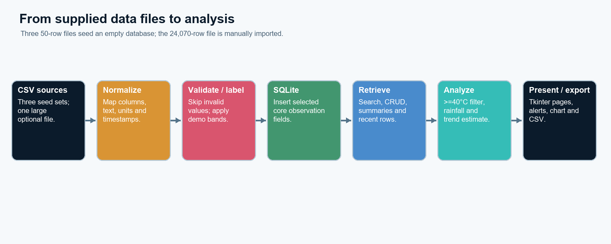
Figure 1. Selected fields move from supplied CSV files through validation into analysis.
CSV row intake · weather_data.py
reader = csv.DictReader(handle)
if not reader.fieldnames:
raise ValueError("This CSV does not contain a header row.")
for line_number, raw in enumerate(reader, start=2):
row = _row_lookup(raw)
temp = _pick(row, ["temperature_c", "temperature_celsius", "temperature", "temp_c", "maximum_temperature", "feels_like_celsius"])
if temp is None:
continue
Validation constrains temperature to −20…60°C and humidity to 0…100%. Original files stay on disk; source identity is not preserved per row. The Exp 04 label claims an IMD source in the supplied cells, but that claim was not independently authenticated.

3 ANALYSIS, WARNING LOGIC AND ESTIMATE
The temperature analyzer creates a list of numeric readings, filters the >=40°C subset and reduces a total used for summary statistics. It also returns mean, extrema, converted Fahrenheit values and the set of stored alert categories. A parallel RainfallAnalyzer provides rainfall totals and wet-reading counts through the same abstract analyze() interface.
Temperature analysis · climate_engine.py
temperatures = list(map(lambda r: float(r["temperature"] if isinstance(r, dict) else r.temperature), observations))
hot = list(filter(lambda temp: temp >= 40.0, temperatures))
total = reduce(lambda a, b: a + b, temperatures, 0.0)
square_first = (lambda value: value * value)(temperatures[0]) if temperatures else None
return {"count": len(temperatures), "average": total / len(temperatures) if temperatures else 0.0,
"minimum": min(temperatures) if temperatures else None,
"maximum": max(temperatures) if temperatures else None,
"total": total, "square_first": square_first, "hot_count": len(hot), "hot_values": hot,
"fahrenheit": list(map(celsius_to_fahrenheit, temperatures)),
"alert_levels": {classify_alert(temp) for temp in temperatures}}
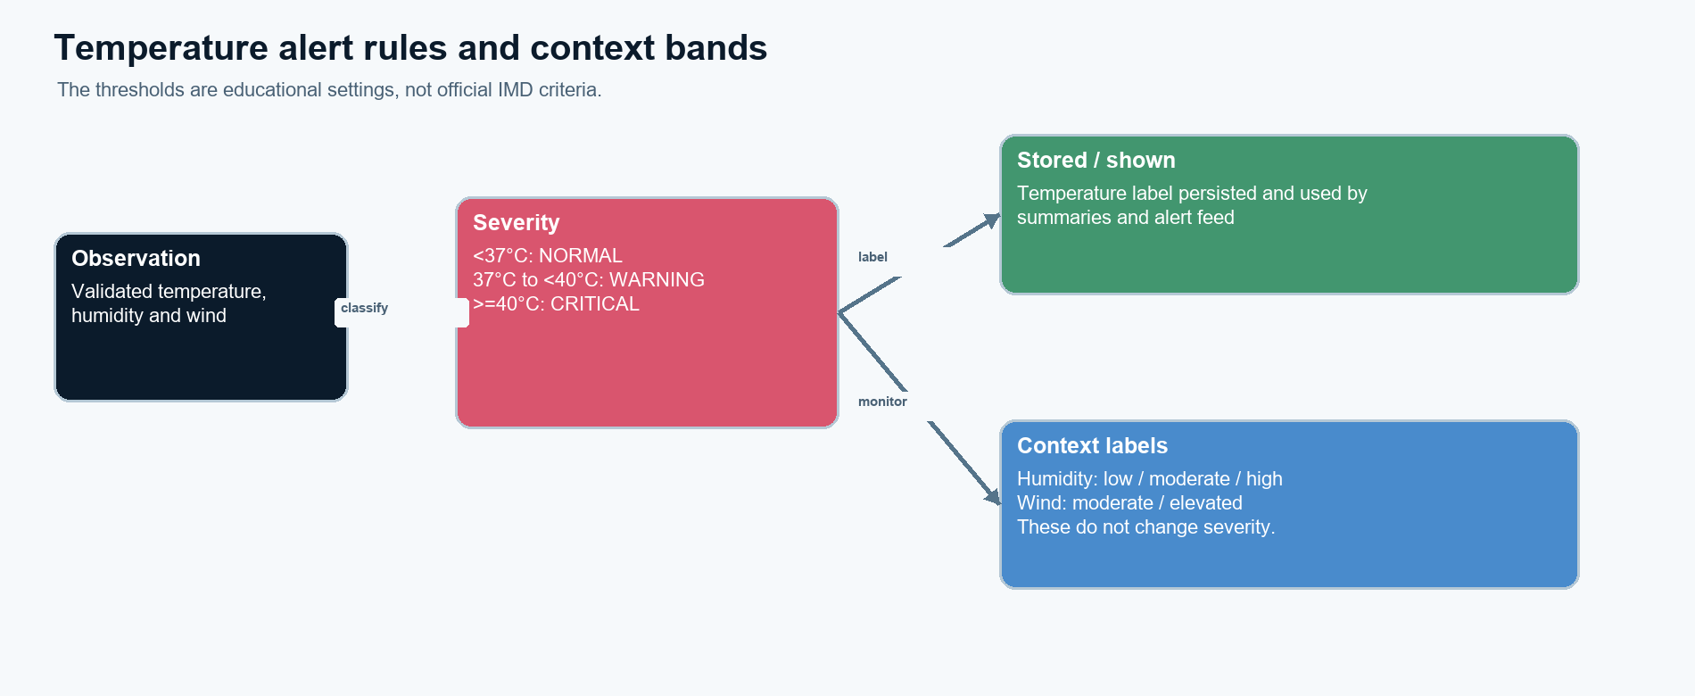
Figure 2. Temperature controls severity; humidity and wind remain descriptive monitor labels.
Temperature classification · alert_engine.py
if temp >= CRITICAL_C:
return "CRITICAL"
if temp >= WARNING_C:
return "WARNING"
return "NORMAL"
The simple prediction screen adds the average first-to-last per-record change from up to eight recent values once to the latest value. Timestamps are not normalized to equal intervals, and no future holdout accuracy is reported. Concurrent checks and simulation are local synthetic workflows, not sensor or API feeds.

4 EXPERIMENT COVERAGE AND CLIMATE USE
Each supplied experiment is represented where supported by the final project. The experiment table distinguishes climate functionality from separate academic support exercises.
EXP. / TOPIC | PYTHON CONCEPT | APPLICATION EVIDENCE
01 · Class creation | Classes, objects, constructor, attributes and encapsulation. | Observation class stores measurements; separate marks classes are not climate analytics.
02 · Constructors and lists | Default/parameterized construction, list accumulation and CRUD. | CSV dictionaries are accumulated then validated into the common observation table.
03 · String handling and inheritance | Whitespace/string methods, base and derived classes, super(). | Header/value text is normalized; inherited imports share base observation behavior.
04 · Abstract classes and polymorphism | ABC, abstract method, overriding and a shared method contract. | A common analyze() contract allows temperature and rainfall summaries to be called consistently.
05 · Exceptions, modules and multithreading | Exceptions, module separation, background/concurrent work. | Bad rows are skipped or rejected; concurrent checks classify saved records without an external feed.
06 · Collections and functional programming | Lists, mappings, sets, lambda, map, filter and reduce. | map/filter/reduce and a set drive conversion, >=40°C counts, totals and alert-category summaries.
Trend calculation · app.py
vals=self.chart_values[-8:]
estimate=vals[-1]
if len(vals)>=2:
delta=(vals[-1]-vals[0])/max(1,len(vals)-1)
estimate=vals[-1]+delta
Database and simulation boundary
SQLite contains one observations table with 12 columns and indexes on observed_at and station. The 41.6°C Nagpur Heatwave Demo is explicitly saved as synthetic; the continuous simulation generates local random records. Dashboard summaries can therefore mix imported, manual and synthetic observations.

5 RESULTS, LIMITATIONS AND CONCLUSION
VALIDATION | RESULT
Parsing / scale | Each small CSV yields 50 records; the 24,070-row file parser maps core fields.
Database | 150-row seed, CRUD and 50-row CSV import/export round trip pass.
Rules / model | 36.9, 37.0 and 40.0°C boundary tests pass; both analyzer implementations are exercised.
Monitoring | GUI smoke confirms all pages, simulation persistence and stored 41.6°C CRITICAL example.
Overall | 16/16 automated tests passed, 13 Oct 2026; no predictive-accuracy evaluation was run.
Interpretation and conclusion
The app turns mixed inputs into a usable teaching workflow, not a climatological series. Its imports have incomplete provenance, duplicate rows can accumulate, and the supplied spreadsheets are not accepted by the GUI. Alert cutoffs are educational rather than official; the map is illustrative. The per-record trend is neither a time-calibrated forecast nor machine learning. With these qualifications, normalization, filtering, aggregation and persisted alert labels make the data path traceable and demonstrable.
Selected references
[1] Python Software Foundation. Python 3 Library Reference: tkinter, csv, sqlite3 and concurrent.futures. [2] SQLite Consortium, SQL Language Reference. [3] Supplied Python experiments 01–06 and project source files, preserved in the project workspace.

