CLIMATE INTELLIGENCE
Climate Intelligence for Heatwave Monitoring, Prediction and Early Warning
USER INTERFACE, SIMULATION AND VALIDATION
A guided case study of interaction and evidence
Student name: ____________________ Roll number: ____________________
Class / division: ____________ Course: ____________ Institution: __________________________
1 USER NEED AND APPLICATION OVERVIEW
A student or evaluator needs to move from a dashboard summary to individual observations, analysis and a repeatable warning demonstration. The local Tkinter application uses a sidebar to navigate Overview, Climate records, Analysis & alerts, Predictions and Project details. The capture below is the one genuine supplied application screenshot; its values describe that captured database state.
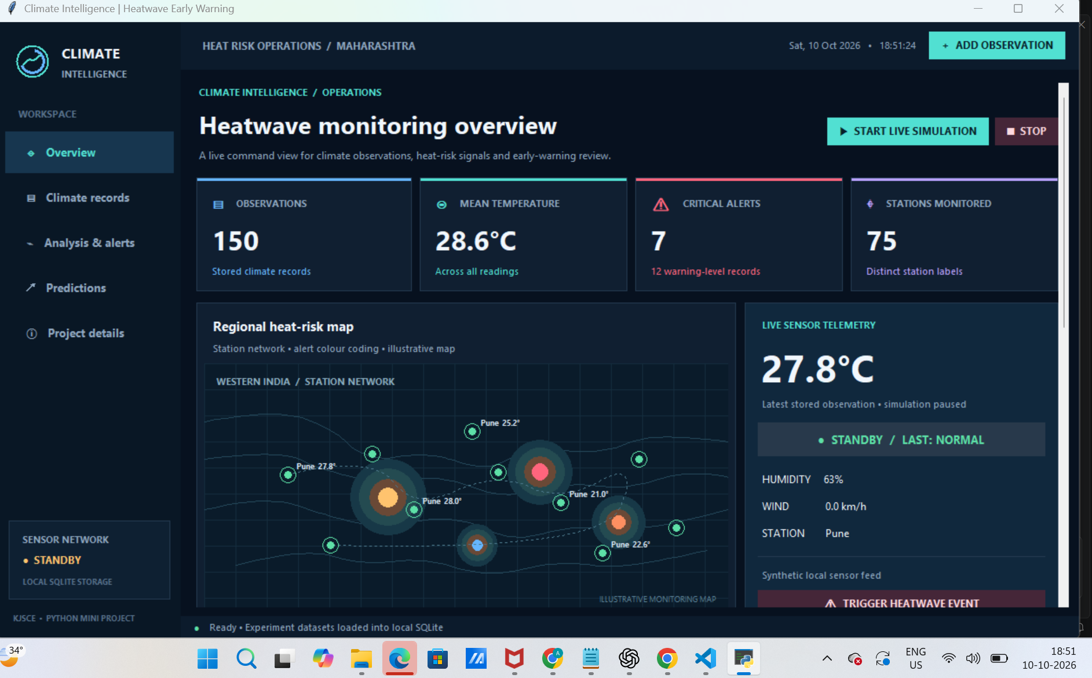
Figure 1. Supplied Overview capture: paused simulation, stored metrics and illustrative station canvas.
Objective: provide clear data entry/search, CSV exchange, climate summaries, textual warning states and a simulation that can be explained without implying remote live monitoring.

2 INTERFACE STRUCTURE AND USER WORKFLOWS
SCREEN | USER TASK / FEEDBACK
Overview | Read metric cards, latest values, illustrative map/telemetry; start/stop synthetic feed or trigger demo.
Climate records | Search by station/city/category/source; select, add, update or delete; CSV import/export.
Analysis & alerts | Review temperature/rain summaries, >=40°C count, category labels and concurrent-monitor result.
Predictions | View recent readings and one-step per-record trend estimate.
Project details | Inspect experiment, dataset and limitation information.
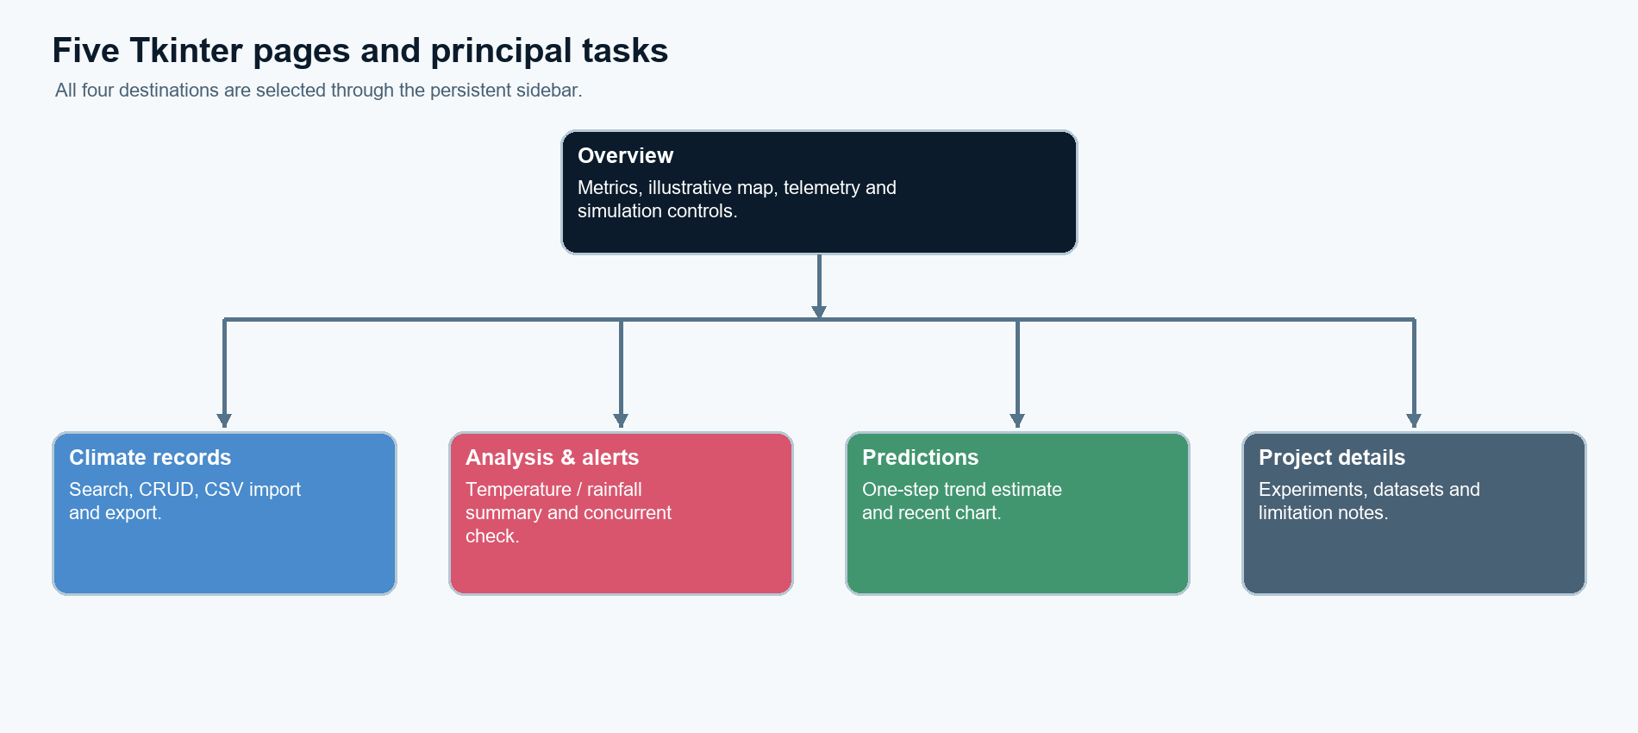
Figure 2. Page destinations are frames selected through Tkinter callbacks.
Deterministic demo action · app.py
record = {
"observed_at": datetime.now().strftime("%Y-%m-%d %H:%M:%S"),
"station": "Nagpur Heatwave Demo", "city": "Nagpur",
"temperature": 41.6, "humidity": 29.0, "wind_speed": 7.5, "rainfall": 0.0,
"condition_text": "Simulated heatwave event", "source": "Scenario simulation",
"notes": "Synthetic demonstration event; not a live weather observation"
}
The database assigns the corresponding temperature category during insertion. Text accompanies color to make severity visible; accessibility and participant testing were not conducted.

3 RECORDS, DATASETS AND COURSE CONCEPTS
SUPPLIED CSV | ROWS / ROLE | FIELDS RETAINED FOR THE COMMON RECORD
weather_data exp 03.csv | 50 / bootstrap | Station, city, temperature, humidity, wind, condition
Exp04_IMD_50_Real_Weather_Observations.csv | 50 / bootstrap | Date, station, temperature, rainfall; source label unverified
Pune_Climate_50_Observations EXP 6.csv | 50 / bootstrap | Time, station, temperature, humidity
Weather data (EXP5).csv | 24,070 / manual import | Selected core weather fields from 20 columns
Two XLSX companions are supplied but import/export dialogs are CSV-only. Empty storage seeds the three 50-row files. SQLite stores one observations table (12 fields) and indexes date/time and station; CRUD is parameterized, but repeated imports may duplicate records and source-level provenance is incomplete.
EXP. / TOPIC | CONCEPT → ACTUAL APPLICATION
01 · Class creation | Classes, objects, constructor, attributes and encapsulation. Validated observation objects carry form/import values; marks classes remain outside the UI.
02 · Constructors and lists | Default/parameterized construction, list accumulation and CRUD. List-backed import staging leads to saved rows; record controls operate on persistent SQLite CRUD.
03 · String handling and inheritance | Whitespace/string methods, base and derived classes, super(). Clean labels and the imported subclass keep displayed records consistent with the base model.
04 · Abstract classes and polymorphism | ABC, abstract method, overriding and a shared method contract. Analysis screens call either analyzer through the shared method interface.
05 · Exceptions, modules and multithreading | Exceptions, module separation, background/concurrent work. Background simulation/monitoring returns queued results for Tk updates; errors are shown as feedback.
06 · Collections and functional programming | Lists, mappings, sets, lambda, map, filter and reduce. Collections and lambdas support the Analysis & alerts results users inspect in the GUI.

4 SIMULATION, RISK FEEDBACK AND IMPLEMENTATION EVIDENCE
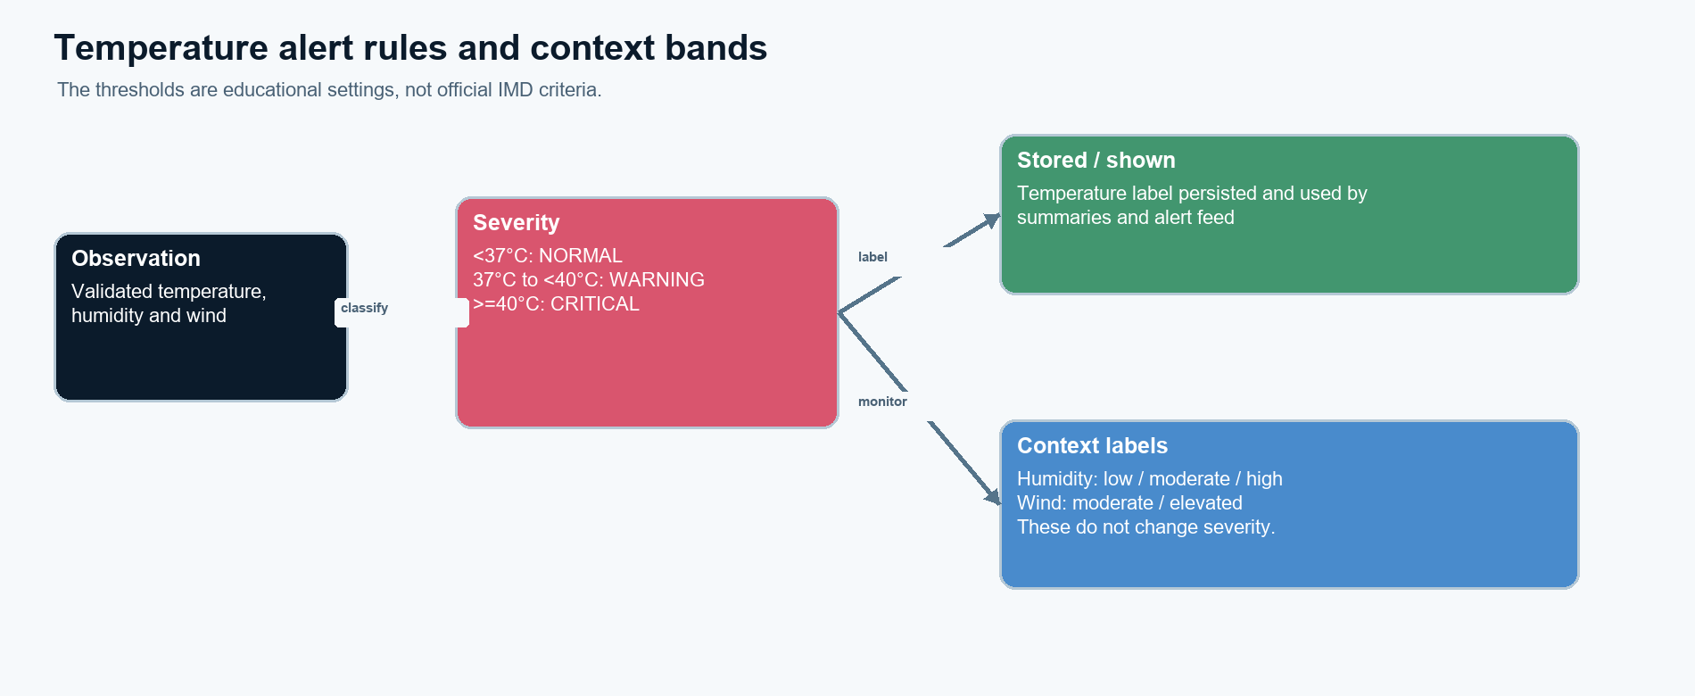
Figure 3. Stored alert bands are temperature-only; humidity/wind are separate context labels.
The live-simulation control creates synthetic local observations on a worker and returns events through a queue for Tk polling. Stop signals the worker. Heatwave Event persists a fixed 41.6°C Nagpur example. Both paths are repeatable demonstrations; neither represents measured weather.
Temperature severity · alert_engine.py
if temp >= CRITICAL_C:
return "CRITICAL"
if temp >= WARNING_C:
return "WARNING"
return "NORMAL"
Concurrent monitor · app.py
from concurrent.futures import ThreadPoolExecutor
def check(row):
r=dict(row);r.update(monitor_conditions(r))
return r
with ThreadPoolExecutor(max_workers=8, thread_name_prefix="heat-check") as pool:
result=list(pool.map(check, rows))
self.events.put(("monitor_done",result))
The estimate shown on Predictions uses up to eight latest readings and adds one average per-reading change to the latest value. It does not account for unequal timestamp gaps and has no accuracy score. There is no trained model or external data feed.

5 OBSERVED TESTS, LIMITATIONS AND CONCLUSION
TEST AREA | VERIFIED OBSERVATION
Navigation / geometry | GUI smoke visits all five page keys and checks 880×580 construction.
Input and risk | Validation rejects invalid humidity; boundary tests pass at 36.9, 37 and 40°C.
Storage / CSV | CRUD, 150-row bootstrap and 50-row import/export round trip pass.
Demonstration | Start/stop simulation persists a reading; event stores 41.6°C as CRITICAL.
Suite total | 16/16 automated tests passed on 13 Oct 2026 using temporary databases.
Limits and conclusion
The UI supports a clear classroom walkthrough, but only one authentic full-screen capture was supplied; other pages are covered by source inspection and smoke tests rather than screenshots. No usability study, screen-reader review, XLSX workflow, real sensor/API, official alert validation or forecast accuracy test is claimed. Imported, manually entered, synthetic and estimated values must remain distinct during a demonstration. Within those limits, the five-page workflow links understandable feedback with persistent local records.
Selected references
[1] Python Software Foundation. Python 3 Library Reference: tkinter, csv, sqlite3 and concurrent.futures. [2] SQLite Consortium, SQL Language Reference. [3] Supplied Python experiments 01–06 and project source files, preserved in the project workspace.

