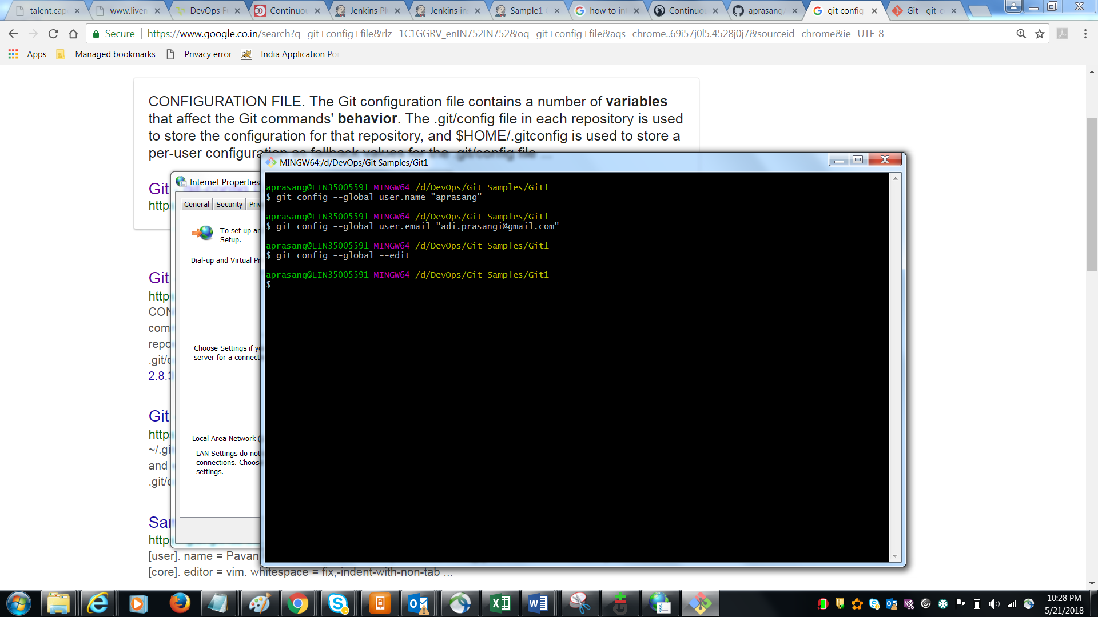

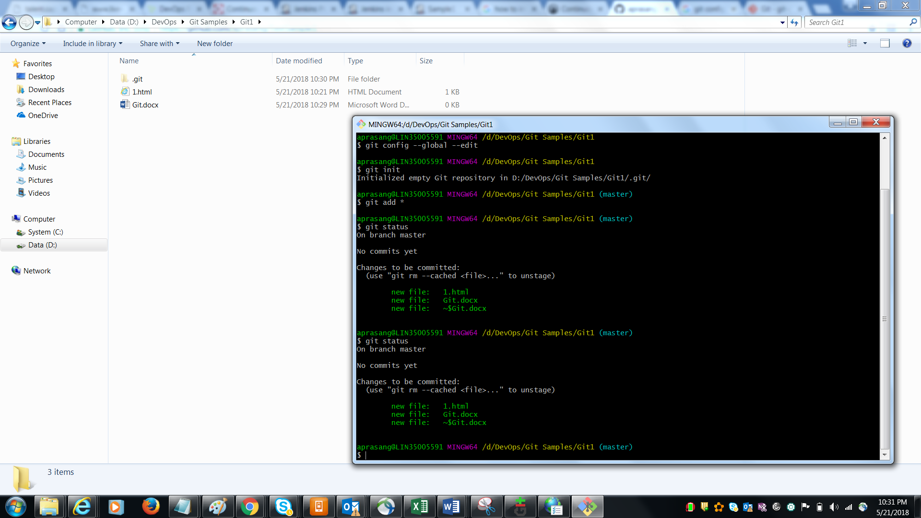

Commands

Git config –global user.name “aprasang”

Git config –global user.email [adi.prasangi@gmail.com](mailto:adi.prasangi@gmail.com)

Git config – global edit (it will edit the global config file in which we can see username and email id)

Create a folder 🡪 right clik and open git bash 🡪

Git init

Git add \* [ to add all files]

Git add “filename.txt” [ to add one file]

Git status [ to know the status ]

Git reset filename [ to remove files from staging i.e after add command]

Git commit -m “committ1”

Git remote add origin https://github.com/aprasang/TestSample1.git

Git push -u origin master

Git fetch -p [ shows all the branches created]

Git checkout <SUB-101>