<http://localhost:8080/pims/persons>

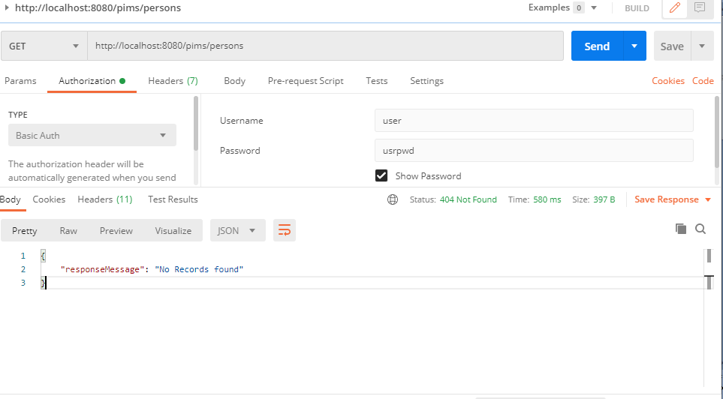

http://localhost:8080/pims/person

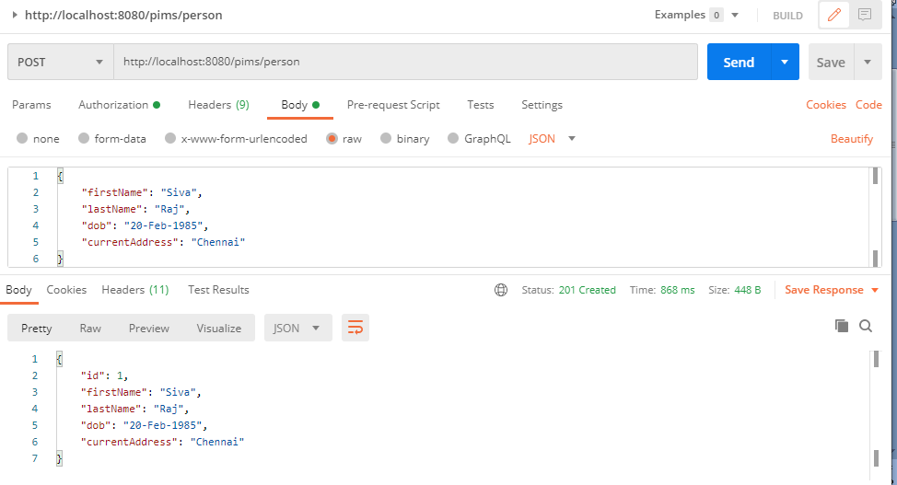

http://localhost:8080/pims/persons

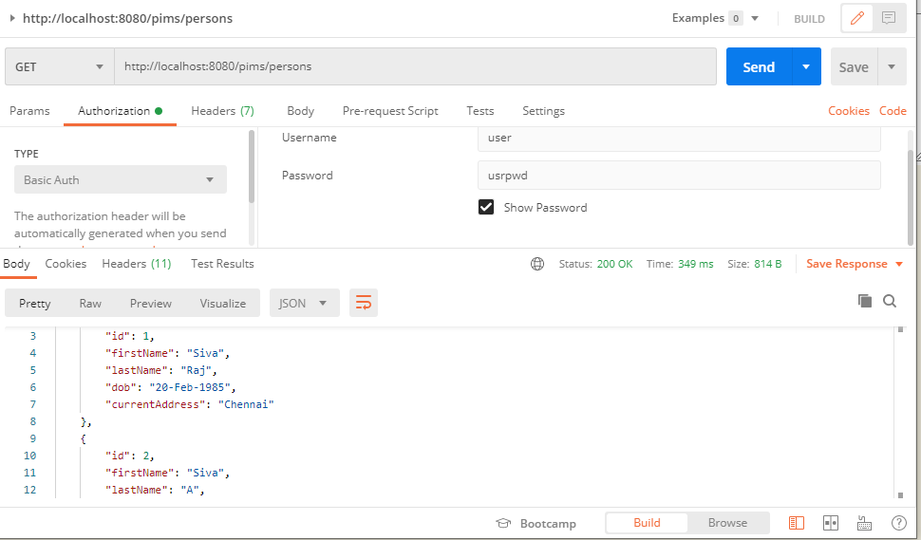

http://localhost:8080/pims/person/1

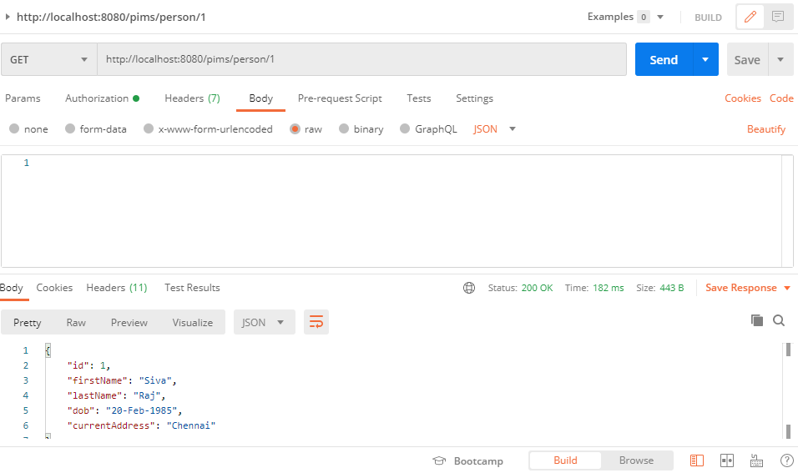

<http://localhost:8080/pims/person/1>

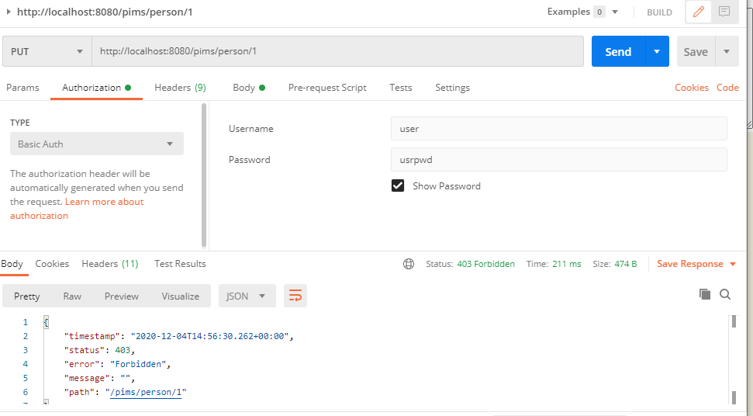

http://localhost:8080/pims/person/1

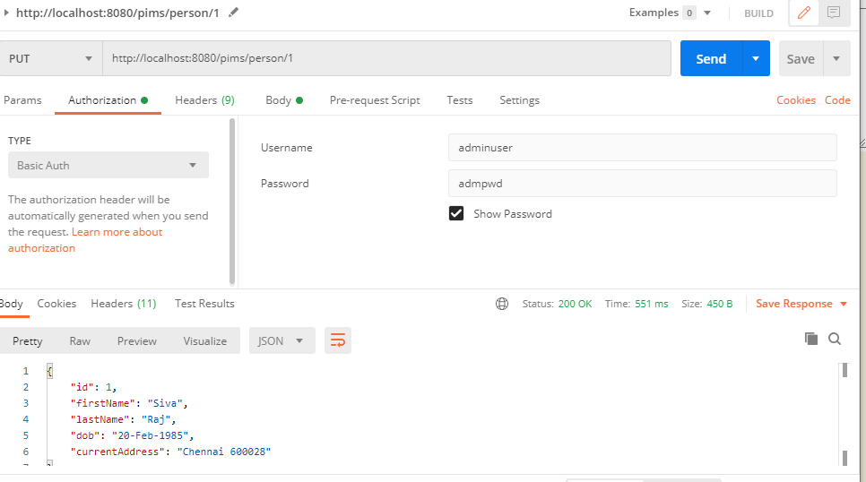

http://localhost:8080/pims/person?firstName=Siva&lastName=

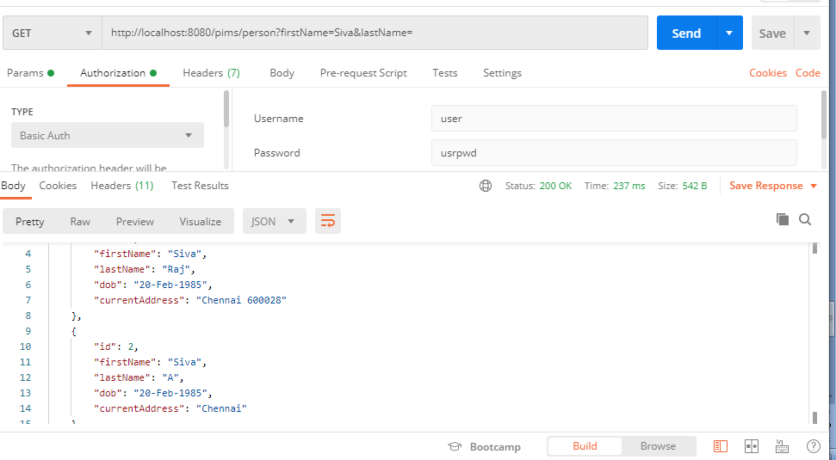

http://localhost:8080/pims/person?firstName=&lastName=A

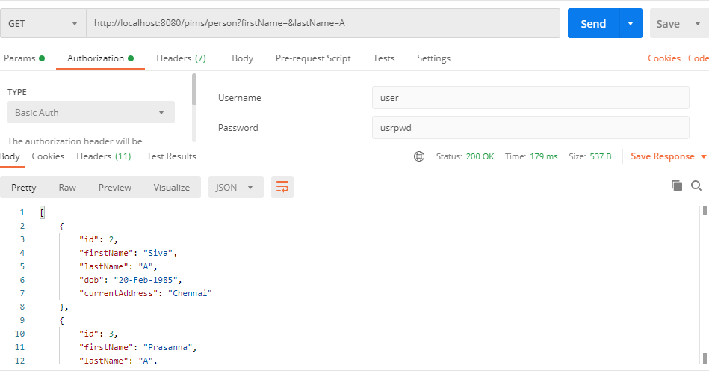

http://localhost:8080/pims/person?firstName=Siva&lastName=A

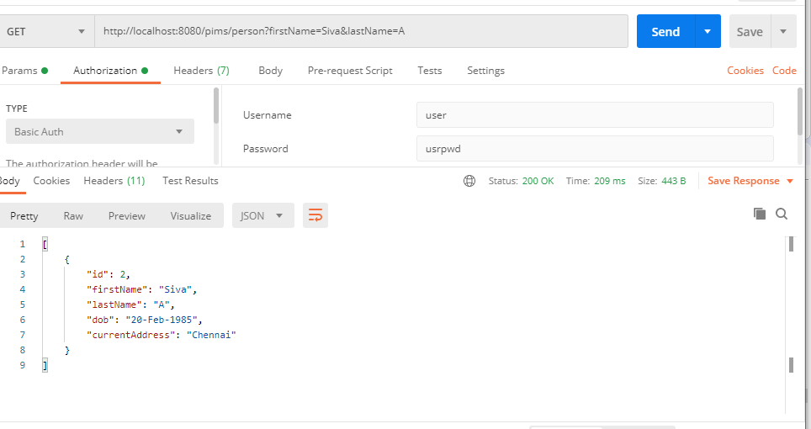

http://localhost:8080/pims/pets

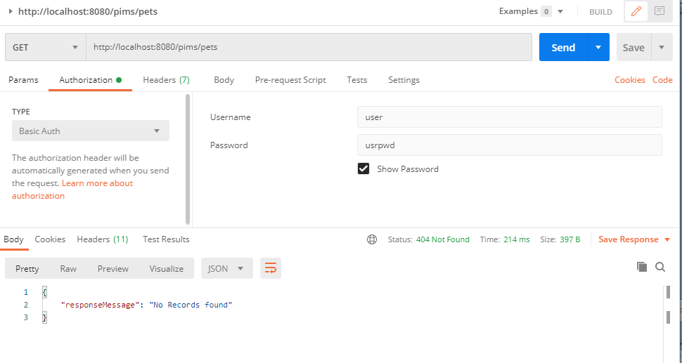

http://localhost:8080/pims/pet

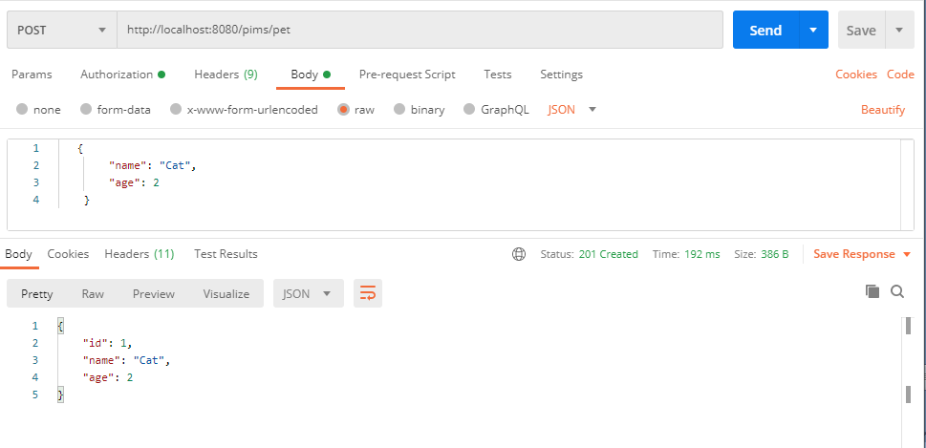

http://localhost:8080/pims/pets

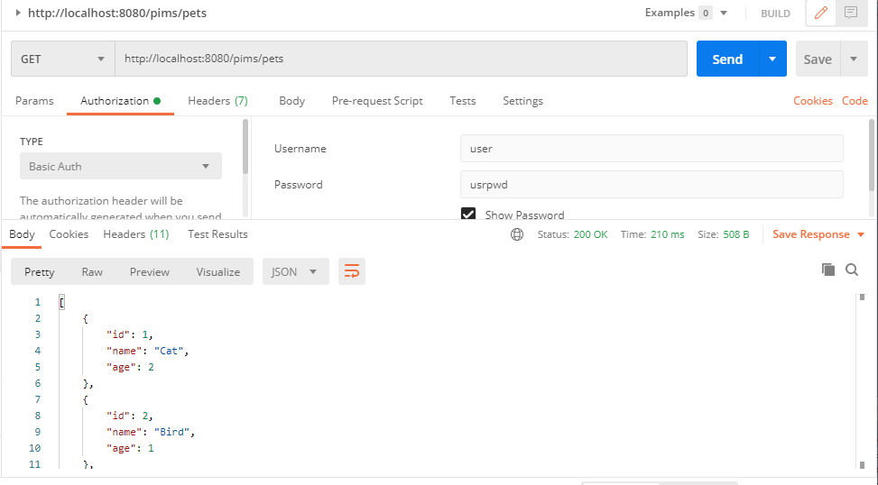

http://localhost:8080/pims/pet/3

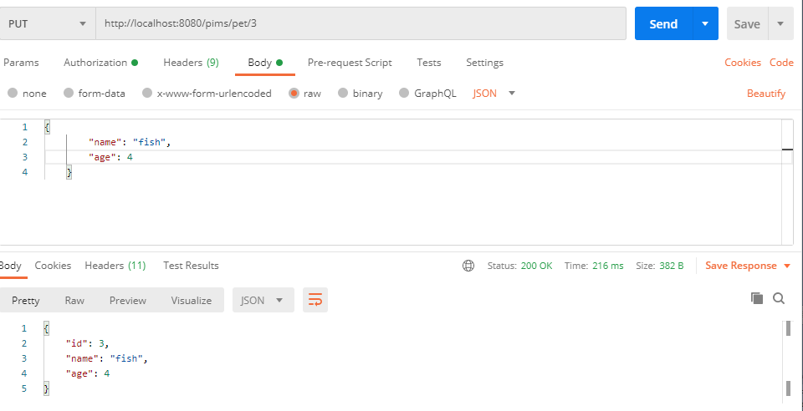

http://localhost:8080/pims/pet/5

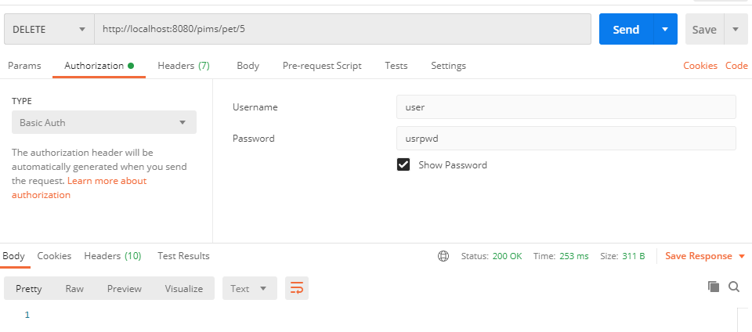

http://localhost:8080/pims/pet/1

