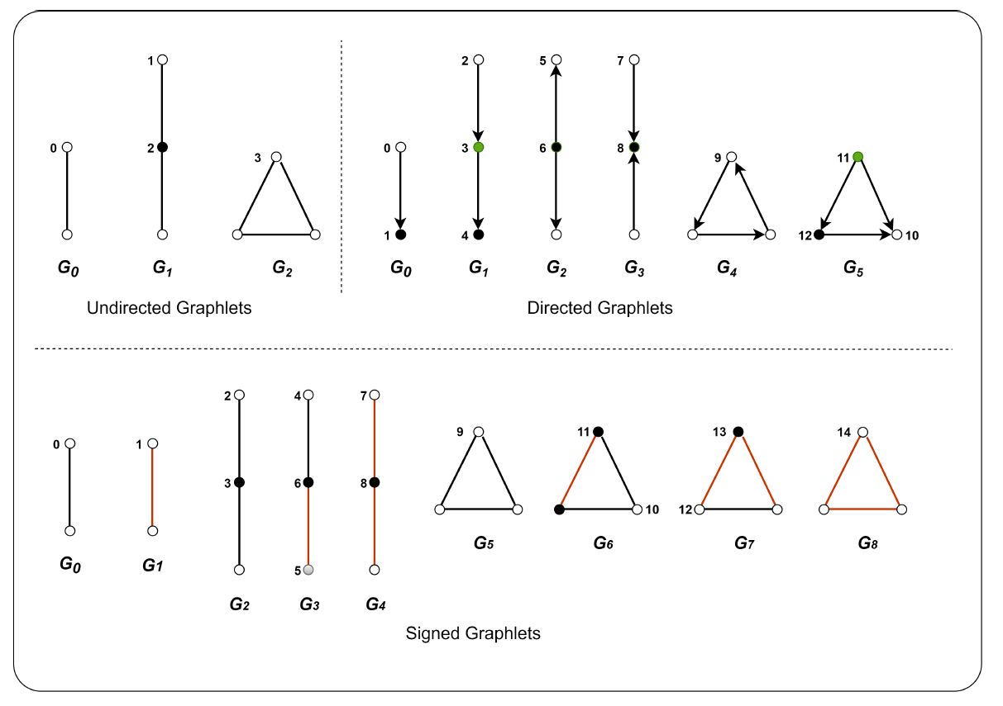

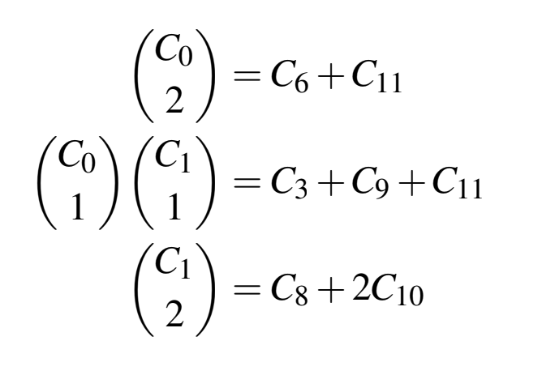

C6 + 2C11

C3 + C9 + 2C12

C8 + 2C10

**Simikameen**

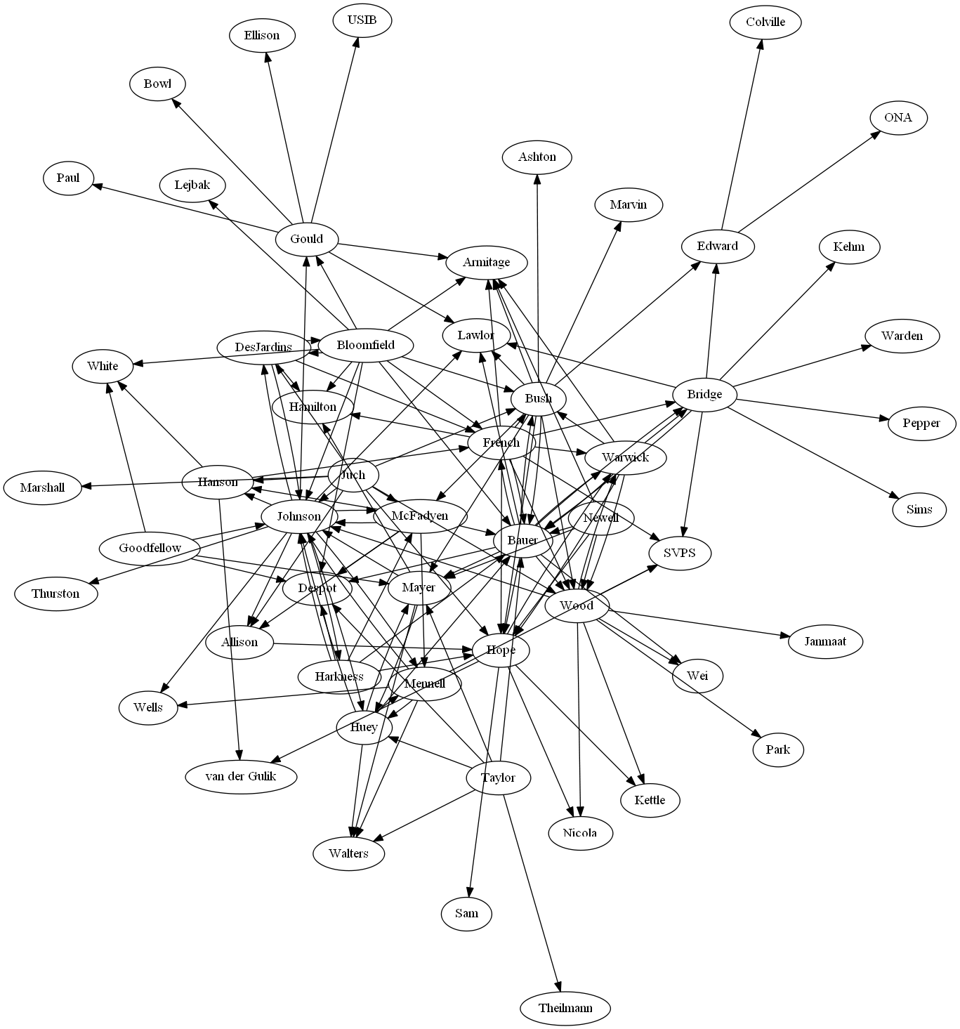

**Kettle**

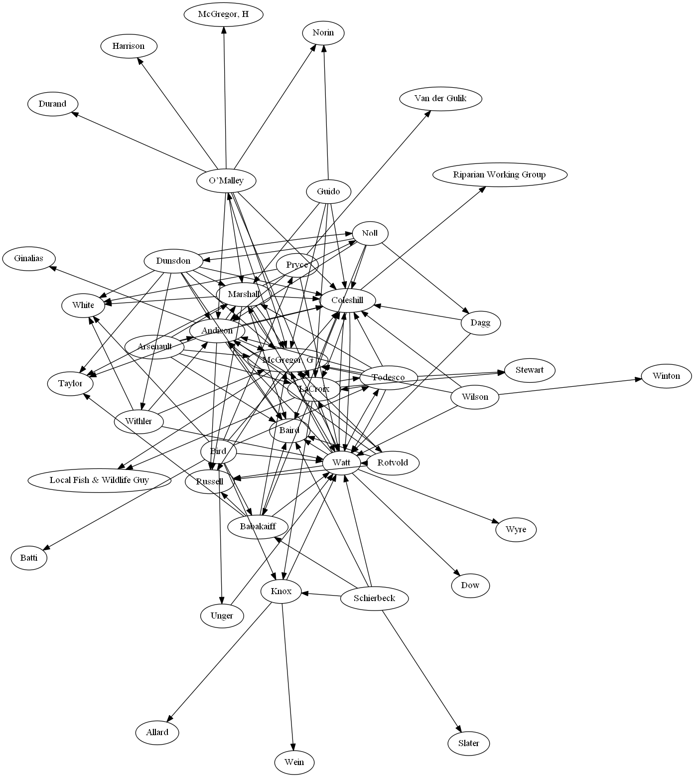

Similkameen - raw

|  |  |  |  |  |  |  |  |  |  |  |  |  |  |
| --- | --- | --- | --- | --- | --- | --- | --- | --- | --- | --- | --- | --- | --- |
|  | 0 | 1 | 2 | 3 | 4 | 5 | 6 | 7 | 8 | 9 | 10 | 11 | 12 |
| 0 | 1 | 0.49 | 0.61 | 0.67 | 0.28 | 0.04 | 0.84 | 0.55 | 0.34 | 0.76 | 0.48 | 0.51 | 0.63 |
| 1 | 0.49 | 1 | 0.01 | 0.73 | 0.49 | 0.64 | 0.39 | -0.1 | 0.82 | 0.66 | 0.87 | 0.01 | 0.61 |
| 2 | 0.61 | 0.01 | 1 | 0.12 | 0.13 | -0.13 | 0.63 | 0.96 | -0.02 | 0.35 | 0.04 | 0.93 | 0.12 |
| 3 | 0.67 | 0.73 | 0.12 | 1 | 0.12 | 0.19 | 0.52 | 0.01 | 0.7 | 0.82 | 0.64 | 0.12 | 0.78 |
| 4 | 0.28 | 0.49 | 0.13 | 0.12 | 1 | 0.65 | 0.26 | 0.04 | 0.21 | 0.32 | 0.45 | 0.03 | 0.16 |
| 5 | 0.04 | 0.64 | -0.13 | 0.19 | 0.65 | 1 | 0.11 | -0.16 | 0.55 | 0.04 | 0.65 | -0.13 | 0.03 |
| 6 | 0.84 | 0.39 | 0.63 | 0.52 | 0.26 | 0.11 | 1 | 0.61 | 0.26 | 0.6 | 0.51 | 0.64 | 0.57 |
| 7 | 0.55 | -0.1 | 0.96 | 0.01 | 0.04 | -0.16 | 0.61 | 1 | -0.09 | 0.19 | -0.03 | 0.89 | 0.02 |
| 8 | 0.34 | 0.82 | -0.02 | 0.7 | 0.21 | 0.55 | 0.26 | -0.09 | 1 | 0.52 | 0.78 | 0.02 | 0.55 |
| 9 | 0.76 | 0.66 | 0.35 | 0.82 | 0.32 | 0.04 | 0.6 | 0.19 | 0.52 | 1 | 0.6 | 0.33 | 0.85 |
| 10 | 0.48 | 0.87 | 0.04 | 0.64 | 0.45 | 0.65 | 0.51 | -0.03 | 0.78 | 0.6 | 1 | 0.08 | 0.66 |
| 11 | 0.51 | 0.01 | 0.93 | 0.12 | 0.03 | -0.13 | 0.64 | 0.89 | 0.02 | 0.33 | 0.08 | 1 | 0.17 |
| 12 | 0.63 | 0.61 | 0.12 | 0.78 | 0.16 | 0.03 | 0.57 | 0.02 | 0.55 | 0.85 | 0.66 | 0.17 | 1 |

Kettle - raw

|  |  |  |  |  |  |  |  |  |  |  |  |  |  |
| --- | --- | --- | --- | --- | --- | --- | --- | --- | --- | --- | --- | --- | --- |
|  | 0 | 1 | 2 | 3 | 4 | 5 | 6 | 7 | 8 | 9 | 10 | 11 | 12 |
| 0 | 1 | 0.28 | 0.75 | 0.48 | 0.26 | 0.14 | 0.63 | 0.69 | 0.24 | 0.57 | 0.22 | 0.76 | 0.5 |
| 1 | 0.28 | 1 | -0.06 | 0.84 | 0.48 | 0.34 | 0.08 | -0.05 | 0.94 | 0.79 | 0.86 | 0.23 | 0.54 |
| 2 | 0.75 | -0.06 | 1 | 0.12 | 0 | 0 | 0.34 | 0.84 | -0.04 | 0.2 | -0.03 | 0.56 | 0.22 |
| 3 | 0.48 | 0.84 | 0.12 | 1 | 0.38 | 0.2 | 0.25 | 0.05 | 0.8 | 0.83 | 0.57 | 0.38 | 0.5 |
| 4 | 0.26 | 0.48 | 0 | 0.38 | 1 | 0.62 | 0.17 | 0.17 | 0.29 | 0.66 | 0.43 | 0.4 | 0.7 |
| 5 | 0.14 | 0.34 | 0 | 0.2 | 0.62 | 1 | -0.08 | 0.36 | 0.23 | 0.6 | 0.43 | 0.42 | 0.83 |
| 6 | 0.63 | 0.08 | 0.34 | 0.25 | 0.17 | -0.08 | 1 | 0.14 | 0 | 0.27 | -0.08 | 0.32 | 0.1 |
| 7 | 0.69 | -0.05 | 0.84 | 0.05 | 0.17 | 0.36 | 0.14 | 1 | -0.04 | 0.3 | 0.08 | 0.64 | 0.48 |
| 8 | 0.24 | 0.94 | -0.04 | 0.8 | 0.29 | 0.23 | 0 | -0.04 | 1 | 0.7 | 0.88 | 0.18 | 0.42 |
| 9 | 0.57 | 0.79 | 0.2 | 0.83 | 0.66 | 0.6 | 0.27 | 0.3 | 0.7 | 1 | 0.69 | 0.59 | 0.87 |
| 10 | 0.22 | 0.86 | -0.03 | 0.57 | 0.43 | 0.43 | -0.08 | 0.08 | 0.88 | 0.69 | 1 | 0.21 | 0.58 |
| 11 | 0.76 | 0.23 | 0.56 | 0.38 | 0.4 | 0.42 | 0.32 | 0.64 | 0.18 | 0.59 | 0.21 | 1 | 0.65 |
| 12 | 0.5 | 0.54 | 0.22 | 0.5 | 0.7 | 0.83 | 0.1 | 0.48 | 0.42 | 0.87 | 0.58 | 0.65 | 1 |

Similkameen – max serriated + redundancy removed

|  |  |  |  |  |  |  |  |  |  |  |
| --- | --- | --- | --- | --- | --- | --- | --- | --- | --- | --- |
|  | 0 | 1 | 3 | 6 | 9 | 4 | 5 | 8 | 2 | 7 |
| 0 | 1 | 0.49 | 0.67 | 0.84 | 0.76 | 0.28 | 0.04 | 0.34 | 0.61 | 0.55 |
| 1 | 0.49 | 1 | 0.73 | 0.39 | 0.66 | 0.49 | 0.64 | 0.82 | 0.01 | -0.1 |
| 3 | 0.67 | 0.73 | 1 | 0.52 | 0.82 | 0.12 | 0.19 | 0.7 | 0.12 | 0.01 |
| 6 | 0.84 | 0.39 | 0.52 | 1 | 0.6 | 0.26 | 0.11 | 0.26 | 0.63 | 0.61 |
| 9 | 0.76 | 0.66 | 0.82 | 0.6 | 1 | 0.32 | 0.04 | 0.52 | 0.35 | 0.19 |
| 4 | 0.28 | 0.49 | 0.12 | 0.26 | 0.32 | 1 | 0.65 | 0.21 | 0.13 | 0.04 |
| 5 | 0.04 | 0.64 | 0.19 | 0.11 | 0.04 | 0.65 | 1 | 0.55 | -0.13 | -0.16 |
| 8 | 0.34 | 0.82 | 0.7 | 0.26 | 0.52 | 0.21 | 0.55 | 1 | -0.02 | -0.09 |
| 2 | 0.61 | 0.01 | 0.12 | 0.63 | 0.35 | 0.13 | -0.13 | -0.02 | 1 | 0.96 |
| 7 | 0.55 | -0.1 | 0.01 | 0.61 | 0.19 | 0.04 | -0.16 | -0.09 | 0.96 | 1 |

Kettle – serriated w.r.t Similkameen + redundancy removed

|  |  |  |  |  |  |  |  |  |  |  |
| --- | --- | --- | --- | --- | --- | --- | --- | --- | --- | --- |
|  | 0 | 1 | 3 | 6 | 9 | 4 | 5 | 8 | 2 | 7 |
| 0 | 1 | 0.28 | 0.48 | 0.63 | 0.57 | 0.26 | 0.14 | 0.24 | 0.75 | 0.69 |
| 1 | 0.28 | 1 | 0.84 | 0.08 | 0.79 | 0.48 | 0.34 | 0.94 | -0.06 | -0.05 |
| 3 | 0.48 | 0.84 | 1 | 0.25 | 0.83 | 0.38 | 0.2 | 0.8 | 0.12 | 0.05 |
| 6 | 0.63 | 0.08 | 0.25 | 1 | 0.27 | 0.17 | -0.08 | 0 | 0.34 | 0.14 |
| 9 | 0.57 | 0.79 | 0.83 | 0.27 | 1 | 0.66 | 0.6 | 0.7 | 0.2 | 0.3 |
| 4 | 0.26 | 0.48 | 0.38 | 0.17 | 0.66 | 1 | 0.62 | 0.29 | 0 | 0.17 |
| 5 | 0.14 | 0.34 | 0.2 | -0.08 | 0.6 | 0.62 | 1 | 0.23 | 0 | 0.36 |
| 8 | 0.24 | 0.94 | 0.8 | 0 | 0.7 | 0.29 | 0.23 | 1 | -0.04 | -0.04 |
| 2 | 0.75 | -0.06 | 0.12 | 0.34 | 0.2 | 0 | 0 | -0.04 | 1 | 0.84 |
| 7 | 0.69 | -0.05 | 0.05 | 0.14 | 0.3 | 0.17 | 0.36 | -0.04 | 0.84 | 1 |

Kettle – max serriated + redundancy removed

|  |  |  |  |  |  |  |  |  |  |  |
| --- | --- | --- | --- | --- | --- | --- | --- | --- | --- | --- |
|  | 0 | 1 | 3 | 8 | 9 | 4 | 5 | 6 | 2 | 7 |
| 0 | 1 | 0.28 | 0.48 | 0.24 | 0.57 | 0.26 | 0.14 | 0.63 | 0.75 | 0.69 |
| 1 | 0.28 | 1 | 0.84 | 0.94 | 0.79 | 0.48 | 0.34 | 0.08 | -0.06 | -0.05 |
| 3 | 0.48 | 0.84 | 1 | 0.8 | 0.83 | 0.38 | 0.2 | 0.25 | 0.12 | 0.05 |
| 8 | 0.24 | 0.94 | 0.8 | 1 | 0.7 | 0.29 | 0.23 | 0 | -0.04 | -0.04 |
| 9 | 0.57 | 0.79 | 0.83 | 0.7 | 1 | 0.66 | 0.6 | 0.27 | 0.2 | 0.3 |
| 4 | 0.26 | 0.48 | 0.38 | 0.29 | 0.66 | 1 | 0.62 | 0.17 | 0 | 0.17 |
| 5 | 0.14 | 0.34 | 0.2 | 0.23 | 0.6 | 0.62 | 1 | -0.08 | 0 | 0.36 |
| 6 | 0.63 | 0.08 | 0.25 | 0 | 0.27 | 0.17 | -0.08 | 1 | 0.34 | 0.14 |
| 2 | 0.75 | -0.06 | 0.12 | -0.04 | 0.2 | 0 | 0 | 0.34 | 1 | 0.84 |
| 7 | 0.69 | -0.05 | 0.05 | -0.04 | 0.3 | 0.17 | 0.36 | 0.14 | 0.84 | 1 |

Observations:

* Differences in orbit distribution suggests importance of divergent vs convergent nodes (orbit 6, 8 & 5,7)
* Transitive cycles are 3 times more likely (orbit 9 vs 10,11,12)
* Heatmap patterns are distinguishable
* Strong intercorrelation between orbits (0,1,3,6,9) for Similkameen vs (1,3,8,9) for Kettle. This can be interpreted in other ways.
* In Similkameen communication is more like a flow (graphlet G1) whereas in Kettle communication is more like having central hub(G2,G3). With this we can say that nodes in Similkameen have either high in degree or out degree and in Kettle nodes have roughly a more closer amount of in degree and out degree. Kettle might have higher in degree since count of orbit 6 > 8
* Correlation between orbit counts and betweenness centrality is “generally” going to be positive. Since centrality measures the total number of shortest paths that pass through a vertex, higher centrality implies higher participation in graphlets. This however will not always be the case. (counter example: 3 K100s bridged by 1 k3)