create table members (

customer_id varchar2(1) primary key,

join_date timestamp);

alter table members modify join_date timestamp;

create table menu (

product_id integer primary key,

product_name varchar2(5),

price integer);

create table sales

(

customer_id varchar2(1) REFERENCES members(customer_id),

order_date date,

product_id integer REFERENCES menu(product_id)

);

insert all

into menu values(1,'sushi',10)

into menu values(2,'curry',15)

into menu values(3,'ramen',12) select * from dual;

insert into members values ('A',to_date('2021-01-07','yyyy-mm-dd'));

insert into members values ('B',to_date('2021-01-09','yyyy-mm-dd'));

insert into members values ('C',to_date('2021-01-07','yyyy-mm-dd'));

insert all

into sales values('A',to_date('2021-01-01','yyyy-mm-dd'),1)

into sales values('A',to_date('2021-01-01','yyyy-mm-dd'),2)

into sales values('A',to_date('2021-01-07','yyyy-mm-dd'),2)

into sales values('A',to_date('2021-01-10','yyyy-mm-dd'),3)

into sales values('A',to_date('2021-01-11','yyyy-mm-dd'),3)

into sales values('A',to_date('2021-01-11','yyyy-mm-dd'),3)

into sales values('B',to_date('2021-01-01','yyyy-mm-dd'),2)

into sales values('B',to_date('2021-01-02','yyyy-mm-dd'),2)

into sales values('B',to_date('2021-01-04','yyyy-mm-dd'),1)

into sales values('B',to_date('2021-01-11','yyyy-mm-dd'),1)

into sales values('B',to_date('2021-01-16','yyyy-mm-dd'),3)

into sales values('B',to_date('2021-02-01','yyyy-mm-dd'),3)

into sales values('C',to_date('2021-01-01','yyyy-mm-dd'),3)

into sales values('C',to_date('2021-01-01','yyyy-mm-dd'),3)

into sales values('C',to_date('2021-01-07','yyyy-mm-dd'),3)

select * from dual;

1)

select customer_id,sum(price) total_amount_spent from(select sales.customer_id,sales.product_id,menu.price from sales inner join menu on sales.product_id=menu.product_id) group by customer_id;

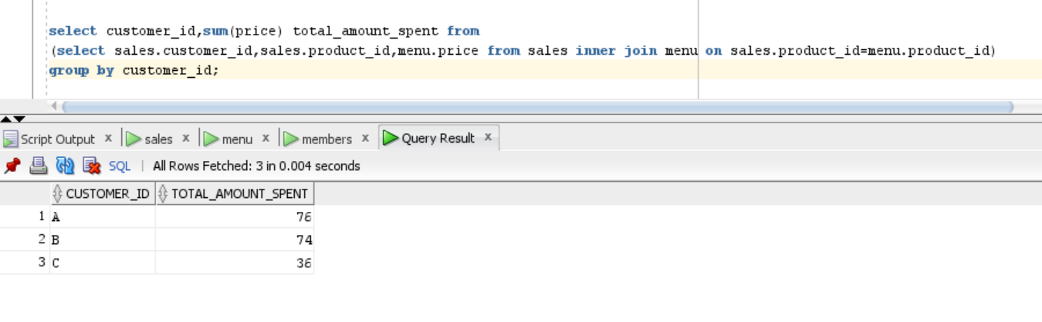

2)

select customer_id,count(distinct date_visited) no_of_days_visited from

(select sales.customer_id,sales.product_id,menu.price,sales.order_date date_visited from sales

inner join menu on sales.product_id=menu.product_id)

group by customer_id;

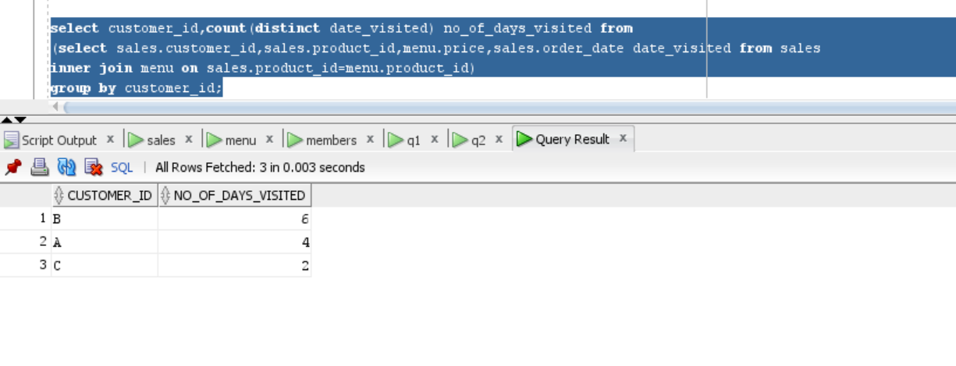

3)

select distinct customer_id,product_name,order_date from(

select sales.customer_id customer_id,sales.product_id,menu.price,sales.order_date order_date,

rank() over(order by sales.order_date) rank_order_date,menu.product_name product_name

from sales inner join menu on sales.product_id=menu.product_id) where rank_order_date=1 order by customer_id ;

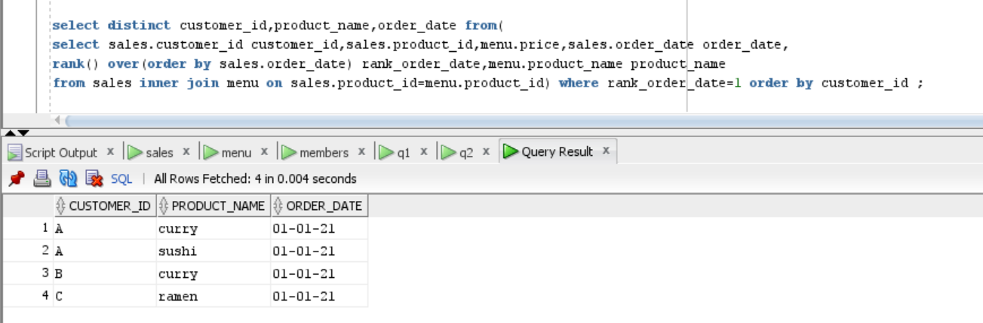

4)

select * from(

select product_id product_id,count(customer_id) no_of_orders,product_name product_name from (

select sales.customer_id customer_id,sales.product_id product_id,menu.price,sales.order_date order_date,

menu.product_name product_name

from sales inner join menu on sales.product_id=menu.product_id )

group by product_id,product_name order by no_of_orders desc) where rownum=1;

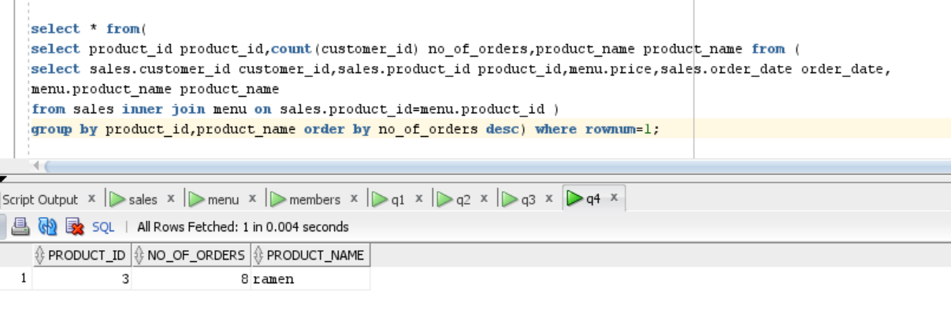

5)

select customer_id,no_of_orders,product_name from(

select customer_id,count(product_id) no_of_orders,product_name product_name,

rank() over(partition by customer_id order by count(product_id) desc) rank_prd from (

select sales.customer_id customer_id,sales.product_id product_id,menu.price,sales.order_date order_date,

menu.product_name product_name

from sales inner join menu on sales.product_id=menu.product_id )

group by customer_id,product_name order by no_of_orders desc ) where rank_prd=1;

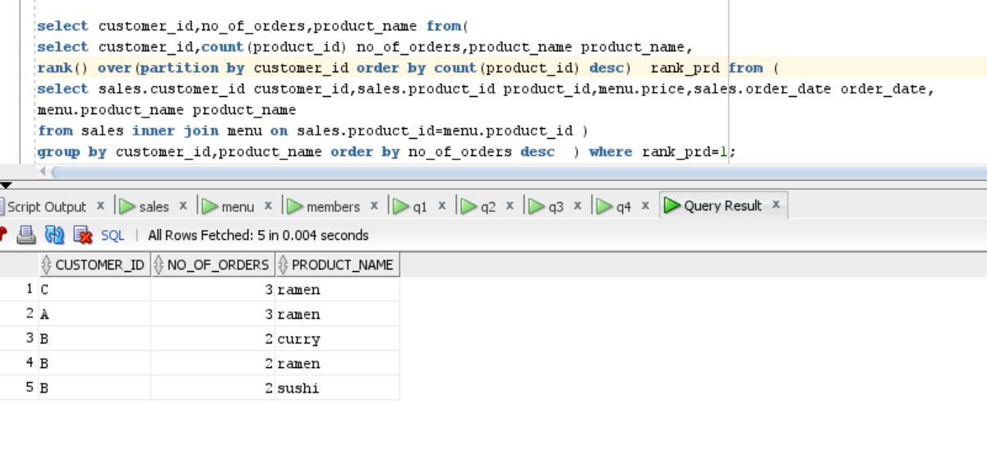

6)

select customer_id,product_id,product_name,to_char(join_date,'dd-mm-yy'),order_date from(

select sales.customer_id customer_id,sales.product_id product_id,sales.order_date order_date,menu.product_name product_name,

members.join_date join_date,rank() over(partition by sales.customer_id order by sales.order_date) rank_date

from sales inner join members on sales.customer_id=members.customer_id and sales.order_date>=members.join_date

inner join menu on sales.product_id=menu.product_id) where rank_date=1;

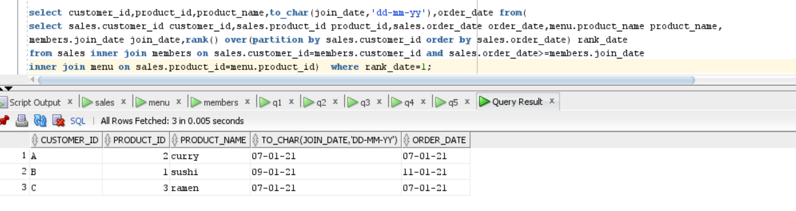

7)

select customer_id,product_id,product_name,to_char(join_date,'dd-mm-yy') join_date,order_date from(

select sales.customer_id customer_id,sales.product_id product_id,sales.order_date order_date,menu.product_name product_name,

members.join_date join_date,rank() over(partition by sales.customer_id order by sales.order_date desc) rank_date

from sales inner join members on sales.customer_id=members.customer_id and sales.order_date<=members.join_date

inner join menu on sales.product_id=menu.product_id) where rank_date=1;

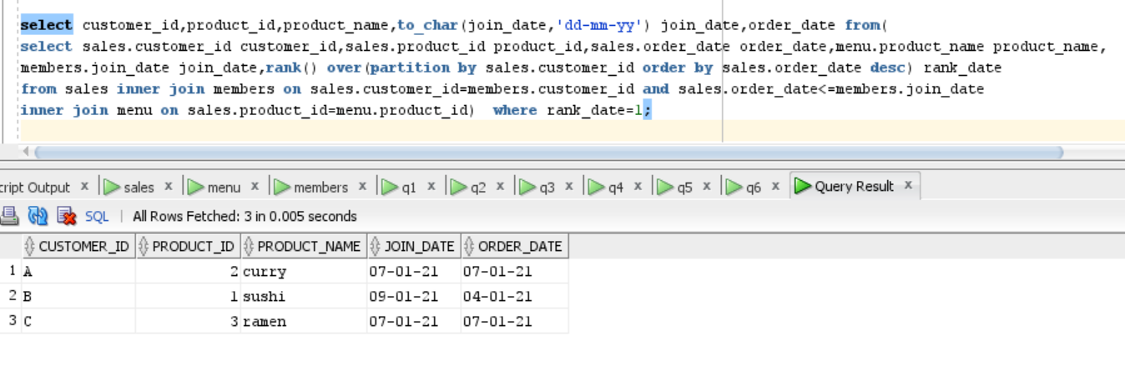

8)

select customer_id,sum(price),count(product_id) total_till_member from(

select sales.customer_id customer_id,sales.product_id product_id,sales.order_date order_date,menu.product_name product_name,

members.join_date join_date,rank() over(partition by sales.customer_id order by sales.order_date desc) rank_date,menu.price

from sales inner join members on sales.customer_id=members.customer_id and sales.order_date<members.join_date

inner join menu on sales.product_id=menu.product_id) group by customer_id;

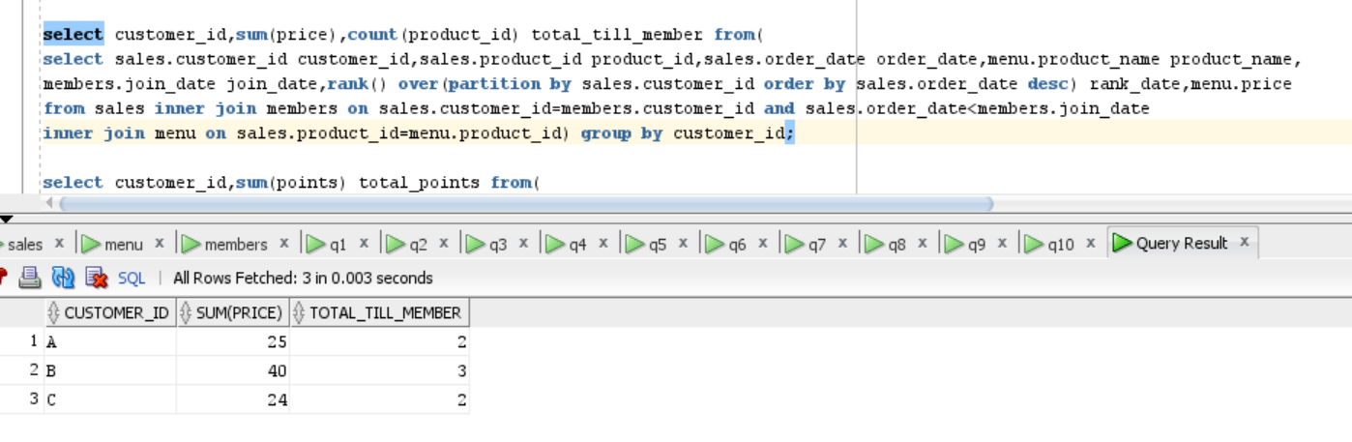

9)

select customer_id,sum(points) total_points from(

select sales.customer_id customer_id,sales.product_id product_id,menu.product_name product_name,menu.price,

case menu.product_name

when 'sushi' then menu.price*2*10

else menu.price*10

end points

from sales inner join members on sales.customer_id=members.customer_id

inner join menu on sales.product_id=menu.product_id) group by customer_id;

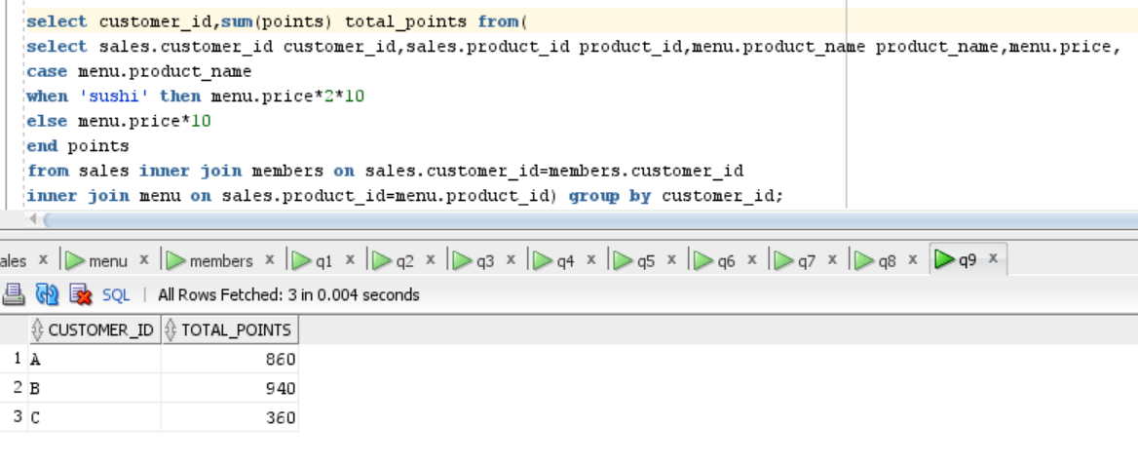

10)

select customer_id,sum(points) total_points from (

select sales.customer_id customer_id,sales.product_id product_id,menu.product_name product_name,menu.price,

sales.order_date-to_date(to_char(members.join_date,'dd-mm-yy')) no_of_days,sales.order_date order_date,

case

when

(sales.order_date-to_date(to_char(members.join_date,'dd-mm-yy')) >0) and

(sales.order_date-to_date(to_char(members.join_date,'dd-mm-yy'))<7) then menu.price*2*10

else( case when product_name ='sushi' then price*10*2 else price*10 end )

end points

from sales inner join members on sales.customer_id=members.customer_id

inner join menu on sales.product_id=menu.product_id ) where order_date < to_date('01-02-21','dd-mm-yy') group by customer_id ;

