Co founders introduction missing
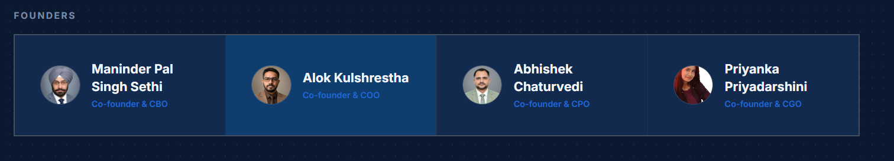
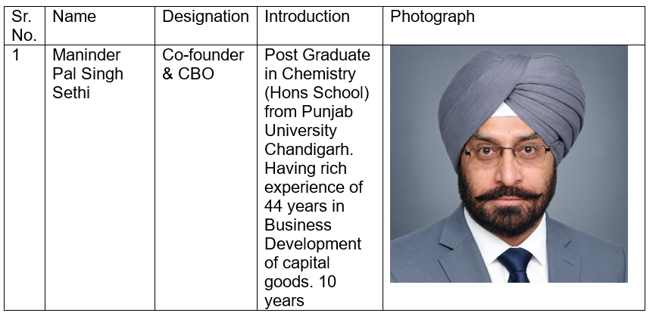
Correct AI enabled and lab testing solution to AI enabled lab testing solution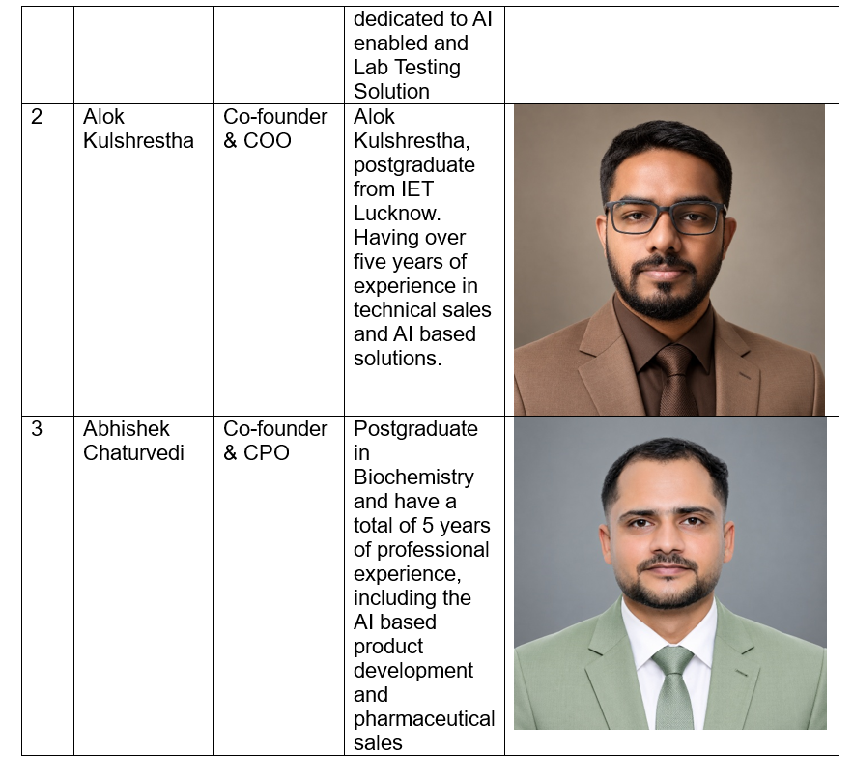
Size of images like BTCardX is very very big reduce it to 25-30 %
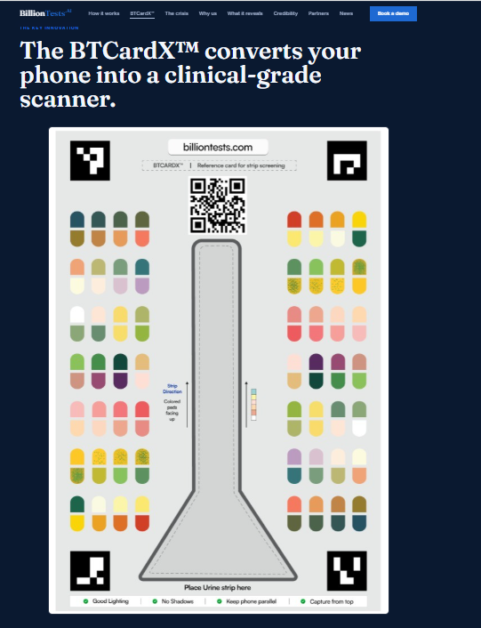

Size of animation watch it in action is too big reduce the size
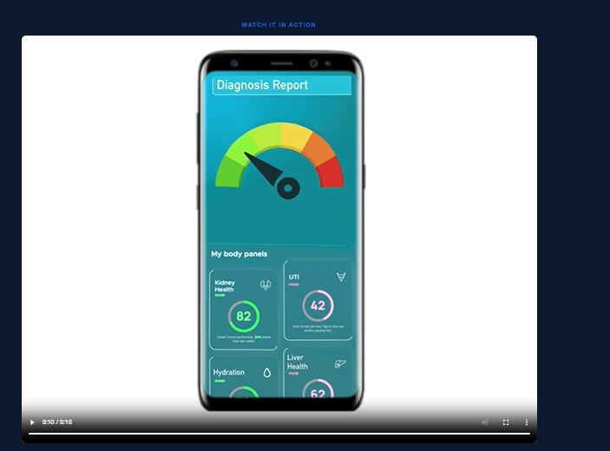
On Main page change Billion test.ai change to BilliontestsTM

On new page change billiontests to billiontests.tm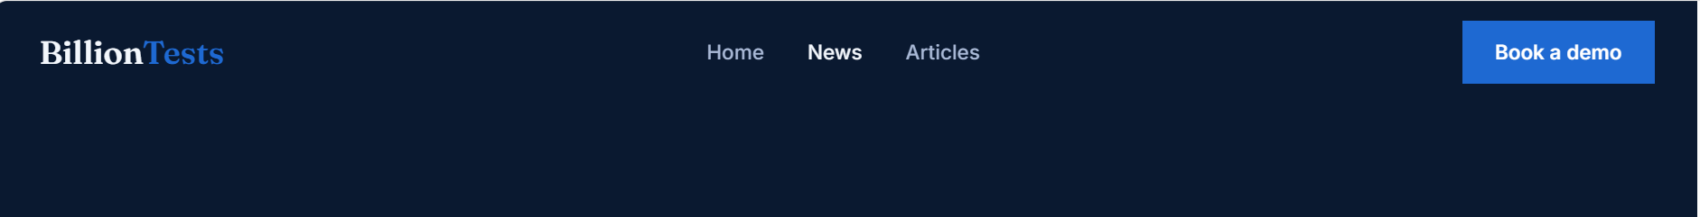

Info email is not in use and it is changed to Abhishek
So mention mpsethi@billiontest at place info
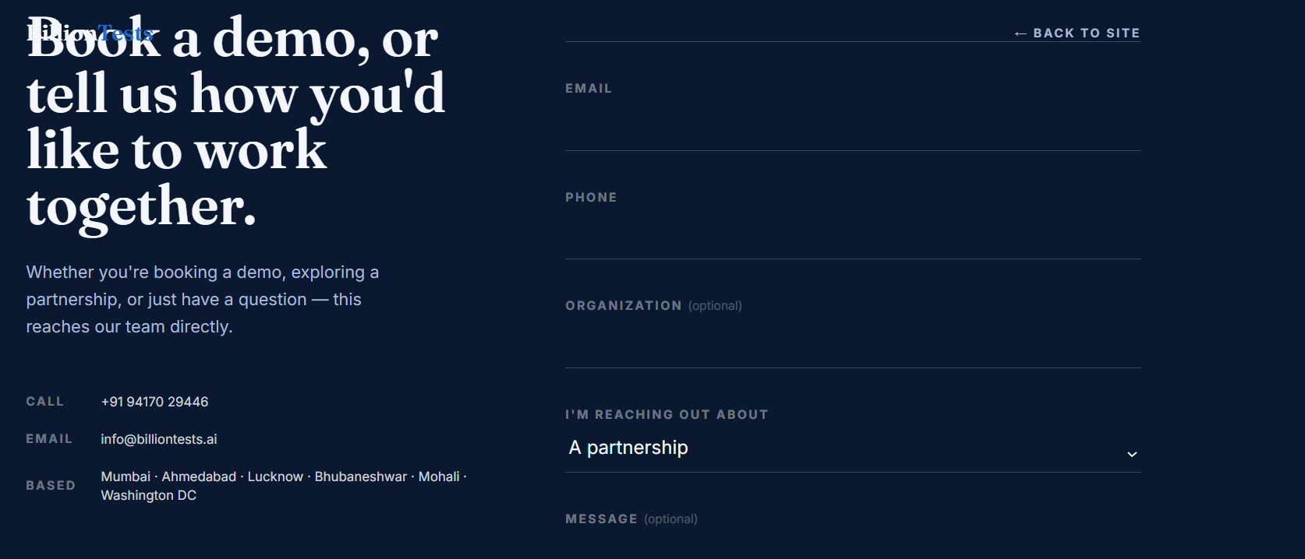

Mention Download BillionTests TM app then give this image download app from Google play and App store by giving their logos
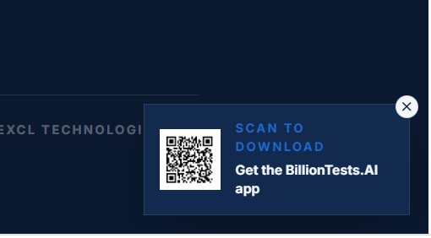
Mention email id partnership@billiontests.ai
Change from Book a demo to Contact for demo & Partnership. And along with mobile give my email also mpsethi@billiontests.ai


Under news both news have unbalanced sizes. Try to reduce the height of right side news