- detail

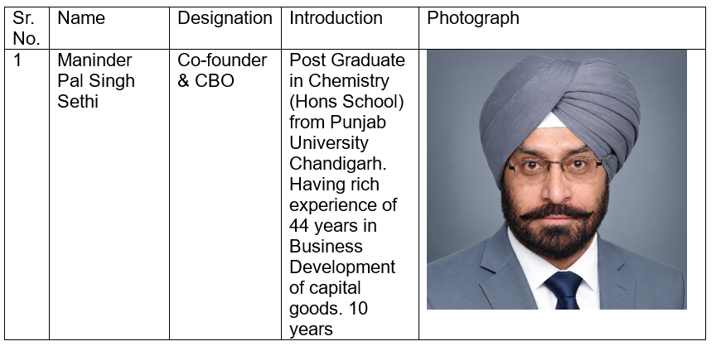
Post Graduate to Postgraduate

- Contact: at contact give just 2 email ids
mpsethi@...... & Partnership@......

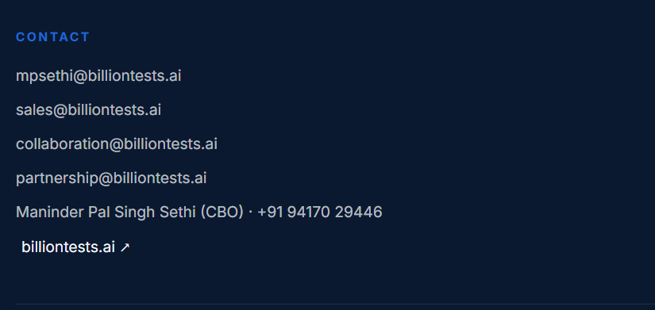

- Remove Apple logo as our a App is not ready for Apple phones yet

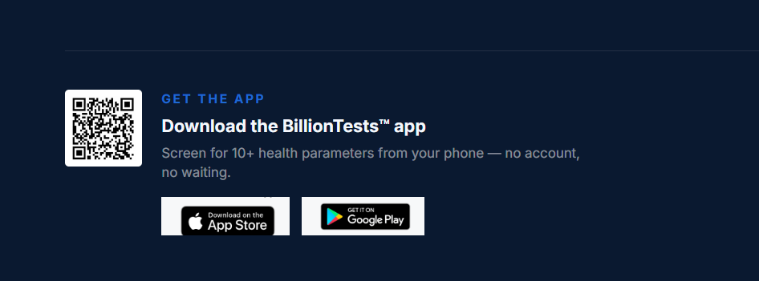

- When we take curser at co founder, colour of block become light.
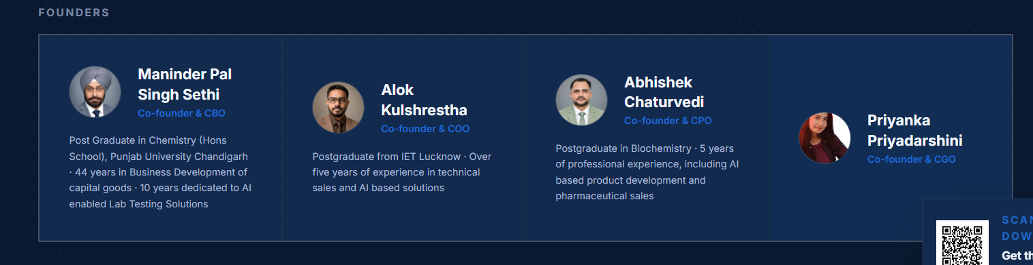
Please do the same for the following blocks

- 

