Visualizing Texas: word_document

2019-03-15

# Packages

We’ll use ggplot2 for visualization, and some light dplyr for data wrangling.

# Texas housing data

This data is loaded for you when you install and load the ggplot2 package.

## Observations: 935  
## Variables: 9  
## $ city <chr> "Austin", "Austin", "Austin", "Austin", "Austin", "Aus…  
## $ year <int> 2000, 2000, 2000, 2000, 2000, 2000, 2000, 2000, 2000, …  
## $ month <int> 1, 2, 3, 4, 5, 6, 7, 8, 9, 10, 11, 12, 1, 2, 3, 4, 5, …  
## $ sales <dbl> 1025, 1277, 1603, 1556, 1980, 1885, 1818, 1880, 1498, …  
## $ volume <dbl> 173053635, 226038438, 298557656, 289197960, 393073774,…  
## $ median <dbl> 133700, 134000, 136700, 136900, 144700, 148800, 149300…  
## $ listings <dbl> 3084, 2989, 3042, 3192, 3617, 3799, 3944, 3948, 4058, …  
## $ inventory <dbl> 2.0, 2.0, 2.0, 2.1, 2.3, 2.4, 2.6, 2.6, 2.6, 2.6, 2.7,…  
## $ date <dbl> 2000.000, 2000.083, 2000.167, 2000.250, 2000.333, 2000…

# Our data is monthly

Here is just a sample of rows from one city to show that we have data for each of the 12 months for each year, except for 2015.

## # A tibble: 16 x 2  
## year n  
## <int> <int>  
## 1 2000 12  
## 2 2001 12  
## 3 2002 12  
## 4 2003 12  
## 5 2004 12  
## 6 2005 12  
## 7 2006 12  
## 8 2007 12  
## 9 2008 12  
## 10 2009 12  
## 11 2010 12  
## 12 2011 12  
## 13 2012 12  
## 14 2013 12  
## 15 2014 12  
## 16 2015 7

# Austin is expensive

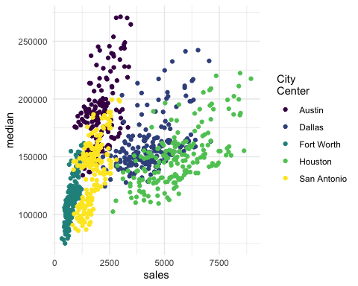

# Austin prices on the rise

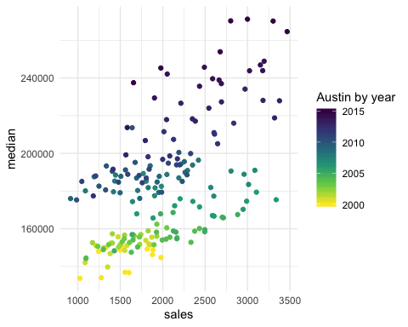

# Fort Worth has more affordable housing

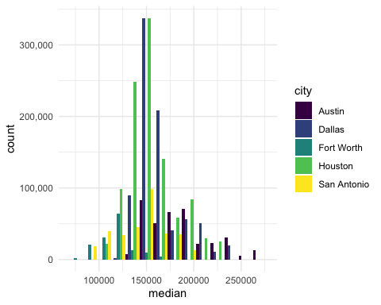

# The current pace of sales is fast

“Months inventory”: amount of time it would take to sell all current listings at current pace of sales.

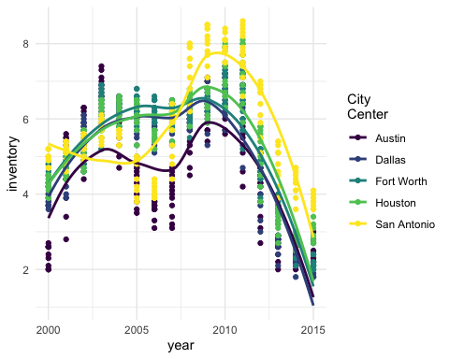

# Thanks to…

* Jennifer Thompson: <https://github.com/jenniferthompson/ParamRmdExample>
* Garrett Grolemund: <https://rmarkdown.rstudio.com/lesson-6.html>