Visualizing Texas: word_document

Alison Hill

2019-03-15

# Packages and data

We’ll use ggplot2 for visualization, and some light dplyr for data wrangling. The txhousing data is loaded for you when you install and load the ggplot2 package.

library(ggplot2) # plotting  
library(dplyr) # wrangling  
txsamp <- txhousing %>%   
 filter(city %in% c("Houston", "Fort Worth", "San Antonio", "Dallas", "Austin"))

# Austin is expensive

ggplot(data = txsamp, aes(x = sales, y = median)) +  
 geom_point(aes(colour = city)) +   
 scale_colour_viridis_d("City\nCenter", option = params$viridis_palette)

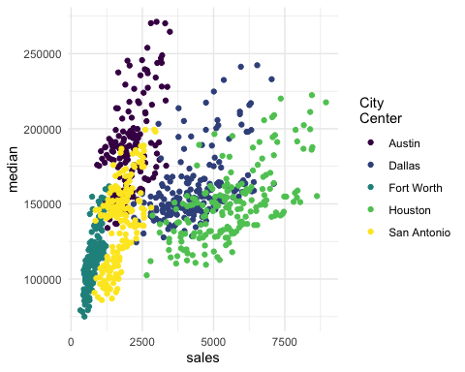

# Austin prices on the rise

ggplot(data = filter(txsamp, city == "Austin"), aes(x = sales, y = median)) +  
 geom_point(aes(colour = year)) +   
 scale_colour_viridis_c("Austin by year", option = params$viridis_palette, direction = -1)

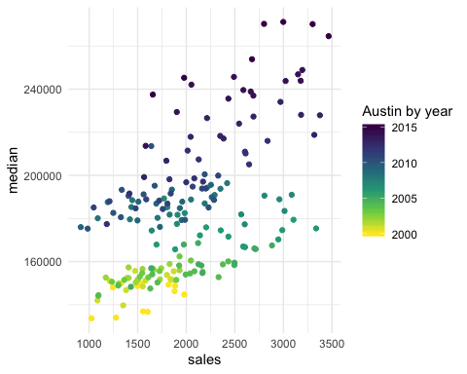

# Fort Worth has more affordable housing

library(scales) # to make y-axis in non-scientific notation  
ggplot(txsamp, aes(x = median, fill = city)) +  
 geom_histogram(aes(weight = sales), position = "dodge", binwidth = 15000) +  
 scale_fill_viridis_d(option = params$viridis_palette)+  
 scale_y_continuous(labels = comma)

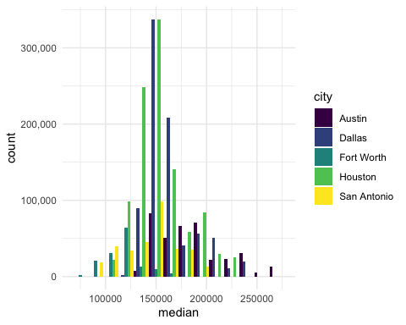

# The current pace of sales is fast

“Months inventory”: amount of time it would take to sell all current listings at current pace of sales.

ggplot(data = txsamp, aes(x = year, y = inventory, colour = city)) +  
 geom_point() +   
 geom_smooth(se = FALSE) +  
 scale_colour_viridis_d("City\nCenter", option = params$viridis_palette)

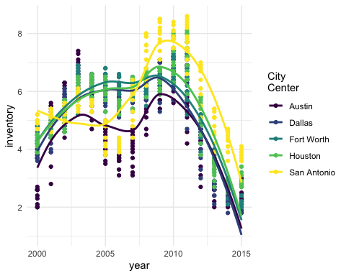

# Thanks to…

* Jennifer Thompson: <https://github.com/jenniferthompson/ParamRmdExample>
* Garrett Grolemund: <https://rmarkdown.rstudio.com/lesson-6.html>