Texas Housing Prices: odt_document
Alison Hill

Packages and data
The txhousing data is available when you install and load the ggplot2 package.
library(tidyverse)
txsamp <- txhousing %>%
filter(city %in% c("Houston", "Fort Worth", "San Antonio", "Dallas", "Austin"))

Austin is expensive
ggplot(data = txsamp, aes(x = sales, y = median)) +
geom_point(aes(colour = city)) +
scale_colour_viridis_d("City\nCenter", option = params$viridis_palette)
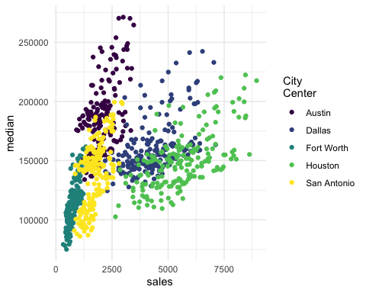

Austin prices on the rise
ggplot(data = filter(txsamp, city == "Austin"), aes(x = sales, y = median)) +
geom_point(aes(colour = year)) +
scale_colour_viridis_c("Austin by year", option = params$viridis_palette, direction = -1)
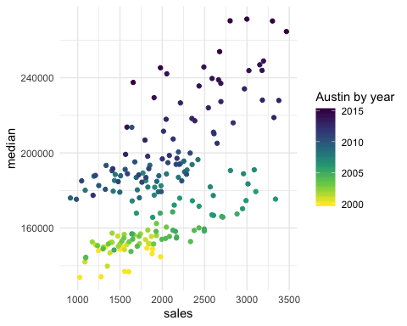

Fort Worth has more affordable housing
library(scales) # to make y-axis in non-scientific notation
ggplot(txsamp, aes(x = median, fill = city)) +
geom_histogram(aes(weight = sales), position = "dodge", binwidth = 15000) +
scale_fill_viridis_d(option = params$viridis_palette)+
scale_y_continuous(labels = comma)
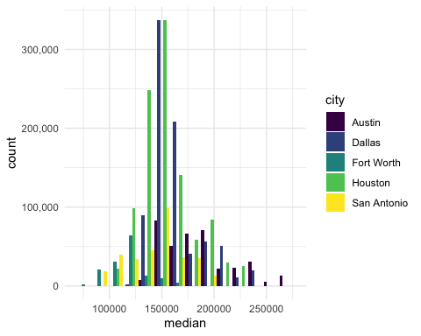

The current pace of sales is fast
“Months inventory”: amount of time it would take to sell all current listings at current pace of sales.
ggplot(data = txsamp, aes(x = year, y = inventory, colour = city)) +
geom_point() +
geom_smooth(se = FALSE) +
scale_colour_viridis_d("City\nCenter", option = params$viridis_palette)
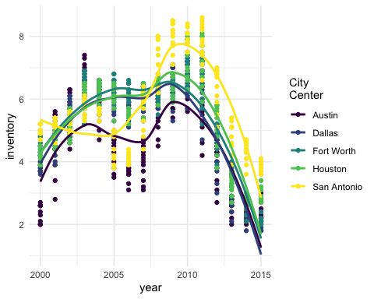

Thanks to…
- Jennifer Thompson: https://github.com/jenniferthompson/ParamRmdExample
- Garrett Grolemund: https://rmarkdown.rstudio.com/lesson-6.html

